Jenkins – 02

Jenkins task for Assignment-02.
- Configure 2 slave machines in the Jenkins master.
create a new EC2 instance
Log in to the slave machine
Install Java for the pre-requisite
create a ssh-keygen
cat id_rsa_pub> authorized _keys
chmod 700 authorized_keys => change the permission
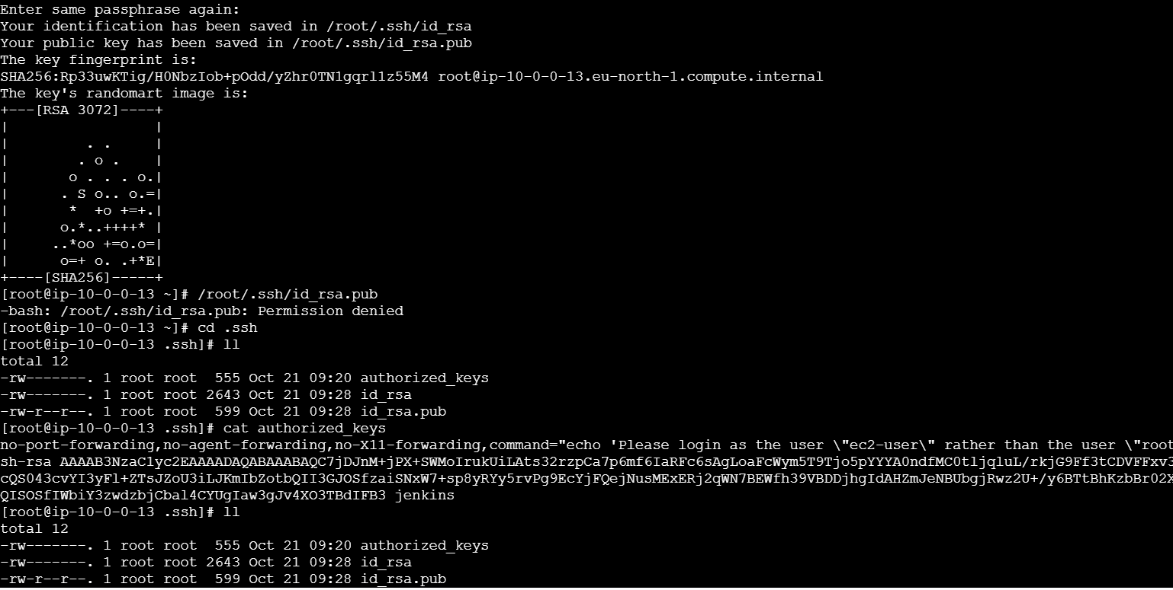
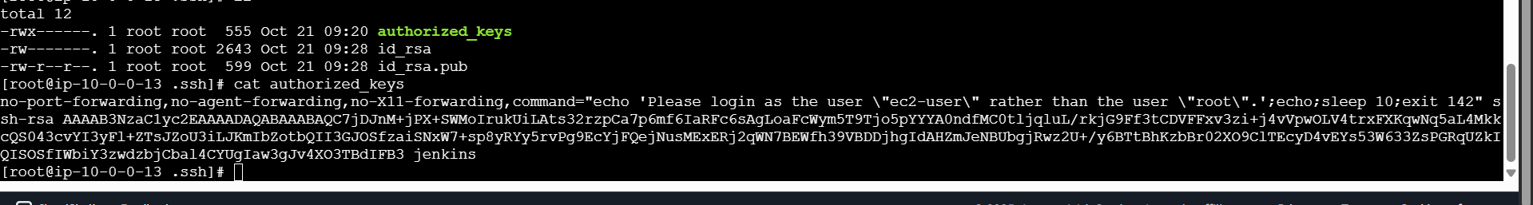
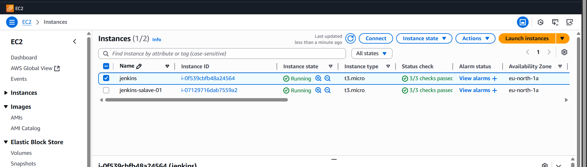
Configuration in the master
step how to configure
switch to root user > mkdir -p /var/lib/Jenkins/.shh > cd varr/lib/Jenkins/.ssh
ssh-keyscan -H 16.170.229.38 >>/var/lib/jenkins/.ssh/known_hosts
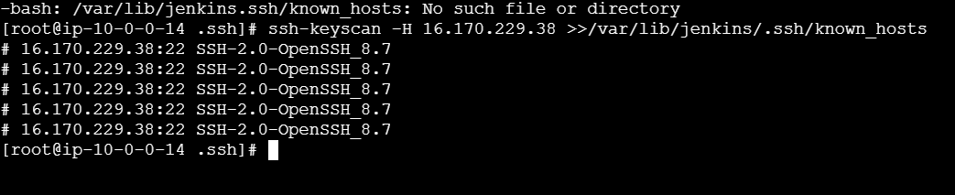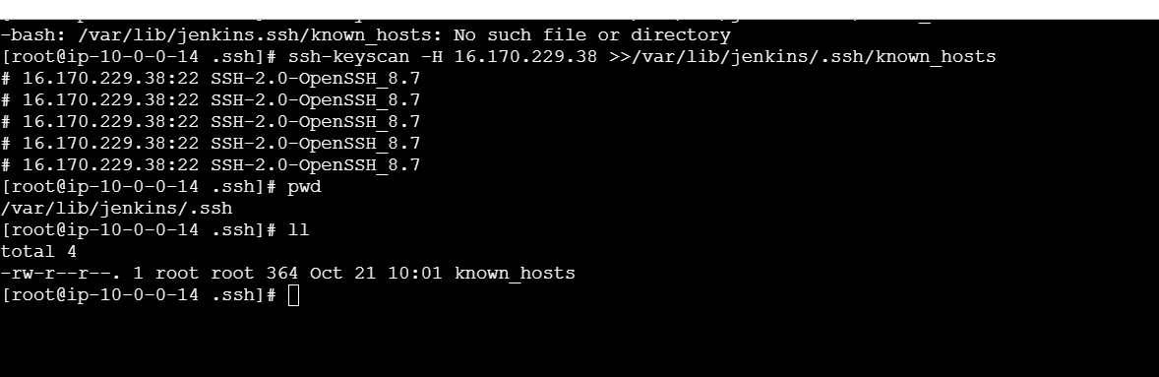
And change the ownership chown Jenkins: Jenkins known_hosts
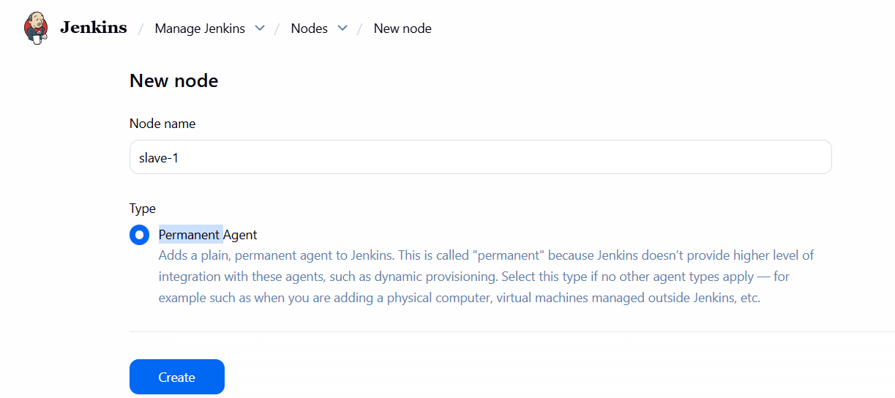
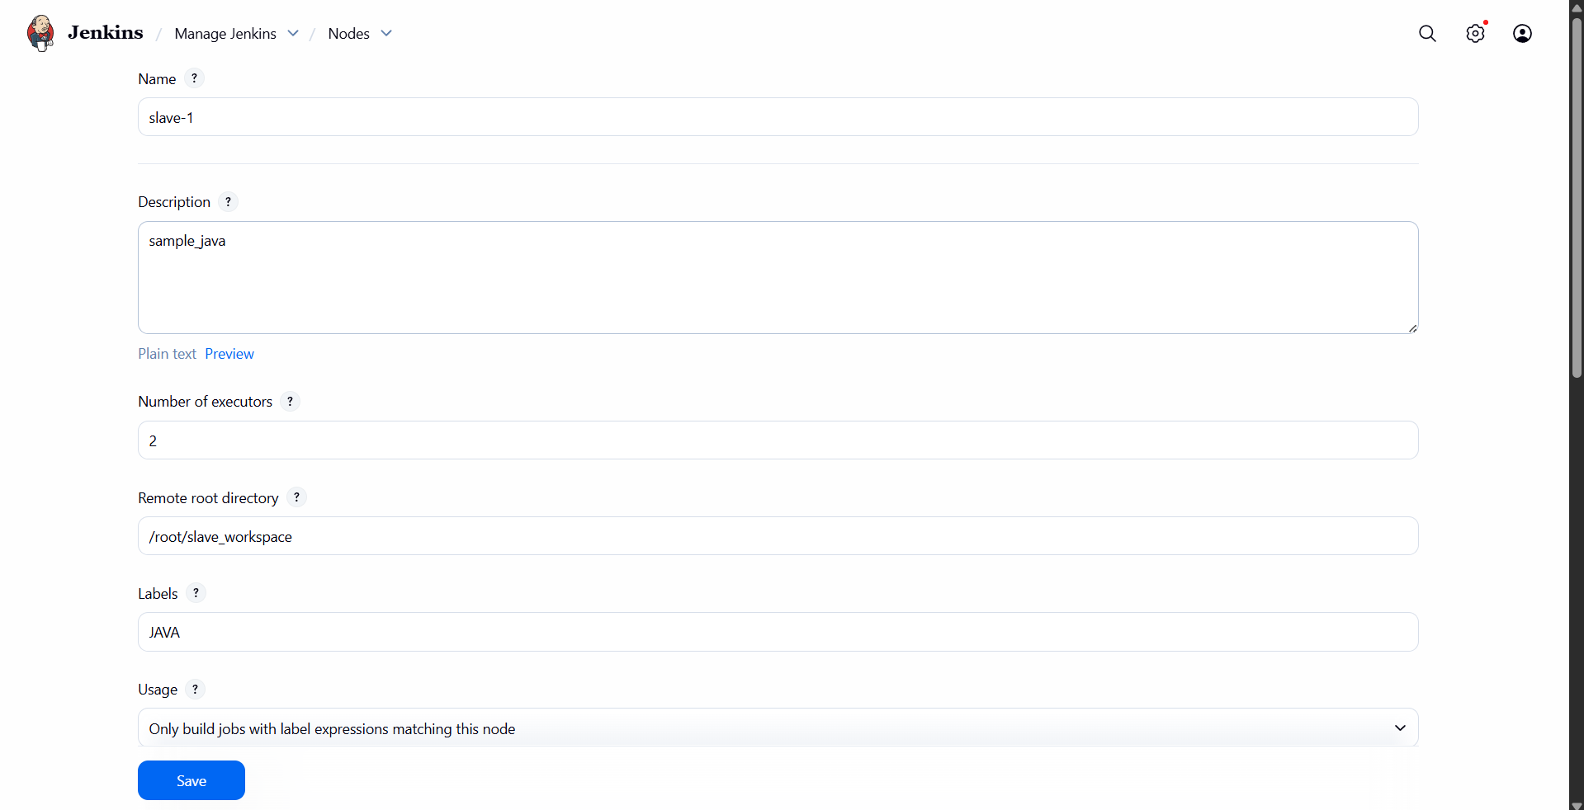
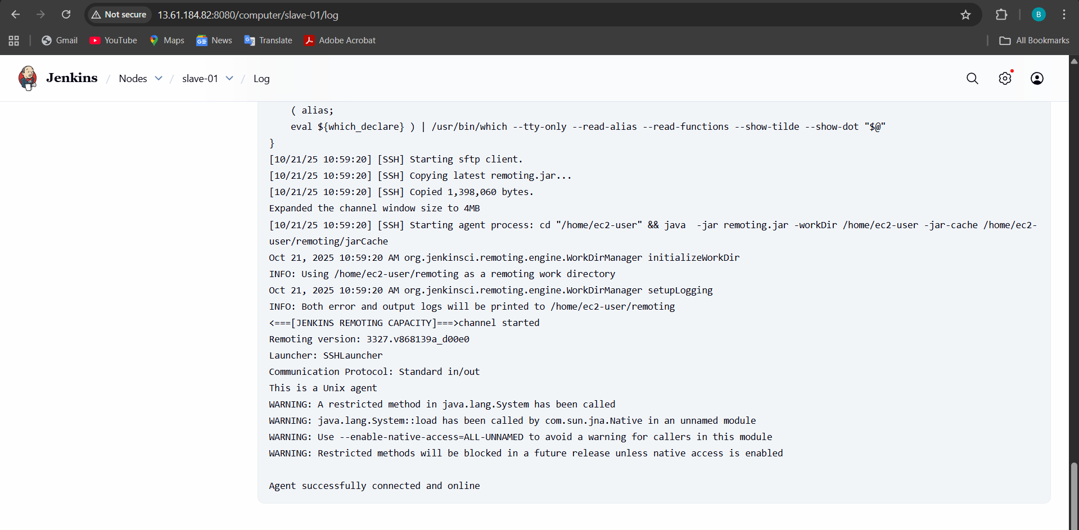
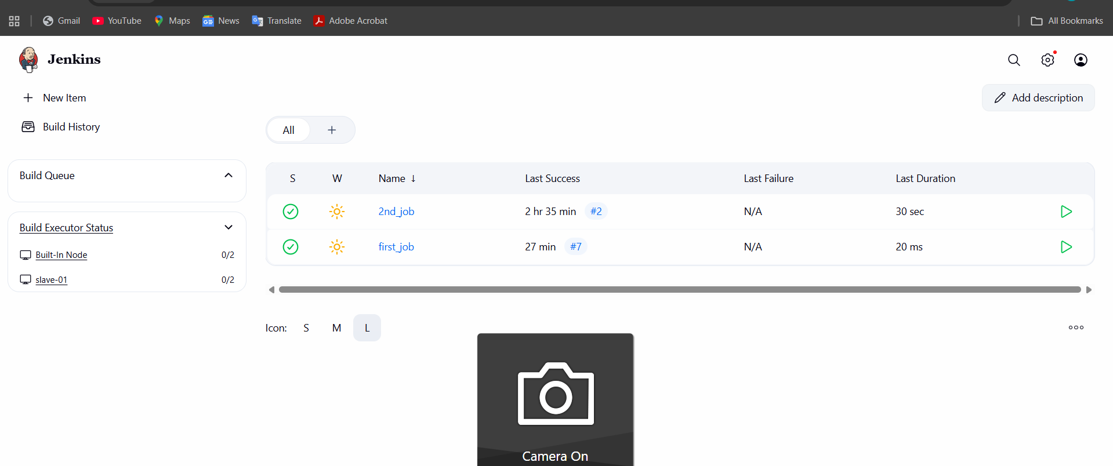

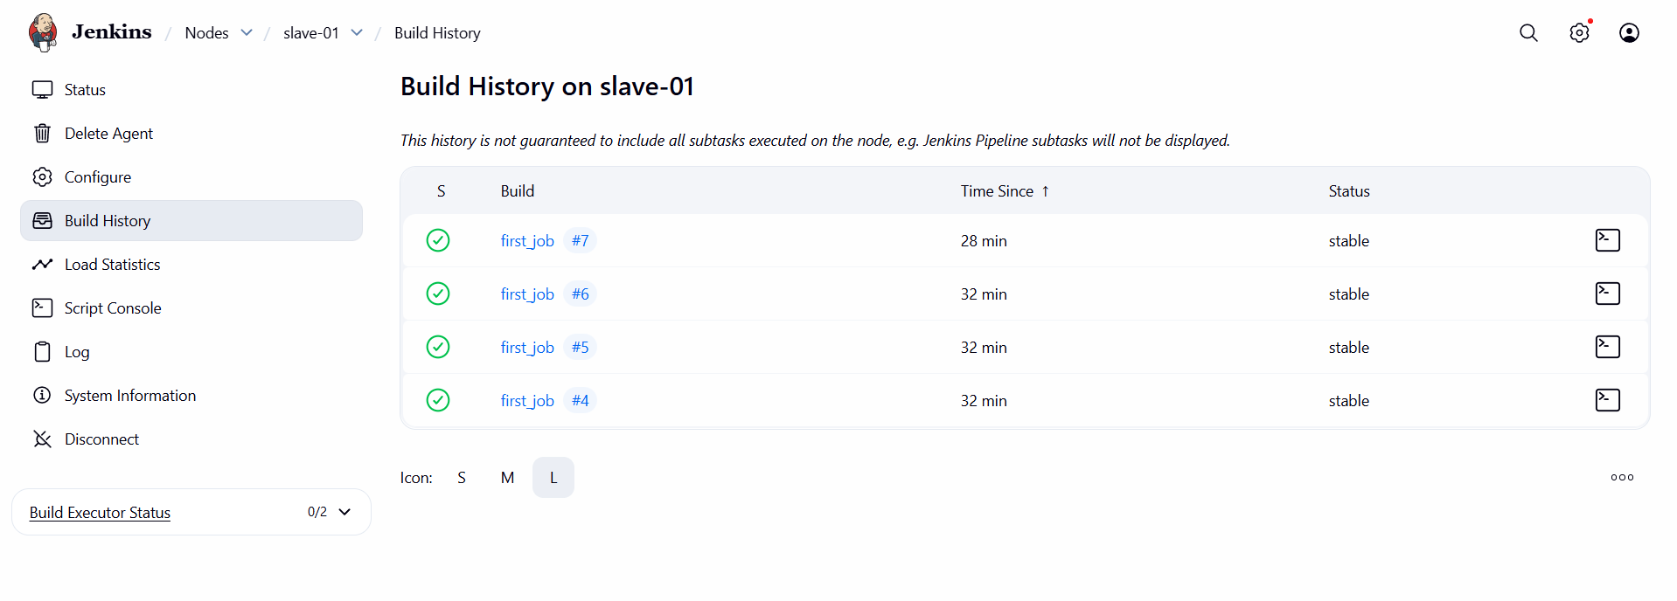
CONFIGURE 2 SLAVE MACHINES IN JENKINS MASTER.
Prerequisites
•Jenkins master is installed and running.
•Slave machines have Java installed and are reachable via SSH.
•You have SSH credentials (username/password or private key) for the slave
machines.
1. Install Required Plugins
•Go to Manage Jenkins > Plugins.
•Ensure SSH Build Agents and Node and Label plugins are installed.
2. Create SSH Credentials
•Go to Manage Jenkins > Credentials > Global > Add Credentials.
•Choose SSH Username with private key.
•Add credentials for each slave machine.
3. Add Slave Nodes
Repeat this for each slave machine:
a. Go to Manage Jenkins > Nodes > New Node
•Name: slave-1 (or slave-2)
•Type: Permanent Agent
b. Configure Node Details
•# of Executors: 1 or more depending on CPU
•Remote root directory: /home/jenkins
•Labels: linux, build, etc. (optional)
•Usage: Use this node as much as possible
c. Launch Method
•Choose Launch agents via SSH
•Enter:
oHost: IP or hostname of slave
oCredentials: Select the SSH credentials you added
oJava path: /usr/bin/java or appropriate path
d. Save and Connect
•Jenkins will try to connect and launch the agent.
•If successful, status will show as Connected.
4. Verify Connection
•Go to Manage Jenkins > Nodes
•Both slave-1 and slave-2 should show as Online
5. Test with a Job
•Create a freestyle job.
•In Restrict where this project can run, enter the label of one of the slaves.
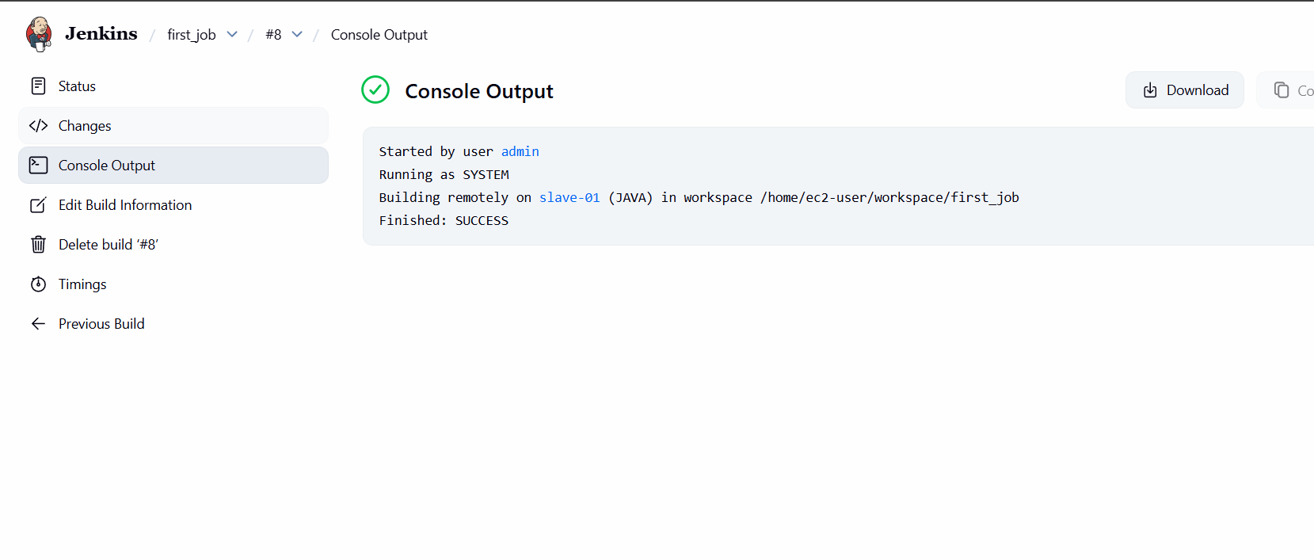
See the difference between you will get know
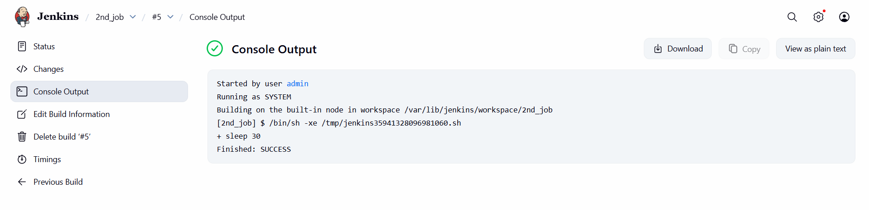

- Configure webhooks to the Jenkins job.
Create or use an existing Jenkins job
- Go to your Jenkins dashboard
- Click “New Item” → Freestyle project (or Pipeline)
- Give it a name, e.g., github-webhook-demo
- Click OK

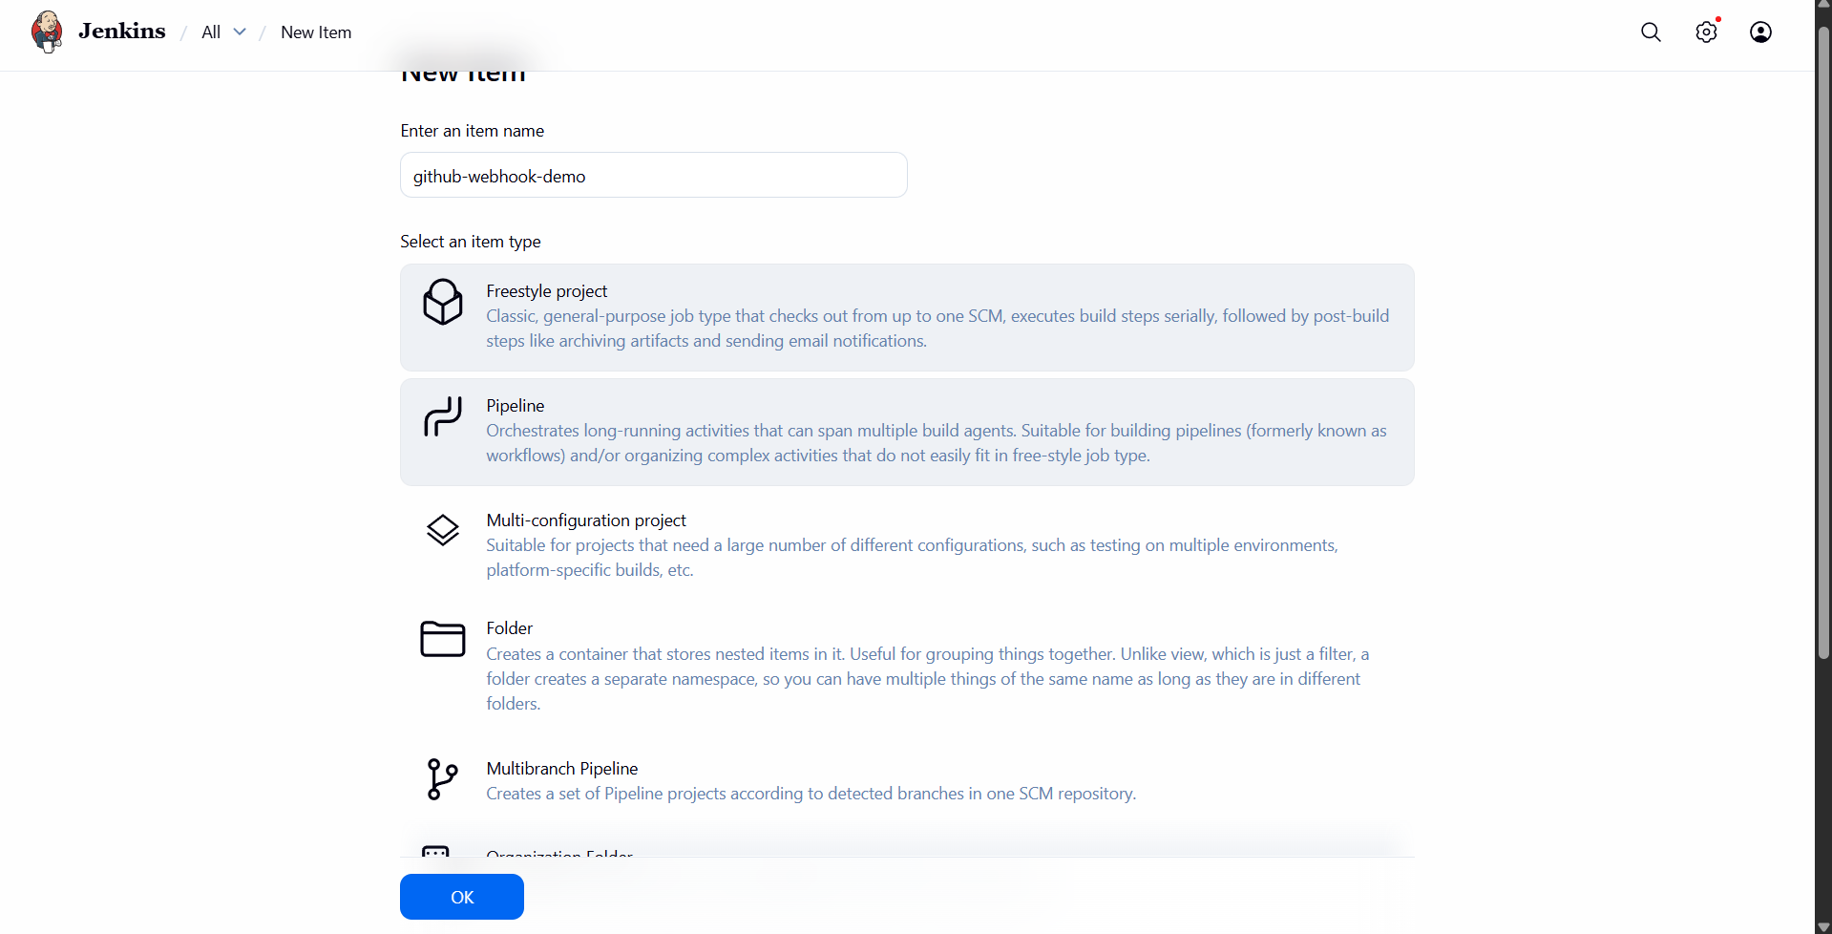
2. Create or Open Jenkins Job
•Go to Jenkins Dashboard > New Item or open an existing job.
•Choose Freestyle project or Pipeline, depending on your setup.
3. Configure Source Code Management
•Under Source Code Management, select Git.
•Enter your repository URL.
•Add credentials if needed.
4. Enable Build Trigger via Webhook
•Scroll to Build Triggers.
•Check:
o GitHub hook trigger for GITScm polling (for GitHub)
o Build when a change is pushed to GitLab (for GitLab)
6. Configure Webhook in GitLab
•Go to your GitLab repo → Settings > Webhooks.
•Add:
oURL: http://<jenkins-server>/project/<job-name>
oChoose events like Push, Merge Request, etc.
oSave.
7. Test the Webhook
•Make a commit or push to the repo.
•Jenkins should automatically trigger the job.

. Enable GitHub/GitLab Integration Plugin
•Go to Manage Jenkins > Plugins.
•Install:
oGitHub Integration Plugin (for GitHub)
oGitLab Plugin (for GitLab)
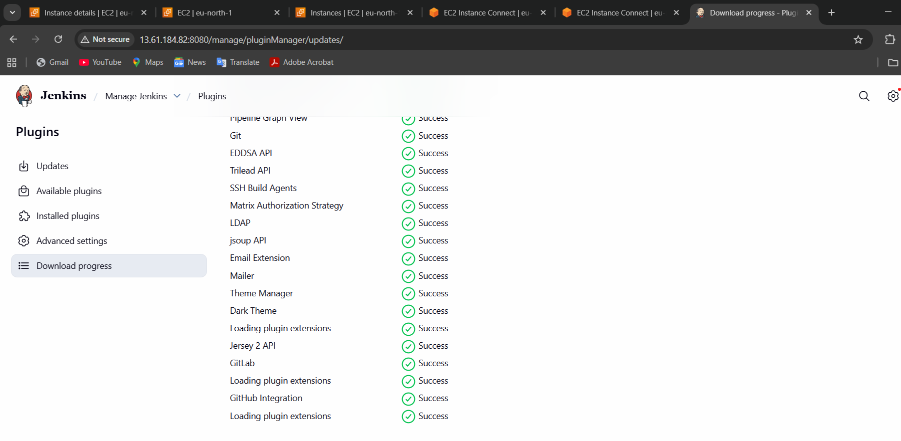
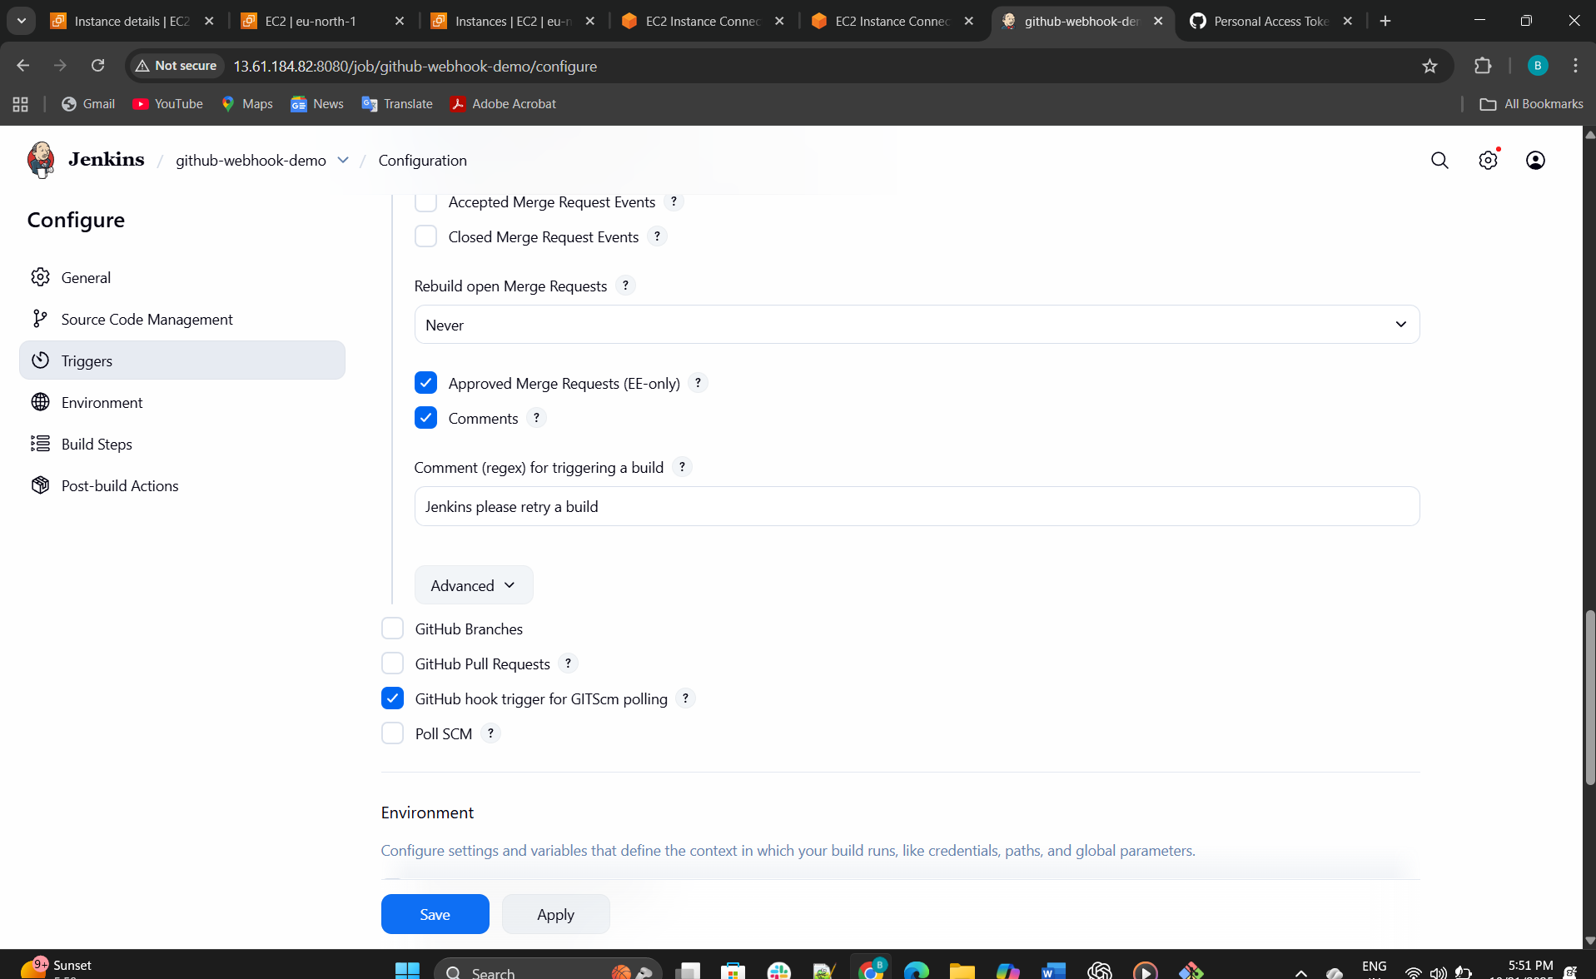
5. Configure Webhook in GitHub
•Go to your GitHub repo → Settings > Webhooks.
•Click Add webhook:
oPayload URL: http://<jenkins-server>/github-webhook/
oContent type: application/json
oEvents: Choose “Just the push event” or others as needed.
oSave.

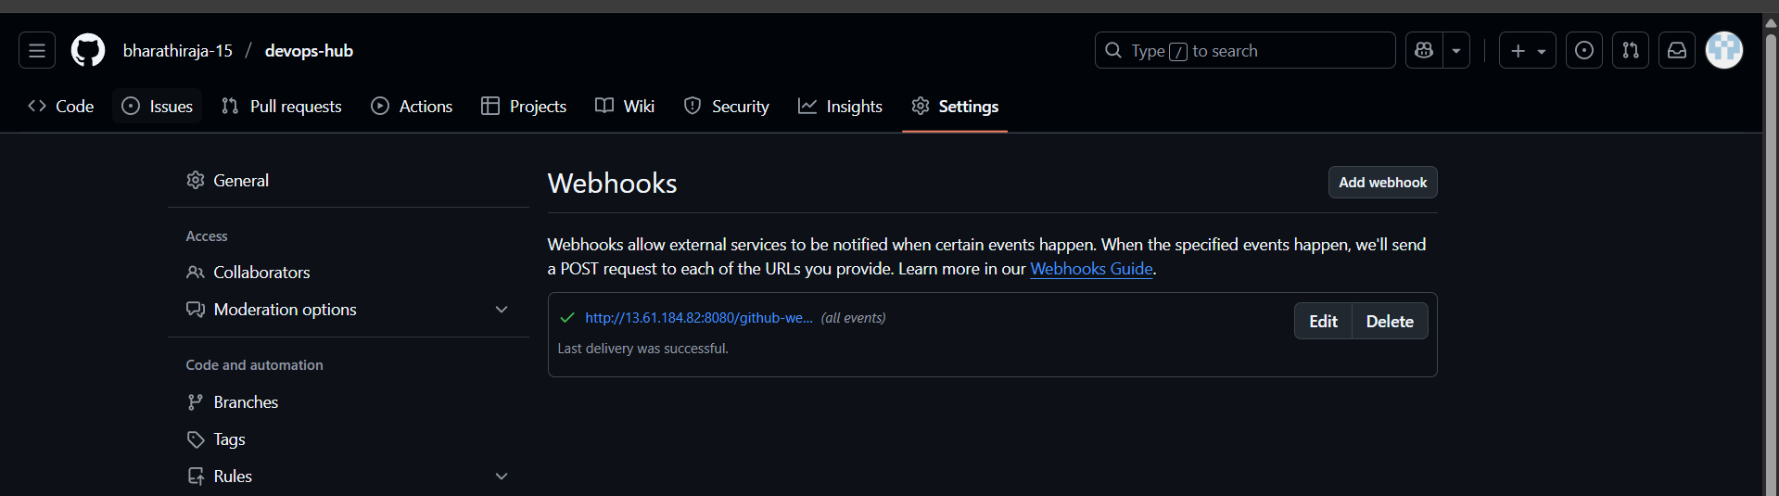
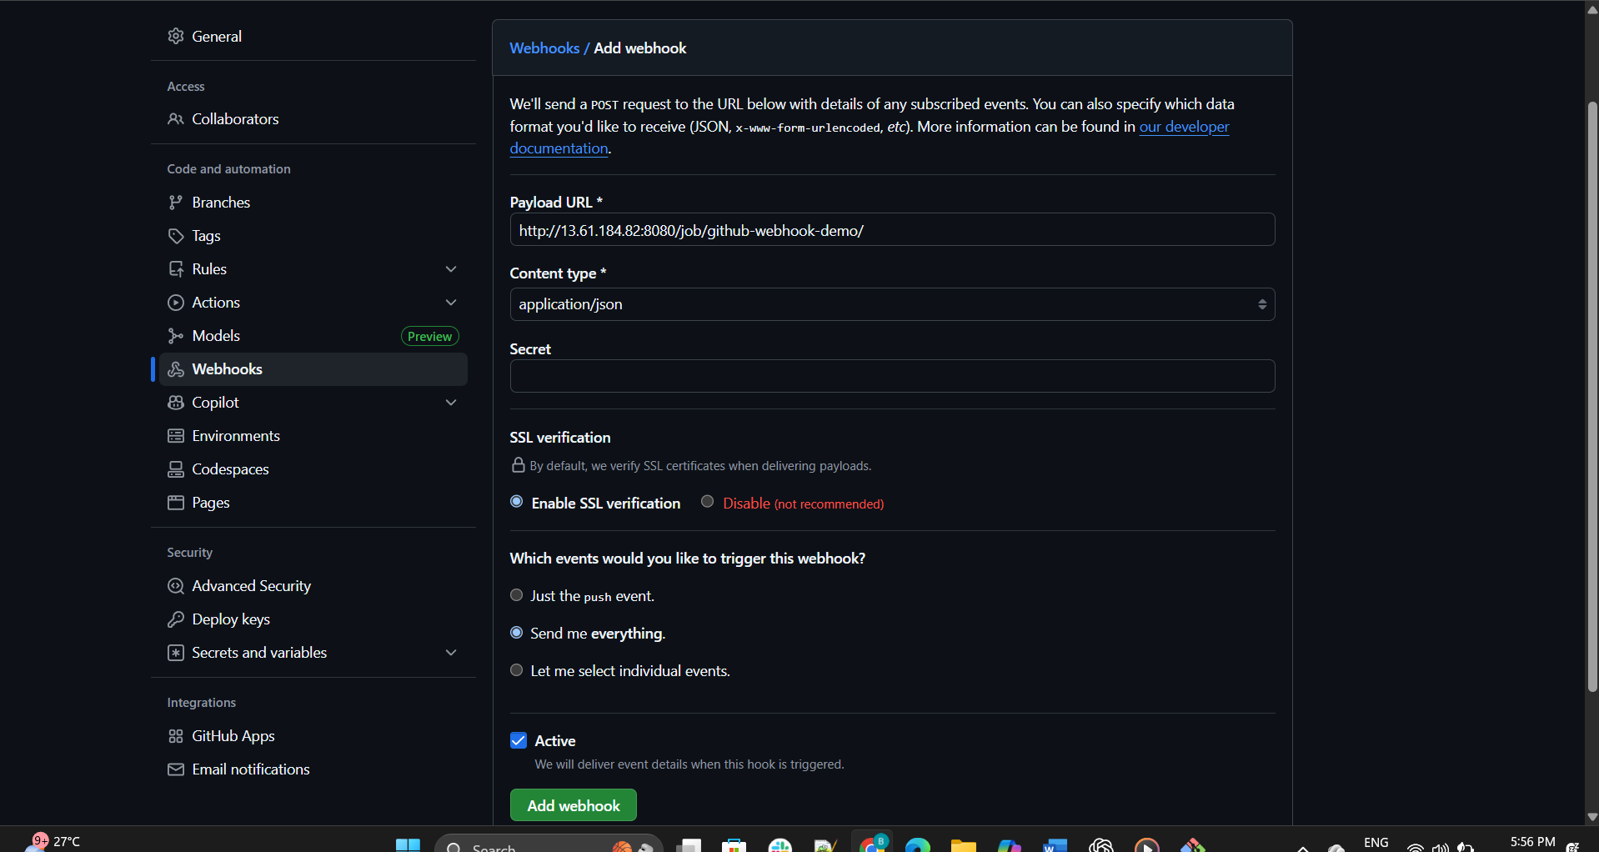

When I trigger or change any code, it will Automatically validate
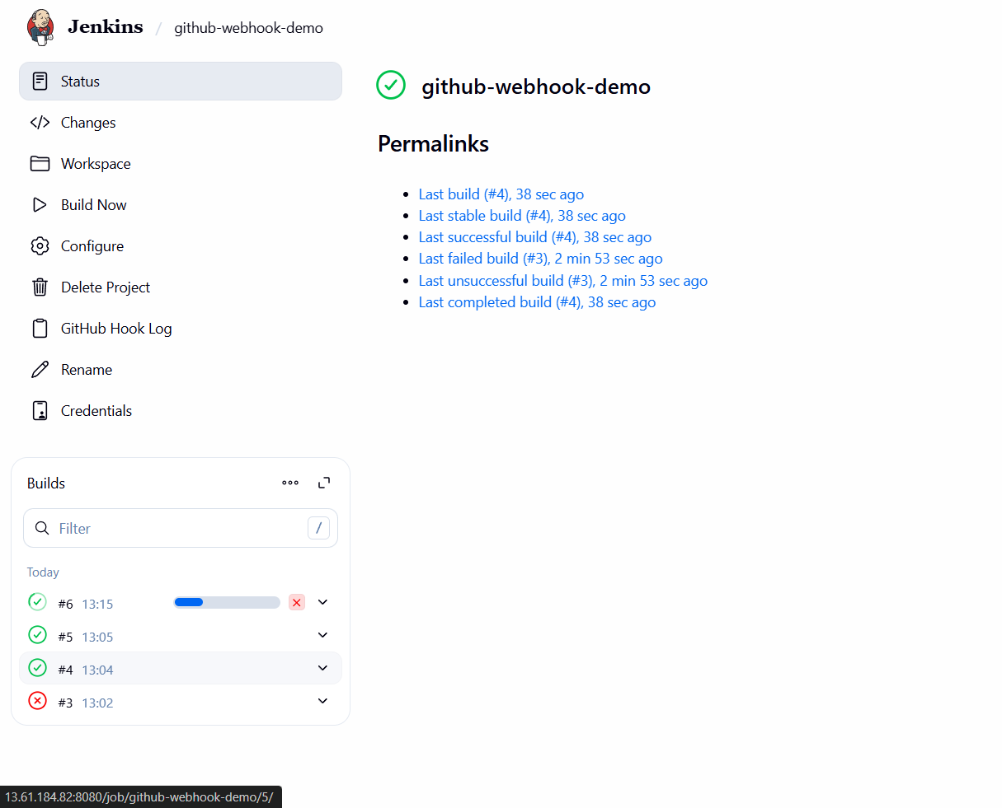

- Configure poll SCM and build periodical options in the Jenkins job.
This is like cron job
CONFIGURE POLL SCM AND BUILD PERIODICAL
OPTIONS IN JENKINS JOB.
1. Configure Poll SCM
This checks the repository for changes at regular intervals.
Steps:
1. Go to your Jenkins job → Configure.
2. Scroll to Build Triggers.
3. Check Poll SCM.
4. In the Schedule field, enter a cron expression. Example:
5. H/15 * * * *
This means: poll every 15 minutes (the H spreads load across nodes).
Notes:
•Jenkins polls the repo but only triggers a build if changes are detected.
Cron format: MINUTE HOUR DOM MONTH DOW
oH/15 * * * * → every 15 minutes
oH 2 * * 1-5 → once at 2 AM on weekdays
2. Configure Build Periodically
This triggers builds at fixed intervals regardless of changes.
Steps:
1. In the same Build Triggers section, check Build periodically.
2. Enter a cron expression. Example:
3. H 4 * * *
This means: build once daily at 4 AM.
Notes:
•Useful for scheduled tasks like nightly builds, backups, or reports.
•Does not check for SCM changes—runs unconditionally.
Example Use Case
If you want Jenkins to:
•Check for code changes every 15 minutes
•Run a full build every night at 2 AM
Use:
•Poll SCM: H/15 * * * *
•Build periodically: H 2 * * *
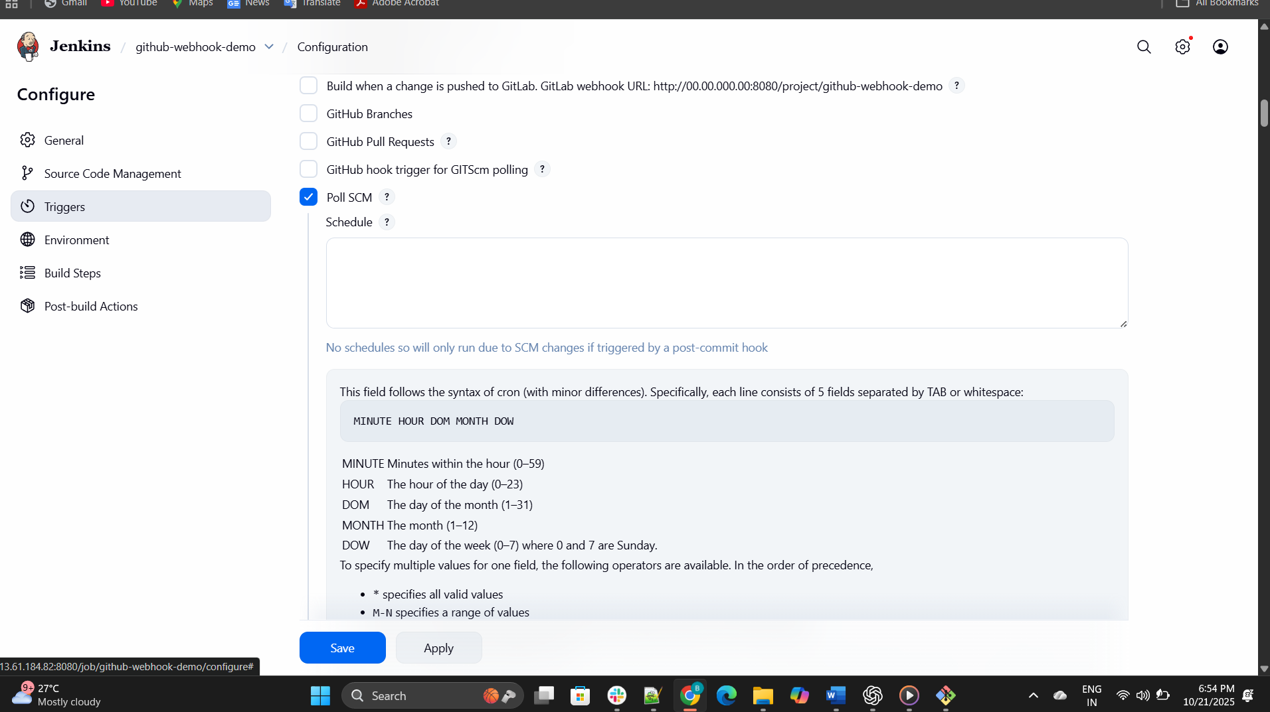
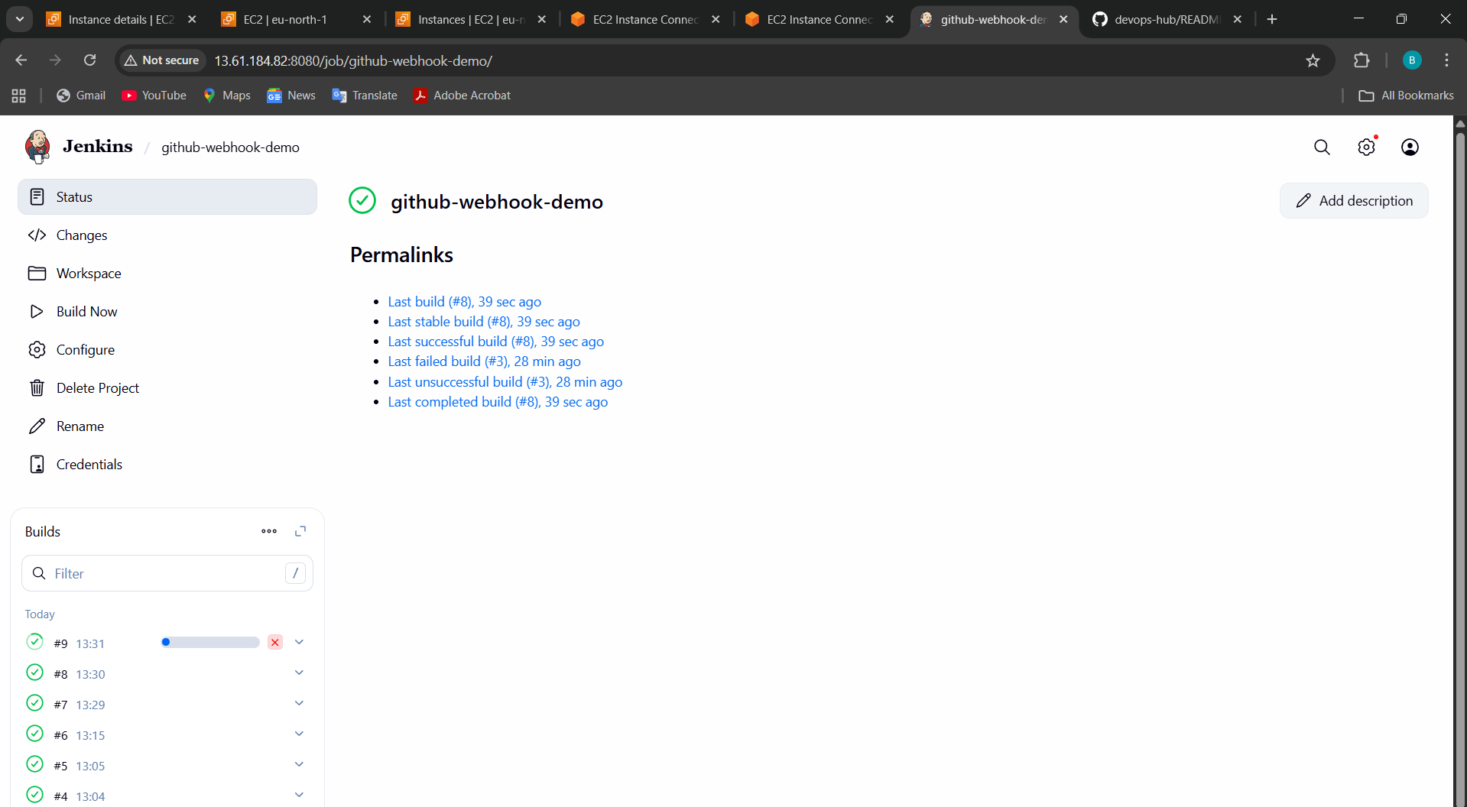

- Take a backup of the Jenkins server by using a bash script.
Step-by-Step Jenkins Backup (Using Bash Script)
Step 1: Create Backup Directory
sudo mkdir -p /backup/jenkins
sudo chmod 755 /backup/jenkins

Step 2: Create the Bash Script
Open a new file:
sudo nano /usr/local/bin/jenkins_backup.sh
Paste this script inside 👇
#!/bin/bash
# ================================
# Jenkins Backup Script
# Author: Bharathiraja Example
# ================================

# Variables
JENKINS_HOME="/var/lib/jenkins"
BACKUP_DIR="/backup/jenkins"
DATE=$(date +'%Y-%m-%d_%H-%M-%S')
BACKUP_FILE="$BACKUP_DIR/jenkins_backup_$DATE.tar.gz"

echo "=============================================="
echo "Starting Jenkins Backup: $(date)"
echo "=============================================="

# Stop Jenkins (optional but recommended)
sudo systemctl stop jenkins
# Create a tarball backup
sudo tar -czvf "$BACKUP_FILE" "$JENKINS_HOME"
# Start Jenkins again
sudo systemctl start jenkins
echo "✅ Backup completed successfully!"
echo "Backup File: $BACKUP_FILE"
echo "=============================================="

Step 3: Give Execute Permission
sudo chmod +x /usr/local/bin/jenkins_backup.sh

Step 4: Run the Script
sudo /usr/local/bin/jenkins_backup.sh
✅ You’ll get an output like:
Starting Jenkins Backup...
tar: Creating archive ‘/backup/jenkins/jenkins_backup_2025-10-21_14-10-30.tar.gz’
✅ Backup completed successfully!
Backup File: /backup/jenkins/jenkins_backup_2025-10-21_14-10-30.tar.gz

Step 5 (Optional): Schedule Automatic Backup (Cron Job)
Run:
sudo crontab -e
Add this line to take backup daily at midnight:
0 0 * * * /usr/local/bin/jenkins_backup.sh >> /var/log/jenkins_backup.log 2>&1

💾 Backup Contains
- All Jenkins jobs
- Plugin configurations
- User credentials
- Jenkins settings
- Build logs (if you didn’t clean up)

🔁 Restore (if needed)
If your Jenkins server crashes, restore backup like this:
sudo systemctl stop jenkins
sudo tar -xzvf /backup/jenkins/jenkins_backup_2025-10-21_14-10-30.tar.gz -C /
sudo systemctl start jenkins

Quick Summary
Step | Command | Purpose
1 | mkdir -p /backup/jenkins | Create backup folder
2 | nano /usr/local/bin/jenkins_backup.sh | Write backup script
3 | chmod +x /usr/local/bin/jenkins_backup.sh | Make it executable
4 | sudo /usr/local/bin/jenkins_backup.sh | Run backup manually
5 | sudo crontab -e | Schedule daily backup

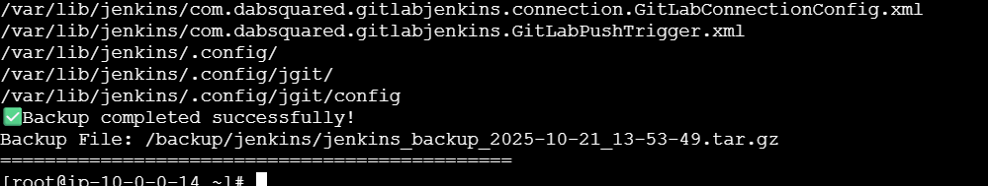
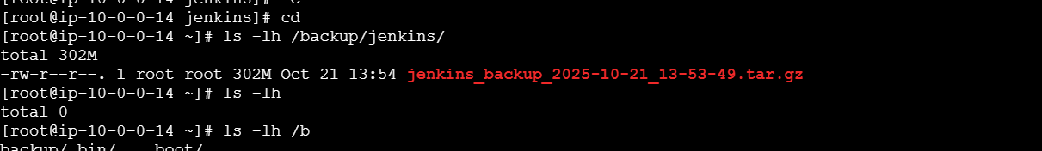
DONE IT

- Take a backup of Jenkins using the rethin backup plugin.
•Go to Jenkins ◊ manage Jenkins◊plugins◊search thin◊instal
Step | Action | Menu Path
1 | Install ThinBackup plugin | Manage Jenkins → Plugins → Available
2 | Configure backup folder | Manage Jenkins → ThinBackup → Settings
3 | Run backup manually | Manage Jenkins → ThinBackup → Backup Now
4 | Schedule automatic backup | Configure cron in ThinBackup
5 | Restore Jenkins | Manage Jenkins → ThinBackup → Restore

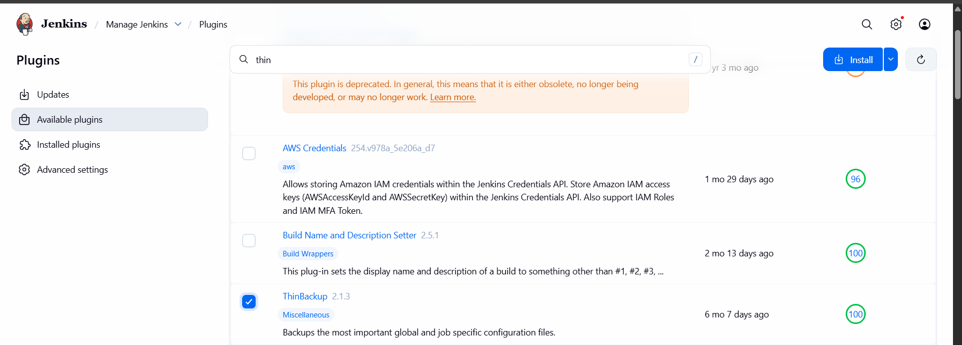
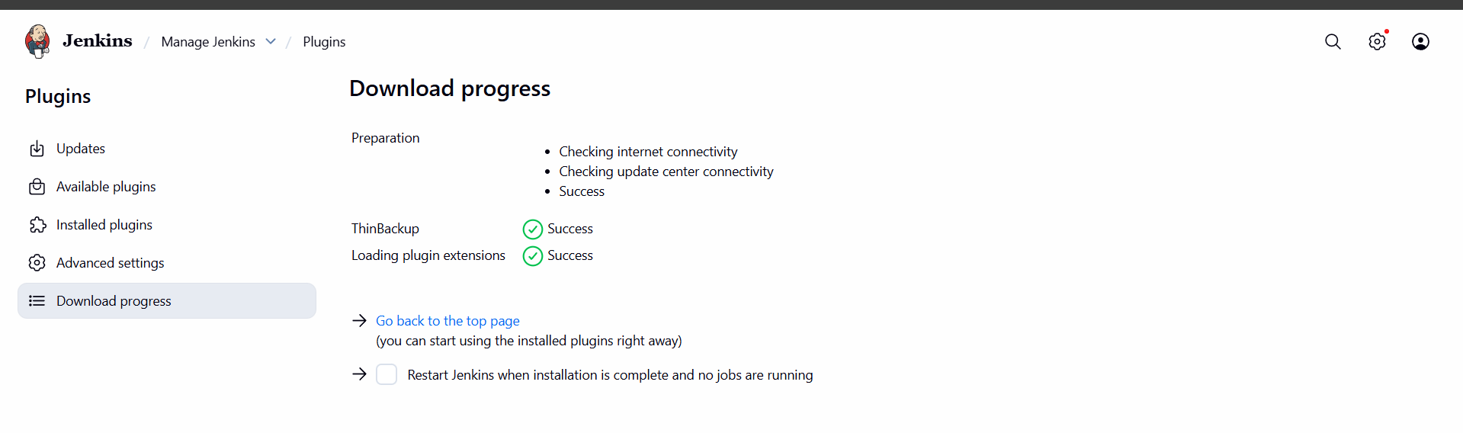
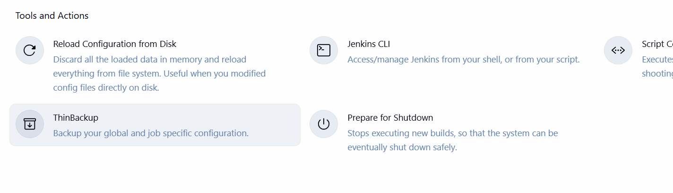
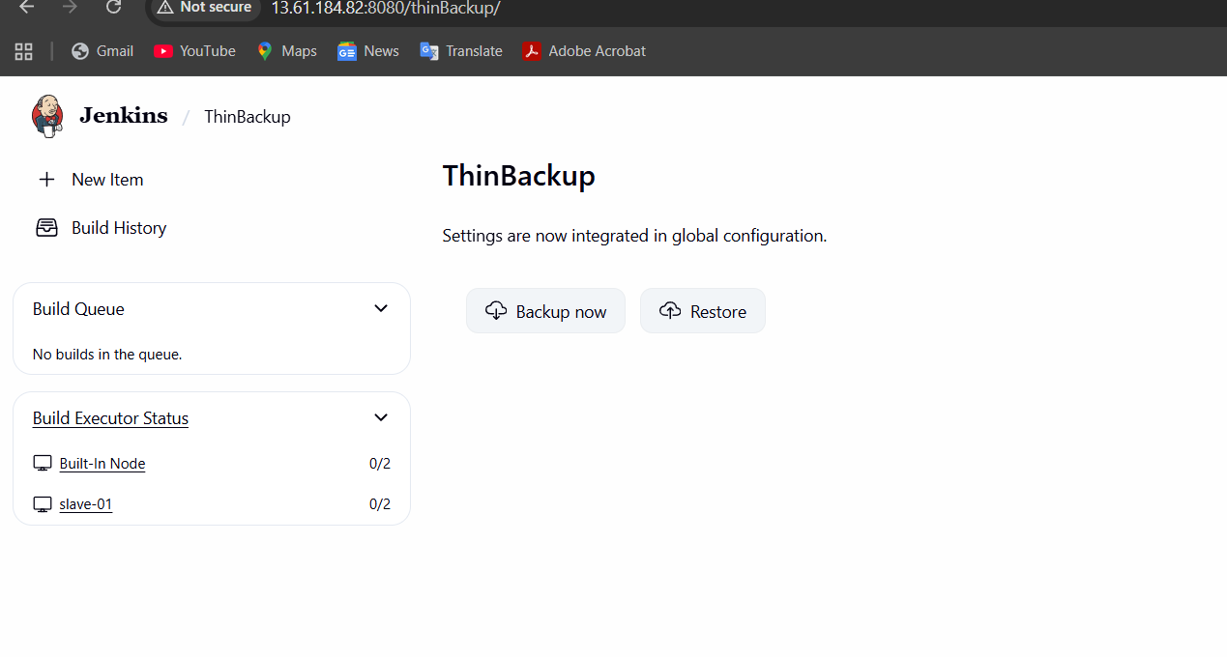
We can see where see back it this is method to see our backup data
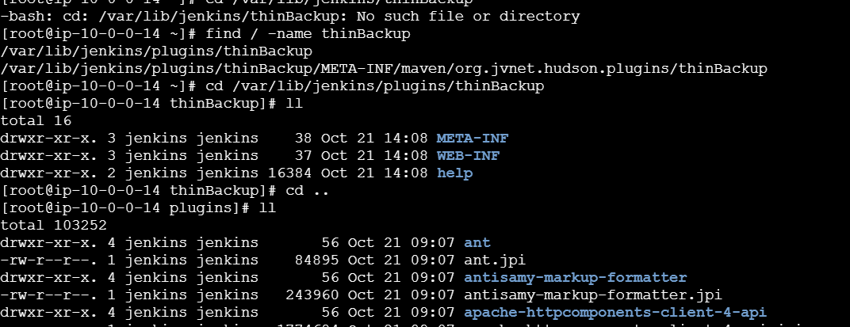

- Set up a new Jenkins server and dump the backup taken in the task
Open one new instance
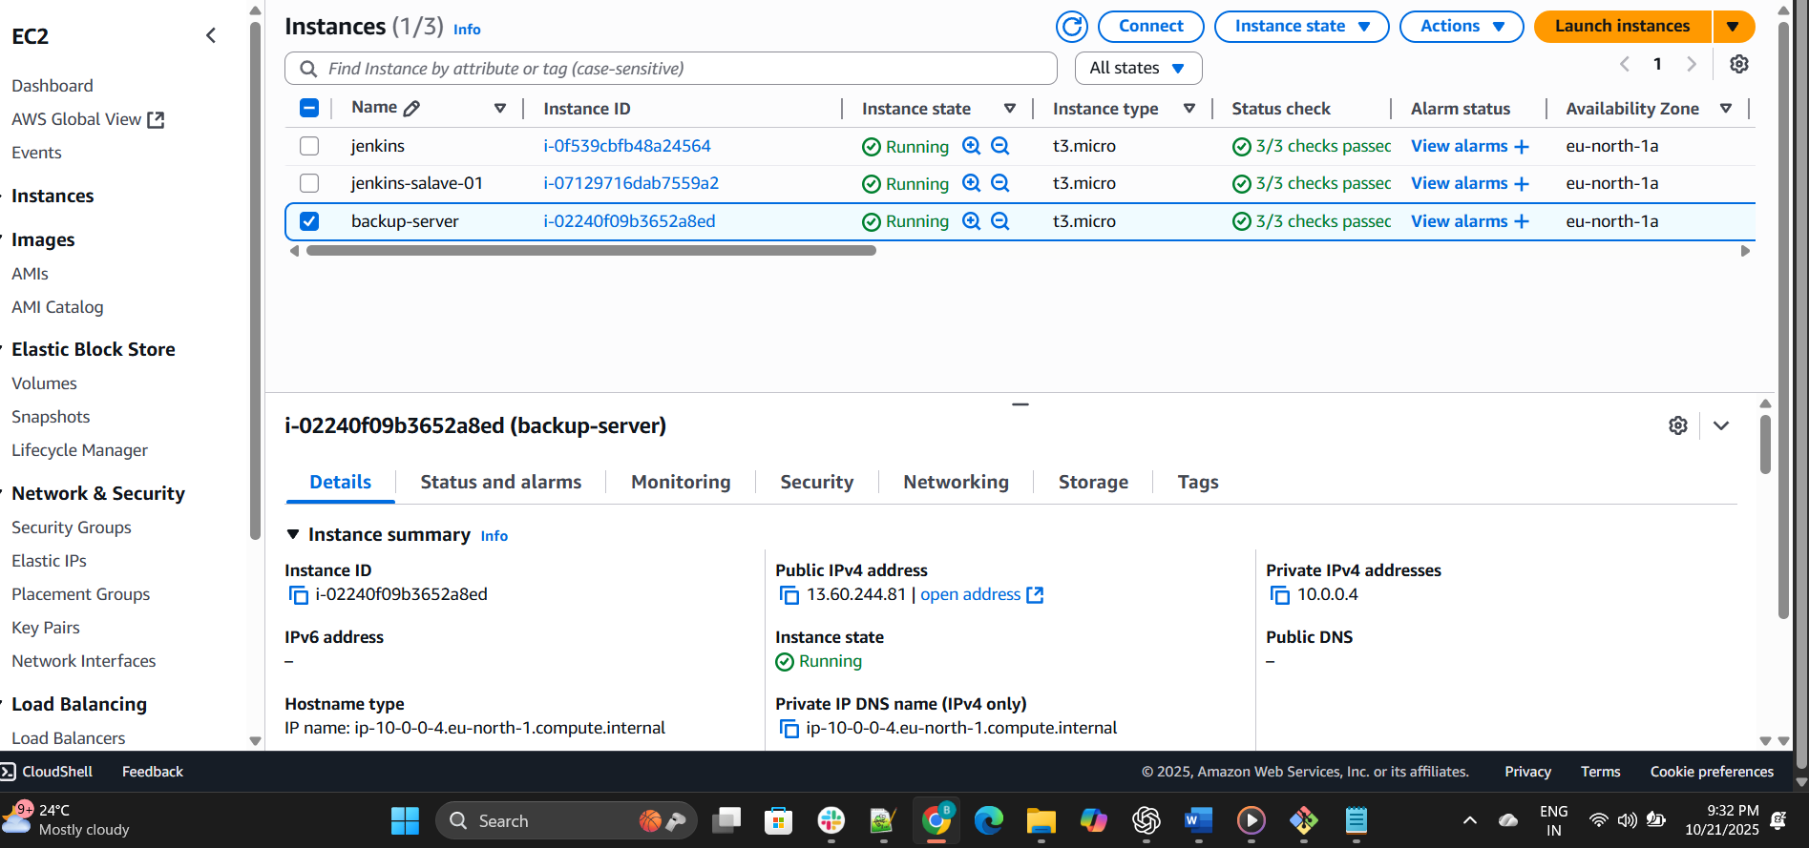
Install java and Jenkins, open a new

