Task 1
Create one Jenkins job using the code below and create three stages:
- stage1: Git clone to download the source code.
- stage2: SonarQube Integration to check the quality of code.
- stage3: Slack Integration to send the alerts to Slack.
URL: https://github.com/betawins/VProfile-1.git

- stage1: Git clone to download the source code.
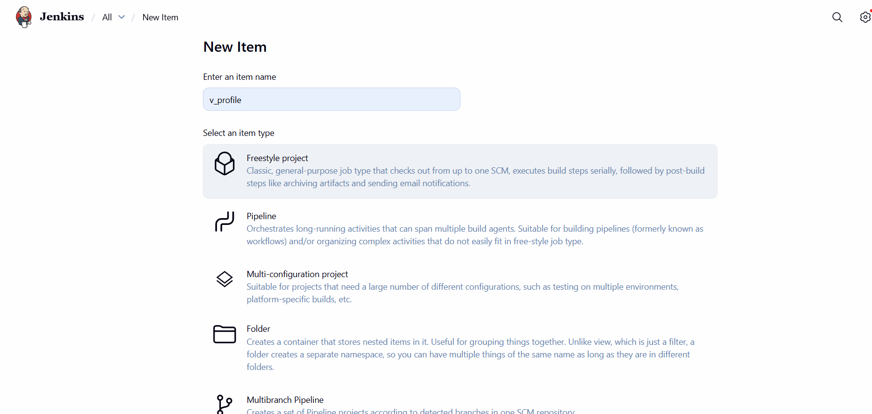
To the source code download
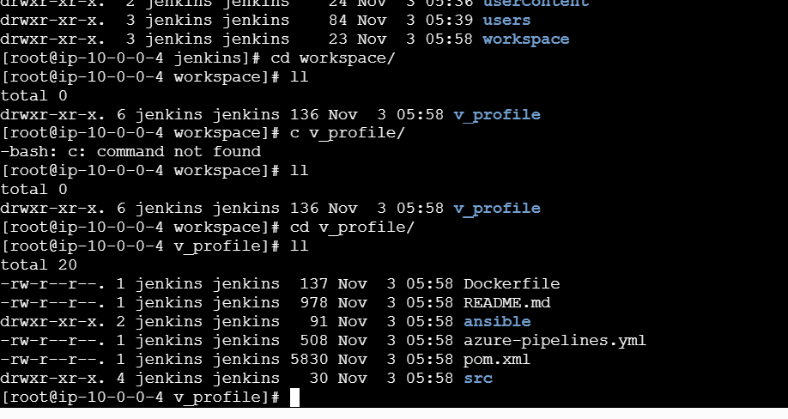

- stage2: SonarQube Integration to check the quality of code.
Prerequisites:
SonarQube requires at least 2 GB of RAM.
- Install Java.
- Install and configure MySQL. (docker install instead of mysql )
- Create a database and a user for SonarQube.
- Install and configure SonarQube.
- Integration with Jenkins Server

- Install java
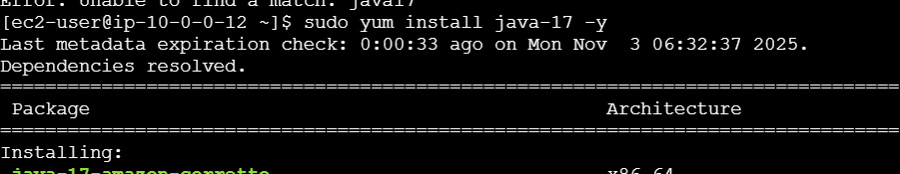
Step-by-Step Installation Process:
Step 1: System Update & Java Installation
bash
# Update system packages
sudo yum update -y

# Install Java 17
sudo yum install java-17 -y

# Verify Java installation
java -version
Step 2: Docker Installation & Setup
bash
# Install Docker
sudo yum install docker -y

# Start Docker service
sudo systemctl start docker

# Enable Docker to start on boot
sudo systemctl enable docker

# Add ec2-user to docker group
sudo usermod -a -G docker ec2-user

# Verify Docker installation
docker --version
Step 3: System Configuration
bash
# Configure system limits for SonarQube
sudo sysctl -w vm.max_map_count=262144
sudo sysctl -w fs.file_max=65536

# Make permanent
echo 'vm.max_map_count=262144' | sudo tee -a /etc/sysctl.conf
echo 'fs.file_max=65536' | sudo tee -a /etc/sysctl.conf
Step 4: Docker Network Setup
bash
# Create custom network for SonarQube
docker network create sonarnet
Step 5: PostgreSQL Database Setup
bash
# Run PostgreSQL container
docker run -d --name sonardb \
--network sonarnet \
-e POSTGRES_USER=sonar \
-e POSTGRES_PASSWORD=sonar \
-e POSTGRES_DB=sonarqube \
-p 5432:5432 \
postgres:15
Step 6: SonarQube Installation
bash
# Run SonarQube container
docker run -d --name sonarqube \
--network sonarnet \
-e SONAR_JDBC_URL=jdbc:postgresql://sonardb:5432/sonarqube \
-e SONAR_JDBC_USERNAME=sonar \
-e SONAR_JDBC_PASSWORD=sonar \
-e SONAR_ES_BOOTSTRAP_CHECKS_DISABLE=true \
-e SONAR_ES_JAVA_OPTS="-Xms512m -Xmx512m" \
-e SONAR_WEB_JAVAOPTS="-Xmx512m -Xms128m" \
-p 9000:9000 \
sonarqube:latest
Step 7: Verification
bash
# Check container status
docker ps -a

# Check SonarQube logs
docker logs -f sonarqube

# Wait for SonarQube to be ready
sleep 180
Step 8: Database Reconfiguration (Optional - you did this later)
bash
# Stop and remove existing PostgreSQL container
docker stop sonardb
docker rm sonardb

# Create new PostgreSQL container with custom credentials
docker run -d --name sonardb \
--network sonarnet \
-e POSTGRES_USER=sonaradmin \
-e POSTGRES_PASSWORD=adminpassword123 \
-e POSTGRES_DB=sonarqube_db \
-v postgres_data:/var/lib/postgresql/data \
-p 5432:5432 \
postgres:15

# Test connection
docker exec -it sonardb psql -U sonaradmin -d sonarqube_db -c "SELECT version();"
Current Status:
- ✅ Java 17 - Installed and working
- ✅ Docker - Installed and running
- ✅ PostgreSQL - Running in container
- ✅ SonarQube - Running in container
- ✅ Network - Custom network created
- SonarQube Installation
- bash
- # Run SonarQube container
- docker run -d --name sonarqube \
- --network sonarnet \
- -e SONAR_JDBC_URL=jdbc:postgresql://sonardb:5432/sonarqube \
- -e SONAR_JDBC_USERNAME=sonar \
- -e SONAR_JDBC_PASSWORD=sonar \
- -e SONAR_ES_BOOTSTRAP_CHECKS_DISABLE=true \
- -e SONAR_ES_JAVA_OPTS="-Xms512m -Xmx512m" \
- -e SONAR_WEB_JAVAOPTS="-Xmx512m -Xms128m" \
- -p 9000:9000 \
- sonarqube:latest

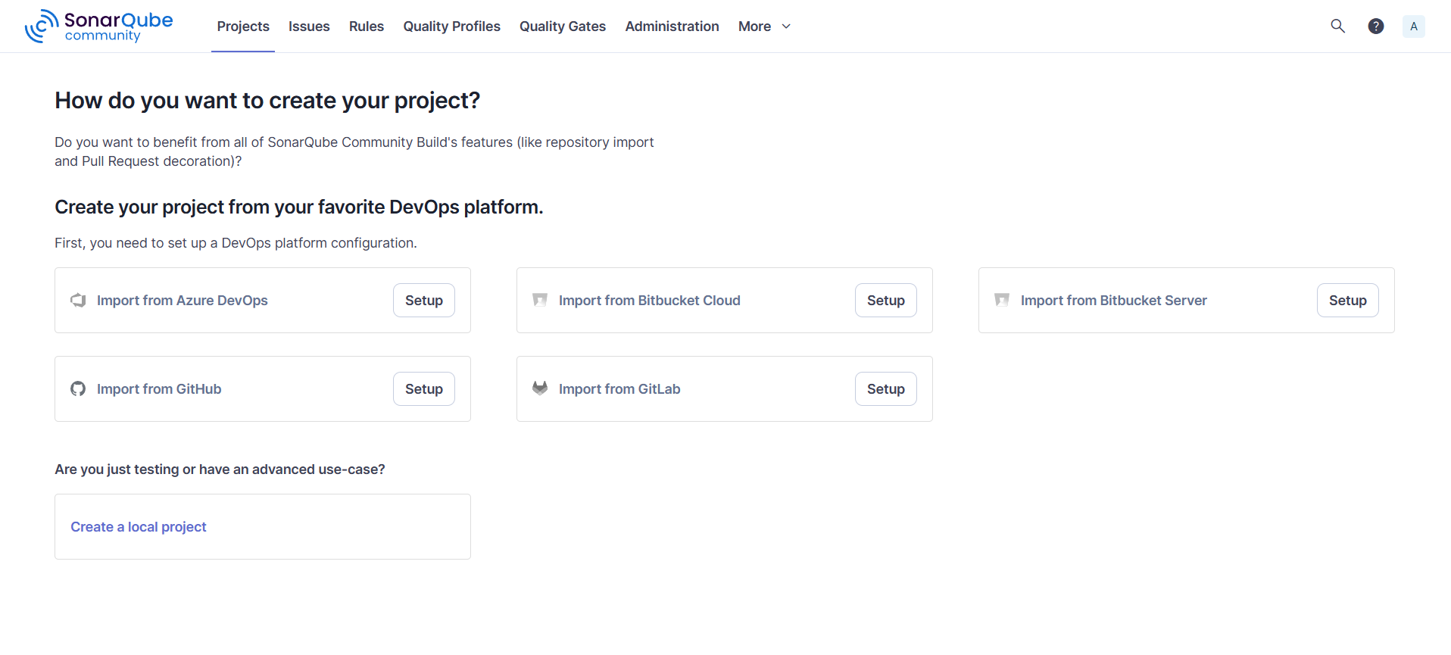

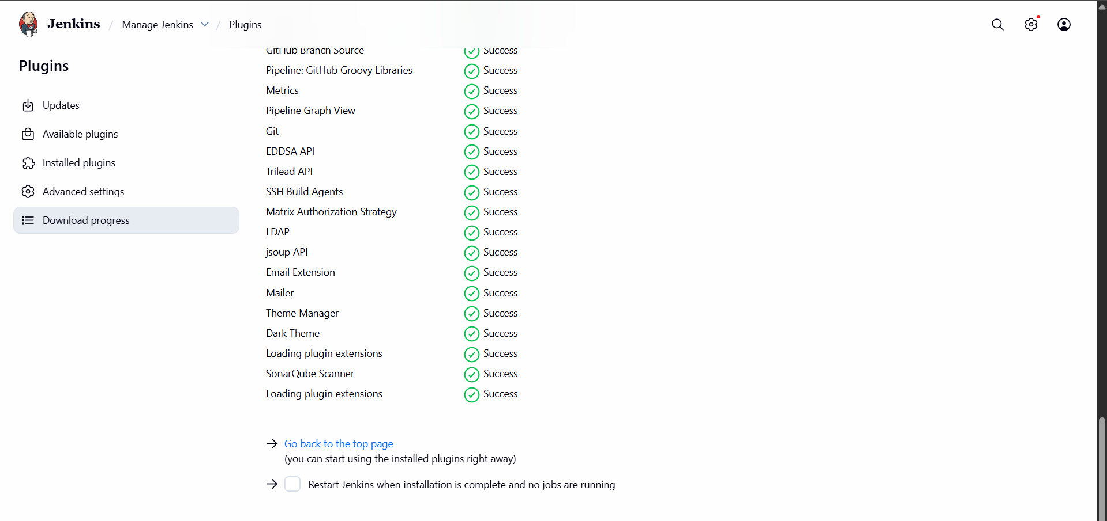
Before we install Sonar Scanner
Once done, sonar integration
After we need to do execute the command and links
# wget https://binaries.sonarsource.com/Distribution/sonar-scanner-cli/sonar-scanner-cli-4.6.2.2472-linux.zip
# unzip sonar-scanner-cli-4.6.2.2472-linux.zip
# mv sonar-scanner-4.6.2.2472-linux /opt/sonar_scanner

Set SonarQube server details in sonar-scanner property file

- Sonar properties file: /opt/sonar_scanner/conf/sonar-scanner.properties
- sonar.host.url=http://`<SONAR_SERVER_IP>`:9000

Login to Jenkins GUI console and install " SonarQube scanner" plugin

- `Manage Jenkins` > `Manage Plugins` > `Avalable` > `SonarQube scanner`

Configure SonarQube scanner home path

Task 2
Create one Jenkins job using the below code and create three stages:
- stage1: Git clone to download the source code.
- stage2: Sonarqube Integration to check the quality of code.
- stage3: Slack Integration to send the alerts to slack.
URL: https://github.com/betawins/hiring-app.git
JENIINS TASK 03
Task 1
Create one Jenkins job using the below code and create three stages:
- stage1: Git clone to download the source code.
Launch one instance
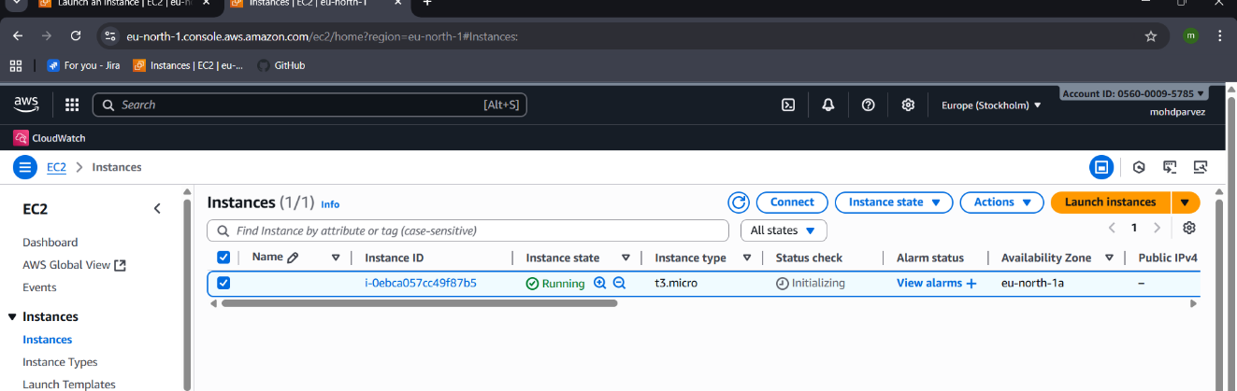
Connect and install Jenkins –
sudo wget -O /etc/yum.repos.d/jenkins.repo \
https://pkg.jenkins.io/redhat/jenkins.repo
sudo rpm --import https://pkg.jenkins.io/redhat/jenkins.io-2023.key
sudo yum upgrade
# Add required dependencies for the jenkins package
sudo yum install fontconfig java-21-openjdk
sudo yum install Jenkins
systemctl start jenkins
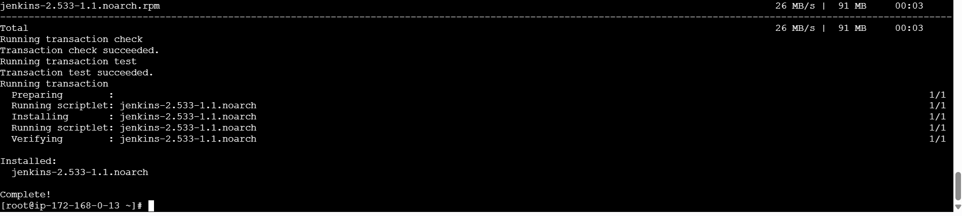
Check in the browser and login : “<ipadress>:8080(port)”
And also install git : yum install git , to clone in Jenkins

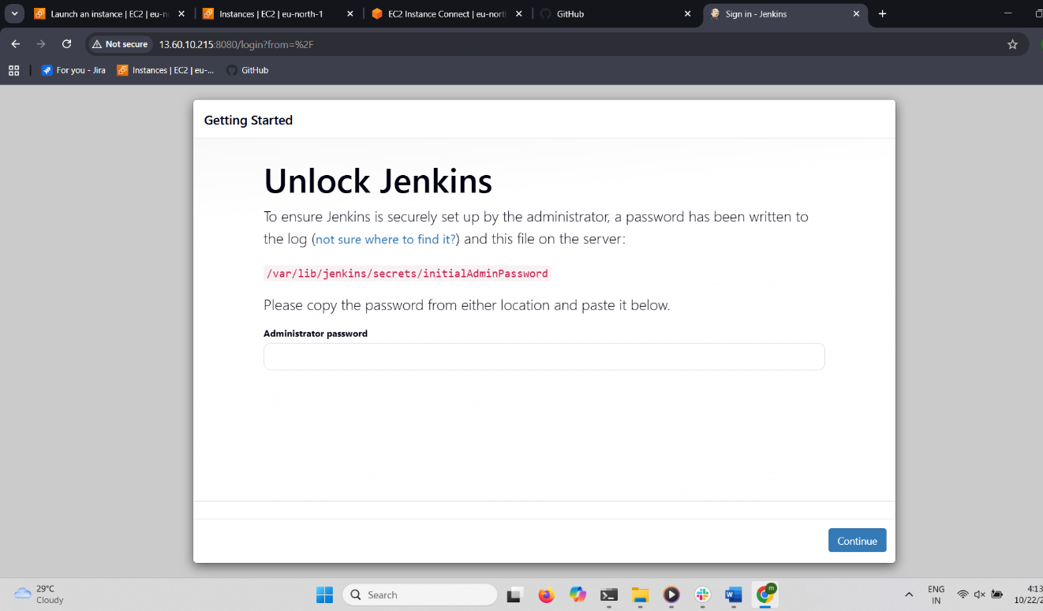
Login using password
You can find password in : cat /var/lib/jenkins/secrets/initialAdminPassword
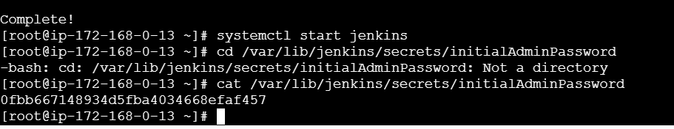
Use the password and login

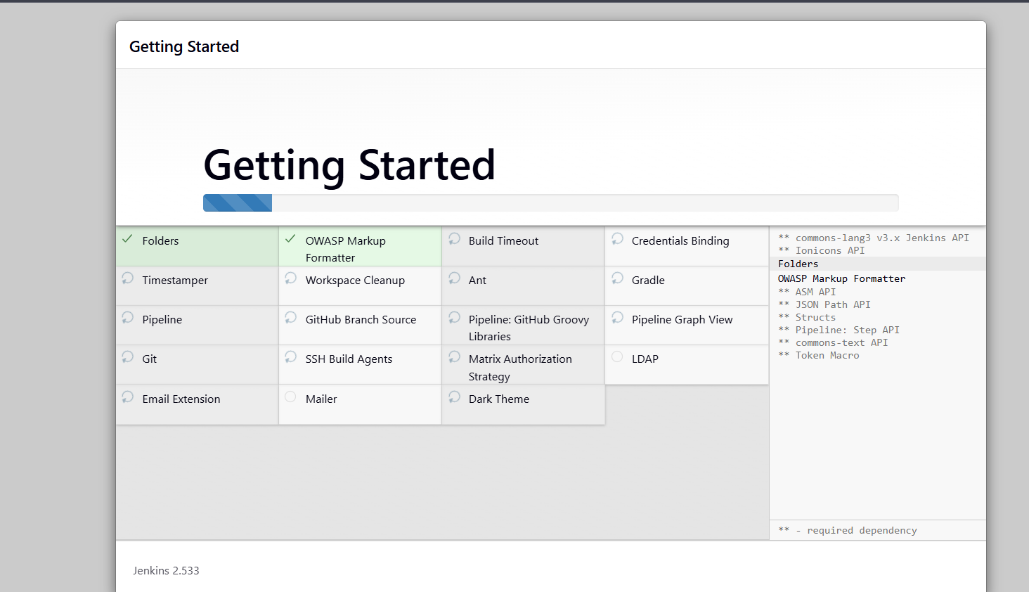after login you can see the dash board

Create new item give name freestyle project
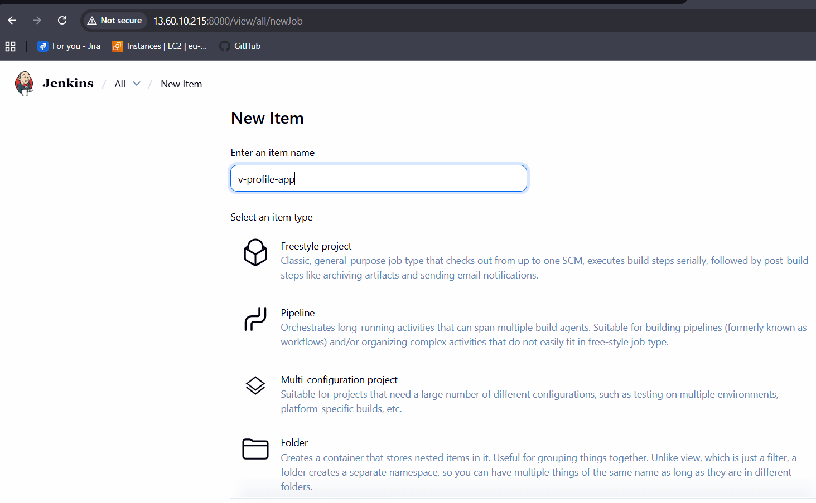
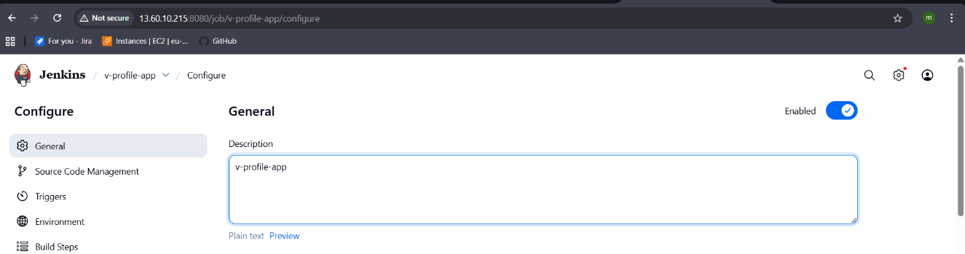
Copy the url of the source code : git hub repository url
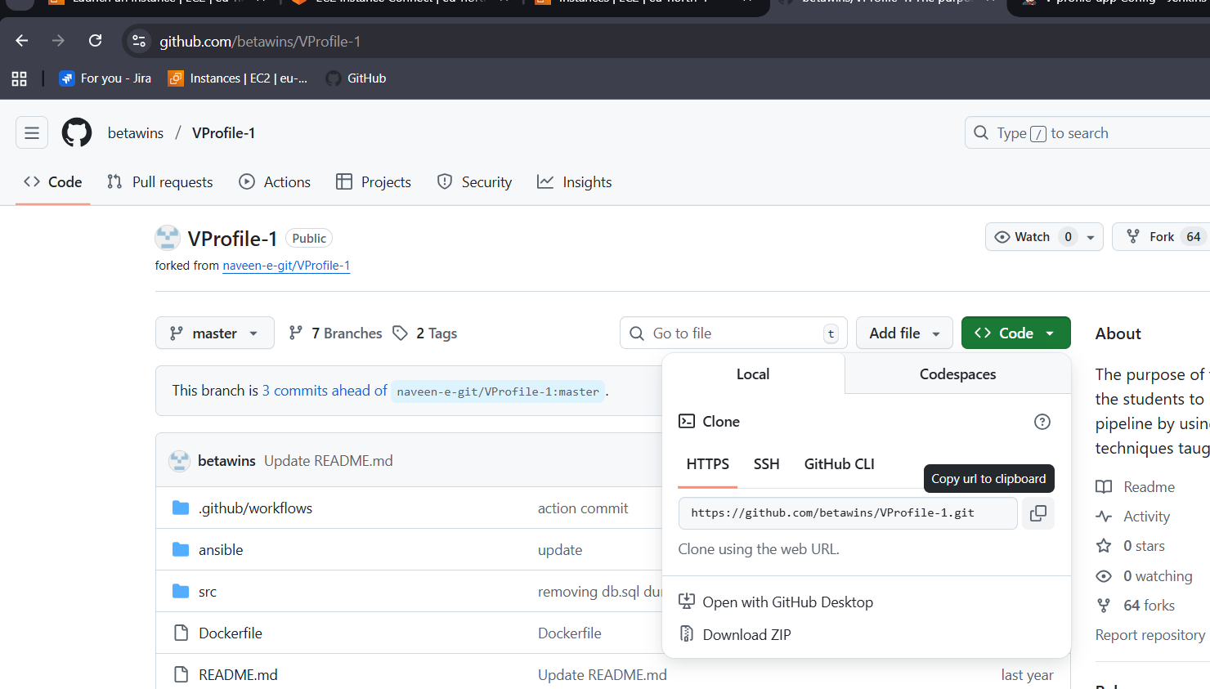
Select the source git Paste the url
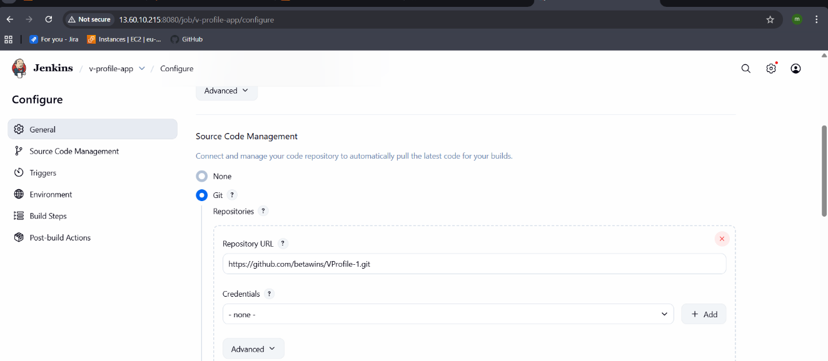
In Jenkins server CLI you can check the v-profile has been cloned from git
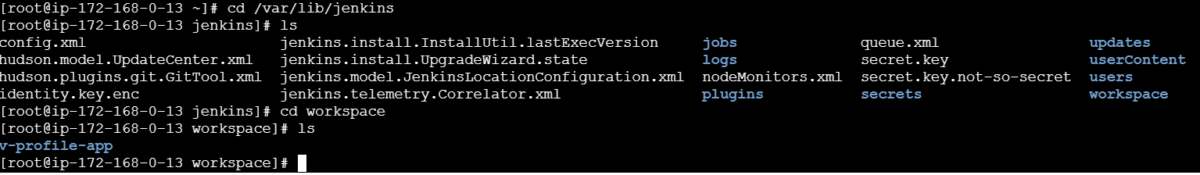
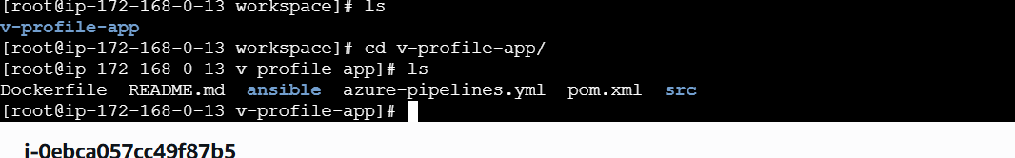
Here it not worked

- stage2: Sonarqube Integration to check the quality of code.
- TRADITIONAL METHOD
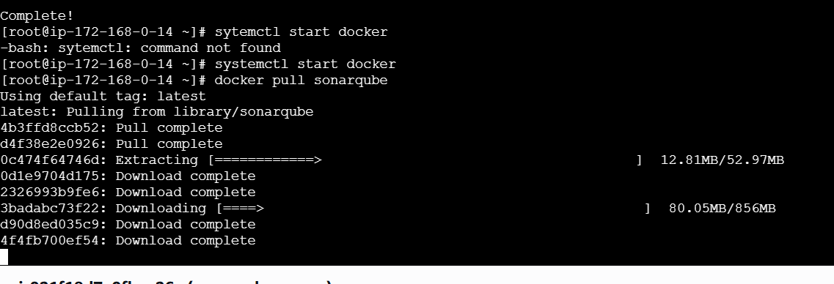
Start the sonarqube:
docker run -d --name sonarqube \
-p 9000:9000 \
-e SONAR_ES_BOOTSTRAP_CHECKS_DISABLE=true \
sonarqube:latest
For sonarqube prerequisites
- EC2 instance with Java installed
- MySQL Database Server or MyQL RDS instance
Launch instance with the t3.large and 20gb of memory
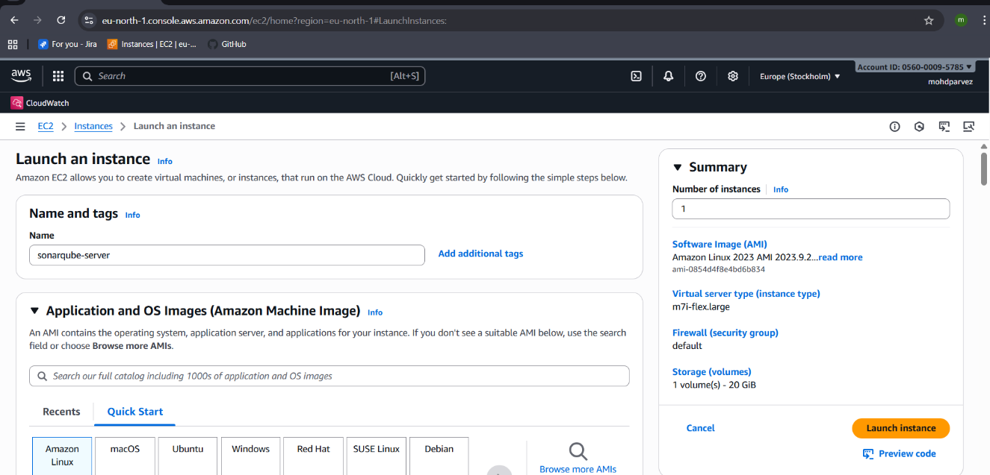
Iam using instance type m7i.flex.large as free tier eligible
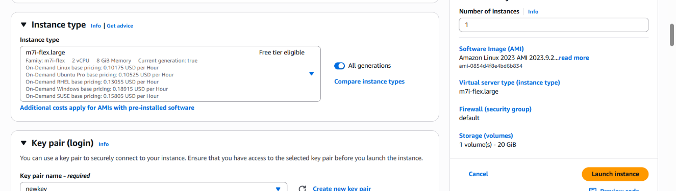
Connect to the instance and install java : yum install java-17
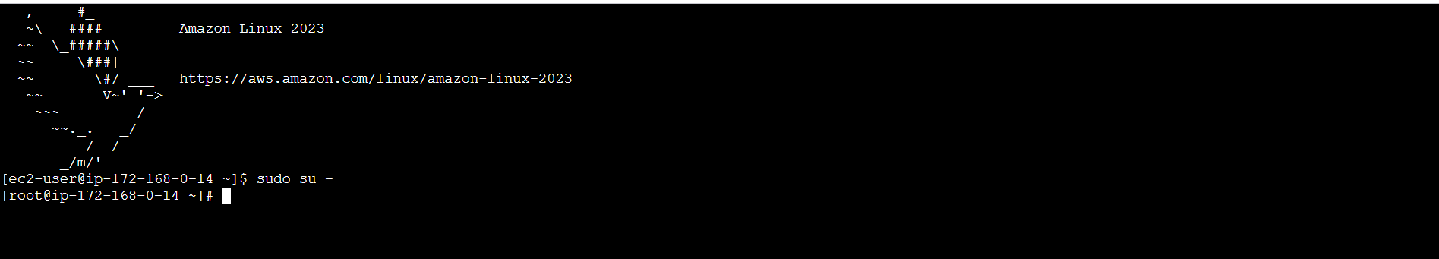
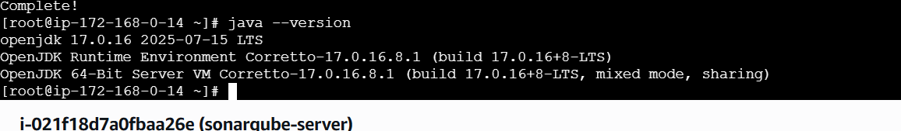
Now install sonarqube in opt directory
Cd opt/
# cd /opt
# wget https://binaries.sonarsource.com/Distribution/sonarqube/sonarqube-7.6.zip
# unzip sonarqube-7.6.zip
# mv /opt/sonarqube-7.6 /opt/sonarNow unzip the file : unzip sonarqube-25.10.0.114319.zip
Now rename the extracted file : mv sonarqube-25.10.0.114319.zip sonar
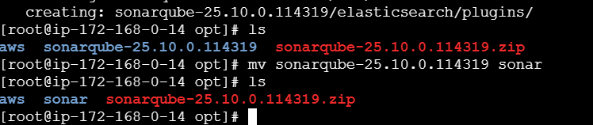
Install mysql :
sudo dnf remove mysql80-community-release
wget https://dev.mysql.com/get/mysql80-community-release-el9-1.noarch.rpm
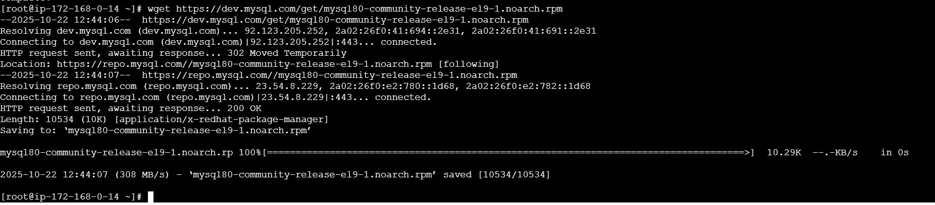
sudo dnf install mysql80-community-release-el9-1.noarch.rpm
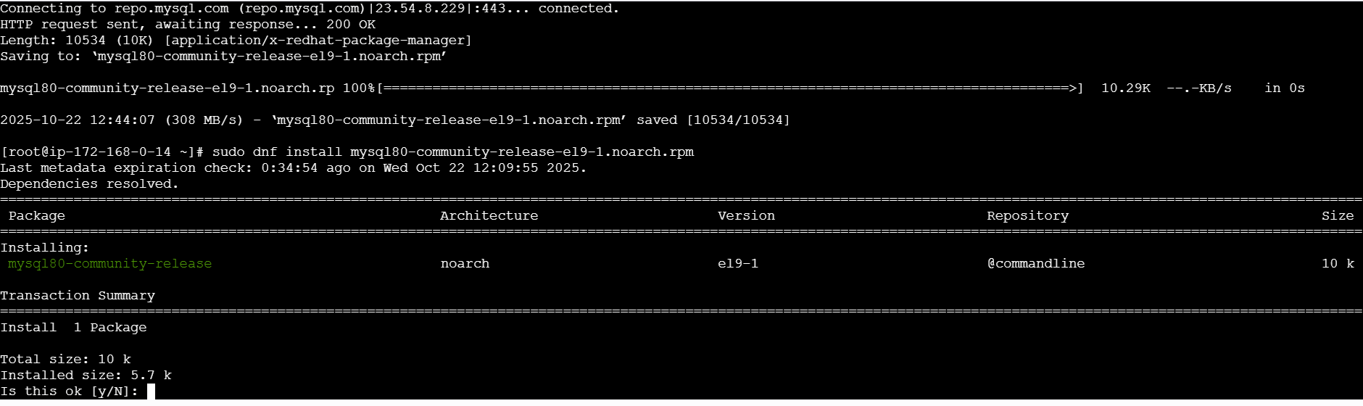
sudo rpm --import https://repo.mysql.com/RPM-GPG-KEY-mysql-2023
sudo dnf clean all
sudo dnf makecache
sudo dnf install mysql-community-server mysql-community-client
sudo systemctl enable --now mysqld
sudo systemctl status mysqld
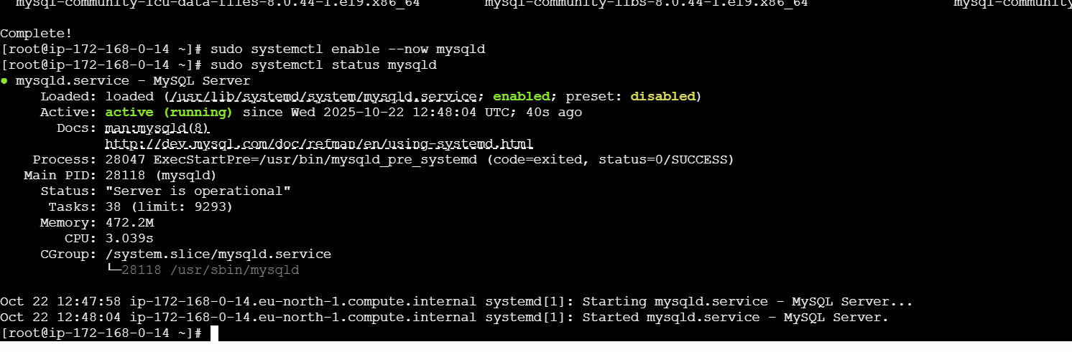
Temporary password generation : grep ‘temporary’ /var/log/mysqld.log
Login to mysql : mysql -u root -p : enter the password that will be shown
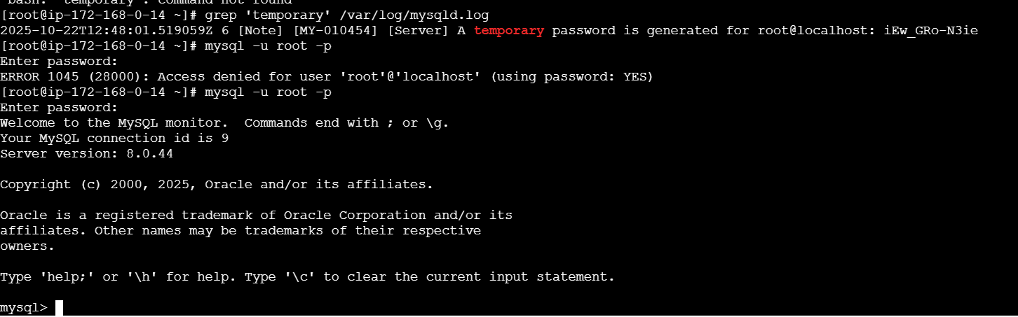
Change the password:
ALTER USER ‘root’@’localhost’ IDENTIFIED BY ‘Admin@123’;
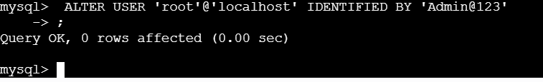
Flush privileges : for updating
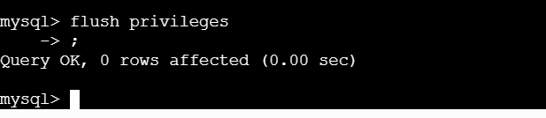
Create new database:
CREATE DATABASE sonar CHARACTER SET utf8 COLLATE utf8_general_ci:
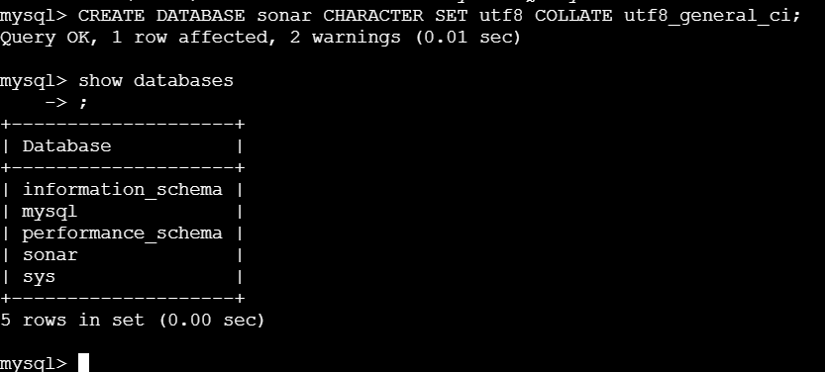

Create remote and local user:
CREATE USER sonar@localhost IDENTIFIED BY 'Sonar@123';
CREATE USER sonar@"%" IDENTIFIED BY 'Sonar@123';
Grant all permission:
GRANT ALL ON sonar.* TO sonar@localhost;
GRANT ALL ON sonar.* TO sonar@"%";
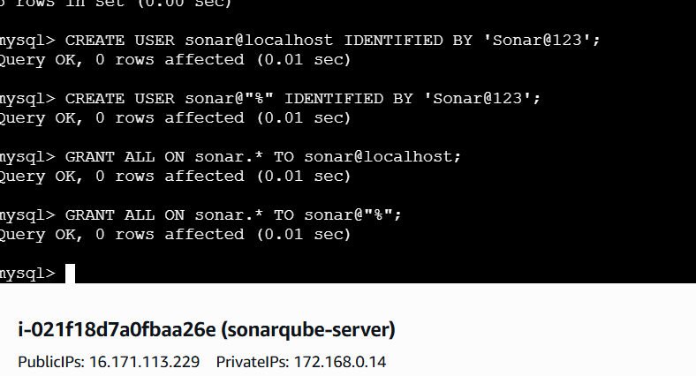

SELECT User FROM mysql.user;
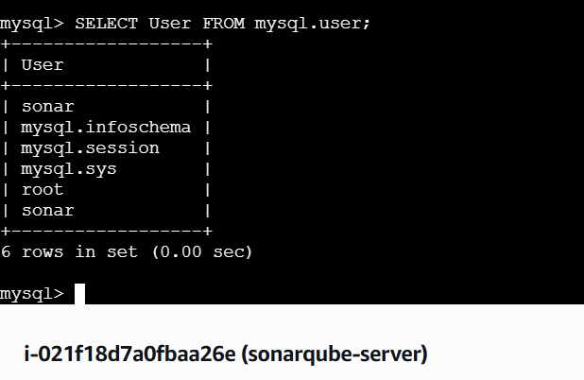
FLUSH PRIVILEGES;
QUIT;
NOW ON EC2 EDIT THE SONAR PROPERTIES
SONARQUBE DID NOT WORK WITH TRADITIONAL METHOD
USING DOCKER FOR SONARQUBE
Yum install docker
Systemctl start docker
docker pull sonarqube:10.3-community

Start the sonarqube:
docker run sonarqube
docker run -itd -p 9000:900 sonarqube:10.3-community
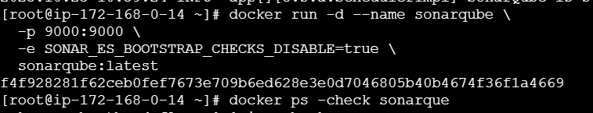

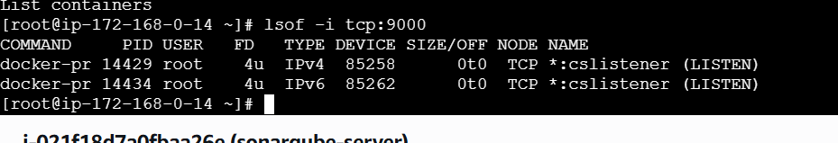
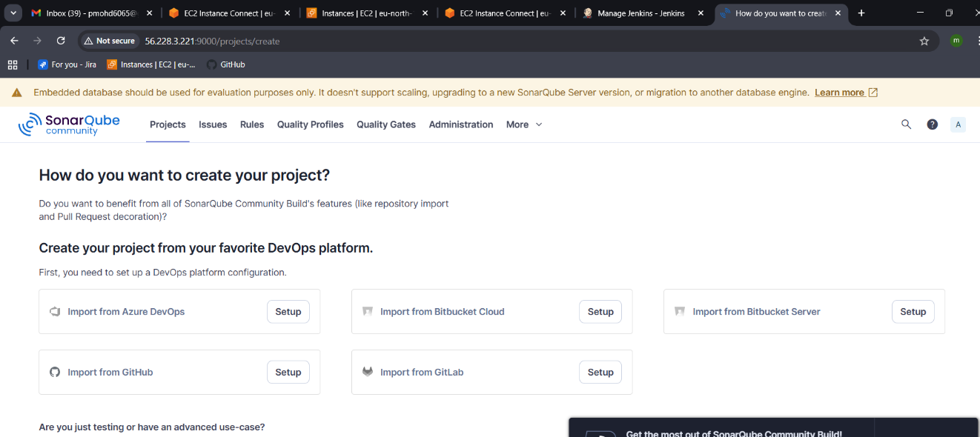
Go to Jenkins server -CLI
use
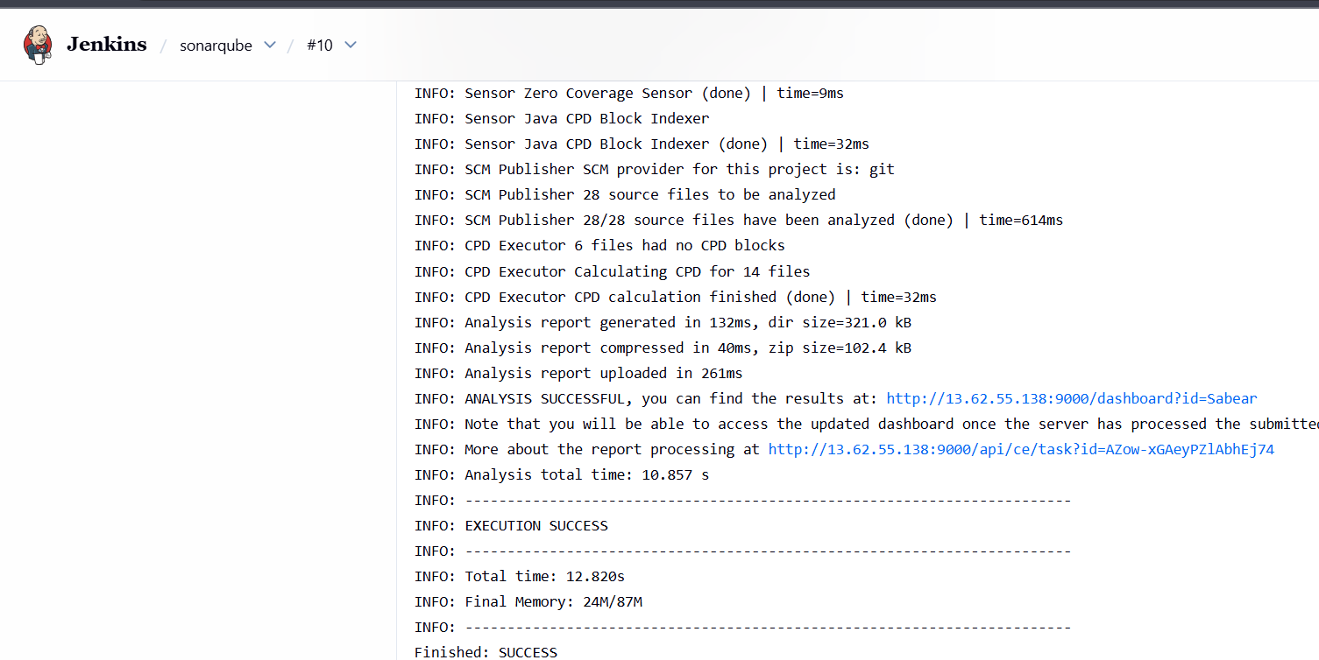
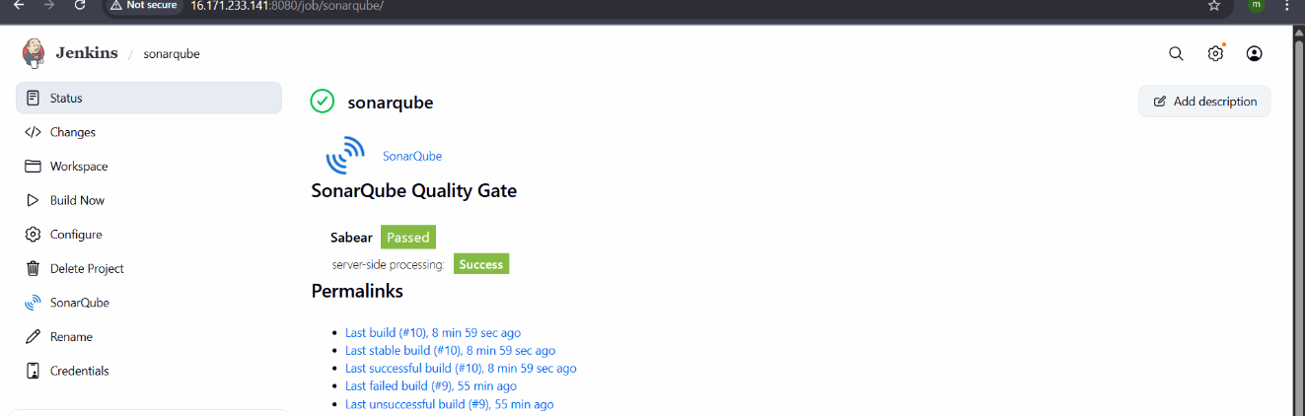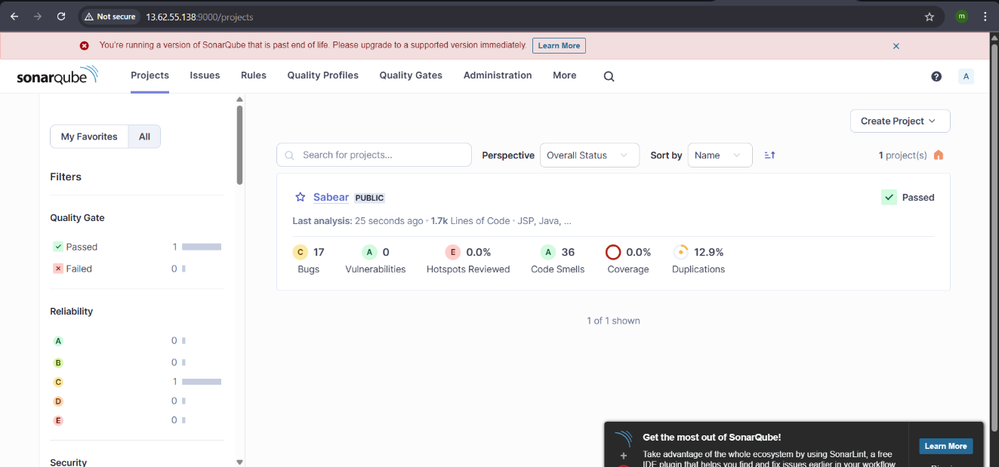

- stage3: Slack Integration to send the alerts to slack.
URL: https://github.com/betawins/VProfile-1.git
INSTALL SLACK NOTIFICATION PLUGIN
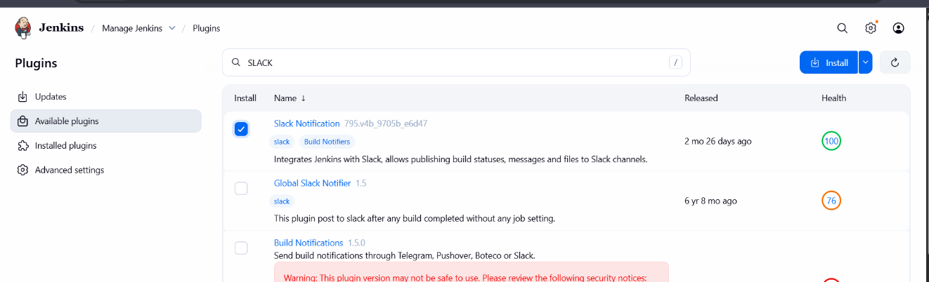

Got to slackmoreappsjenkins add Jenkins integrationcopy secret text create credential and test the connection.
