Jenkins task 01

- Install Jenkins and run Jenkins on port number 8081.
# 1. Update system
sudo yum update -y
# 2. Install Java (Jenkins requires Java 11 or 17)
sudo amazon-linux-extras install java-openjdk11 -y
# OR
sudo yum install java-11-openjdk -y = ( # Add Amazon Corretto (Java 17)
sudo rpm --import https://yum.corretto.aws/corretto.key
sudo curl -Lo /etc/yum.repos.d/corretto.repo https://yum.corretto.aws/corretto.repo

# Install Corretto 17 (Java 17)
sudo yum install java-17-amazon-corretto-devel -y) <==== use this method definatly it will work
# 3. Add Jenkins repository
sudo wget -O /etc/yum.repos.d/jenkins.repo \
https://pkg.jenkins.io/redhat-stable/jenkins.repo
# 4. Import Jenkins key
sudo rpm --import https://pkg.jenkins.io/redhat-stable/jenkins.io-2023.key
# 5. Install Jenkins
sudo yum install jenkins -y
# 6. Start Jenkins service
sudo systemctl start jenkins
# 7. Enable Jenkins to start at boot
sudo systemctl enable jenkins
# 8. Check Jenkins status
sudo systemctl status Jenkins

# 1. Update system
sudo yum update -y

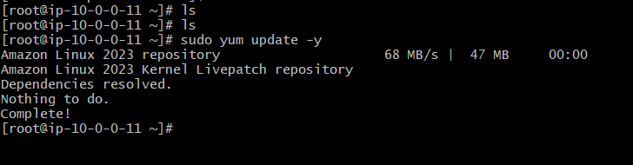
Install java version
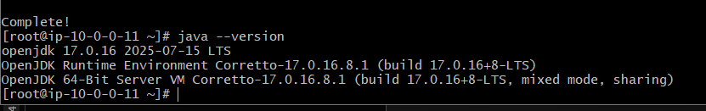
Sudo yum install Jenkins -y
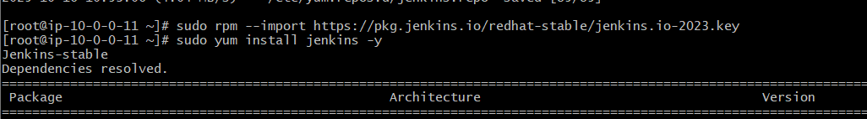
Sudo systemctl status jenkins
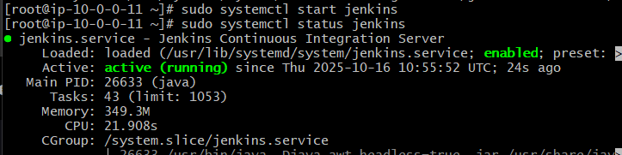
Check the public ip:8080 pert number
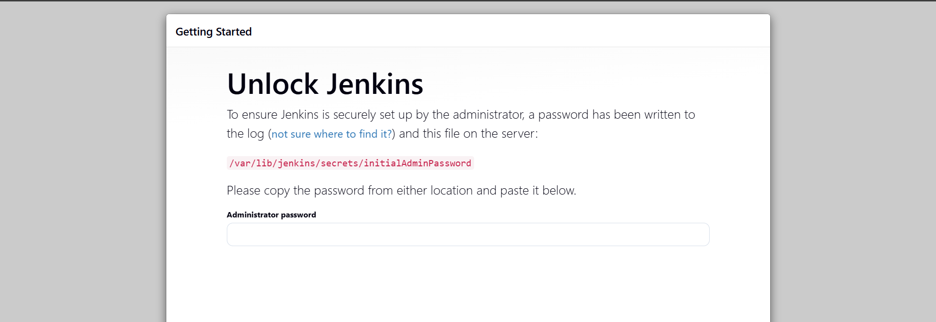
Enter the password the to get the passwd sudo cat /var/lib/jenkins/secrets/initialAdminPassword

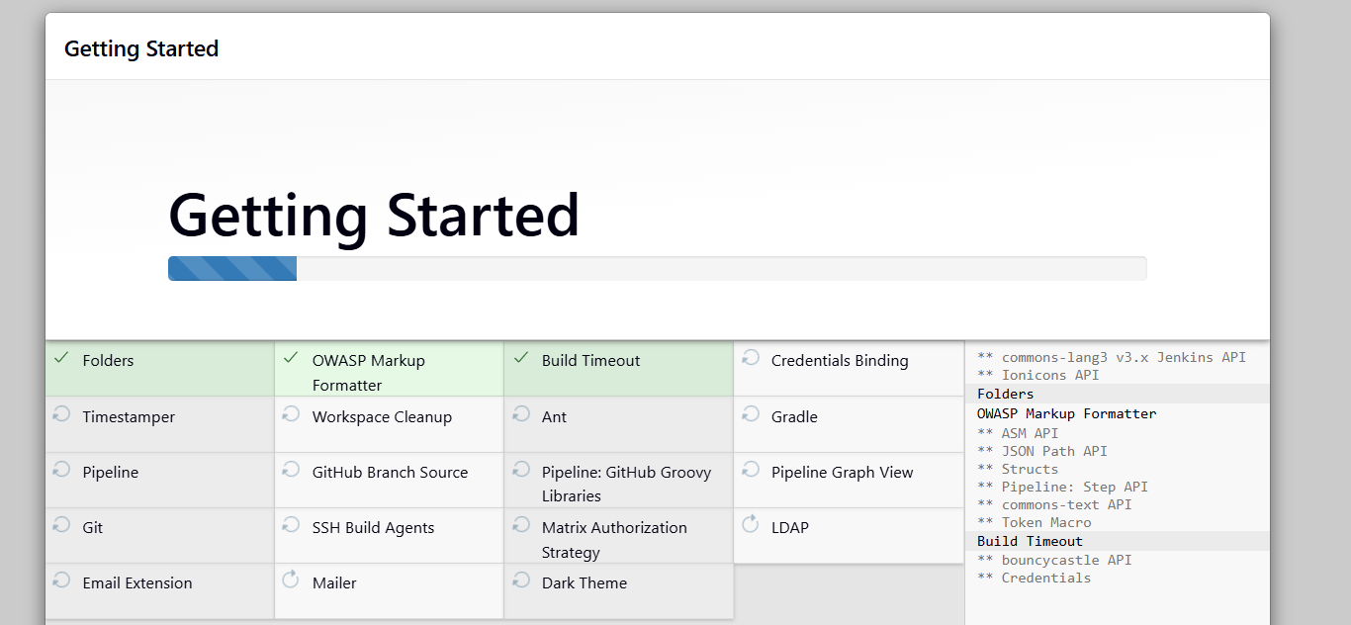
http://13.60.10.138:8080/
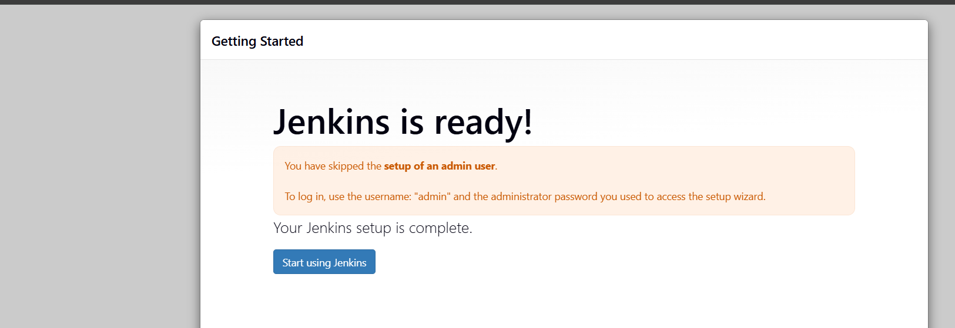
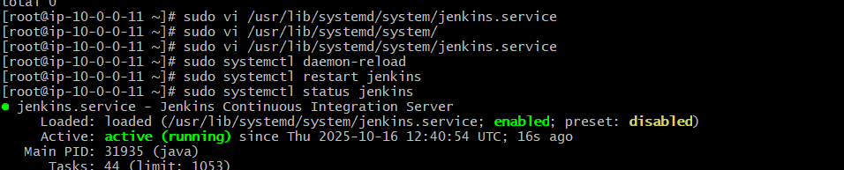
sudo vi /usr/lib/systemd/system/jenkins.service
I changed the port number 8080 to 8081

- Secure Jenkins server
Go to Jenkins, go to the admin, click on that security, there is an old pass, remove that change the new password => click save and apply
After we should delete the previous passwords
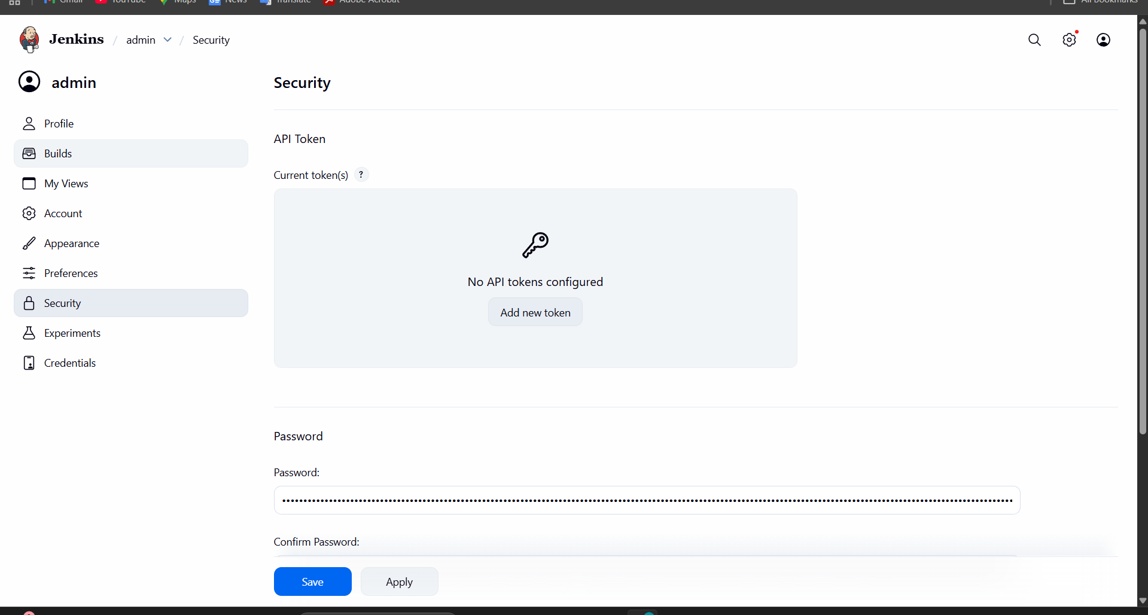
Then after the delete the cli password
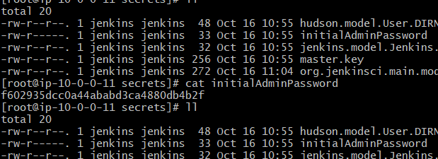

- Create users called DevOps, Testing in Jenkins with Limited access.
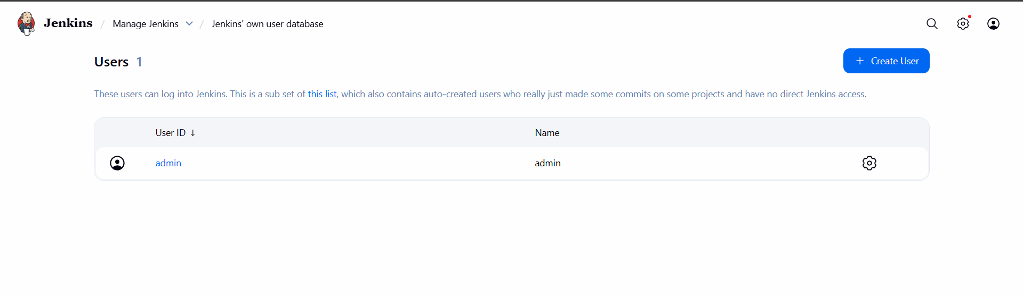
Go to the Manage Jenkins and click on the plugins
choice the available option plugins there is a search button. search role based on click on that, then install without restart, give an option that is better for us
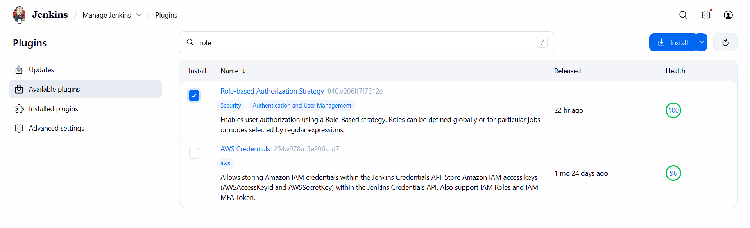
Role-based authorization makes sure the installation is ok
Once installed, go to the user and create the new user
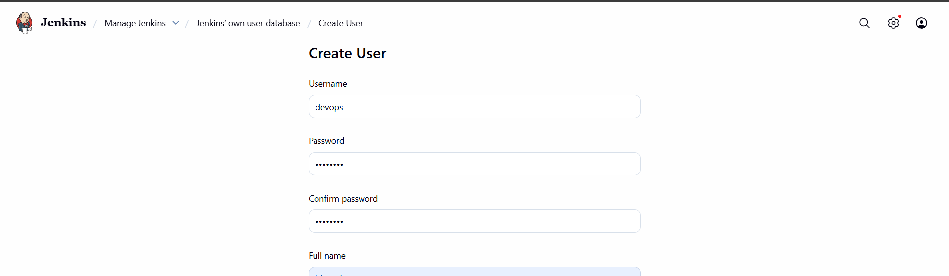
I created a name, it is devops11
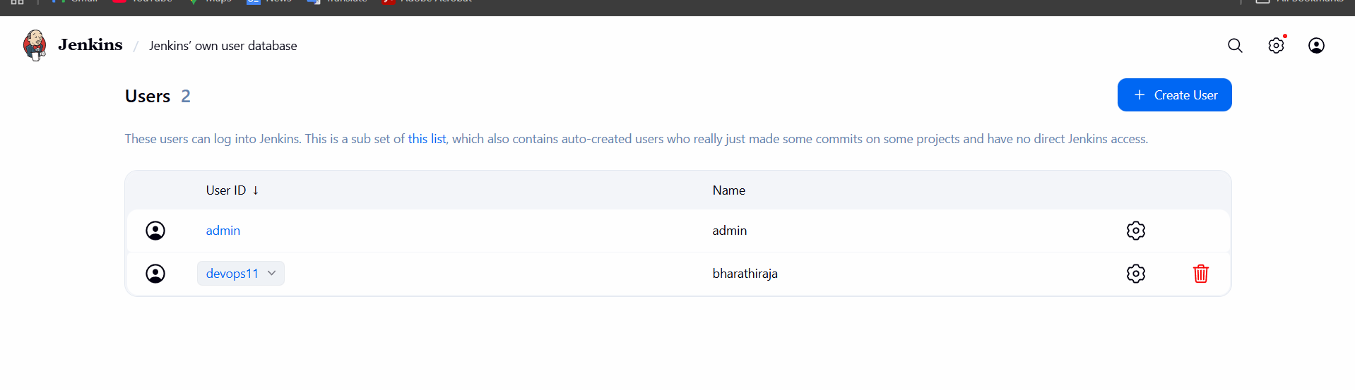
I opened the Incongtube browser 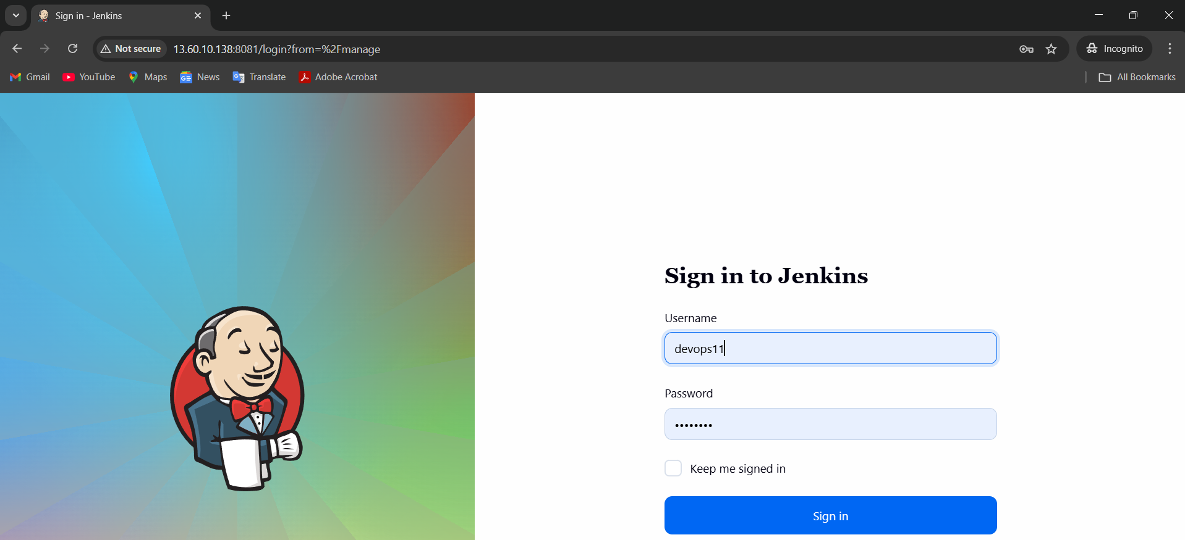
Go to security
Choose this one
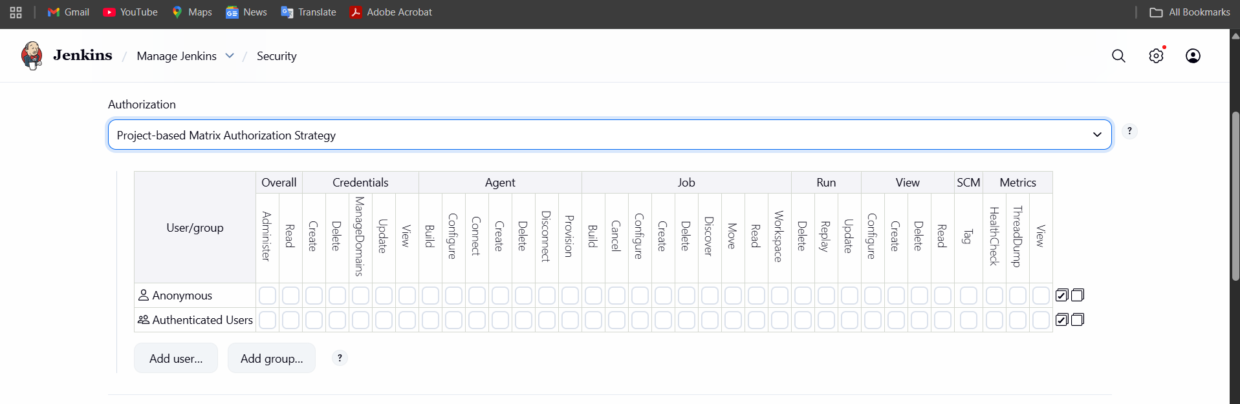
I give the user over-read only so that the user can’t do anything
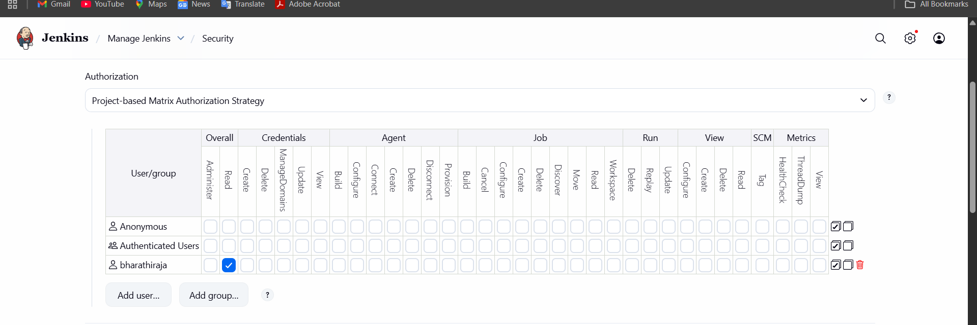
Give and save apply
Now I can see the new user, but only read option
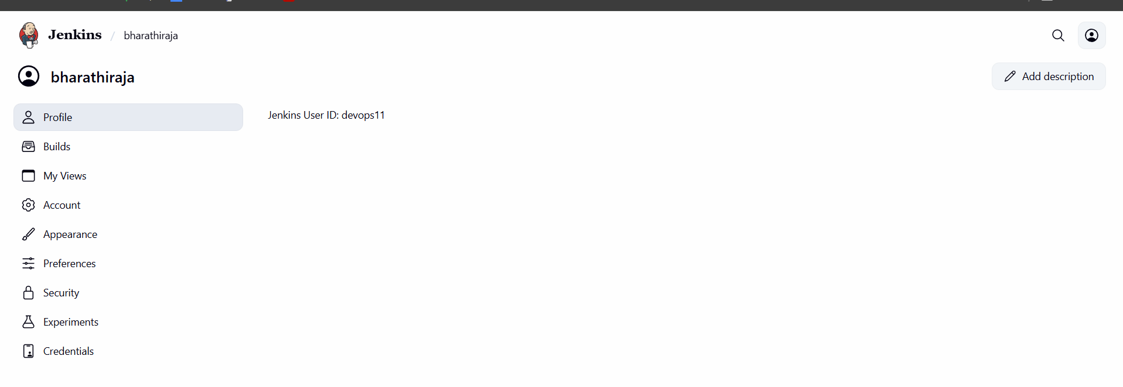
This is the way to access the control new user

- Configure labels and restrict the jobs to execute based on label only.
Here the explanation about label and restrict jobs.
¬Go to manage Jenkins first.
¬Then go to plugins >> nd available plugins >> node label
parameter >> install.
¬Then in manage Jenkins >> node > check the node.
¬Then go to the dashboard >> create job >> gave a URL
its shows you error first.
¬Then connect to the your instance nd check the git
version.
¬If its not available then use “yum install git -y”
¬Then the error will gone.
¬If is showing some error.
¬Click the job nd check error in console output:
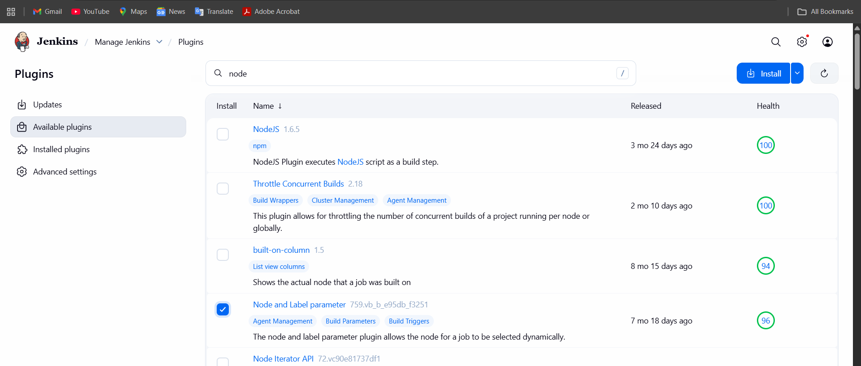
Then go to plugins >> nd available plugins >> node label
parameter >> install.
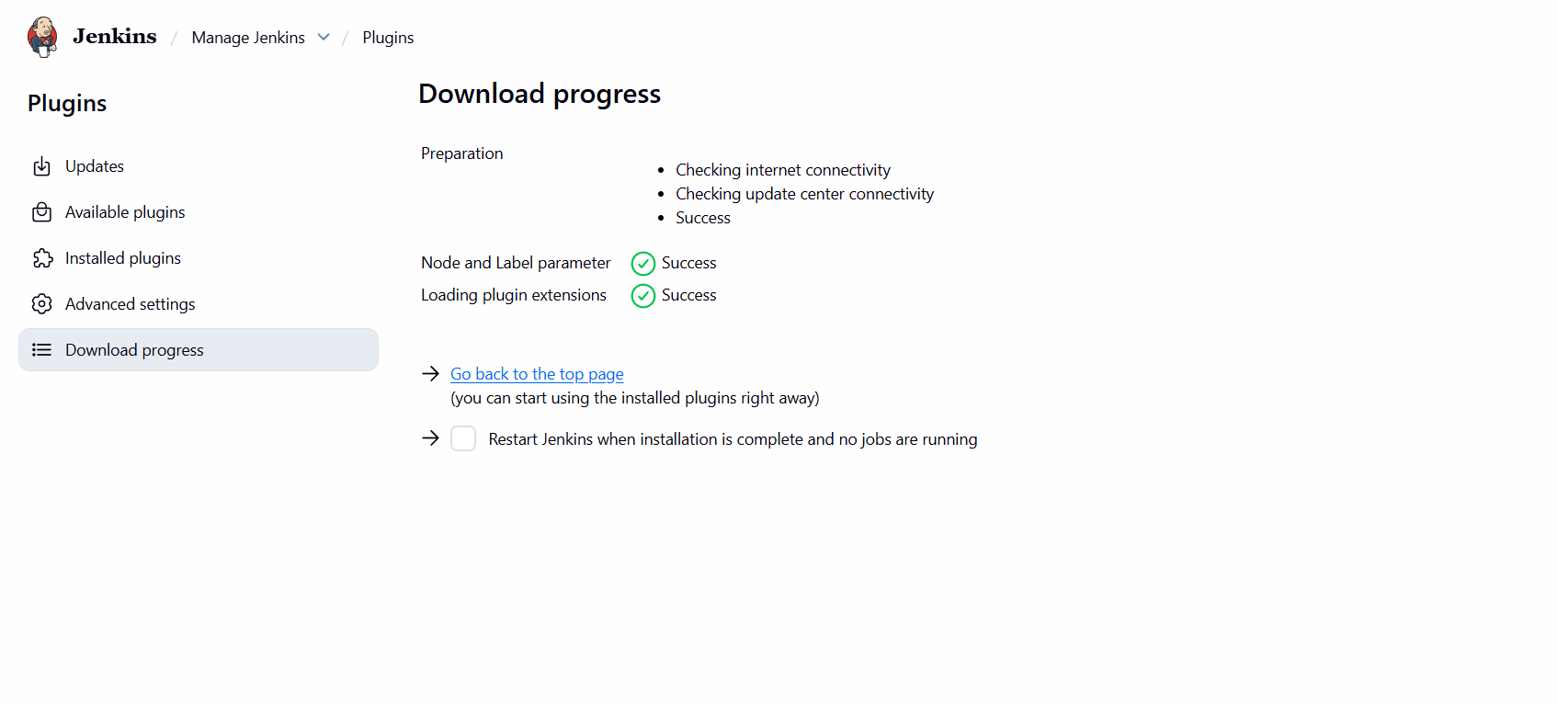
size below it is 0.1GB
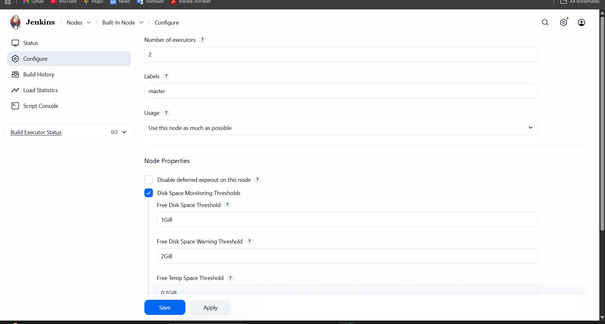

Then in manage Jenkins >> node > check the node

- Create Three sample jobs using the below URL. https://github.com/betawins/Techie_horizon_Login_app.git

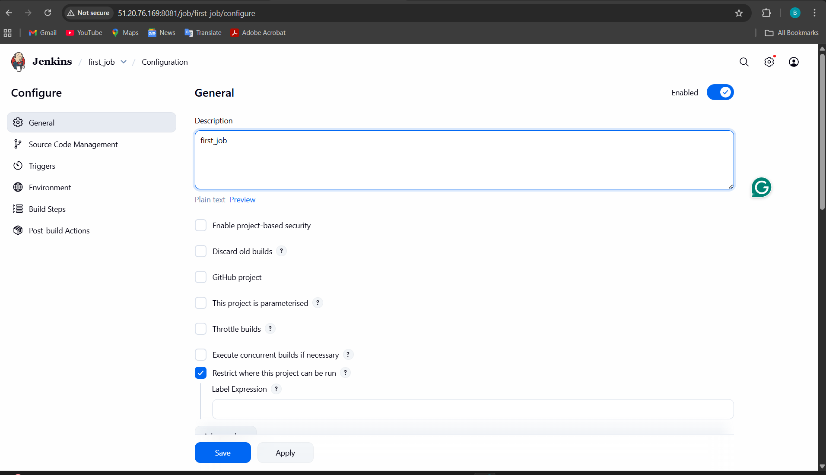
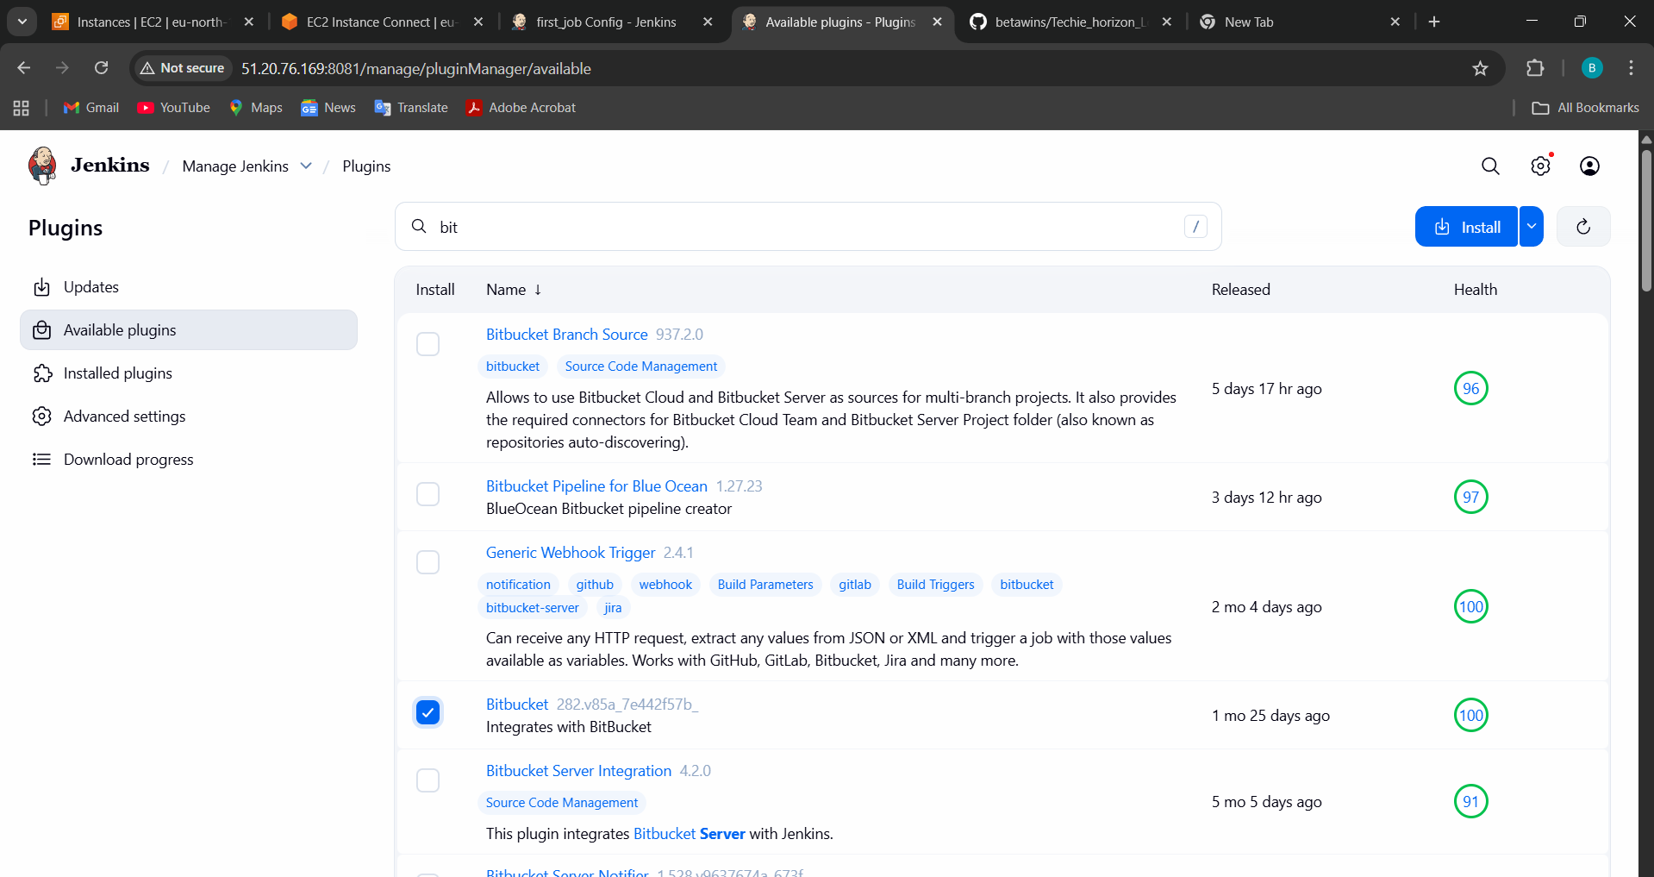
Choice without restart
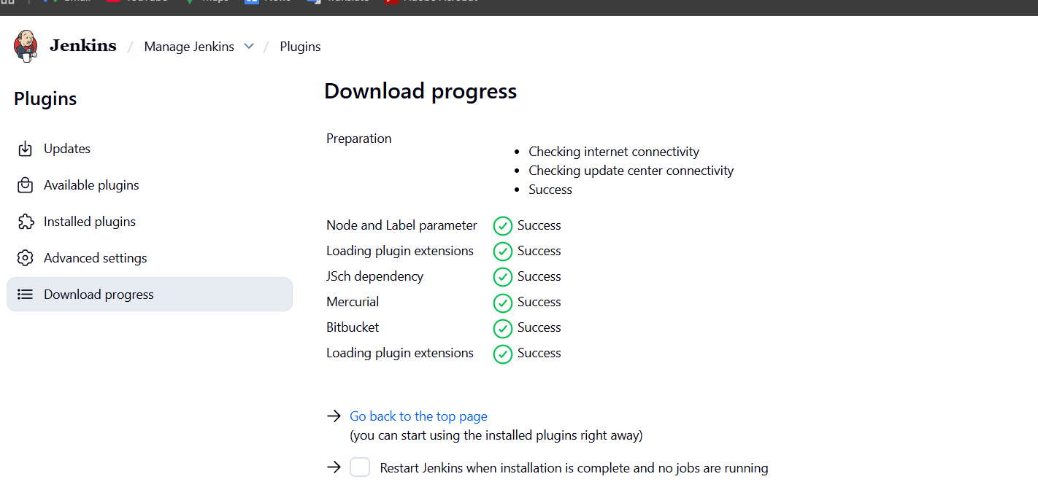
Then after install go to back click on save apply
W cant able to see the
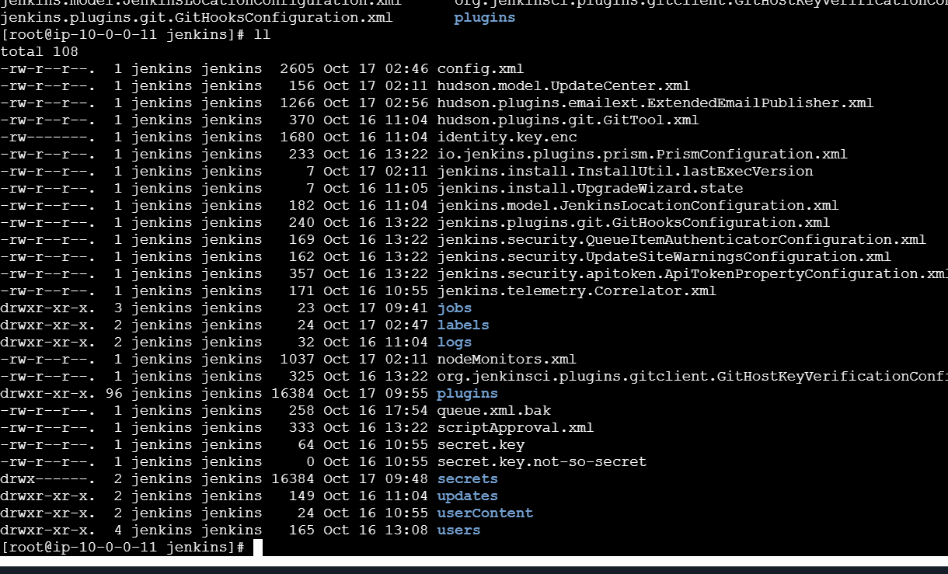
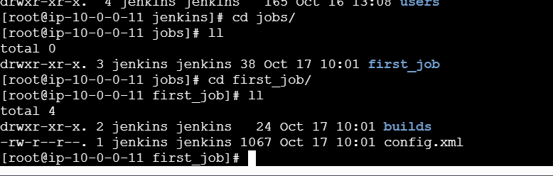
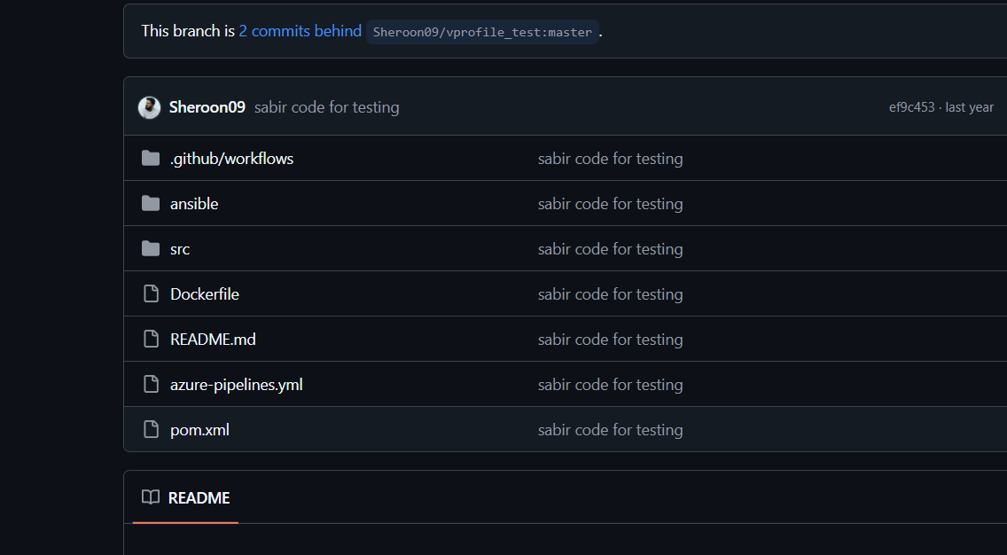
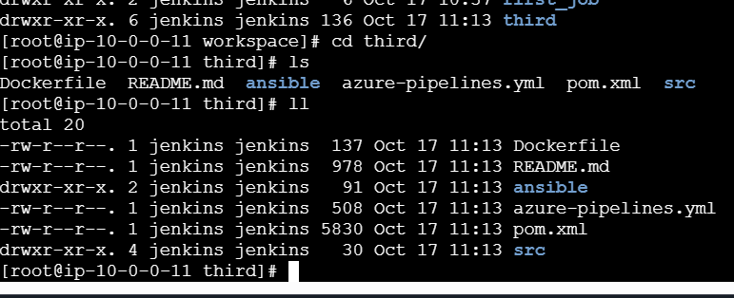
Five_job execute shall choice
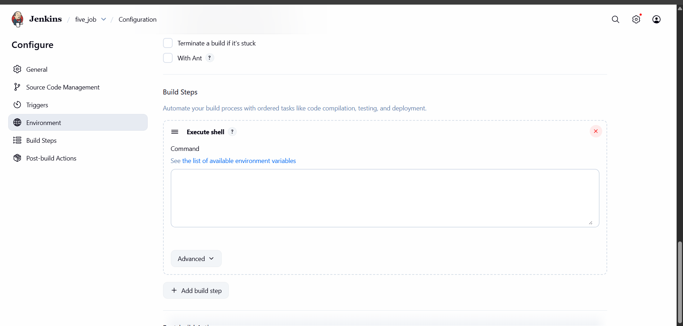
Give and save
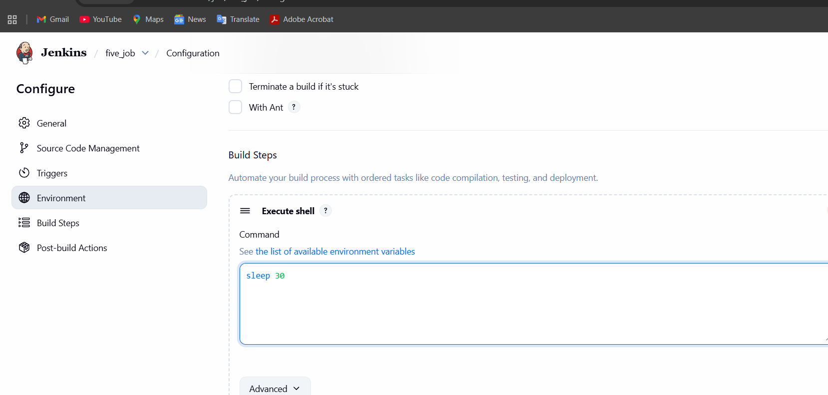
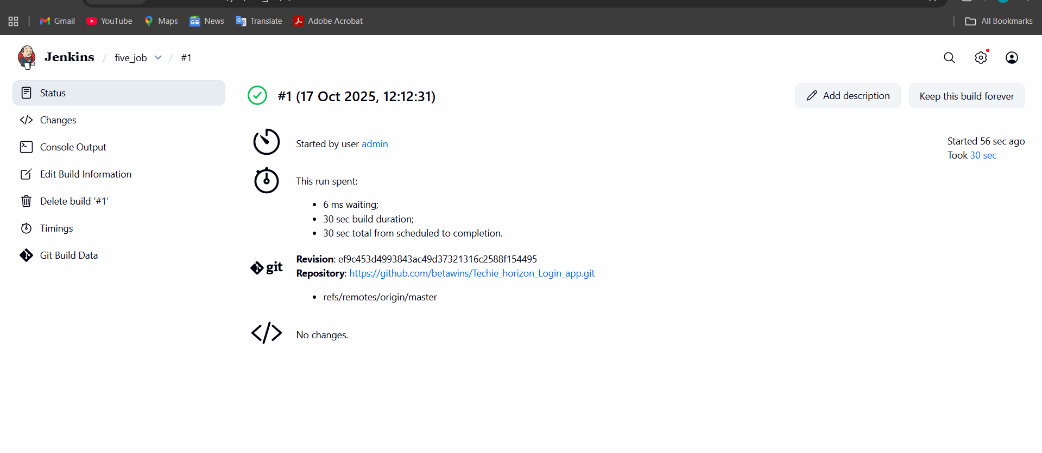
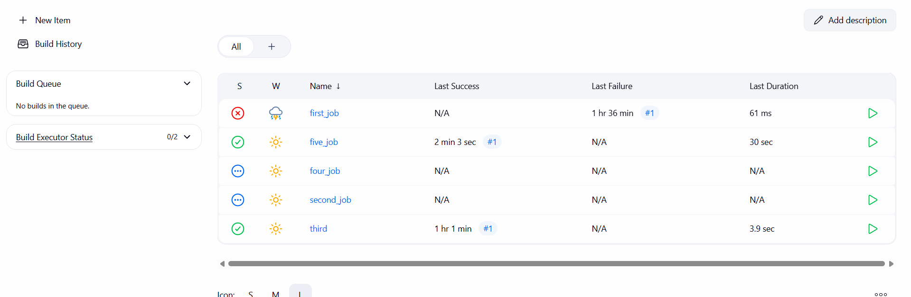

- Create one Jenkins job using a GitHub private repository.

