Terraform challenge.

Write a code using Terraform that deploys and achieves the following:-
- Create an EC2 Instance on AWS Cloud using the below-mentioned ubuntu AMI and instance_type. Or, (You can use of your choice as well) ami = "ami-0461b1436c9b3c1a3" instance_type = "t2.micro"
provider "aws" { region = "eu-north-1" }

resource "aws_security_group" "web_sg" {
name = "web-server-sg"
description = "Allow HTTP on 8080"
vpc_id = "vpc-066db054a2229890a"

ingress {
from_port = 8080
to_port = 8080
protocol = "tcp"
cidr_blocks = ["0.0.0.0/0"]
}

egress {
from_port = 0
to_port = 0
protocol = "-1"
cidr_blocks = ["0.0.0.0/0"]
}
}

resource "aws_instance" "web" {
ami = "ami-0c7d68785ec07306c"
instance_type = "t3.micro"
subnet_id = "subnet-0d91e8fd1fa2524c9"
vpc_security_group_ids = [aws_security_group.web_sg.id]

user_data = <<-EOF
#!/bin/bash
apt update -y
apt install -y nginx
sed -i 's/listen 80 default_server/listen 8080 default_server/' /etc/nginx/sites-available/default
systemctl restart nginx
EOF

tags = { Name = "terraform-web-server" }
}

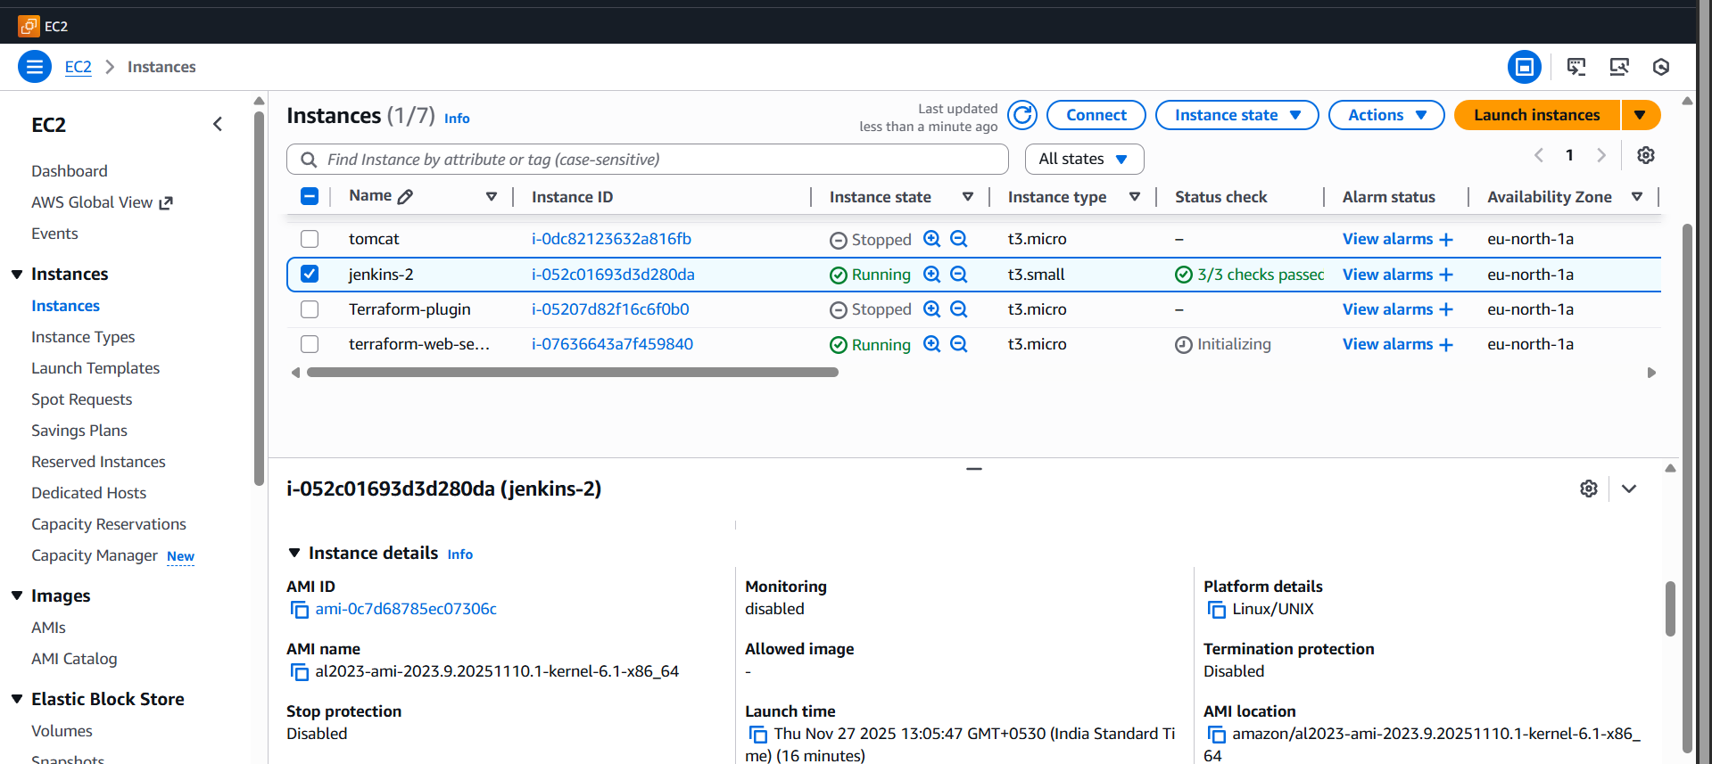
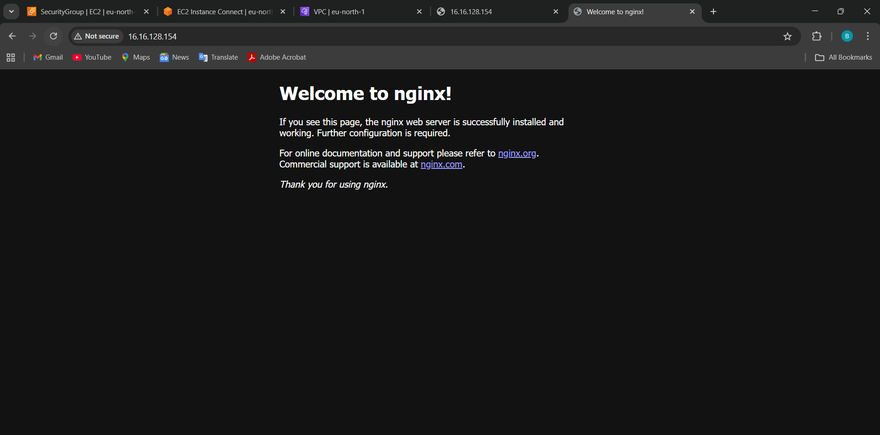

- Install a web server on the same EC2 Instance. The web server should listen on port 8080.
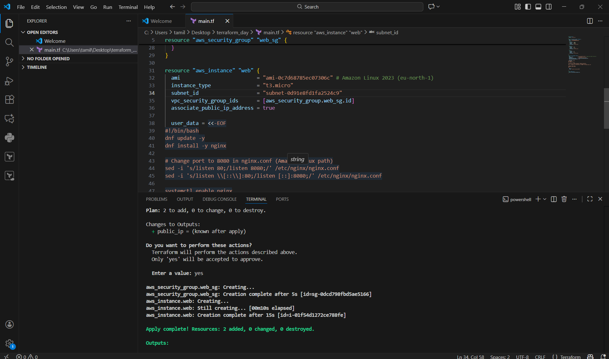
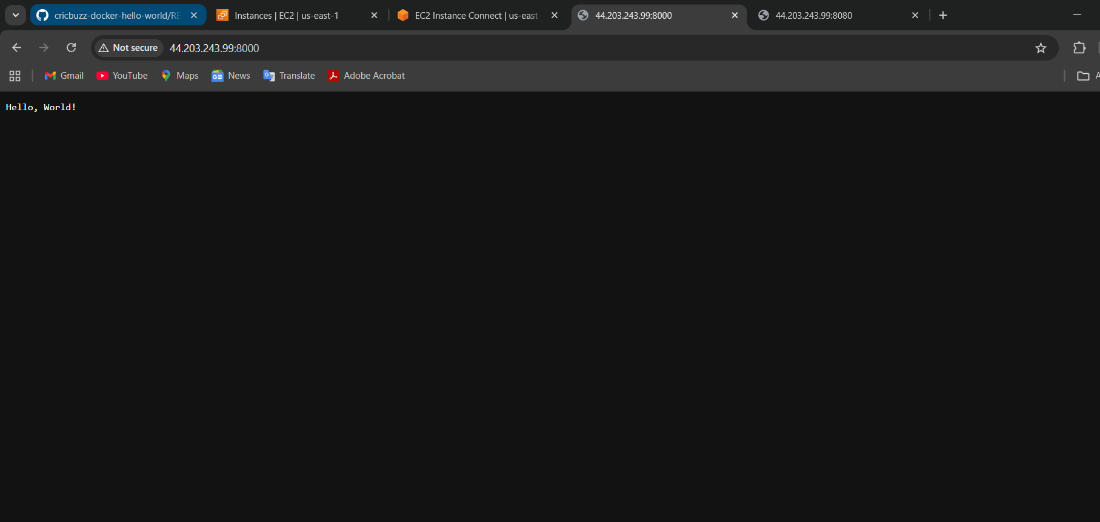

- Create a Docker-compose file for the project: https://github.com/betawins/cricbuzz-docker-hello-world.git and point it to port 8000.

You want Terraform user_data that:
✔ Installs Docker
✔ Installs Docker Compose
✔ Clones this repo:
👉 https://github.com/betawins/cricbuzz-docker-hello-world.git
✔ Creates a docker-compose.yml
✔ Runs container on port 8000
✔ Opens in browser via:
Make the web server point to the above service so that 8080 returns the response from the Docker service.
Make the web server point to the above service so that
8080 returns the response from the Docker service
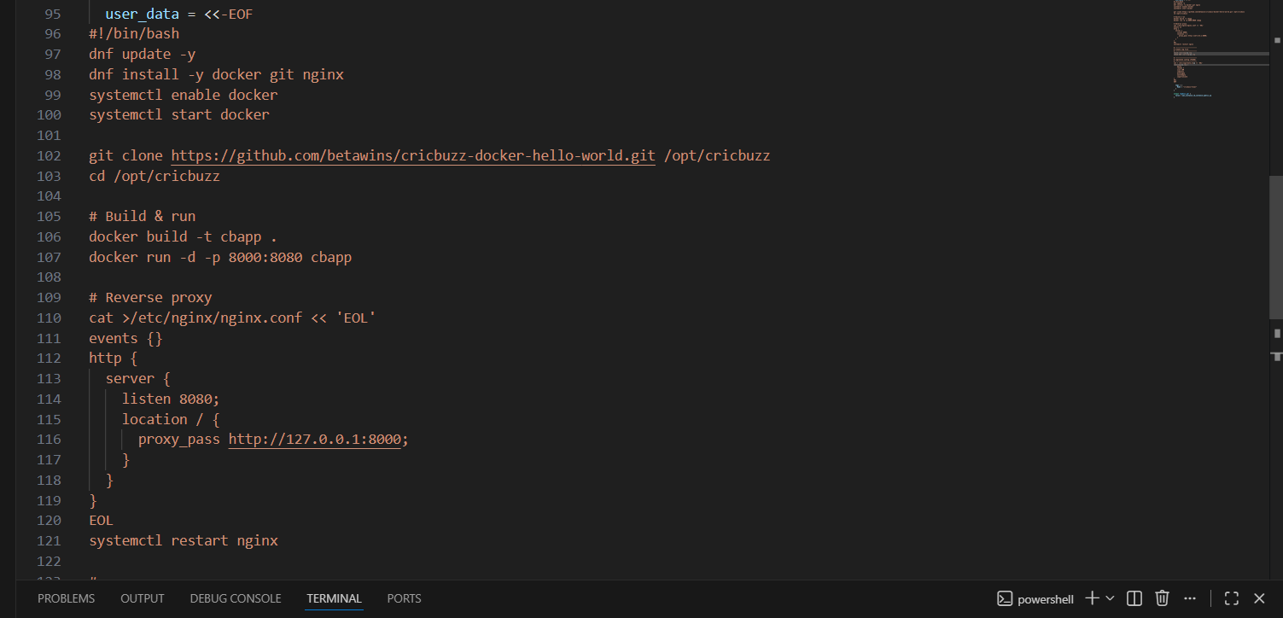
There is docker line we need to execute
in the git readme there someslines
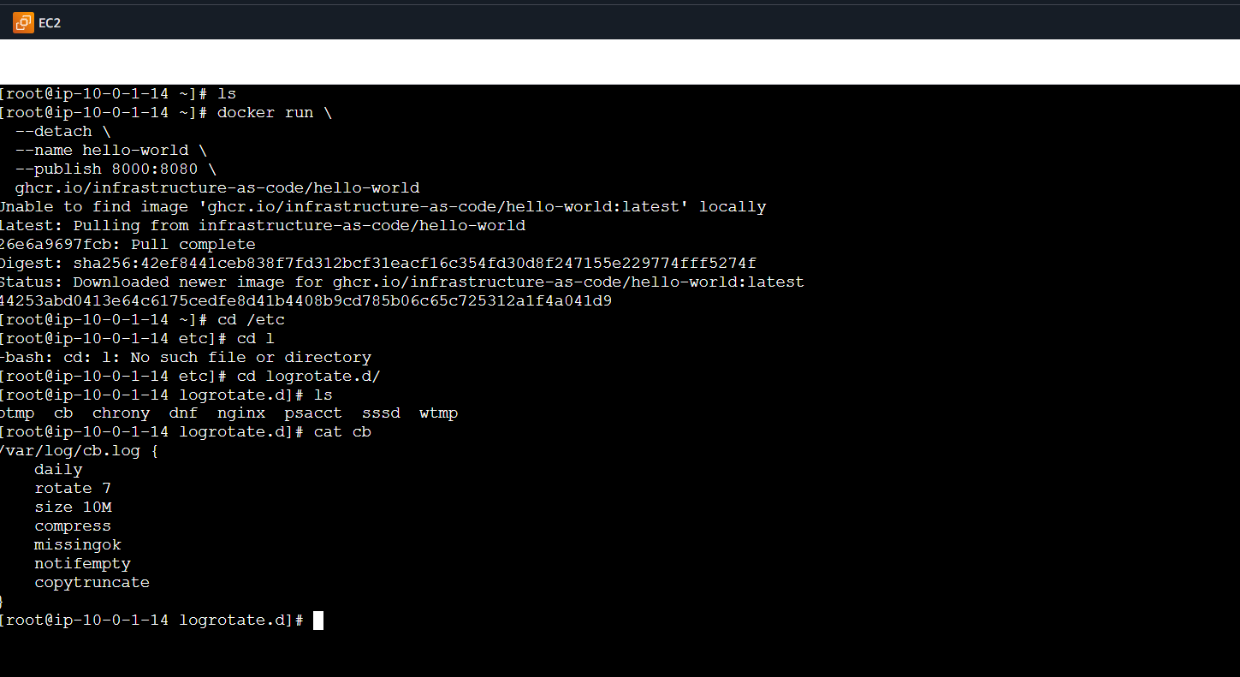
# start the container
docker run \
--detach \
--name hello-world \
--publish 8000:8080 \
ghcr.io/infrastructure-as-code/hello-world

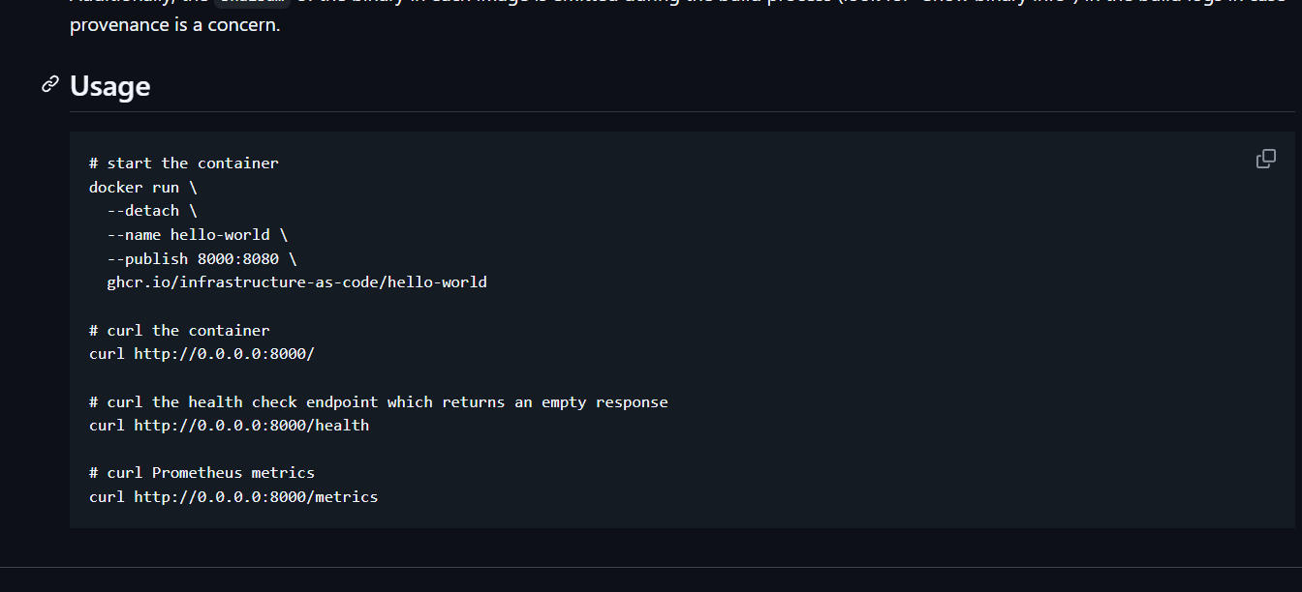
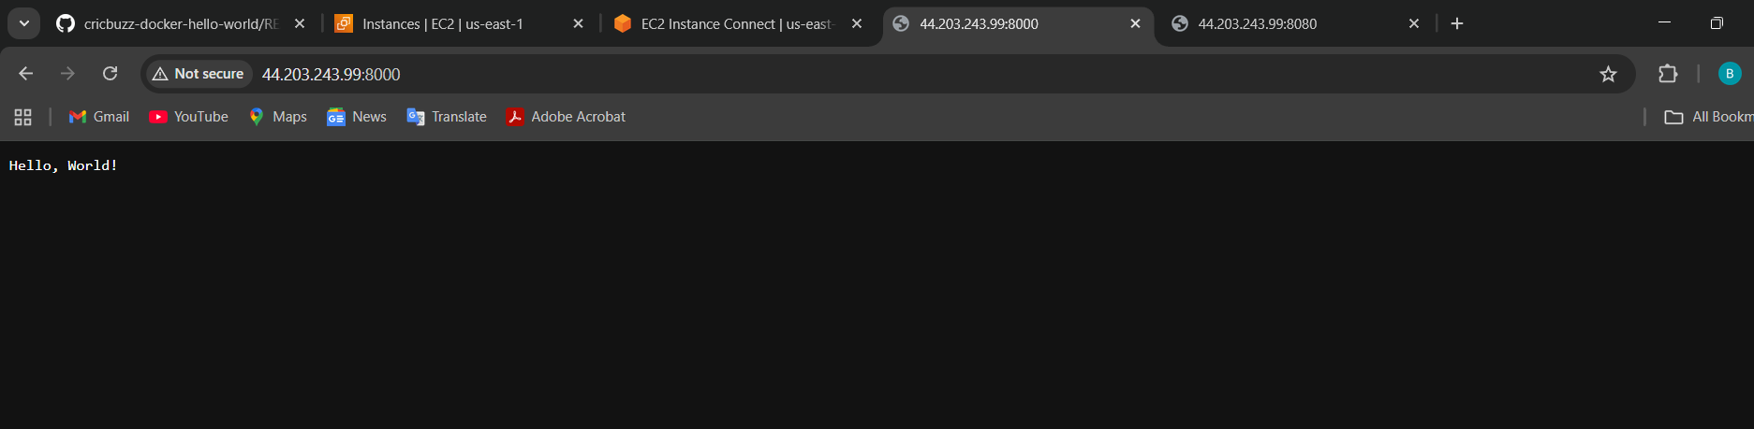

Configure to Save the Logs in the location /var/log/cb.log
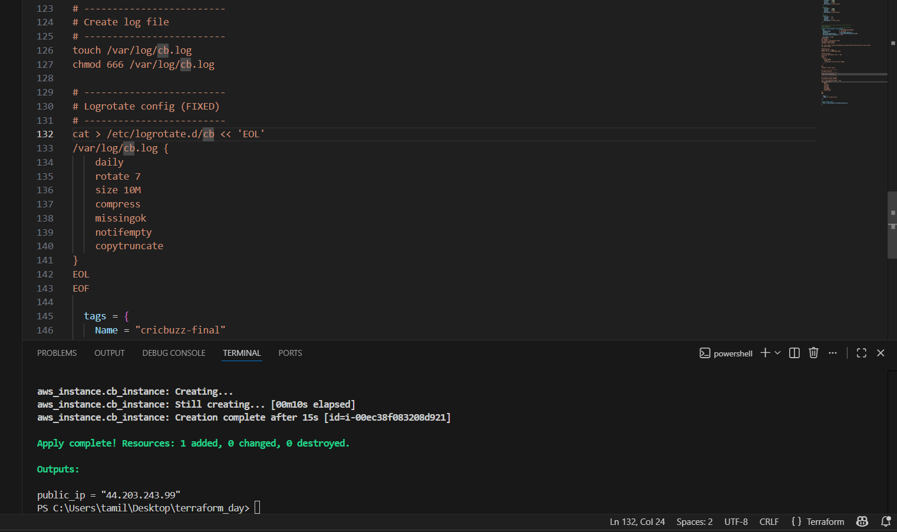

Write the Log rotate configuration for the above file
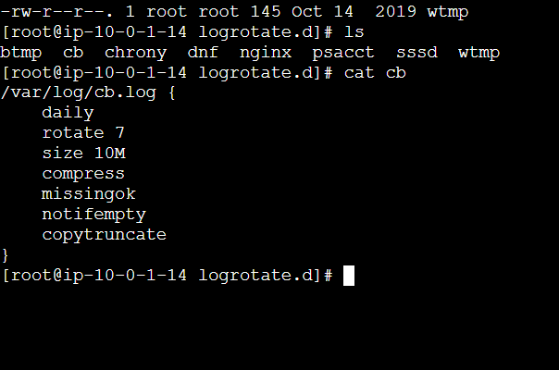
provider "aws" {
region = "us-east-1"
}

# ------------------------------------------------
# VPC
# ------------------------------------------------
resource "aws_vpc" "main" {
cidr_block = "10.0.0.0/16"
enable_dns_support = true
enable_dns_hostnames = true
}

# ------------------------------------------------
# Subnet
# ------------------------------------------------
resource "aws_subnet" "public" {
vpc_id = aws_vpc.main.id
cidr_block = "10.0.1.0/24"
map_public_ip_on_launch = true
availability_zone = "us-east-1a"
}

# ------------------------------------------------
# Internet Gateway
# ------------------------------------------------
resource "aws_internet_gateway" "igw" {
vpc_id = aws_vpc.main.id
}

# ------------------------------------------------
# Route Table
# ------------------------------------------------
resource "aws_route_table" "public_rt" {
vpc_id = aws_vpc.main.id

route {
cidr_block = "0.0.0.0/0"
gateway_id = aws_internet_gateway.igw.id
}
}

resource "aws_route_table_association" "public_assoc" {
subnet_id = aws_subnet.public.id
route_table_id = aws_route_table.public_rt.id
}

# ------------------------------------------------
# Security Group
# ------------------------------------------------
resource "aws_security_group" "cb_sg" {
name = "cb-sg-final"
description = "Allow SSH, 8080, 8000"
vpc_id = aws_vpc.main.id

ingress {
from_port = 22
to_port = 22
protocol = "tcp"
cidr_blocks = ["0.0.0.0/0"]
}

ingress {
from_port = 8080
to_port = 8080
protocol = "tcp"
cidr_blocks = ["0.0.0.0/0"]
}

ingress {
from_port = 8000
to_port = 8000
protocol = "tcp"
cidr_blocks = ["0.0.0.0/0"]
}

egress {
from_port = 0
to_port = 0
protocol = "-1"
cidr_blocks = ["0.0.0.0/0"]
}
}

# ------------------------------------------------
# EC2 Instance
# ------------------------------------------------
resource "aws_instance" "cb_instance" {
ami = "ami-0fa3fe0fa7920f68e"
instance_type = "t3.micro"
subnet_id = aws_subnet.public.id
vpc_security_group_ids = [aws_security_group.cb_sg.id]
associate_public_ip_address = true

user_data = <<-EOF
#!/bin/bash
dnf update -y
dnf install -y docker git nginx
systemctl enable docker
systemctl start docker

git clone https://github.com/betawins/cricbuzz-docker-hello-world.git /opt/cricbuzz
cd /opt/cricbuzz

# Build & run
docker build -t cbapp .
docker run -d -p 8000:8080 cbapp

# Reverse proxy
cat >/etc/nginx/nginx.conf << 'EOL'
events {}
http {
server {
listen 8080;
location / {
proxy_pass http://127.0.0.1:8000;
}
}
}
EOL
systemctl restart nginx

# -------------------------
# Create log file
# -------------------------
touch /var/log/cb.log
chmod 666 /var/log/cb.log

# -------------------------
# Logrotate config (FIXED)
# -------------------------
cat > /etc/logrotate.d/cb << 'EOL'
/var/log/cb.log {
daily
rotate 7
size 10M
compress
missingok
notifempty
copytruncate
}
EOL
EOF

tags = {
Name = "cricbuzz-final"
}
}

output "public_ip" {
value = aws_instance.cb_instance.public_ip
}

