Task on monitoring
- Enable CloudTrail monitoring and store the events in s3 and CloudWatch log events.
Create one cloud trail give name specific name which able to understand
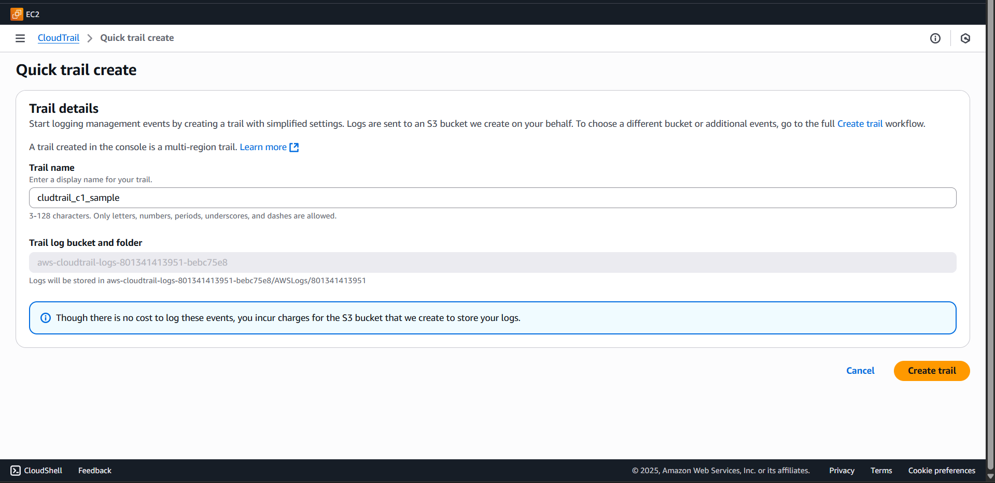
Cloud trail created
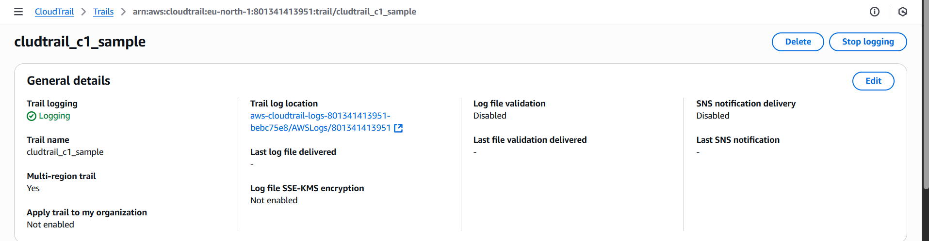
Go to Cloud, create a trail
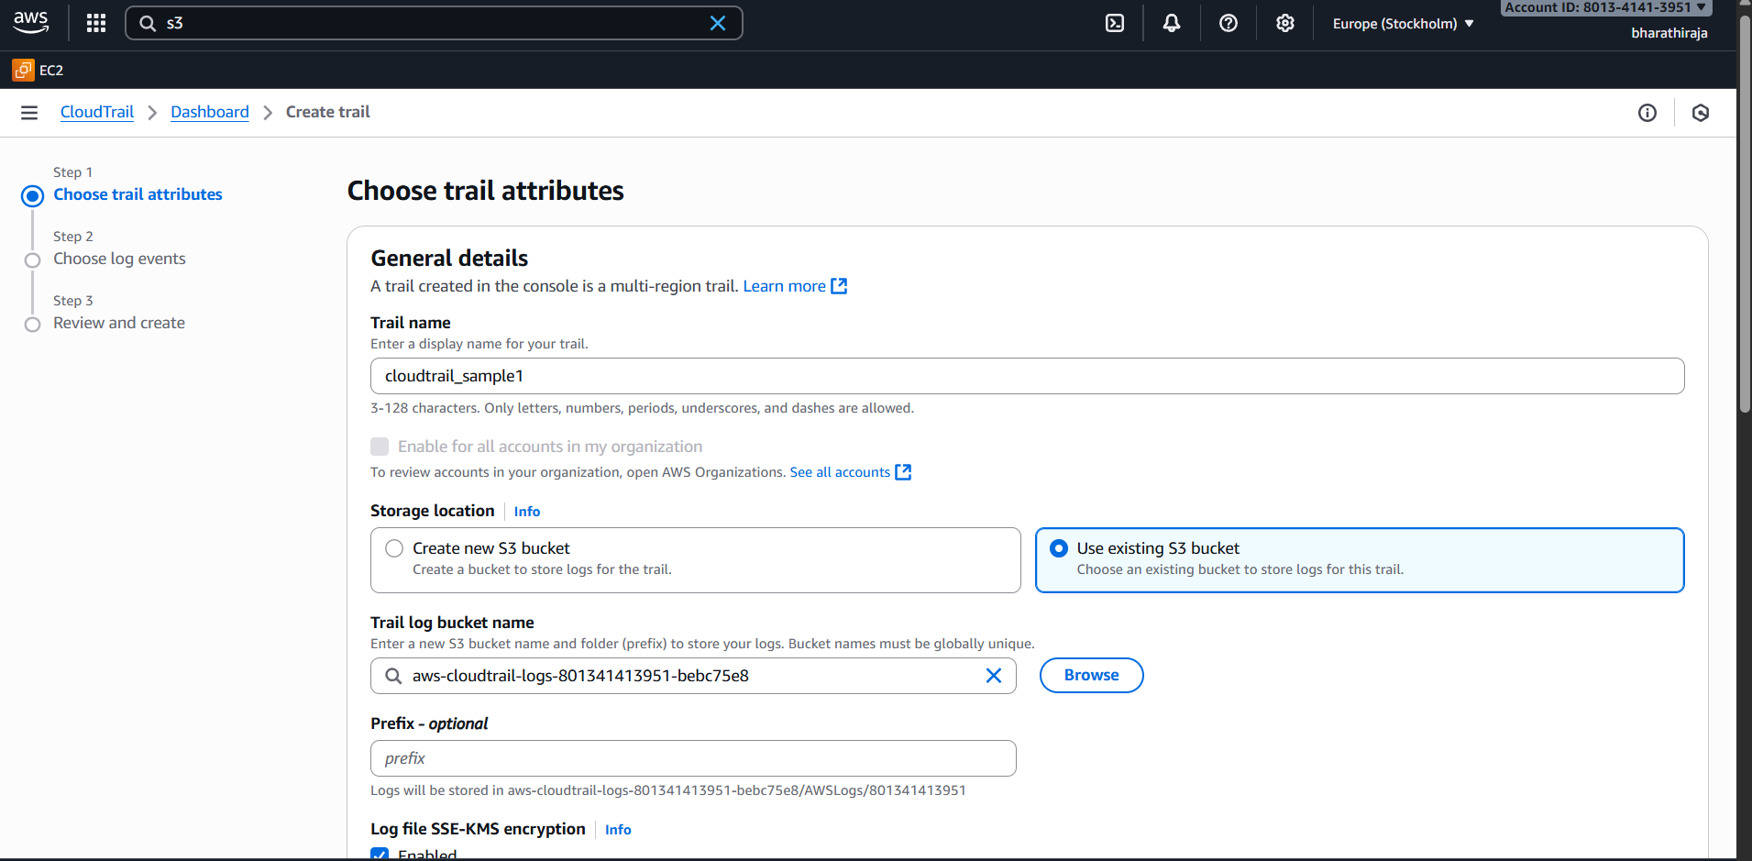
In the event choice management event
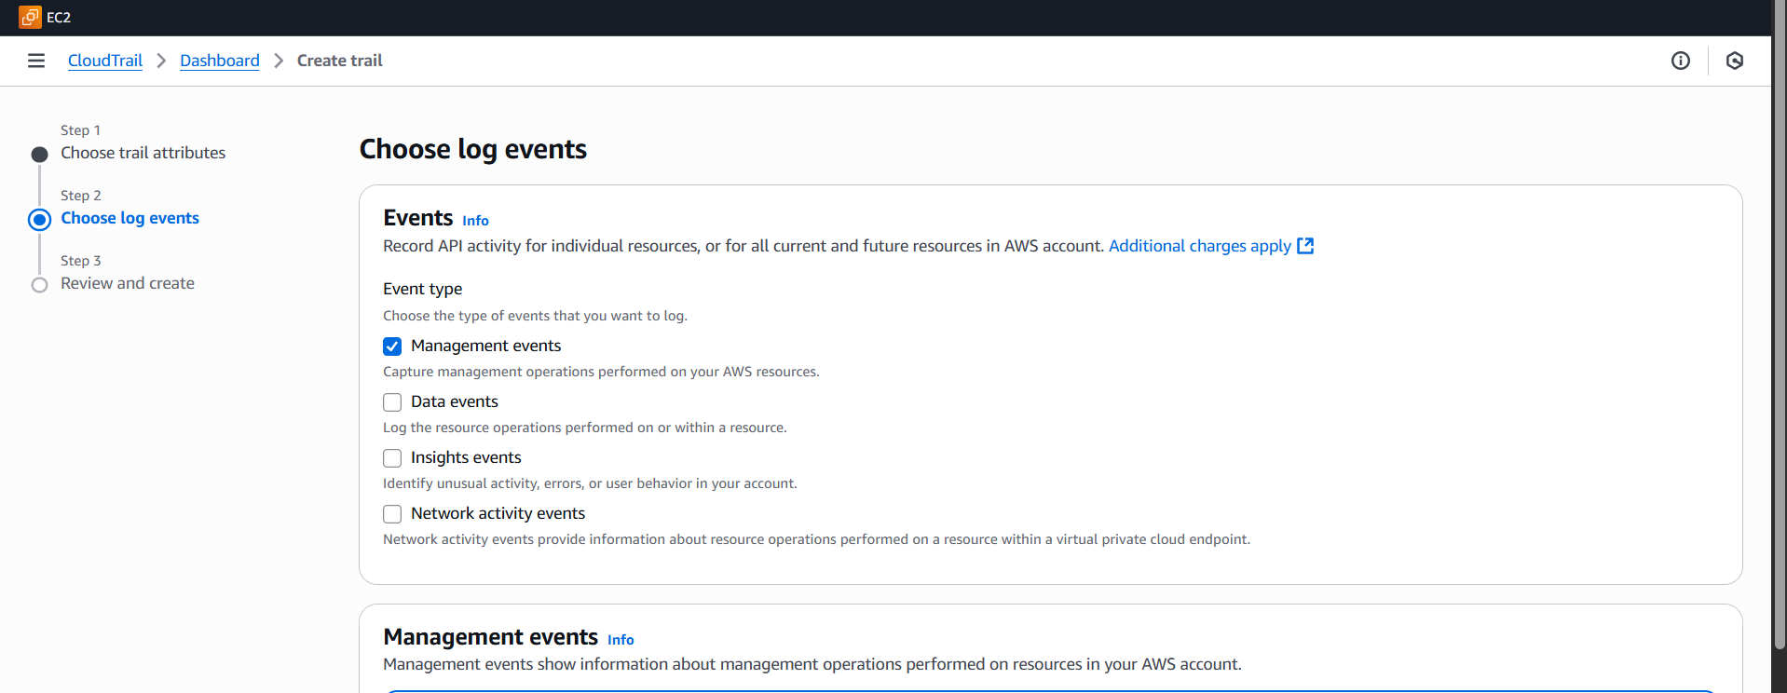
Created cloud trail I was created 2
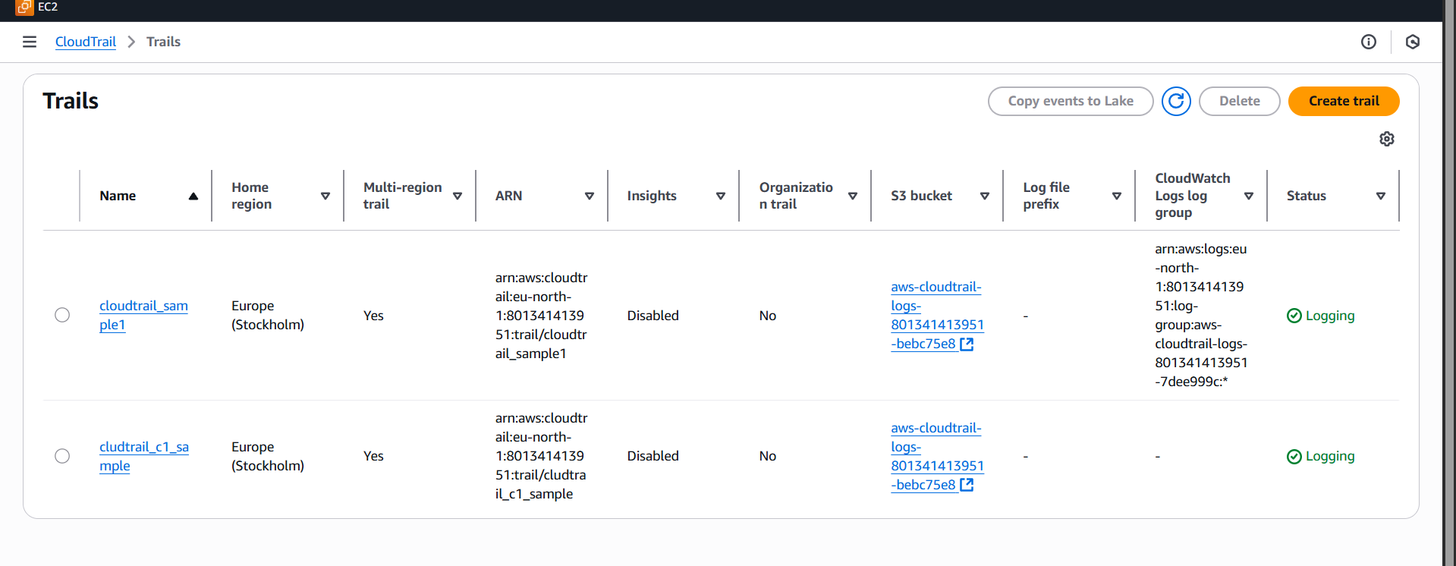
- Enable SNS for cloudtrial to send alert on email.
Go to amazon SNS first
choice first topics, then start to create one topic and subscrption
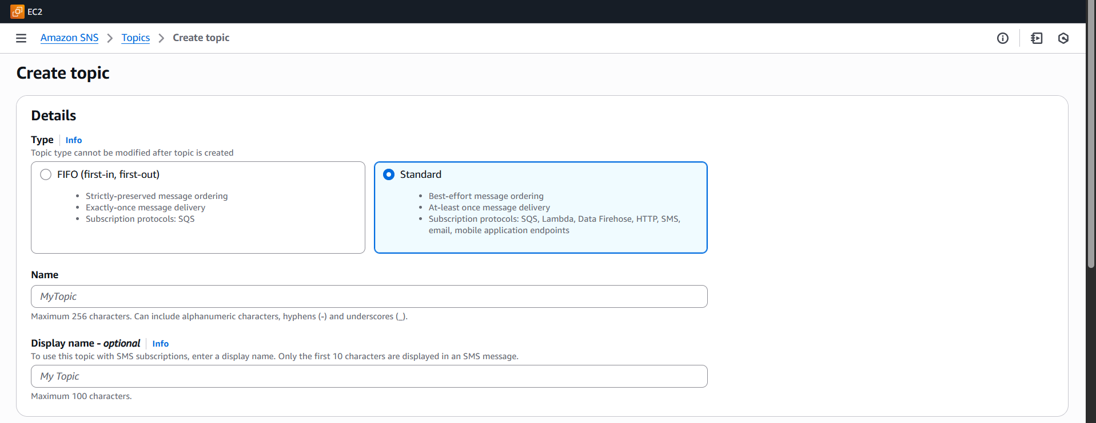
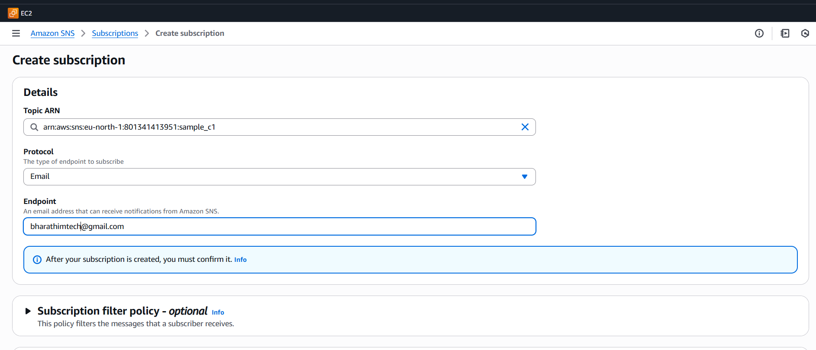
See, there is pending confirmation we have to go email we ashould accept 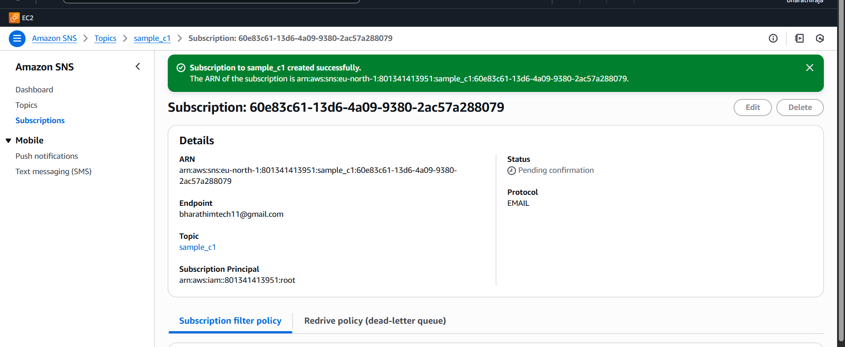
I got the mail to confirm the mail
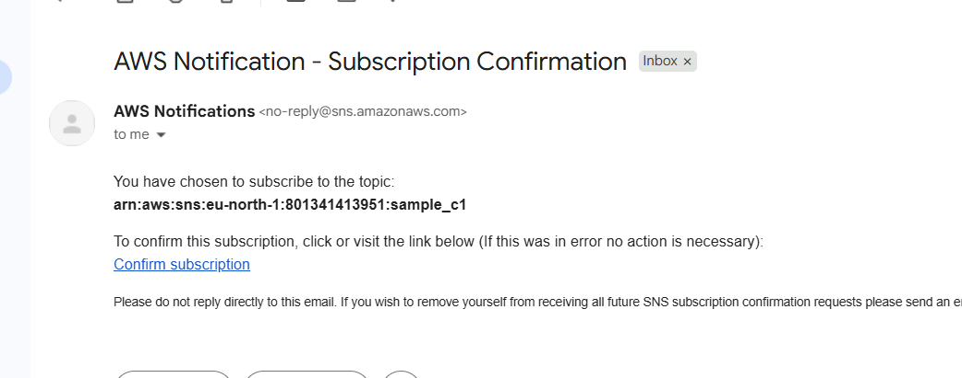
Confirm the mail
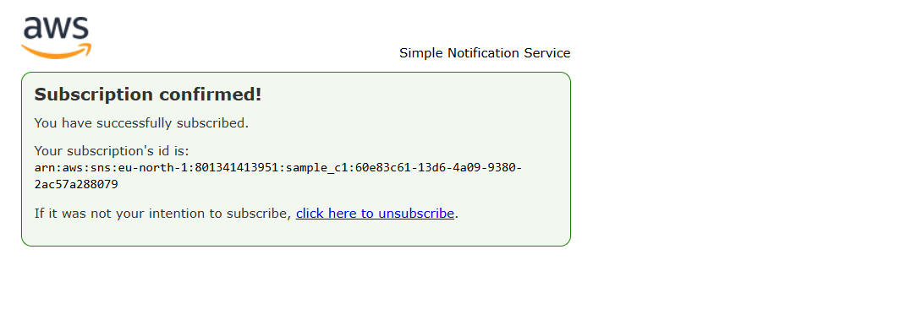
Now we can check the configuration
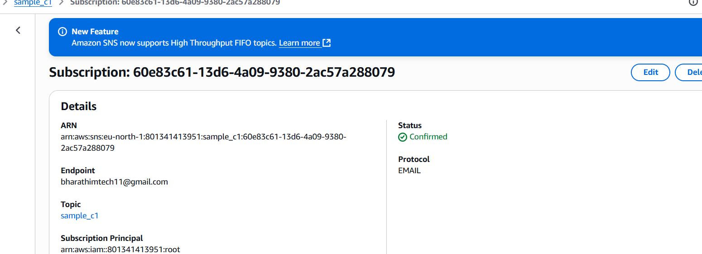
I got mail notification
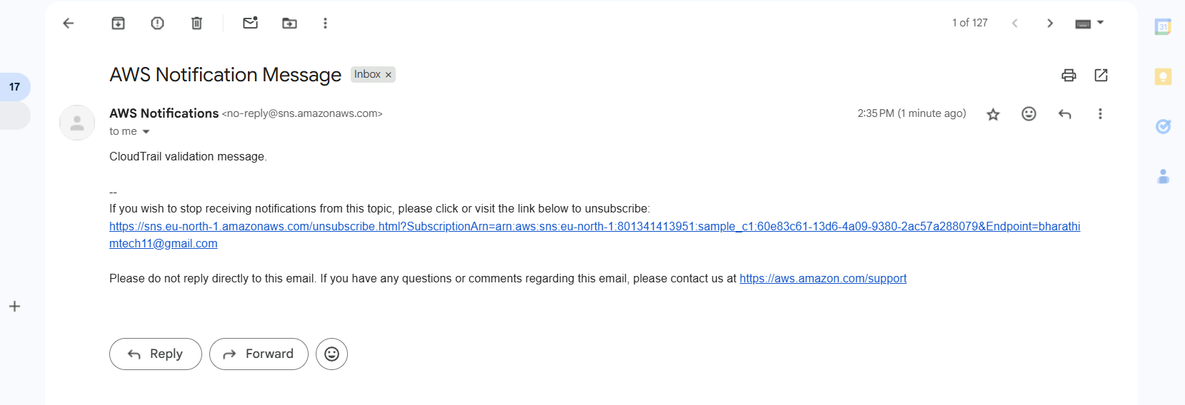
- Configure CloudWatch monitoring and record the CPU utilization and other metrics of EC2.
Open one ec2-instance and enable the detailed cloud watch monitoring
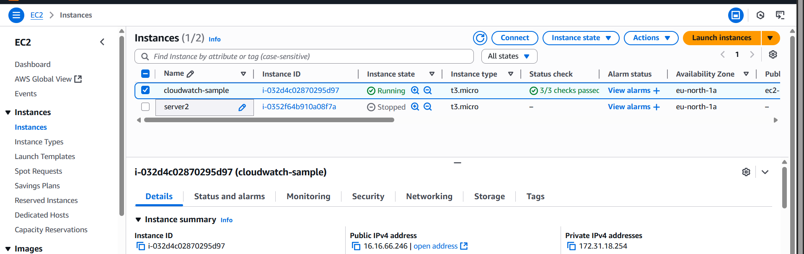
go to the cloud watch and go into that metrics and click all metrices
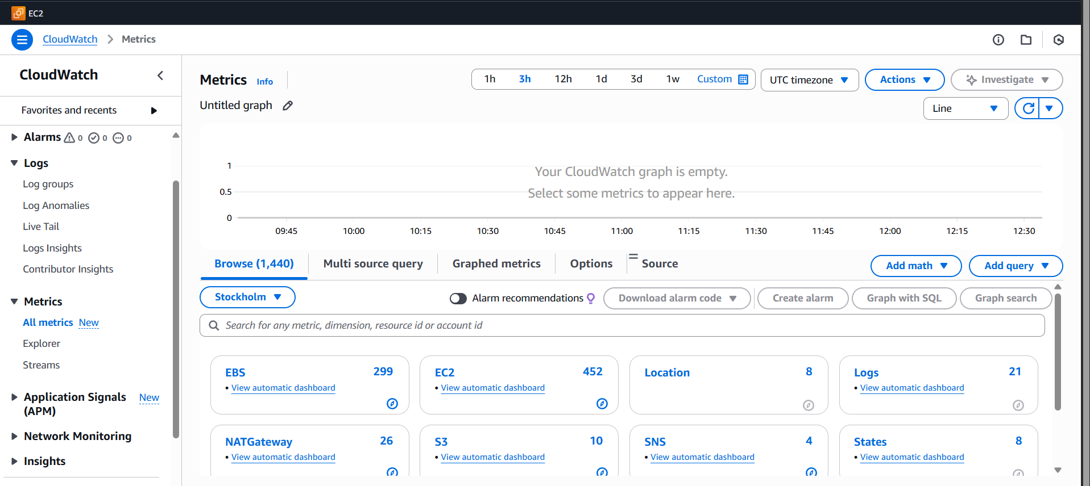
Ec2- instanace id i-032d4c02870295d97 we should copy and paste it then it will get some list and it will show all thing cpu utilization click on it
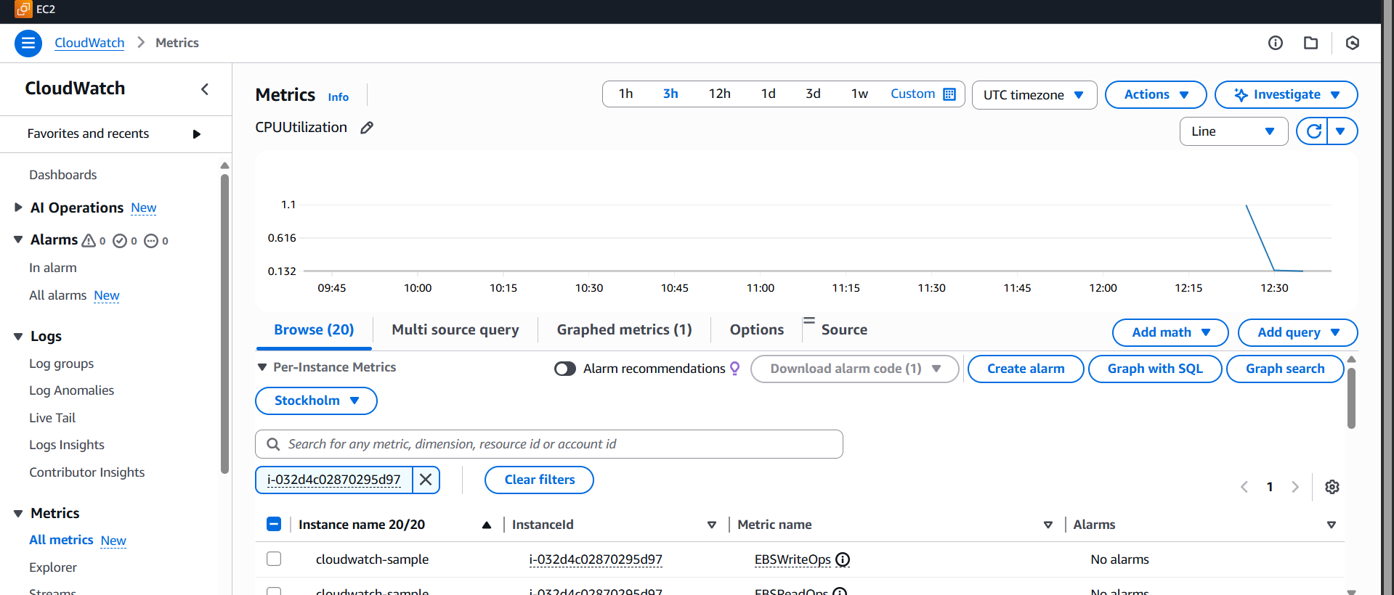
Then later if you want alarm set go to alarm part and create alarm set
We need fill the some details
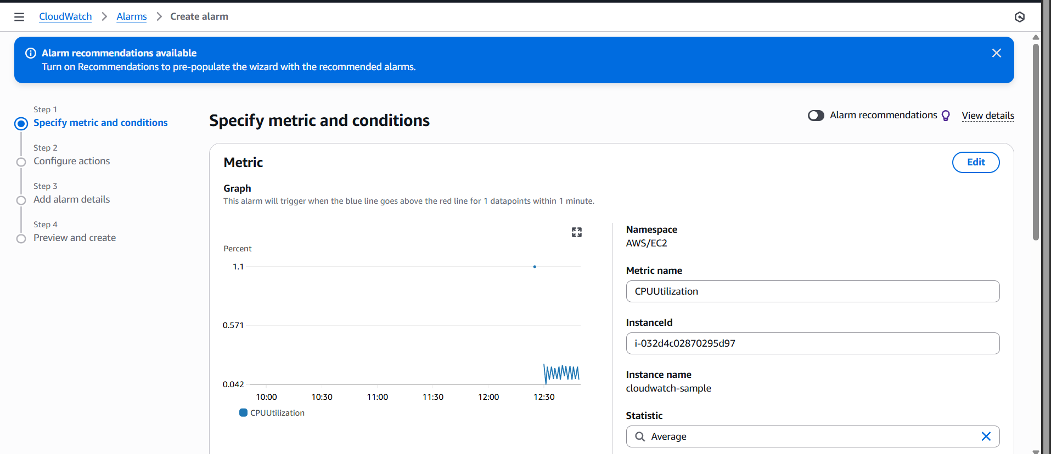
Give the details as much as you want
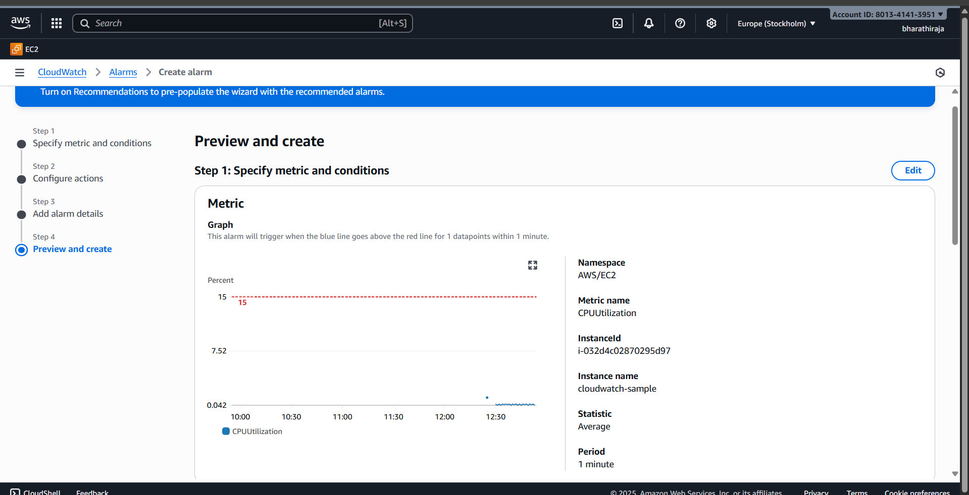
I ceated one alarm
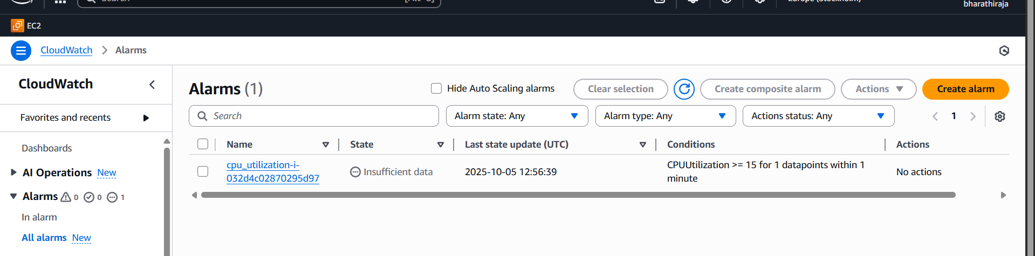
Check my graph
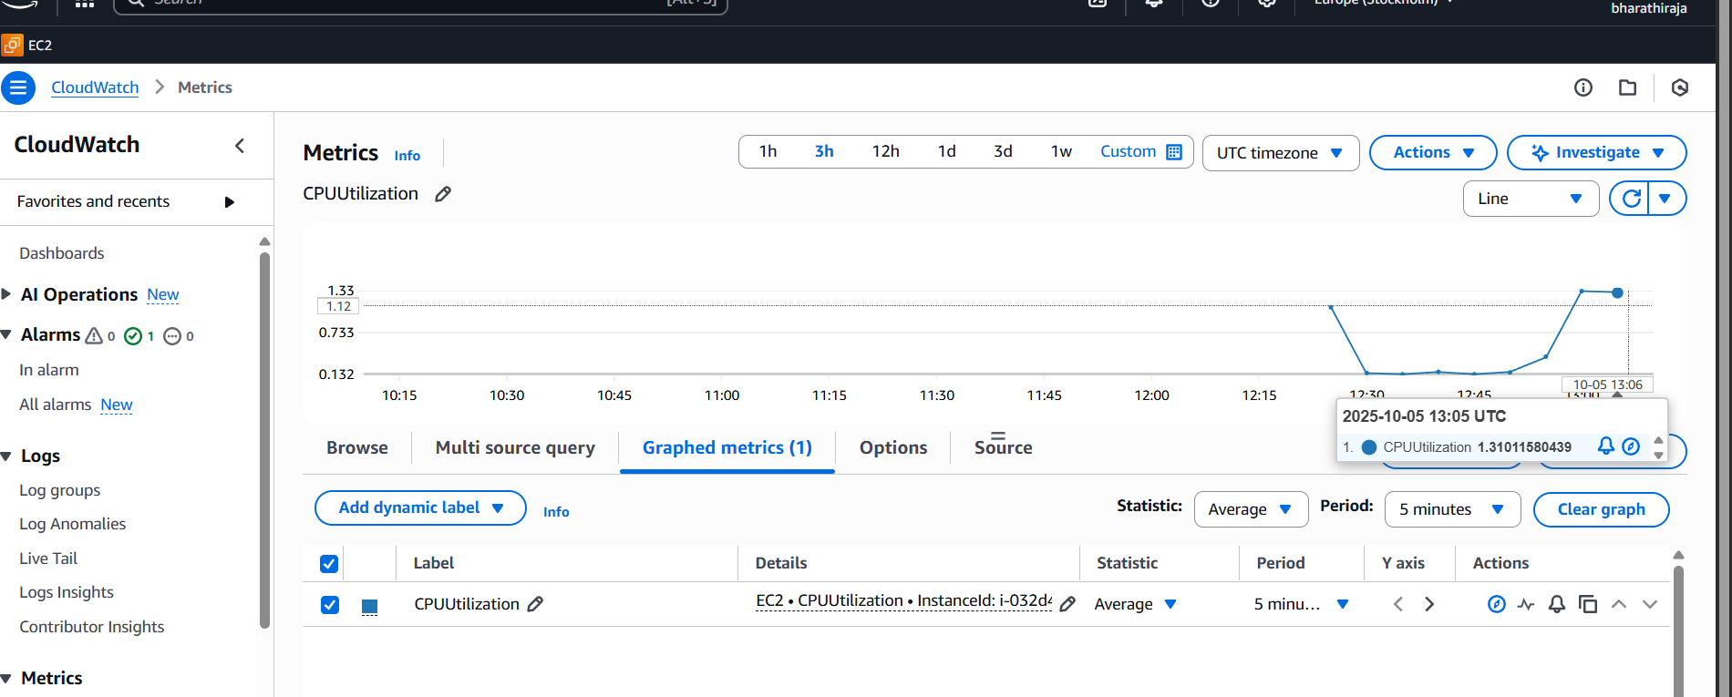
sudo amazon-linux-extras install epel -y
sudo yum install stress -y
stress --help
stress -c 1 -t 3600 use this command increses the cpu utilization
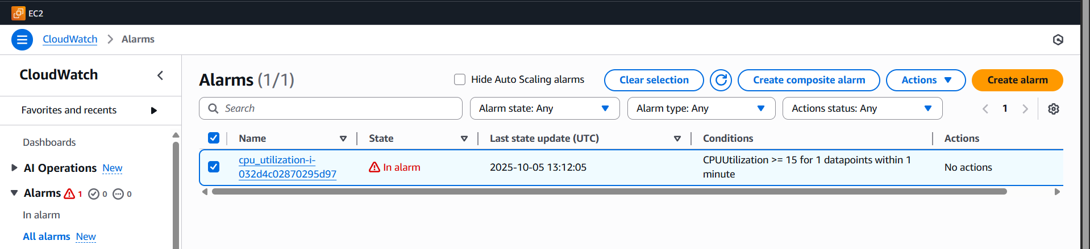
we can check my cpu utilization 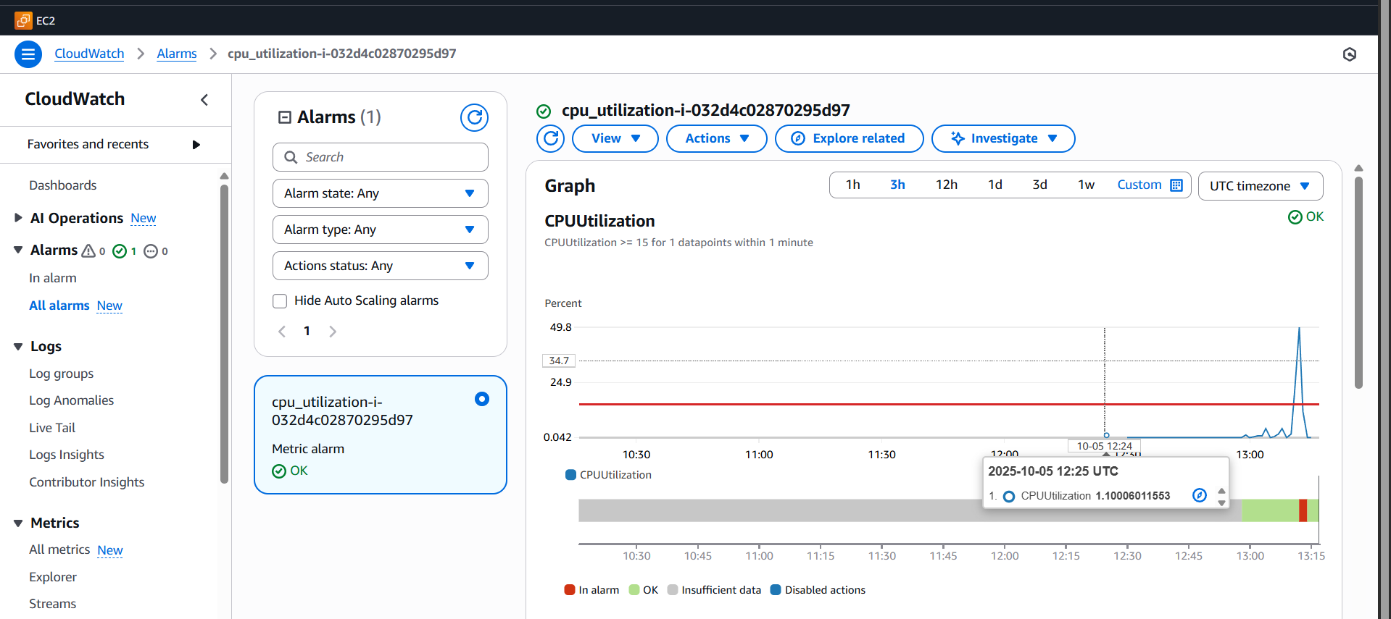
now check cpu analysis
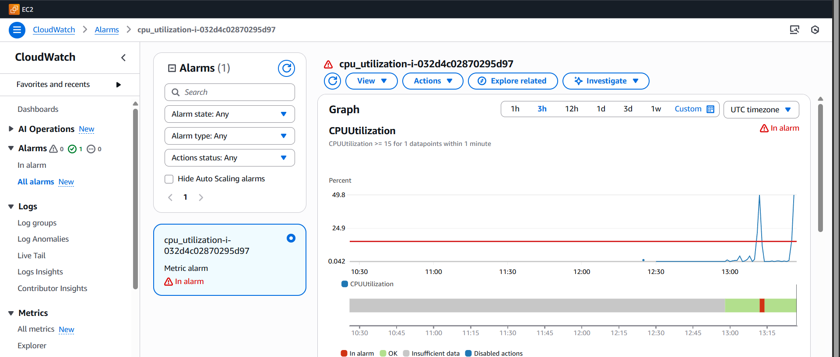

- Create one alarm to send alert to email if the cpu utilization is more than 70 percent.
Same as create one EC2 instance and alarm also and metric also
Open CloudWatch
- Go to AWS Management Console → search CloudWatch → open it.

Create SNS Topic for Email
- On the left menu → Alarms → Notifications → Topics → Create topic

Create CPU Alarm
- In CloudWatch → Alarms → All alarms → Create alarm
- Select EC2 Metrics → Per-Instance Metrics
- Choose CPUUtilization for your instance → click Select metric
- Configure threshold:
  - Threshold type: Static
  - Whenever CPUUtilization is: Greater/Equal → 70
  - For: 5 minutes (or your preferred duration)
- Click Next
- Configure actions:
  - Send a notification to: your SNS topic (HighCPUAlert)
- Name the alarm, e.g., CPU_Utilization_70%_Alarm
- Click Create alarm
- Done! Now if CPU > 70%, you’ll get an email.

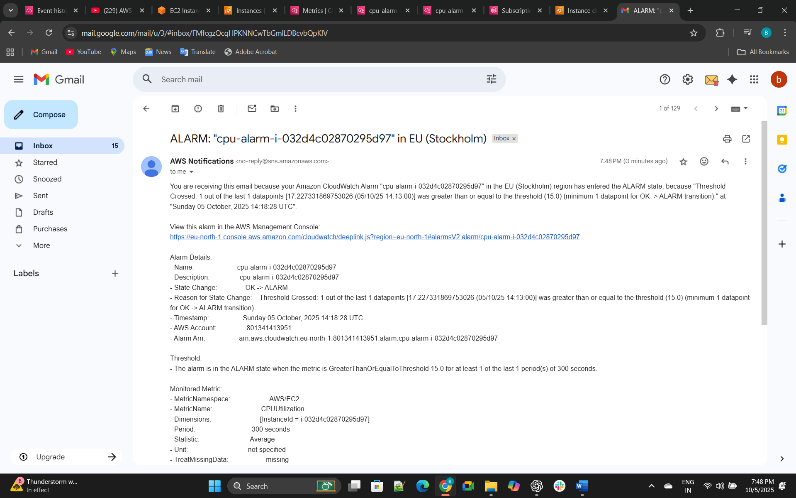
- Create a Dashboard and monitor Tomcat service, whether it is running or not, and send an alert.
Sudo yum install java-17 -y
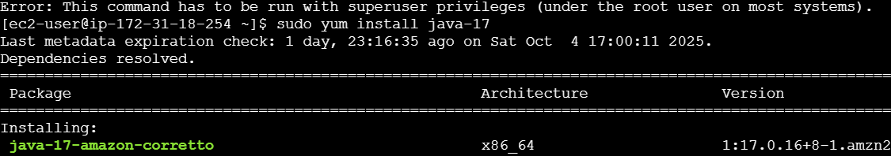
- yum install java-17 -y
⦁ wget https://dlcdn.apache.org/tomcat/tomcat-9/v9.0.109/bin/a
pache-tomcat-9.0.109.tar.gz
⦁ vi /opt/monitoring.sh
⦁ paste these code here
--------------------------------------------------------------------------------------------
---
#!/bin/bash
# Check if Tomcat service is active
if systemctl is-active --quiet tomcat; then
STATUS=1
else
STATUS=0
- fi
# Push custom metric to CloudWatch
aws cloudwatch put-metric-data \
--namespace "TomcatMonitoring" \
--metric-name "TomcatStatus" \
--value $STATUS \
--region eu-north-1
----------------------------------------------------------------------------------------------------
--
chmod 777 monitoring.sh
aws configure (paste your access id and secret key)
crontab -e
paste these in crontab editor (* * * * * /opt/monitoring.sh)
sh monitoring.sh
go to aws console and go to cloud watch
create a dashboard---select widget---number---select tomcat-
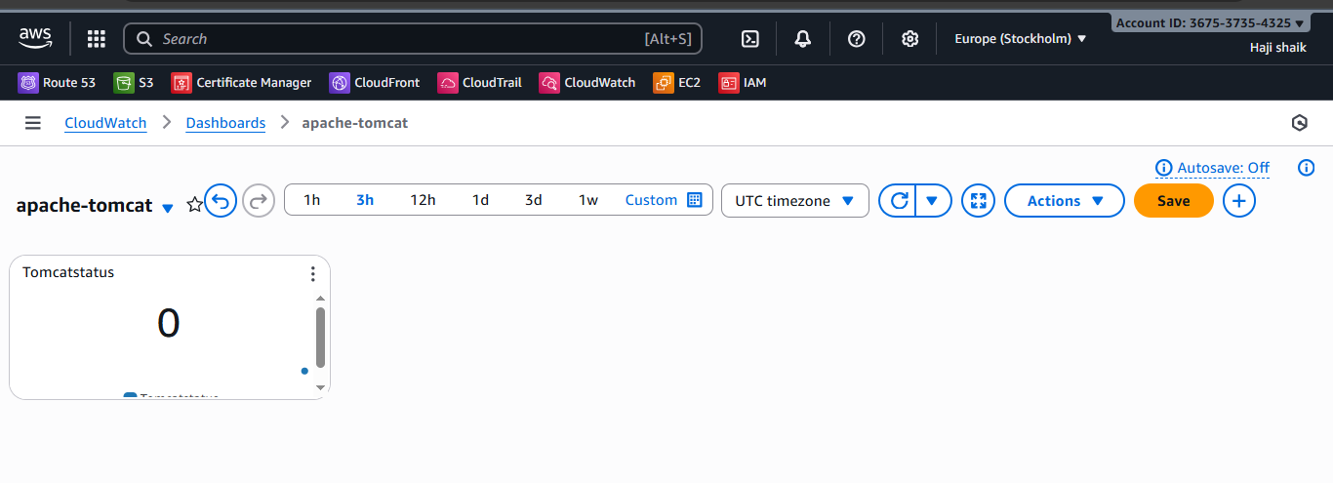

- Create a Dashboard and monitor the nginx service to send an alert if nginx is not running.
Create a intsanse in aws console
yum install nginx -y
systemctl start nginx
systemctl enable nginx
yum install cronie -y
systemctl start cronie
systemctl enable cronie
crontab -e
paste these code in cronie editor (* * * * * /home/ec2-
user/nginx-monitor.sh)
aws configure (paste your access id and secret key ) here
vi nginx-monitor.sh
---------------------------------------------------------------------------------------
---
#!/bin/bash
# Check if nginx service is active
if systemctl is-active --quiet nginx; then
STATUS=1
else
STATUS=0
fi
# Push custom metric to CloudWatch
aws cloudwatch put-metric-data \
--namespace "NginxMonitoring" \
--metric-name "NginxStatus" \
--value $STATUS \
--region us-east-1
--------------------------------------------------------------------------------------------------------------------
----
sh nginx-monitor.sh
go to console and cloud watch dashboard
add widget number
add nginx-monitor
create
it will show value 1 in the monitoring chart when nginx is running or
else 0 when stopped
