Task for today Assignment-04.

- Set up Jenkins CICD pipeline using a freestyle job using Docker containers using code below. https://github.com/betawins/hiring-app.git Stages:
  - Git Clone
  - SonarQube Integration
  - Maven Compilation
  - Nexus Artifactory
  - Slack Notification
  - Deploy on Tomcat

https://github.com/betawins/hiring-app.git Stages:
Git Clone
configure the Jenkins job and download the source code from git hub to the repository
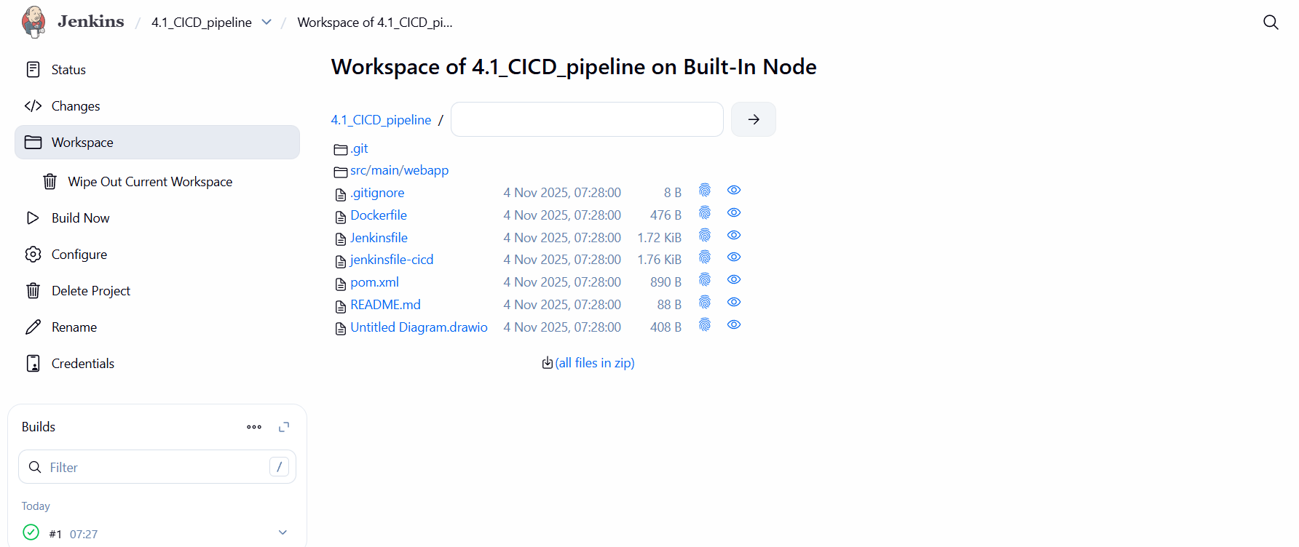
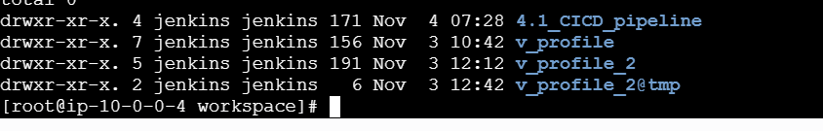

Create a token in sonarqube go to account then, open the security and create the security give necssary data then it will be open
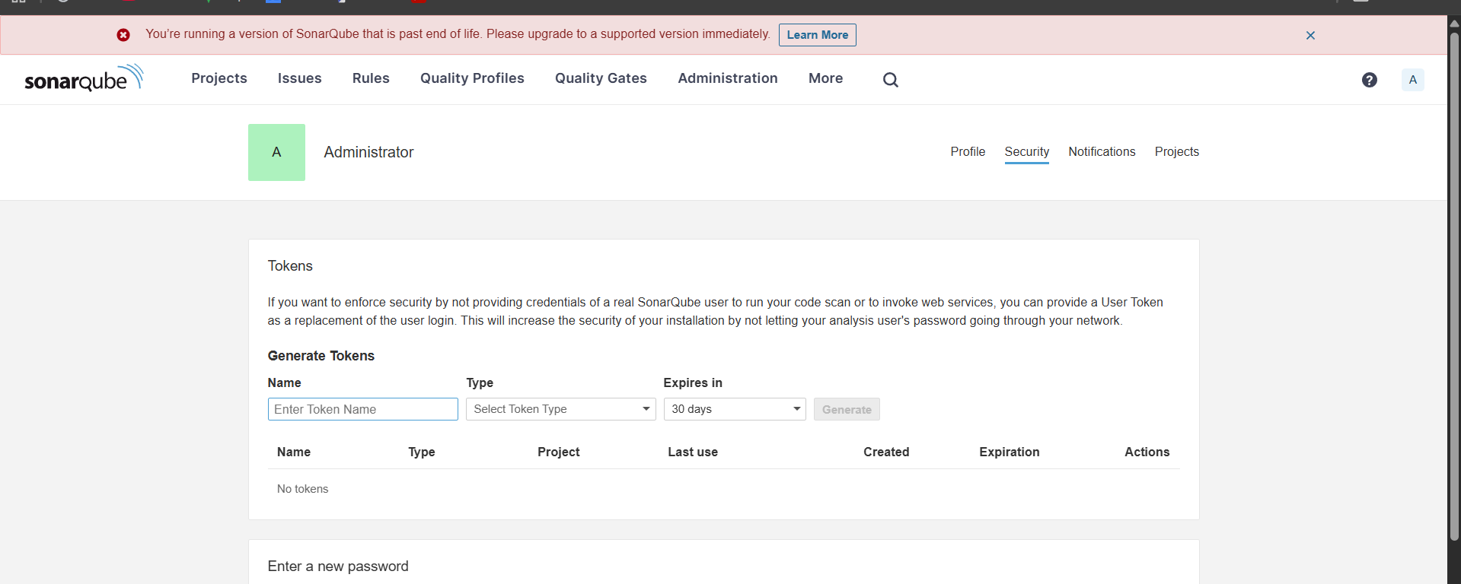
This is a step to generate the token
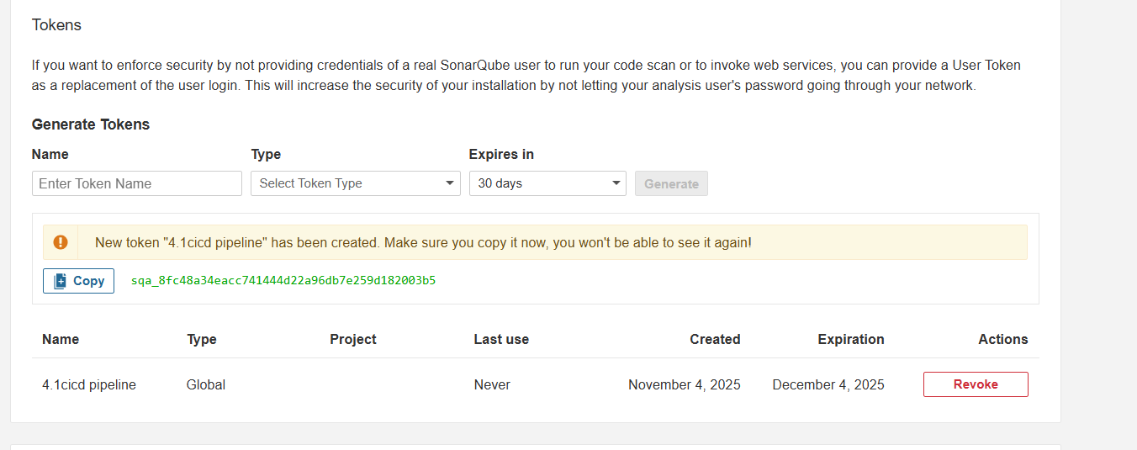
### Implementation
Login to Jenkins server and install sonarqube scanner.
- SonarQube scanner URL : https://docs.sonarqube.org/display/SCAN/Analyzing+with+SonarQube+Scanner
- Package : https://sonarsource.bintray.com/Distribution/sonar-scanner-cli/sonar-scanner-cli-3.2.0.1227-linux.zip
# wget https://binaries.sonarsource.com/Distribution/sonar-scanner-cli/sonar-scanner-cli-4.6.2.2472-linux.zip
# unzip sonar-scanner-cli-4.6.2.2472-linux.zip
# mv sonar-scanner-4.6.2.2472-linux /opt/sonar_scanner

After the give location where do you need
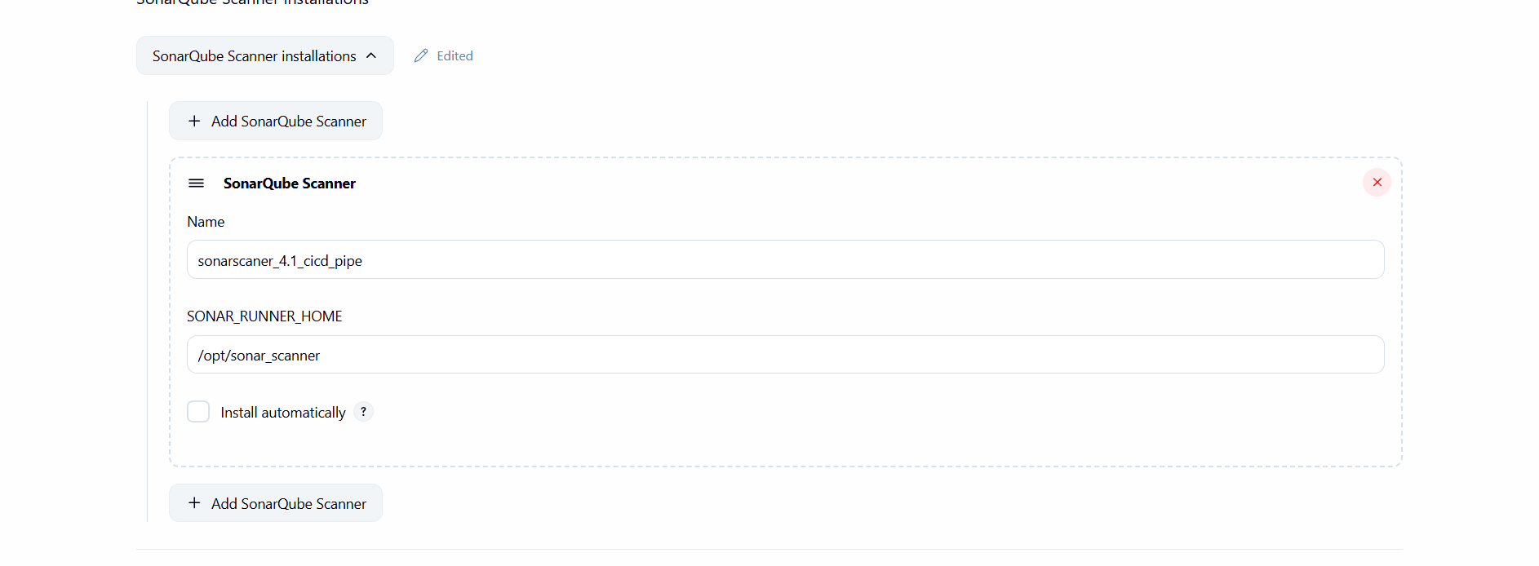
Go to git hub there sonaralaysis the code
sonar.project=test
sonar.soruce=.
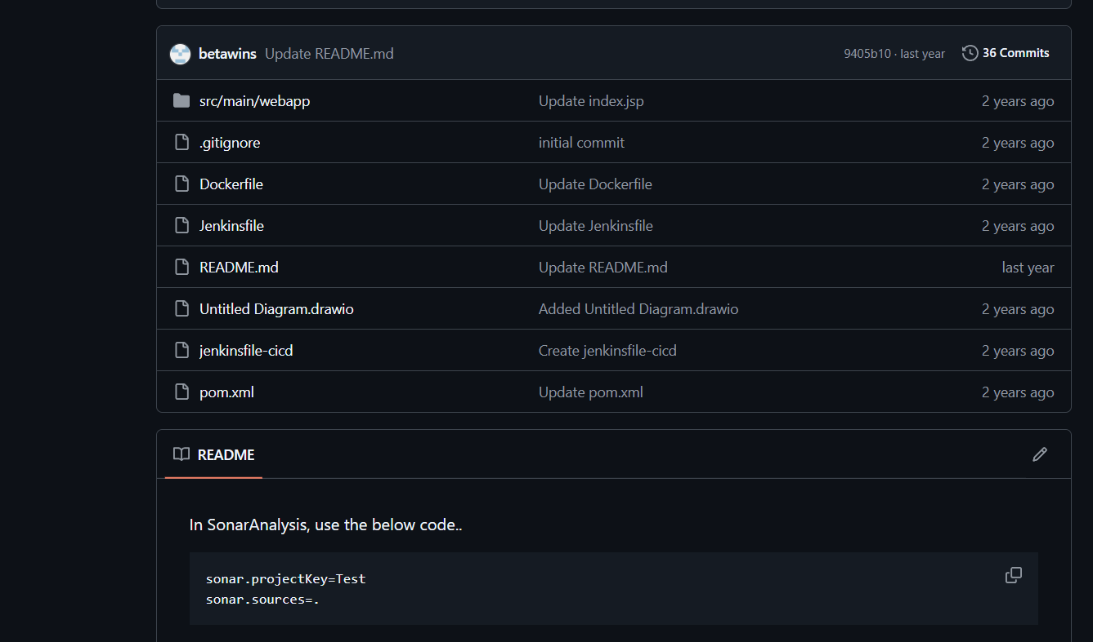
Then configure
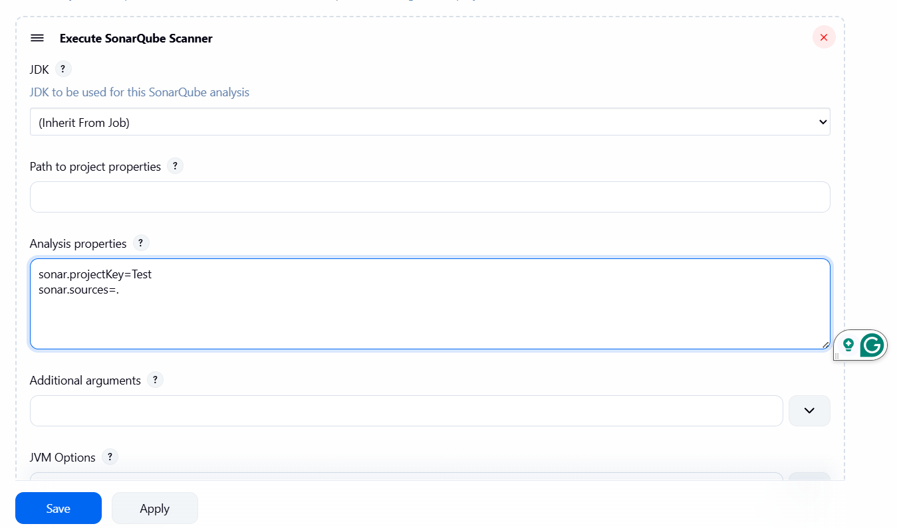
Before build
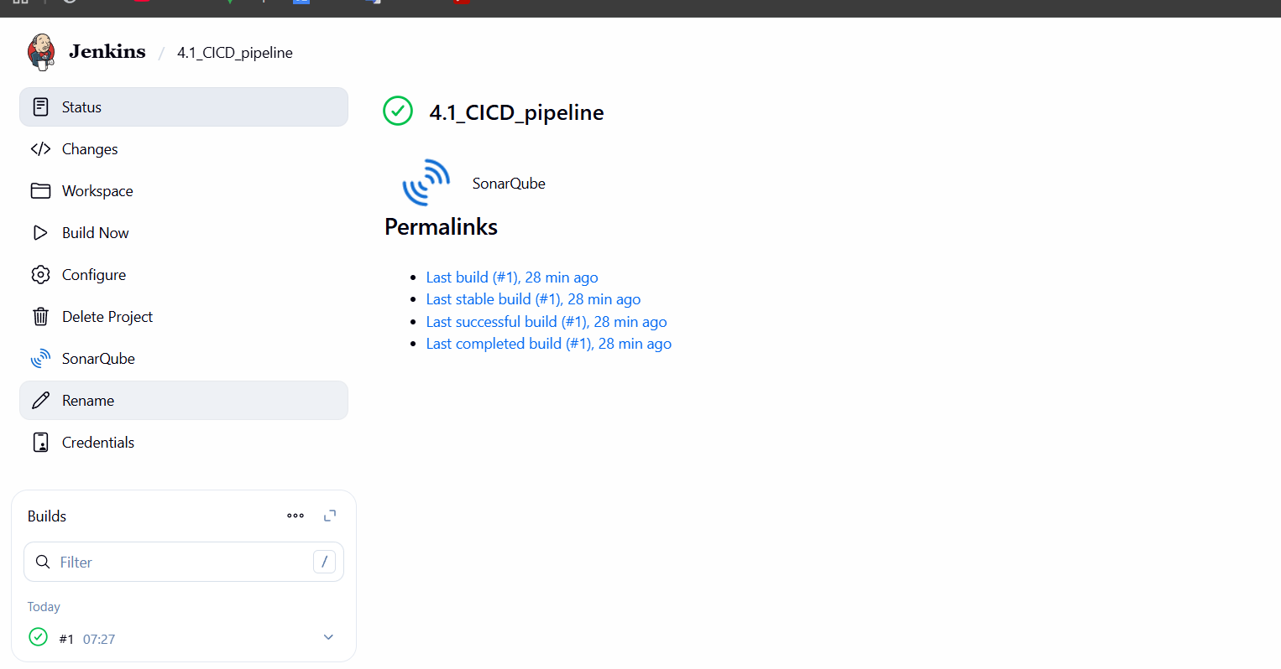

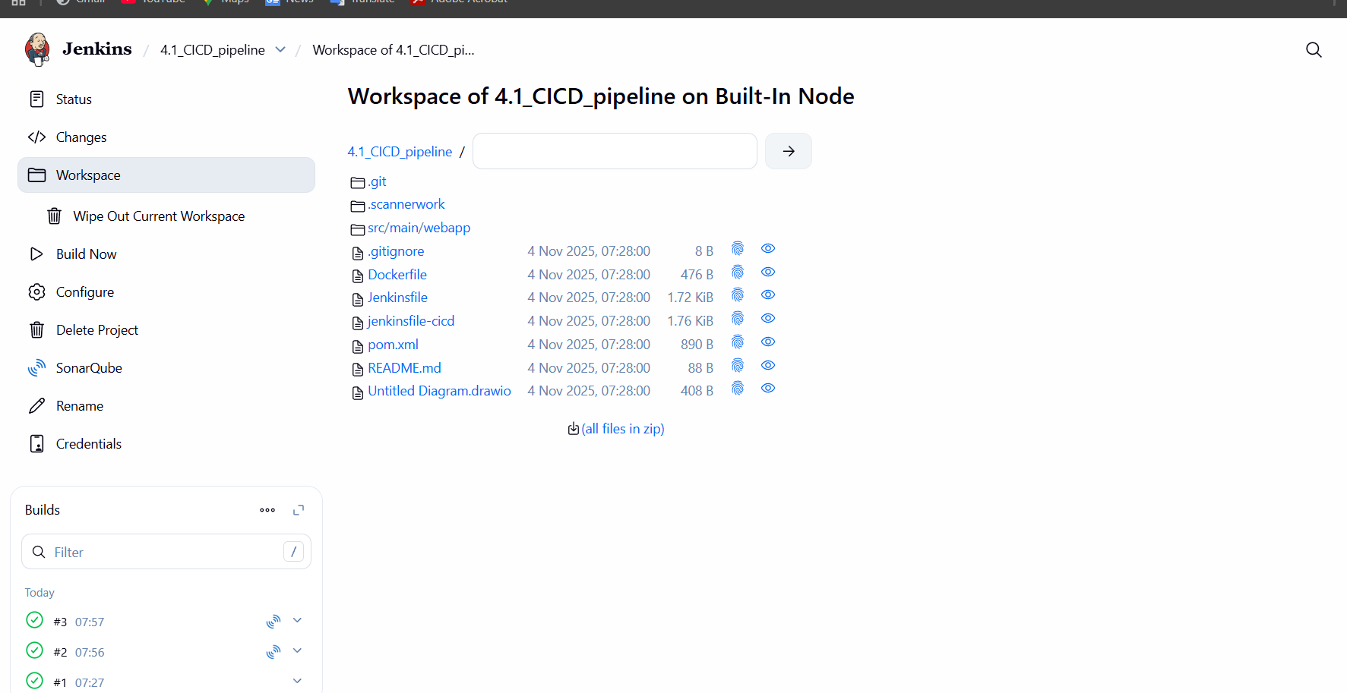

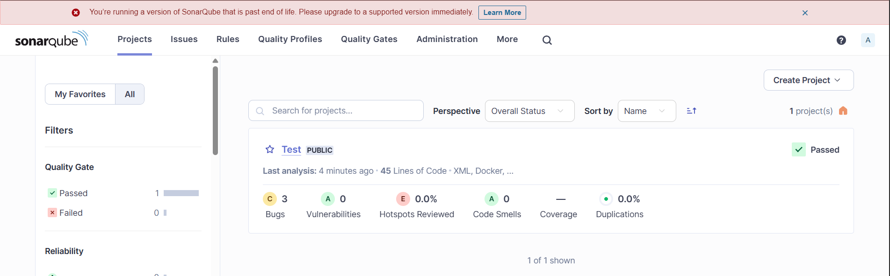
c. Maven Compilation:
In Jenkins server go to cd /opt and download
maven
• Go to browser and search maven download
and copy link address and by wget <link
adress>
cd /opt
wget https://dlcdn.apache.org/maven/maven-3/3.9.11/binaries/apache-maven-3.9.11-bin.tar.gz
tar -xvf apache-maven-3.9.11-bin.tar.gz
mv apache-maven-3.9.11 maven
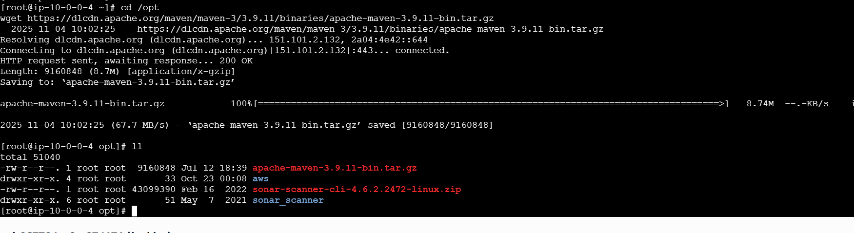
Go to bin directory and copy the path
/opt/apache-maven3.9.11/bin and paste the
address in vi .bash_profile
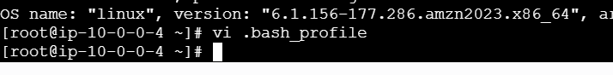
Paste it insde the .bash profile
MVN_HOME=/opt/apache-maven-3.9.11/bin
PATH=$PATH:$HOME/bin:$MVN_HOME
export PATH
To execute that source ~/.bash_profile
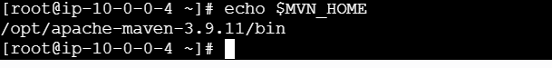

Go to Jenkins server and go to mange
Jenkins,tools in that we are having add maven
there you will give name and path
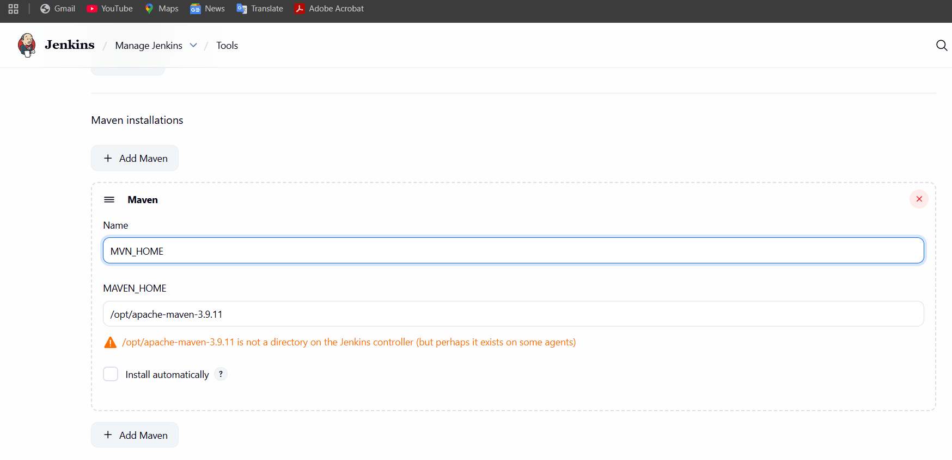
Go to build steps there youwill find invoke top-
level Maven targets
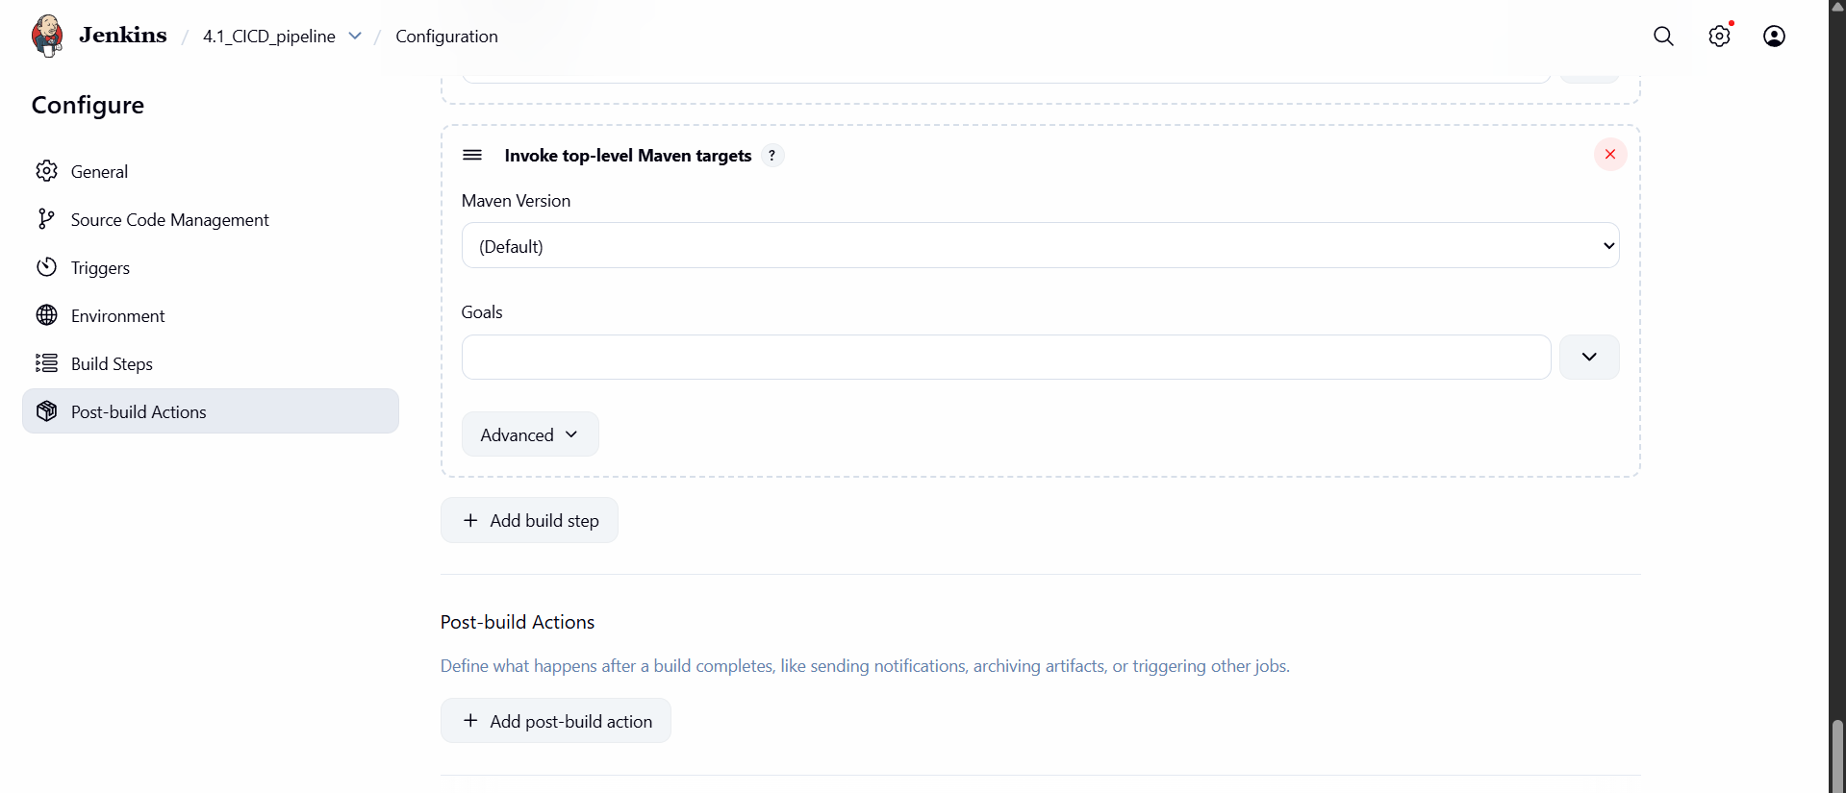
Give the details like that
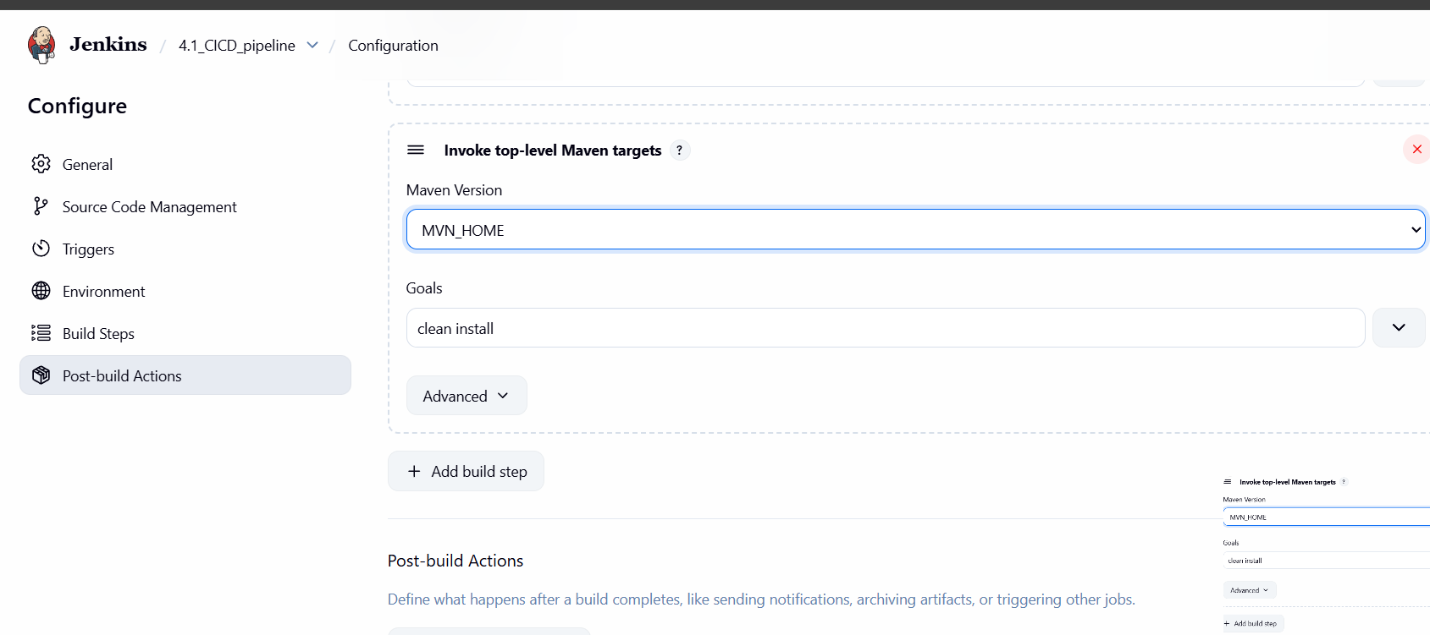
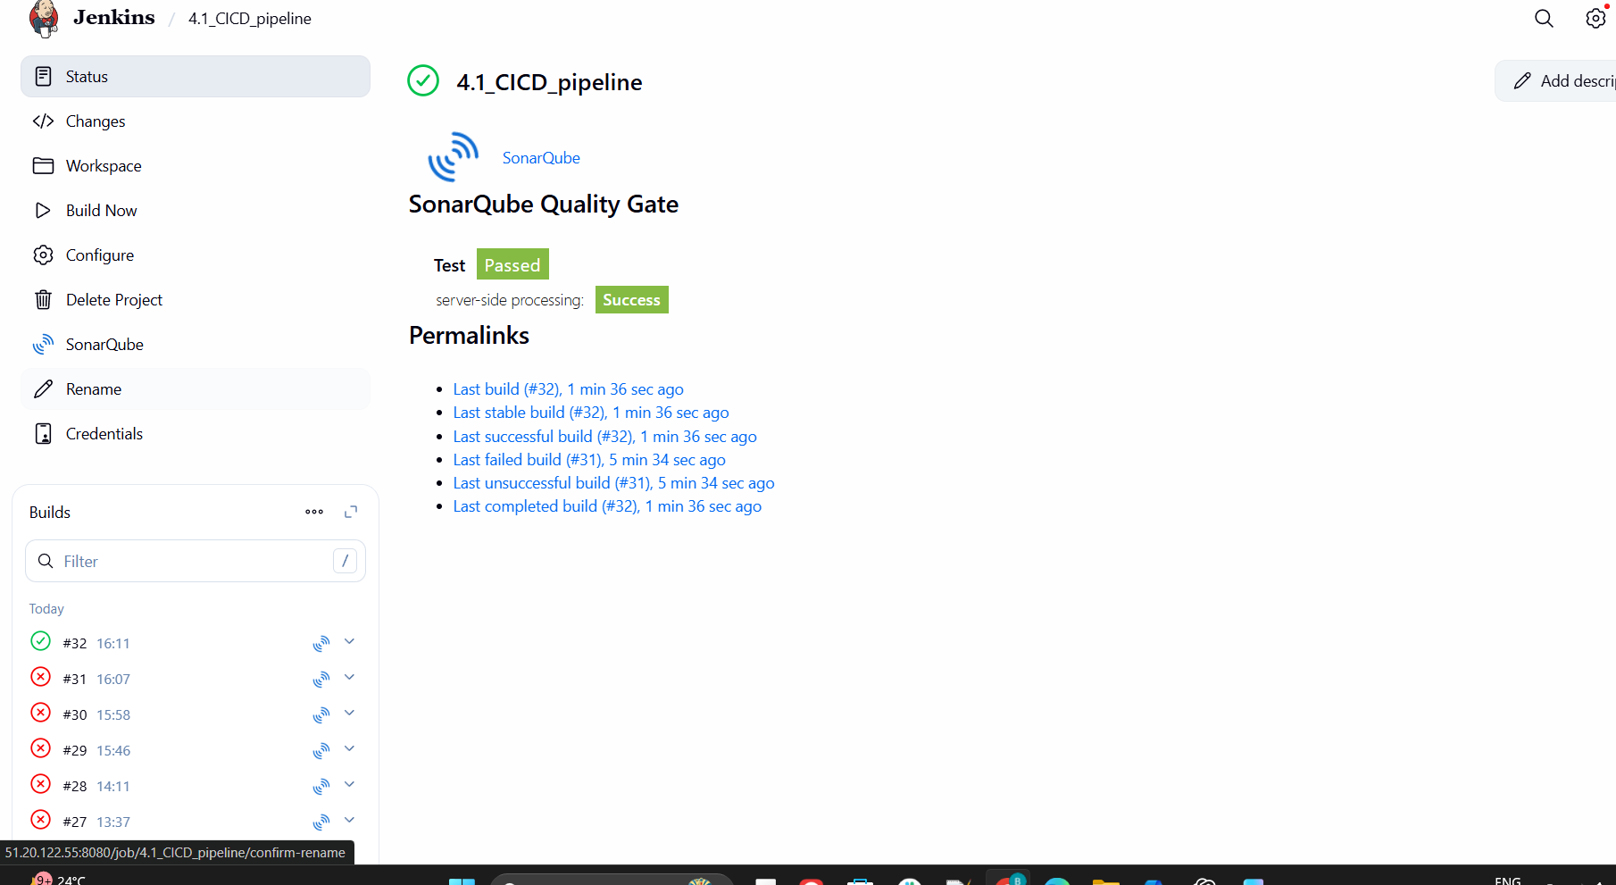
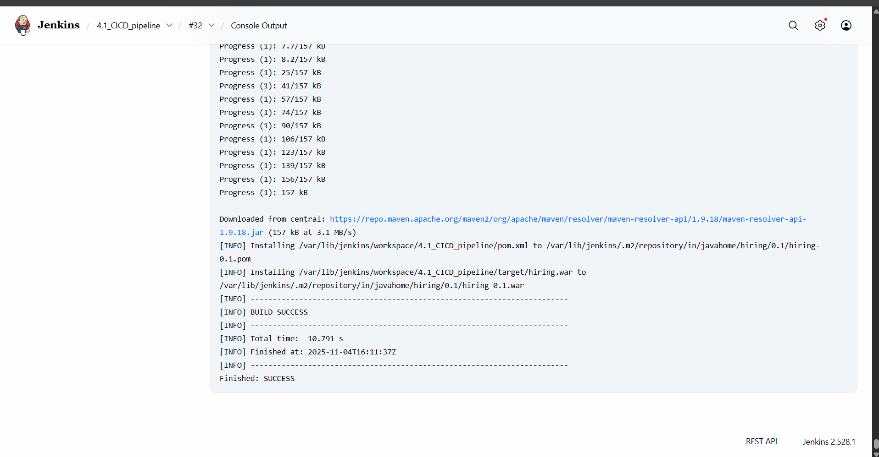

d. Nexus Artifactory:
create an ec2-instance with the name nexus.
• use c7-flexlarge instance type.
• Use the memory as 20 gb
java install
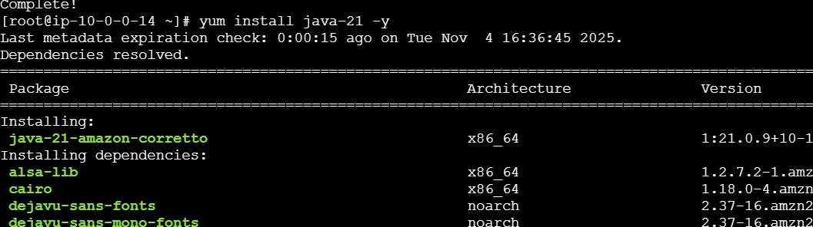
Tar -xvzf nexu-3.68………………..
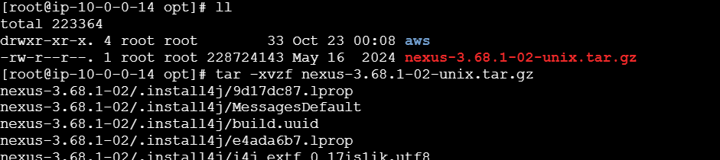
Change the directory to cd opt/nexus/bin/vi
nexus.rc
Write the user as ec2-user in that file
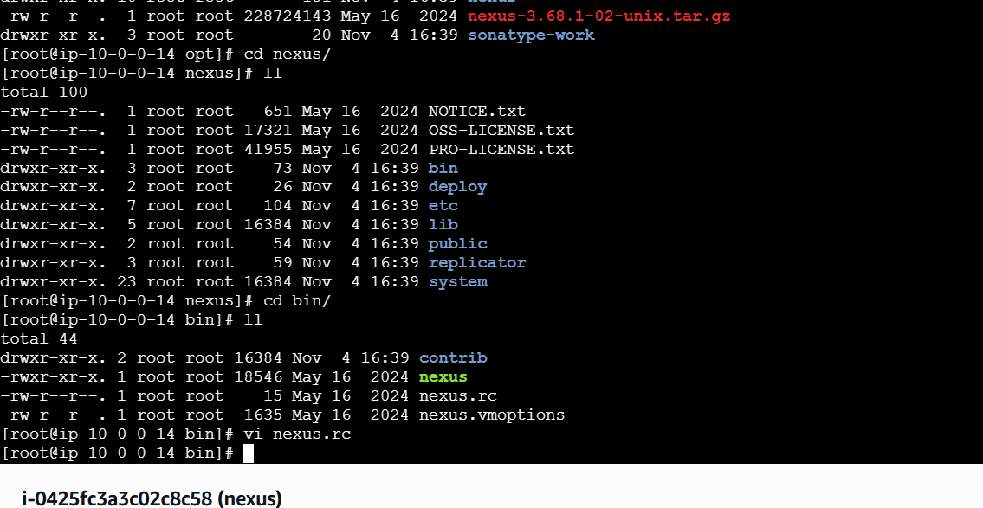
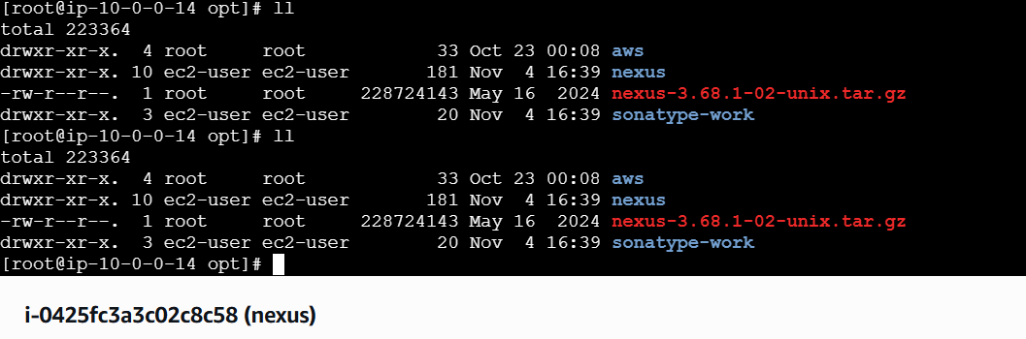
# Nexus Installation
Nexus is one a artifact repository which helps to store your build outcomes.

### Follow this article in **[Youtube](https://www.youtube.com/watch?v=83AGz9huJGo)
### Prerequisites
1. EC2 instance with java
### Implementation steps
Download and setup nexus stable version
cd /opt
wget https://sonatype-download.global.ssl.fastly.net/nexus/3/nexus-3.0.2-02-unix.tar.gz
tar -zxvf nexus-3.0.2-02-unix.tar.gz
mv /opt/nexus-3.0.2-02 /opt/nexus
As a good security practice, it is not advised to run nexus service as root. so create new user called nexus and grant sudo access to manage nexus services
sudo adduser nexus
# visudo \\ nexus ALL=(ALL) NOPASSWD: ALL
sudo chown -R nexus:nexus /opt/nexus
Open /opt/nexus/bin/nexus.rc file, uncomment run_as_user parameter and set it as following.
vi /opt/nexus/bin/nexus.rc
run_as_user="nexus" (file shold have only this line)
Add nexus as a service at boot time
sudo ln -s /opt/nexus/bin/nexus /etc/init.d/nexus
Login as a nexus user and start service
su - nexus
service nexus start
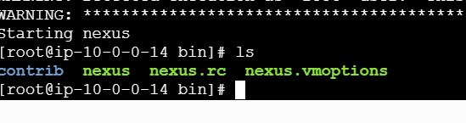
[nexus@ip-10-0-0-8 bin]$ ./nexus start
Starting nexus
Started Sonatype Nexus OSS...
[nexus@ip-10-0-0-8 bin]$ ./nexus status
nexus is running.

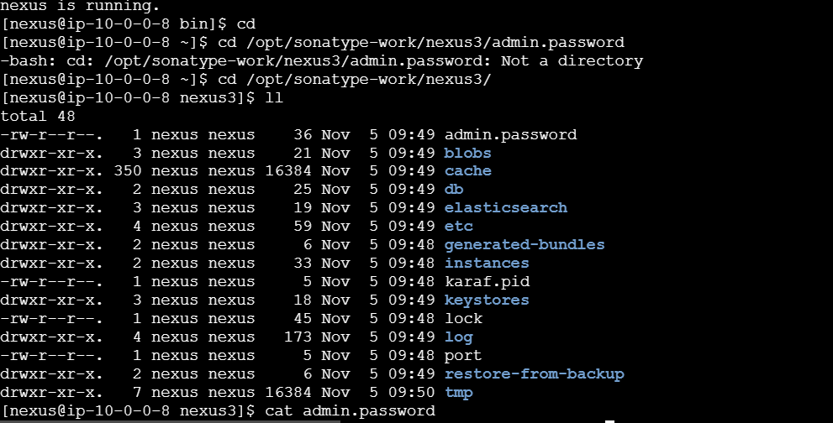
Once you finish then start Jenkins pulgins
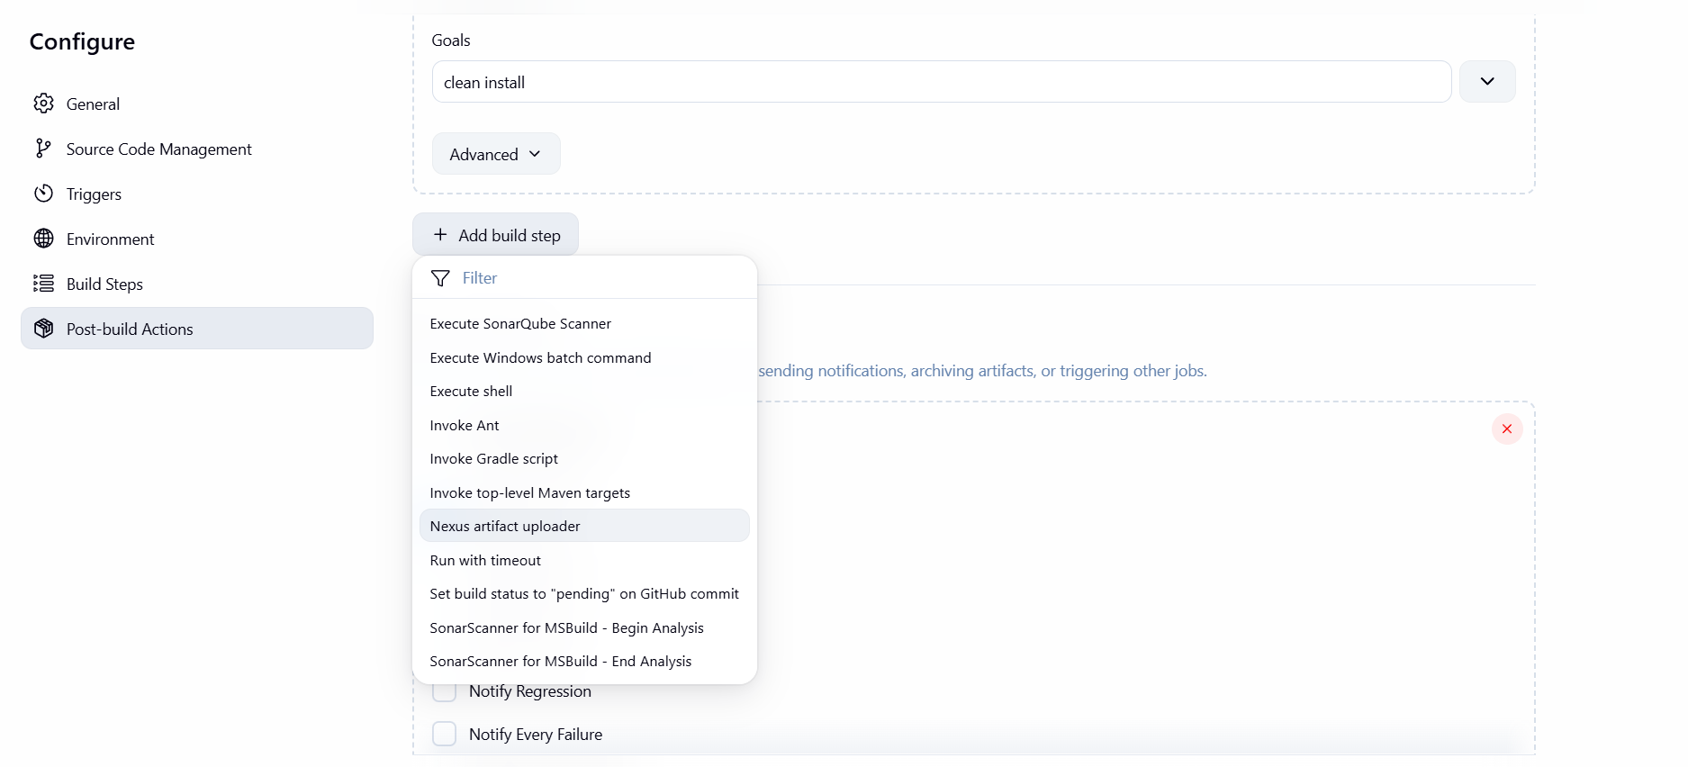
http
nexus url
Version 0.1
We have to have sufficient details 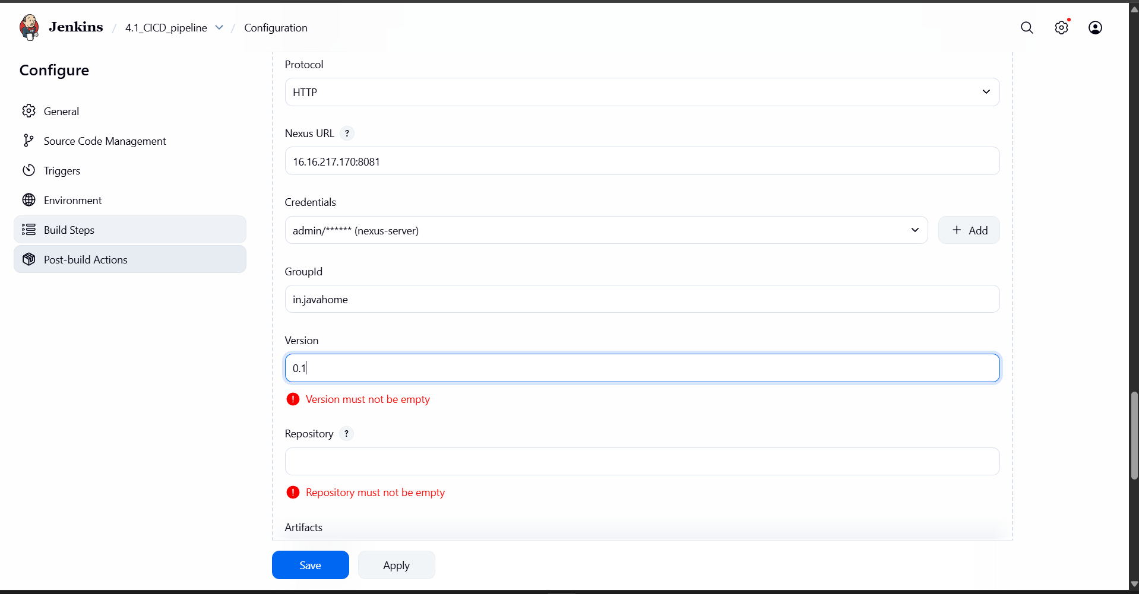
Go to the nexus and create a repository and give details for what there asked

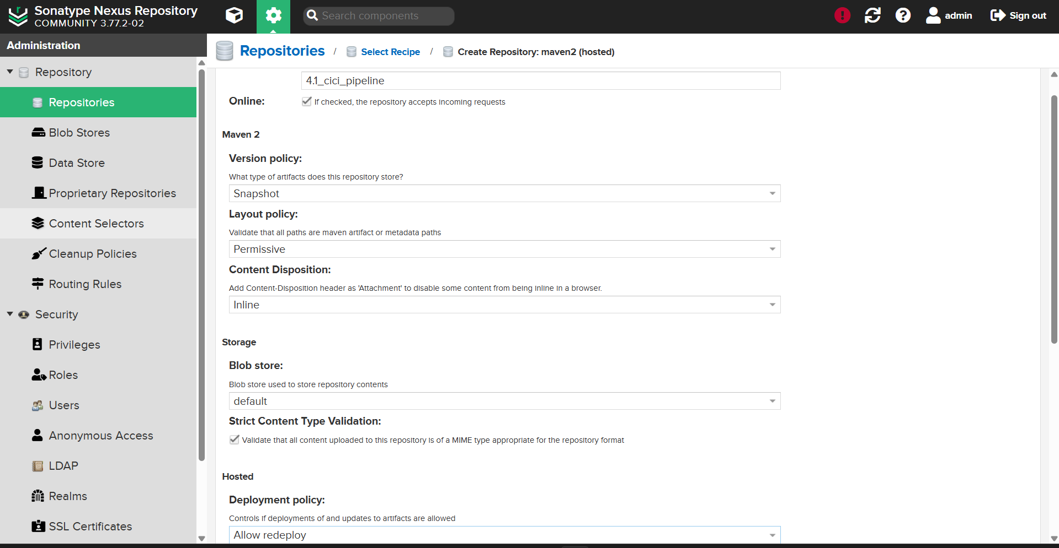
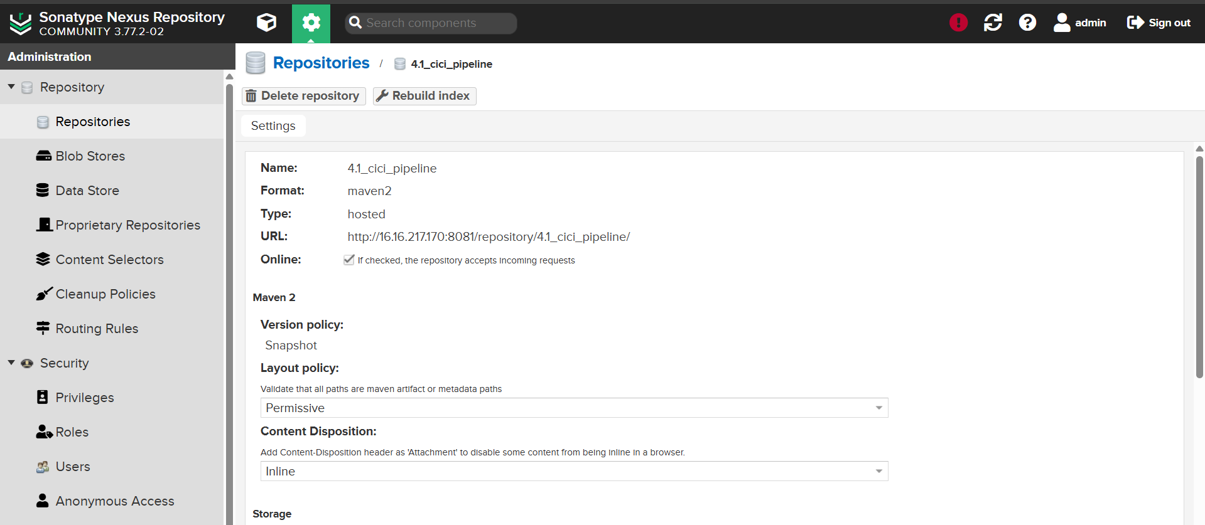
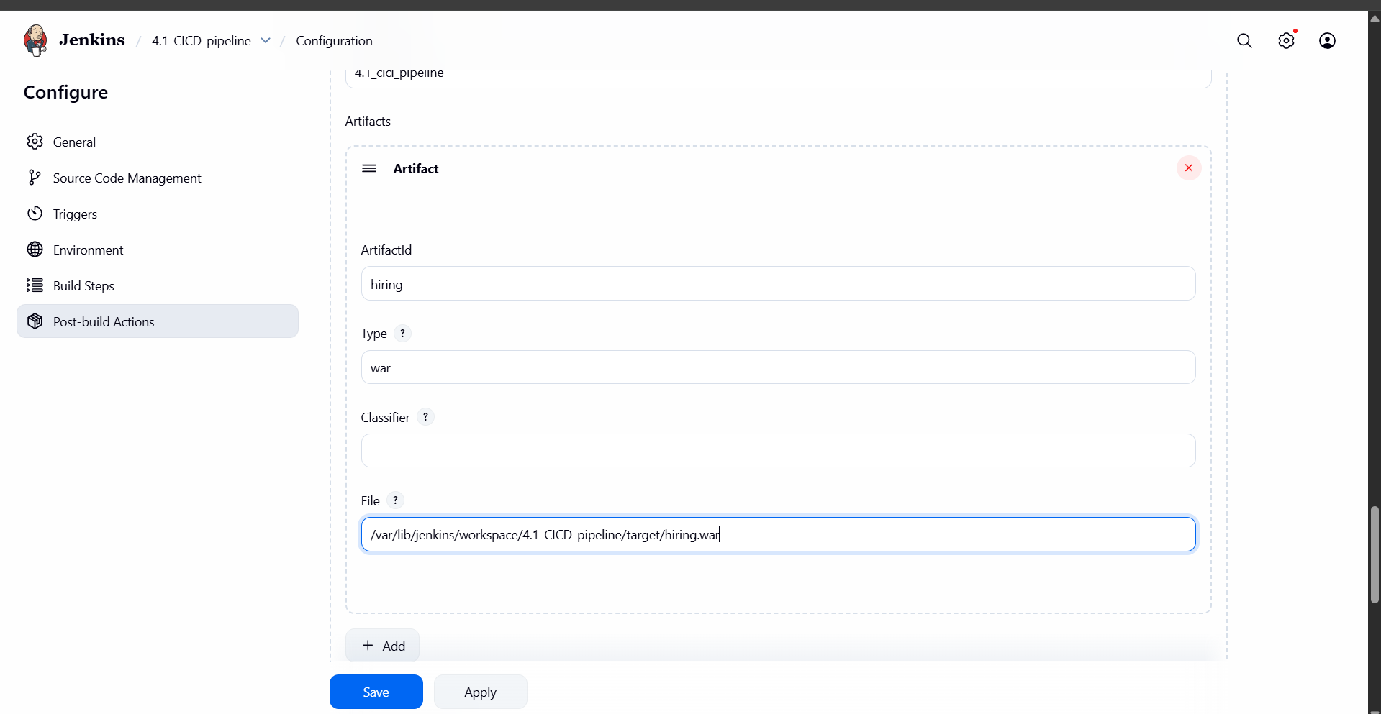

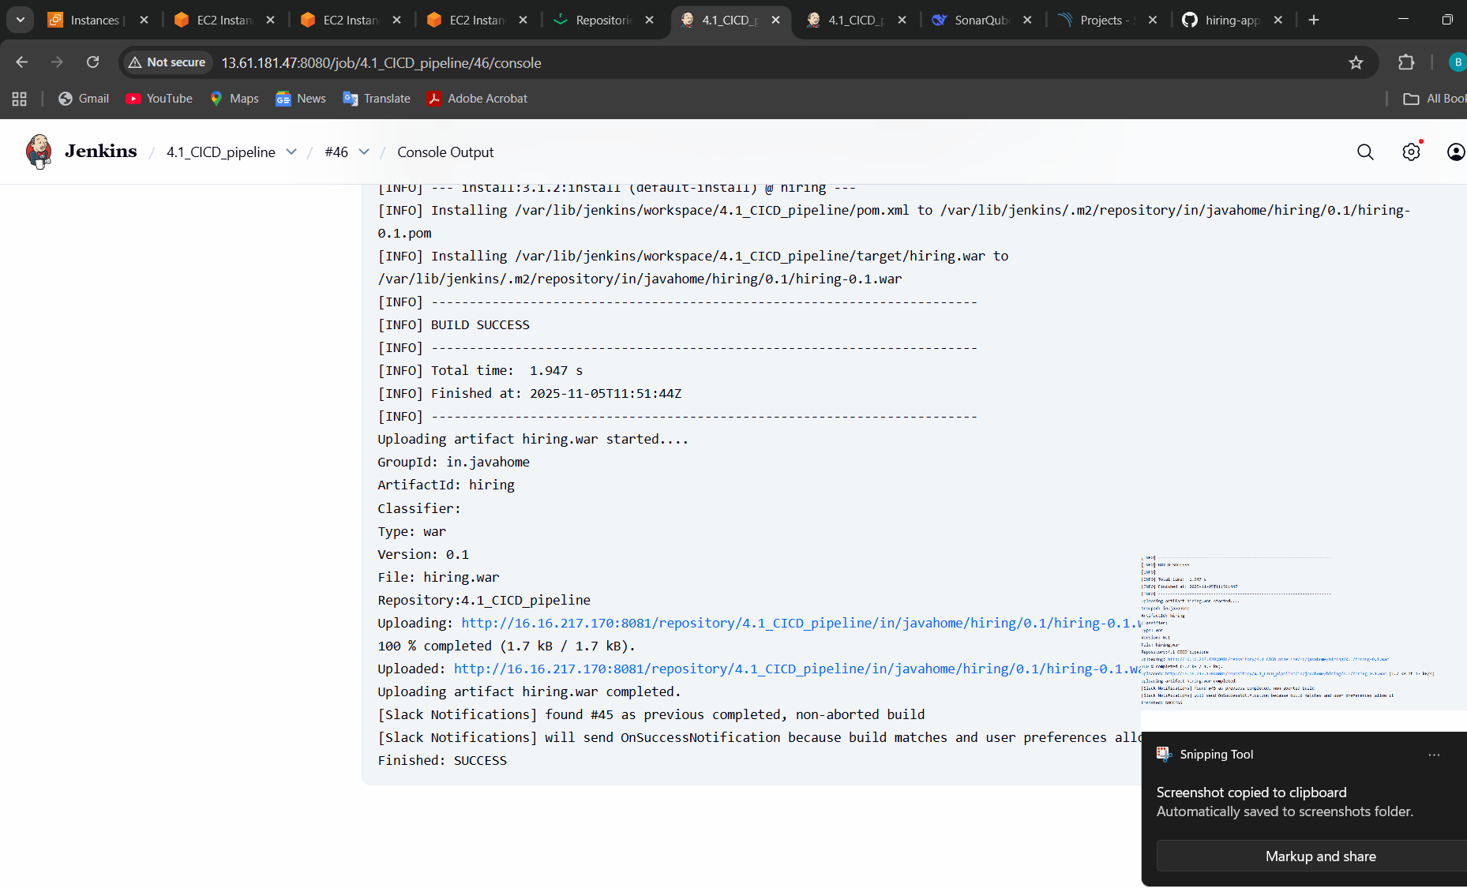
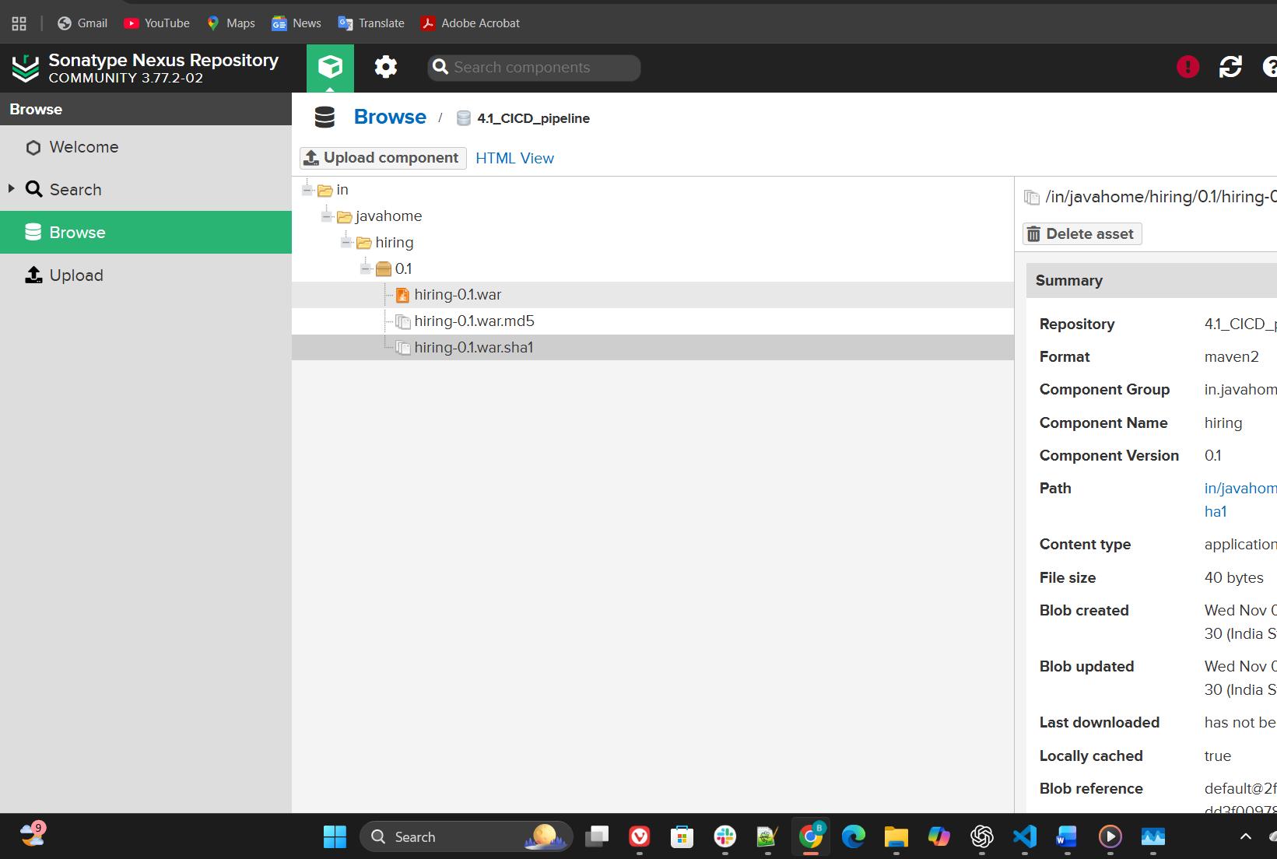

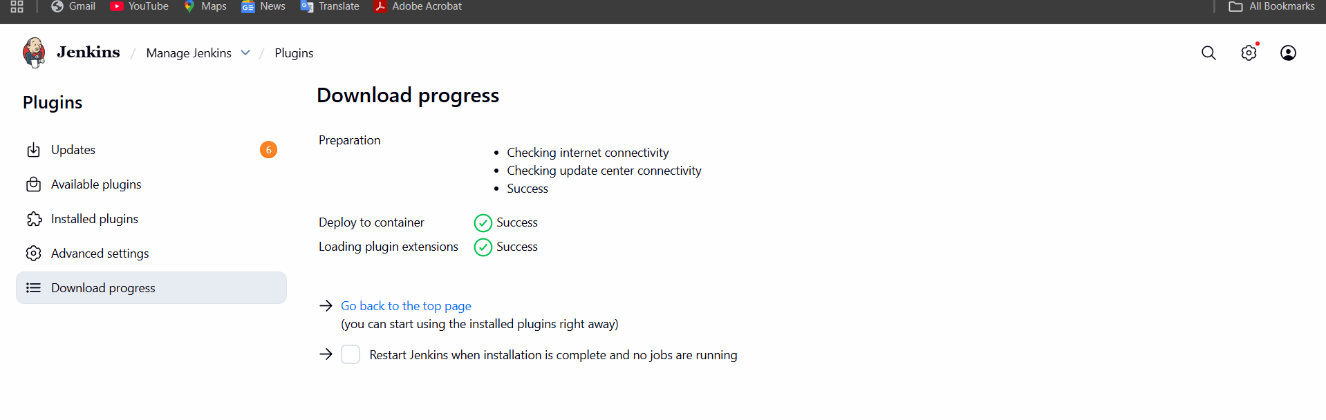
Open a new instance for tomcat deploying
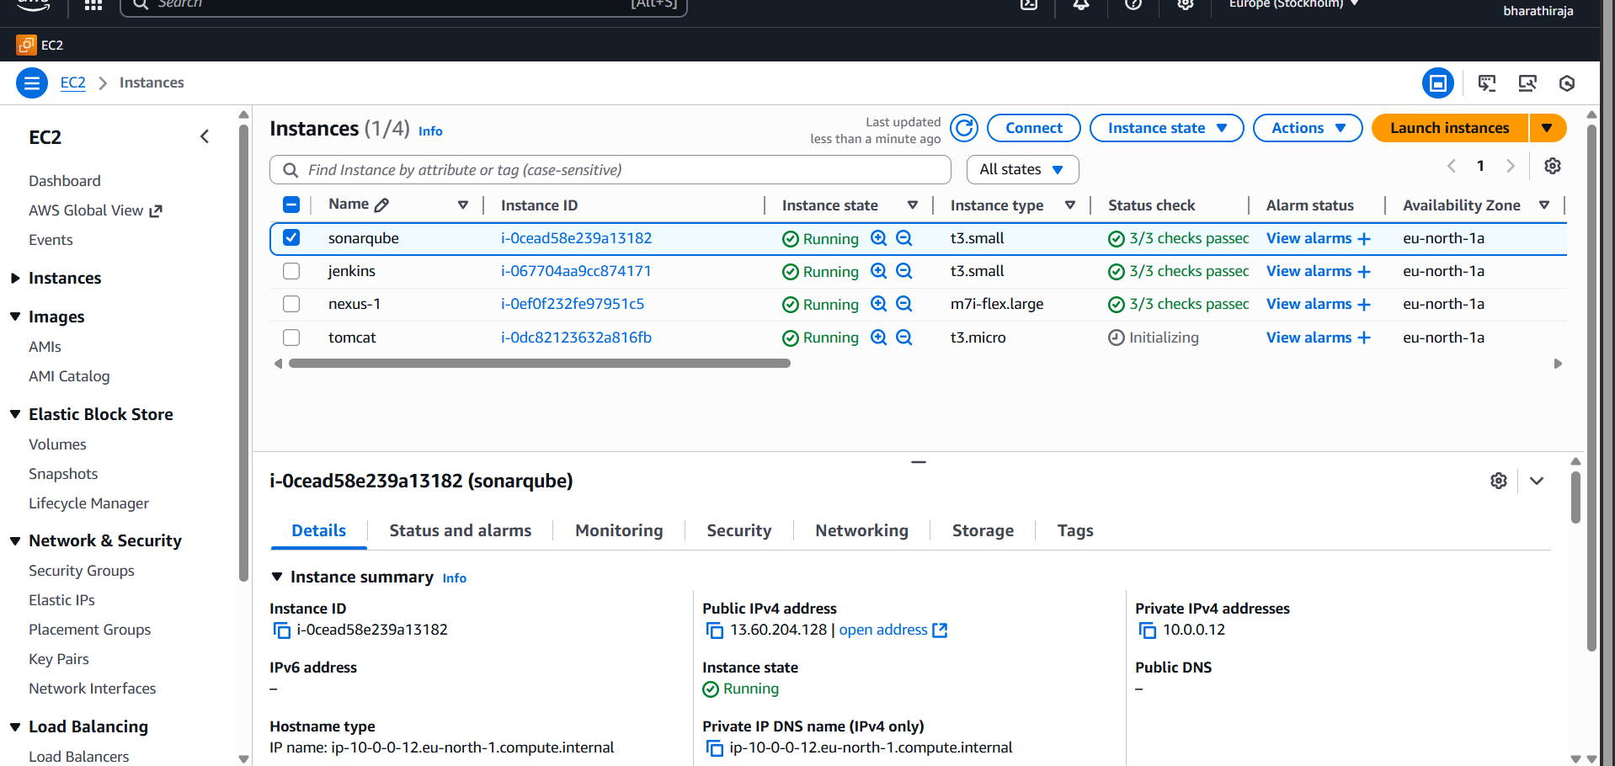
Install java first

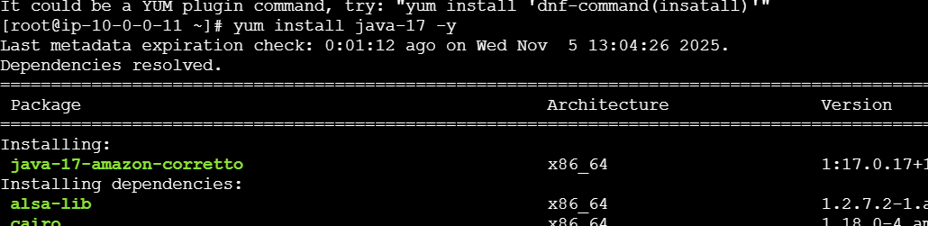
Cd /opt/wget (link)
An extract the file tar xvf file name
then go to bin and bash startup .bin
ip+8080 you get tomcat
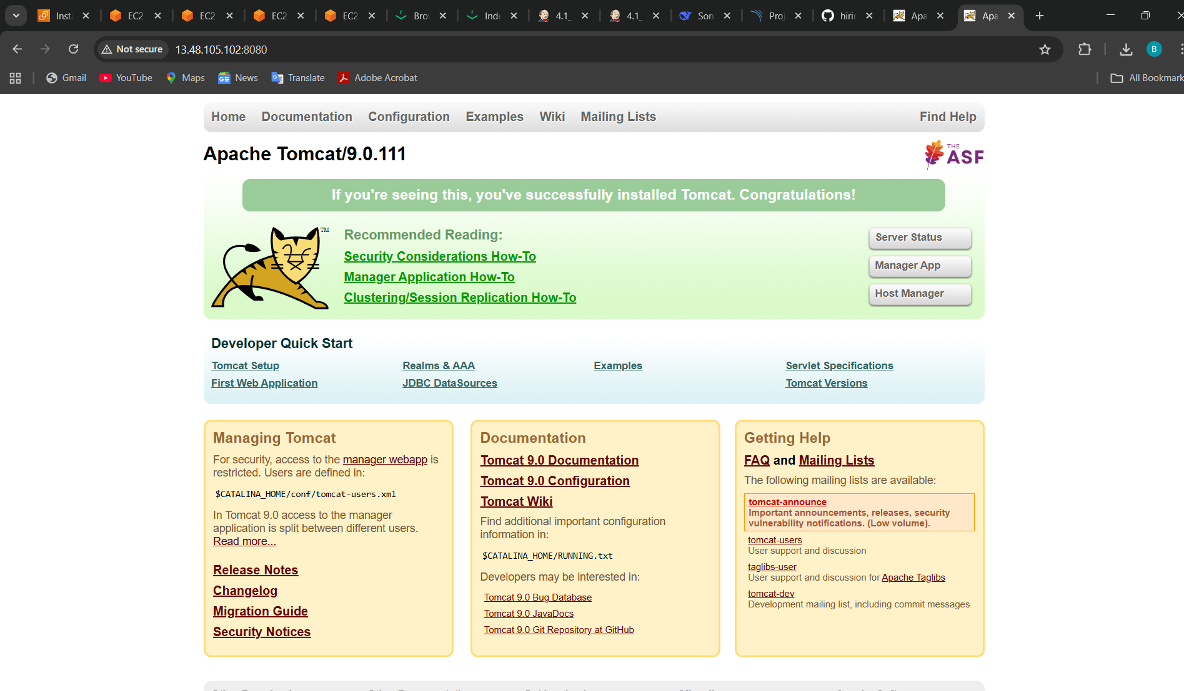
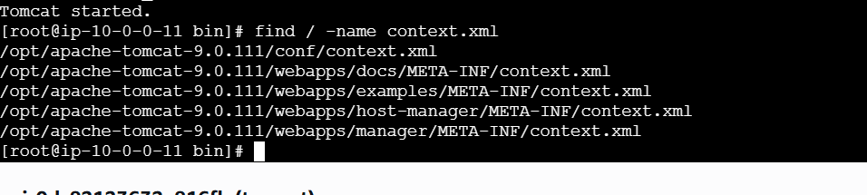
In the four file we should change

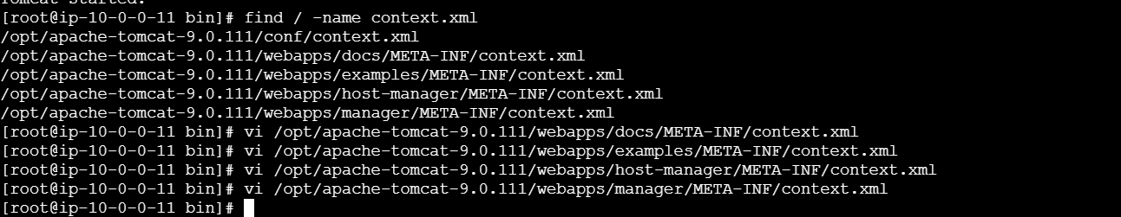
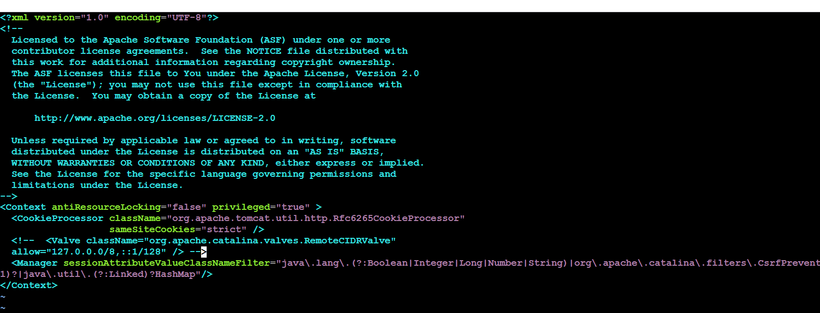jok follow the steps
I had marked area that so
Once finish after go to the file
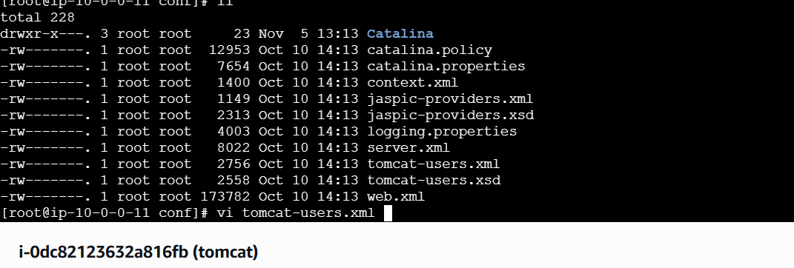
Paste it this
<role rolename="manager-gui"/>
<role rolename="manager-script"/>
<role rolename="manager-jmx"/>
<role rolename="manager-status"/>
<user username="admin" password="admin" roles="manager-gui, manager-script, manager-jmx, manager-status"/>
<user username="deployer" password="deployer" roles="manager-script"/>
<user username="tomcat" password="s3cret" roles="manager-gui"/>

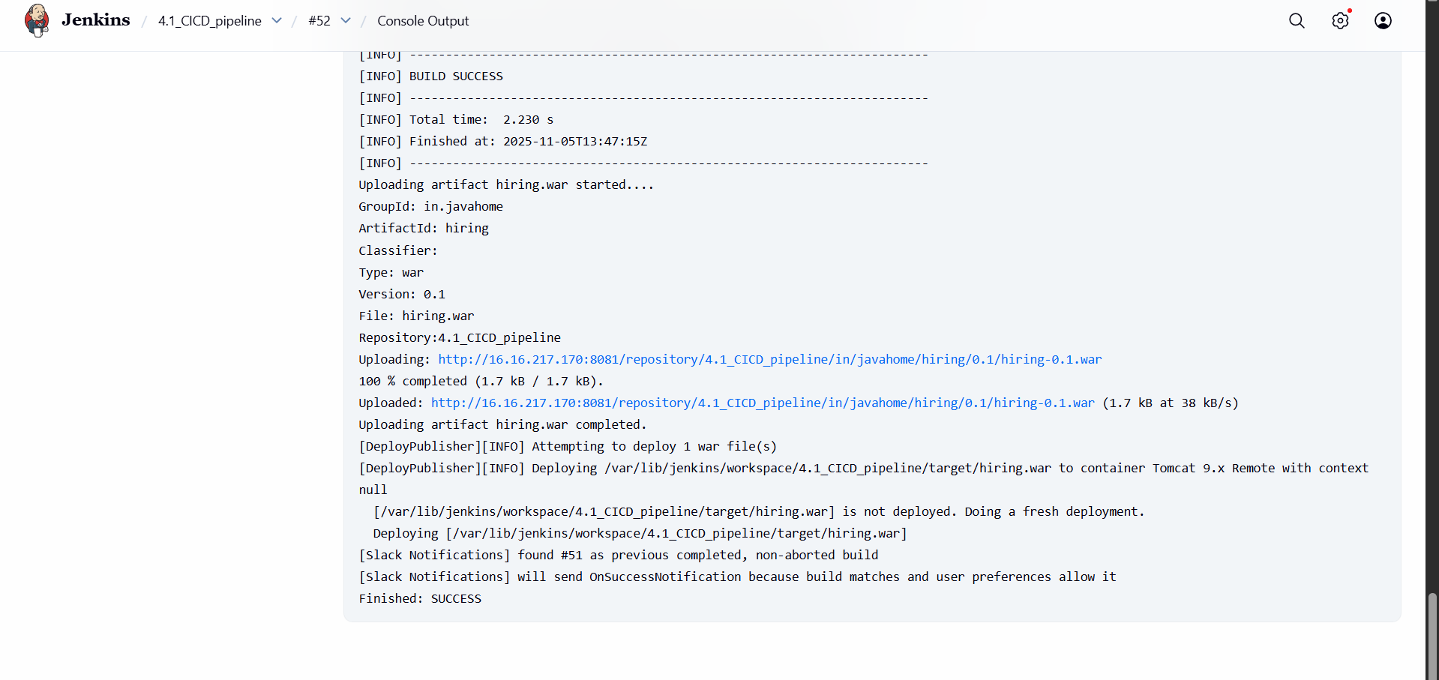
Then I got success
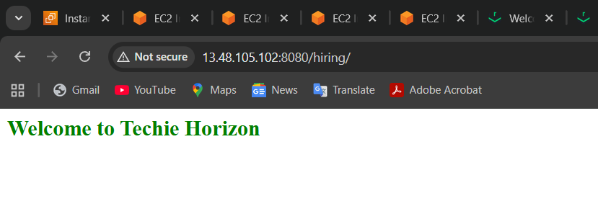
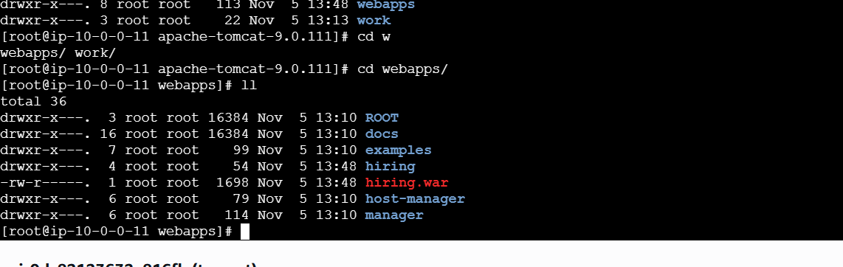

2) Setup a Jenkins CICD pipeline using Declarative pipeline using feature-1.1 branch. https://github.com/betawins/sabear_simplecutomerapp/tree/feature-1.1
- stages:
  - Git Clone
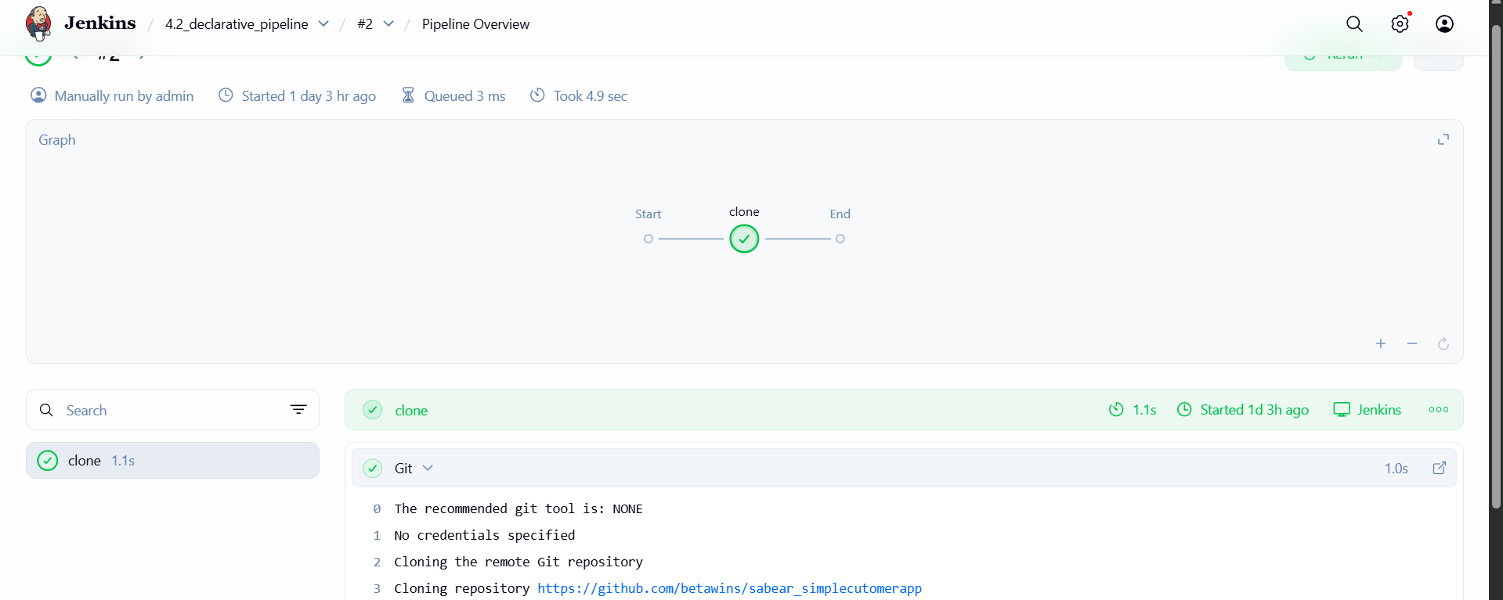
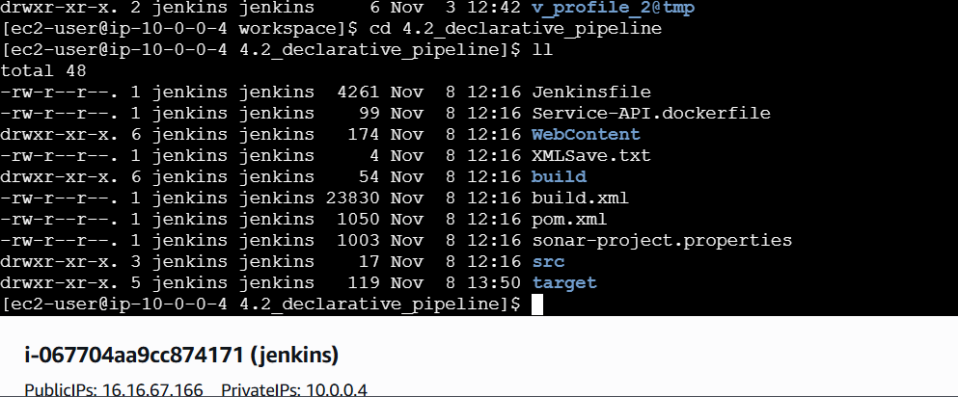
  - SonarQube Integration
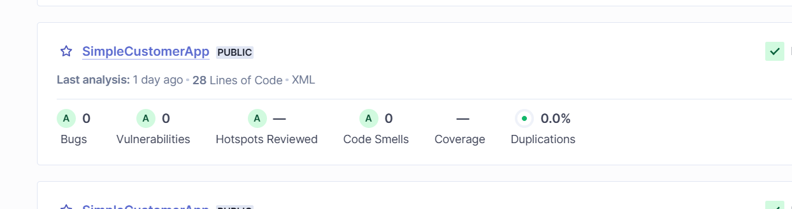
  - Maven Compilation
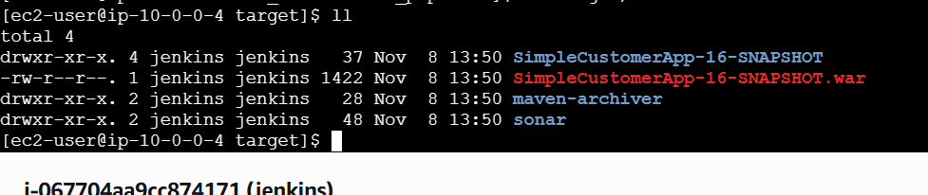
  - Nexus Artifactory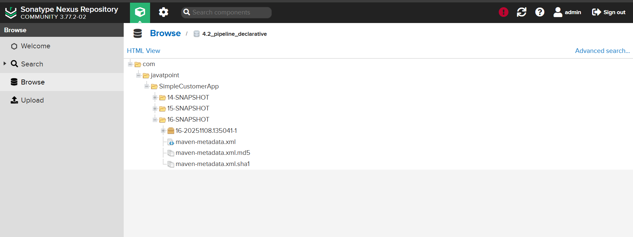

  - Slack Notification
  - Deploy On tomcat
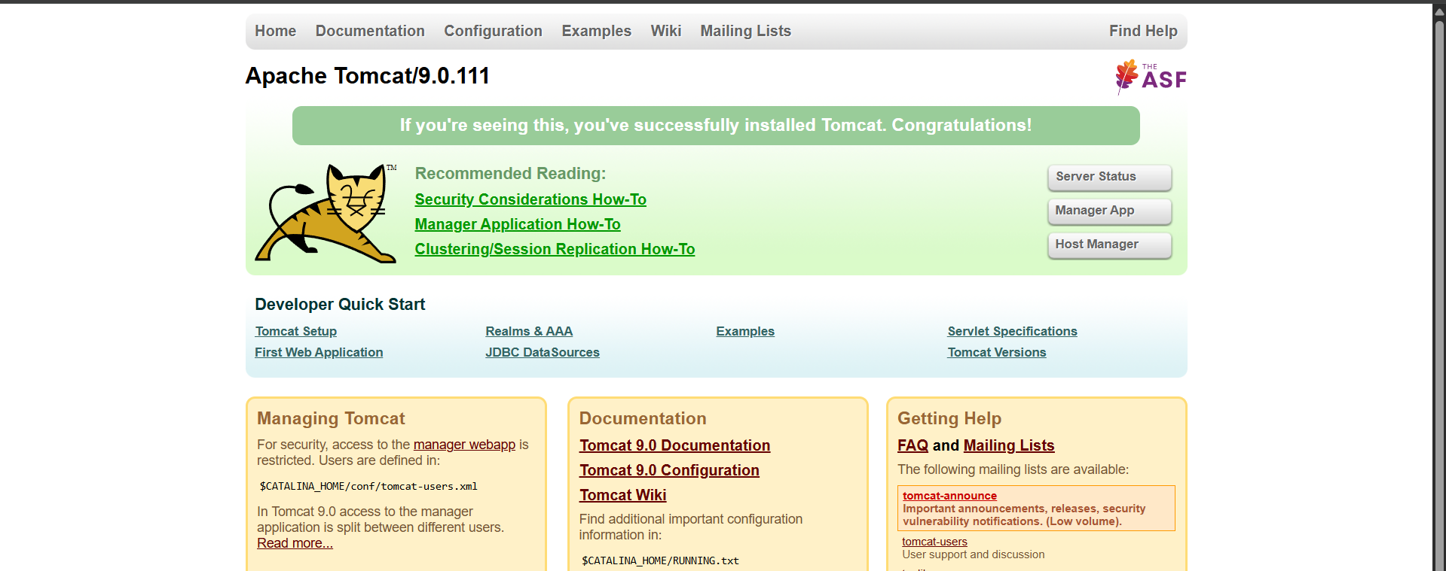

    - Setup a Jenkins CICD pipeline using Scripted pipeline using feature-1.1 branch. https://github.com/betawins/sabear_simplecutomerapp/tree/feature-1.1
stages:
      - Git Clone
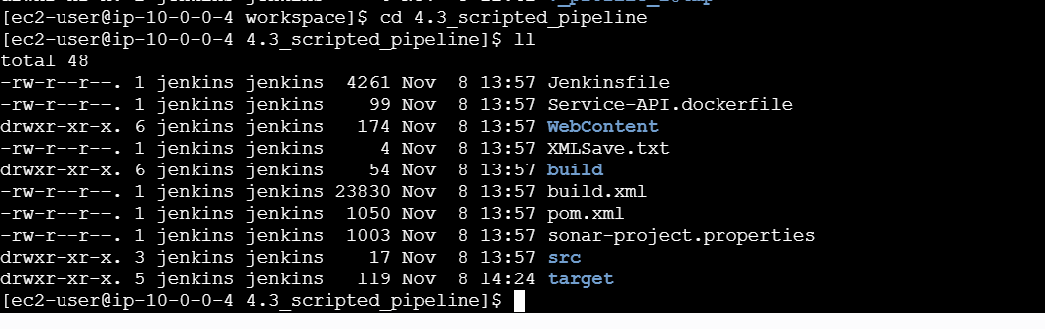
  - SonarQube Integration
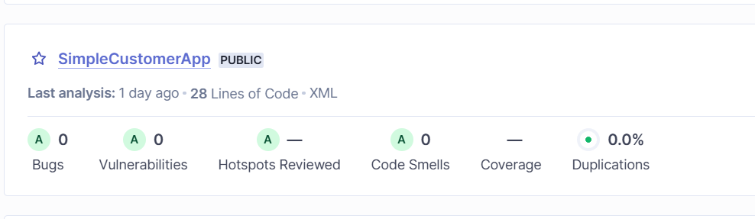
  - Maven Compilation
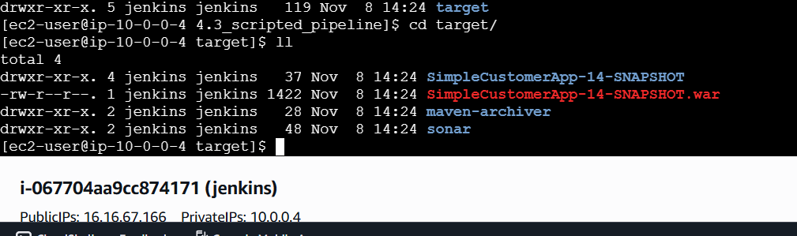
  - Nexus Artifactory
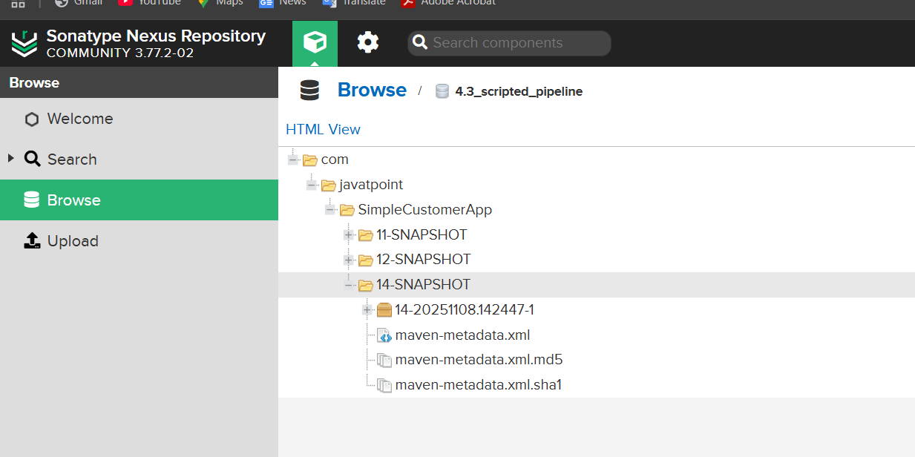
  - Slack Notification
  - Deploy On tomcat
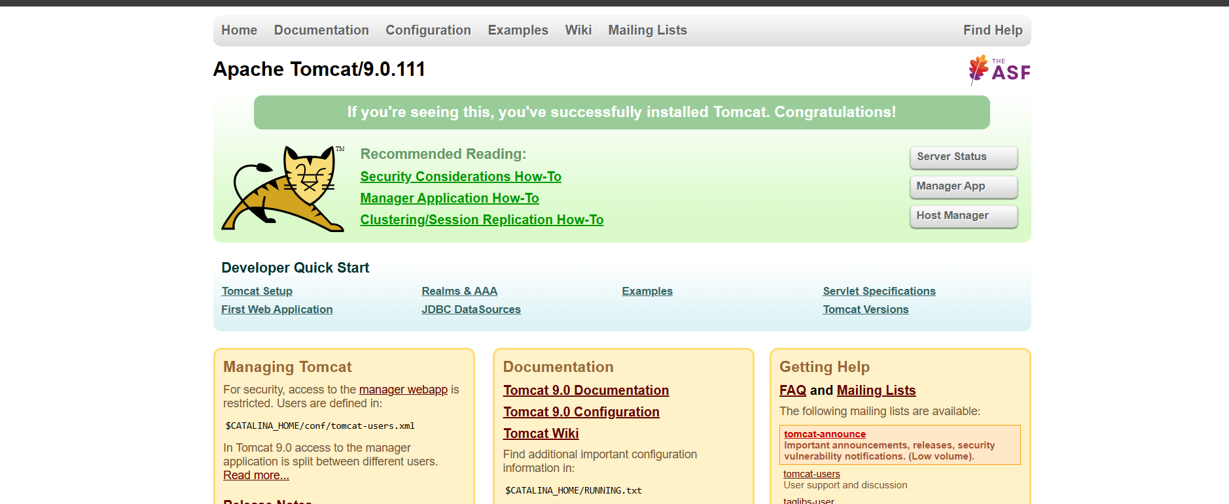
- Write sample skeleton of pipelines.
pipeline {
agent any // Runs on any available Jenkins agent

tools {
maven 'MVN_HOME' // (Optional) Load Maven tool from Jenkins
}

stages {

// 1️⃣ Clone the source code
stage('Clone Repository') {
steps {
echo "Cloning the project..."
git branch: 'main', url: 'https://github.com/example/repo.git'
}
}

// 2️⃣ Build the project
stage('Build') {
steps {
echo "Building the project..."
sh 'mvn clean install'
}
}

// 3️⃣ Run tests
stage('Test') {
steps {
echo "Running tests..."
sh 'mvn test'
}
}

// 4️⃣ Deploy (optional)
stage('Deploy') {
steps {
echo "Deploying application..."
// example: deploy to Tomcat or any server
}
}
}

post {
success {
echo "Pipeline completed successfully! ✅"
}
failure {
echo "Pipeline failed ❌"
}
}
}
- Create a parameterized job in Jenkins. https://github.com/betawins/spring3-mvc-maven-xml-hello-world-1.git
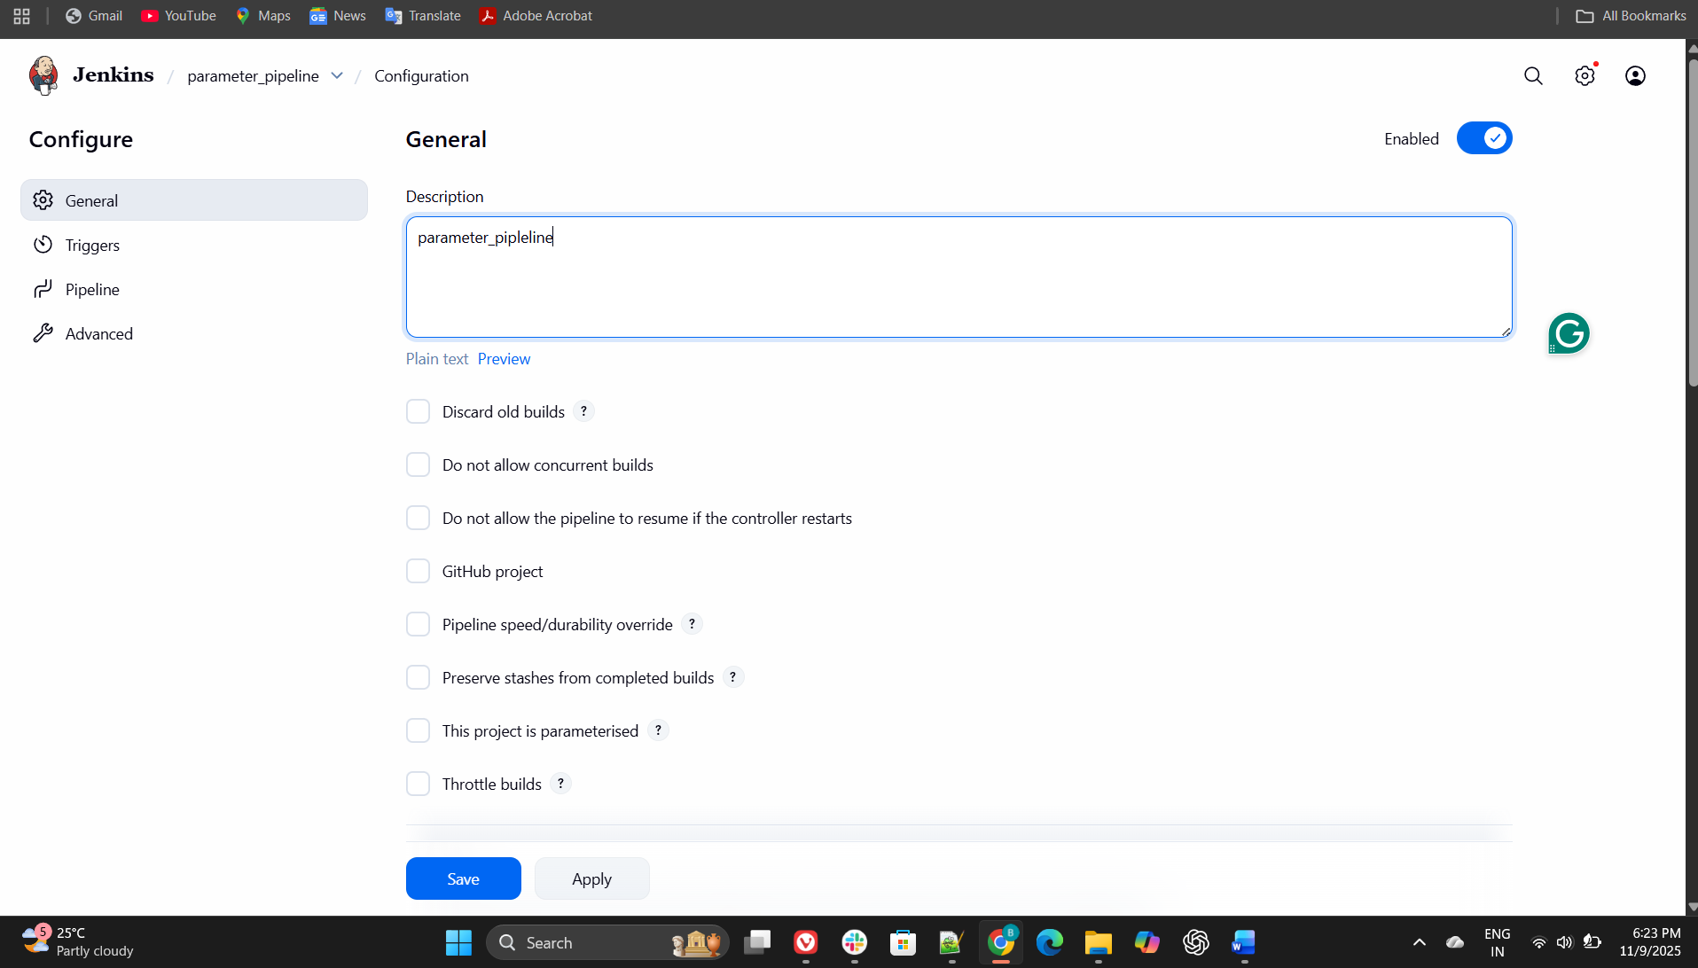
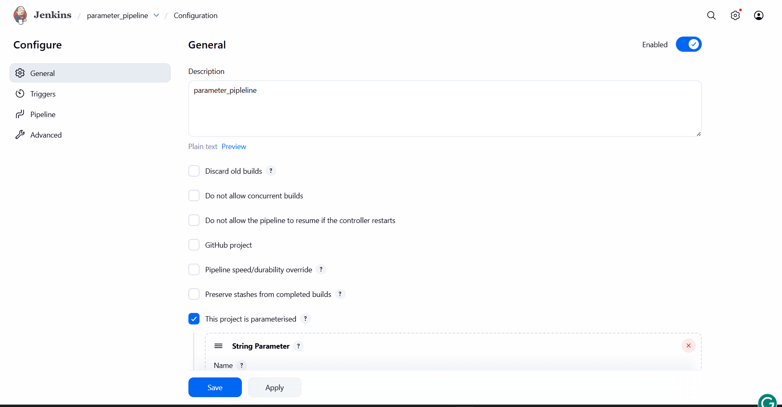
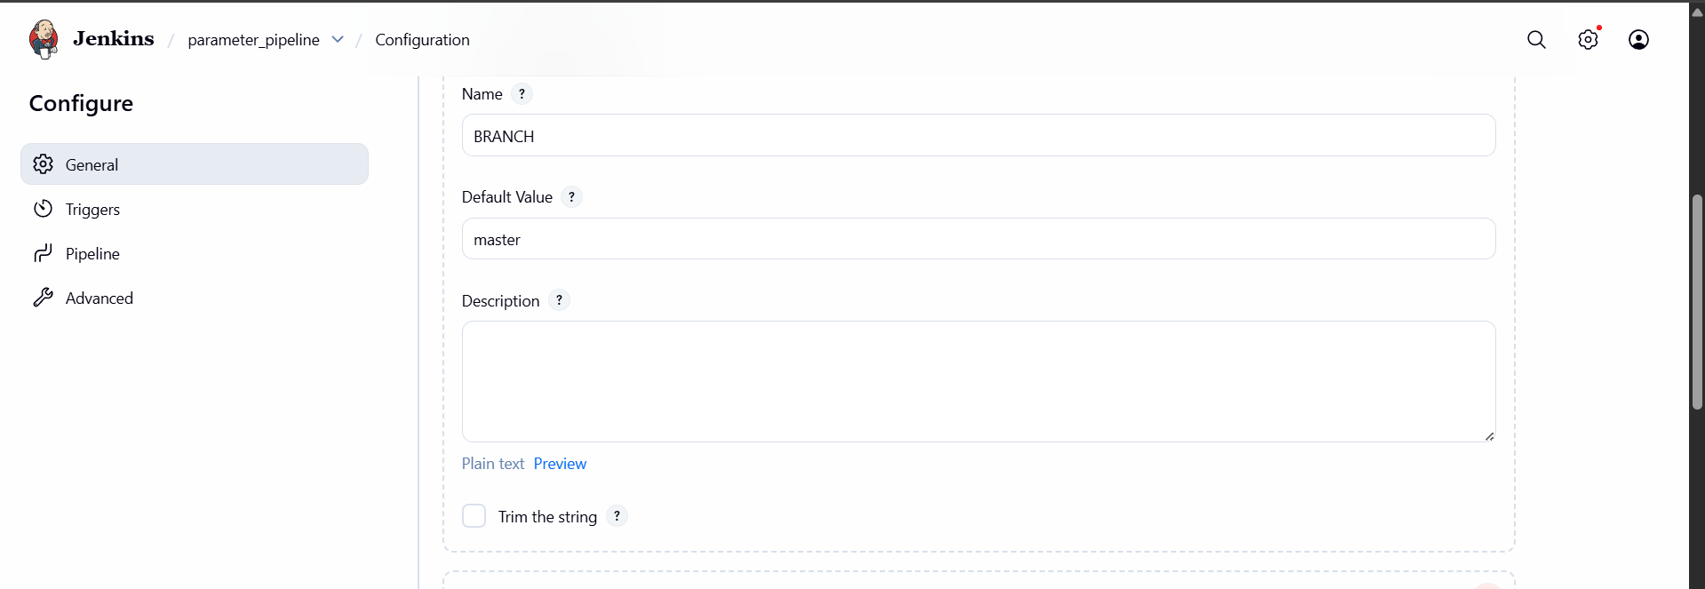
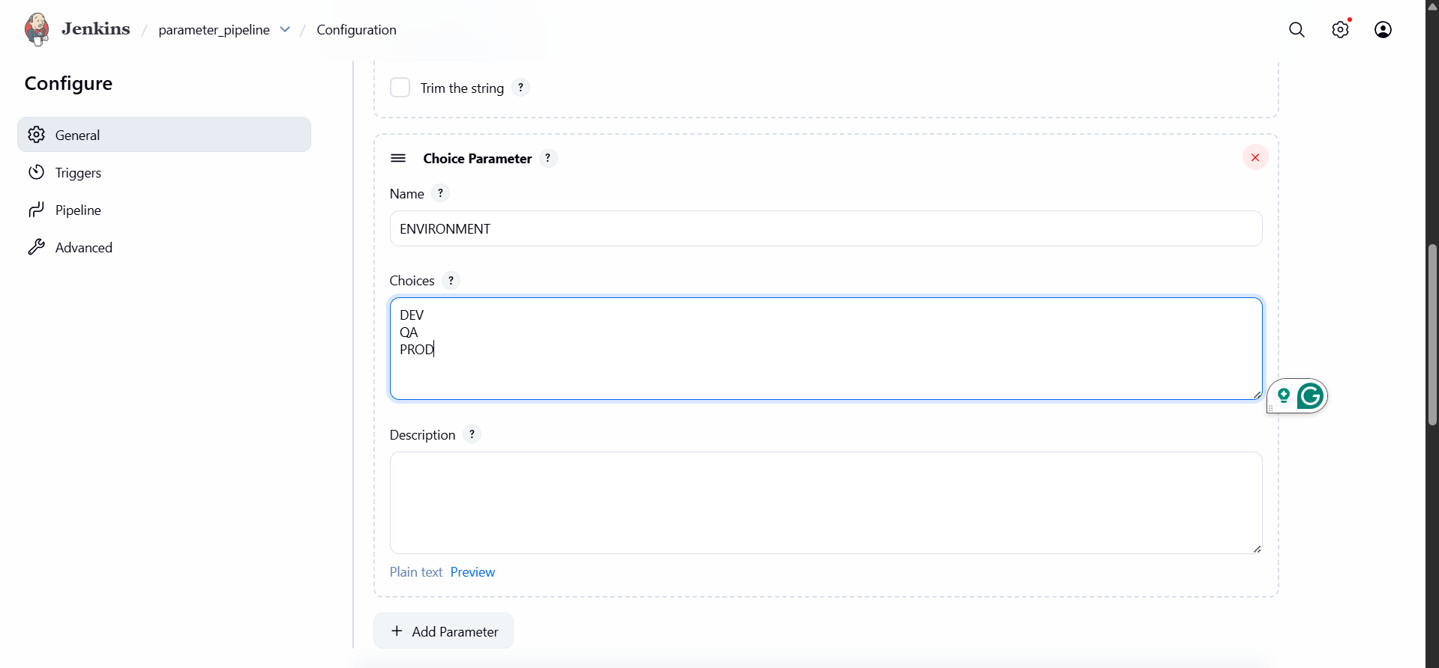
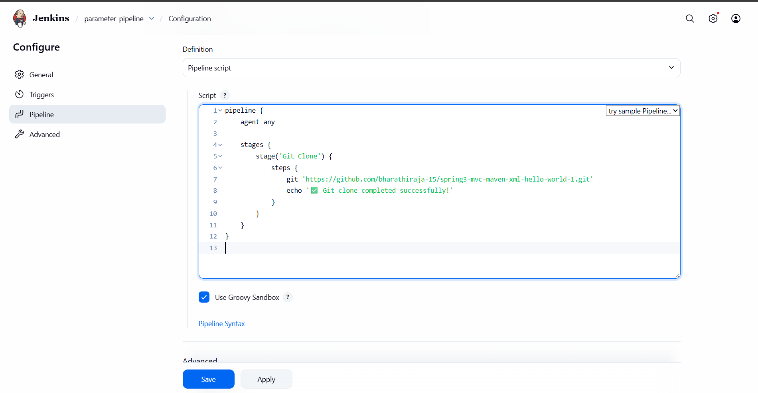
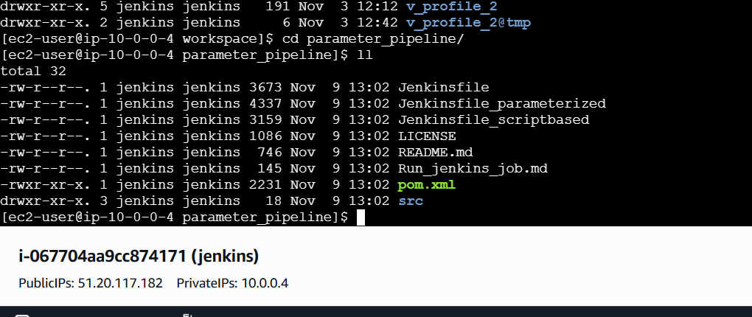
5) Set up one slave machine for Jenkins.

