- Watch the Terraform-03 video.
Completed watching the video
- Execute the script shown in the video.
Ls the before we need to save the file
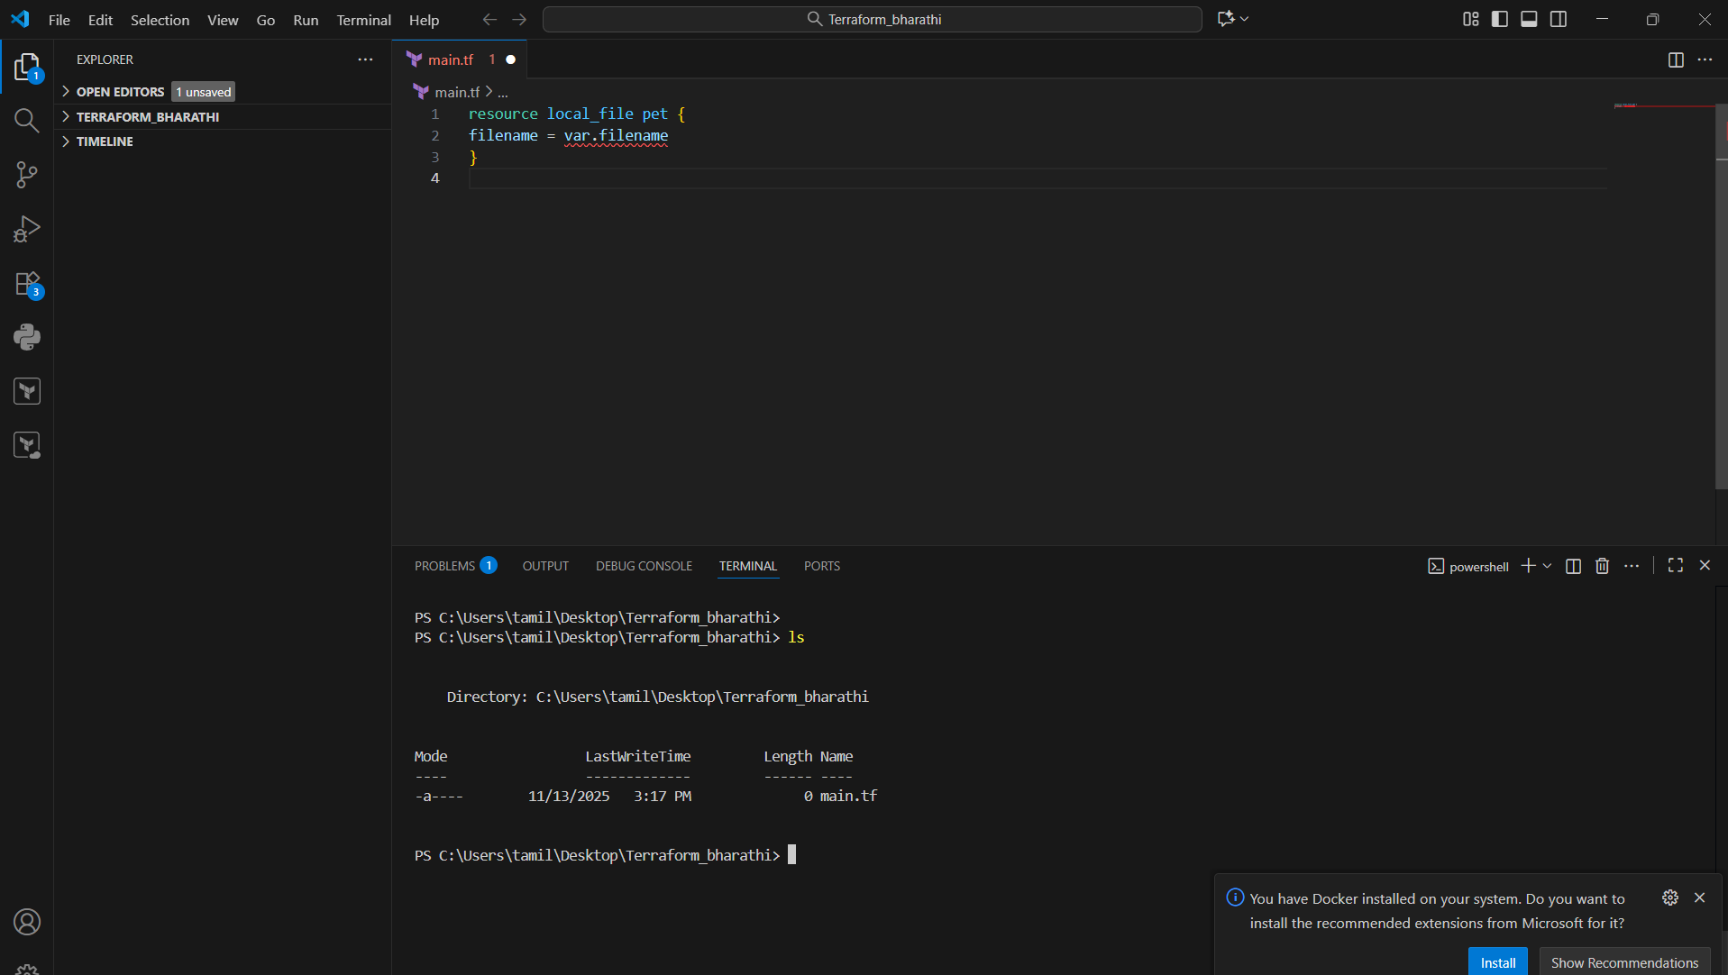
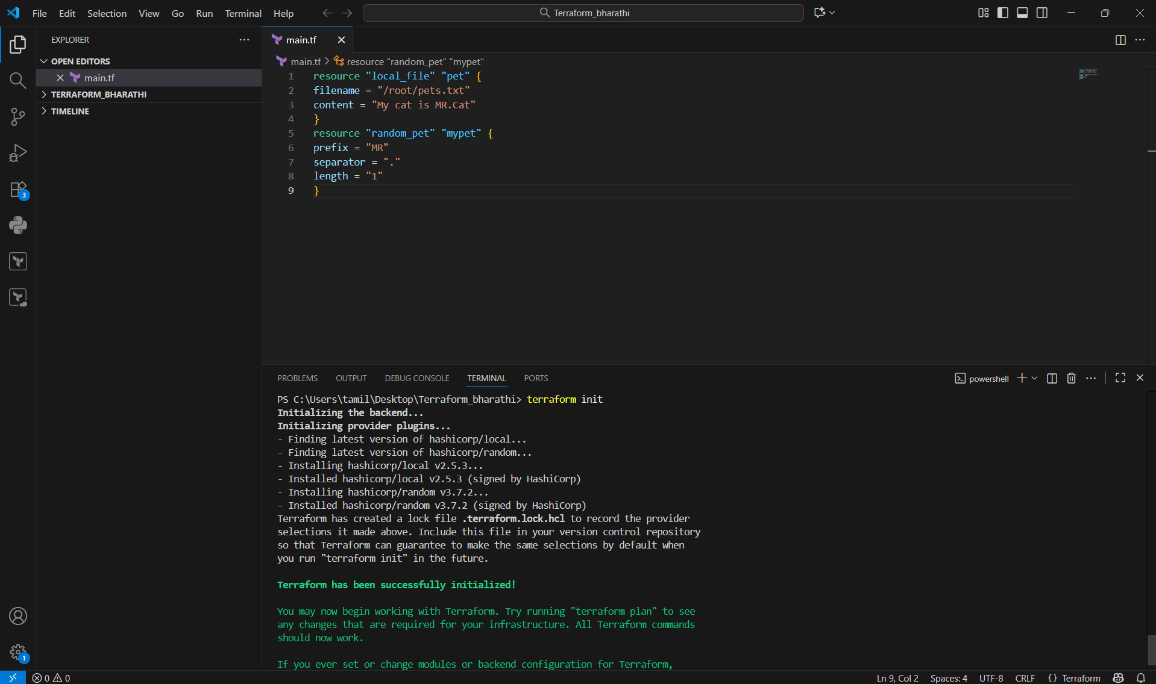
Terraform apply it will change or updated and created
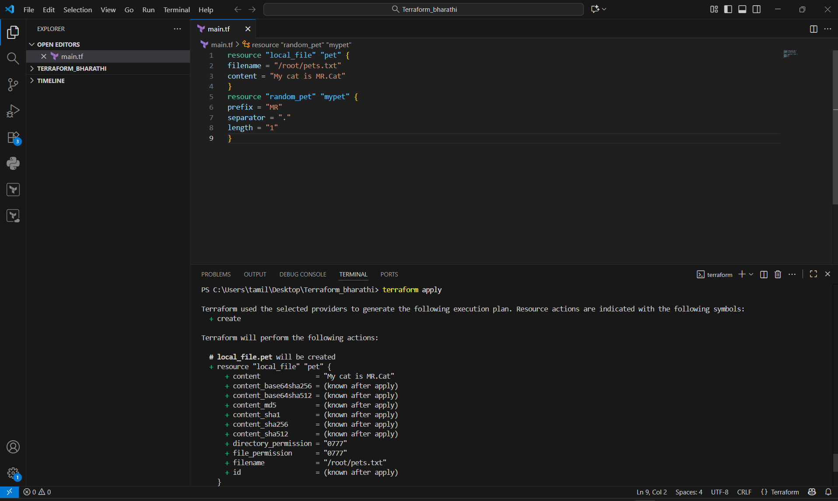
Now we can see below their ad I gave yes
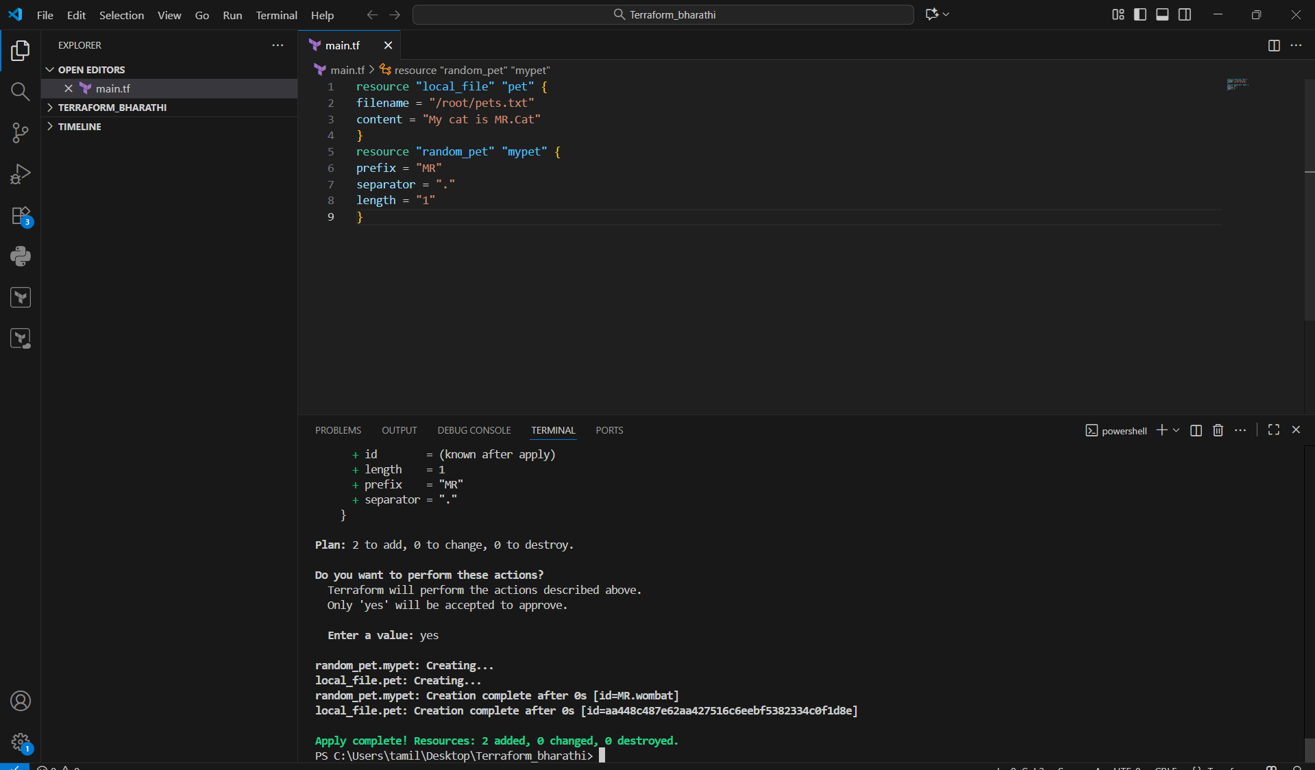
I got all the files created
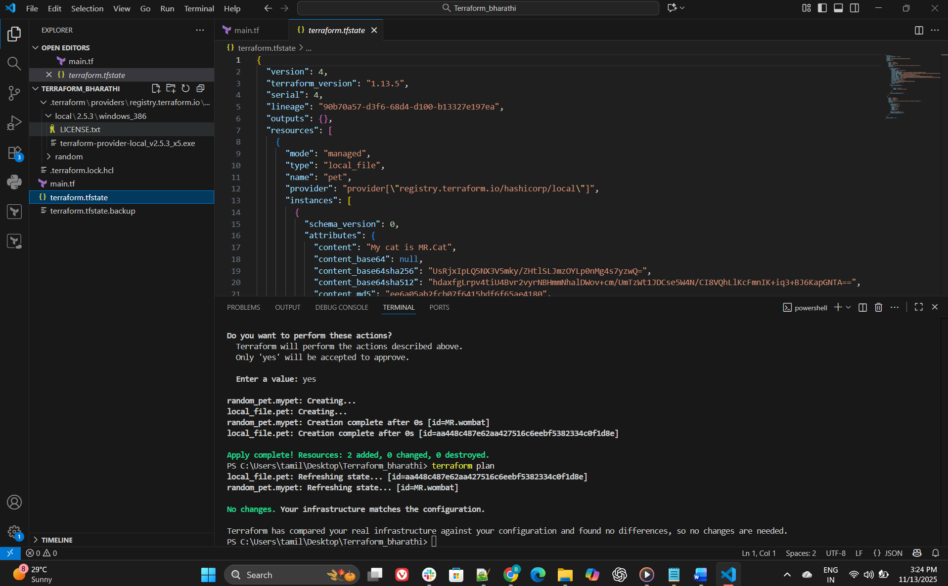
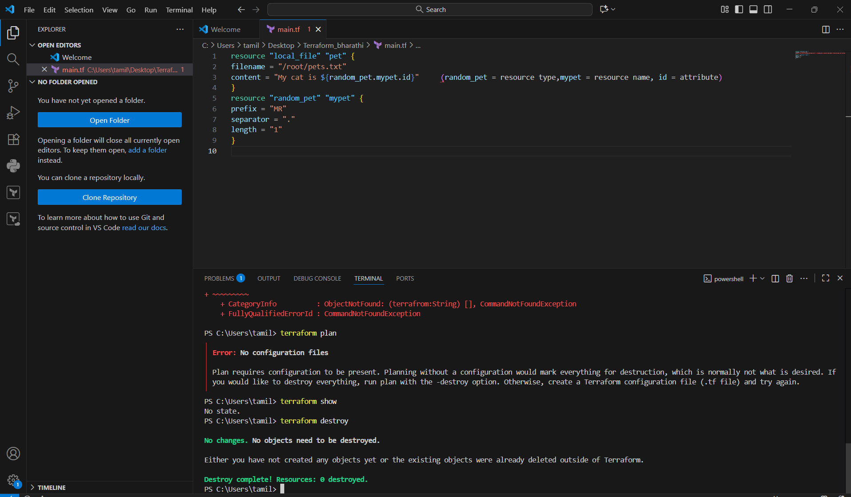
- Integrate Terraform in Jenkins using the Terraform plugin.
I plugin in the Terraform I build the Jenkins
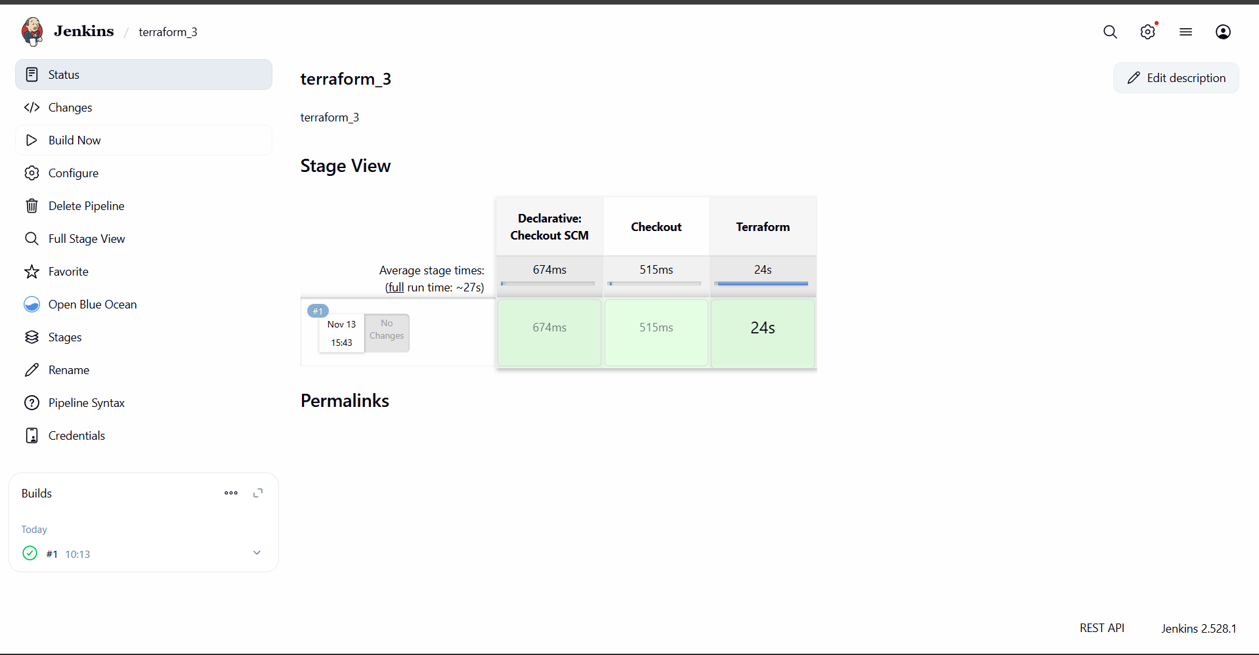
I got the EC2
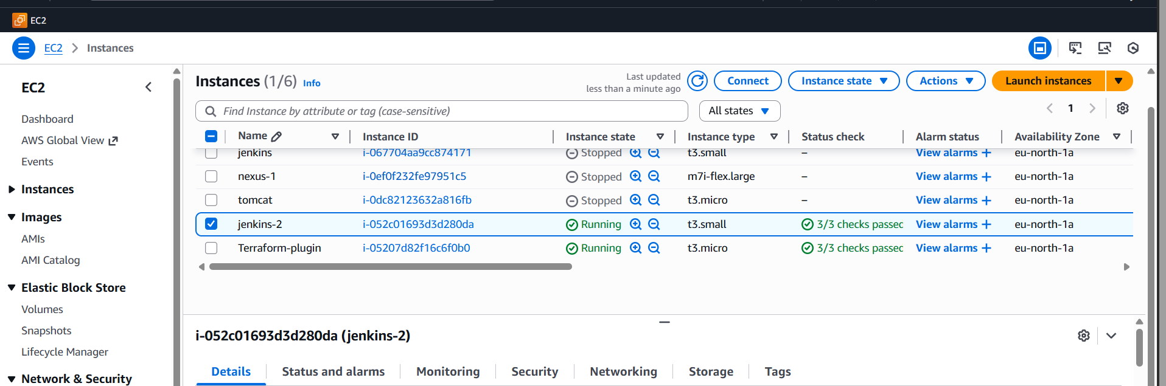

- Create one Jenkins job using a Maven Project for the code below with two stages:
  - Stage 1: Git clone
  - Stage 2: Maven Compilation Code: https://github.com/betawins/java-Working-app.git
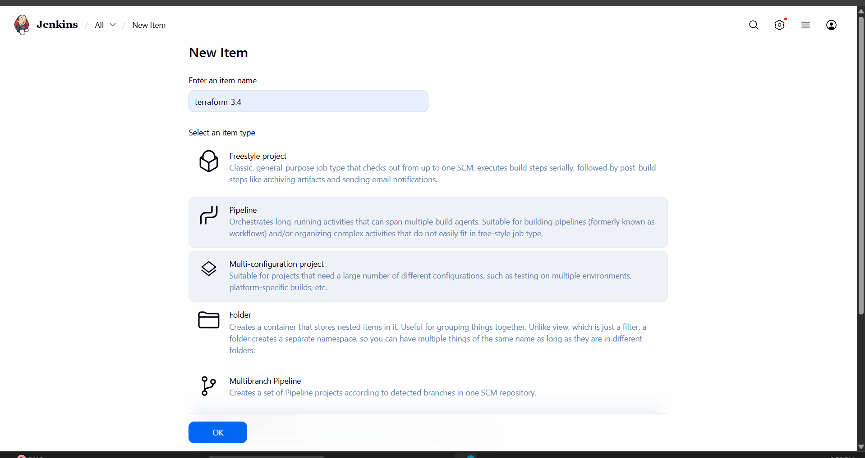
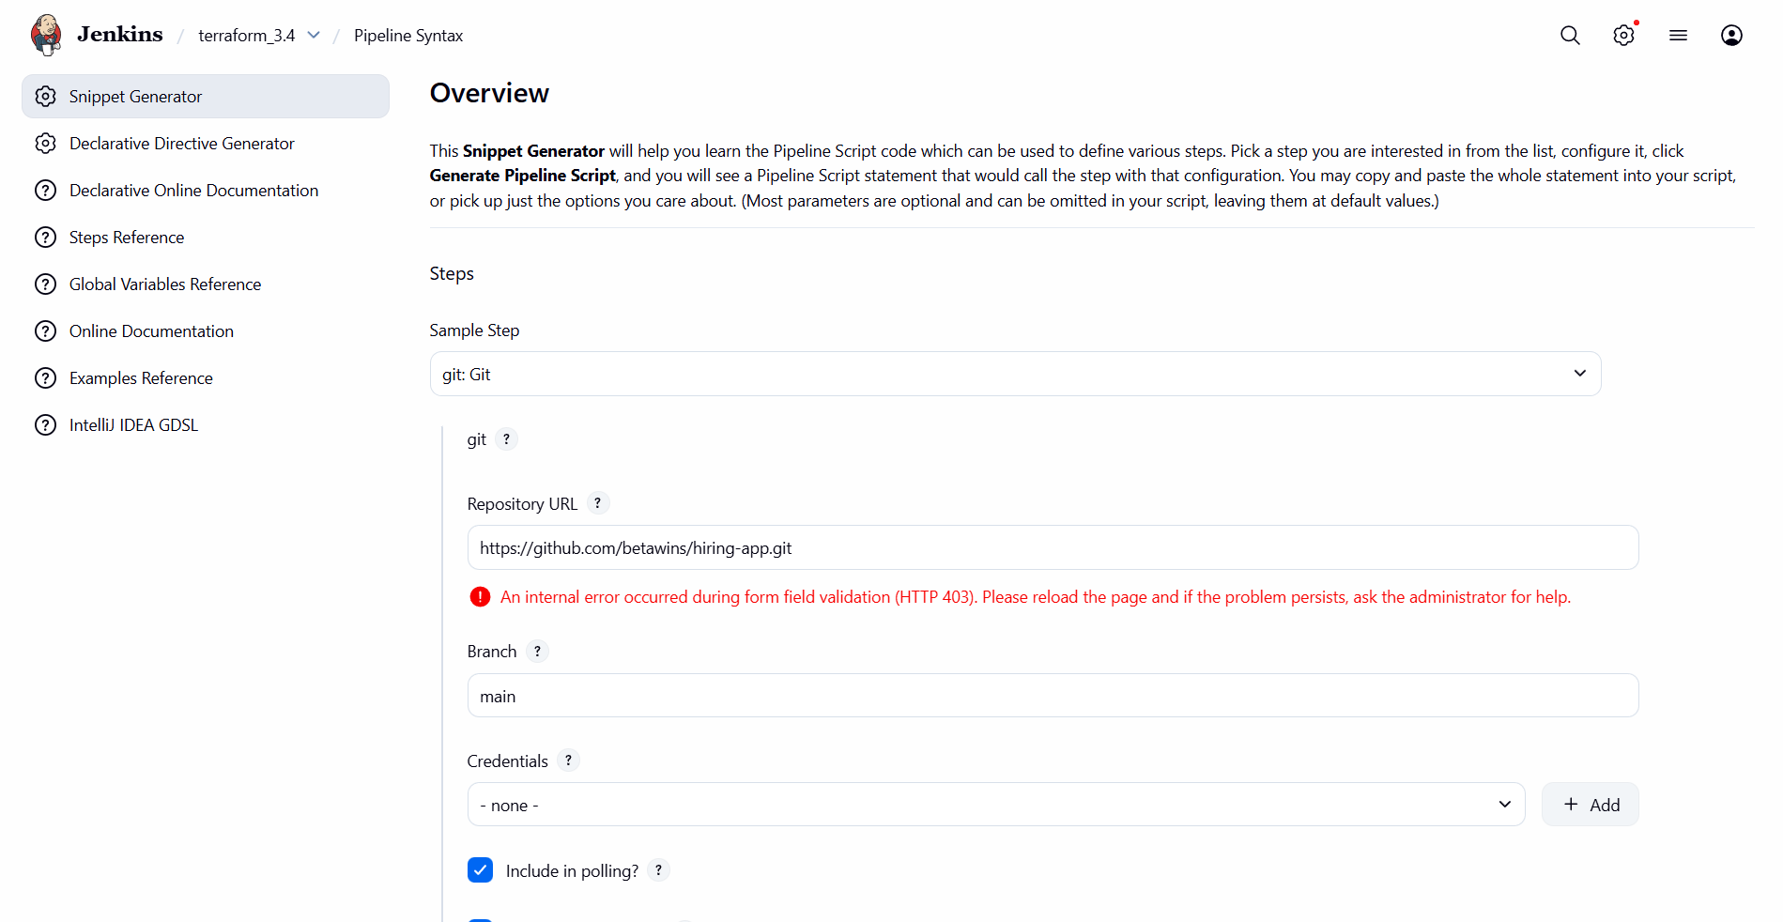
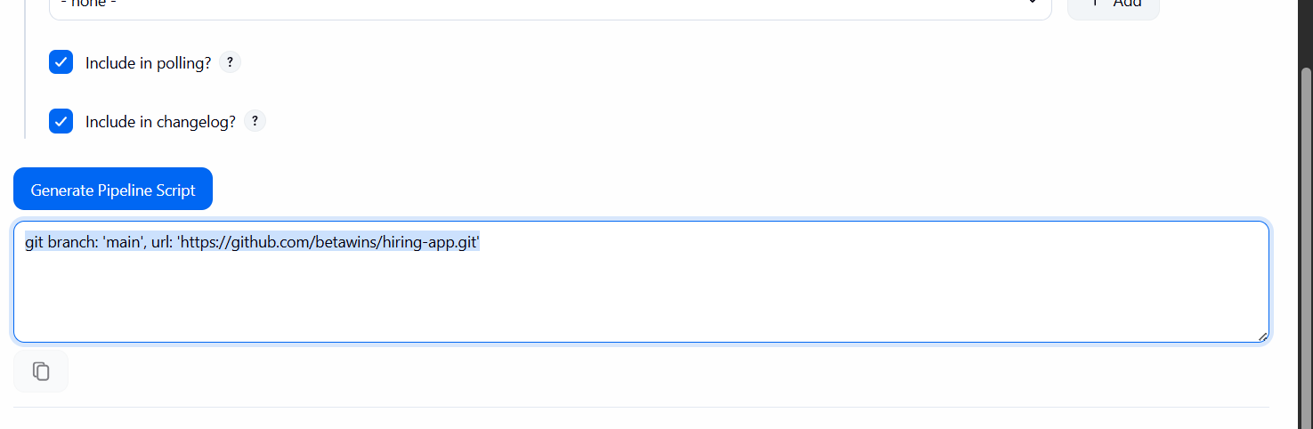
This is the code that has been written
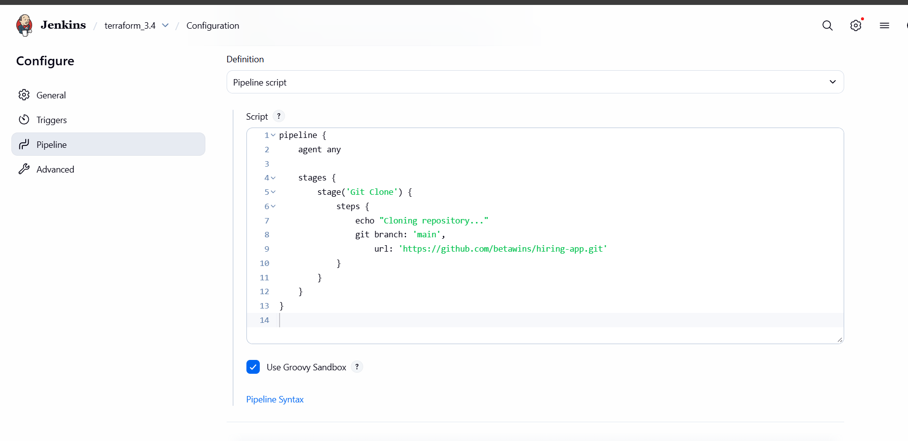
Git clone done step 1
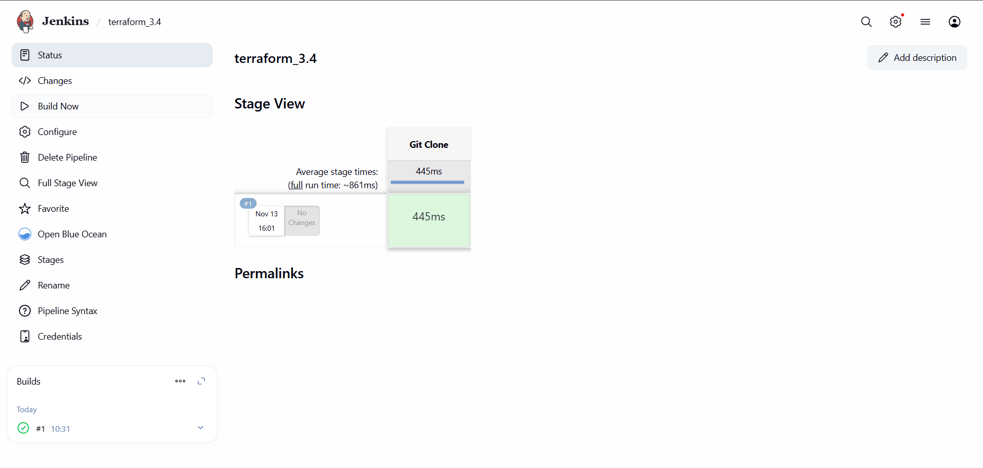
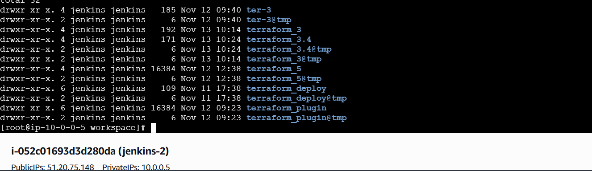
Now maven added code
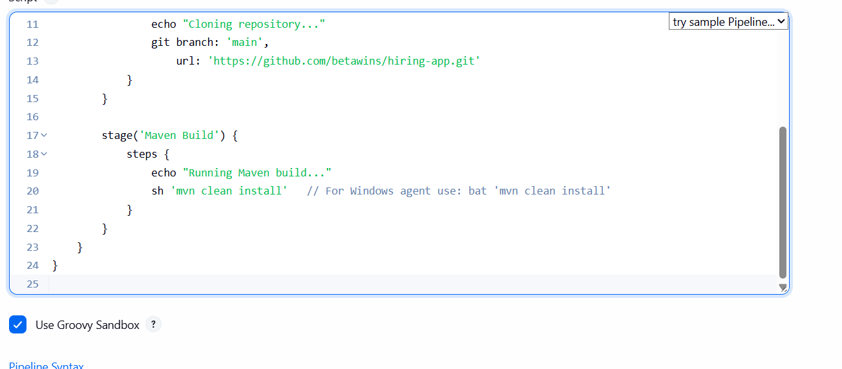
See, there is no file before compilation
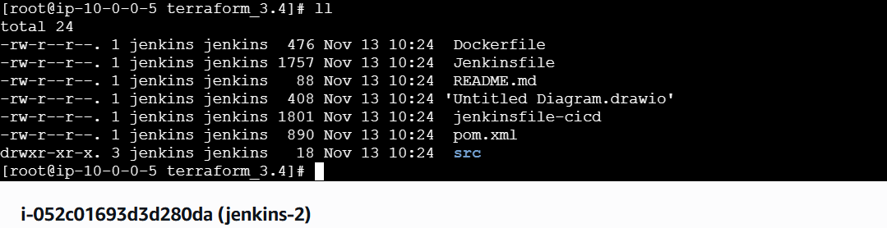
STEP 1 — Configure Maven in Jenkins
Go to:
Manage Jenkins → Global Tool Configuration → Maven
➡ Click Add Maven
➡ Give a name: MAVEN_HOME (recommended)
We should add this mavan home
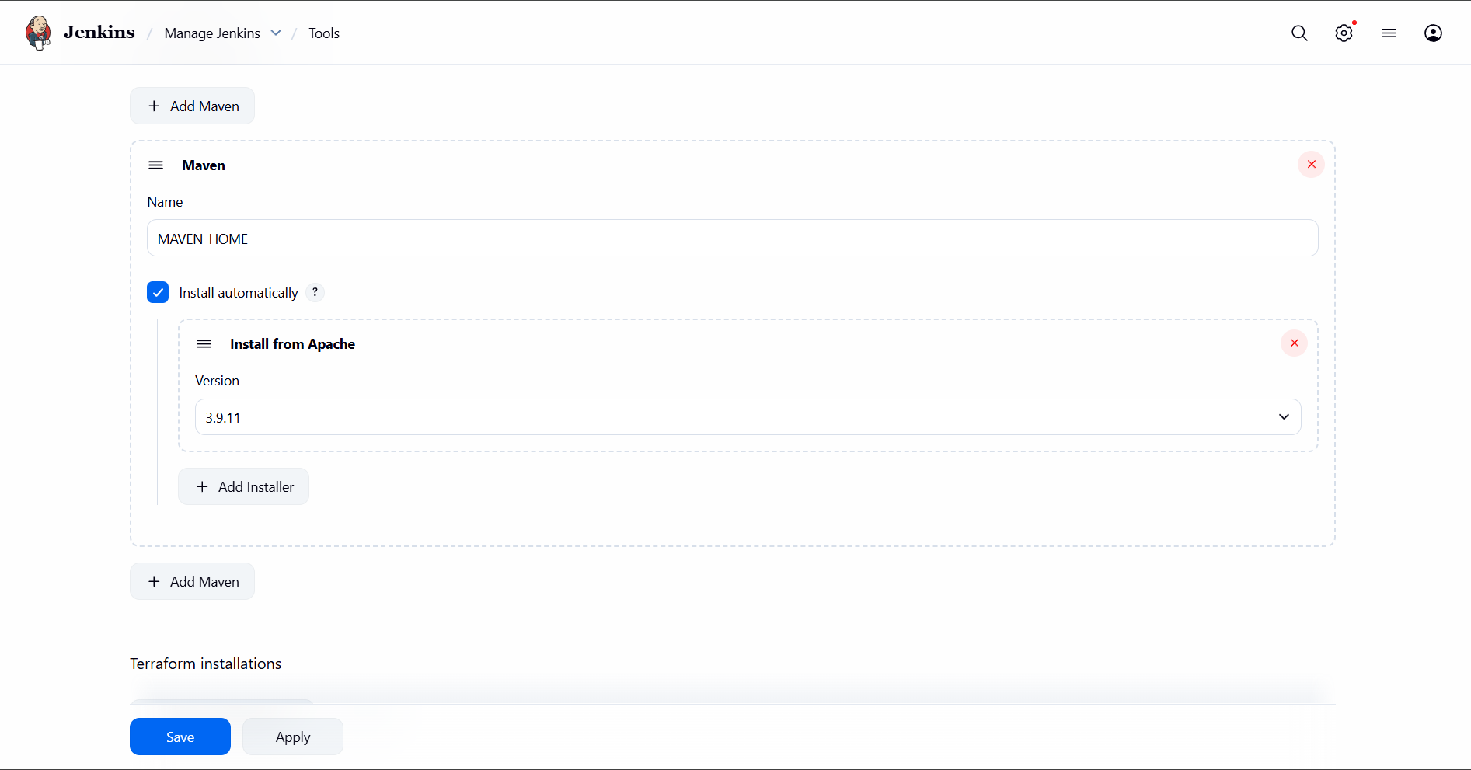
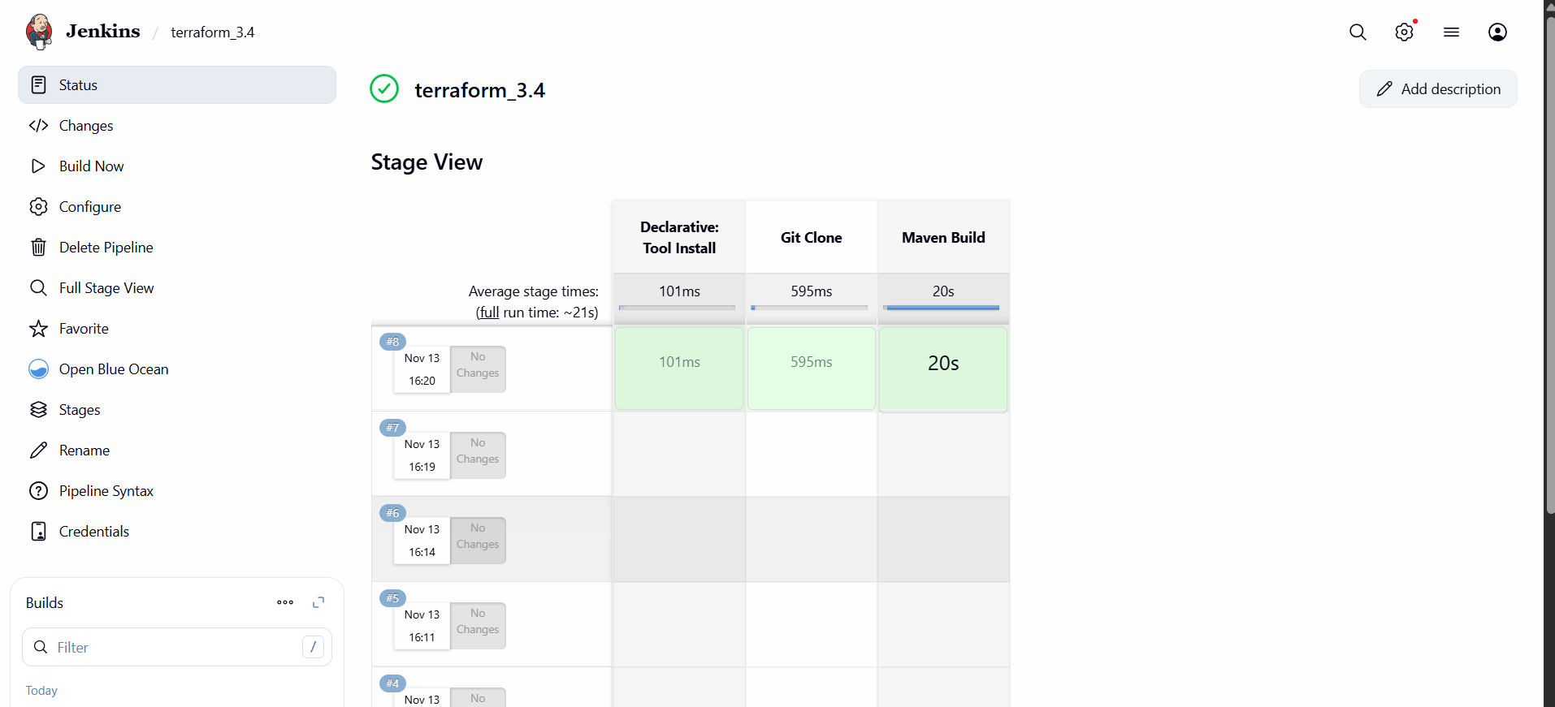
I got Target 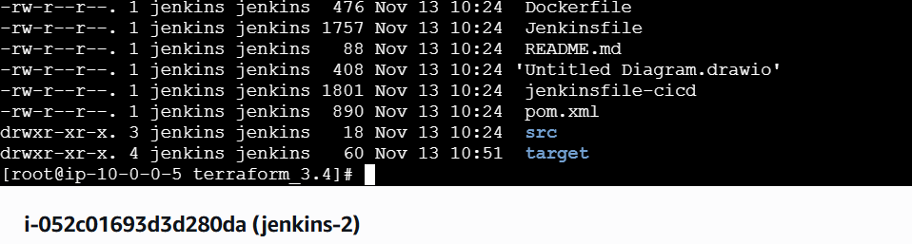
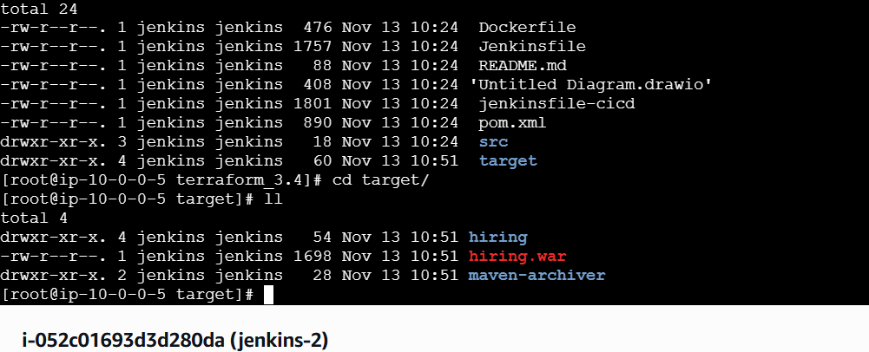

- Use the same code and create a parameterized job in Jenkins with:
  - Stage 1: Git clone
  - Stage 2: Maven Compilation Code: https://github.com/betawins/java-Working-app.git
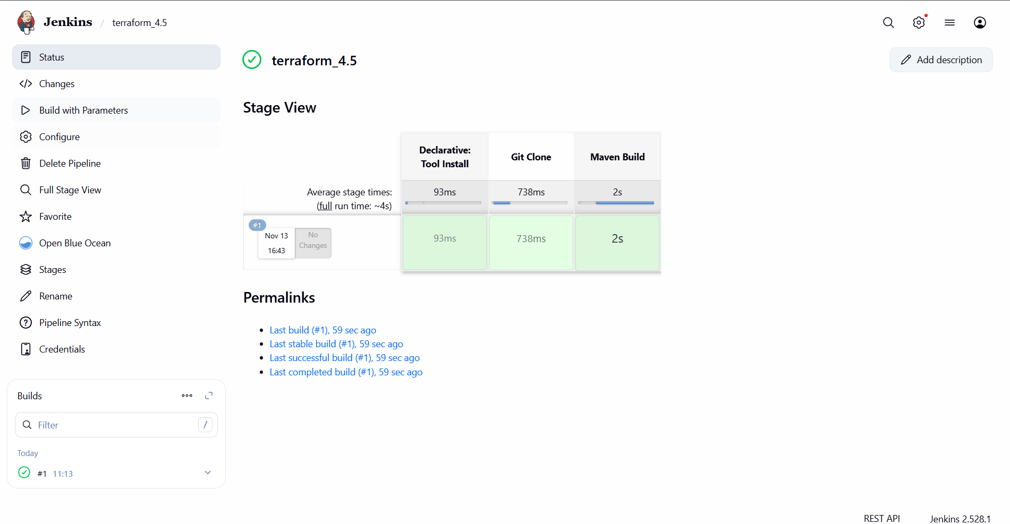
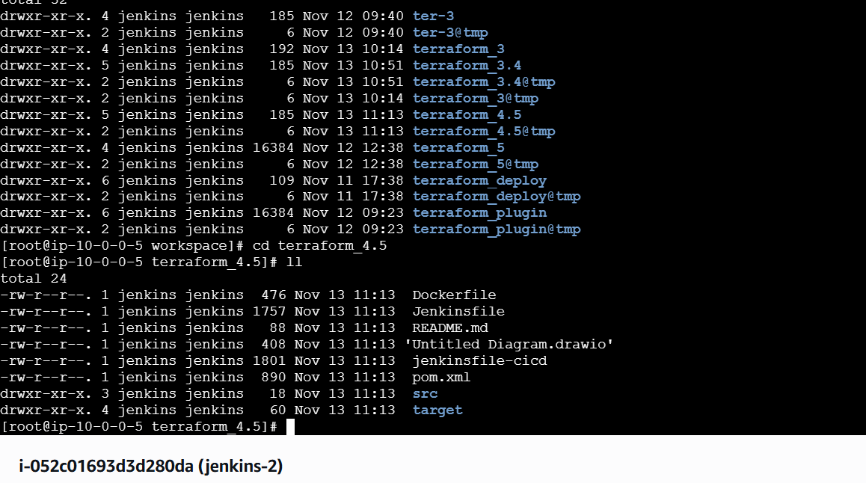
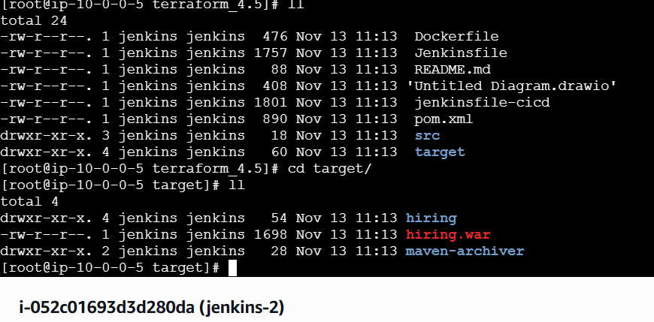
pipeline {
agent any

tools {
maven 'MAVEN_HOME' // Make sure this name matches Jenkins Maven tool
}

parameters {
string(
name: 'BRANCH_NAME',
defaultValue: 'main',
description: 'Enter the Git branch to clone'
)

string(
name: 'REPO_URL',
defaultValue: 'https://github.com/betawins/hiring-app.git',
description: 'Enter the Git repository URL'
)
}

stages {

stage('Git Clone') {
steps {
echo "Cloning repository: ${params.REPO_URL}"
echo "Branch: ${params.BRANCH_NAME}"

git branch: params.BRANCH_NAME,
url: params.REPO_URL
}
}

stage('Maven Build') {
steps {
echo "Running Maven build..."
sh 'mvn clean install'
}
}

}

}

- What are the global variables in Jenkins?
Global variables in Jenkins are built-in objects automatically available in every pipeline.
The most important ones are env, params, currentBuild, scm, and pipeline.
They provide access to environment variables, job parameters, build metadata, Git SCM information, and pipeline utilities.
We use them without declaring anything manually.
They help pipelines access build details, workspace paths, Git commits, job info, and parameter values.

