Terraform-task-04

- Watch Terraform-04 video.
Completed watching the video
- Execute the script shown in the video.
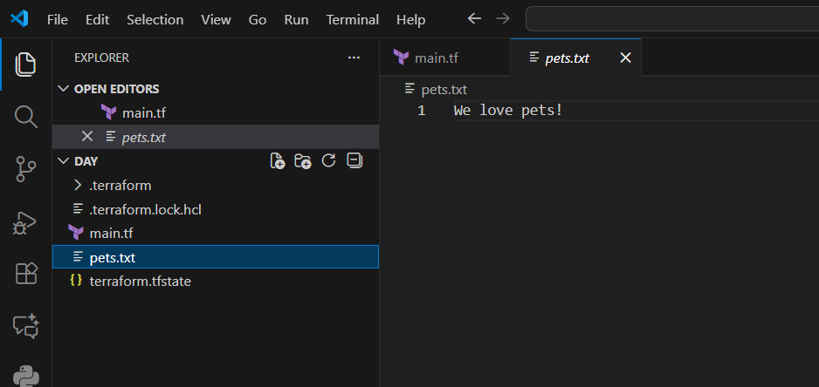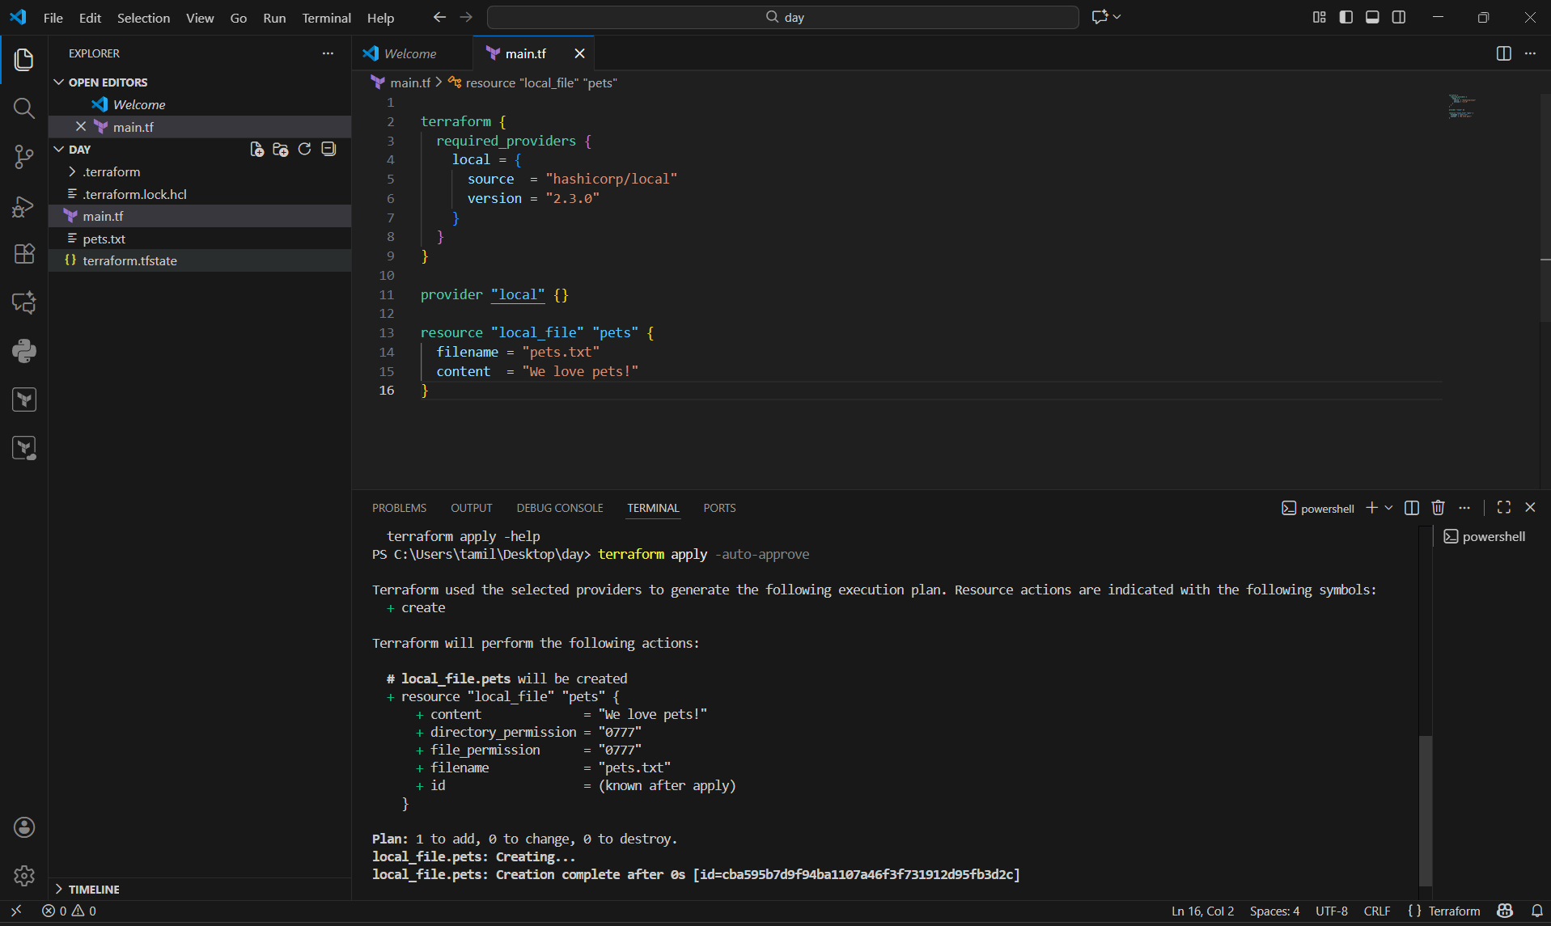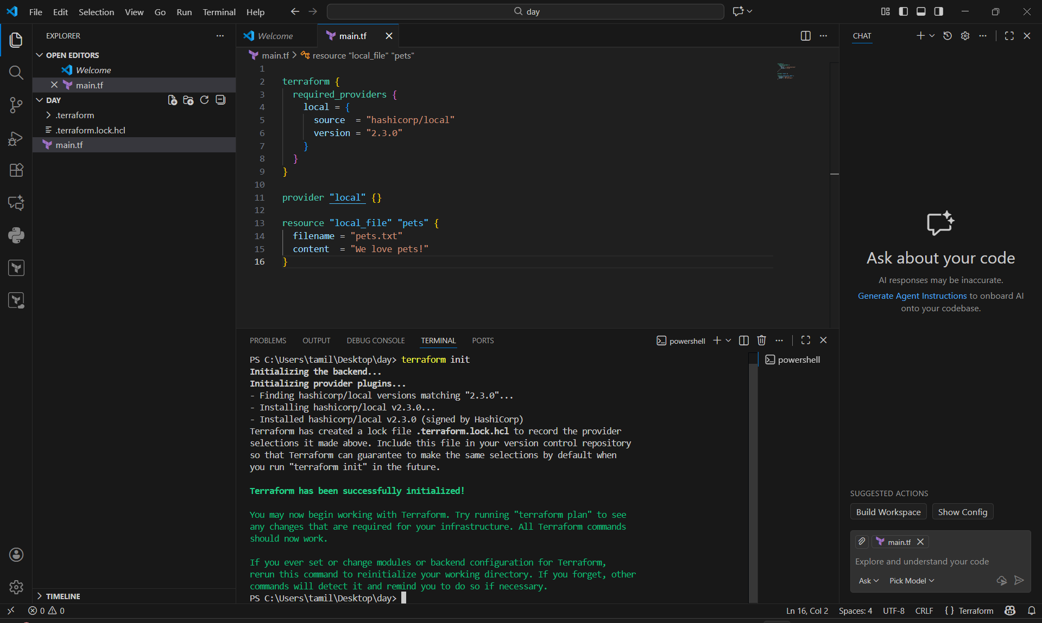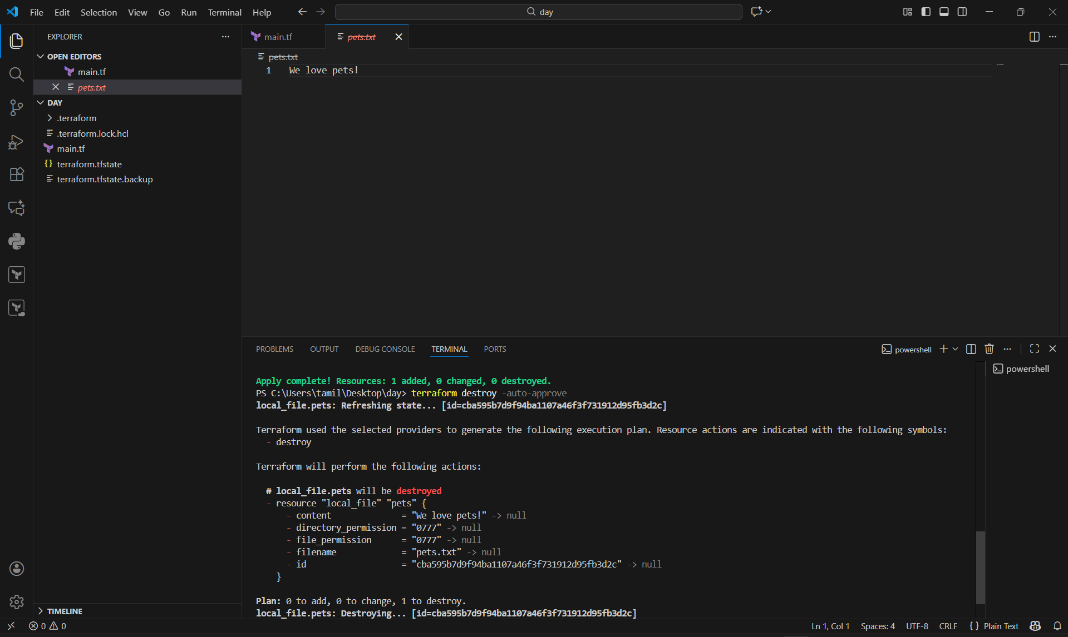
- Integrate Terraform in Jenkins using the Terraform plugin.
STEP 1 — Install Terraform Plugin in Jenkins
- Open Jenkins Dashboard
- Go to Manage Jenkins
- Click Manage Plugins
- Go to Available tab
- Search Terraform
- Click Install without restart
✔ Terraform plugin is installed.
STEP 2 — Install Terraform Tool
- Go to Manage Jenkins
- Click Global Tool Configuration
- Scroll down → You will see Terraform
- Click Add Terraform
- Give name:
👉 terraform
- Select Install automatically
✔ Now Jenkins can run Terraform.
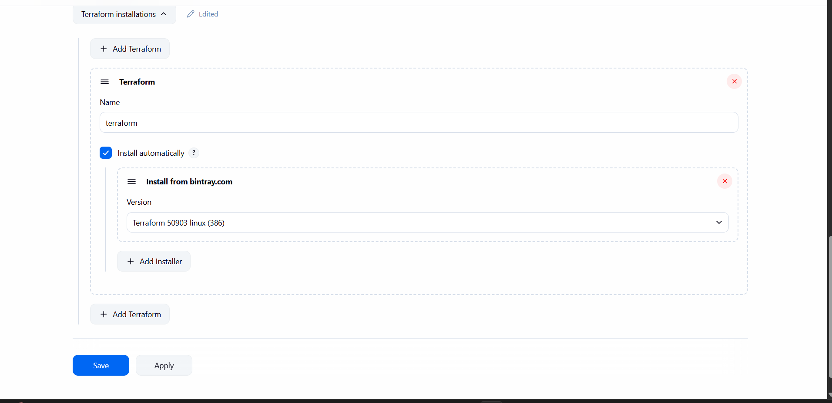
STEP 3 — Add Cloud Credentials (AWS example)
- Go to Manage Jenkins
- Click Credentials
- Add:
  - AWS Access Key
  - AWS Secret Key
- Give ID:
👉 aws-creds
✔ Jenkins now has access to AWS.

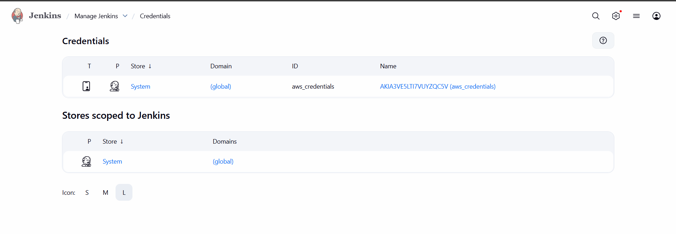
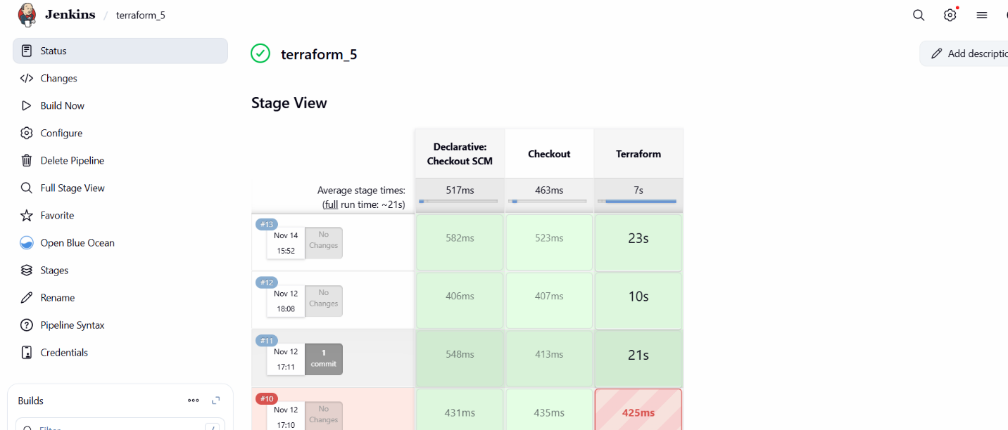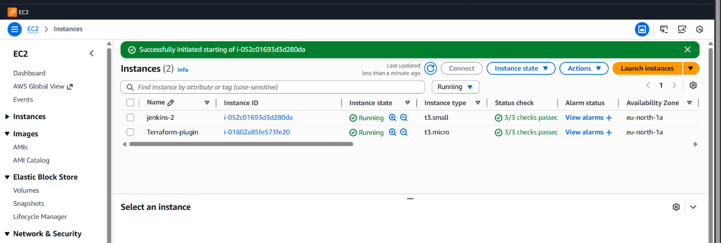

- Create a CI/CD pipeline for a Nodejs Application: https://github.com/betawins/Trading-UI.git

Pre-requisites (One-time setup)
On your Jenkins server (Linux):
- Steps
Install Git
sudo apt update
sudo apt install -y git
2) steps
Install Node.js + npm
(You already have Install nodejs and npn using linux.txt in repo – follow that, or for quick setup:)
curl -fsSL https://deb.nodesource.com/setup_18.x | sudo -E bash -
sudo apt install -y nodejs
node -v
npm -v
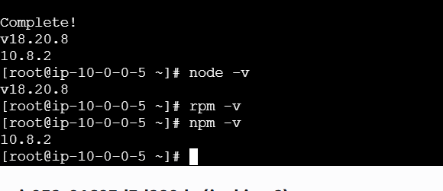

- Step Create deployment folder (for CD demo)
sudo mkdir -p /var/www/trading-ui
sudo chown -R jenkins:jenkins /var/www/trading-ui
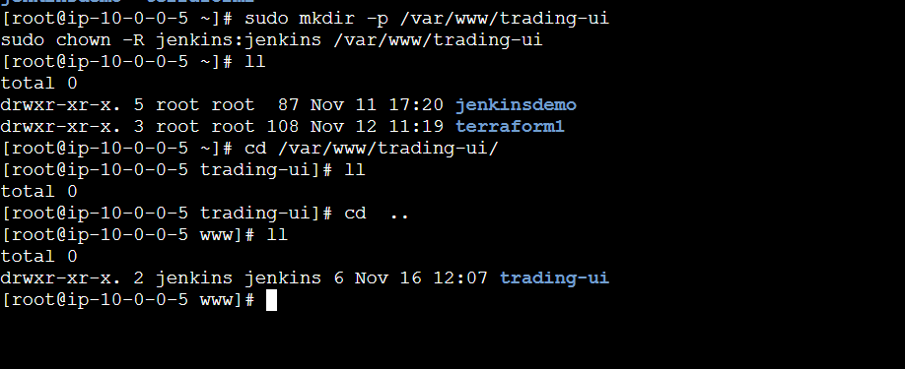
4 steps
Make sure Jenkins can run shell scripts
You’re already using Pipeline jobs, so you’re good.

2. Create Pipeline Job in Jenkins
- Open Jenkins UI → click “New Item”.
- Enter name: Trading-UI-CI-CD
- Select “Pipeline” → click OK.
Now configure the job:
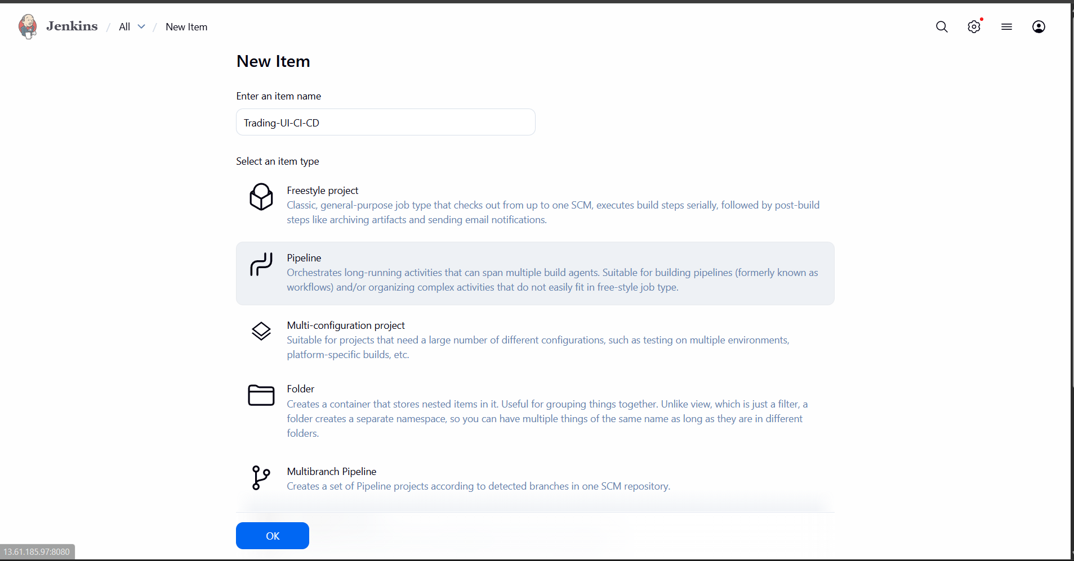

C. Pipeline section
- Definition: Pipeline script from SCM
- SCM: Git
- Repository URL:
https://github.com/betawins/Trading-UI.git
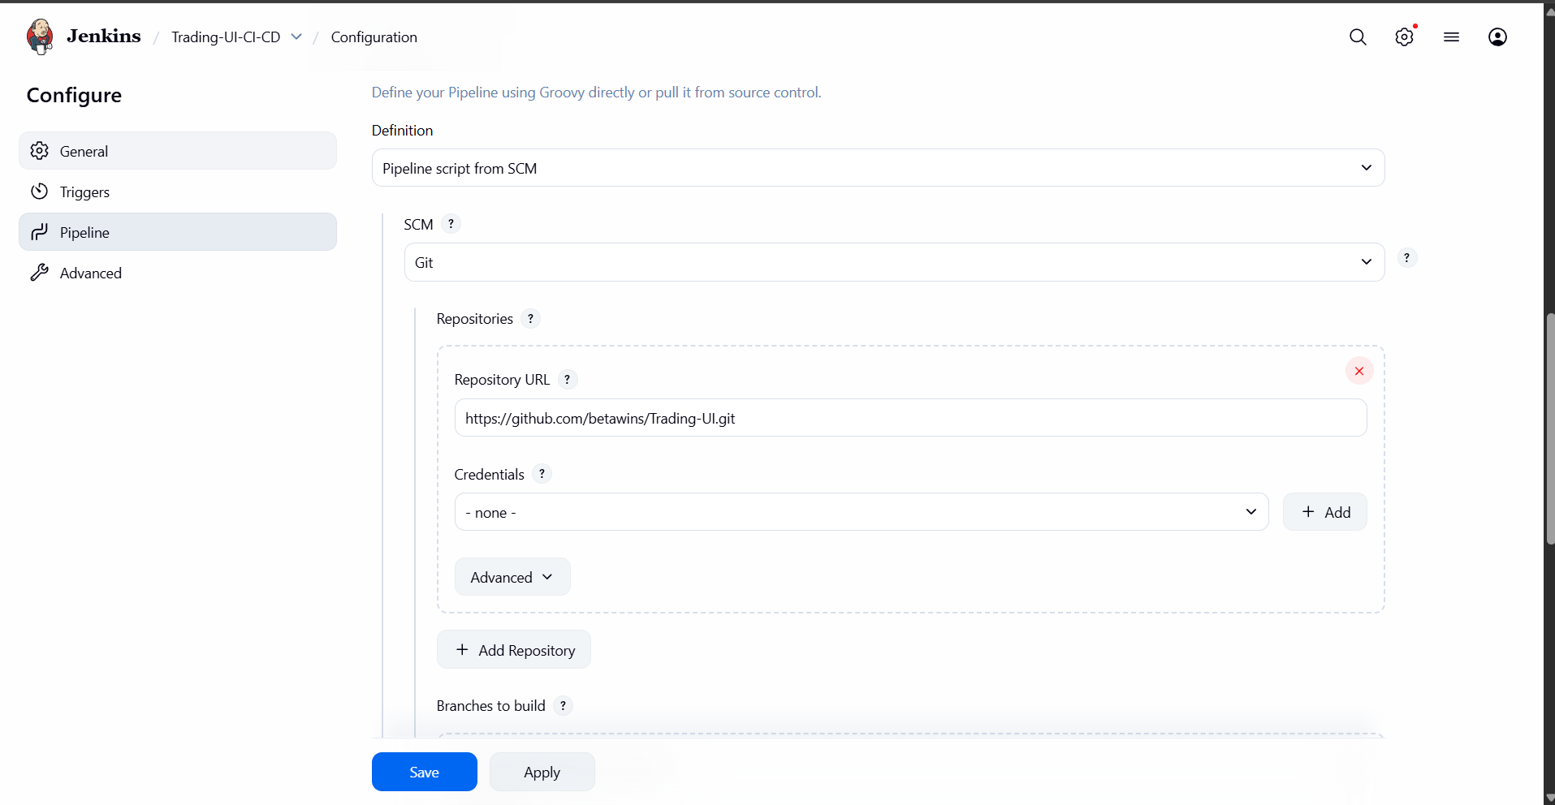
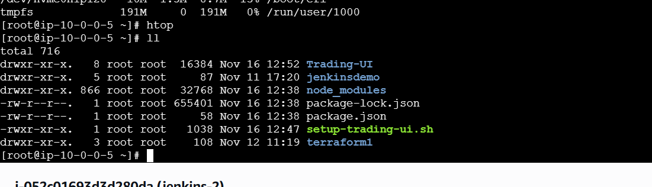
- Credentials:
  - If public: you can leave None.
  - If private: add GitHub username/token and select it.
- Branches to build:
*/master
- Script Path:
Jenkinsfile
Click Save.

3. Run the Pipeline Once
- Open the job: Trading-UI-CI-CD.
- Click “Build Now”.
- Click the running build → Console Output and watch step-by-step:
  - Checkout
  - npm install
  - npm test
  - npm run build
  - Archive build
  - Deploy
If it fails at any stage, Jenkins will show exactly where (npm error, test fail, permission issue, etc.).

- Explain 10 Maven commands.
Top 10 Maven Commands (Easy Explanation)

1. mvn --version
✔ Shows Maven version, Java version, OS details.
➡ Use this to confirm Maven is installed correctly.

2. mvn clean
✔ Deletes the target folder.
➡ Removes old compiled files before a fresh build.
Use case: Avoids conflicts from old builds.

3. mvn compile
✔ Compiles the Java source code from src/main/java.
➡ Converts code into .class files.

4. mvn test
✔ Runs all test cases from src/test/java.
➡ Ensures the application is working properly before packaging.

5. mvn package
✔ Creates the final build output (JAR/WAR).
➡ Output goes into target/ directory.
Example:
- Java project → .jar
- Web project → .war

6. mvn install
✔ Builds the project and installs the package into the local Maven repository (~/.m2).
➡ Other local projects can use this dependency.

7. mvn deploy
✔ Uploads the built package to a remote repository (Nexus, Artifactory).
➡ Used in CI/CD pipelines.

8. mvn validate
✔ Checks whether the project structure is correct.
➡ Ensures all required files (like pom.xml) are valid.

9. mvn dependency:tree
✔ Shows dependency hierarchy including transitive dependencies.
➡ Helps find:
- Version conflicts
- Duplicate dependencies
- Dependency mismatches

10. mvn site
✔ Generates a project website with reports like:
- Test coverage
- Code quality
- Documentation
➡ Useful for project documentation.

🔥 Quick Summary Table
Command | Use
mvn --version | Check Maven installation
mvn clean | Delete old build files
mvn compile | Compile source code
mvn test | Run unit tests
mvn package | Create JAR/WAR
mvn install | Add build to local repo
mvn deploy | Upload build to remote repo
mvn validate | Validate project structure
mvn dependency:tree | Show dependency hierarchy
mvn site | Generate documentation site

