Terraform-05.

- Watch the Terraform-05 video.
Completed watching the video
- Execute the script shown in the video.
S3 Backend and DynamoDB State Locking
This setup is crucial for team collaboration.
a) Script to Create an S3 Bucket (for storing state file)
- File: main.tf

resource "aws_s3_bucket" "s3_backend" {
bucket = "your-unique-s3-bucket-name" # Choose a globally unique name
acl = "private"

tags = {
Name = "S3 Remote Backend"
}
}
terraform init
terraform apply

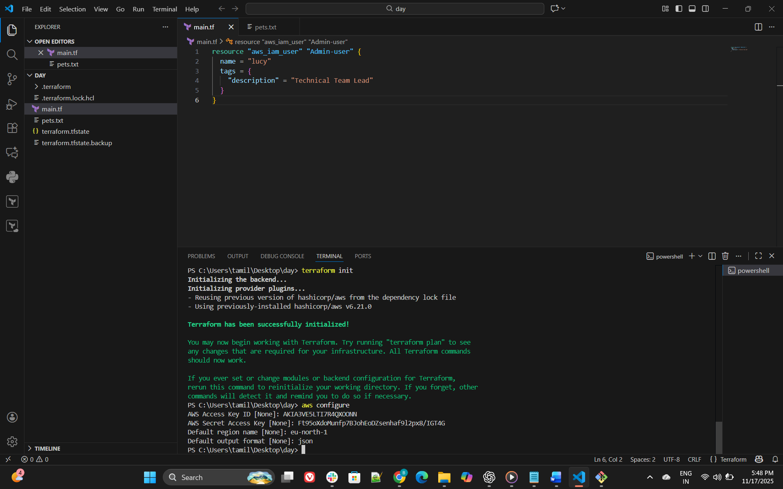
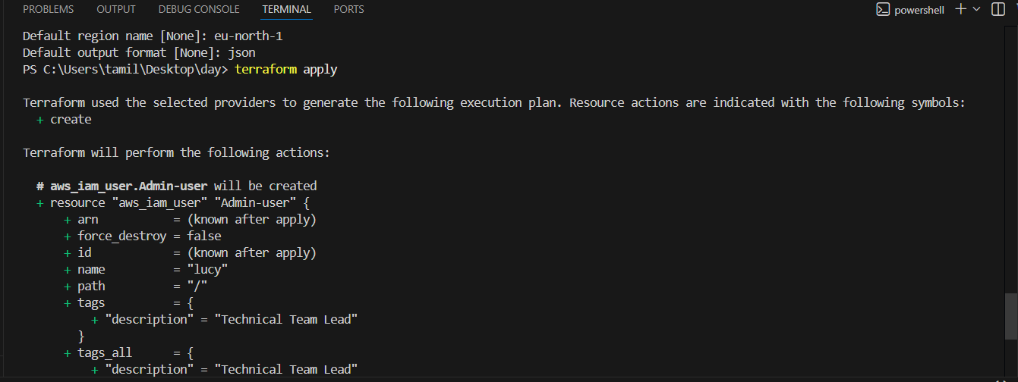
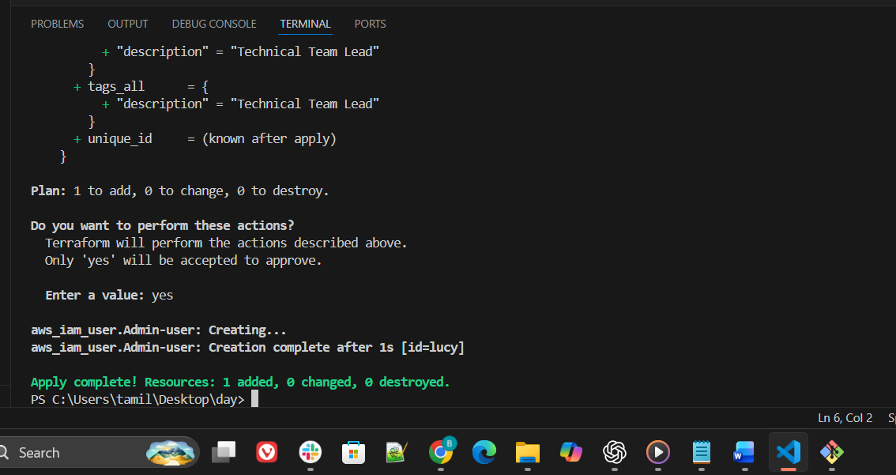
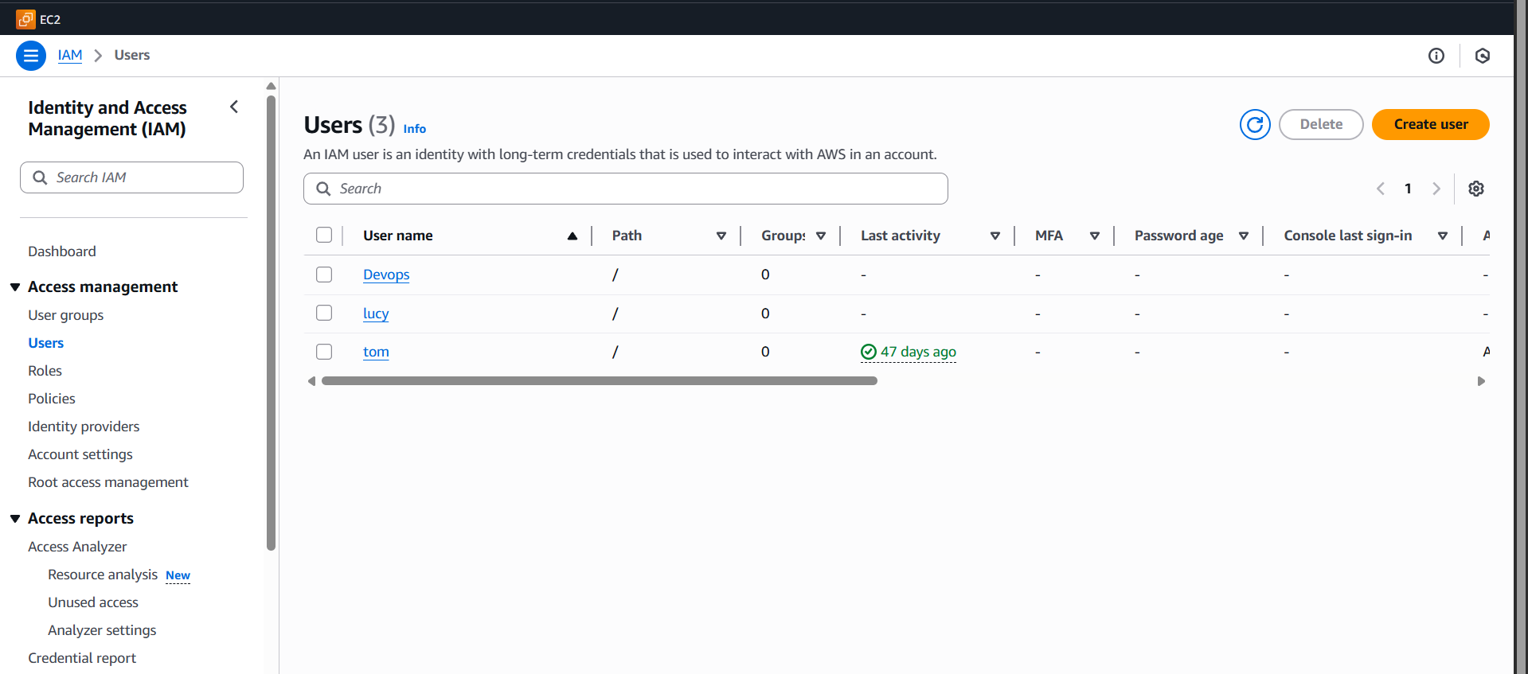
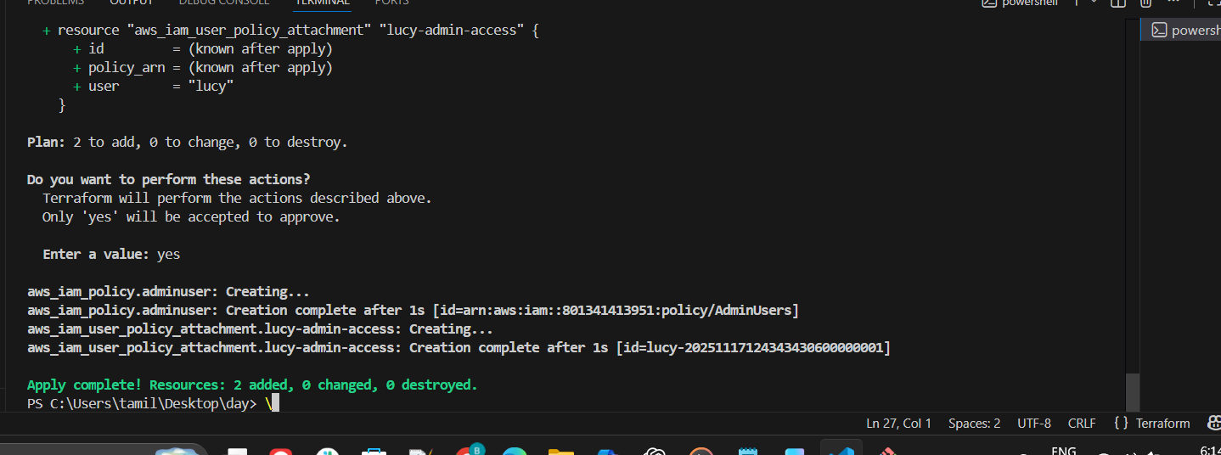
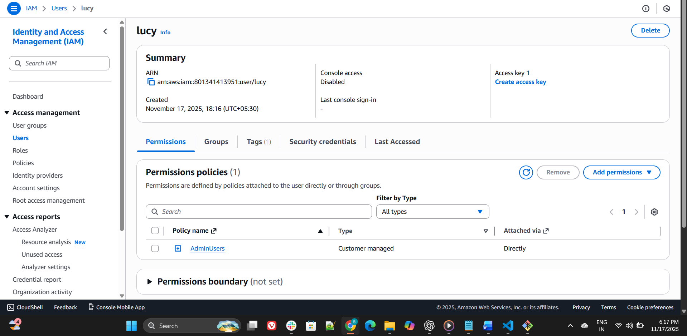

- Create one EC2 instance with httpd installed using a Terraform script.

########################################
- # Provider
- ########################################
- provider "aws" {
- region = "eu-north-1"
- }

- ########################################
- # VPC
- ########################################
- resource "aws_vpc" "main_vpc" {
- cidr_block = "10.0.0.0/16"
- }

- ########################################
- # Internet Gateway
- ########################################
- resource "aws_internet_gateway" "igw" {
- vpc_id = aws_vpc.main_vpc.id
- }

- ########################################
- # Public Subnet
- ########################################
- resource "aws_subnet" "public_subnet" {
- vpc_id = aws_vpc.main_vpc.id
- cidr_block = "10.0.1.0/24"
- availability_zone = "eu-north-1a"

- map_public_ip_on_launch = true
- }

- ########################################
- # Route Table
- ########################################
- resource "aws_route_table" "public_rt" {
- vpc_id = aws_vpc.main_vpc.id

- route {
- cidr_block = "0.0.0.0/0"
- gateway_id = aws_internet_gateway.igw.id
- }
- }

- ########################################
- # Route Table Association
- ########################################
- resource "aws_route_table_association" "public_rta" {
- subnet_id = aws_subnet.public_subnet.id
- route_table_id = aws_route_table.public_rt.id
- }

- ########################################
- # Security Group
- ########################################
- resource "aws_security_group" "web_sg" {
- name = "web-server-sg"
- description = "Allow HTTP and SSH"
- vpc_id = aws_vpc.main_vpc.id

- ingress {
- from_port = 80
- to_port = 80
- protocol = "tcp"
- cidr_blocks = ["0.0.0.0/0"]
- }

- ingress {
- from_port = 22
- to_port = 22
- protocol = "tcp"
- cidr_blocks = ["0.0.0.0/0"]
- }

- egress {
- from_port = 0
- to_port = 0
- protocol = "-1"
- cidr_blocks = ["0.0.0.0/0"]
- }
- }

- ########################################
- # EC2 Instance
- ########################################
- resource "aws_instance" "web_server" {
- ami = "ami-0c7d68785ec07306c"
- instance_type = "t3.micro"

- subnet_id = aws_subnet.public_subnet.id
- security_groups = [aws_security_group.web_sg.id]

- key_name = "jenkins"

- user_data = <<-EOF
- #!/bin/bash
- yum update -y
- yum install httpd -y
- systemctl start httpd
- systemctl enable httpd
- echo "<h1>Hello from Terraform EC2!</h1>" > /var/www/html/index.html
- EOF
- }

- ########################################
- # Output
- ########################################
- output "web_public_ip" {
- value = aws_instance.web_server.public_ip
- }

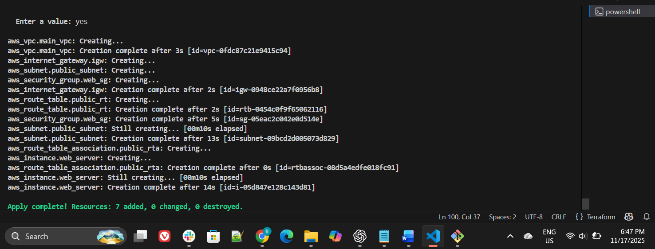
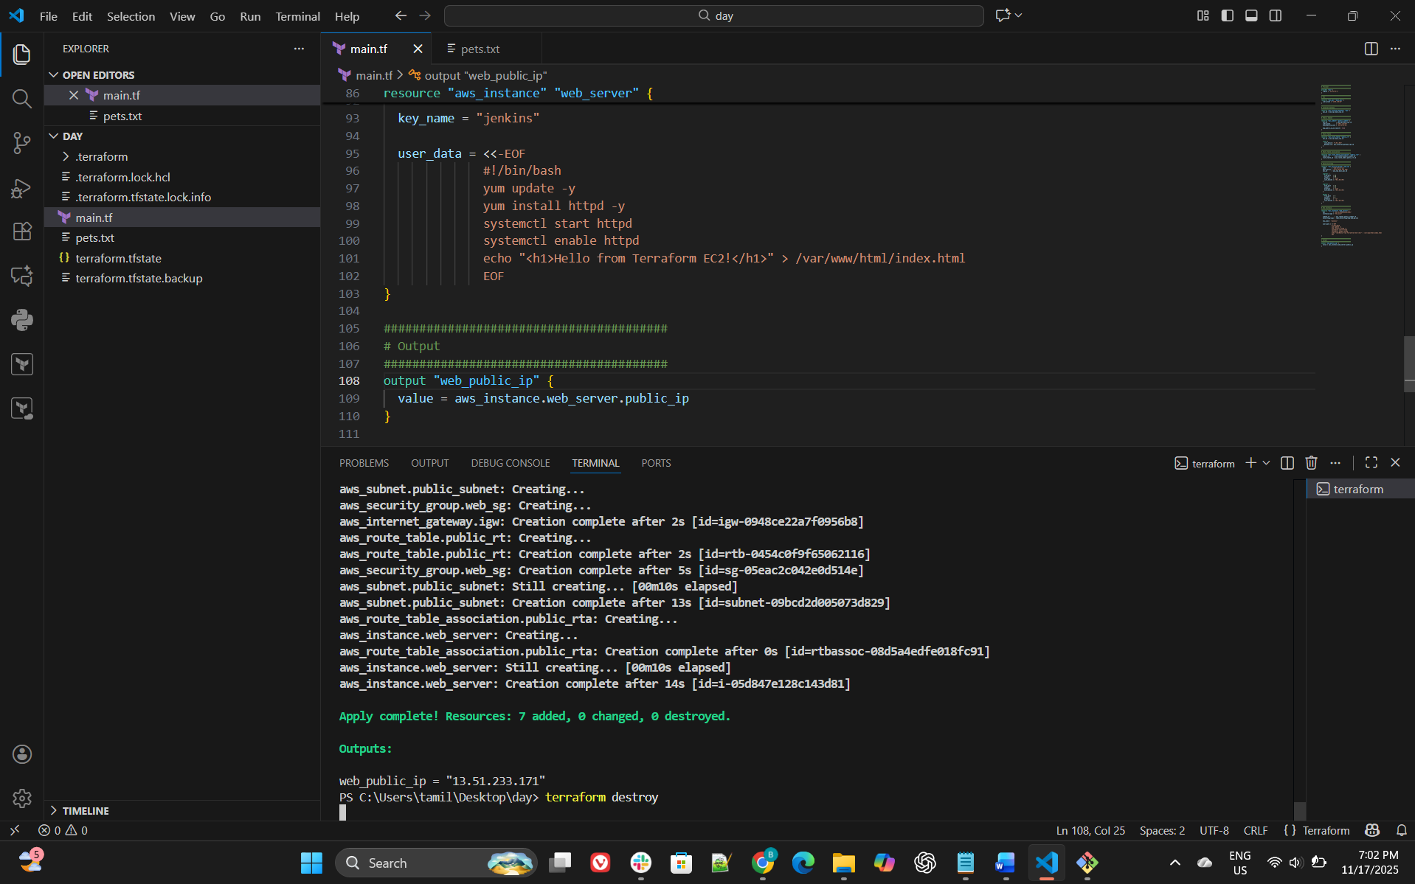

- Set up S3 as the backend for task 3.
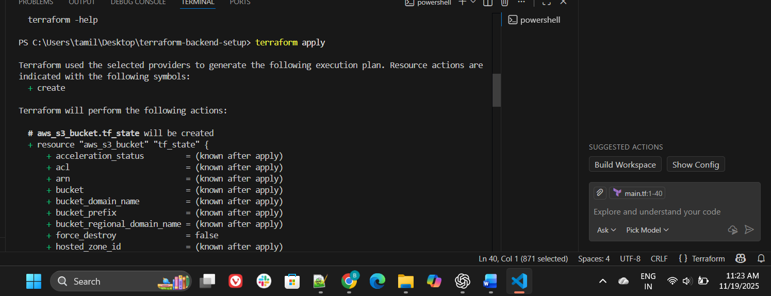
########################################
# Provider
########################################
provider "aws" {
region = "eu-north-1"
}

########################################
# Random ID (for unique bucket name)
########################################
resource "random_id" "suffix" {
byte_length = 4
}

########################################
# S3 Bucket
########################################
resource "aws_s3_bucket" "my_bucket" {
bucket = "bharathiraja-bucket-${random_id.suffix.hex}"

tags = {
Name = "bharathiraja-s3"
}
}
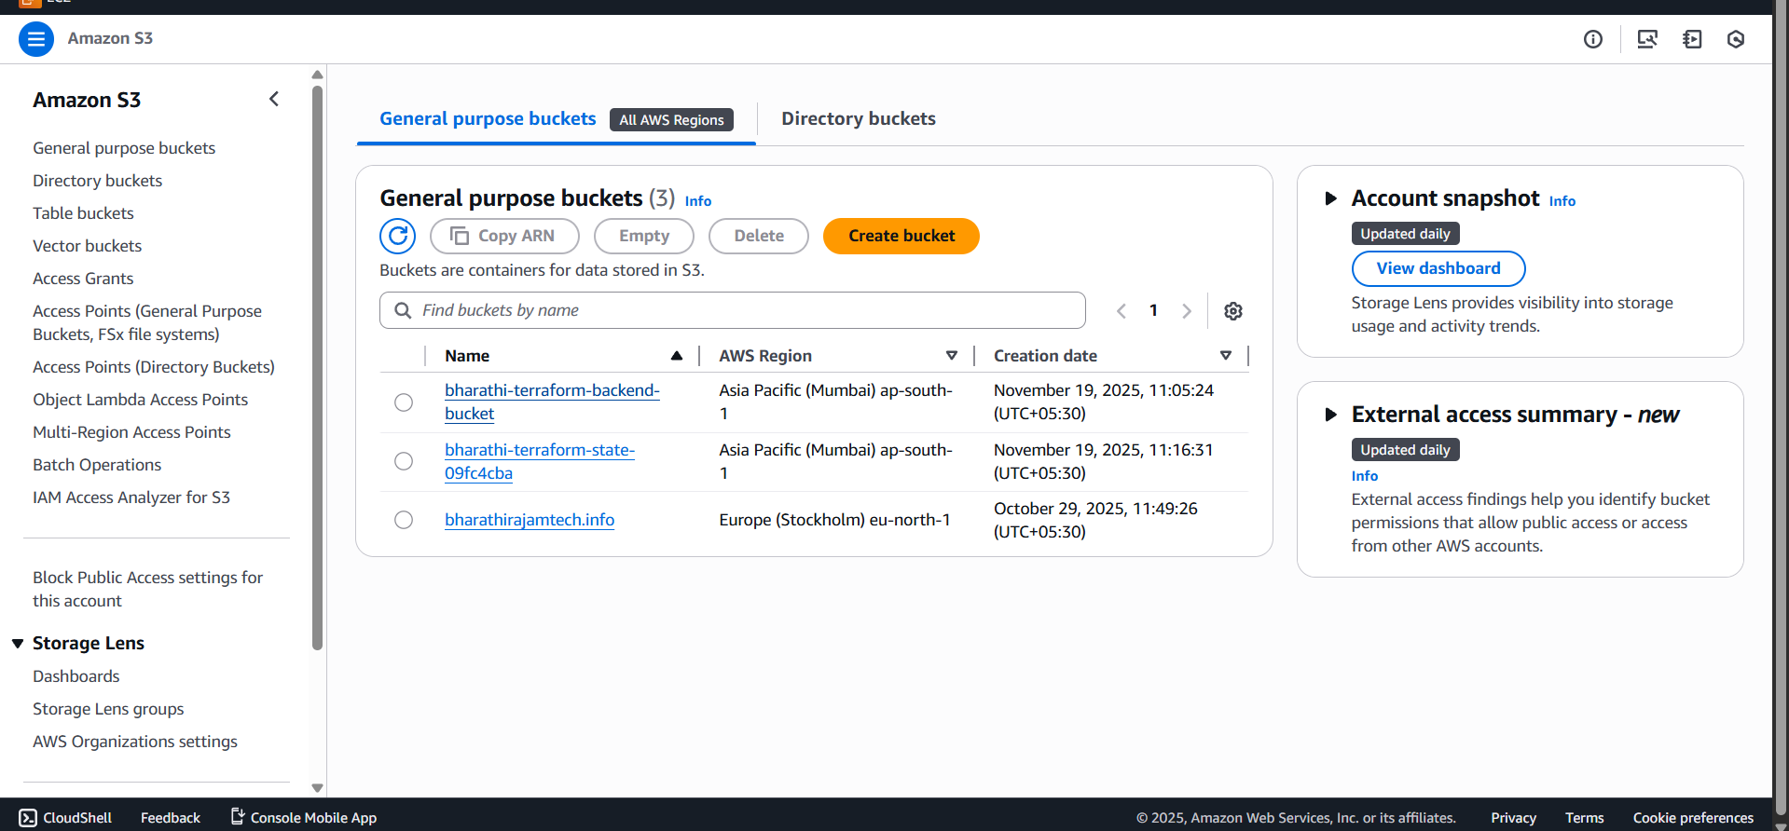
- Set up DynamoDB locking for task 3.
