Terraform-task-06

- Watch the Terraform-06 video.
Completed the watching the video
Execute the script shown in the video.

Provision EC2, S3, and VPC using Terraform modules.
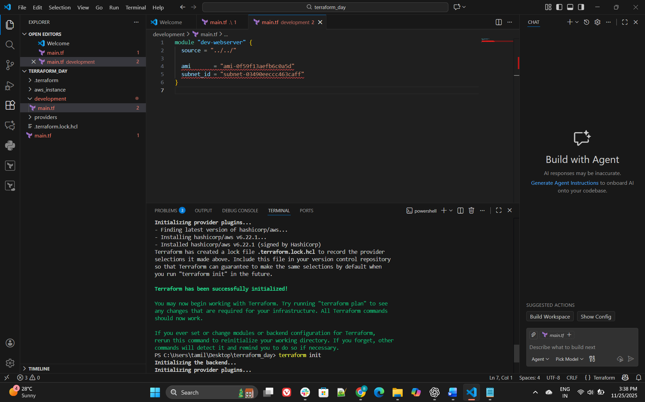
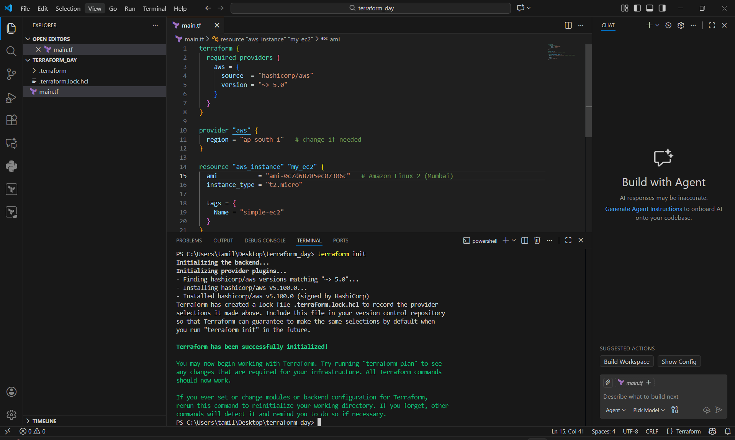
Creating s3 bucket
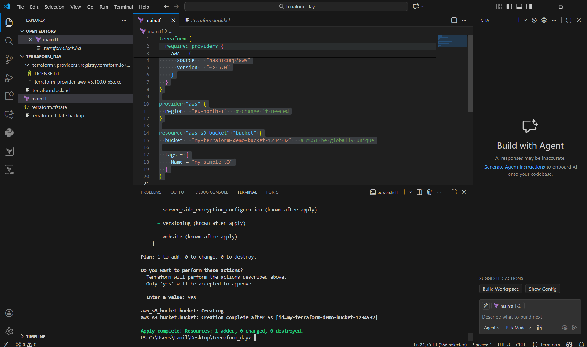

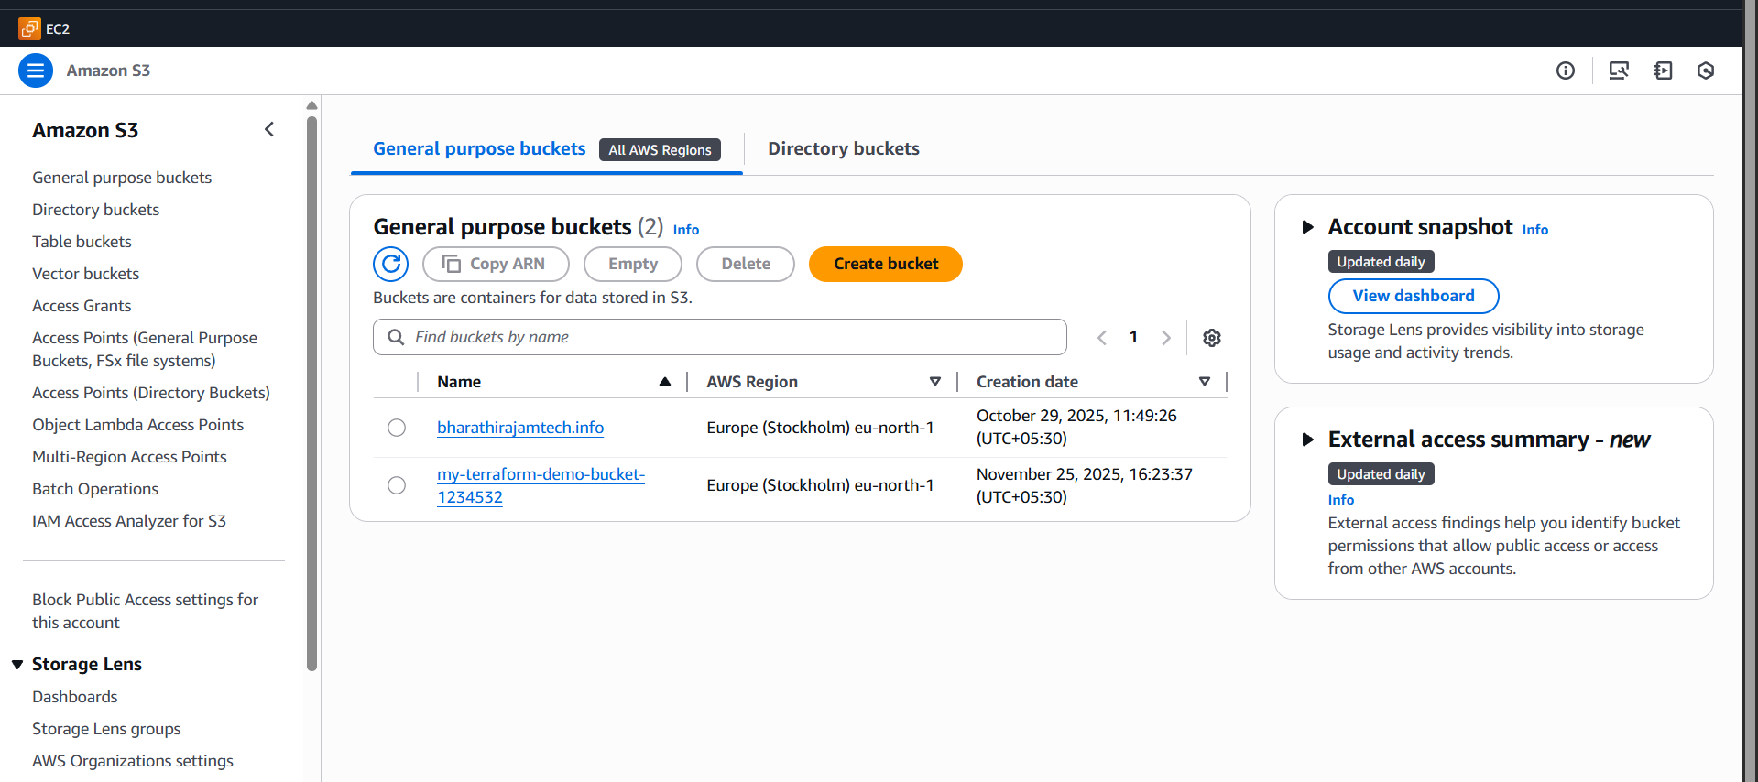
terraform {
required_providers {
aws = {
source = "hashicorp/aws"
version = "~> 5.0"
}
}
}

provider "aws" {
region = "eu-north-1" # change if needed
}

resource "aws_s3_bucket" "bucket" {
bucket = "my-terraform-demo-bucket-1234532" # MUST be globally unique

tags = {
Name = "my-simple-s3"
}
}

Creating vpc
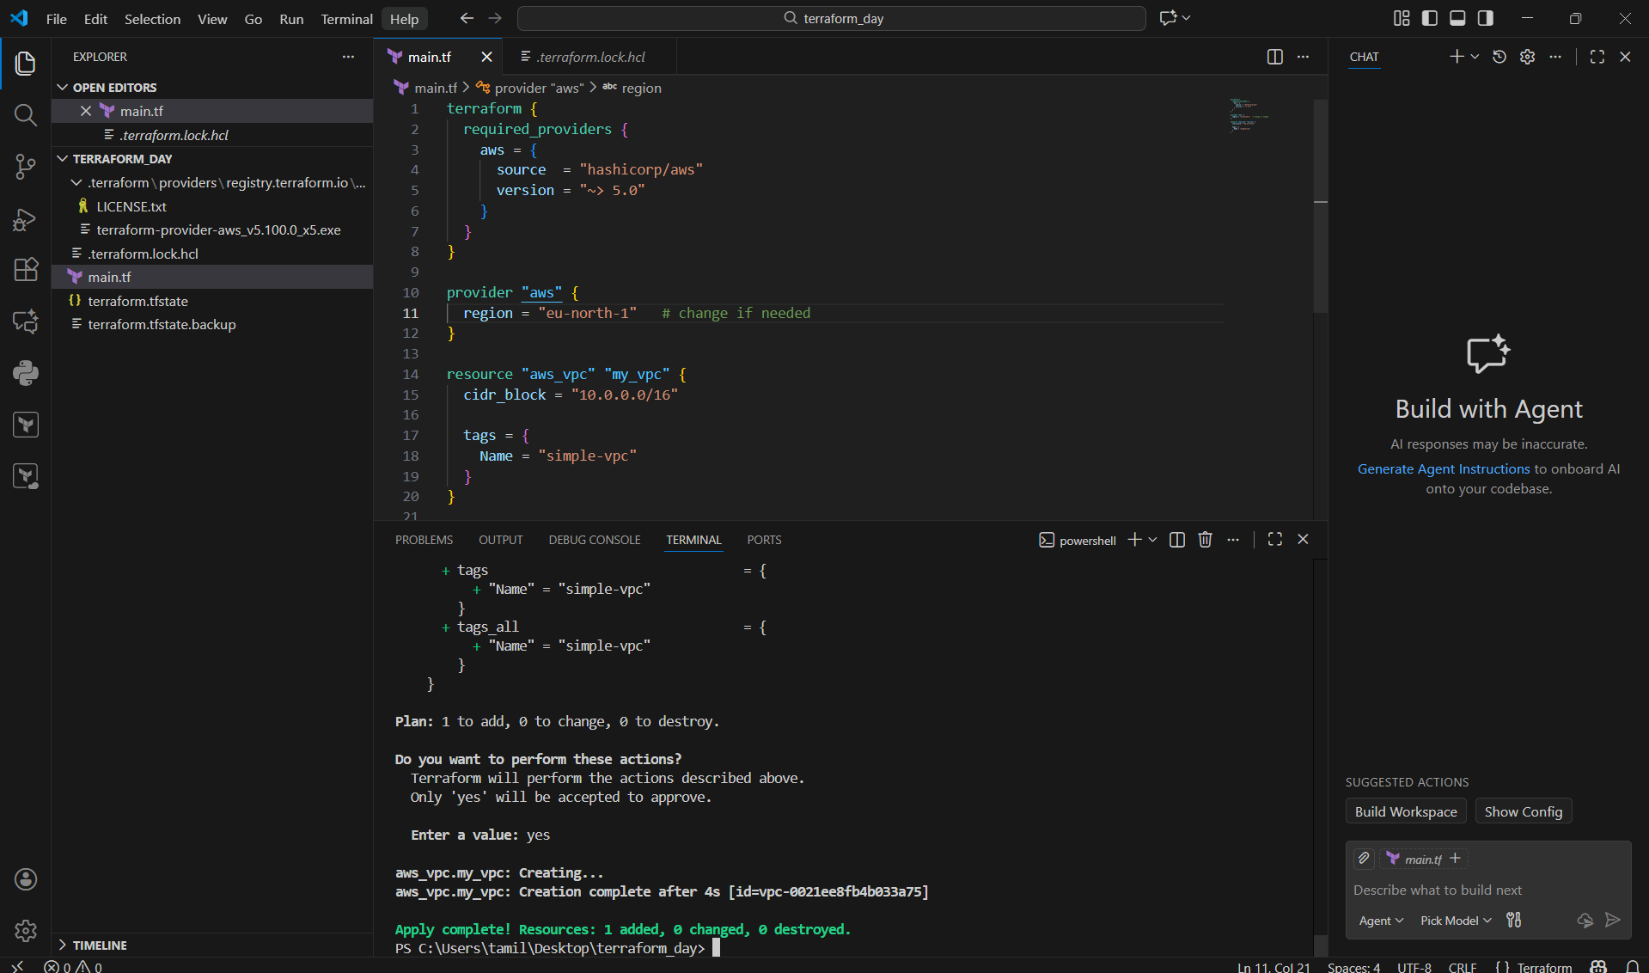
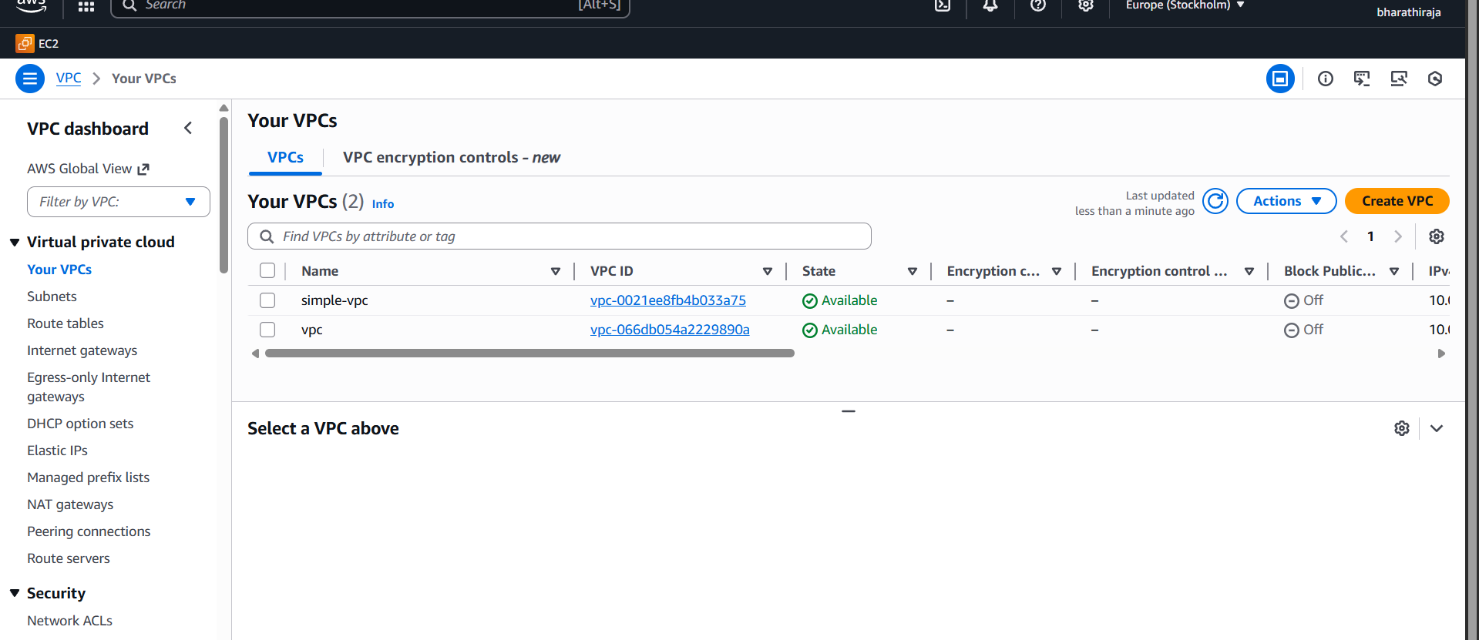
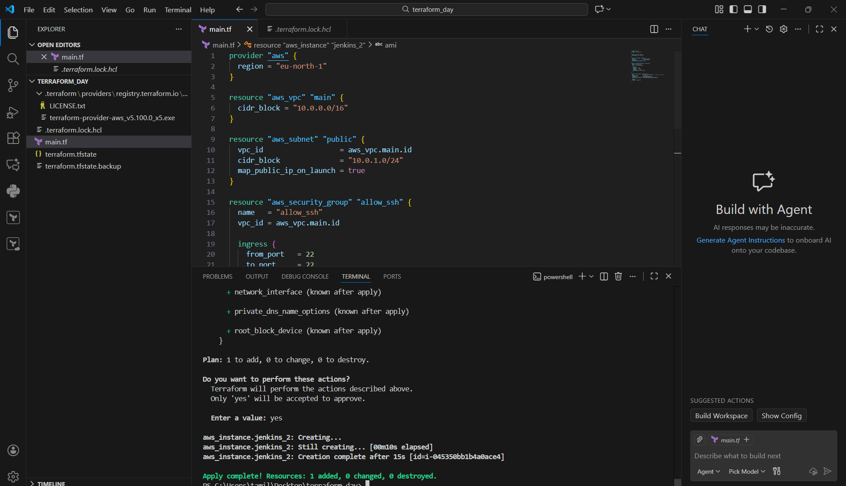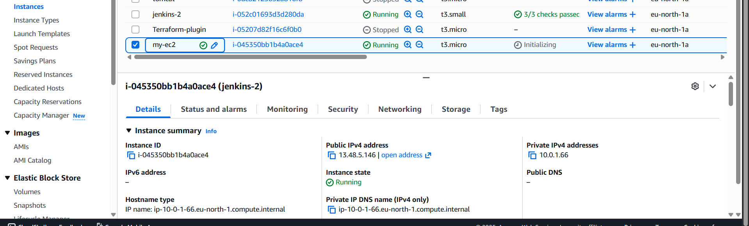

- Provision EC2 for 3 different environments (Dev, Staging, and Prod) using Terraform workspaces.

