working on final Terraform Final Task.

- Create VPC
terraform {
required_providers {
aws = {
source = "hashicorp/aws"
version = "~> 5.0"
}
}
}

provider "aws" {
region = "eu-north-1" # ✅ change if needed
}

resource "aws_vpc" "my_vpc" {
cidr_block = "10.0.0.0/16"
enable_dns_support = true
enable_dns_hostnames = true

tags = {
Name = "my-simple-vpc"
}
}

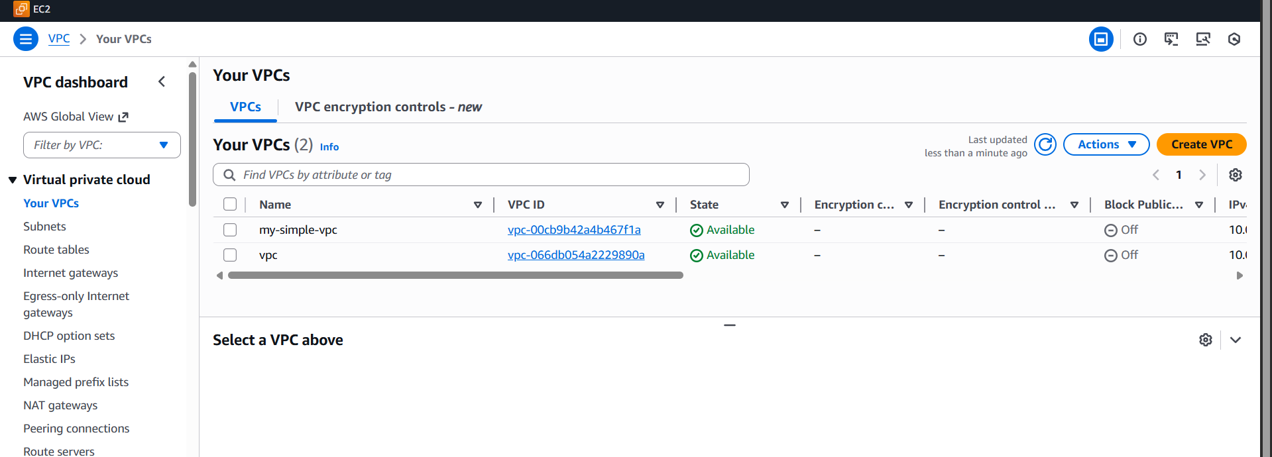

- Create Internet gateway
terraform {
required_providers {
aws = {
source = "hashicorp/aws"
version = "~> 5.0"
}
}
}

provider "aws" {
region = "ap-south-1" # change if needed
}

# 1) Create VPC
resource "aws_vpc" "my_vpc" {
cidr_block = "10.0.0.0/16"
enable_dns_support = true
enable_dns_hostnames = true

tags = {
Name = "my-simple-vpc"
}
}

# 2) Create Internet Gateway
resource "aws_internet_gateway" "igw" {
vpc_id = aws_vpc.my_vpc.id

tags = {
Name = "my-vpc-igw"
}
}
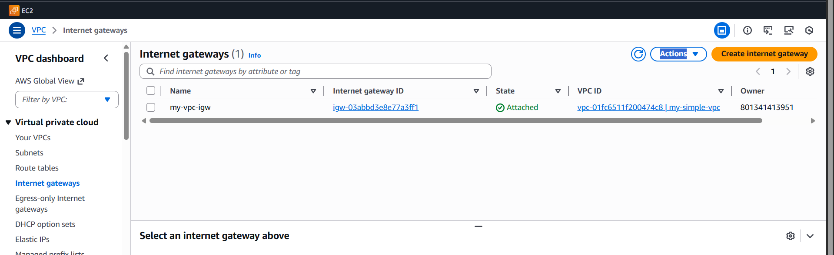

- Create Custom Route Table
terraform {
required_providers {
aws = {
source = "hashicorp/aws"
version = "~> 5.0"
}
}
}

provider "aws" {
region = "ap-south-1" # change if needed
}

# 1) Create VPC
resource "aws_vpc" "my_vpc" {
cidr_block = "10.0.0.0/16"
enable_dns_support = true
enable_dns_hostnames = true

tags = {
Name = "my-simple-vpc"
}
}

# 2) Create Internet Gateway
resource "aws_internet_gateway" "igw" {
vpc_id = aws_vpc.my_vpc.id

tags = {
Name = "my-vpc-igw"
}
}

# 3) Create Custom Route Table
resource "aws_route_table" "public_rt" {
vpc_id = aws_vpc.my_vpc.id

route {
cidr_block = "0.0.0.0/0"
gateway_id = aws_internet_gateway.igw.id
}

tags = {
Name = "my-public-route-table"
}
}
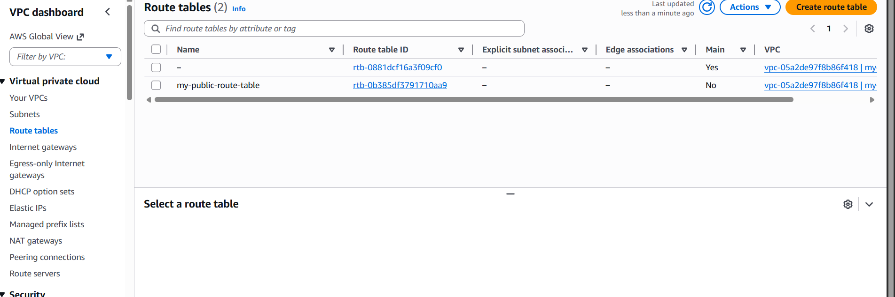

- Create Subnet
# 4) Create Public Subnet
resource "aws_subnet" "public_subnet" {
vpc_id = aws_vpc.my_vpc.id
cidr_block = "10.0.1.0/24"
map_public_ip_on_launch = true
availability_zone = "ap-south-1a" # change if needed

tags = {
Name = "my-public-subnet"
}
}
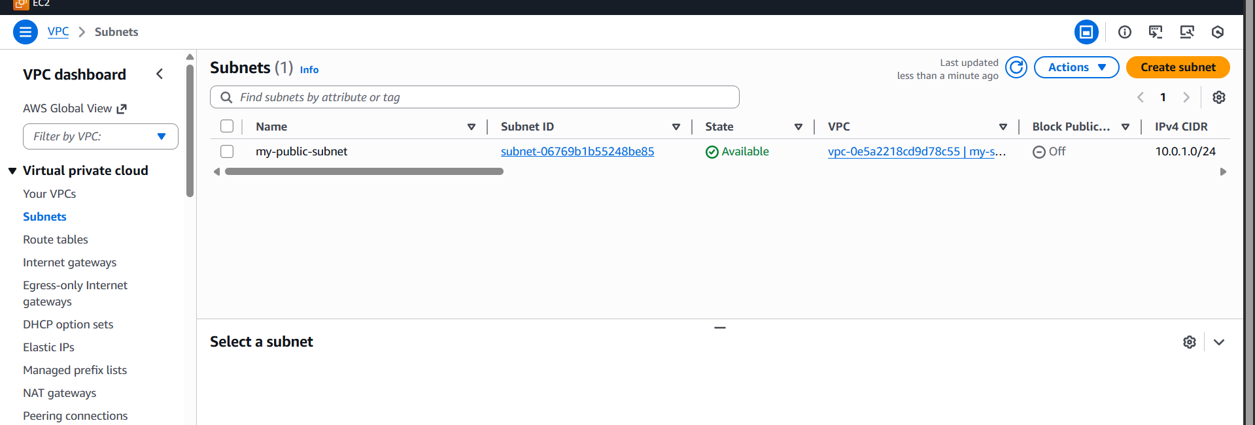
- Associate subnet with Route Table
# 5) Associate Subnet with Route Table
resource "aws_route_table_association" "public_assoc" {
subnet_id = aws_subnet.public_subnet.id
route_table_id = aws_route_table.public_rt.id
}
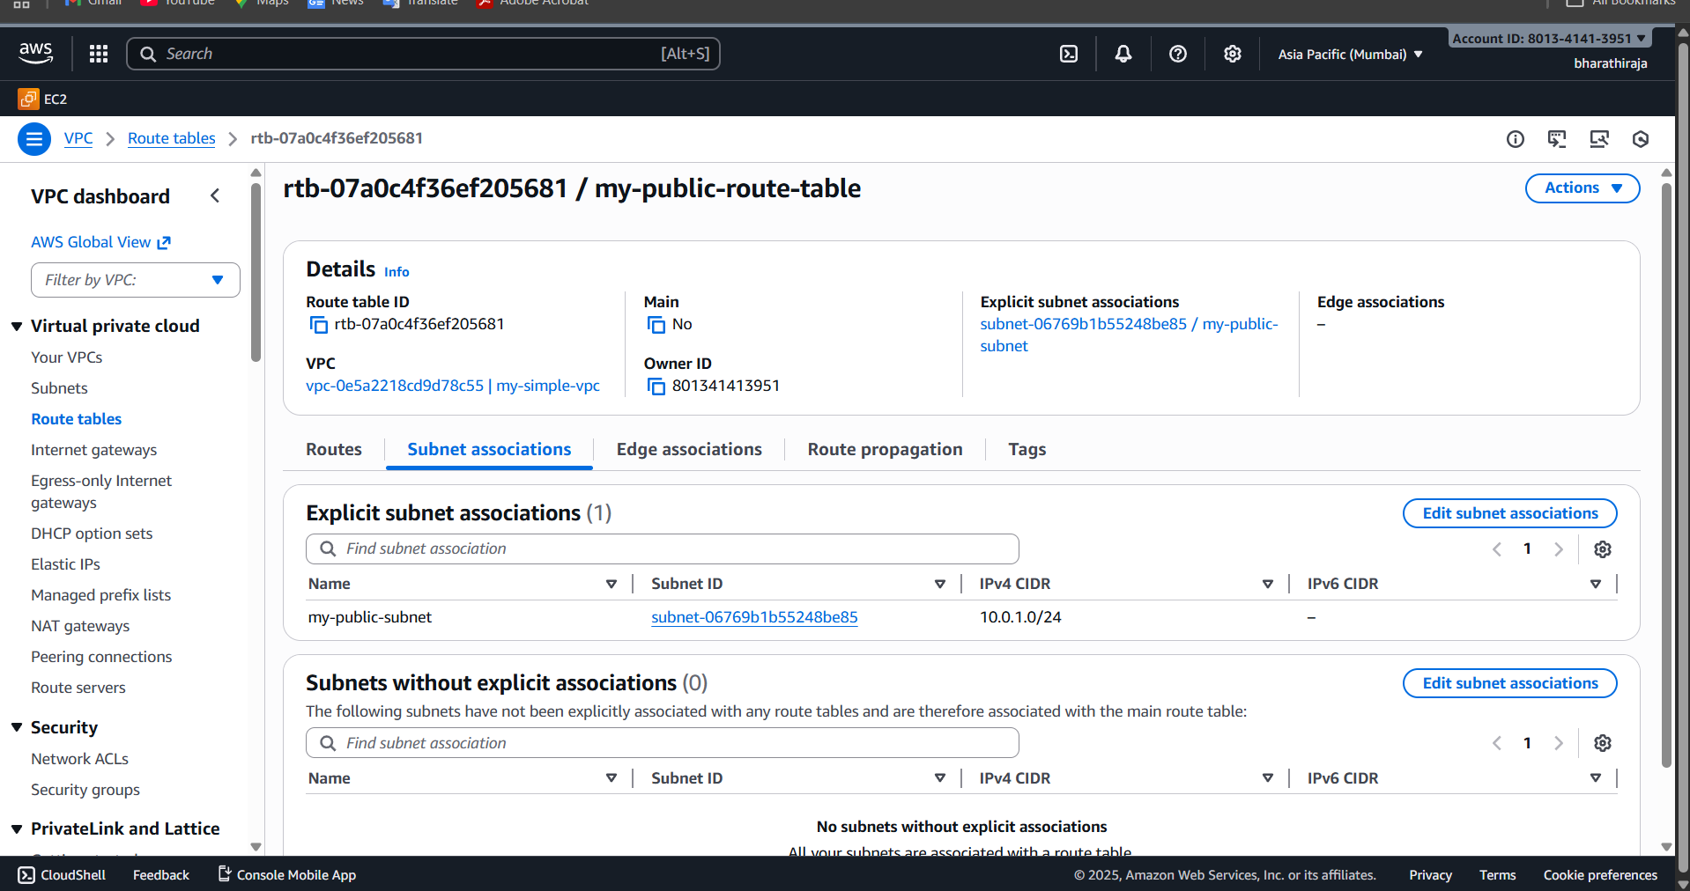
- Create Security Group to allow port 22.80,443
# 6) Create Security Group to allow SSH, HTTP, HTTPS
resource "aws_security_group" "web_sg" {
name = "allow-web-traffic"
description = "Allow SSH (22), HTTP (80), and HTTPS (443)"
vpc_id = aws_vpc.my_vpc.id

ingress {
description = "SSH"
from_port = 22
to_port = 22
protocol = "tcp"
cidr_blocks = ["0.0.0.0/0"]
}

ingress {
description = "HTTP"
from_port = 80
to_port = 80
protocol = "tcp"
cidr_blocks = ["0.0.0.0/0"]
}

ingress {
description = "HTTPS"
from_port = 443
to_port = 443
protocol = "tcp"
cidr_blocks = ["0.0.0.0/0"]
}

egress {
description = "Allow all outbound traffic"
from_port = 0
to_port = 0
protocol = "-1"
cidr_blocks = ["0.0.0.0/0"]
}

tags = {
Name = "web-security-group"
}
}
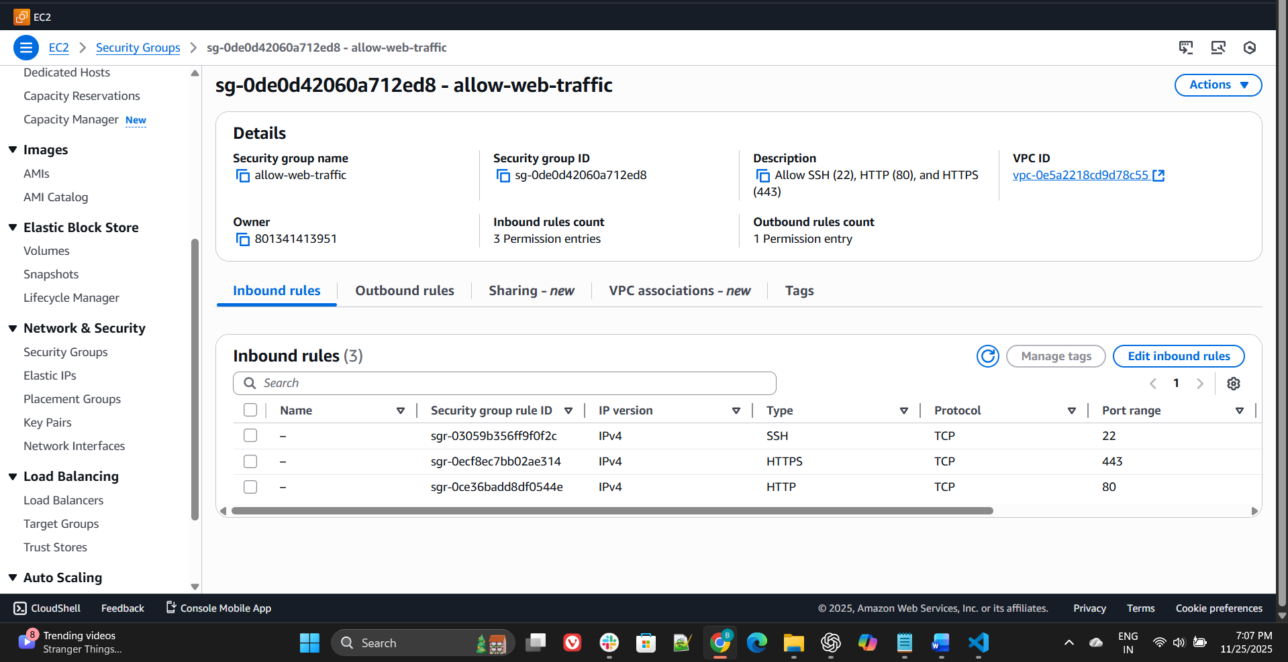

- Create a network interface with an ip in the subnet that was created in step 4
# 7) Create Network Interface inside the subnet
resource "aws_network_interface" "eni" {
subnet_id = aws_subnet.public_subnet.id
private_ips = ["10.0.1.50"]
security_groups = [aws_security_group.web_sg.id]

tags = {
Name = "my-network-interface"
}
}
✅ What this will do
✔ Creates an ENI in your public subnet
✔ Assigns static private IP: 10.0.1.50
✔ Attaches the same security group, allowing ports 22/80/443
✔ Can later be attached to an EC2 instance
⚠️ Make sure the IP is inside your subnet range:
- Subnet CIDR: 10.0.1.0/24
- Valid range: 10.0.1.1 → 10.0.1.254
So 10.0.1.50 ✅ is valid

- Assign an elastic IP to the network interface created in step 7
# 8) Create Elastic IP
resource "aws_eip" "eip" {
vpc = true

tags = {
Name = "my-eip"
}
}

This allocates a new public IP in AWS
❗ But it is not yet attached
# 9) Associate Elastic IP with the Network Interface
resource "aws_eip_association" "eip_assoc" {
network_interface_id = aws_network_interface.eni.id
allocation_id = aws_eip.eip.id
}
✅ This attaches the EIP to your ENI
✅ No need to restart anything
✅ ENI will now have a public IP

- Create Ubuntu server and install/enable Apache2

terraform {
required_providers {
aws = {
source = "hashicorp/aws"
version = "~> 5.0"
}
}
}

provider "aws" {
region = "eu-north-1"
}

############################
# 1) VPC
############################
resource "aws_vpc" "my_vpc" {
cidr_block = "10.0.0.0/16"
enable_dns_support = true
enable_dns_hostnames = true

tags = {
Name = "my-vpc"
}
}

############################
# 2) Public Subnet
############################
resource "aws_subnet" "public_subnet" {
vpc_id = aws_vpc.my_vpc.id
cidr_block = "10.0.1.0/24"
map_public_ip_on_launch = true
availability_zone = "eu-north-1a"

tags = {
Name = "my-public-subnet"
}
}

############################
# 3) Internet Gateway
############################
resource "aws_internet_gateway" "igw" {
vpc_id = aws_vpc.my_vpc.id

tags = {
Name = "my-igw"
}
}

############################
# 4) Route Table + Association
############################
resource "aws_route_table" "public_rt" {
vpc_id = aws_vpc.my_vpc.id

route {
cidr_block = "0.0.0.0/0"
gateway_id = aws_internet_gateway.igw.id
}

tags = {
Name = "my-public-rt"
}
}

resource "aws_route_table_association" "public_assoc" {
subnet_id = aws_subnet.public_subnet.id
route_table_id = aws_route_table.public_rt.id
}

############################
# 5) Security Group
############################
resource "aws_security_group" "web_sg" {
name = "web-sg"
vpc_id = aws_vpc.my_vpc.id

ingress {
from_port = 22
to_port = 22
protocol = "tcp"
cidr_blocks = ["0.0.0.0/0"]
}

ingress {
from_port = 80
to_port = 80
protocol = "tcp"
cidr_blocks = ["0.0.0.0/0"]
}

ingress {
from_port = 443
to_port = 443
protocol = "tcp"
cidr_blocks = ["0.0.0.0/0"]
}

egress {
from_port = 0
to_port = 0
protocol = "-1"
cidr_blocks = ["0.0.0.0/0"]
}

tags = {
Name = "web-security"
}
}

############################
# 6) Network Interface
############################
resource "aws_network_interface" "eni" {
subnet_id = aws_subnet.public_subnet.id
private_ips = ["10.0.1.50"]
security_groups = [aws_security_group.web_sg.id]

tags = {
Name = "my-eni"
}
}

############################
# 7) Elastic IP + Association
############################
resource "aws_eip" "eip" {
domain = "vpc"

tags = {
Name = "my-eip"
}
}

resource "aws_eip_association" "eip_assoc" {
allocation_id = aws_eip.eip.id
network_interface_id = aws_network_interface.eni.id
}

############################
# 8) Ubuntu AMI Lookup
############################
data "aws_ami" "ubuntu" {
most_recent = true
owners = ["099720109477"]

filter {
name = "name"
values = ["ubuntu/images/hvm-ssd/ubuntu-jammy-22.04-amd64-server-*"]
}
}

############################
# 9) Ubuntu EC2 + Apache2
############################
resource "aws_instance" "ubuntu_web" {
ami = data.aws_ami.ubuntu.id
instance_type = "t3.micro"

network_interface {
network_interface_id = aws_network_interface.eni.id
device_index = 0
}

user_data = <<-EOF
#!/bin/bash
apt-get update -y
apt-get install -y apache2
systemctl enable apache2
systemctl start apache2
echo "<h1>Hello from Terraform Ubuntu + Apache2 ✅</h1>" > /var/www/html/index.html
EOF

tags = {
Name = "ubuntu-apache-server"
}
}
