Docker_task _01.

- Setup a virtual machine using Ubuntu image.
- Install VirtualBox
  - Download & install from virtualbox.org and install the Extension Pack (if you want USB 2/3, RDP).
- Create new VM
  - Open VirtualBox → New.
  - Name: Ubuntu-22.04 (or whichever). Type: Linux. Version: Ubuntu (64-bit).
  - Memory: set to 4096 MB (4 GB) or as desired.
  - Create virtual hard disk → VDI, dynamically allocated, 20–40 GB.
- Attach ISO
  - Select the VM → Settings → Storage.
  - Under Controller: IDE/ SATA, click the empty optical drive → click disk icon → Choose a disk file → select the downloaded Ubuntu ISO.
- Network & other settings
  - Settings → Network: Adapter 1 → Attached to: NAT (or Bridged Adapter if you want LAN access).
  - Settings → System → Boot Order: ensure Optical is before Hard Disk.
  - Settings → Display → Video Memory: increase to 128 MB for better UI.
- Start VM and install Ubuntu
  - Start VM. Ubuntu installer will boot from ISO.
  - Follow on-screen installer:
    - Select language, keyboard layout.
    - “Install Ubuntu” → Normal installation, tick “Download updates while installing” and optionally “Install third-party software”.
    - For disk, choose “Erase disk and install Ubuntu” (this affects only the virtual disk).
    - Create username/password and finish.
- Post-install
  - Remove ISO (Devices → Optical Drives → Remove disk) and reboot.
  - Update packages: open Terminal and run:
sudo apt update && sudo apt upgrade -y
- Install Guest Additions
  - VirtualBox → Devices → Insert Guest Additions CD image.
  - Inside Ubuntu: mount and run installer or run sudo apt install virtualbox-guest-utils virtualbox-guest-x11 (depending on distro).
  - Reboot VM.
- Snapshot (optional)
  - In VirtualBox Manager, right-click VM → Snapshots → Take — good for rollback points.

B. VMware Workstation Player (Windows/Linux)
- Install VMware Player
  - Download from vmware.com and install (free for noncommercial use).
- Create new VM
  - Open VMware Player → Create a New Virtual Machine.
  - Choose “Installer disc image file (iso)” → select Ubuntu ISO.
  - Product/Version autodetects; set username/password.
  - Set disk size (20–40 GB) and store as a single file for performance.
- Customize hardware
  - Before finishing, click Customize Hardware: set Memory (4GB+), Processors (2+), Network (NAT/Bridged), Video memory.
- Start & install
  - Start VM and follow Ubuntu installer (same steps as VirtualBox).
- Install VMware Tools
  - Player menu → Manage → Install VMware Tools. Follow instructions in Ubuntu to install open-vm-tools:
sudo apt update && sudo apt install open-vm-tools-desktop -y then reboot.

C. Hyper-V (Windows 10/11 Pro, Enterprise)
- Enable Hyper-V
  - Windows Search → “Turn Windows features on or off” → check Hyper-V, then reboot.
- Open Hyper-V Manager
  - Create Virtual Switch (for bridged networking) in Virtual Switch Manager if needed.
- New Virtual Machine
  - Action → New → Virtual Machine → Next.
  - Generation: Generation 2 for modern Ubuntu (UEFI). Give name.
  - Assign Memory: 4096 MB, enable Dynamic Memory if desired.
  - Configure Networking: select virtual switch or Default Switch for NAT.
  - Connect Virtual Hard Disk: create VHDX 20–40 GB.
  - Install options: choose the ISO.
- Start and install
  - Connect → Start → Install Ubuntu (same installer steps).
- Install Hyper-V Linux Integration Services
  - For most modern Ubuntu, integration is built in. Ensure linux-virtual packages are present:
sudo apt update && sudo apt install linux-virtual linux-cloud-tools-virtual -y

- Install docker on ec2.
I created an EC2 instance by name docker server
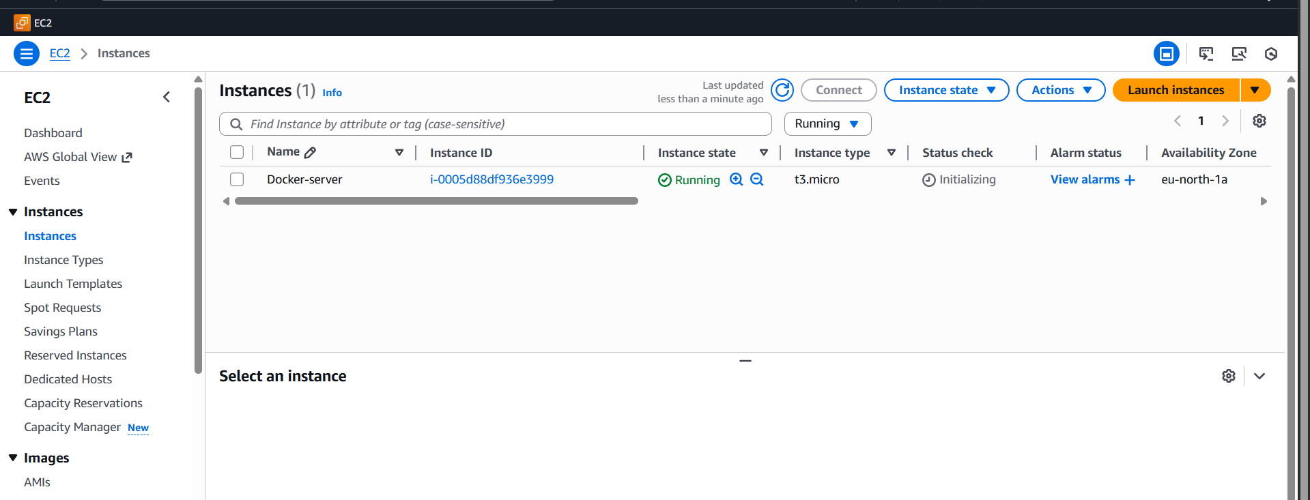
Then use this command to install Docker
sudo yum update -y
Sudo yum install docker -y
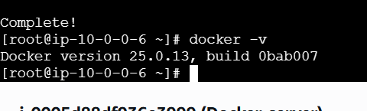
Or alternatively use this command for installing Docker => sudo amazon-linux-extras install docker -y
sudo systemctl start docker
sudo systemctl enable docker then, use this command to start

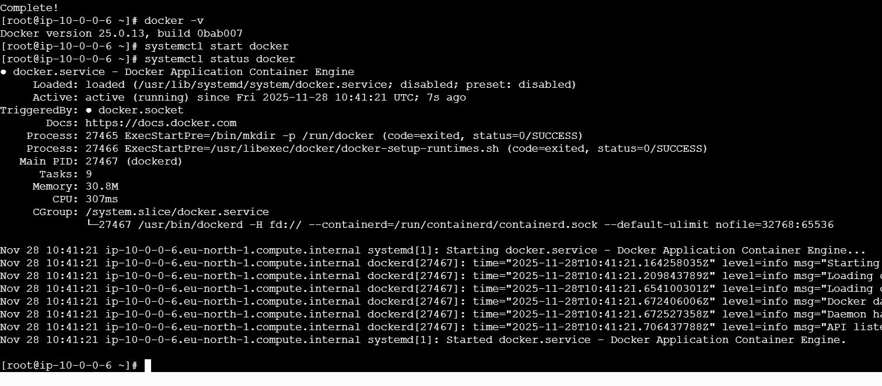

- Pull 5 docker images. (nginx, Apache tomcat, ubuntu, Jenkins, SonarQube)
docker pull nginx
docker pull tomcat
docker pull ubuntu
docker pull jenkins/jenkins:lts
docker pull sonarqube:lts
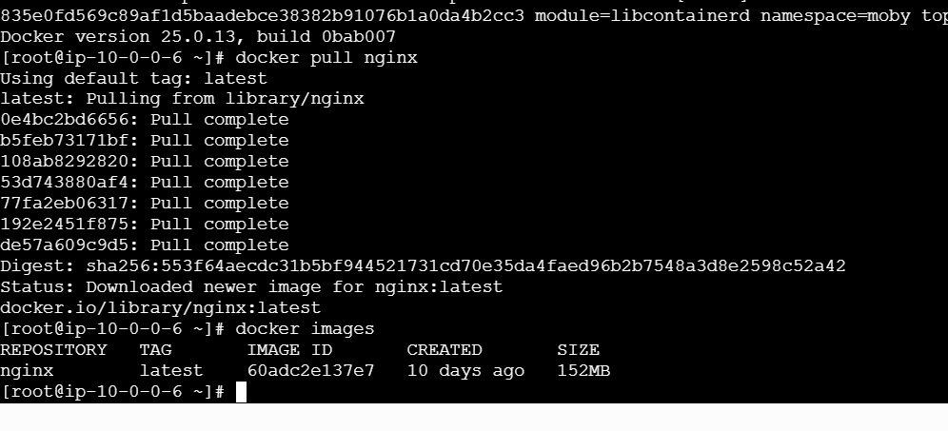

Use this command:
docker run -d --name mynginx -p 80:80 nginx

Docker pull tomcat => use this commad
Run this image instead:
docker run -d --name mytomcat --rm -p 8080:8080 tomcat:9.0

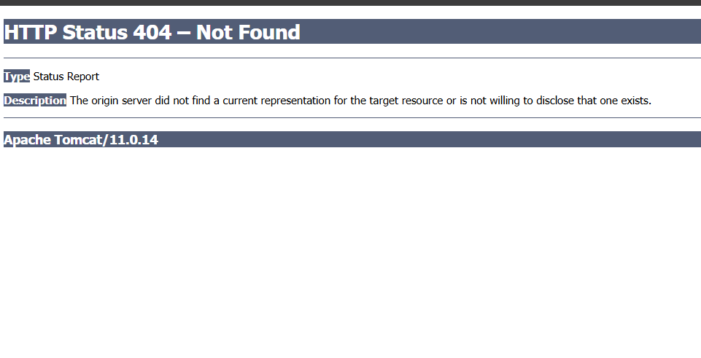

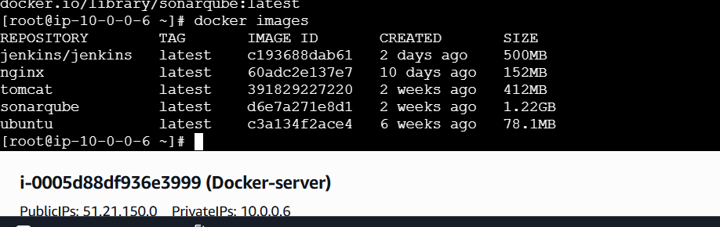
- Run nginx container and expose on port 81.
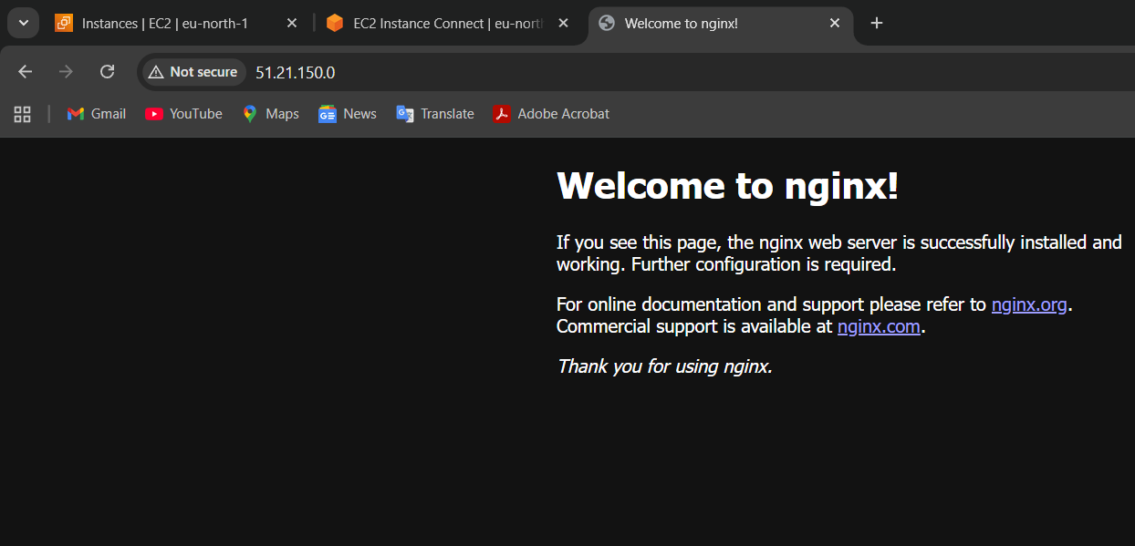
- Delete the Apache Tomcat image from local.
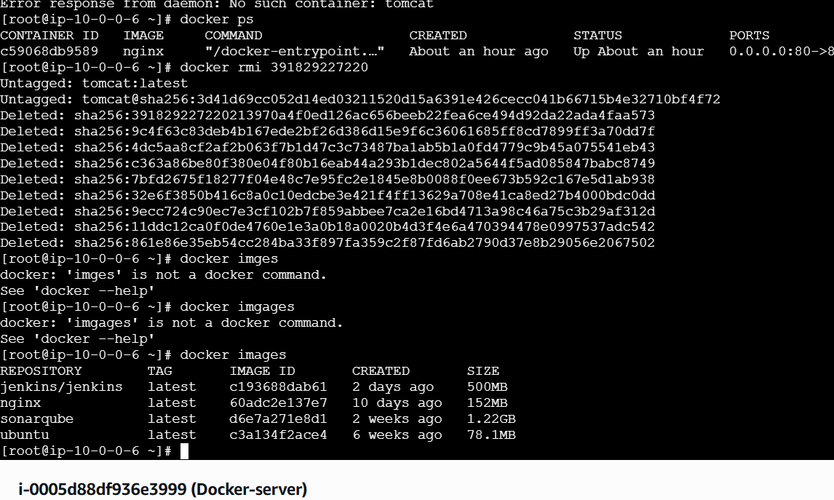

- Inspect the Jenkins image and, SonarQube image.
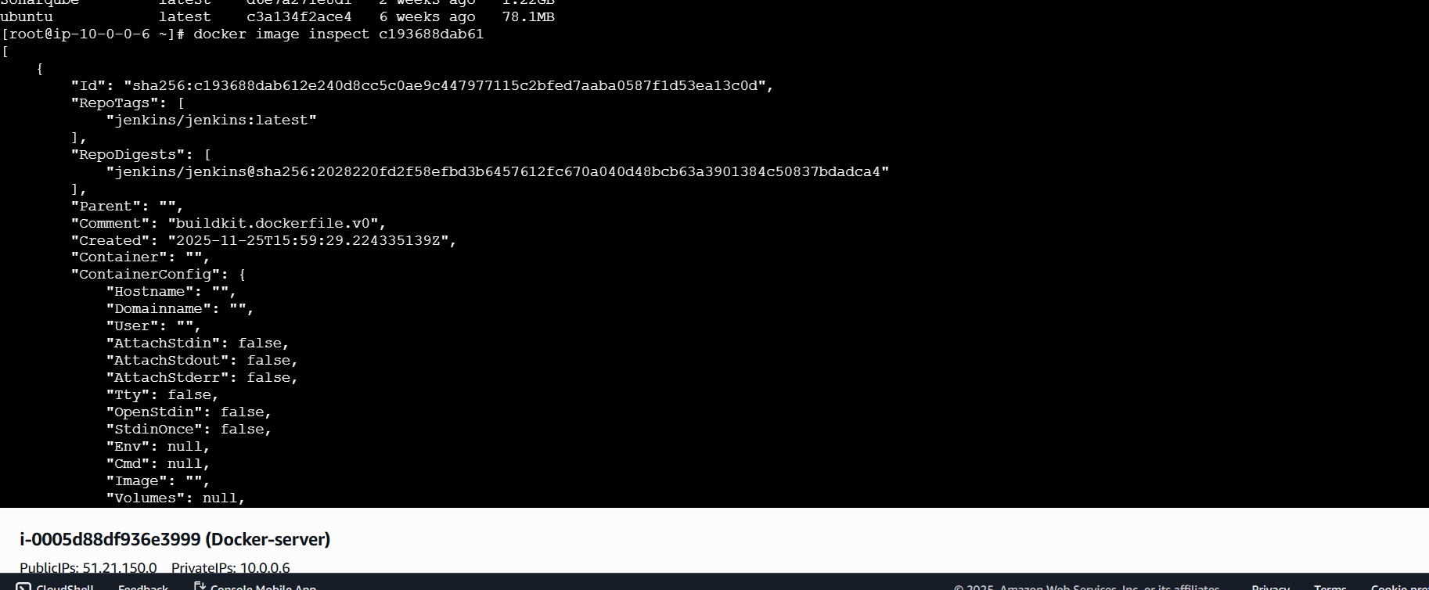
docker image inspect tells you:

What you learn | Why it matters
Exposed ports | So you can open the right ports on EC2
Volumes | So you know where data is stored
Entrypoint & CMD | Know how the app starts
Environment variables | Know default configuration
Layers | Optimization & troubleshooting
Labels | Metadata

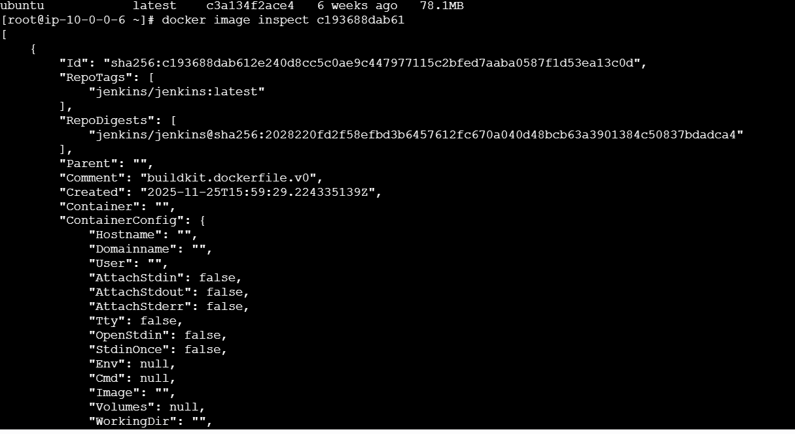
- Run the Jenkins container and run one sample job.
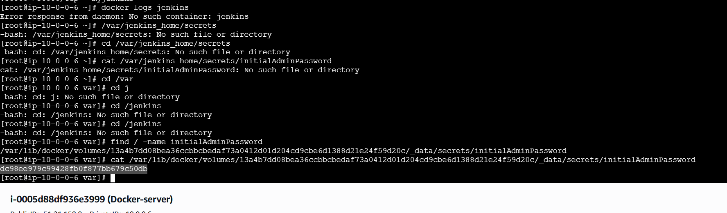
First, run jenkis in a Docker server an EC2 instance
get passwd form there paste it start Jenkins and create a sample job run it
