Start working on Docker-02.
- Create a tomcat container on 8080 and deploy the sample application in Tomcat.

First, the docker pull tomcat
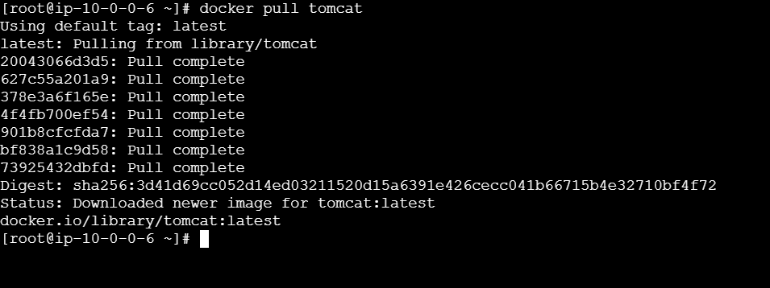
docker container run -itd -p 8080:8081 --name tomcat_test tomcat:latest
this command for run docker =>
container run -its -p 8080:8081 –name tomcat_test tomcat:latest
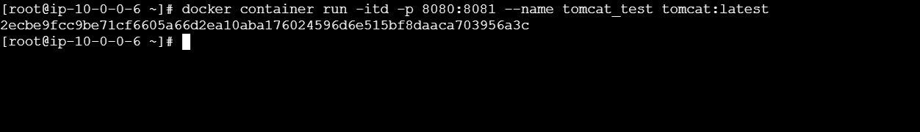
Check the status Docker container ps -a

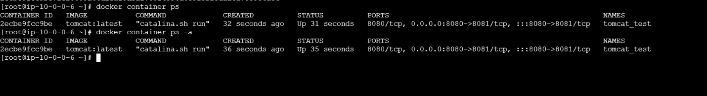
now check ip+8081 it will show like that page will show
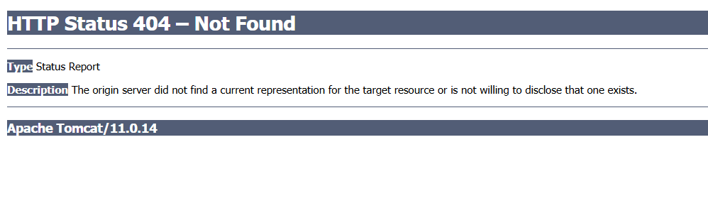
Docker exec -it id /bin/bash
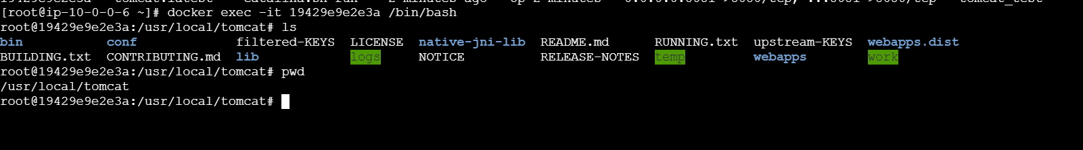
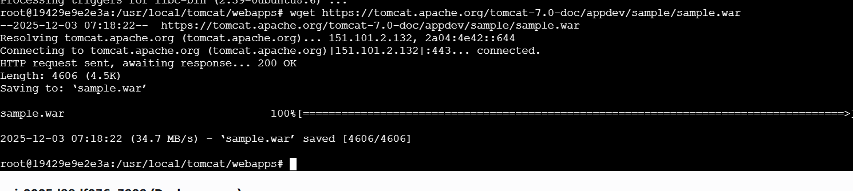
Once download the application
give ll ll it will extract application tar to nomal
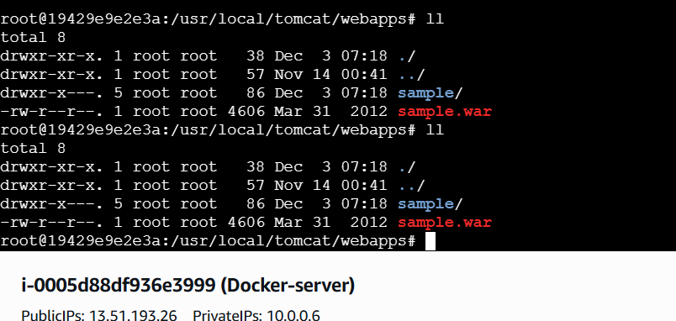
Ip_8081/sample/
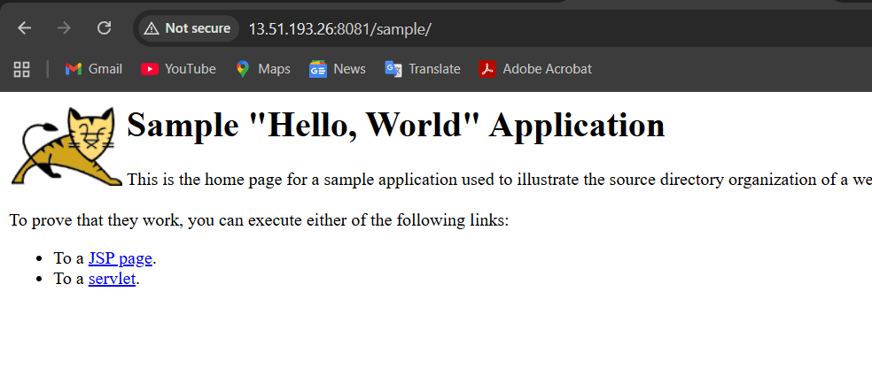

- Create volume and deploy tomcat container on port 8081.

Docker volume create mydate it will crete docker volume
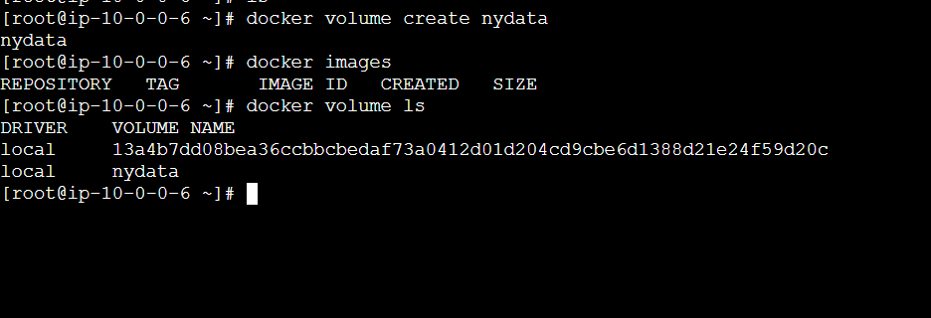
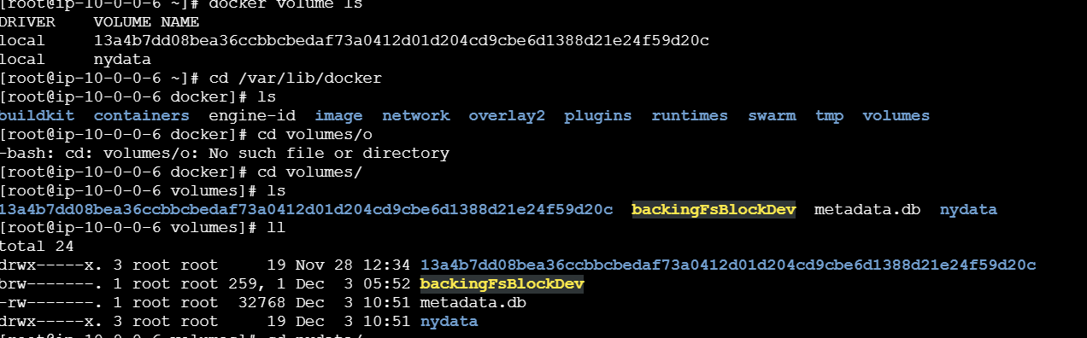
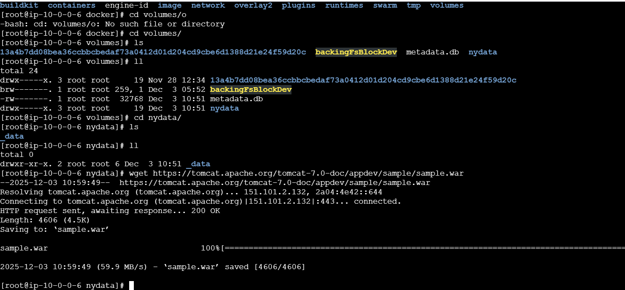
docker container run -itd -p 8082:8080 -v /var/lib/docker/volumes/nydata/_data:/usr/local/tomcat/webapps tomcat:latest
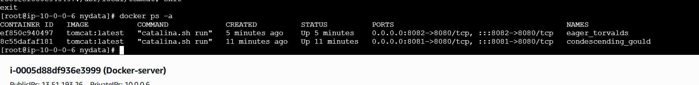

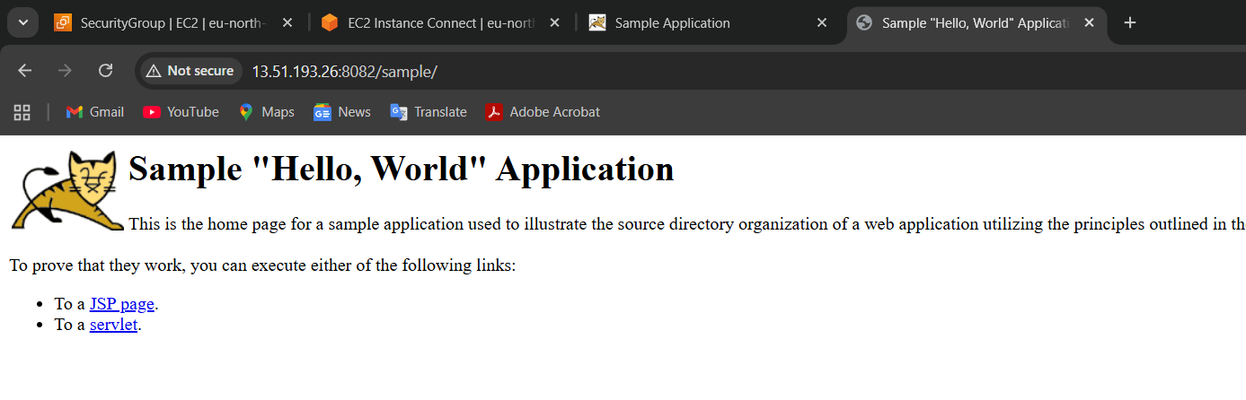

- Limit the nginx container to 500 MB.
docker container run -itd -p 8082:80 --memory 512m --name nginx_test nginx
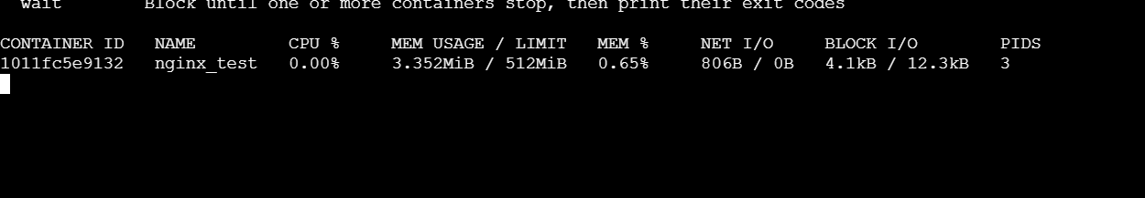
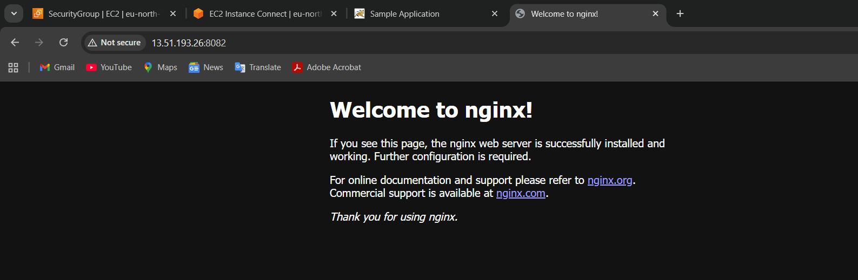
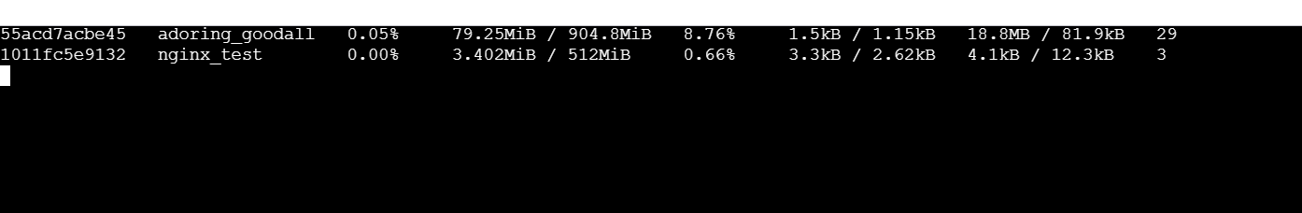
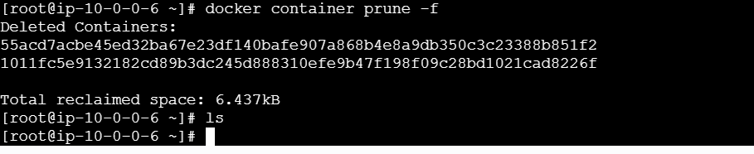

- Create a sample docker file using below instructions.
  - Base module as amazonlinux:latest
  - Maintainer you name
  - Install nginx
  - COPY one index.html file to image
  - Expose on port 80
  - Command to start the nginx container
FROM amazonlinux:latest
MAINTAINER Bharathiraja
RUN yum update -y && \
yum install -y nginx && \
yum clean all
COPY index.html /usr/share/nginx/html/index.html
EXPOSE 80
CMD ["nginx", "-g", "daemon off;"]

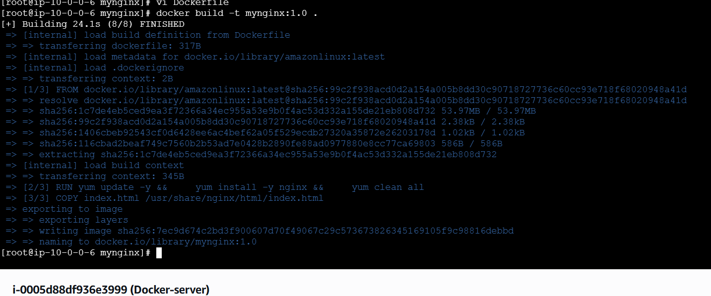
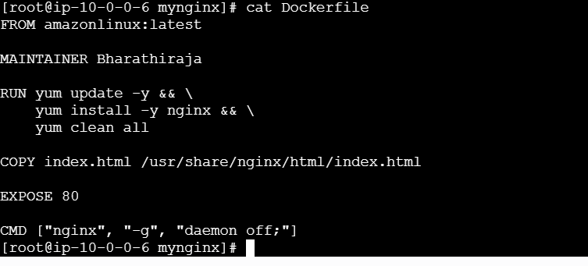

- Push image to Docker Hub
Create a Docker hub account
Give name as I give like that
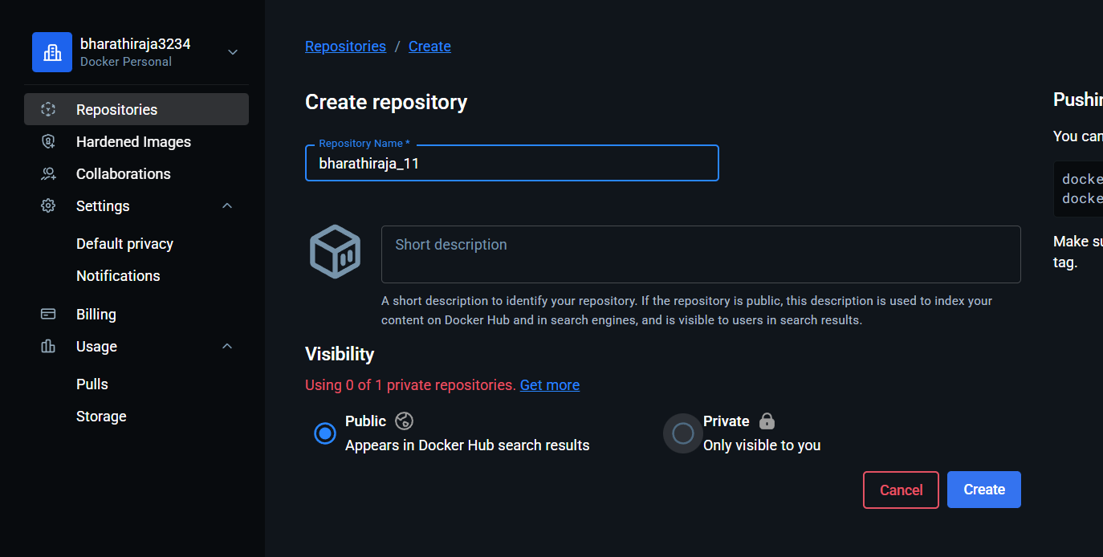
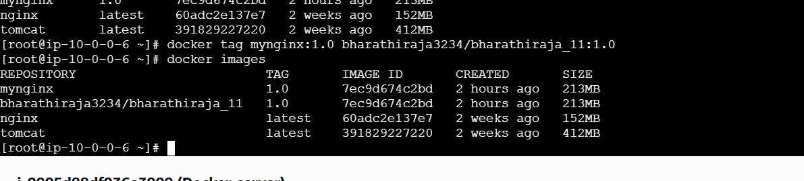
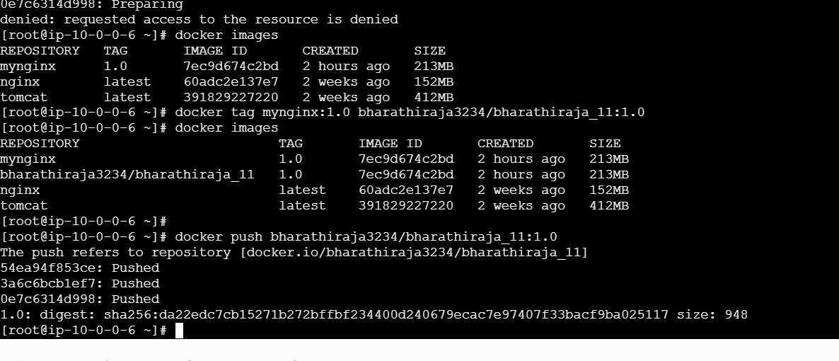
I push the images

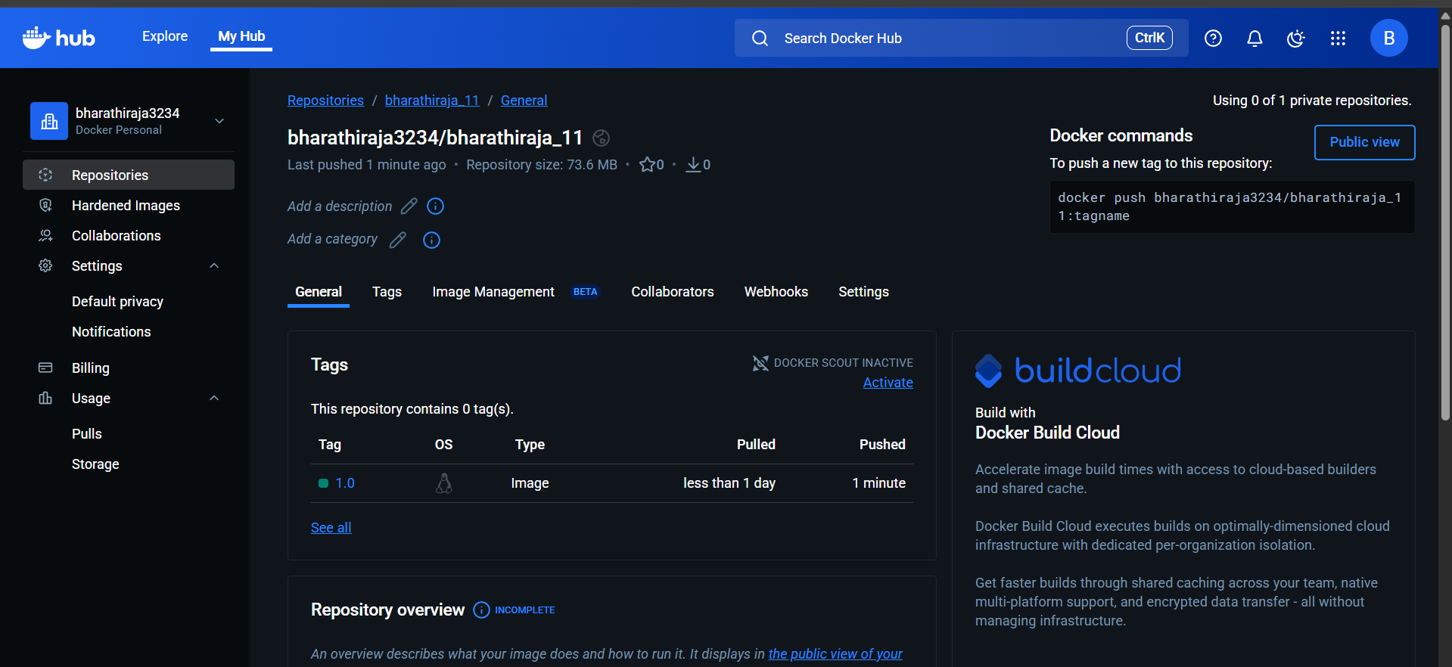

- push image to AWS ECR

