Docker- task-03.
- Create an image from a running container.
Docker images
It will list out the images list
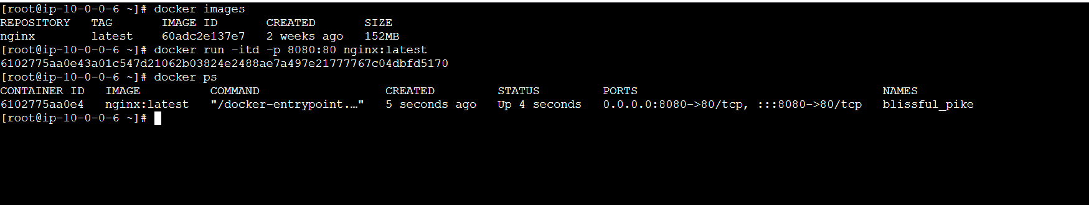
Docker images
docker commit container id name
it will create a custom id
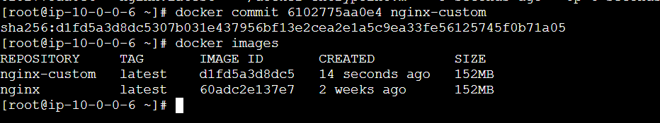

- Copy the image from the local machine to the Docker server and load the image.
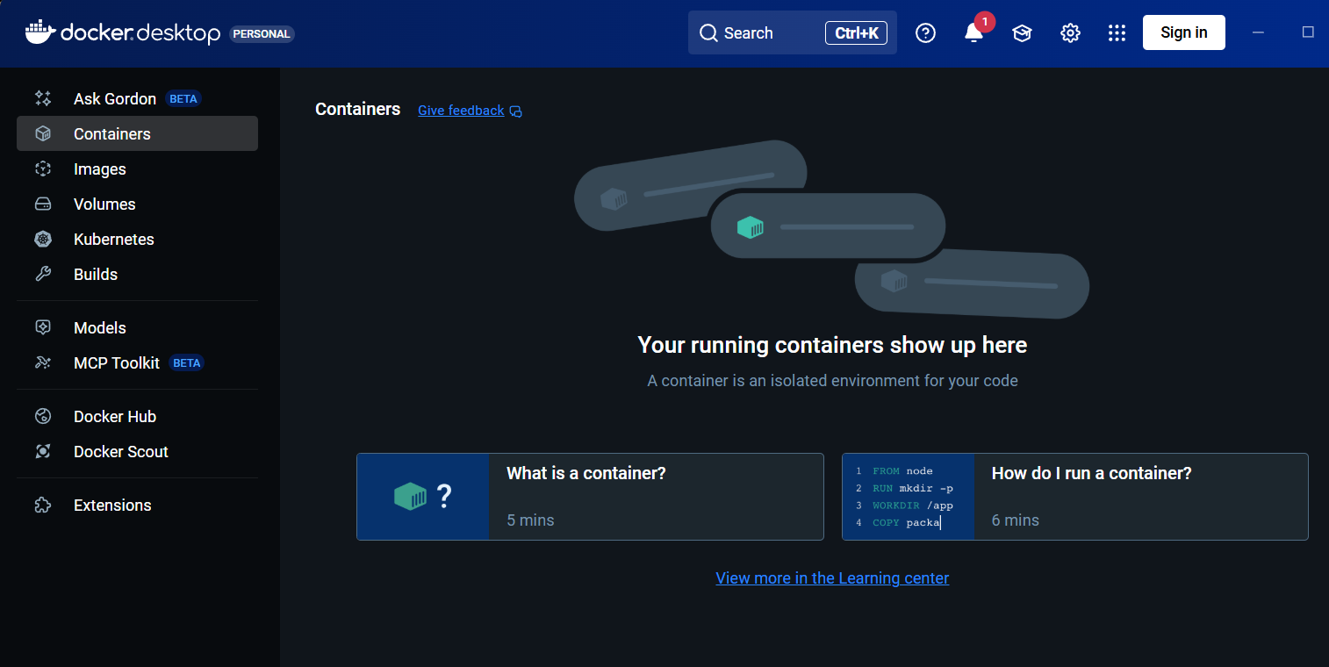
For checking Docker imaegs
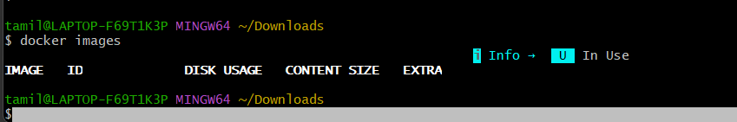
Docker pull tomcat
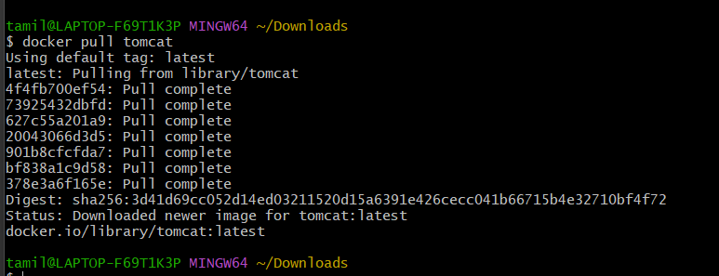
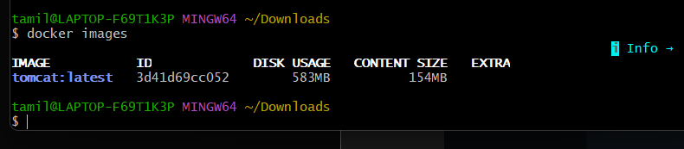
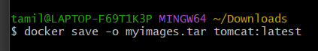
Docker save -o myimages.tar tomcat:latest
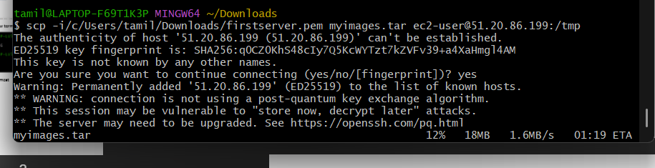
scp -i/c/Users/tamil/Downloads/firstserver.pem myimages.tar ec2-user@51.20.86.199:/tmp
go to the ec2 instance and changes it to tmp directory
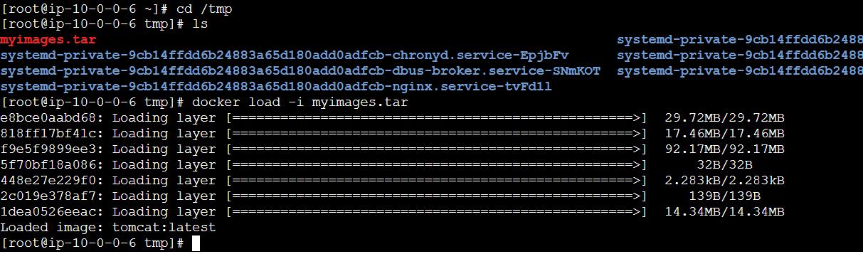
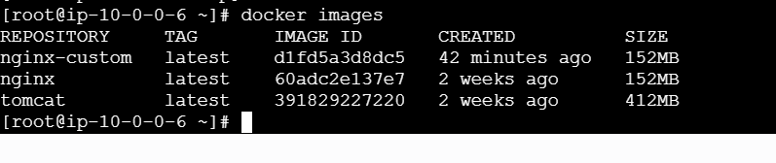

- Create a Docker image using Alpine and customize it with Tomcat.
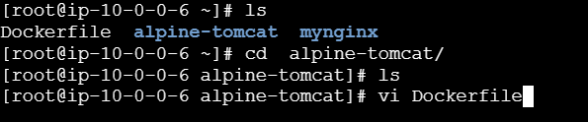
In that created directory create a file named as docker file
and give this script

FROM alpine:latest
# Install required packages (OpenJDK + curl)
RUN apk update && \
apk add --no-cache openjdk17 curl tar bash
# Set environment variables
ENV CATALINA_HOME /opt/tomcat
ENV PATH $CATALINA_HOME/bin:$PATH
# Download and install Tomcat
RUN mkdir -p $CATALINA_HOME && \
curl -O https://dlcdn.apache.org/tomcat/tomcat-
9/v9.0.112/bin/apache-tomcat-9.0.112.tar.gz && \
tar xzf apache-tomcat-9.0.112.tar.gz -C /opt/tomcat --
strip-components=1 && \
rm apache-tomcat-9.0.112.tar.gz
# Expose Tomcat port
EXPOSE 8080
# Start Tomcat
CMD ["bash", "-c", "$CATALINA_HOME/bin/catalina.sh run"]
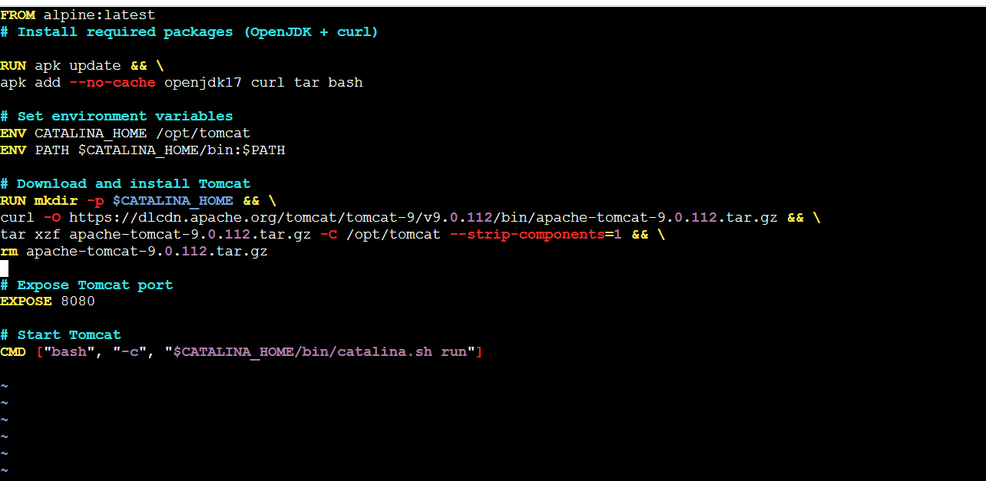
Docker build -t alpine-tomcat:latest . => to execute this command for run the dokcer file

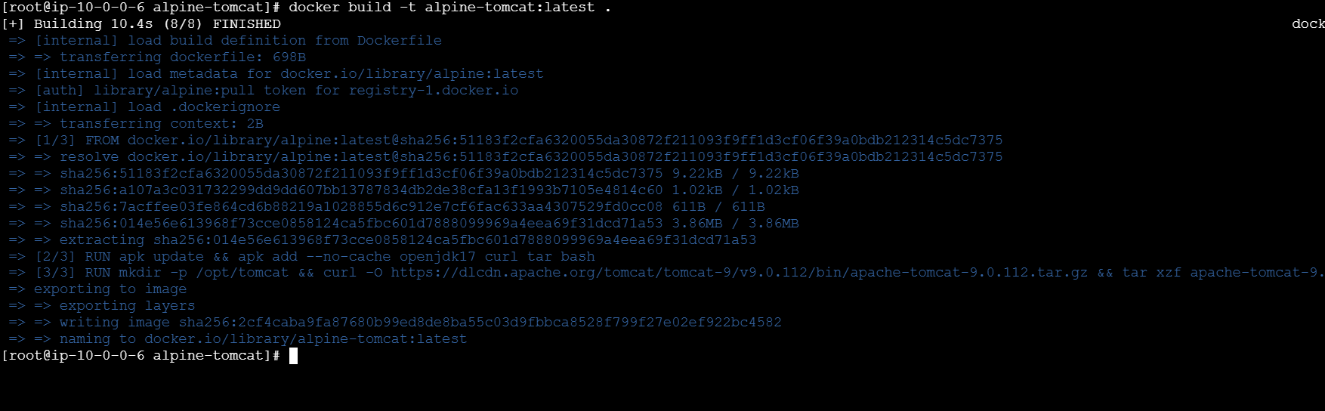
docker run -d -p 8080:8080 alpine-tomcat:latest => to run the
Ip+8080 check the website it will appear tomcat
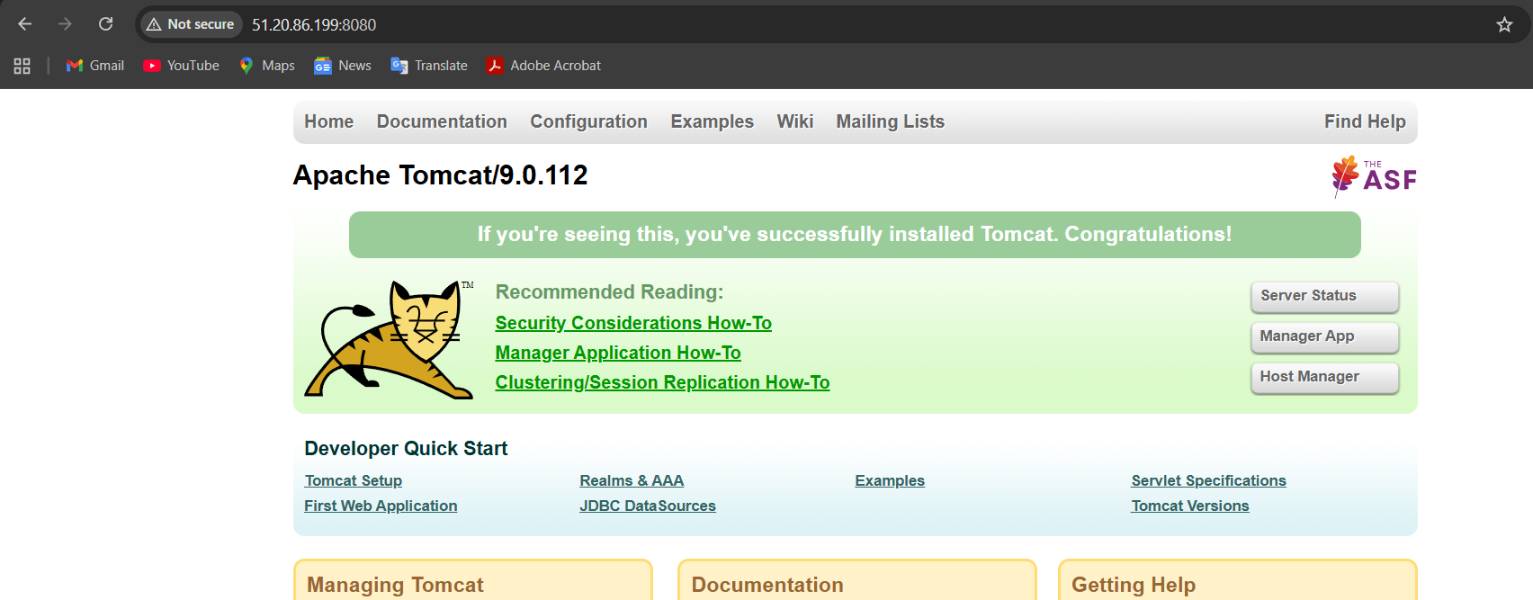

- Create single stage and multi-stage Docker file using this source code: https://github.com/betawins/multi-stage-example.git
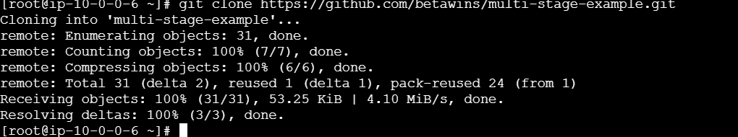
Cd multistage file
vi Dockerfile

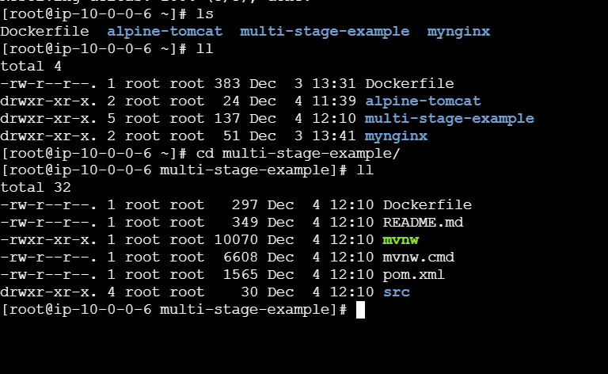

single-app -p 8081:8080 single-stage-app:latest
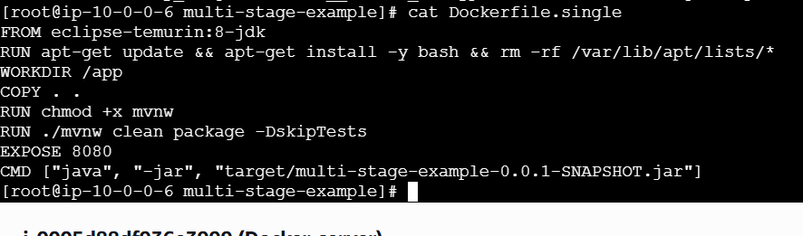
docker buildx build -f Dockerfile.single -t my_image:1.0 .
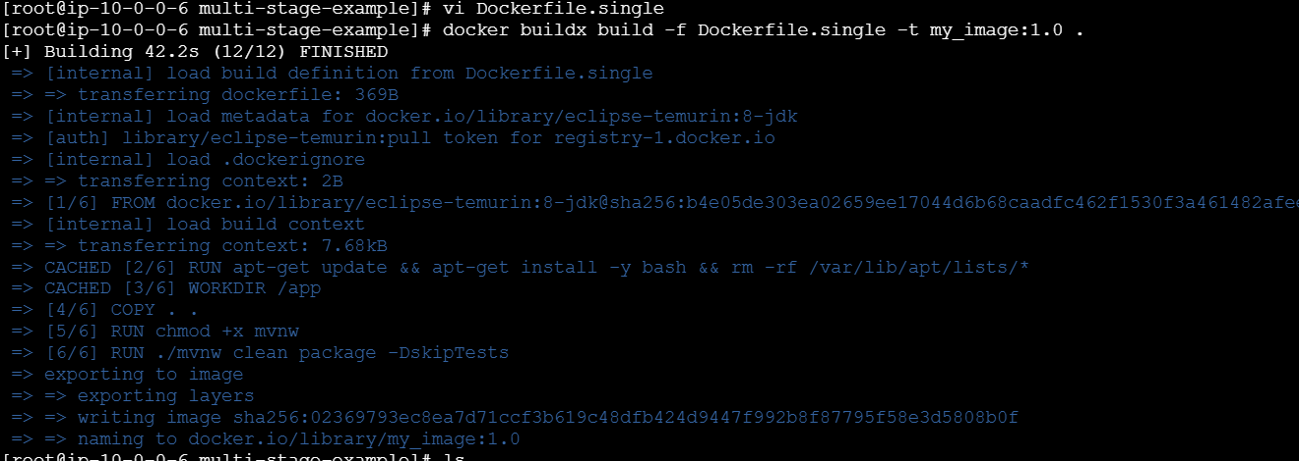
docker run -itd -p 8081:8080 my_image:1.0
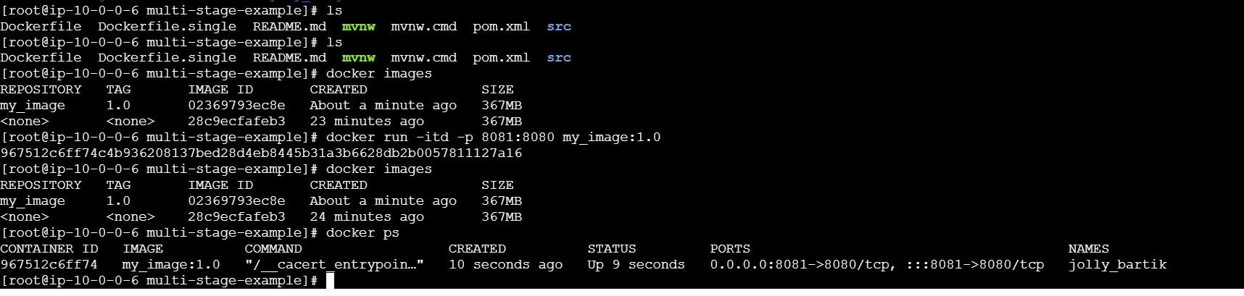
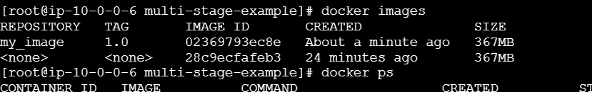

Creata a Docker multistage
add the code
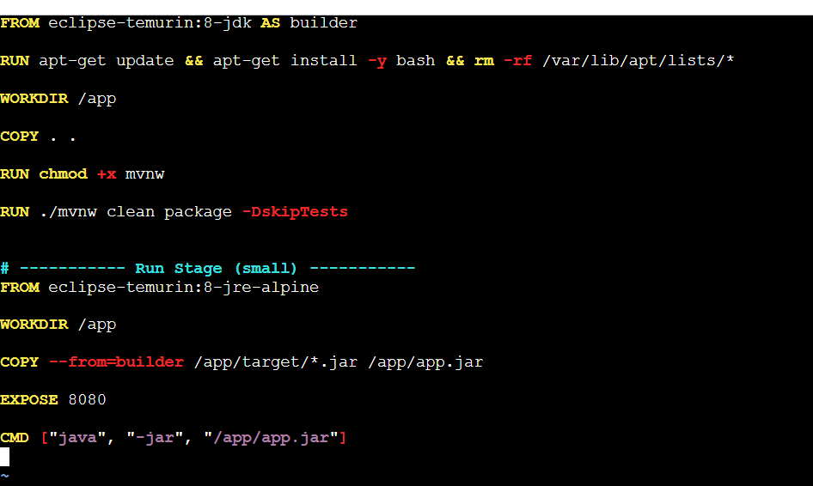
docker build -f Dockerfile.multistage -t my_image:1.0 . => for build
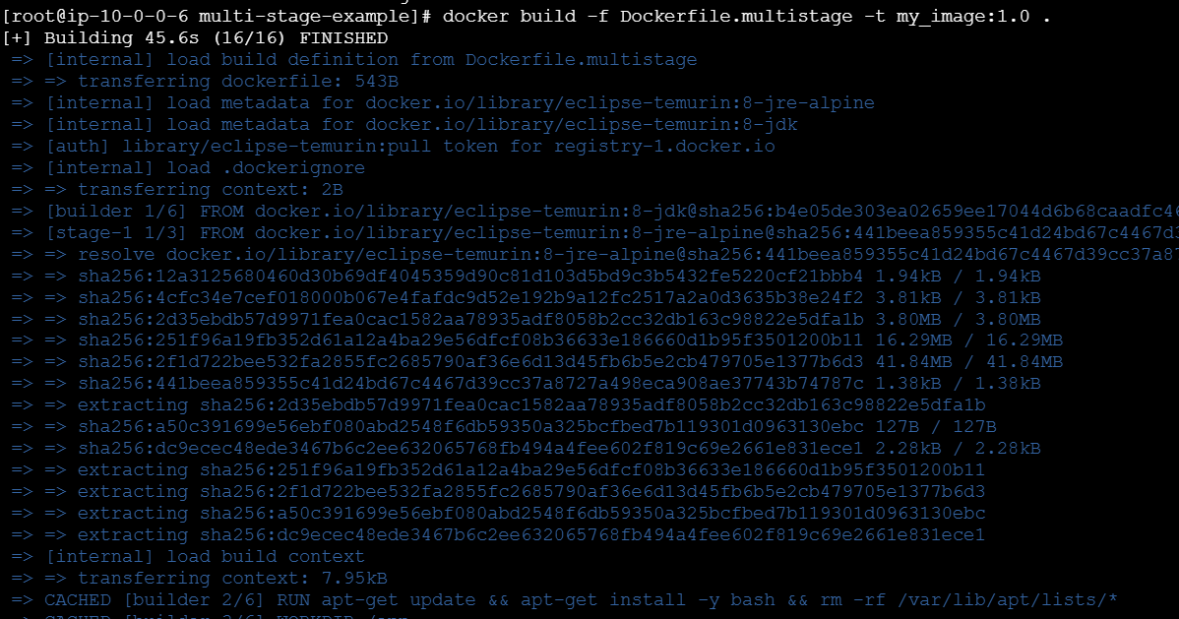

docker run -d -p 8082:8080 my_image:1.0 => for run it
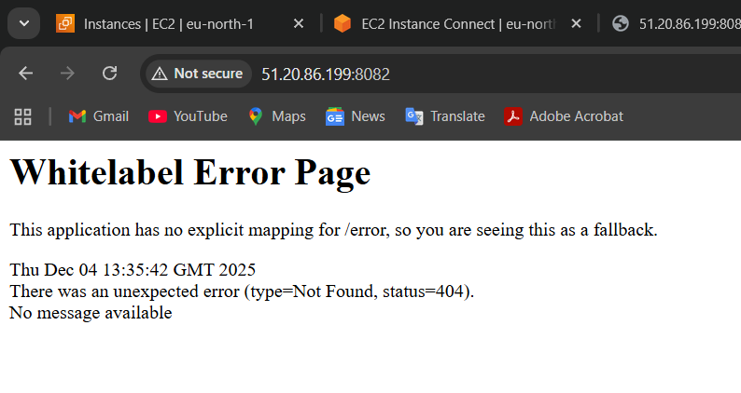

- Install Docker Compose and execute the sample application.

curl -SL
https://github.com/docker/compose/releases/download
/v2.23.0/docker-compose-linux-x86_64 -o
/usr/local/bin/docker-compose

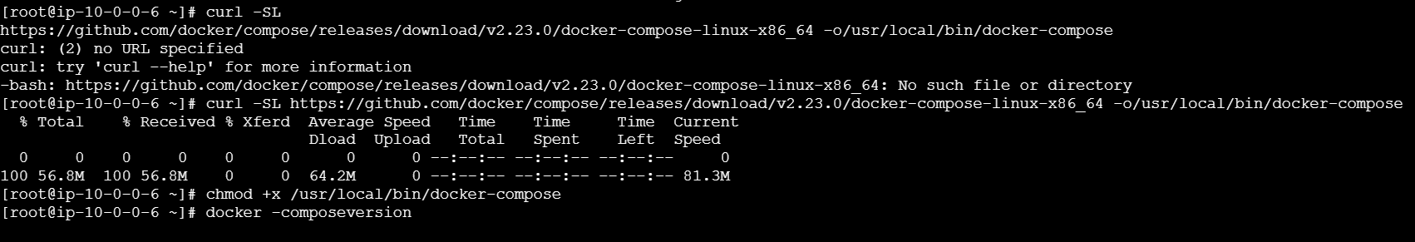
chmod +x /usr/local/bin/docker-compose
docker-compose version
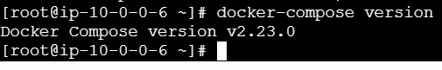
version: "3.8"

services:
db:
image: mysql:5.7
restart: always
volumes:
- db_data:/var/lib/mysql
environment:
MYSQL_ROOT_PASSWORD: somewordpress
MYSQL_DATABASE: wordpress
MYSQL_USER: wordpress
MYSQL_PASSWORD: wordpress

wordpress:
image: wordpress:latest
restart: always
depends_on:
- db
ports:
- "8000:80"
environment:
WORDPRESS_DB_HOST: db:3306
WORDPRESS_DB_USER: wordpress
WORDPRESS_DB_PASSWORD: wordpress
WORDPRESS_DB_NAME: wordpress

volumes:
db_data:
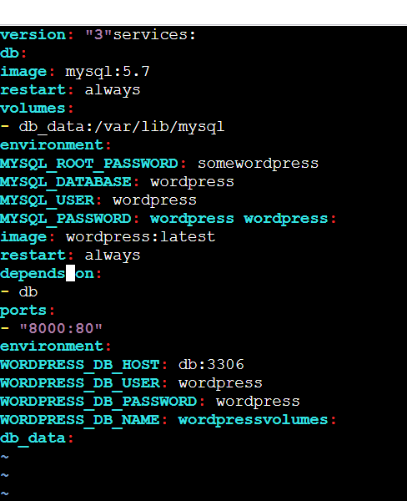
docker compose up -d
http://51.20.108.17:8000/wp-admin/install.php

- Implement a solution to scan images when pushed to the Docker registry.
First we need to login docker
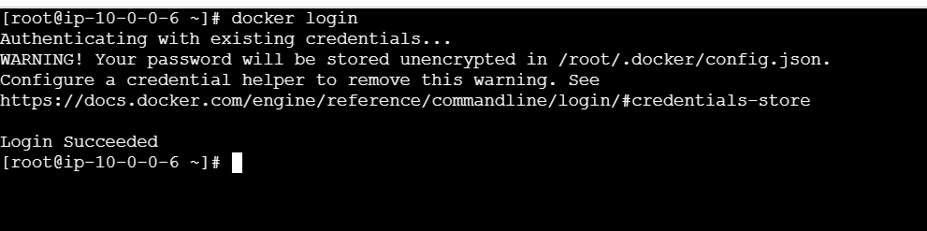
Image has been created
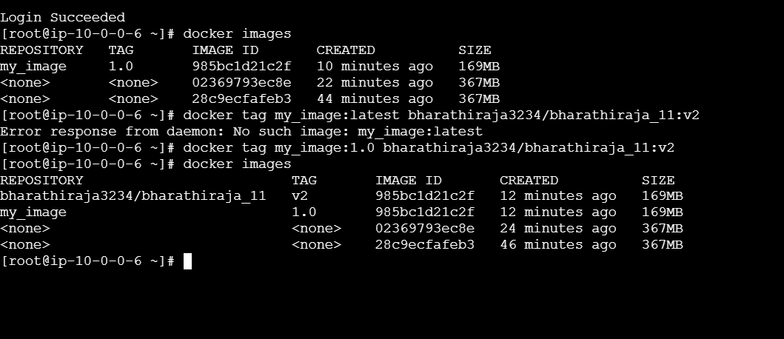
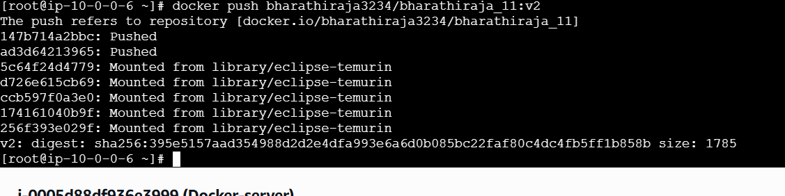
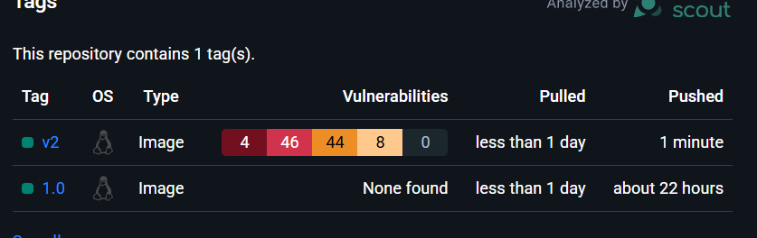
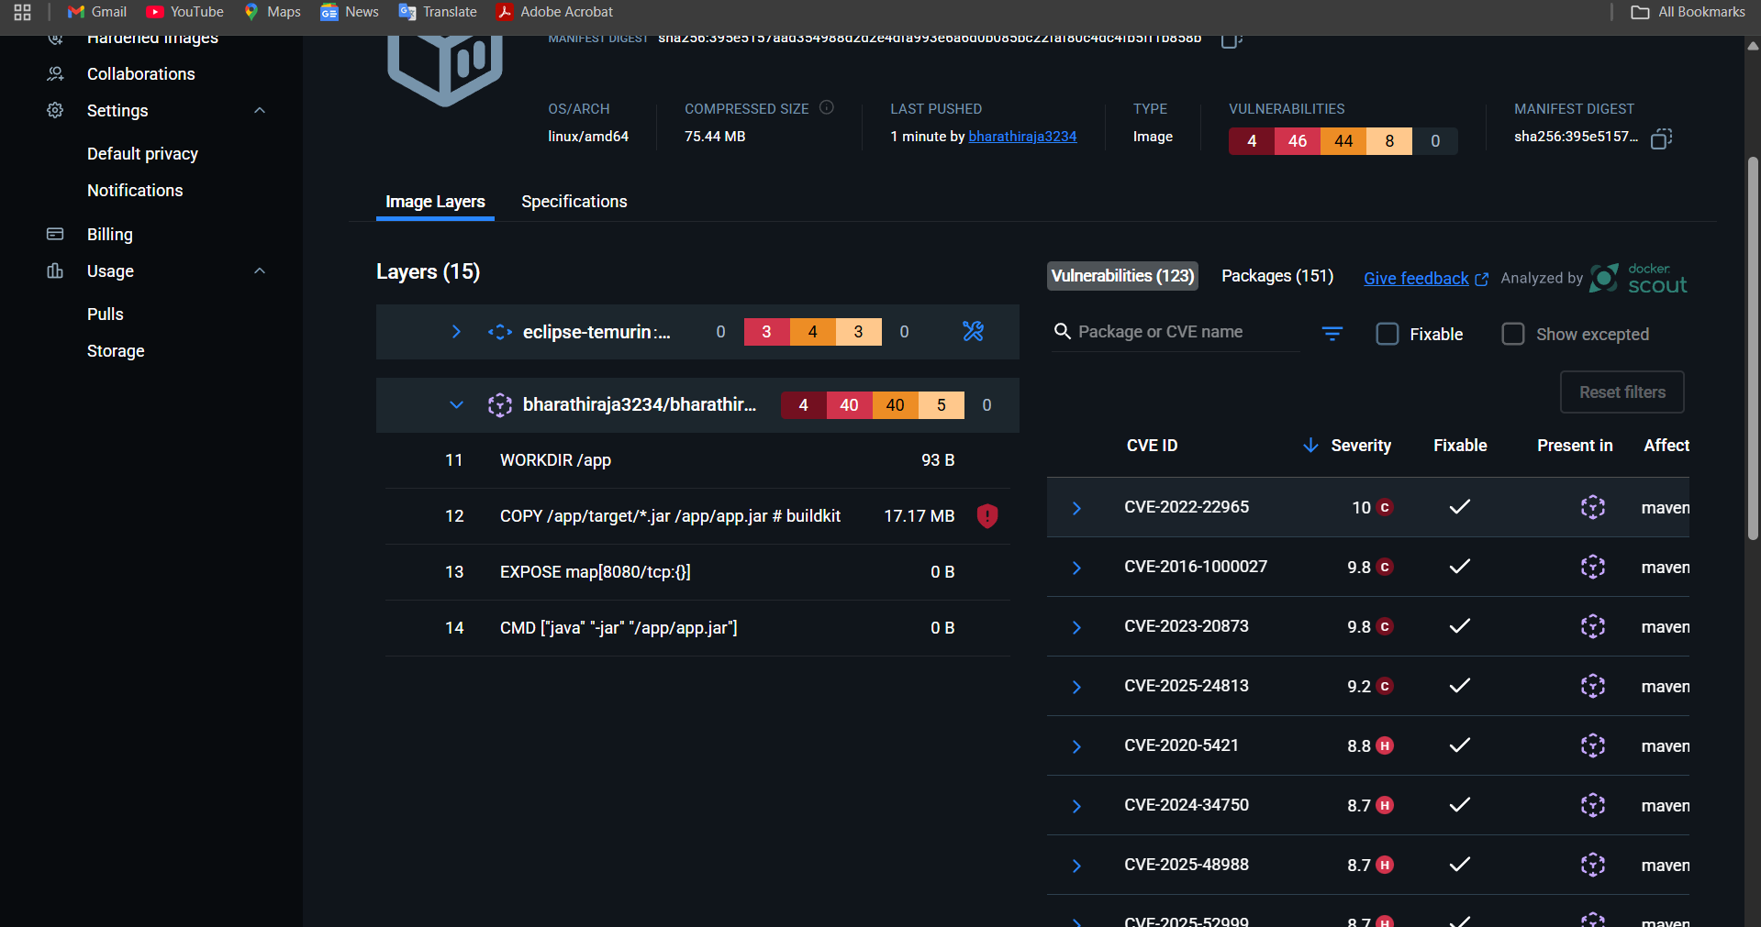

- Implement a solution to scan images when pushed to AWS ECR.
curl -sfL
https://raw.githubusercontent.com/aquasecurity/trivy/
main/contrib/install.sh | sudo sh -s -- -b /usr/local/bin
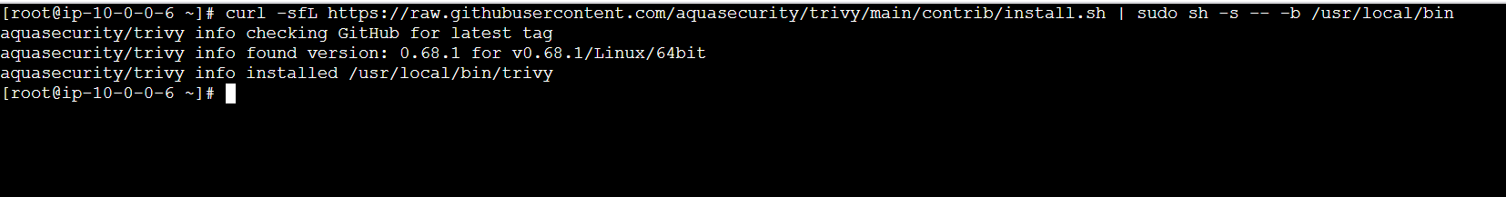
- Create a Jenkins pipeline to create a Docker image and push the image to Docker Hub.
Create a new pipeline
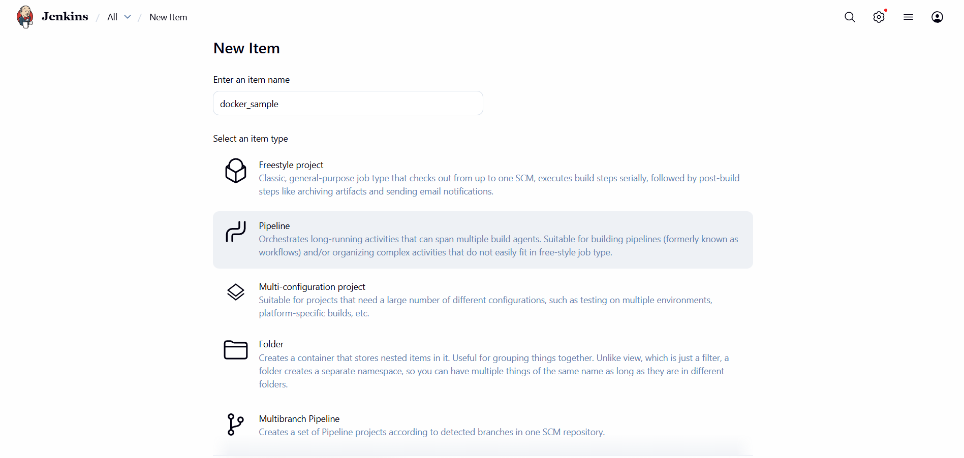
Add a credential Docker Hub form Jenkins
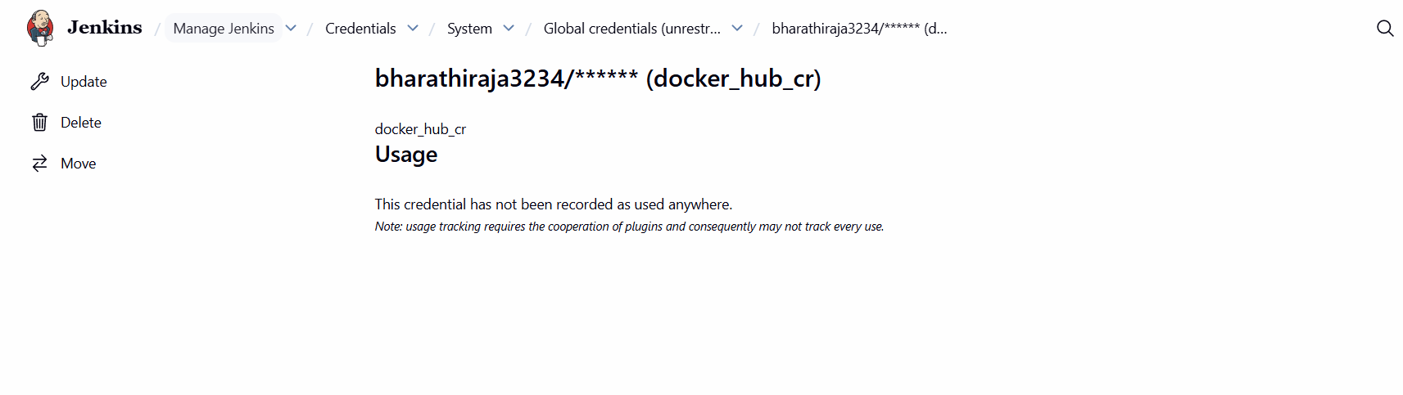
Create a use name
sudo usermod -aG docker jenkins
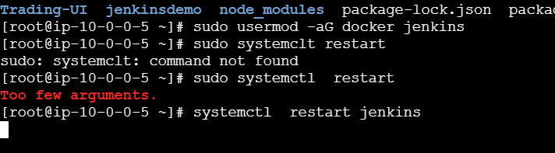
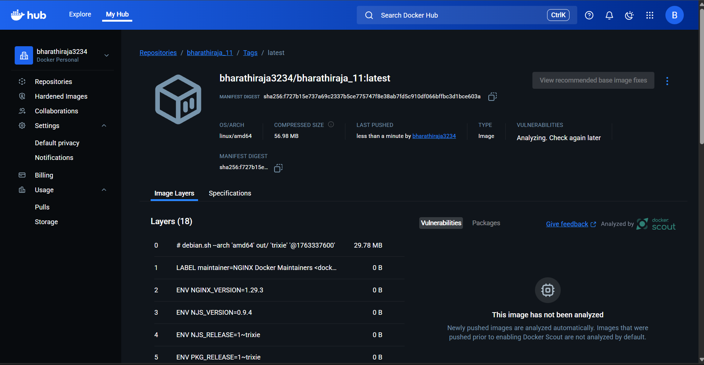
Once run after check the docker hub
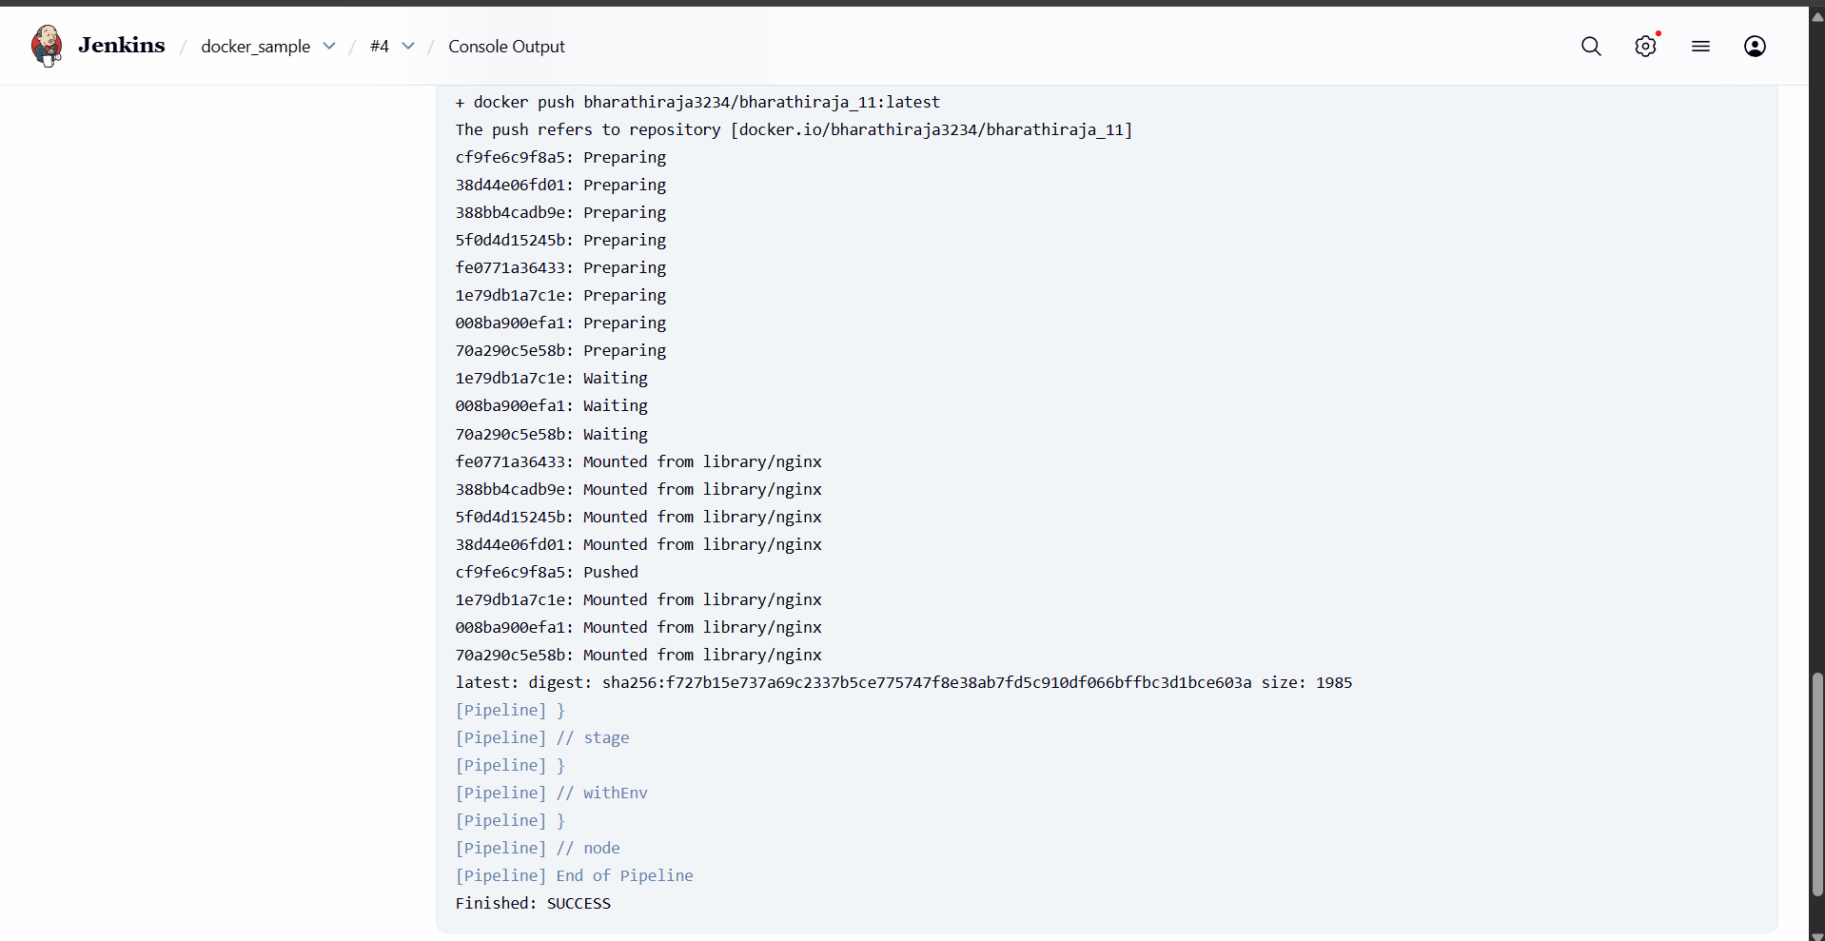
<!DOCTYPE html>
<html>
<head>
<title>Test Page</title>
</head>
<body>
<h1>Hello from Jenkins Docker Build!</h1>
</body>
</html>

FROM nginx:latest
COPY index.html /usr/share/nginx/html/index.html

pipeline {
agent any

environment {
// Replace with your Docker Hub username/repository
DOCKER_IMAGE = "bharathiraja3234/bharathiraja_11:latest"
}

stages {

stage('Build Docker Image') {
steps {
sh '''
docker build -t $DOCKER_IMAGE.
'''
}
}

stage('Login to Docker Hub') {
steps {
withCredentials([usernamePassword(credentialsId: 'docker_hub_cr',
usernameVariable: 'DOCKER_USER',
passwordVariable: 'DOCKER_PASS')]) {
sh '''
echo $DOCKER_PASS | docker login -u $DOCKER_USER --password-stdin
'''
}
}
}

stage('Push Docker Image') {
steps {
sh '''
docker push $DOCKER_IMAGE
'''
}
}

}
}

