Start working on Ansible-01 tasks:
- Watch the ansible-01 video and write down notes.
- Set up one master and two worker nodes in Ansible.
Create a master server
worker -01
worker -02
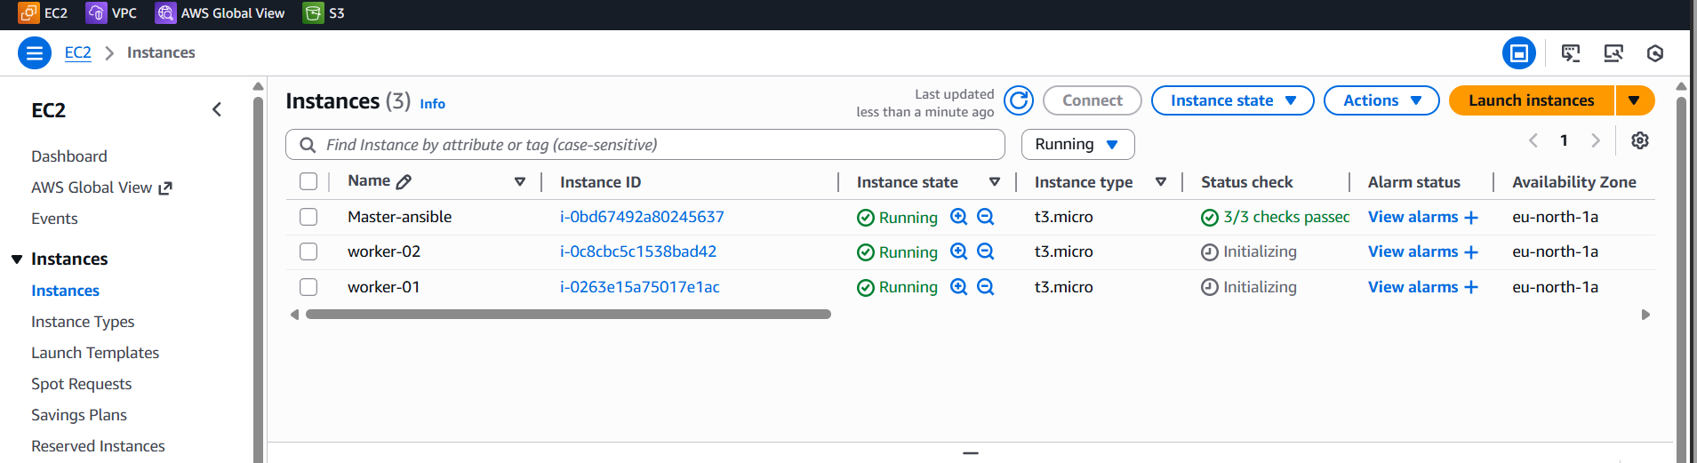
Check the command for version Python3 --version
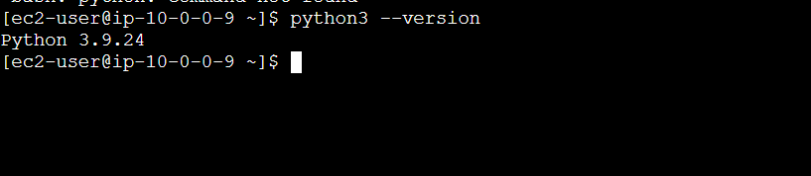
To install Ansible, yum install ansible -y use this command
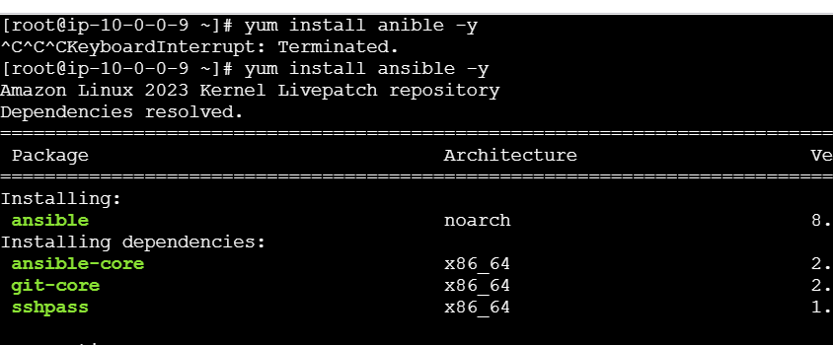
Check the Ansible version: ansible --version
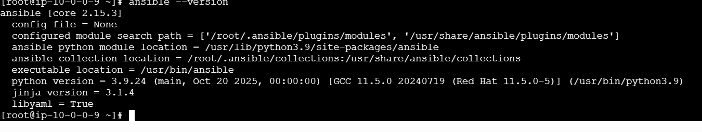
Go to /etc/ansible an change the hosts file.
• cd /etc/ansible
• vi hosts
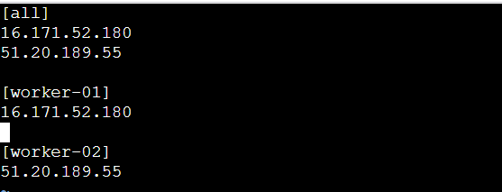
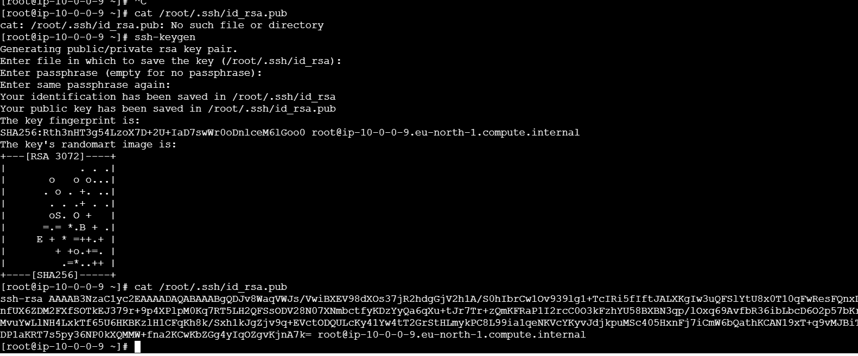
Copy the key and login to worker-01 server, go to .ssh
directory and make the paste the copied key in authorized
files
• cd .ssh
• vi authorized_keys
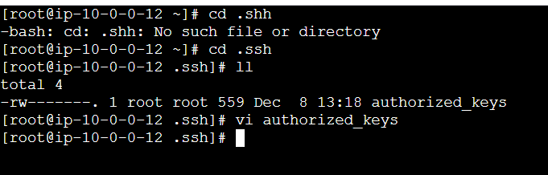
Login to the worker-02 go to .ssh directory and make the
paste the copied key in authorized files
• cd .ssh
• vi authorized_keys
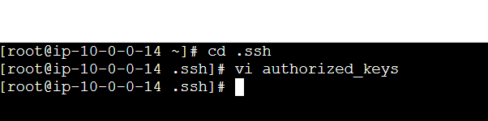
Go to your main server
• ansible all -m ping
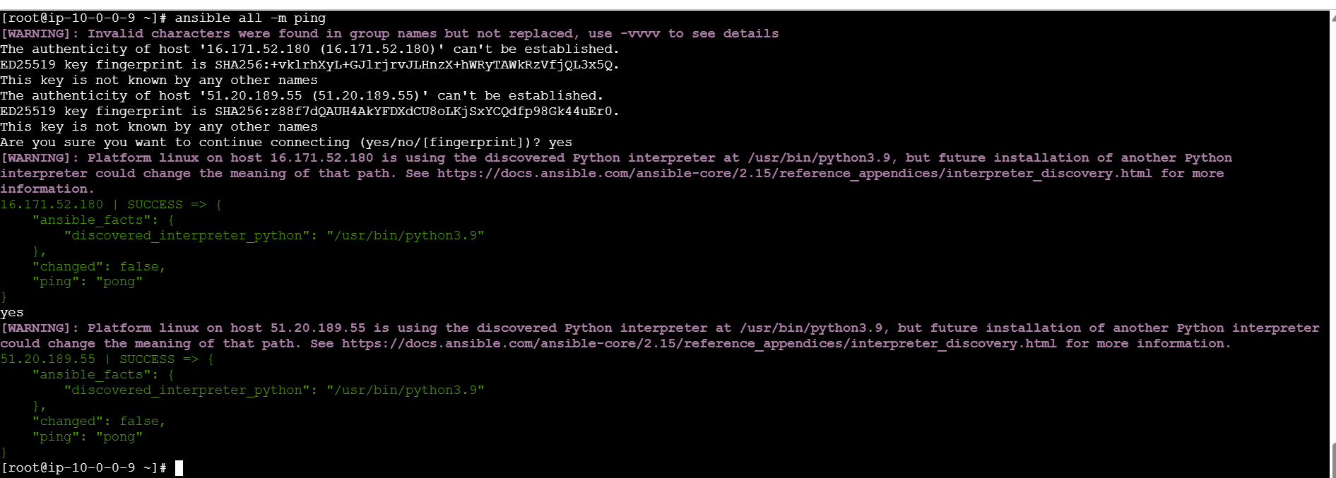
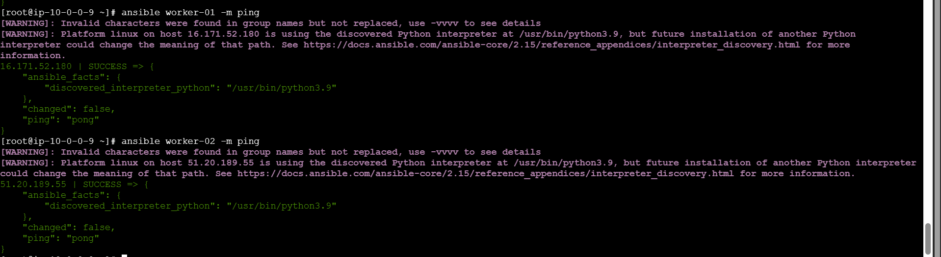
ansible all -m setup
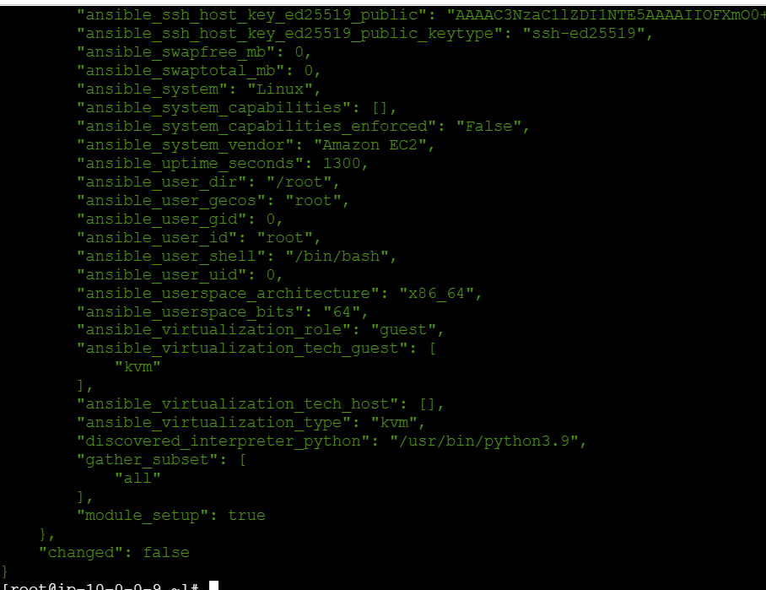

- Execute the adhoc command shared in #dvps-cloud-documents-12 Channel.

ansible all -a uptime
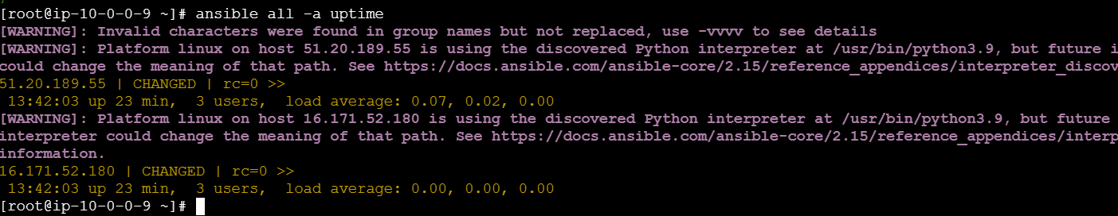
• ansible all -a free -m
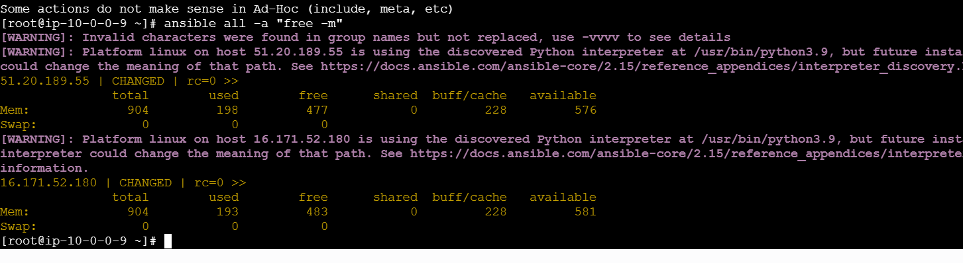
• ansible all -m yum -a name=httpd state=installed
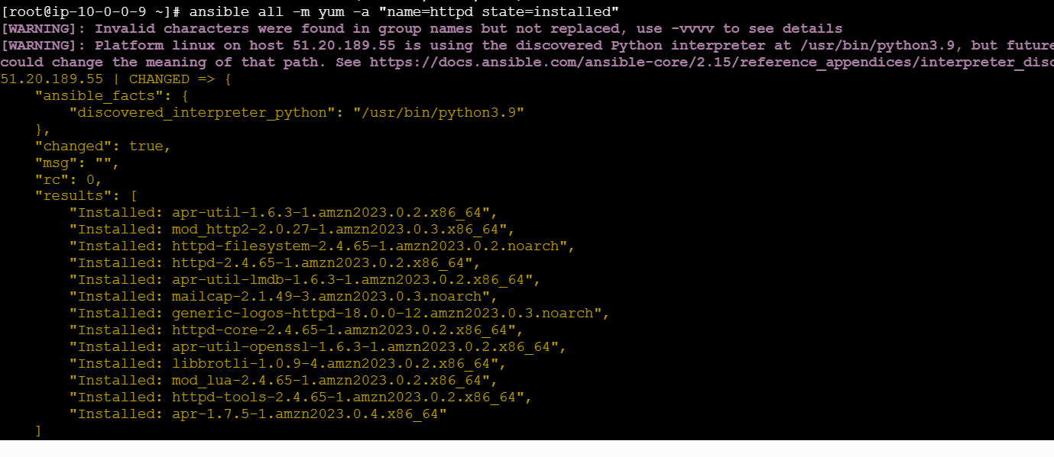
ansible all -m service -a “name=httpd state=started
enabled=yes”
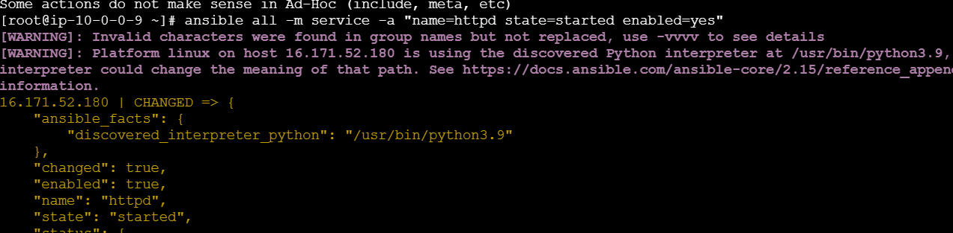
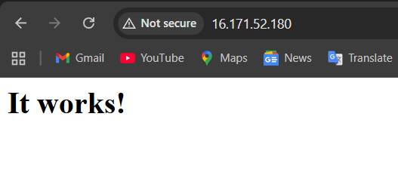
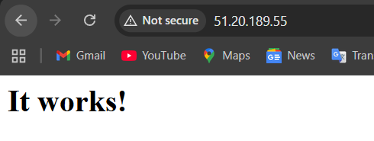
ansible all -m service -a name=httpd state=stopped
enabled=yes
stop the service it will not work
