Docker challenges -02

Goal of the Exercise
The goal of this exercise is to test your understanding of a Cloud Compute deployment with Terraform.
You are tasked with creating a codebase for a microservice deployment on a cloud environment, using Terraform. Since our focus is not the application itself, the service will be a simple web server that returns a static page.Requirements
Service Details
- The service will be a simple web server that returns a static page.
- You can use apache2 or nginx to serve a simple HTML file.
- The service should be containerized and stored in a Docker registry.
- The service should be deployed on a single VM instance as a docker container.
- The image should be pulled from the registry specified earlier.
- The service should not be accessible from the internet but only through a Load Balancer, except for SSH access from specific IP addresses.
Deliverables
You are to provide the following as part of your solution:
- Dockerfile to build the image.
- Terraform codebase to deploy the following:
  - Docker registry
  - VPC and all required networking resources
  - EC2 instance
  - Load Balancer
Notes
- Since a CI/CD pipeline is not part of this exercise, we will work around that with the help of Terraform.
- To push the image to the Docker registry, build the image locally before running the Terraform code.
- Once the image registry is created, use Terraform to push the local image to the registry.
- Similarly, use Terraform to pull the image from the registry and run it on the VM instance once it is created.
- For SSH access:
  - Use a locally created key.
  - Add it to the cloud provider key storage.
  - Attach it to the instance.
- Use Terraform best practices for file structure and code organization.
  - Use variables, locals, modules, etc. when appropriate.
- Include all tfvars, scripts, and other helper files used to deploy the application.
- You may use any cloud provider of your choosing, although AWS is preferred.
- Use a free tier account or a trial account to deploy the resources

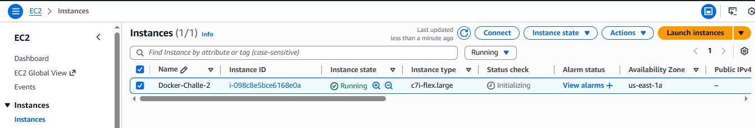

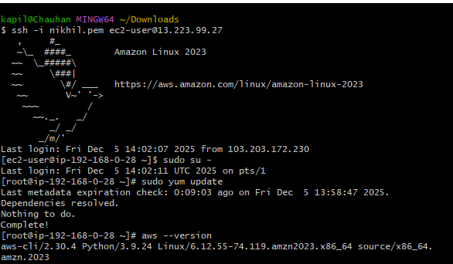

- Install Terraform

- sudo yum install -y yum-utils shadow-utils

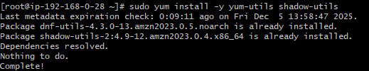

- sudo yum-config-manager --add-repo https://rpm.releases.hashicorp/AmazonLinux/hashicorp.repo

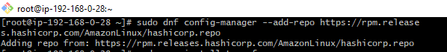

- sudo yum install terraform

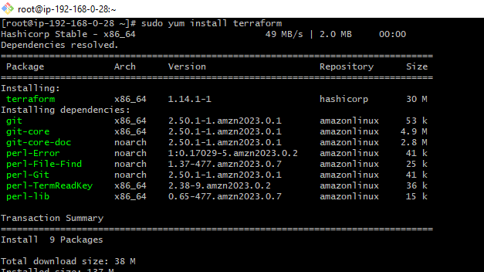

- Insatll Docker

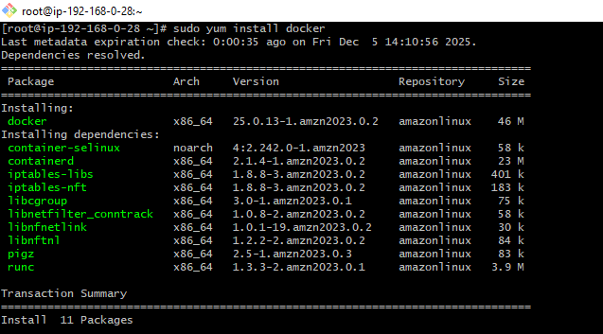
- Systemctl start docker
- Systemctl status docker
- Dockerhub login

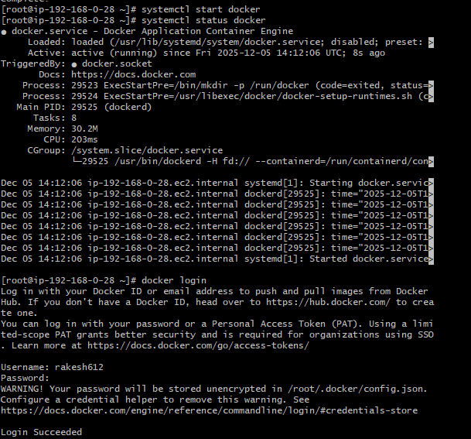

- AWS Configure credentials

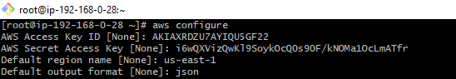

- Ssh-keygen

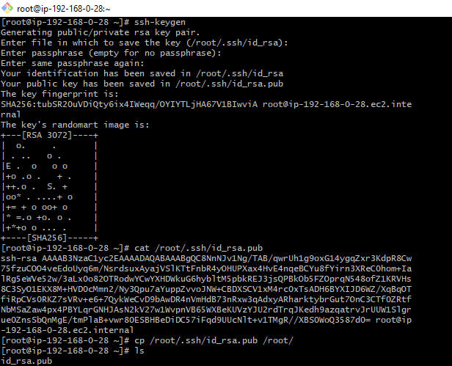

- Create vi Dockerfile

FROM nginx:alpine
RUN rm -rf /usr/share/nginx/html/*
COPY index.html /usr/share/nginx/html/index.html
EXPOSE 80
CMD ["nginx", "-g", "daemon off;"]

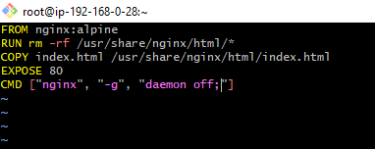

- Create vi index.html

<!DOCTYPE html>
<html lang="en">
<head>
<meta charset="UTF-8">
<title>Welcome</title>
<style>
body {
font-family: Arial, sans-serif;
background-color: #f2f2f2;
text-align: center;
padding-top: 100px;
}
h1 {
color: #2c3e50;
}
</style>
</head>
<body>
<h1>Hello, World! 👋</h1>
<p>This is a sample index.html file.</p>
<p>Deployed using Docker & Jenkins 👋</p>
</body>
</html>

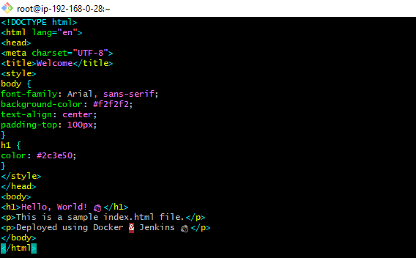

- Create Main.tf
terraform {
required_version = ">= 1.5.0"
required_providers {
aws = {
source = "hashicorp/aws"
version = "~> 5.0"
}
}
}
provider "aws" {
region = var.aws_region
profile = var.aws_profile == "" ? null : var.aws_profile
}
#################################
# Variables (INLINE – no variables.tf)
#################################
variable "aws_region" {
type = string
default = "us-east-1"
}
variable "aws_profile" {
type = string
default = ""
}
variable "allowed_ssh_cidr" {
description = "CIDR allowed to SSH"
type = string
default = "0.0.0.0/0"
}
#################################
# Networking
#################################
data "aws_availability_zones" "available" {}
resource "aws_vpc" "main" {
cidr_block = "10.0.0.0/16"
enable_dns_support = true
enable_dns_hostnames = true
}
resource "aws_internet_gateway" "igw" {
vpc_id = aws_vpc.main.id
}
resource "aws_subnet" "public" {
vpc_id = aws_vpc.main.id
cidr_block = "10.0.1.0/24"
availability_zone = data.aws_availability_zones.available.names[0]
map_public_ip_on_launch = true
}
resource "aws_route_table" "public" {
vpc_id = aws_vpc.main.id
route {
cidr_block = "0.0.0.0/0"
gateway_id = aws_internet_gateway.igw.id
}
}
resource "aws_route_table_association" "public_assoc" {
subnet_id = aws_subnet.public.id
route_table_id = aws_route_table.public.id
}
#################################
# ECR Repository
#################################
resource "aws_ecr_repository" "service" {
name = "microservice-demo-repo"
force_delete = true
}
locals {
ecr_repo_url = aws_ecr_repository.service.repository_url
}
#################################
# Push Docker Image to ECR (local machine)
#################################
resource "null_resource" "push_image" {
provisioner "local-exec" {
command = <<EOF
aws ecr get-login-password --region ${var.aws_region} \
| docker login --username AWS --password-stdin ${local.ecr_repo_url}
docker build -t microservice:latest .
docker tag microservice:latest ${local.ecr_repo_url}:latest
docker push ${local.ecr_repo_url}:latest
EOF
}
depends_on = [aws_ecr_repository.service]
}
#################################
# SSH Key Pair
#################################
resource "aws_key_pair" "ssh_key" {
key_name = "microservice-key"
public_key = file("id_rsa.pub")
}
#################################
# Security Group
#################################
resource "aws_security_group" "instance_sg" {
name = "instance-sg"
vpc_id = aws_vpc.main.id
ingress {
from_port = 22
to_port = 22
protocol = "tcp"
cidr_blocks = [var.allowed_ssh_cidr]
}
ingress {
from_port = 80
to_port = 80
protocol = "tcp"
cidr_blocks = ["0.0.0.0/0"]
}
egress {
from_port = 0
to_port = 0
protocol = "-1"
cidr_blocks = ["0.0.0.0/0"]
}
}
#################################
# EC2 Instance (x86 SAFE)
#################################
data "aws_ami" "amazon_linux" {
most_recent = true
owners = ["amazon"]
filter {
name = "name"
values = ["al2023-ami-*-x86_64"]
}
}
resource "aws_instance" "web" {
ami = data.aws_ami.amazon_linux.id
instance_type = "t3.micro"
subnet_id = aws_subnet.public.id
key_name = aws_key_pair.ssh_key.key_name
vpc_security_group_ids = [aws_security_group.instance_sg.id]
associate_public_ip_address = true
user_data = <<EOF
#!/bin/bash
dnf update -y
dnf install -y docker awscli
systemctl start docker
systemctl enable docker
aws ecr get-login-password --region ${var.aws_region} \
| docker login --username AWS --password-stdin ${local.ecr_repo_url}
docker pull ${local.ecr_repo_url}:latest
docker run -d -p 80:80 --restart always --name web ${local.ecr_repo_url}:latest
EOF
depends_on = [null_resource.push_image]
tags = {
Name = "microservice-web"
}
}

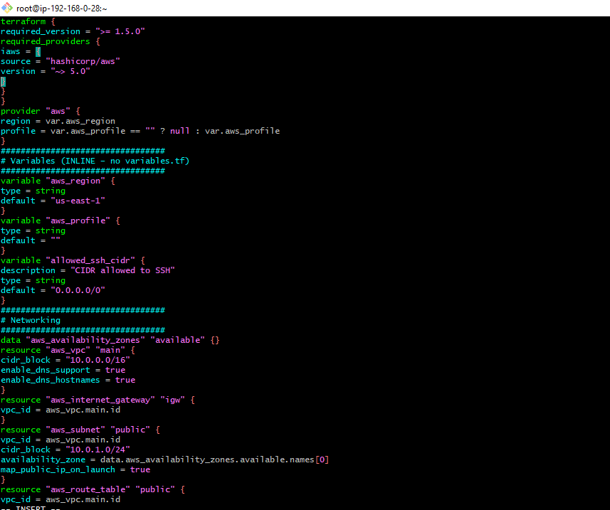
- Terraform init
- Terraform plan
- Terraform apply

- Here wecan see that one Instance was created

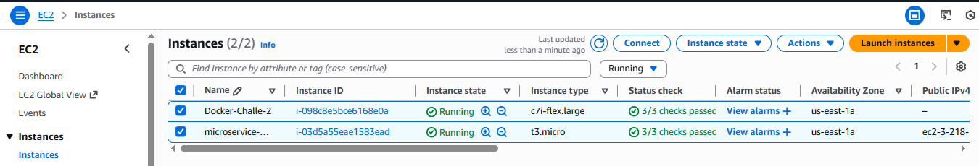

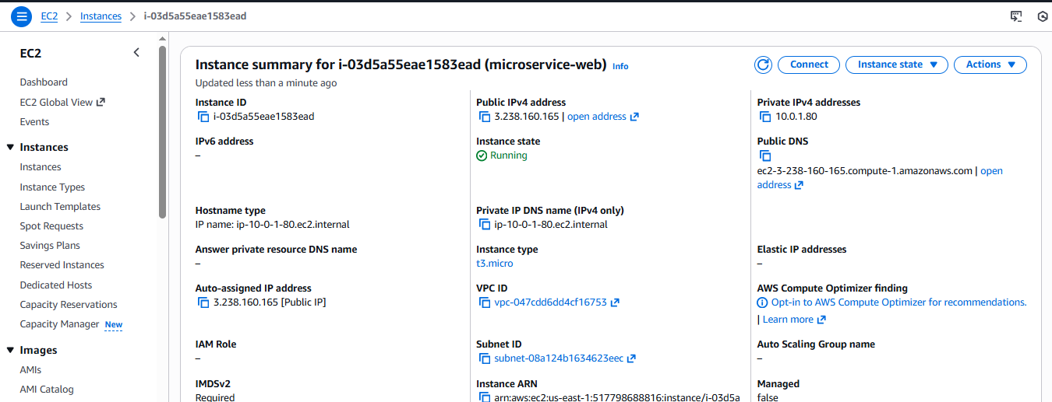

- Logging to this server and Search images
- docker images
- we can see 3 images was creted

z