Start working on below Ansible challenge.
Create ci pipeline that will deploy and configure these VMs using terraform and ansible according following requirements
- Deploy 2 virtual machines using terraform.
  - first vm on Amazon linux, hostname: c8.local
  - second vm on ubuntu 21.04, hostname: u21.local
- As a result of Terraform execution, dynamically create inventory for ansible
  - c8.local should be in the frontend group
  - u21.local should be in the backend group
- Create ansible playbook for c8.local and u21.local
- for Linux OS playbook should apply the following changes
  - selinux: disable
  - firewalld: disable
- for the frontend playbook group should install and configure nginx
  - nginx configuration should do proxying from port 80 on port 19999 to the
  - backend group
- for the backend group, the playbook must install the Netdata application from the
  - official repositories and run it on port 19999.

https://github.com/bharathiraja-15/ansible-task.git this git gub link
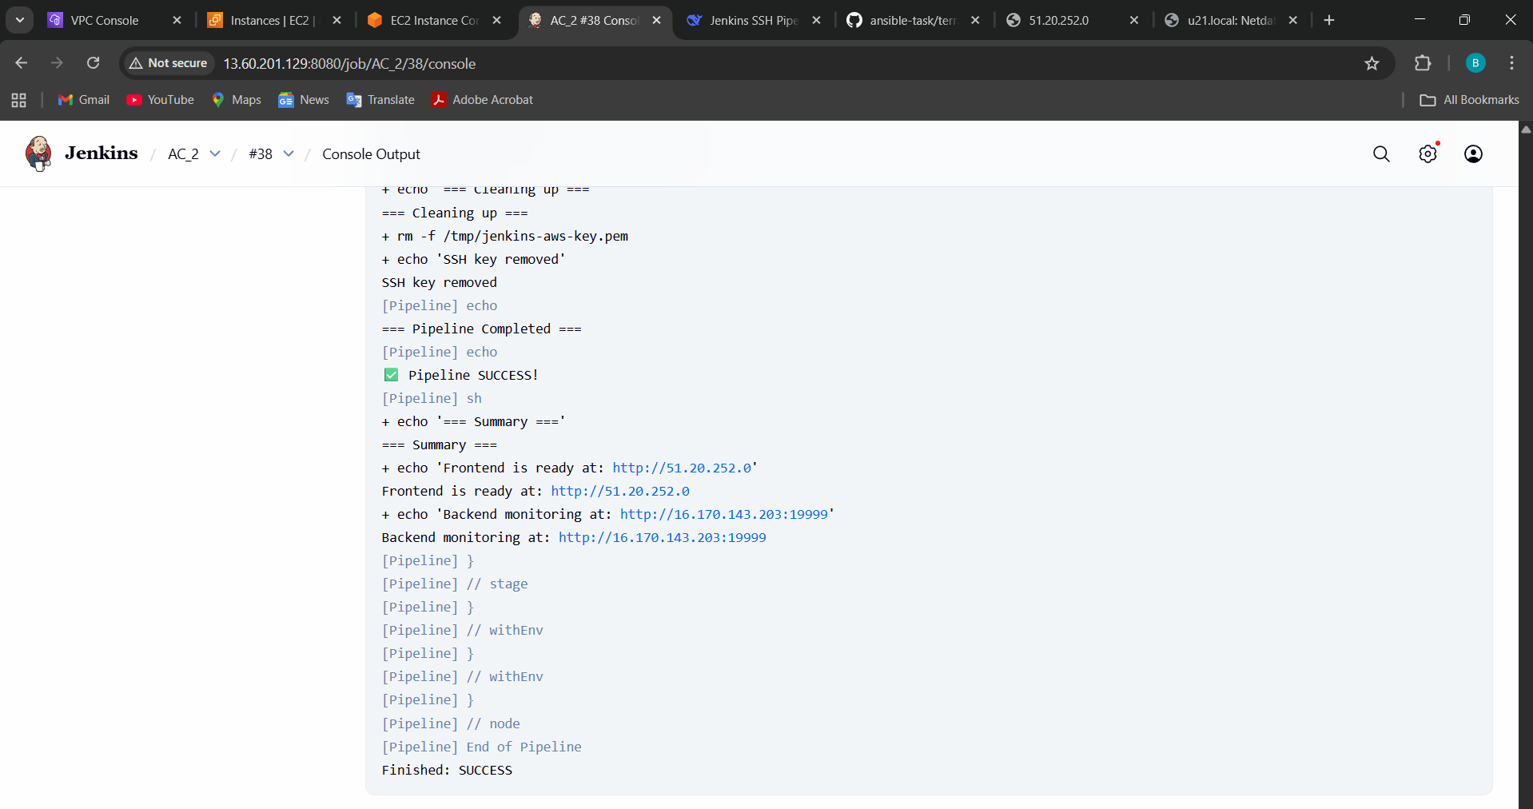

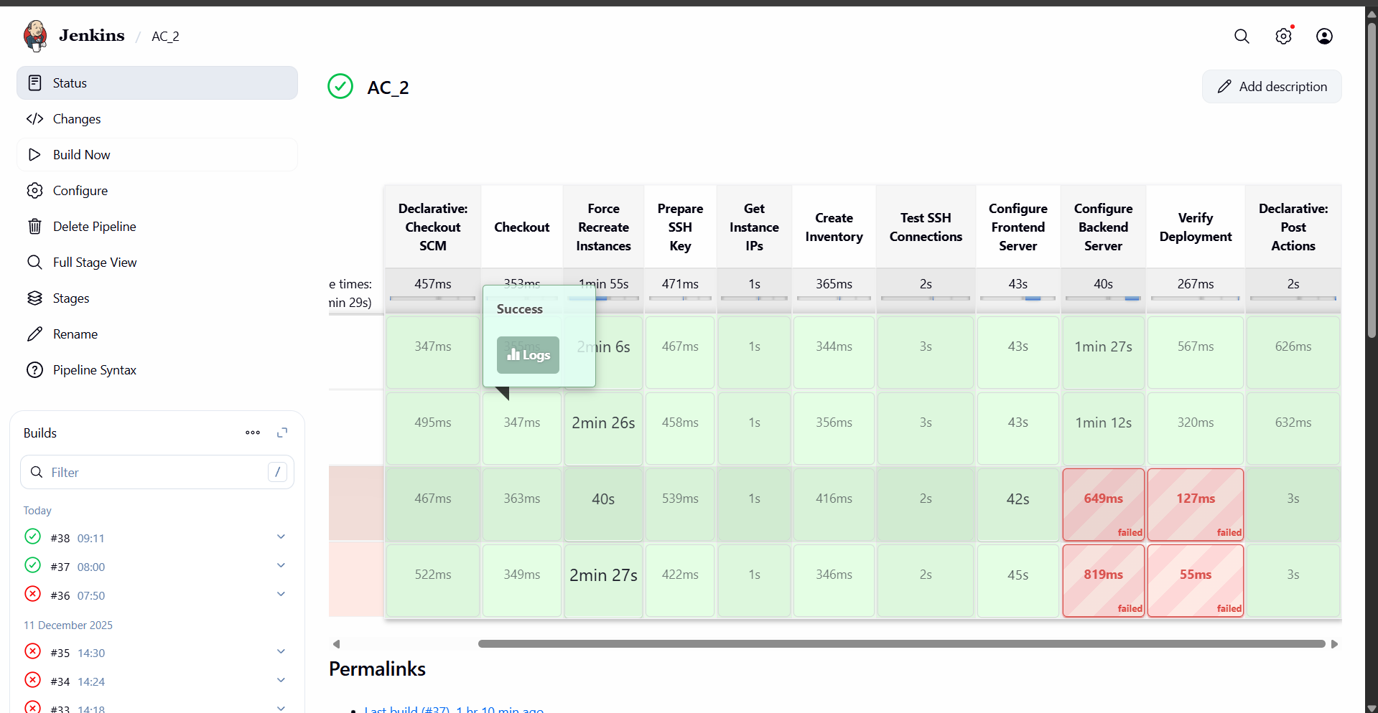
http://16.170.143.203:19999/ to check the daata
