Ansible-task_02

- Watch the ansible-02 video and write down notes.
Completed the watch video.
- Install httpd using an Ansible playbook, use handlers, and notifiers.
Create directory named as playbooks and go to that directory
and crete a file named as httpd.yml
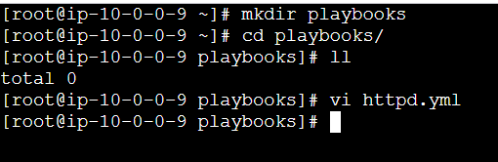
Create an index.html file also
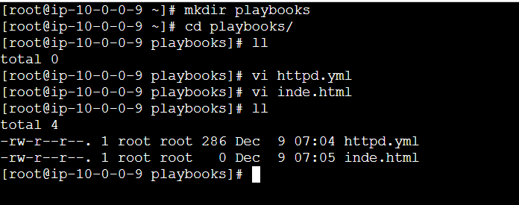
Give the script like this
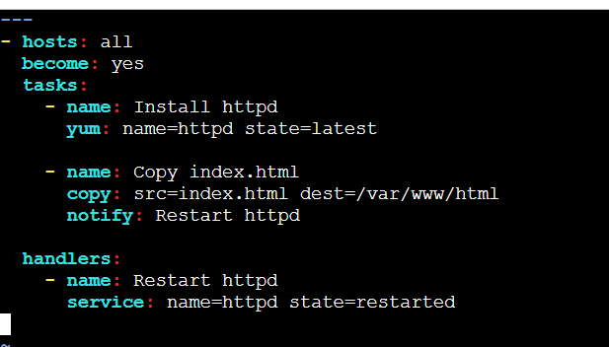
Create index.html in the playbooks directory.
To check the syntax of playbook use this command.
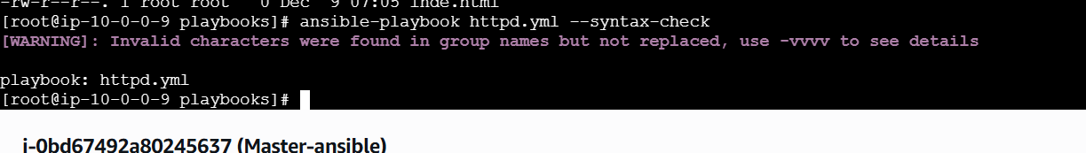
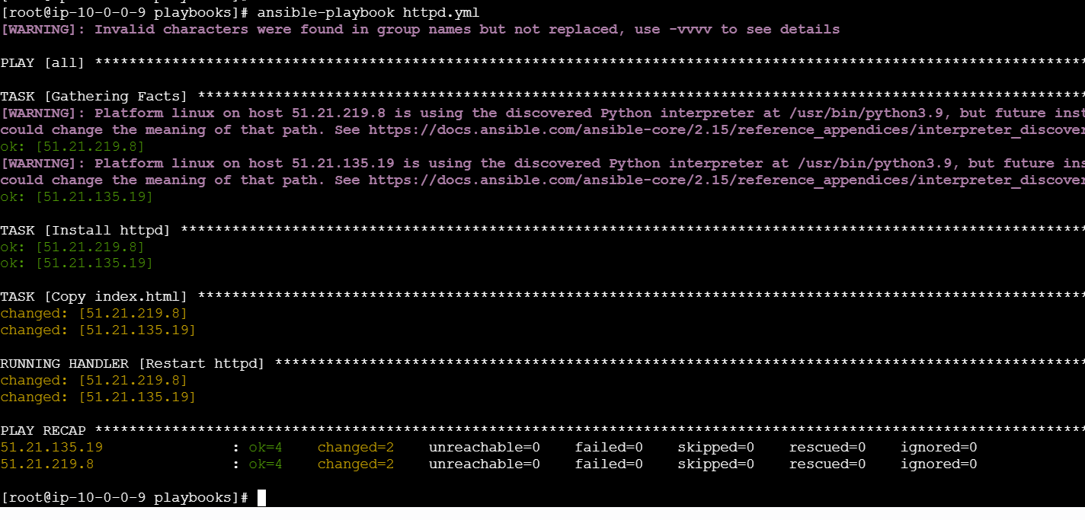
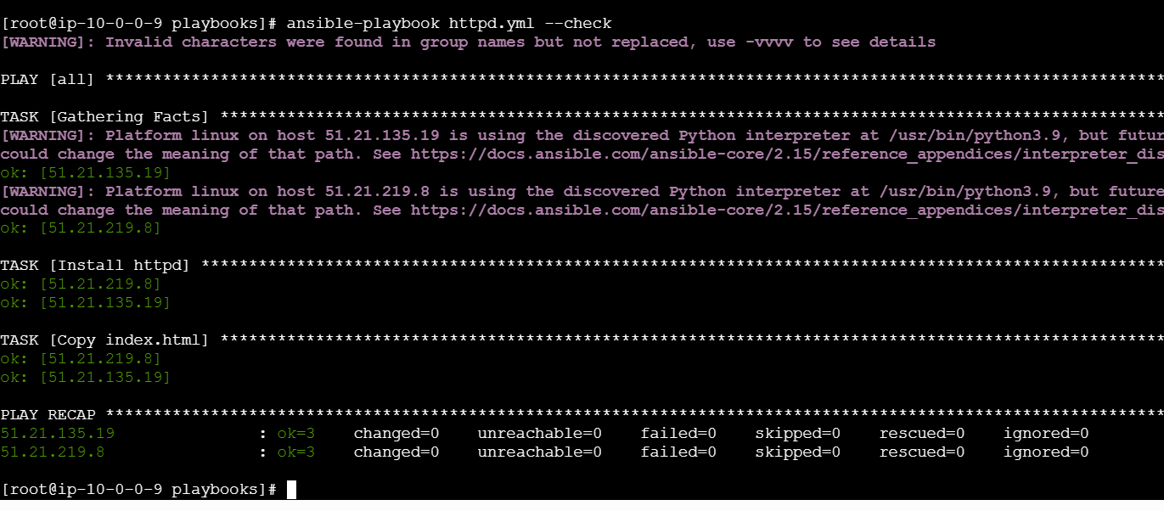
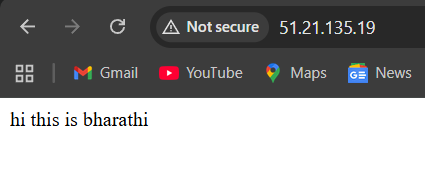
If your YAML is valid, you will see:
playbook: httpd.yml
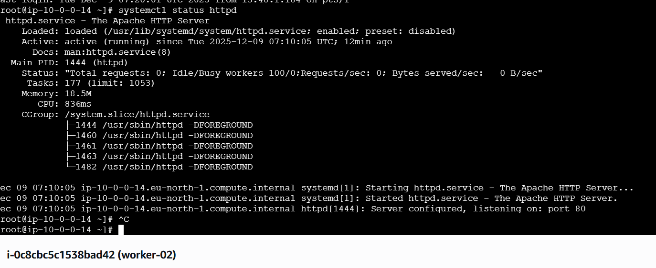
If you want to stop this services
ansible all -m service -a "name=httpd state=stopped" -b
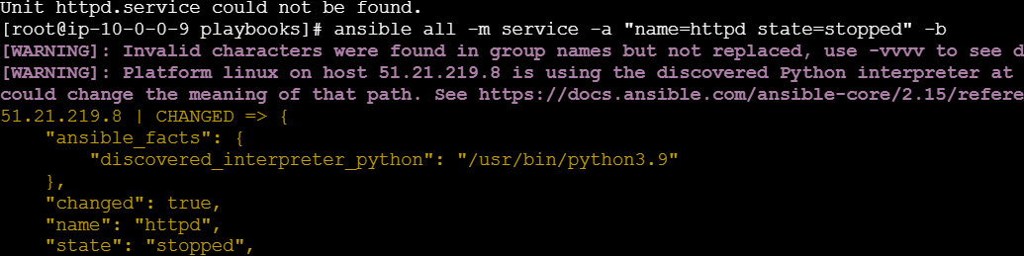

- Write an Ansible playbook to install Apache Tomcat.
Create a folder vi tomcat.ymal file insdie the paste it the code
---
- hosts: all
become: yes

tasks:
- name: Install Java (Amazon Linux 2023)
package:
name: java-17-amazon-corretto
state: present

- name: Create Tomcat directory
file:
path: /opt/tomcat
state: directory

- name: Download Tomcat
get_url:
url: https://archive.apache.org/dist/tomcat/tomcat-10/v10.1.26/bin/apache-tomcat-10.1.26.tar.gz
dest: /tmp/tomcat.tar.gz

- name: Extract Tomcat
unarchive:
src: /tmp/tomcat.tar.gz
dest: /opt/tomcat
remote_src: yes
extra_opts: [--strip-components=1]

- name: Start Tomcat
command: /opt/tomcat/bin/startup.sh

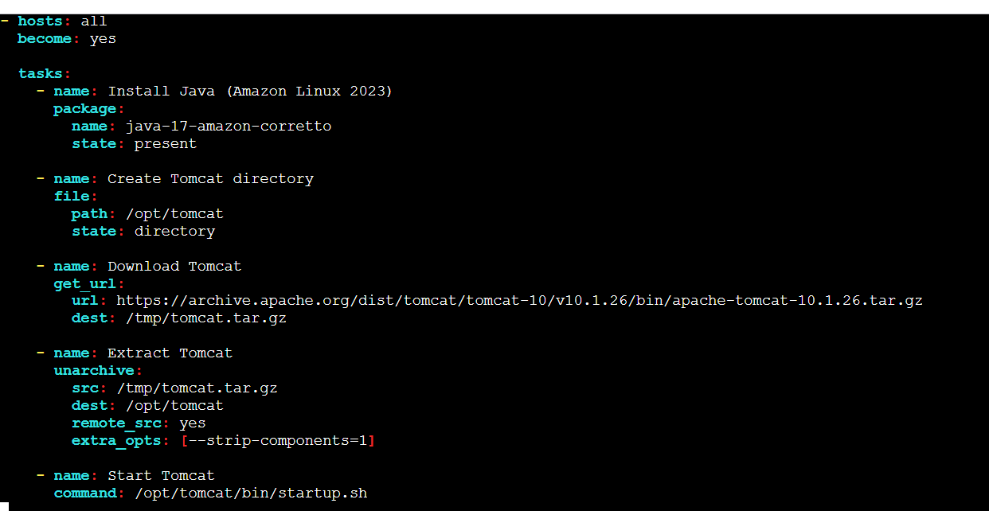
Checking the syntax
ansibnle-playbook tomca.yaml –sysntax-check
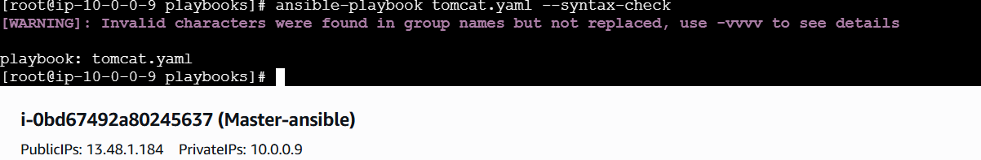
To execute ansible-playbook tomcat.yaml
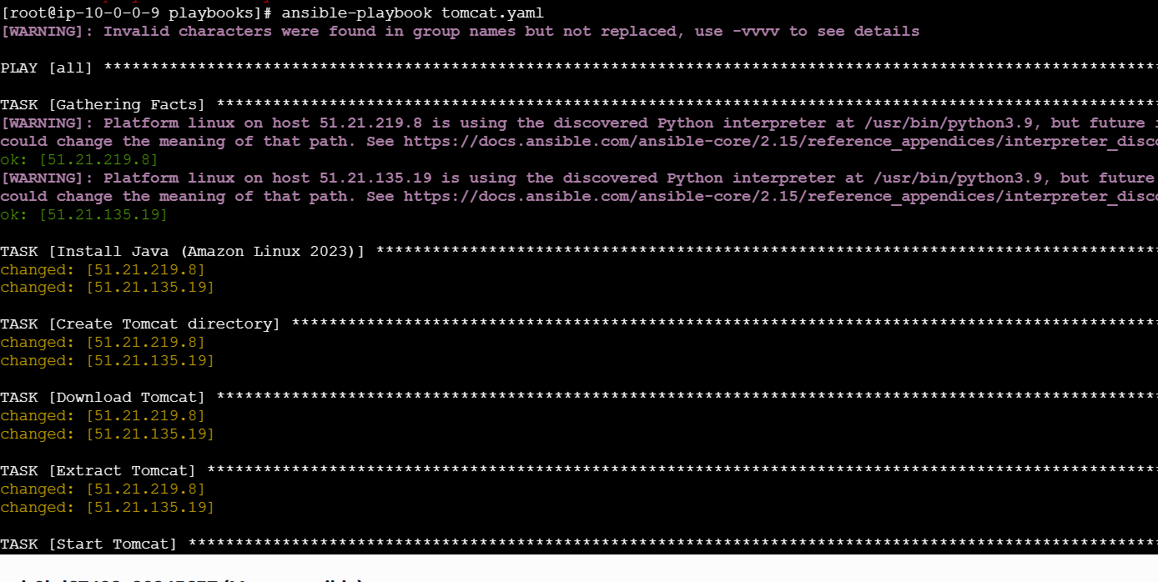
Server-02
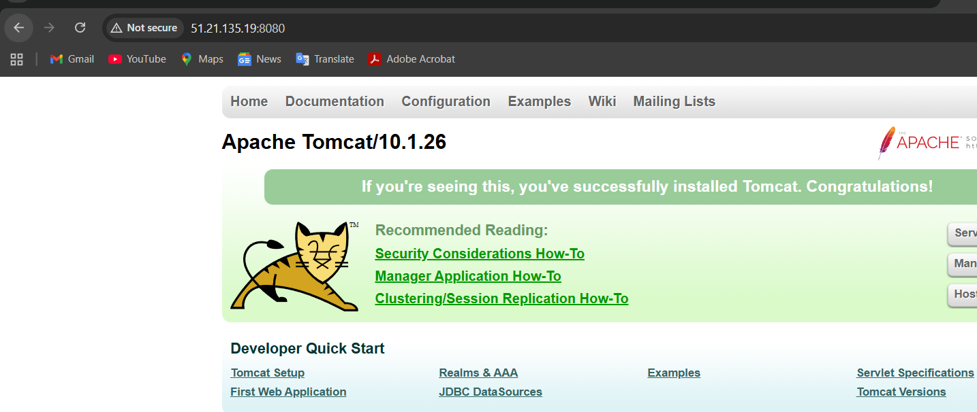
Server 01
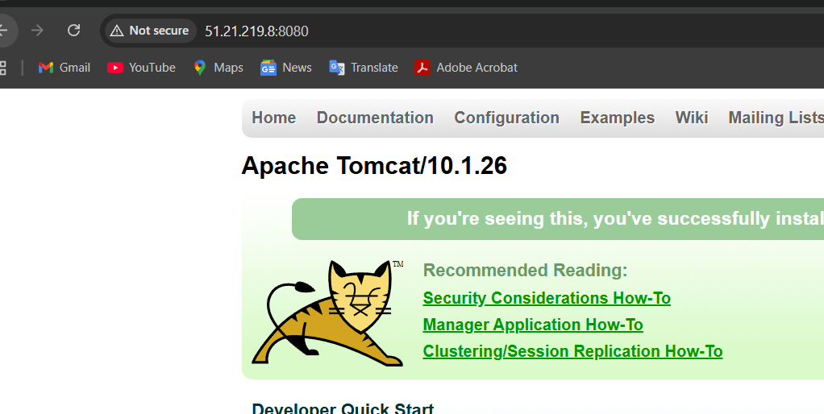

- Write an Ansible playbook to provision one EC2 on AWS.
Create a file named as ec2.yml
Make sure you install this commands.
• ansible-galaxy collection install amazon.aws
• yum install python3-pip -y
• pip3 install boto3 botocore
1. Install the Amazon AWS Ansible Collection
ansible-galaxy collection install amazon.aws
This installs all AWS modules such as:
- amazon.aws.ec2_instance
- amazon.aws.ec2_vpc_net
- amazon.aws.ec2_key
- amazon.aws.ec2_security_group

✅ 2. Install Python3 pip (required for AWS SDK)
On RHEL/CentOS/Amazon Linux:
yum install python3-pip -y
On Ubuntu/Debian:
apt install python3-pip -y
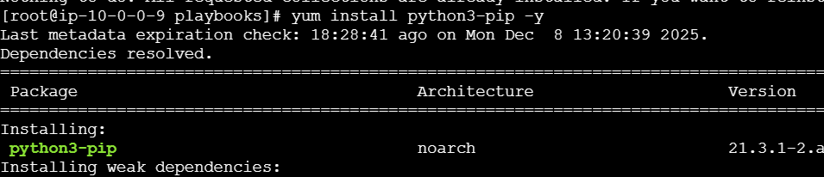

✅ 3. Install AWS Python SDK (boto3 + botocore)
pip3 install boto3 botocore
This is required because Ansible uses boto3 to interact with AWS APIs.
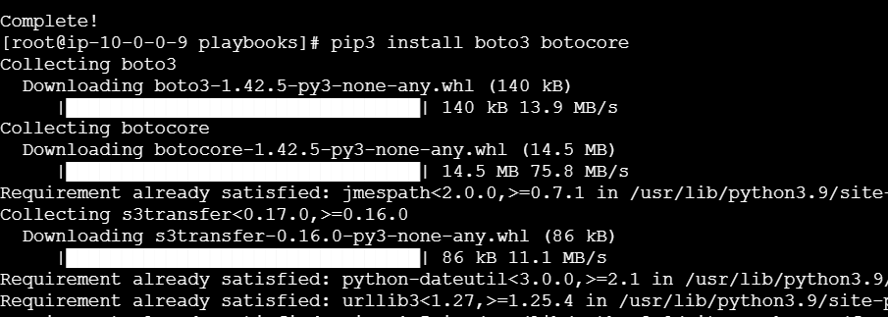
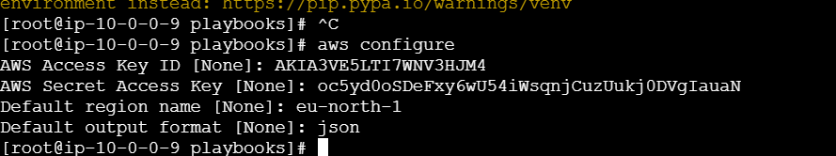
Aws configure is important

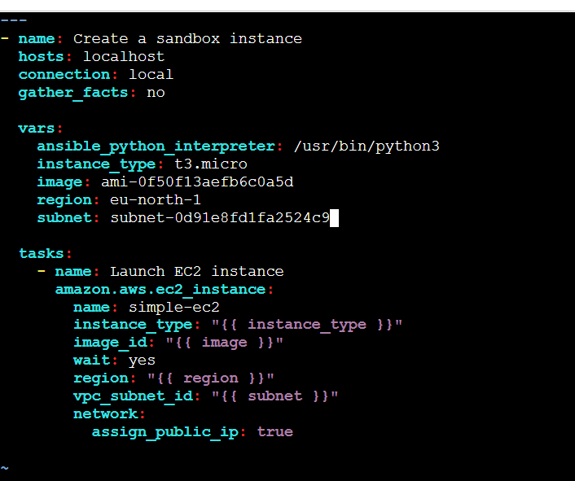
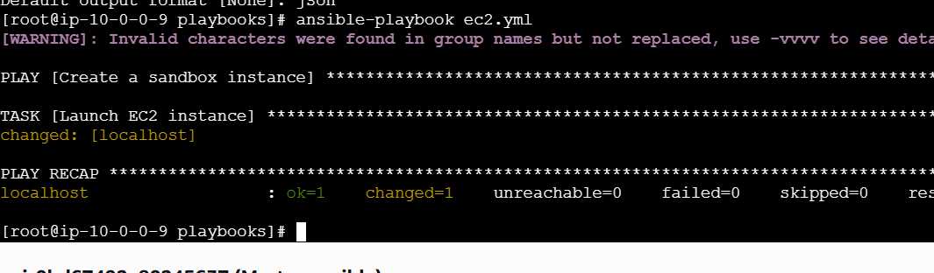
Ec2-instacne created
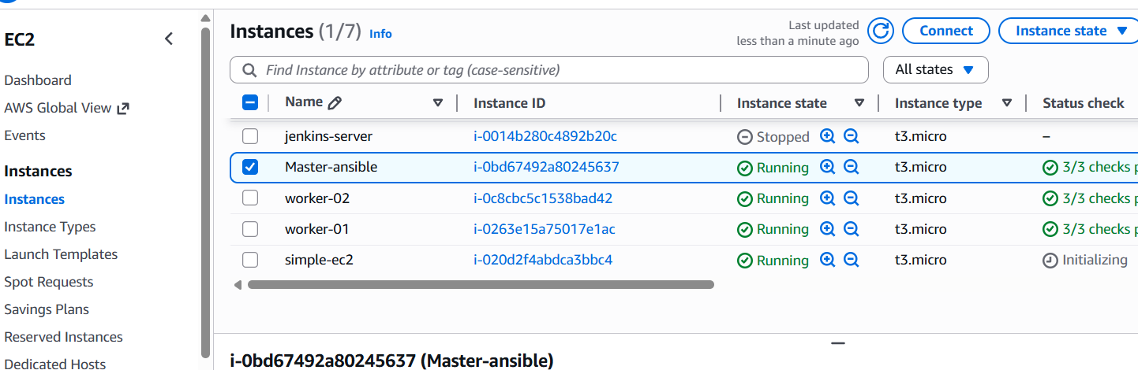
- Write an Ansible playbook to copy one file from node-1 to node-2.
Server 01 I have test1 file
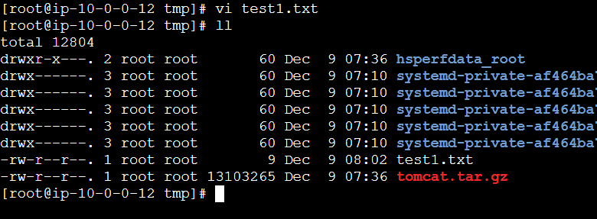
Create a file vi copy.yml file paste it the scripts
---
- name: Fetch file from worker-01
hosts: worker-01
become: yes

tasks:
- name: Fetch /tmp/test.txt from worker-01
fetch:
src: /tmp/test.txt
dest: /tmp/test.txt
flat: yes

- name: Copy file to worker-02
hosts: worker-02
become: yes

tasks:
- name: Copy /tmp/test.txt to worker-02
copy:
src: /tmp/test.txt
dest: /tmp/test.txt
How this works
Play 1 → worker-01
✔ Fetches /tmp/test.txt
✔ Saves it on master at /tmp/test.txt
Play 2 → worker-02
✔ Copies the fetched file from master → worker-02
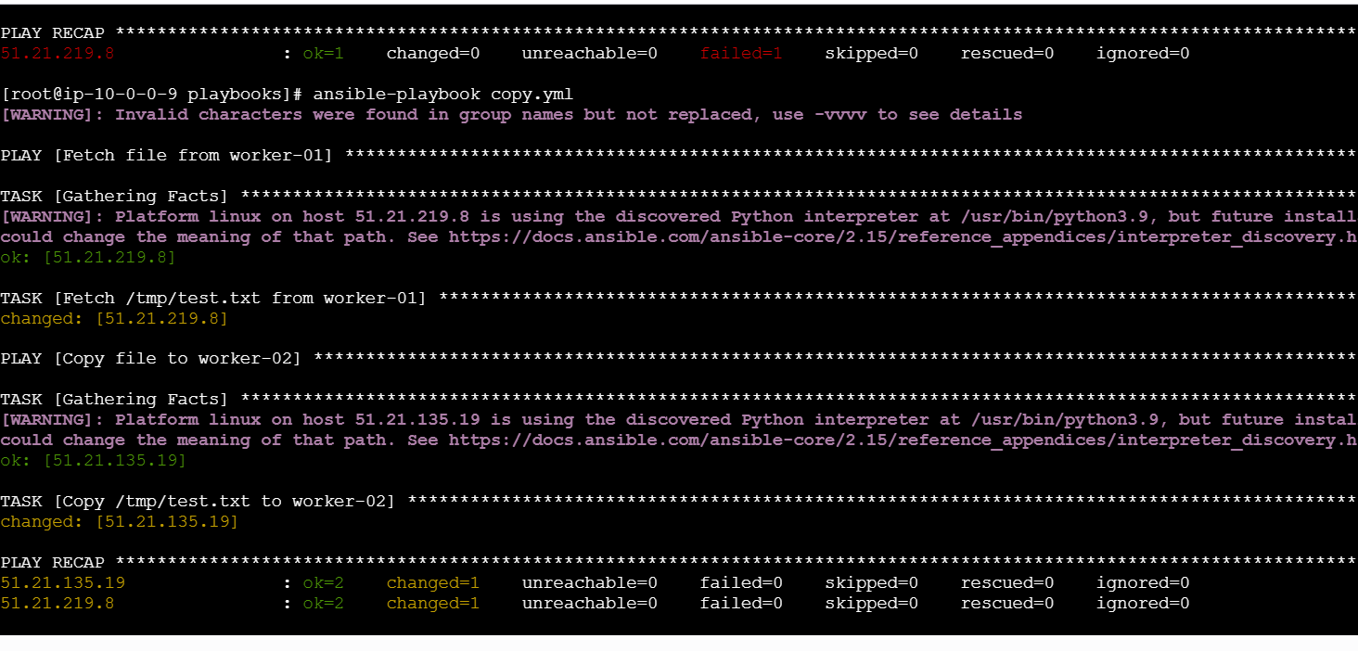
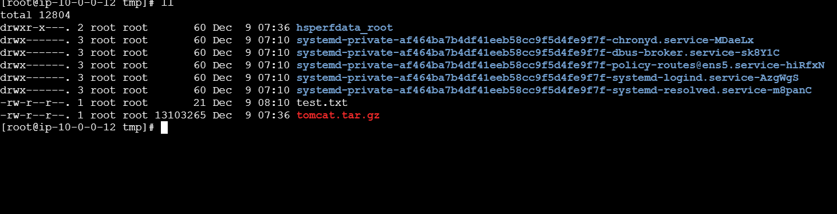
Worker 02
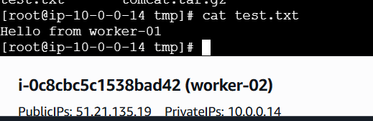
Worker 01
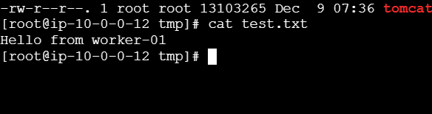
- Write an Ansible playbook to create different files with different names using a single playbook.
Create a playbook named as createfiles.yml and add this
script
---
- name: Create multiple files using a loop
hosts: all
become: yes

vars:
files_list:
- /tmp/file1.txt
- /tmp/file2.log
- /tmp/report.json

tasks:
- name: Create files with different names
file:
path: "{{ item }}"
state: touch
loop: "{{ files_list }}"

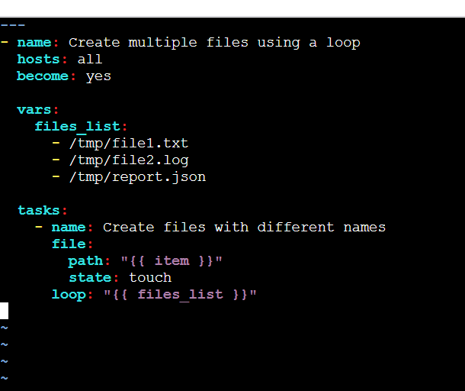
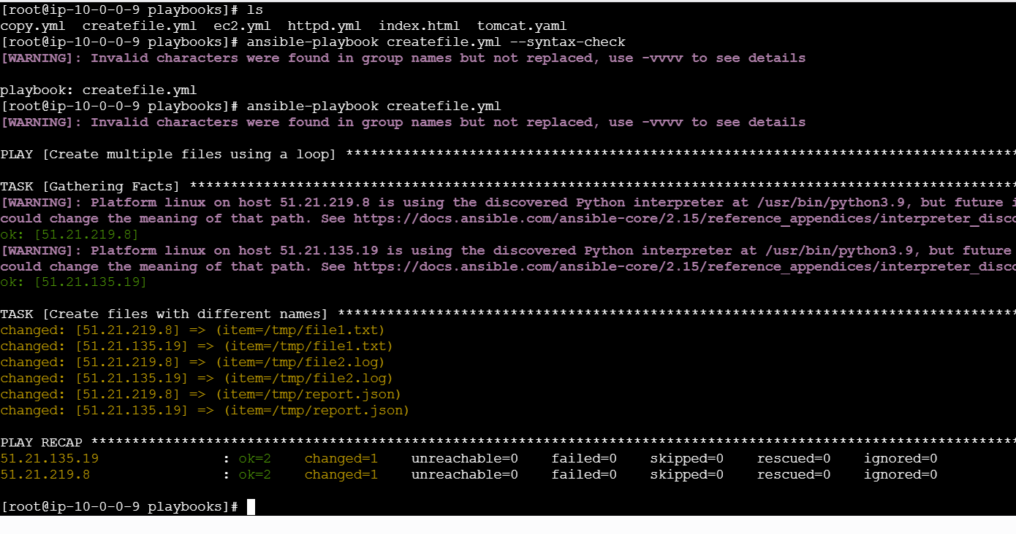
Files has been created worker notdded 1 cd /tmp files
