Ansible -3

- Write a single ansible playbook which will install apache and nginx. Note: Playbook should not be hardcoded and pass the variables from a different file.

Create a playbook named as vi web.yml and give this.

---
- name: Install web server using external variables
hosts: all
become: yes
vars_files:
- vars/web_vars.yml

tasks:
- name: Install selected web server
package:
name: "{{ web_package }}"
state: present

- name: Start and enable service
service:
name: "{{ web_service }}"
state: started
enabled: yes
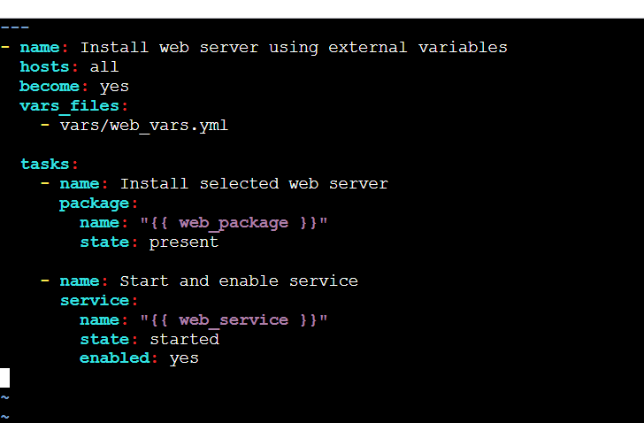

In the playbooks directory create a directory named as vars in
that vars directory create a file named as web_vars.yml and
like this.
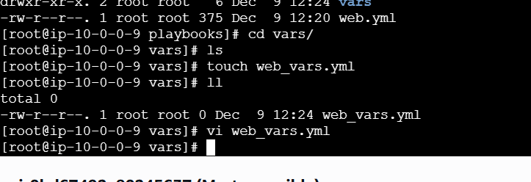
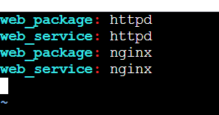
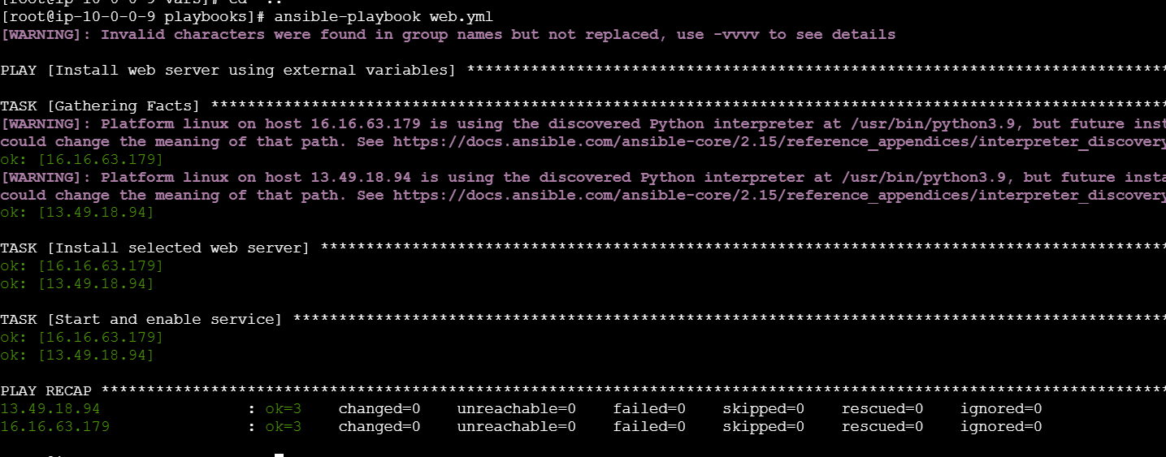

- Ansible playbook to create 10 different directories with minimal code and directory names should be passed as variables.

Write a playbook named as directories.yml
---
- name: Create multiple directories
hosts: all
become: yes

vars:
dir_list:
- /opt/dir1
- /opt/dir2
- /opt/dir3
- /opt/dir4
- /opt/dir5
- /opt/dir6
- /opt/dir7
- /opt/dir8
- /opt/dir9
- /opt/dir10

tasks:
- name: Create directories from list
file:
path: "{{ item }}"
state: directory
mode: '0755'
loop: "{{ dir_list }}"
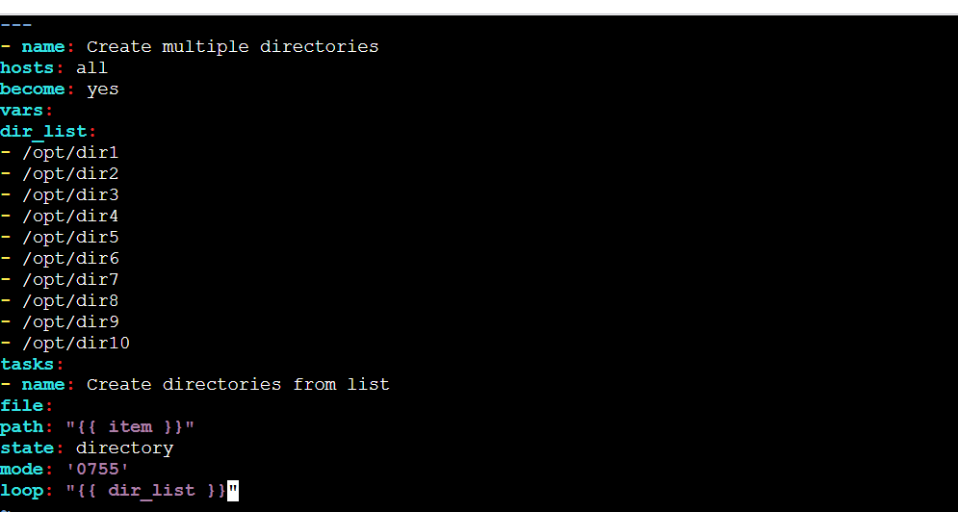
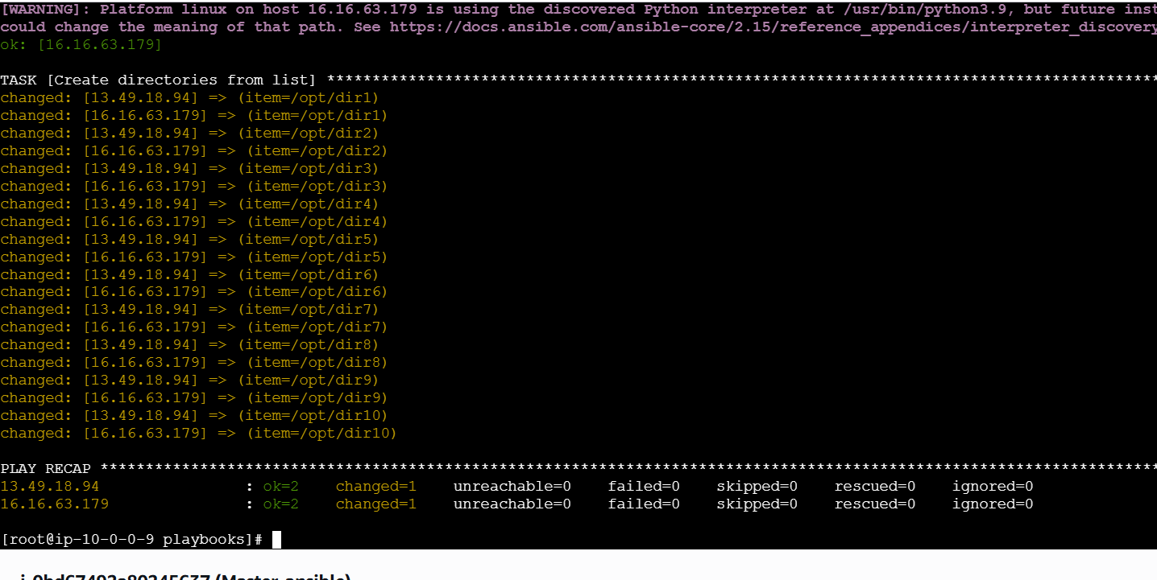
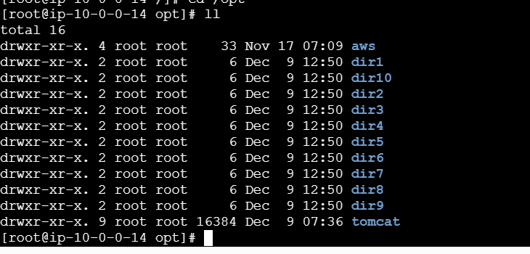
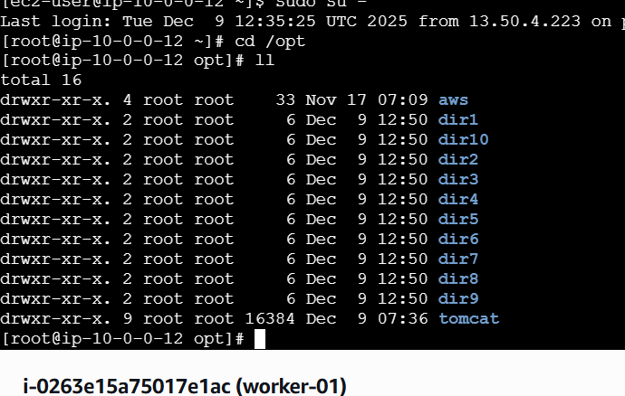

- Ansible playbook to copy ssh-keygen from master to worker nodes. Note: a)Provision new 3 ec2 machines, one master and two worker nodes. b)Create common user called ansadm and provide sudo priviliges on 3 ec2 instances. c)Create ssh-keygen in master and your playbook should copy the keygen making it password less authentication.
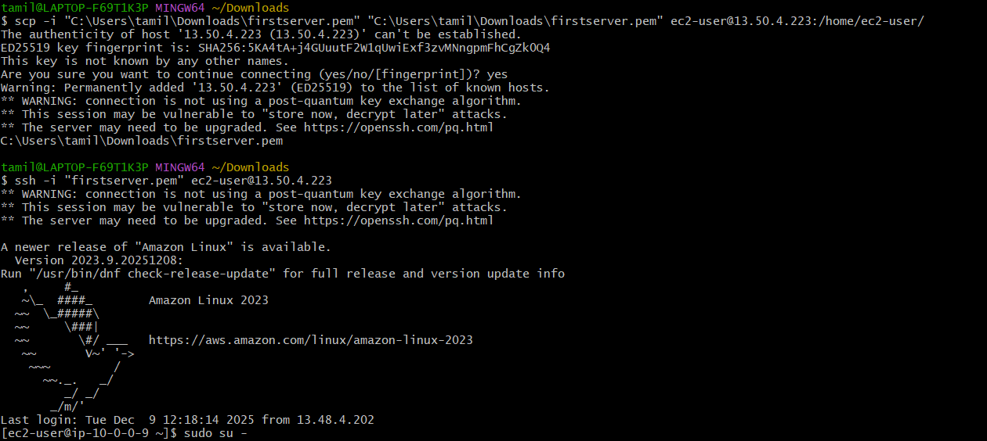
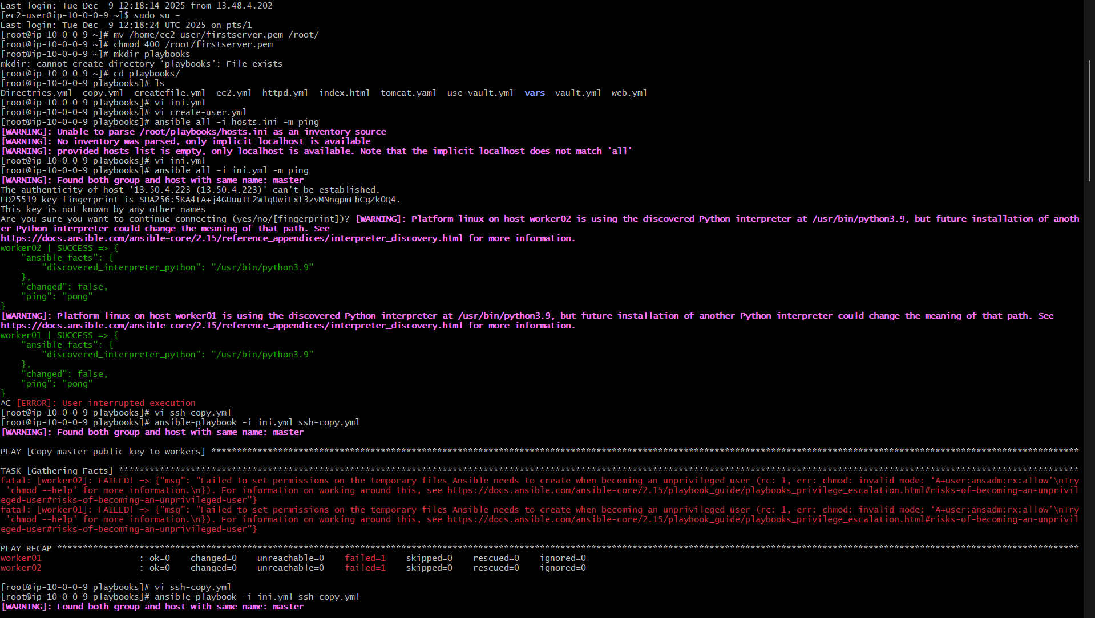
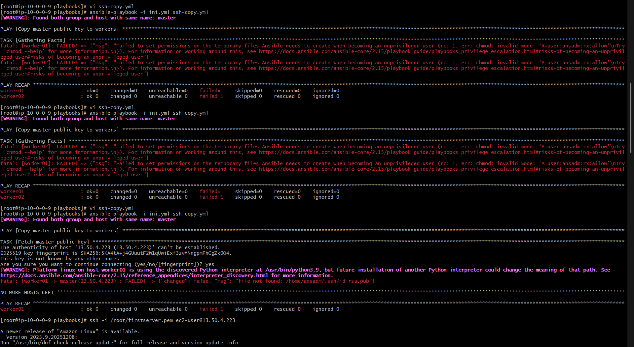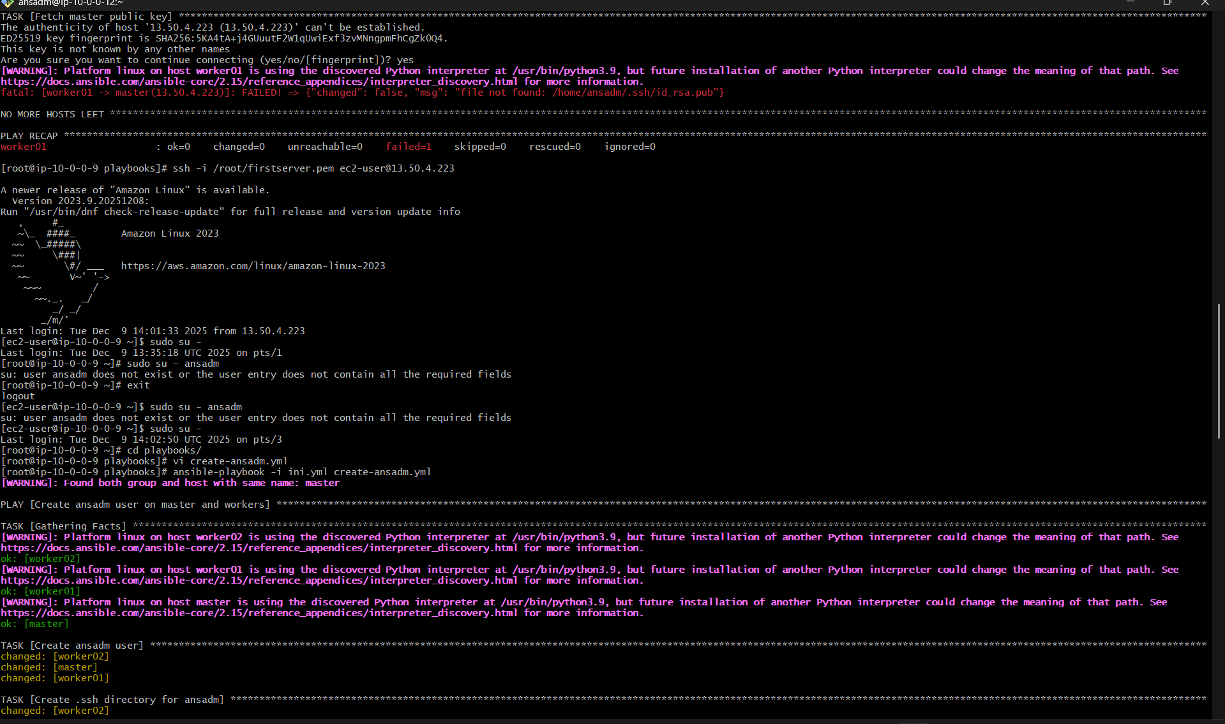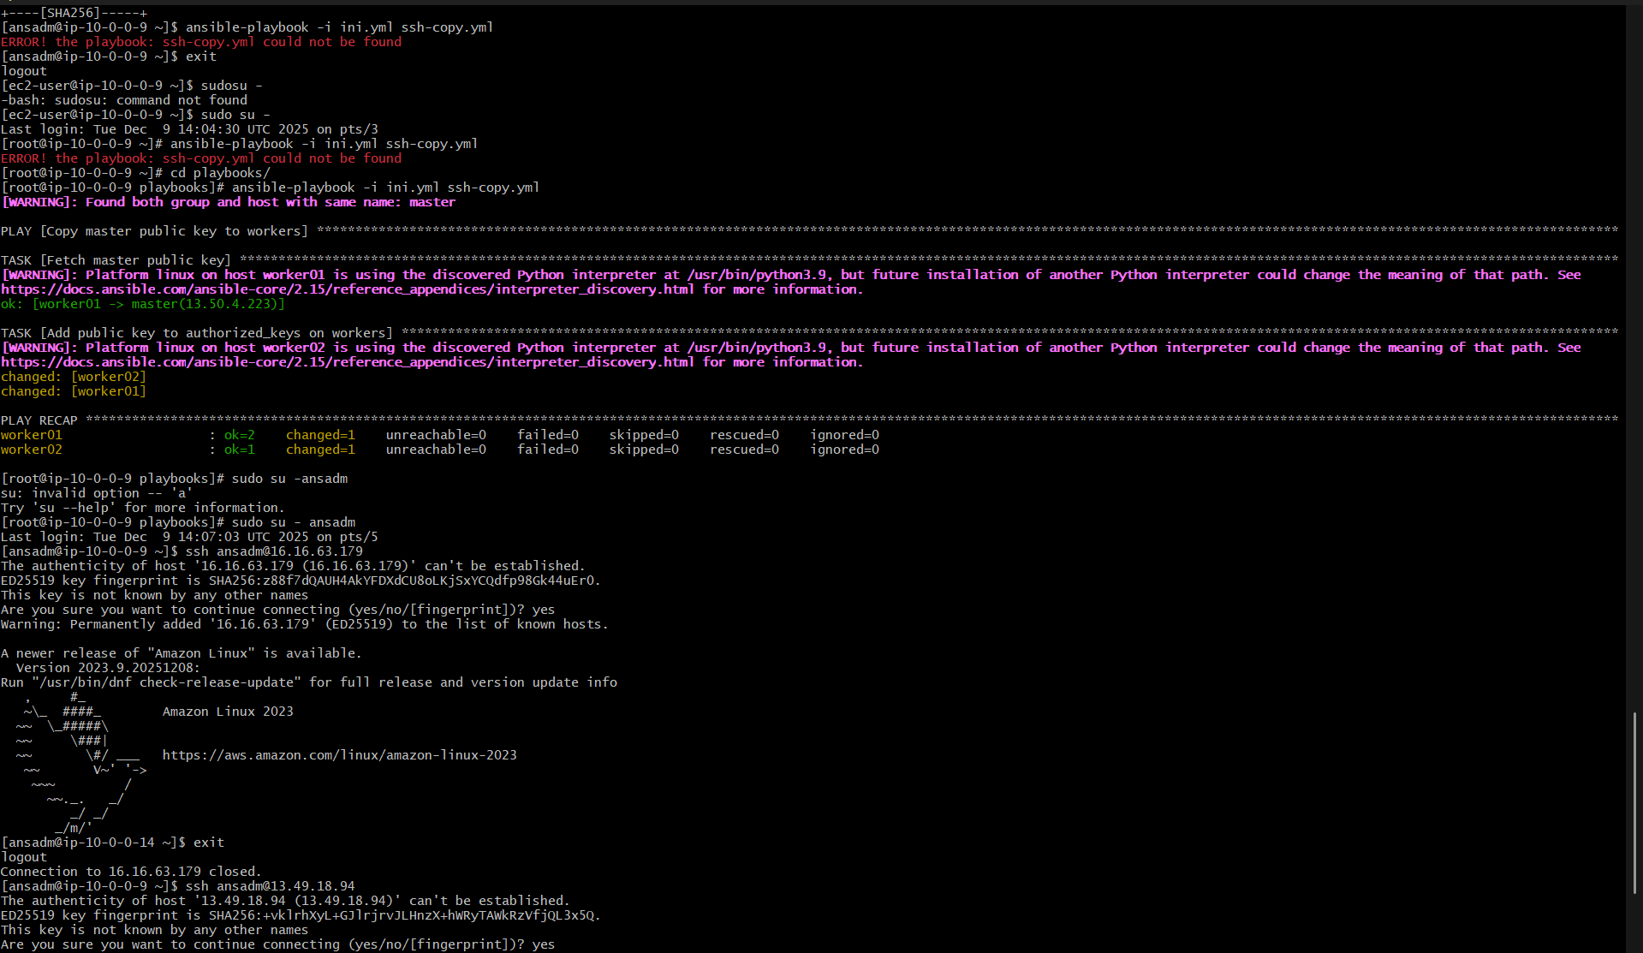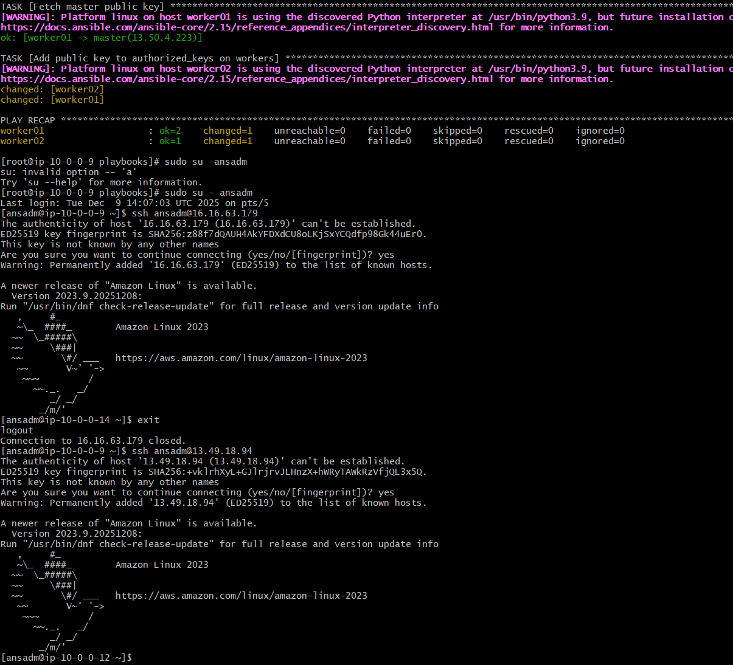
13.49.18.94 worker 1 ip
16.16.63.179 worker 2 ip

- Ansible playbook to inject ansible vault variables.

Create a vault by using
• ansible-vault create vault.yml
it will ask for a password.
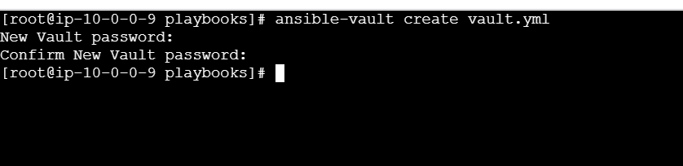
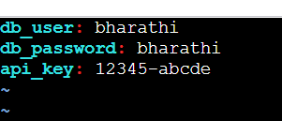
After giving the word, it will open a file you need to
provide your secrets in that.
Ansible-vault view vault.yml to view the file
