Ansible-04 tasks:
- Create ansible playbook to create ansible vault.

Create a file named password and write the secrets in that
file.
• touch password
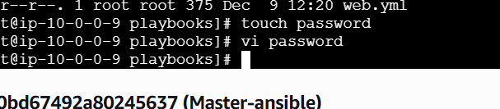
• vi password
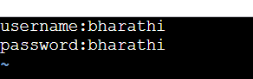
• ansible-vault encrypt password.
If you want view the encrypted data in the file.
• ansible-vault view password
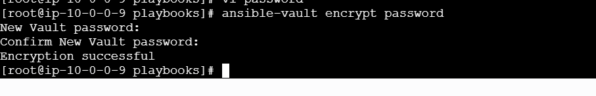
If you want view the encrypted data in the file.
• ansible-vault view password
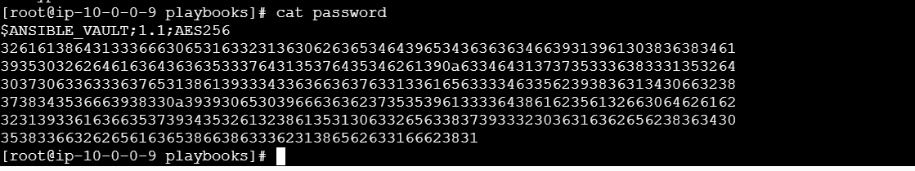
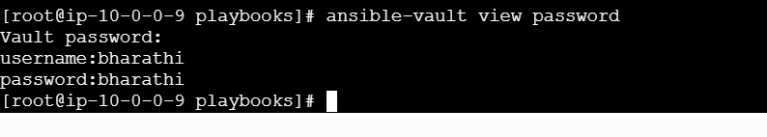
create a playbook for variables
vi variables.yml
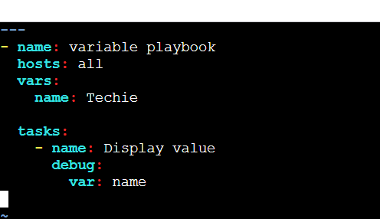
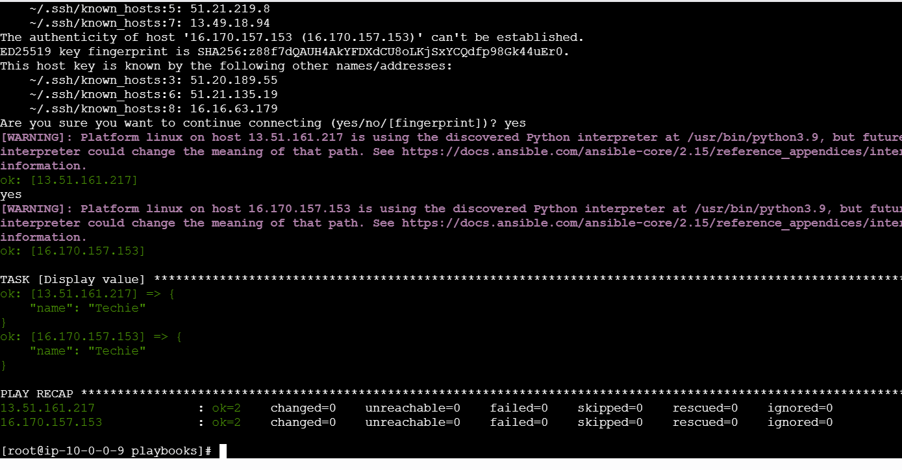

- Write a ansible playbook to install apache in linux and ubuntu machine by using when condition.

Create a playbook with the name install apache.yml
---
- name: Install Apache on Linux distributions using when condition
hosts: all
become: yes

tasks:
# ------------------- Ubuntu / Debian -------------------
- name: Install Apache on Ubuntu/Debian
apt:
name: apache2
state: present
update_cache: yes
when: ansible_os_family == "Debian"

- name: Start and enable Apache on Ubuntu/Debian
service:
name: apache2
state: started
enabled: yes
when: ansible_os_family == "Debian"

# ------------------- RHEL / CentOS / Amazon Linux -------------------
- name: Install Apache on RHEL/CentOS/Amazon Linux
yum:
name: httpd
state: present
when: ansible_os_family == "RedHat"

- name: Start and enable Apache on RHEL/CentOS/Amazon Linux
service:
name: httpd
state: started
enabled: yes
when: ansible_os_family == "RedHat"
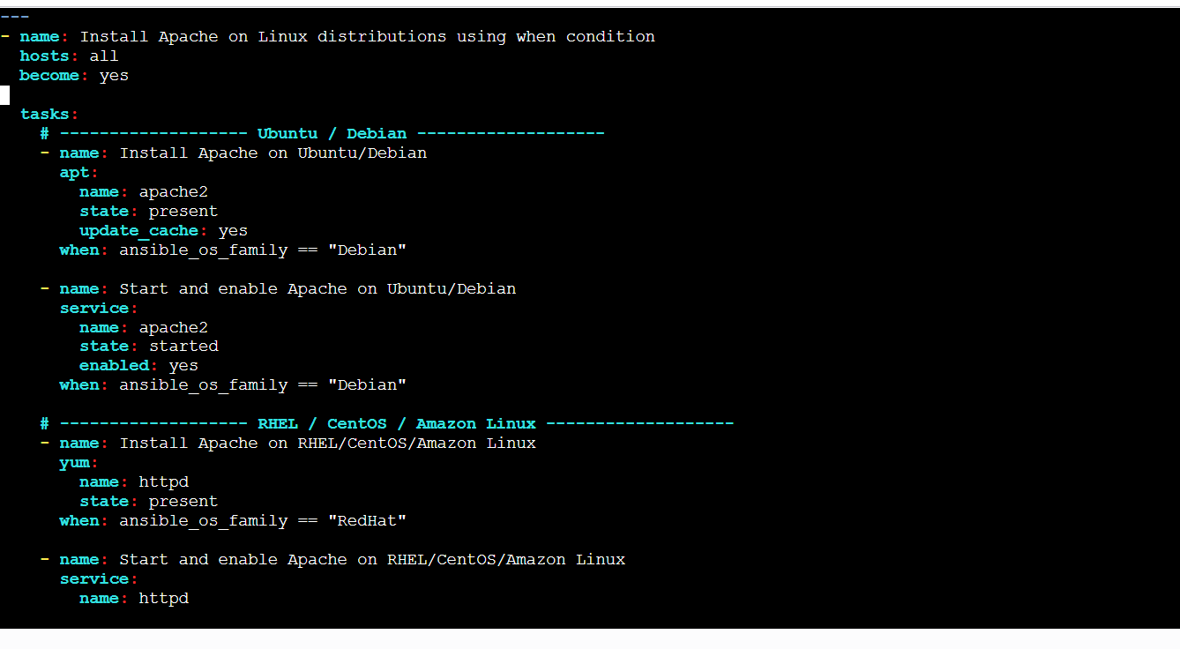

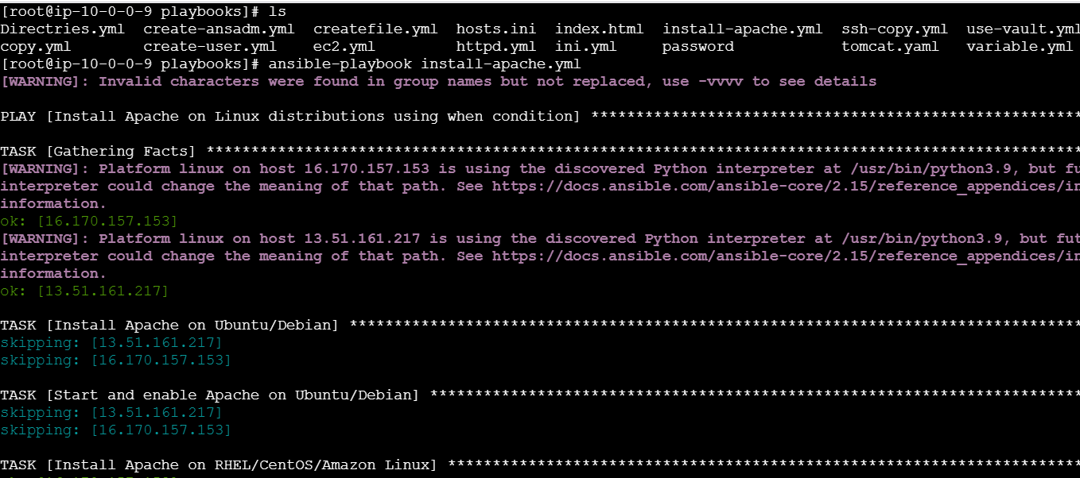
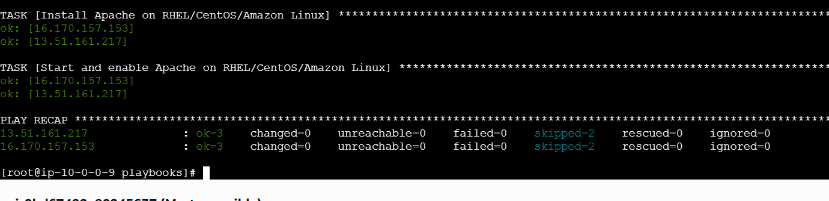
- Create ansible playbook using roles to configure LAMP stack

lamp_stack/
├── site.yml
└── roles/
├── apache/
│ └── tasks/main.yml
├── php/
│ └── tasks/main.yml
└── mysql/
└── tasks/main.yml
Vi roles/apache/tasks/main.yml
- name: Install Apache on Ubuntu
apt:
name: apache2
state: present
update_cache: yes
when: ansible_os_family == "Debian"
- name: Install Apache on Linux (RHEL/CentOS/Amazon)
yum:
name: httpd
state: present
when: ansible_os_family == "RedHat"
- name: Start Apache service on Ubuntu
service:
name: apache2
state: started
enabled: yes
when: ansible_os_family == "Debian"
- name: Start Apache service on Linux
service:
name: httpd
state: started
enabled: yes
when: ansible_os_family == "RedHat"
vi roles/php/tasks/main.yml
---
- name: Install PHP on Ubuntu
apt:
name:
- php
- php-mysql
state: present
update_cache: yes
when: ansible_os_family == "Debian"
- name: Install PHP on Linux (RHEL/CentOS/Amazon)
yum:
name:
- php
- php-mysqlnd
state: present
when: ansible_os_family == "RedHat"
Vi roles/mysql/tasks/main.yml
------
# Ensure wget available
- name: Install wget
dnf:
name: wget
state: present
# Import BOTH GPG keys required by MySQL
- name: Import MySQL primary GPG key
rpm_key:
key: "https://repo.mysql.com/RPM-GPG-KEY-mysql"
state: present
- name: Import MySQL community GPG key
rpm_key:
key: "https://repo.mysql.com/RPM-GPG-KEY-
mysql-2022"
state: present
# Download repo file
- name: Download MySQL 8.0 community repo
get_url:
url: "https://repo.mysql.com/mysql80-community-
release-el9.rpm"
dest: /tmp/mysql-el9.rpm
mode: "0644"
# Install repo
- name: Install MySQL repository
dnf:
name: /tmp/mysql-el9.rpm
state: present
# Clean metadata
- name: Clean metadata
command: dnf clean all
# Install MySQL Server
- name: Install MySQL Server
dnf:
name: mysql-community-server
state: present
# Start & enable service
- name: Start & enable MySQL
service:
name: mysqld
state: started
enabled: yes
vi site.yml
---
- name: Configure full LAMP stack
hosts: all
become: yes
roles:
- apache
- php
-mysql
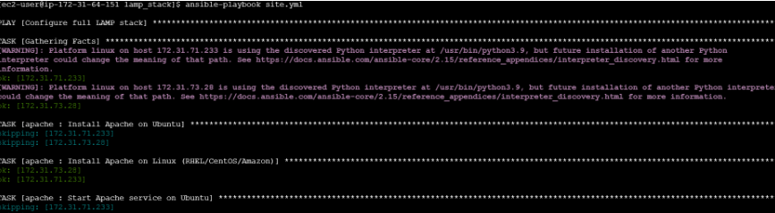

- Setup ansible AWX and explore the options.
Login to that ec2.
• sudo dnf -y update
• yum install docker -y
• systemctl start docker
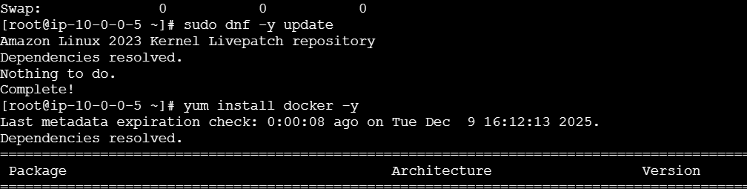
Yum install git
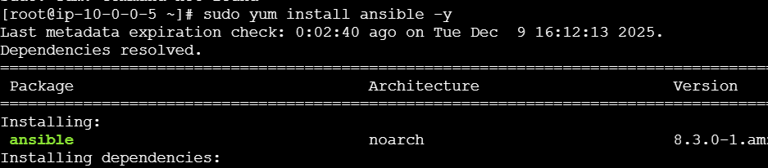
Yum install ansible -y
Yum install ansible -y
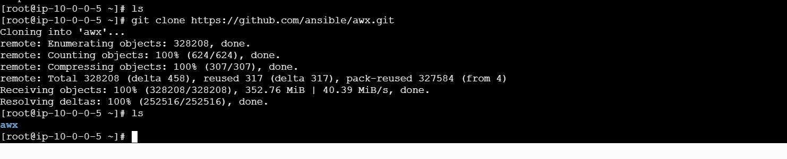

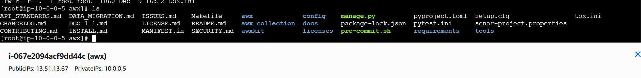
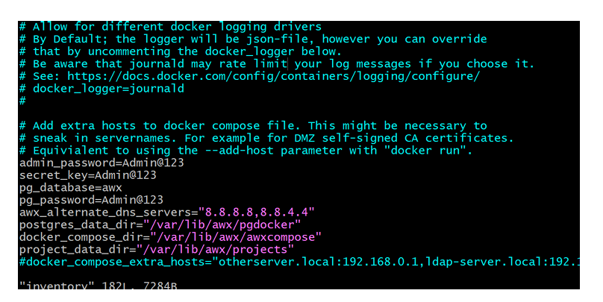
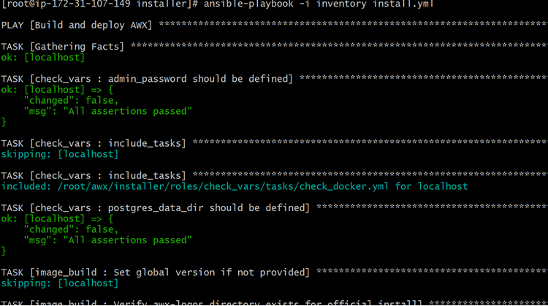
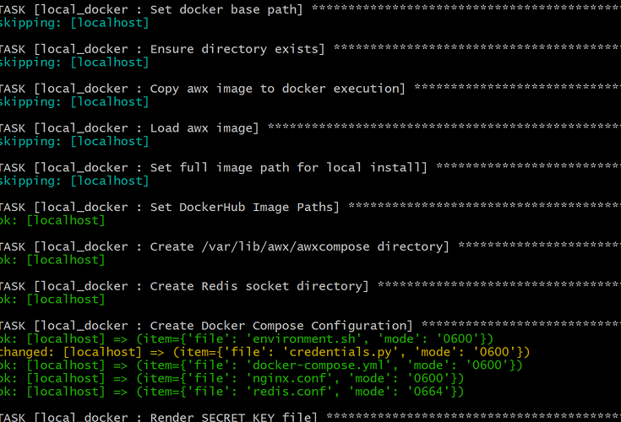

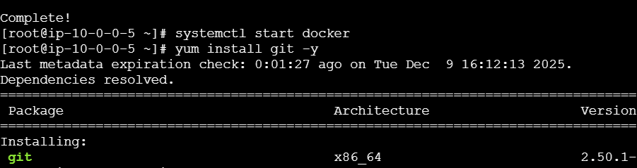
Search in browser with the public_ip and port:80 Username:admin Password:Admin@123
