ELASTIC CONTAINER SERVICE

Task related to ECS.
- Setup a highly available ecs cluster with load balancer and dynamic port mapping.
NOTE:
- Your cluster should maintain atleast 6 tasks at any point of time and should be highly availble across multiple AZ's.
- Use the below image from deployment: sabair0509/hiring-app:works

First pull the docker image : sabair0509/hiring-app:works => use this name
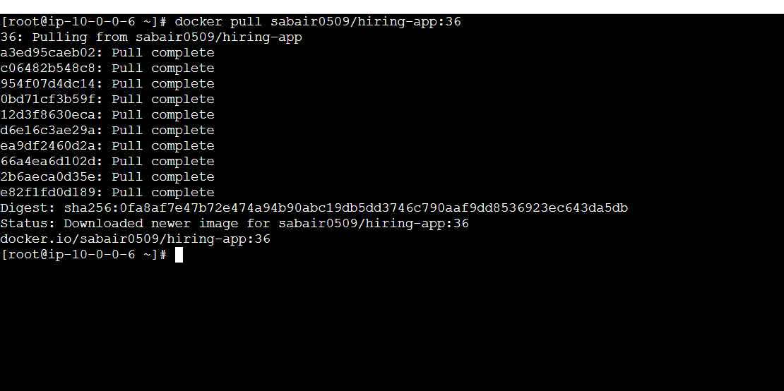create a repo and push the images from cli to repo
Before we need to login aws
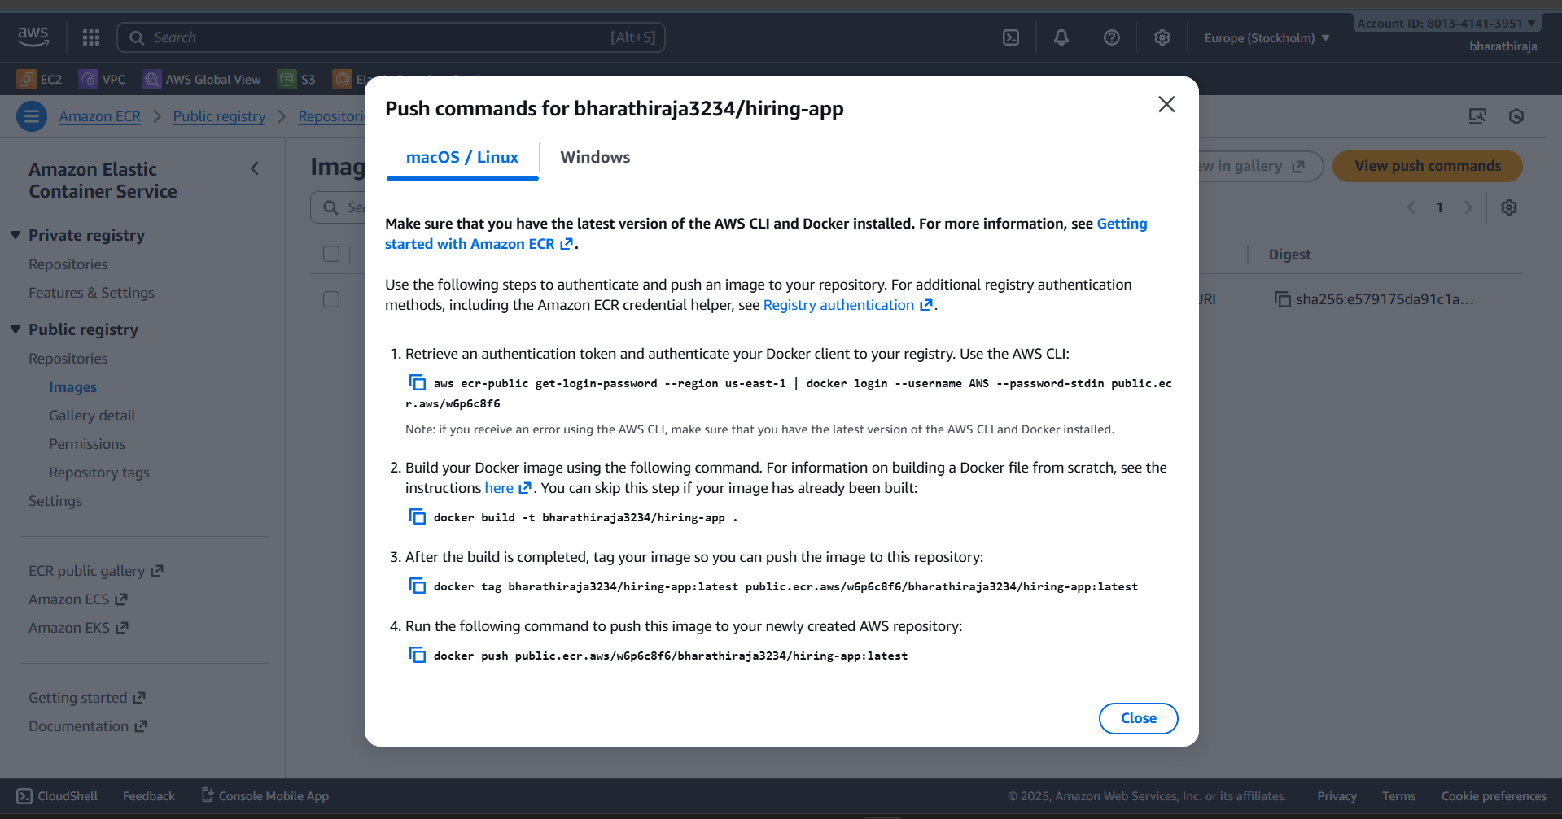
There is you able to use four commands and the first command is login and
4th command for pushing use it and push it

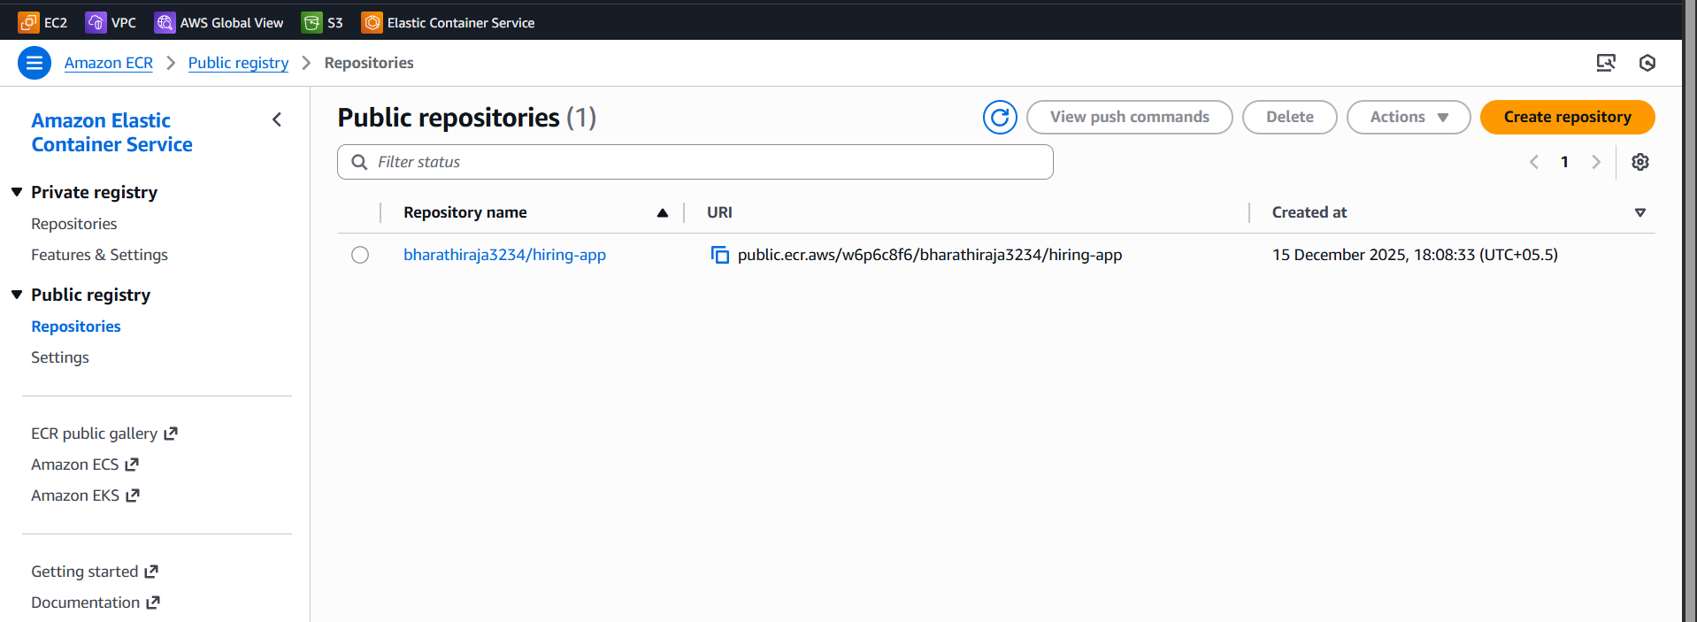
I push the images here to aws repo
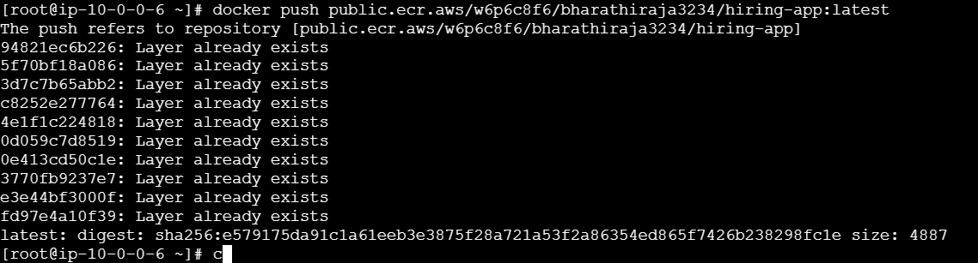
After the push the images I got here
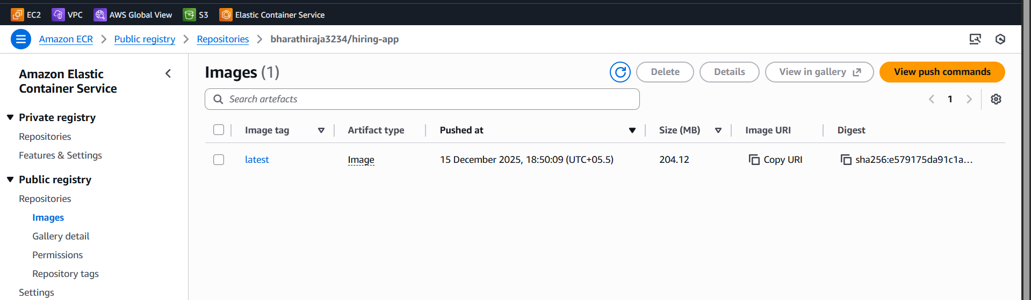
Go to ECS and create express mode
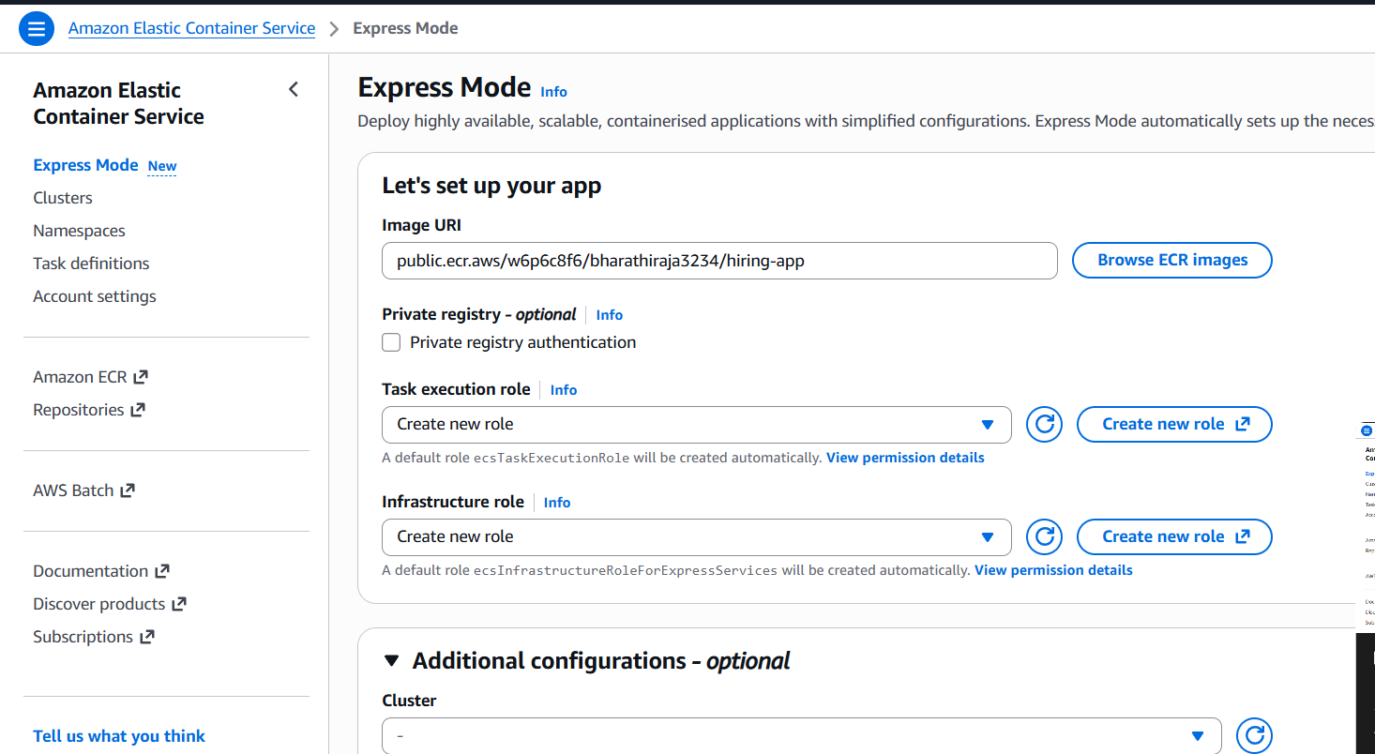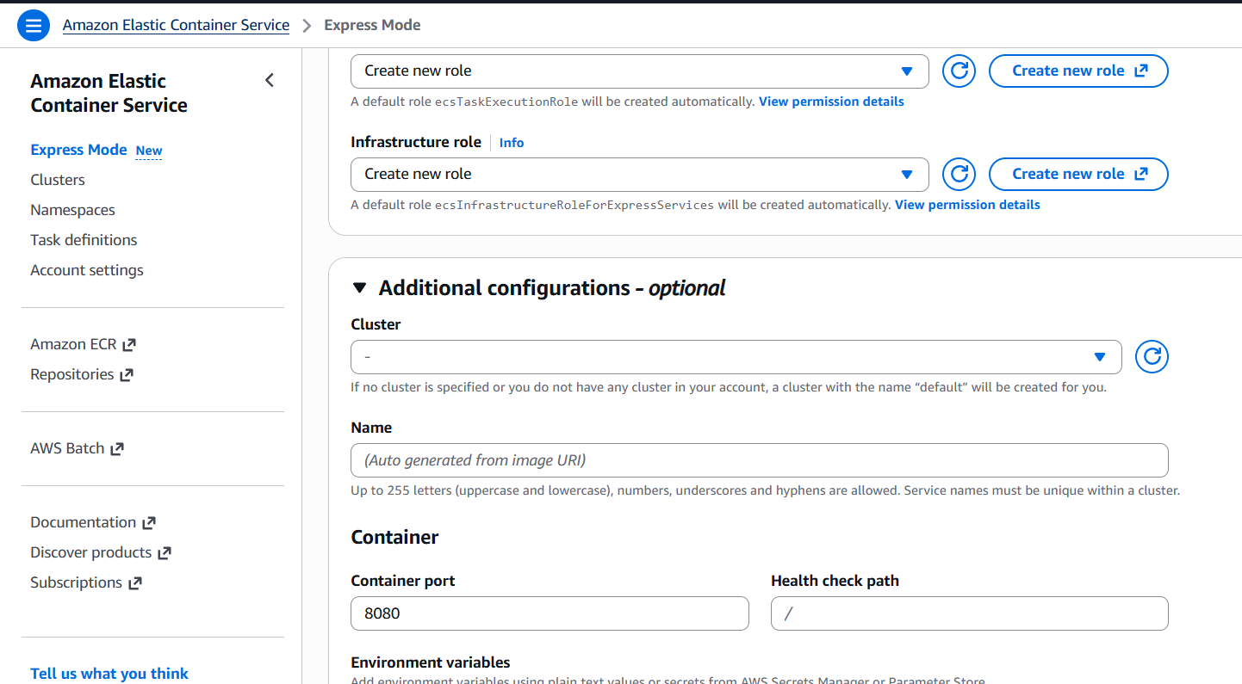
We need to necessary details 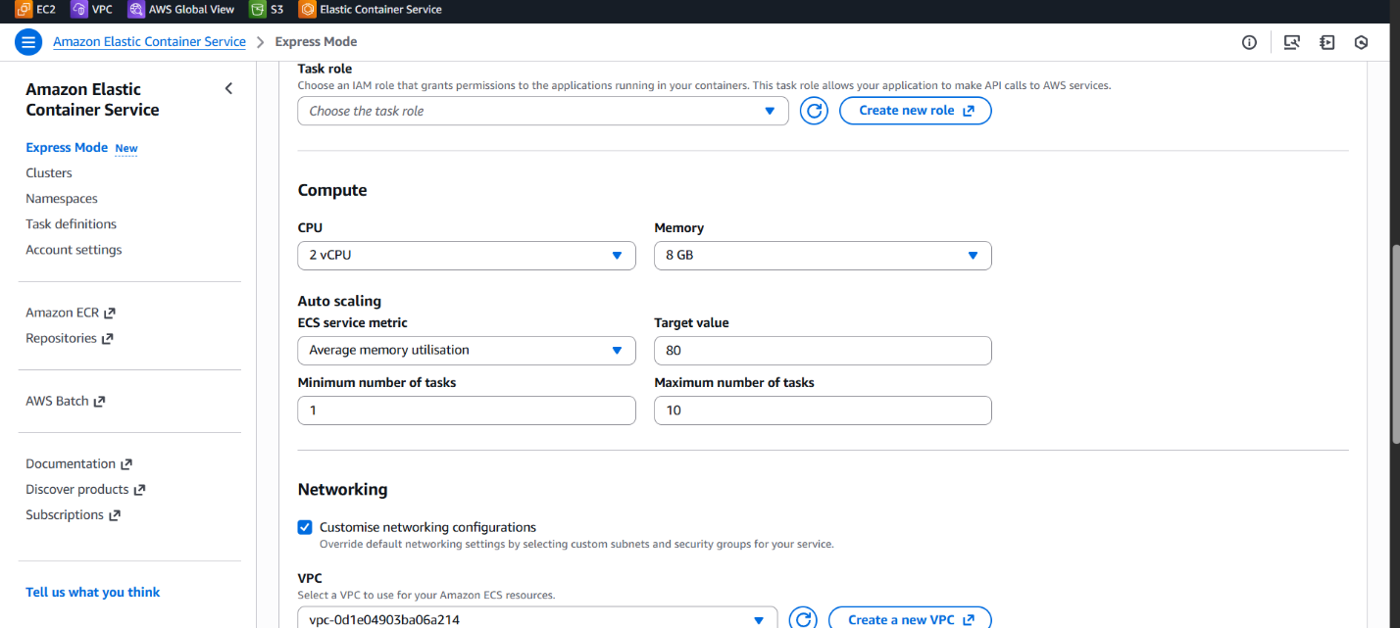
Processing here
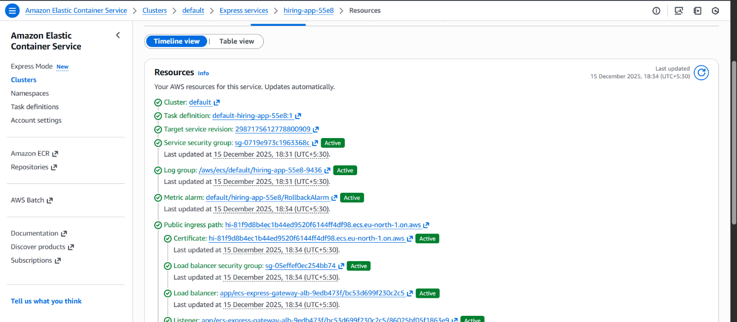
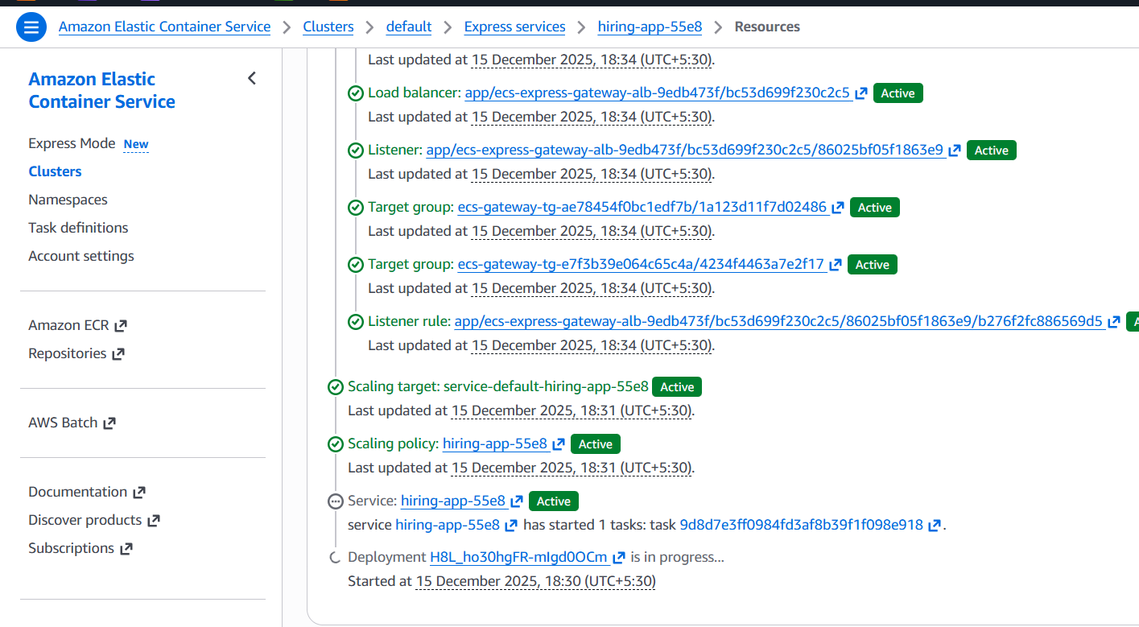
Finll created
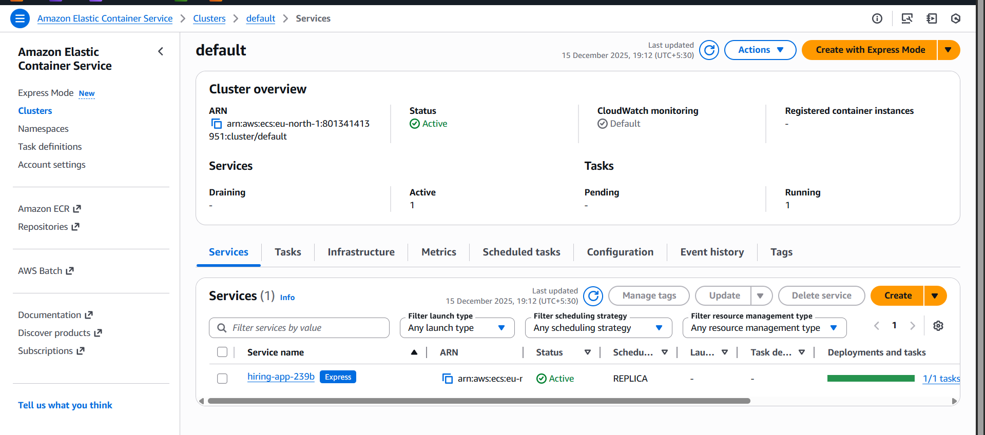
Finally I created after deploying 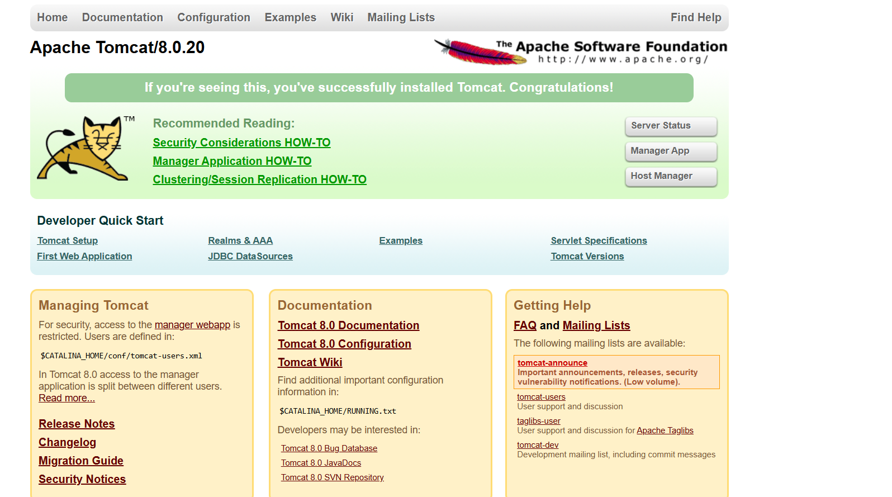
Check if it's active or not. Here, mine is active

