KUBERNETES_01_TASKS
Start working on k8s-01 tasks.
- Set up Minikube on your local machine.
- Set up k8s master and two worker nodes on Ubuntu.
- Run one nginx pod.
- Mug up Master and slave components on k8s.

  - Set up Minikube on your local machine.

https://docs.docker.com/desktop/install/windows-install/
click the link on the top
then docker desktop for window, click on that download
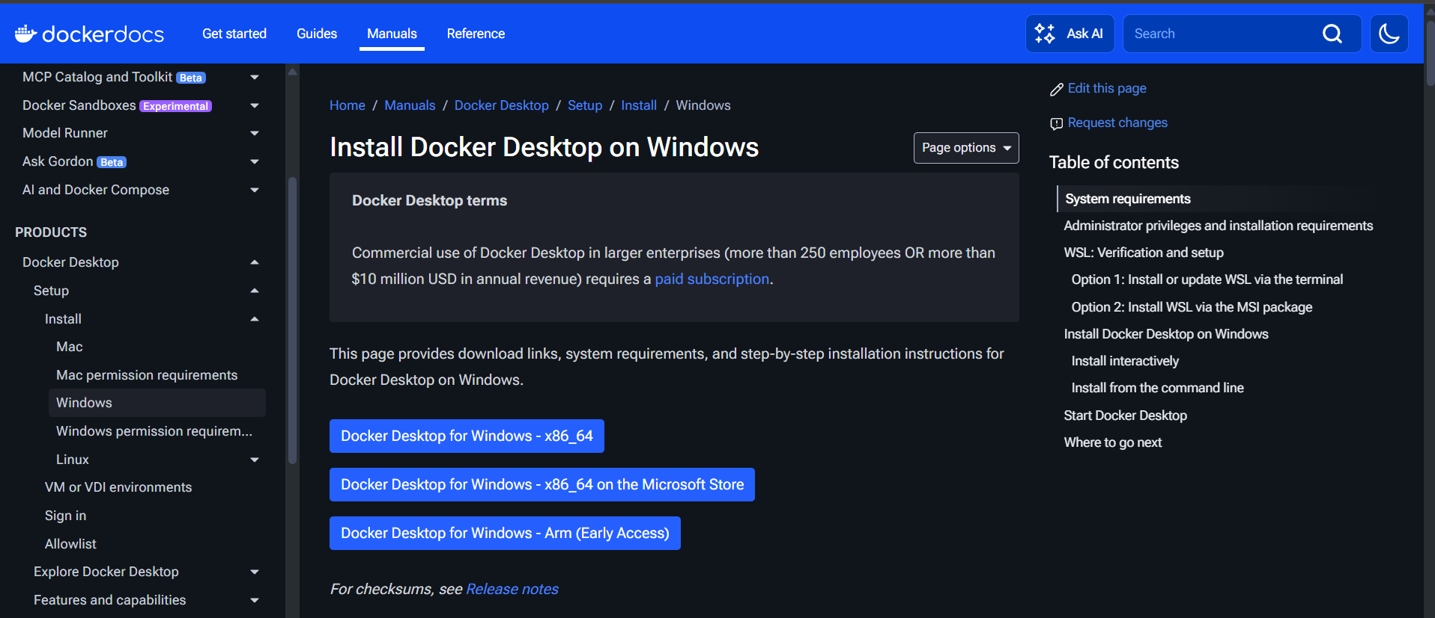
Download successfully and install that
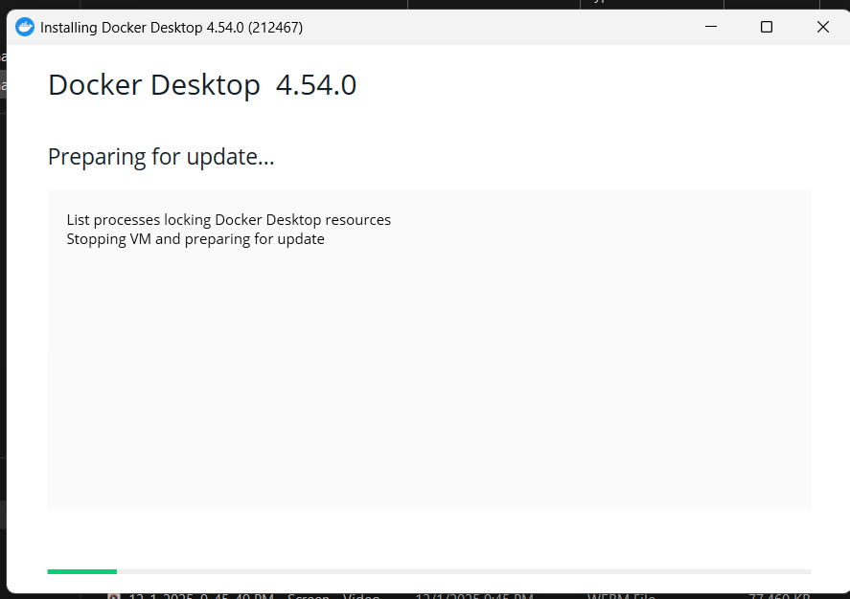
Installed successfully
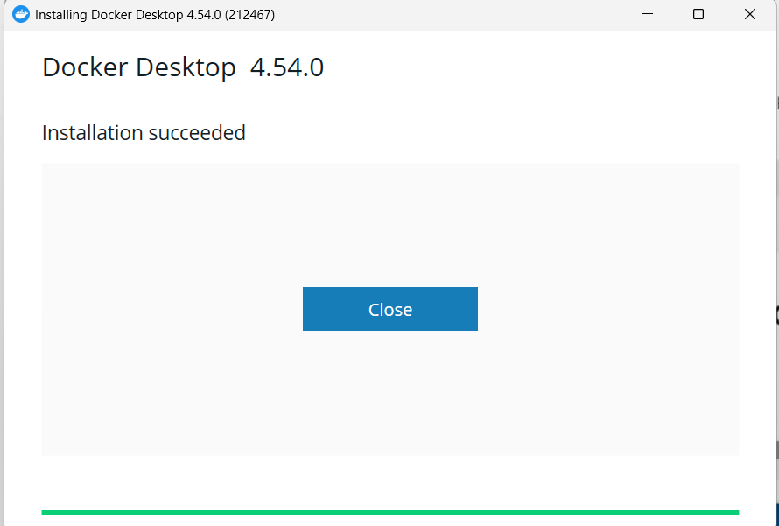
Verify if Docker is installed or not
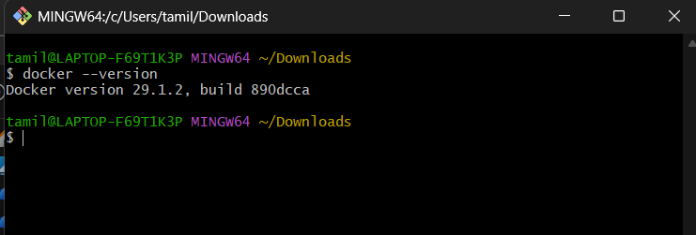
VirtualBox is already installed
Go the page then copy the first command
open the PowerShell paste it it will download
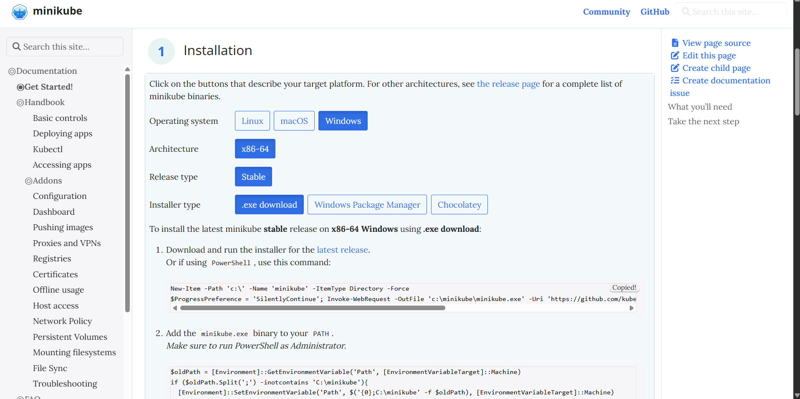
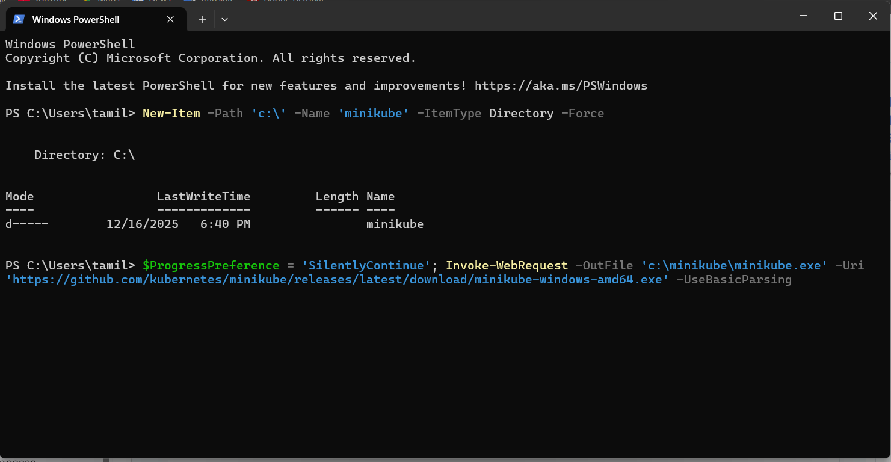
In PowerShell, give the start
There are three pic install processing
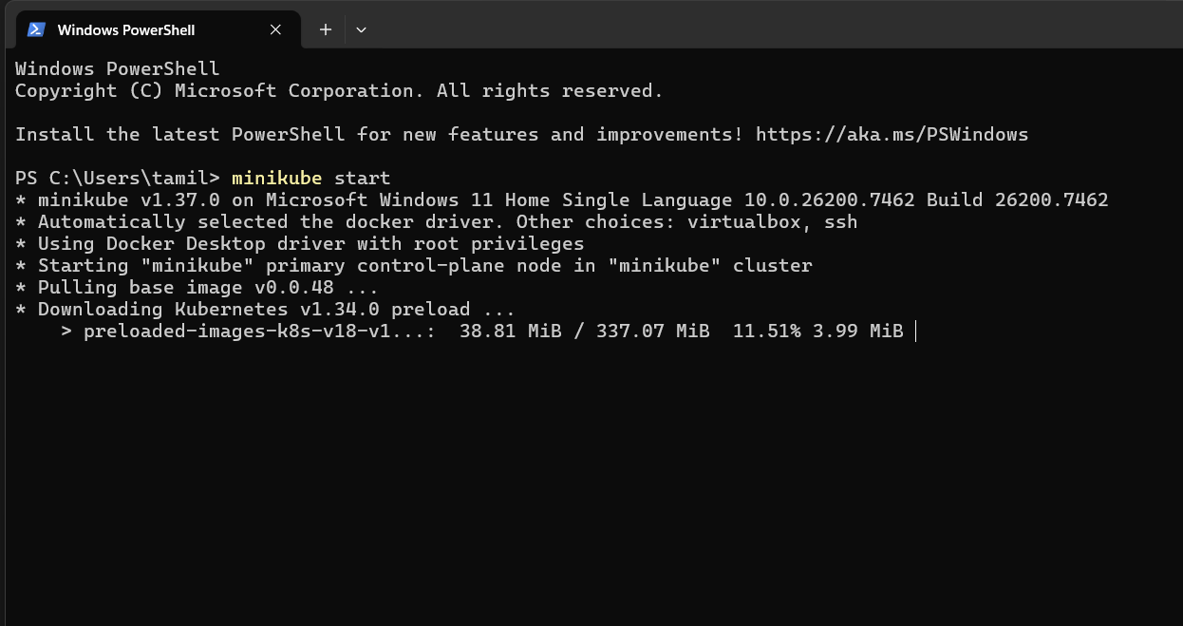
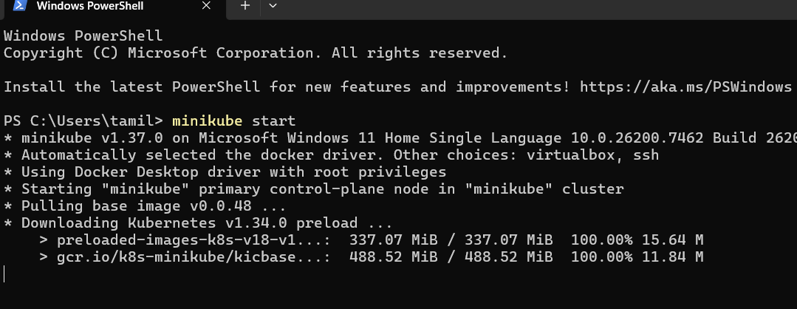

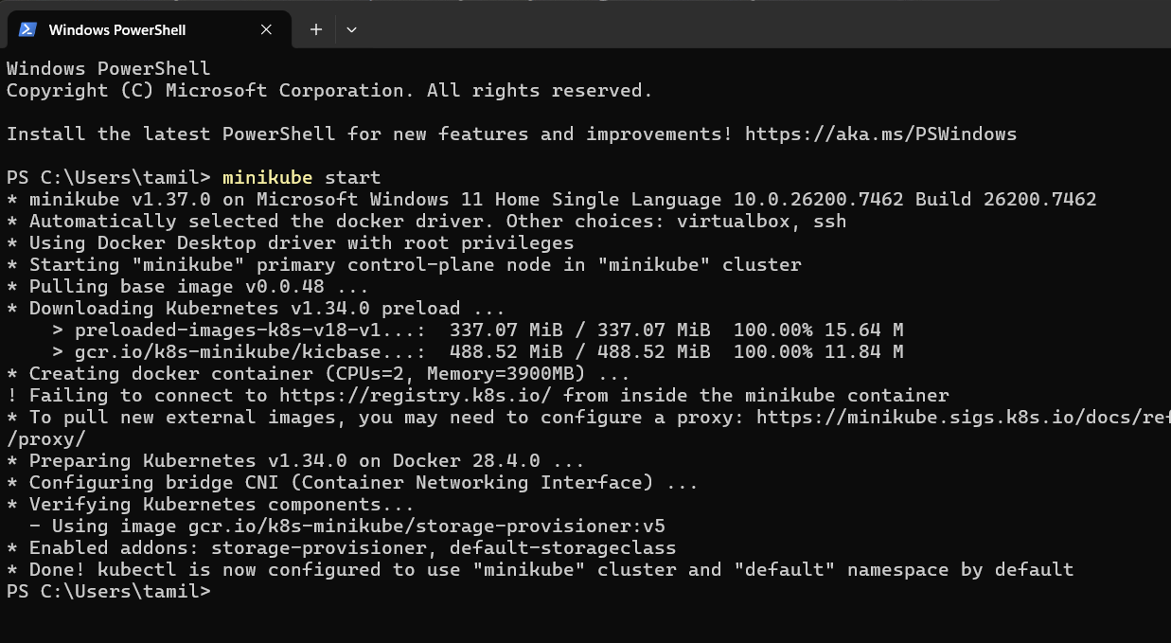
Install finished
After checking minikube ip, checking IP address, it will allocate new IP for specifically
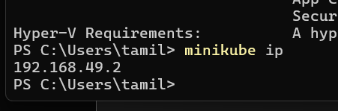
Minikube ssh
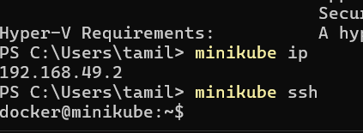
Docker ps => command for check docker for containers
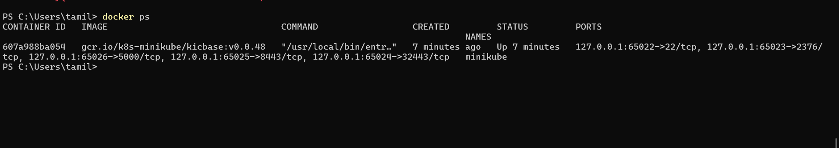
5) Set the minikube path to environmental varaible
export PATH=$PATH:/c/minikube
6) Restart PowerShell and start minikube
minikube start

2.Set up k8s master and two worker nodes on Ubuntu

Setup 3 nodes k8s cluster,1 master and 2 node machines:
======================================================
1) launch 3 instances of type t2.medium and linux2 AMI.
2) Disable swap memory from instances.(Because k8s wants the cpu to utilized 100%)
free - h to check the swap memeory allocated
swapoff -a to off the swap memory
To not enable this after restart then comment this in fstab file.
3) Install docker based on Operating system in 3 instances.
https://docs.docker.com/engine/install/
4) To setup k8s cluster we have different tools like kops and kubeadm.
https://kubernetes.io/docs/setup/production-environment/tools/kubeadm/install-kubeadm/
5) Now we need to setup networking and configure master and worker nodes.
https://kubernetes.io/docs/setup/production-environment/tools/kubeadm/create-cluster-kubeadm/
6) TO configure master we need to initialize with CIDR
kubeadm init --pod-network-cidr=10.244.0.0/16
7) To start using your cluster, you need to run the following as a regular user:
mkdir -p $HOME/.kube
sudo cp -i /etc/kubernetes/admin.conf $HOME/.kube/config
sudo chown $(id -u):$(id -g) $HOME/.kube/config
8) If we execute kubectl get nodes we can see the status as notready because we haven't installed flannel
9) Install Flannel and check the status of nodes
kubectl apply -f https://github.com/flannel-io/flannel/releases/latest/download/kube-flannel.yml
10) Now copy the token and execute on worker machines.

1) launch 3 instances of type t2.medium and linux2 AMI.
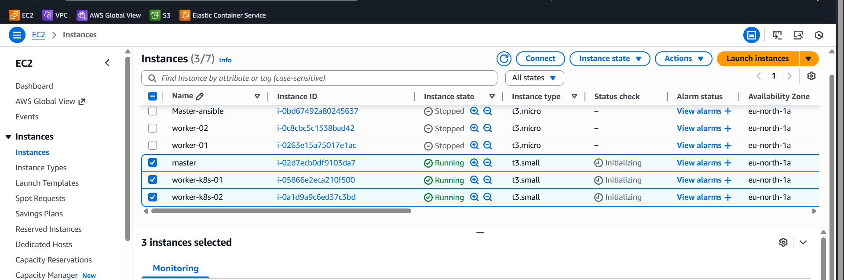
I changed the hostname
2) Disable swap memory from instances.(Because k8s wants the cpu to utilized 100%)
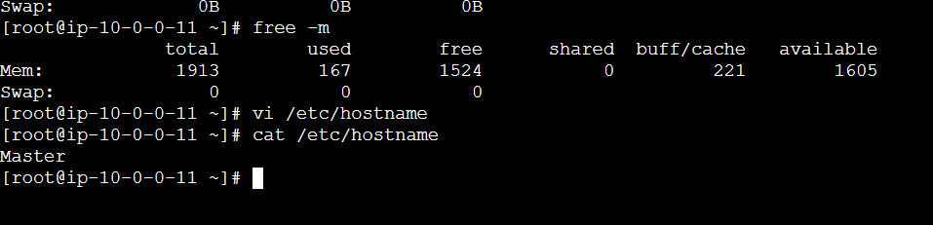
I changed the master name
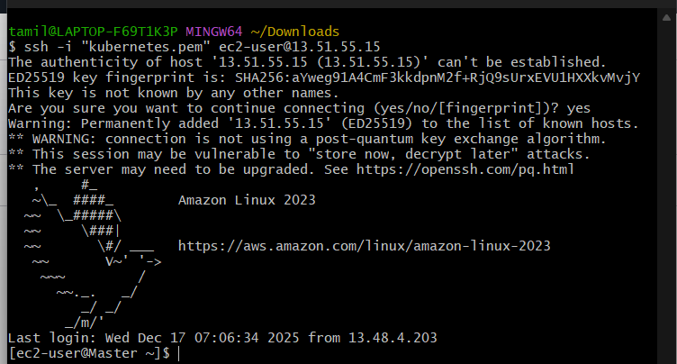
Worker-01 node I changed the name
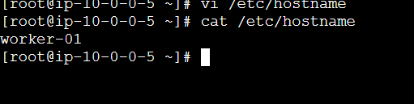
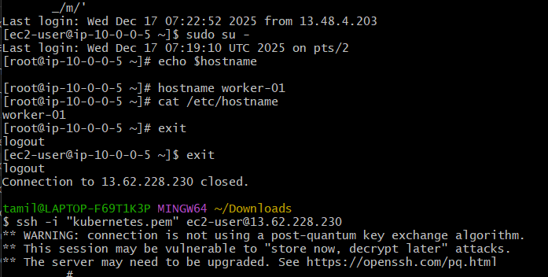

3) Install docker based on the Operating system in 3 instances.
https://docs.docker.com/engine/install/
docker -version to check the version
I installed 3 instances
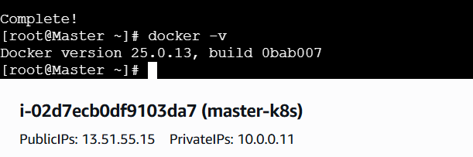
Systemctl start docker
systyemctl enable docker
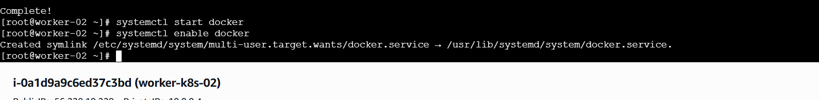

4) To setup k8s cluster we have different tools like kops and kubeadm.
https://kubernetes.io/docs/setup/production-environment/tools/kubeadm/install-kubeadm/
cat <<EOF | sudo tee /etc/yum.repos.d/kubernetes.repo
[kubernetes]
name=Kubernetes
baseurl=https://pkgs.k8s.io/core:/stable:/v1.34/rpm/
enabled=1
gpgcheck=1
gpgkey=https://pkgs.k8s.io/core:/stable:/v1.34/rpm/repodata/repomd.xml.key
exclude=kubelet kubeadm kubectl cri-tools kubernetes-cni
EOF
Execute 3 instances necessary
sudo sed -i 's/^SELINUX=enforcing$/SELINUX=permissive/' /etc/selinux/config

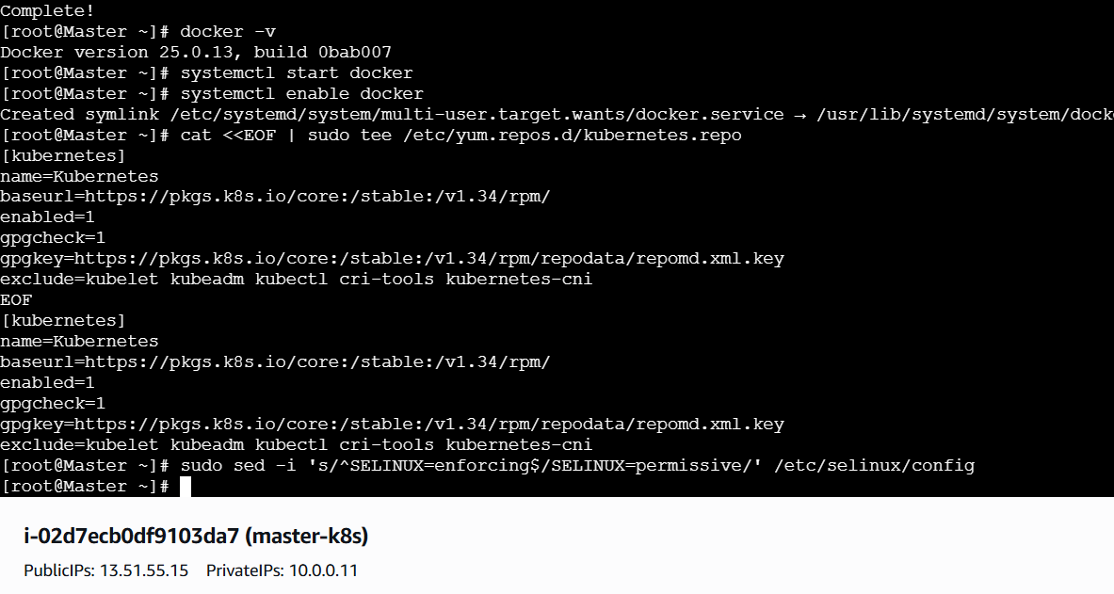
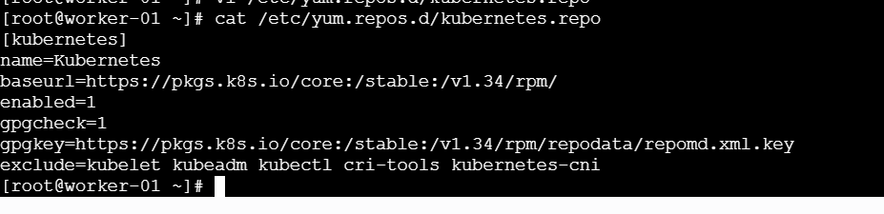
sudo yum install -y kubelet kubeadm kubectl --disableexcludes=kubernetes

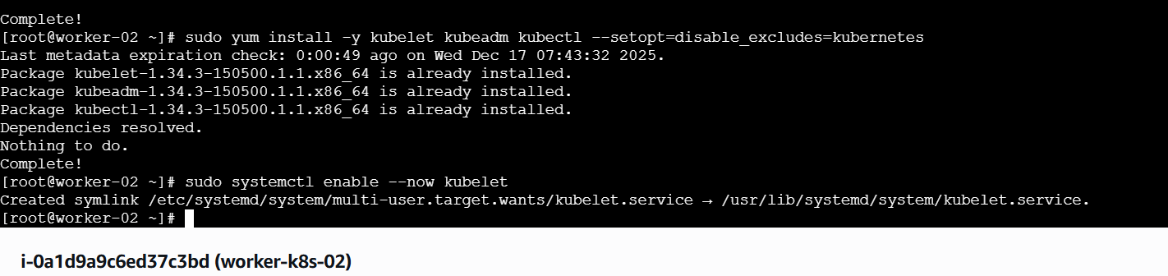
I execute these commands
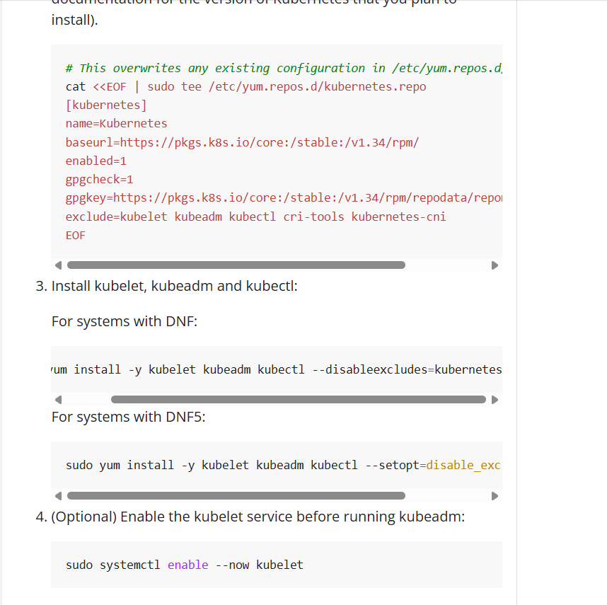

5) Now we need to setup networking and configure master and worker nodes.
https://kubernetes.io/docs/setup/production-environment/tools/kubeadm/create-cluster-kubeadm/

6) TO configure master we need to initialize with CIDR
kubeadm init --pod-network-cidr=10.244.0.0/16
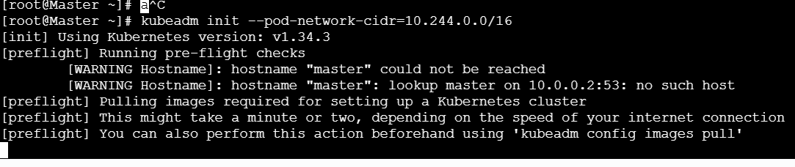
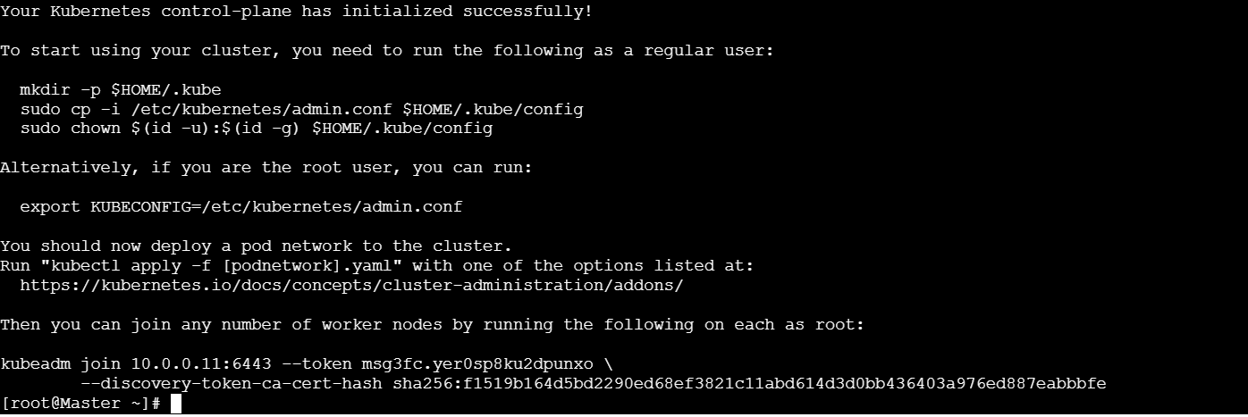
execute three commands
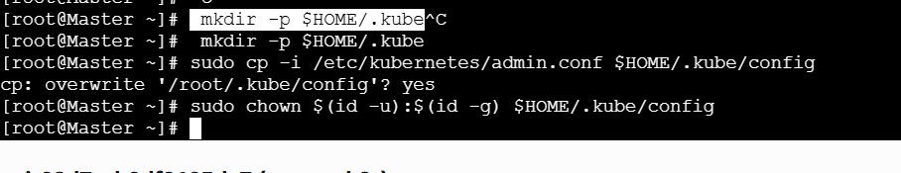

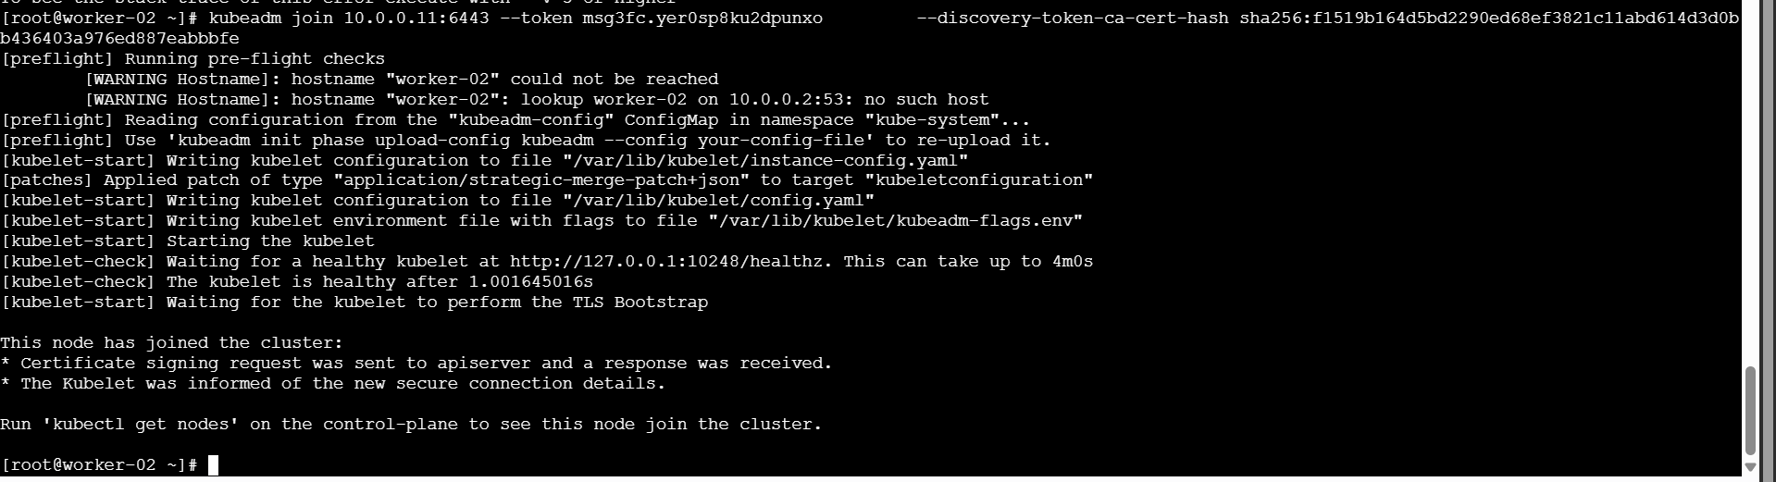
Kubectl get node
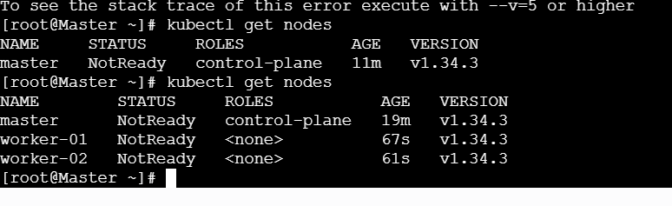
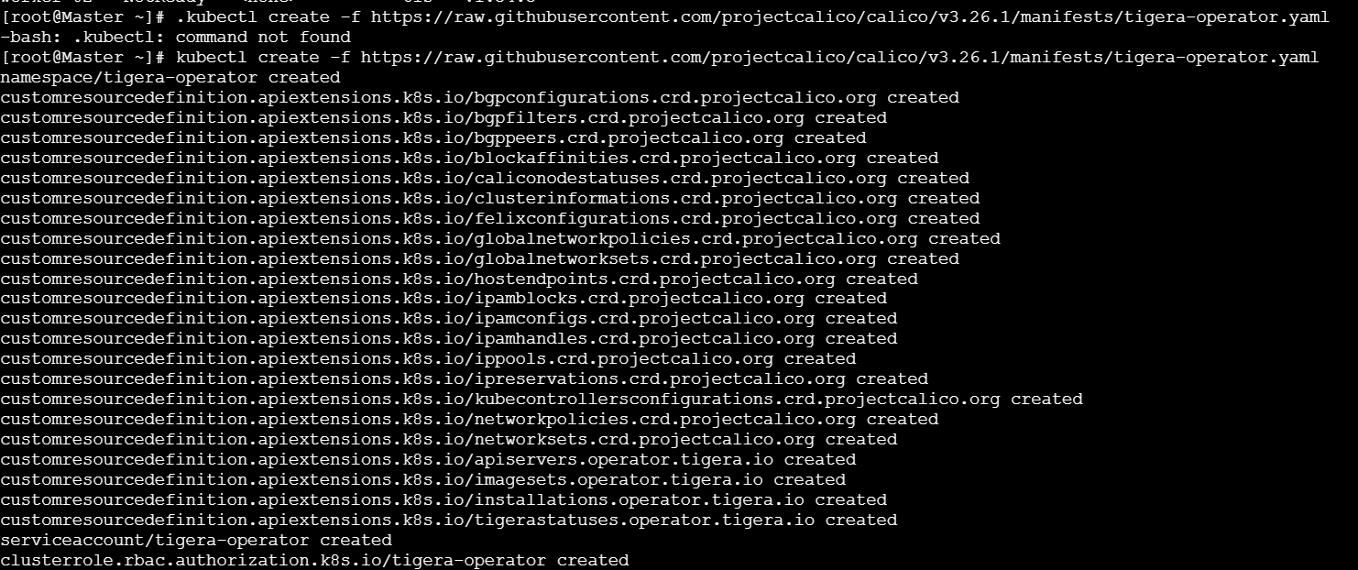

8) If we execute kubectl get nodes we can see the status as notready because we haven't installed flannel

9) Install Flannel and check the status of nodes
kubectl apply -f https://github.com/flannel-io/flannel/releases/latest/download/kube-flannel.yml
kubectl apply -f https://raw.githubusercontent.com/flannel-io/flannel/master/Documentation/kube-flannel.yml
use this command to make it rready master and node also
curl https://raw.githubusercontent.com/projectcalico/calico/v3.26.1/manifests/custom-resources.yaml -O
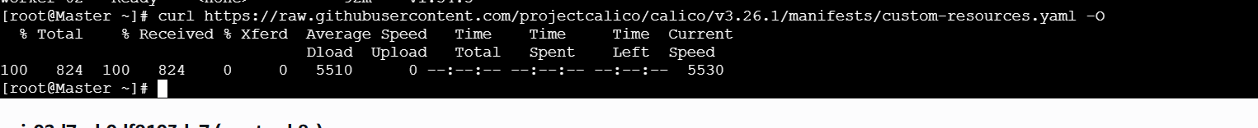
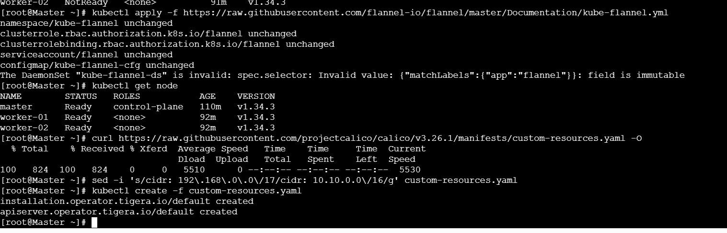

3.Run one nginx pod.
Step 1: Check if aby pods are running and create nginx pod by using following commands.
kubectl get pods
kubectl run firstpod --image=nginx
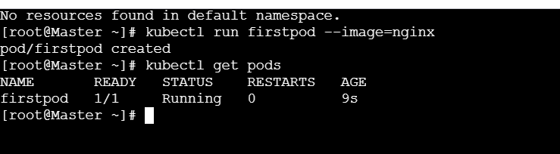
Step 2: Expose the port number and access it using worker-2 public_ip:31954 using following
commands.
kubectl expose pod firstpod --port=80 --type=NodePort
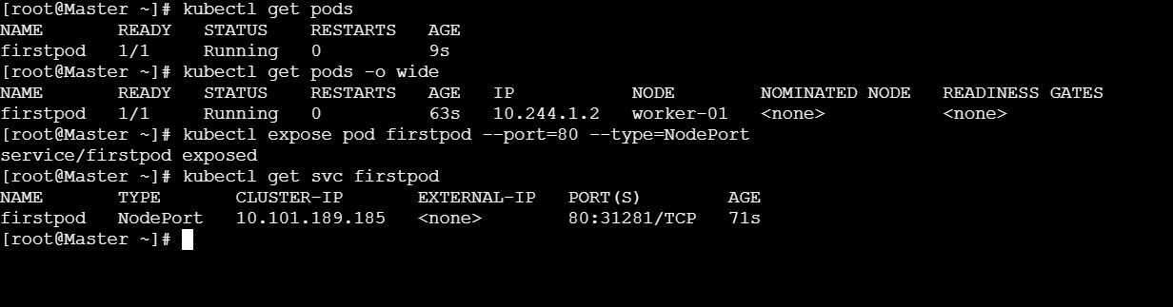
Step 3: Deploy using following commands and run.
kubectl create deployment nginx --image=nginx
kubectl scale deployment nginx --replicas=3
kubectl get pods -o wide
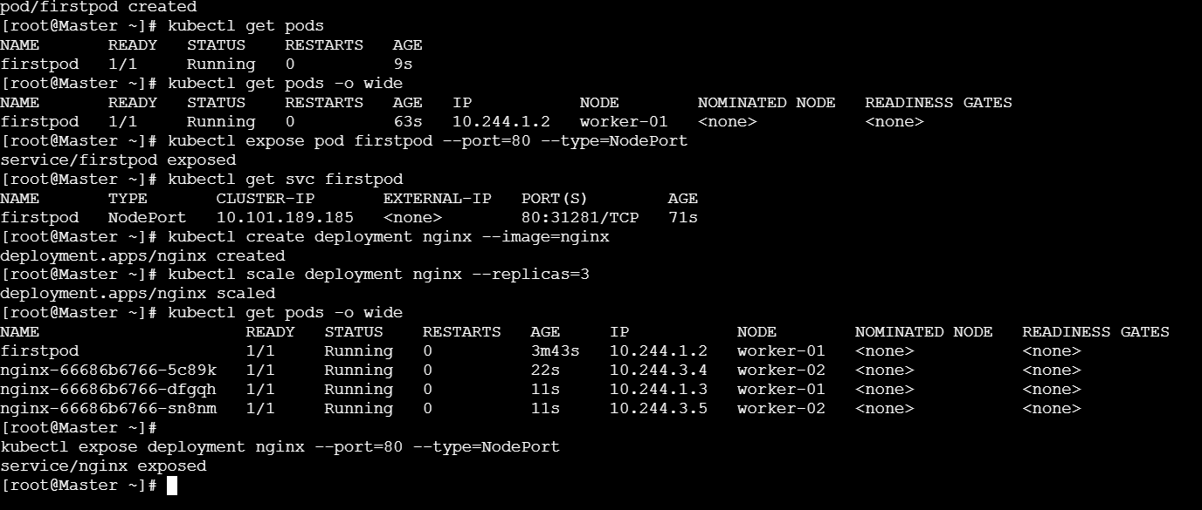

4 . Mug up Master and slave components on k8s.
MASTER (Control Plane) – “Brain”
4 MAIN COMPONENTS
1. API Server
• Entry point to Kubernetes
• All commands go through this
Think: Gate / Front door
2. etcd
• Stores all cluster data
• Pods, nodes, configs, secrets
Think: Database / Memory
3. Scheduler
• Decides which node a pod runs on
Think: Pod → Node allocator
4. Controller Manager
Kubernetes Task - 01
• Keeps desired state = actual state
• Creates/deletes pods if needed
Think: Auto-corrector
MASTER IN ONE-LINE MUG UP
API - ETCD - Scheduler - Controller
SLAVE / WORKER NODE – “Doer”
3 MAIN COMPONENTS
1. kubelet
• Runs on every node
• Talks to master
• Starts pods
Think: Node manager
2. Container Runtime
• Runs containers
• Example: containerd, CRI-O
Think: Engine
3. kube-proxy
• Handles networking
• Service → Pod traffic
Think: Traffic police
WORKER IN ONE-LINE MUG UP
Kubelet – Runtime – Kube-proxy

