Start working on k8s-02 tasks.
- Create a Simple Pod Using YAML Task: Write a YAML file to create a Pod named firstpod with an nginx container. Verify the Pod creation using kubectl get pods and check the logs of the container using kubectl logs firstpod.

Step 1: Create a YAML file
Create a file named firstpod.yaml
vi firstpod.yaml
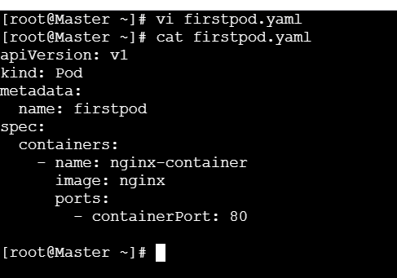
Explanation (simple):
- apiVersion: v1 → Core Kubernetes API
- kind: Pod → We are creating a Pod
- name: firstpod → Pod name
- image: nginx → Nginx container image from Docker Hub

Step 3: Create the Pod
Run the command:
kubectl apply -f firstpod.yaml
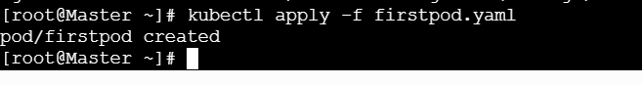
Step 4: Verify Pod creation
Check the Pod status:
kubectl get pods
📌 Expected output:
NAME READY STATUS RESTARTS AGE
firstpod 1/1 Running 0 10s
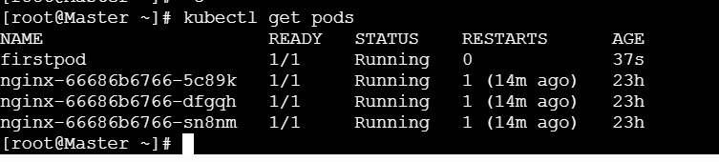
Step 5: Describe the Pod (Optional but good practice)
kubectl describe pod firstpod
✔️ Shows:
- Node details
- Container image
- Events
- IP address
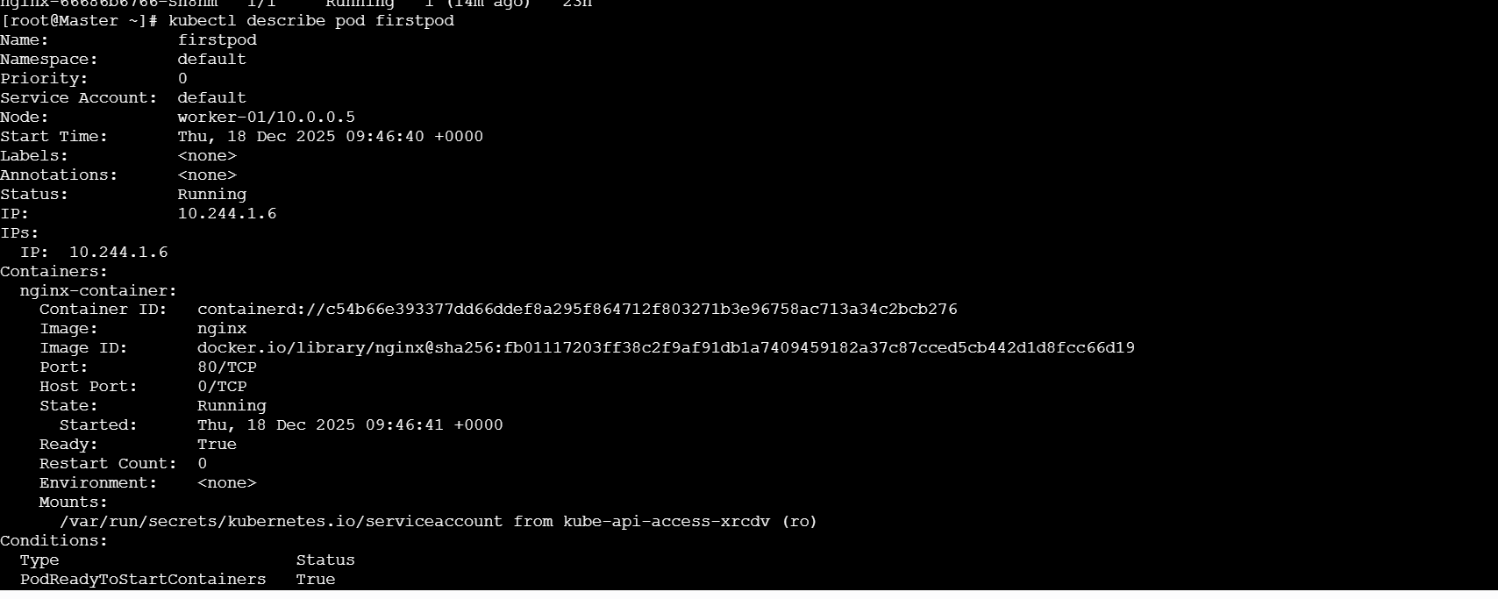
Step 6: Check container logs
Run:
kubectl logs firstpod
📌 You will see nginx startup logs, for example:
/docker-entrypoint.sh: Configuration complete; ready for start up
✔️ This confirms the container is running properly
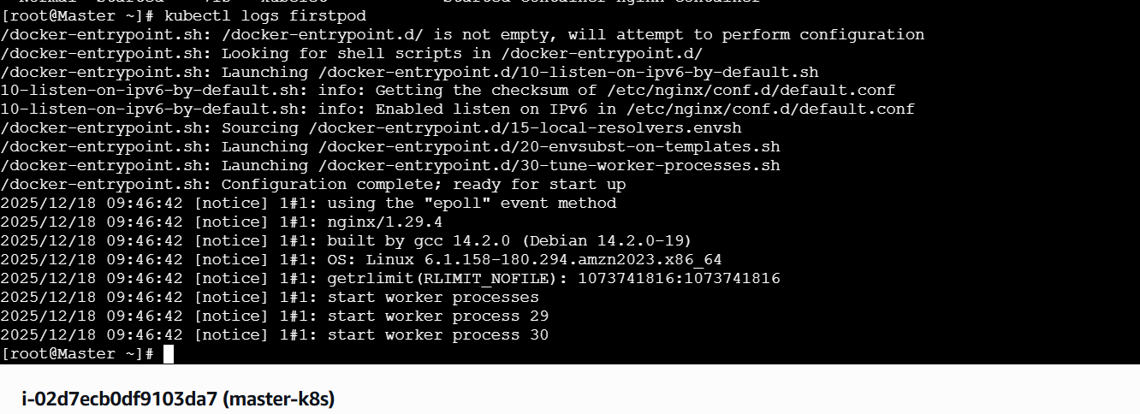
Step 7: (Optional) Access inside the container
kubectl exec -it firstpod -- /bin/bash
Check nginx:
ps -ef | grep nginx
Exit:
Exit
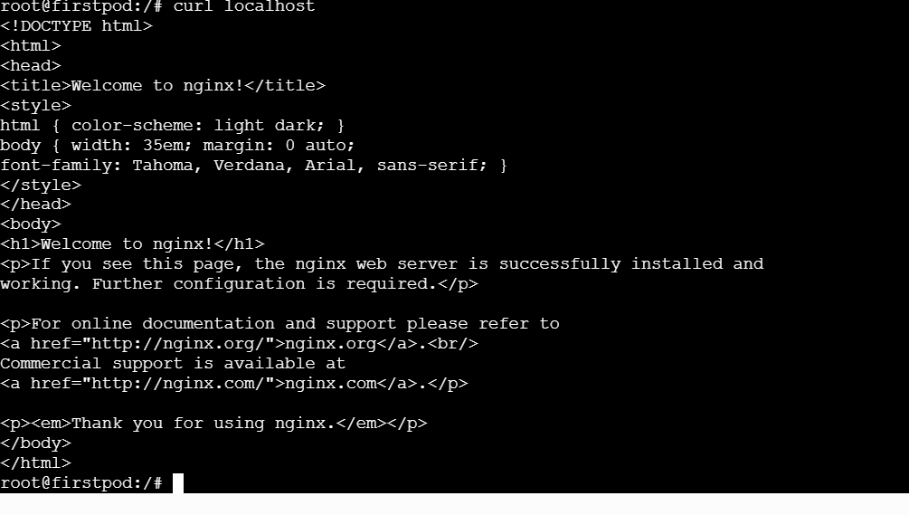
To get the details about pods
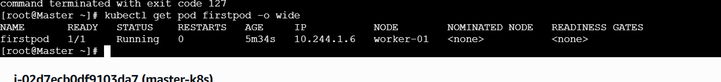

- Set Environment Variables in a Pod Task: Modify the YAML file to include environment variables myname: sabair and City: Hyderabad. Deploy the Pod and use kubectl exec <pod_name> -- env to check if the environment variables are set properly.

Step 1: Delete old Pod (VERY IMPORTANT)
Pods are immutable, so first delete the existing pod.
kubectl delete pod firstpod
yes, I deleted before what I have done it

Step 2: Modify the YAML file
Open your YAML file:
vi firstpod.yaml

Step 3: Add Environment Variables in YAML
Replace the content with this
apiVersion: v1
kind: Pod
metadata:
name: firstpod
spec:
containers:
- name: nginx-container
image: nginx
ports:
- containerPort: 80
env:
- name: myname
value: sabair
- name: City
value: Hyderabad
Important:
- env: must be inside container, not outside
Step 4: Deploy the Pod
kubectl apply -f firstpod.yaml
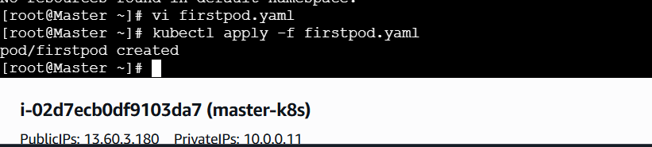
Step 5: Check Pod status
kubectl get pods
Expected:
firstpod 1/1 Running
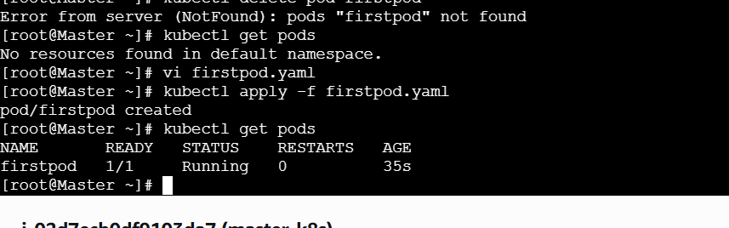
Step 6: Verify Environment Variables
Run:
kubectl exec firstpod -- env
You should see:
myname=sabair
City=Hyderabad
✔️ Environment variables are set correctly.
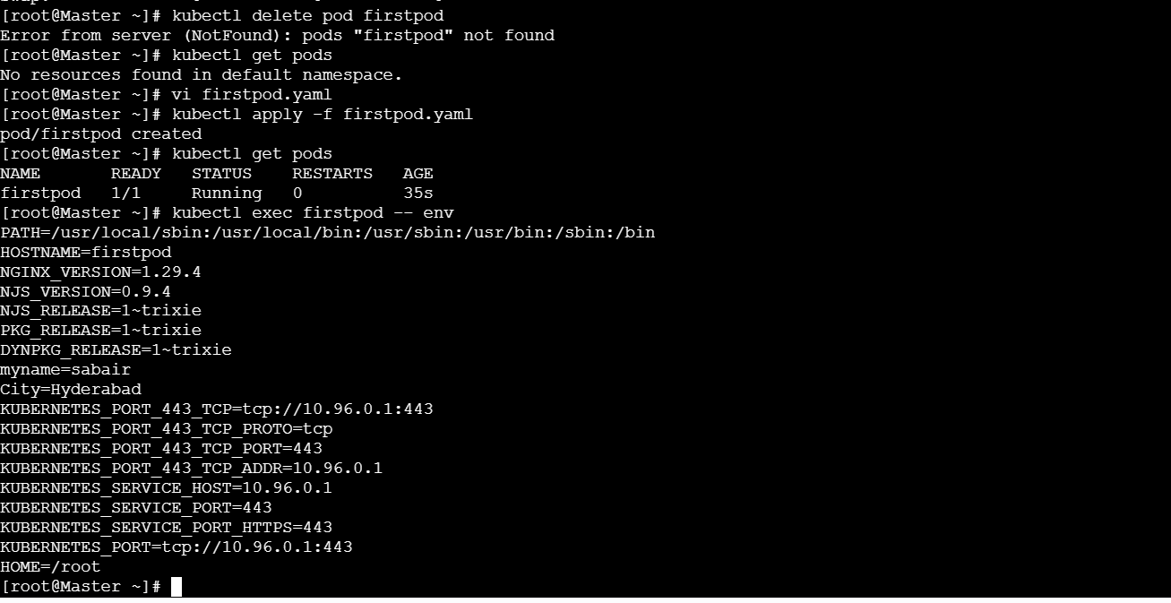
Step 7: (Optional) Check one variable only
kubectl exec firstpod -- printenv myname
kubectl exec firstpod -- printenv City
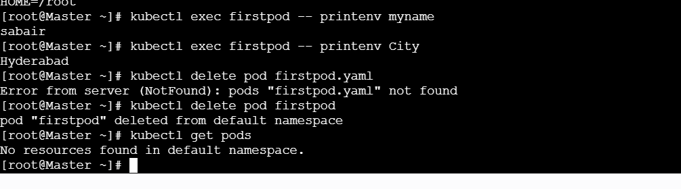

🧠 Key concept (Interview GOLD)
Environment variables in Kubernetes Pods are defined inside the container spec using the env field and are accessible at runtime using standard Linux environment commands.

🎤 Interview 2-Line Answer
“I define environment variables inside the Pod YAML using the env field. After deployment, I verify them using kubectl exec and env or printenv commands.”

- Deploy a Pod with Commands (Args) in YAML Task: Modify the YAML file to add args that instruct the container to sleep for 50 seconds. Deploy the Pod and use kubectl describe pod to verify the args are correctly passed to the container.

Task Goal (Simple)
- Create a Pod
- Pass args (arguments) to the container
- Container should sleep for 50 seconds
- Verify using kubectl describe pod

🔑 Important concept (before starting)
- command → overrides ENTRYPOINT
- args → overrides CMD
For nginx, we’ll use a simple image that supports sleep easily → busybox
(This is standard practice for learning args)

Step 1: Delete old Pod (MANDATORY)
kubectl delete pod firstpod
Verify:
kubectl get pods
✔️ firstpod should be gone.

Step 2: Modify the YAML file
Open the YAML file:
vi firstpod.yaml
Step 3: Add args to sleep for 50 seconds
Paste this content 👇
apiVersion: v1
kind: Pod
metadata:
name: firstpod
spec:
containers:
- name: sleep-container
image: busybox
args:
- sleep
- "50"
👉 Explanation:
- busybox image has sleep command
- "50" is in quotes because YAML treats numbers differently
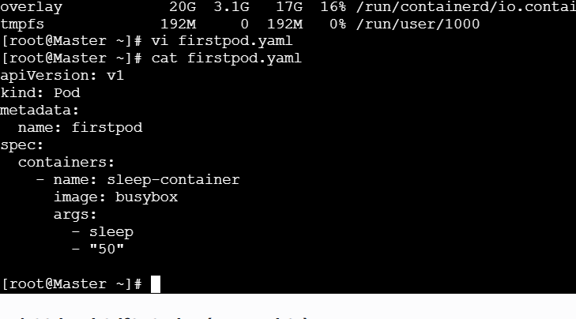
Step 4: Deploy the Pod
kubectl apply -f firstpod.yaml
Expected:
pod/firstpod created
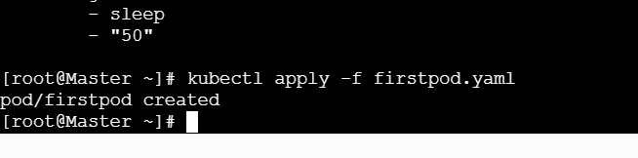
Step 5: Check Pod status
kubectl get pods
You may see:
firstpod 0/1 Completed 0 50s
✔️ This is CORRECT
The container sleeps for 50 seconds and exits.

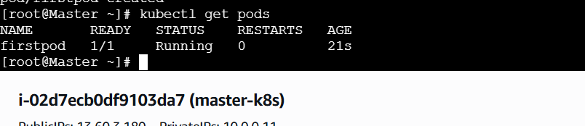
Step 6: Verify args using kubectl describe
kubectl describe pod firstpod
Look for this section 👇
Containers:
sleep-container:
Image: busybox
Args:
sleep
50
✔️ This confirms args are passed correctly.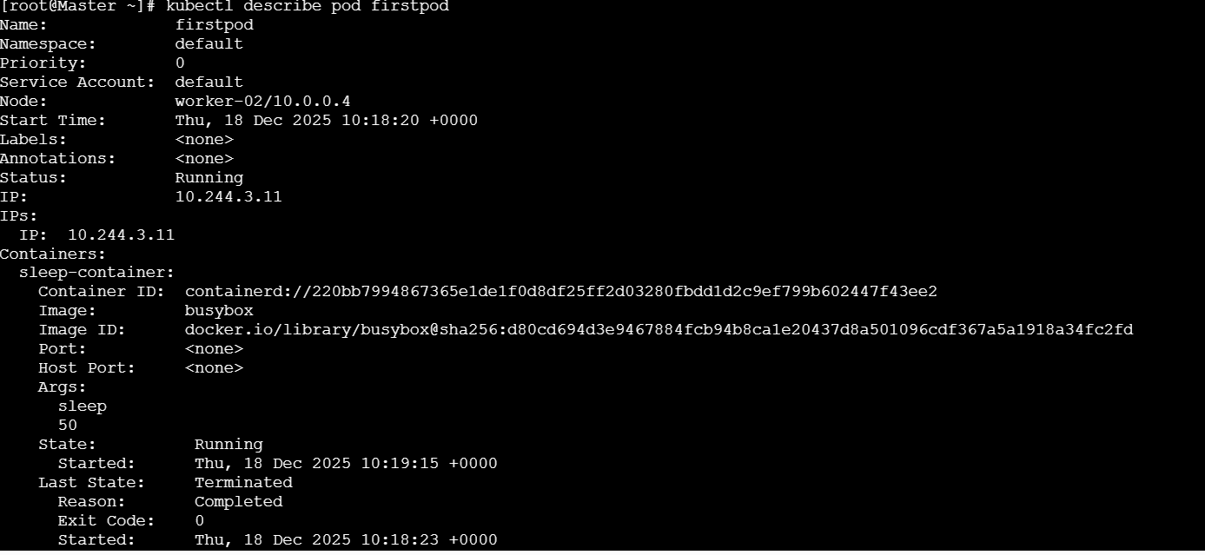

Key learning (Interview GOLD)
Field | Purpose
Command | Overrides ENTRYPOINT
args | Overrides CMD

- Create a Pod with Two Containers Task: Create a YAML file to define a Pod with two nginx containers inside. Use kubectl exec to access both containers and verify that both containers can communicate through the same network (e.g., using telnet between them).
Task Goal (Simple)
- Create ONE Pod
- Pod has TWO containers
- Both containers run nginx
- Verify:
  - You can exec into each container
  - Both containers communicate using the same Pod network

Important concept (VERY IMPORTANT)
- Containers inside the same Pod share:
  - Same IP address
  - Same network namespace
- Containers talk to each other using localhost + different ports
- Step 1: Delete old Pod (MANDATORY)
- kubectl delete pod firstpod
- Verify:
- kubectl get pods
- ✔️ firstpod should not exist.

Step 2: Create YAML file with TWO containers
Open file:
vi firstpod.yaml
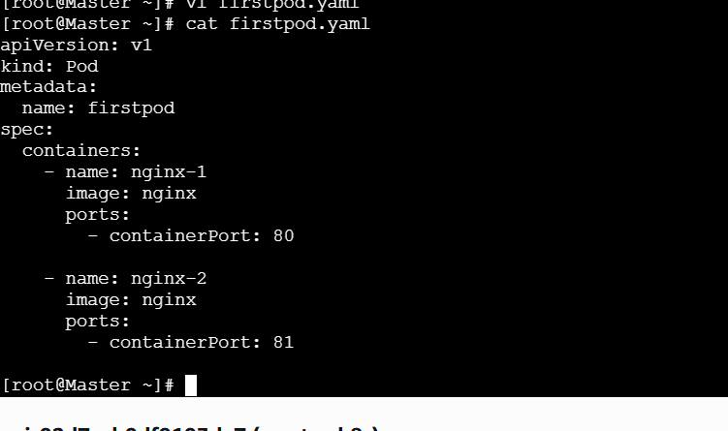
Why different ports?
- Both containers share same IP
- Ports must be different to avoid conflict
- Step 4: Deploy the Pod
- kubectl apply -f firstpod.yaml
- Expected:
- pod/firstpod created
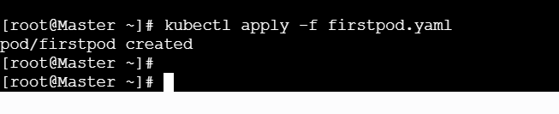
Step 5: Verify Pod status
kubectl get pods
Expected:
firstpod 2/2 Running
✔️ 2/2 means both containers are running
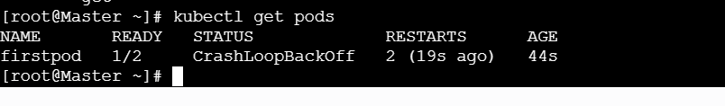
Step 6: List containers inside the Pod
kubectl describe pod firstpod
You’ll see:
Containers:
nginx-1
nginx-2

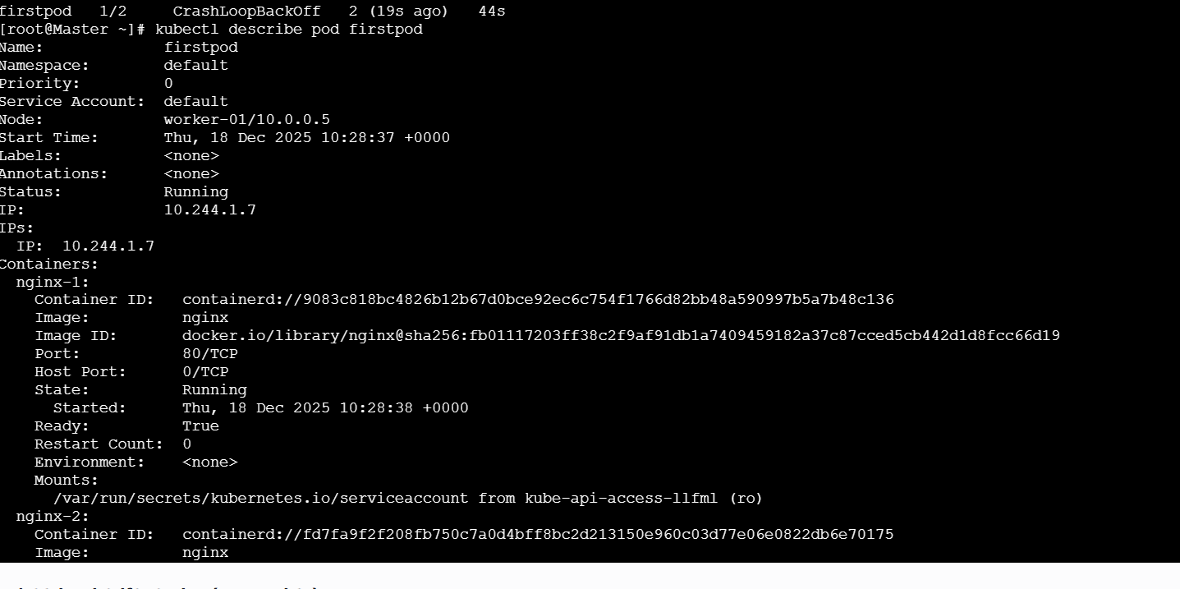Step 7: Exec into FIRST container
kubectl exec -it firstpod -c nginx-1 -- bash
Inside container, test nginx:
curl localhost:80
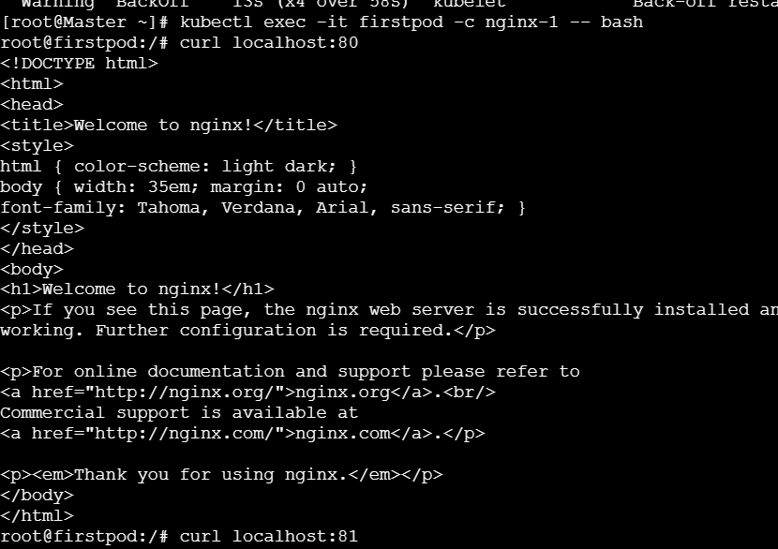
Step 8: Exec into SECOND container
kubectl exec -it firstpod -c nginx-2 -- bash
Test second nginx:
curl localhost:81
✔️ nginx page again
Exit;
kubectl exec -it twonginx -c nginx1 -- bash
kubectl exec -it twonginx -c nginx2 -- bash

- Set Up an Init Container in a Pod Task: Modify the YAML to include an init container that sleeps for 30 seconds before the main containers start. Verify the init container's execution using kubectl describe pod and check the logs to confirm its completion.

Task Goal (Simple)
- Create a Pod
- Add an init container
- Init container sleeps for 30 seconds
- Main container starts only after init container completes
- Verify using:
  - kubectl describe pod
  - kubectl logs

🔑 Important concept (1 minute read)
- Init containers run FIRST
- They run one by one
- Main containers start only after init containers finish successfully
- If init container fails → Pod will NOT start

Step 1: Delete existing Pod (MANDATORY)
Pods are immutable 👇
kubectl delete pod firstpod
Confirm:
kubectl get pods
✔️ firstpod should not be listed.
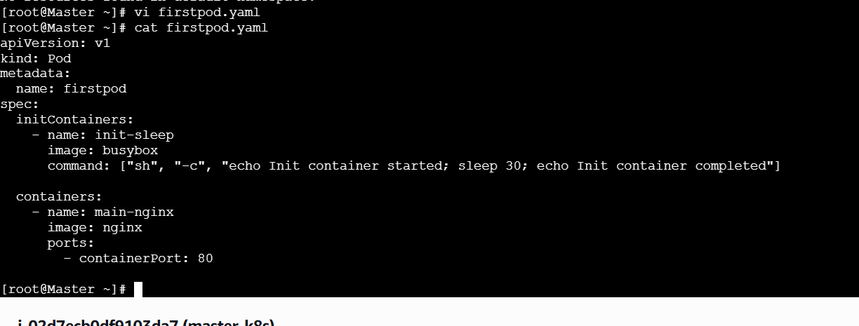
Explanation:
- initContainers: → runs before main containers
- busybox → lightweight image
- sleep 30 → waits 30 seconds
- nginx starts only after init completes
- Step 4: Deploy the Pod
- kubectl apply -f firstpod.yaml
- Expected:
- pod/firstpod created
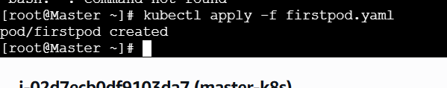

Step 5: Observe Pod status (IMPORTANT)

Immediately run:
kubectl get pods
You will see:
firstpod 0/1 Init:0/1

This means:
- Init container is still running
- Main container has NOT started yet
After ~30 seconds:
firstpod 1/1 Running
✔️ Init container completed successfully.

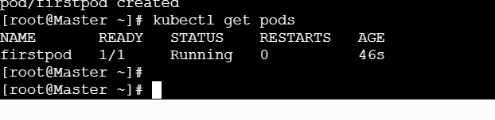
Step 6: Verify Init Container execution
🔹 Describe the Pod
kubectl describe pod firstpod
Look for this section 👇
Init Containers:
init-sleep:
State: Terminated
Reason: Completed
This confirms init container finished.

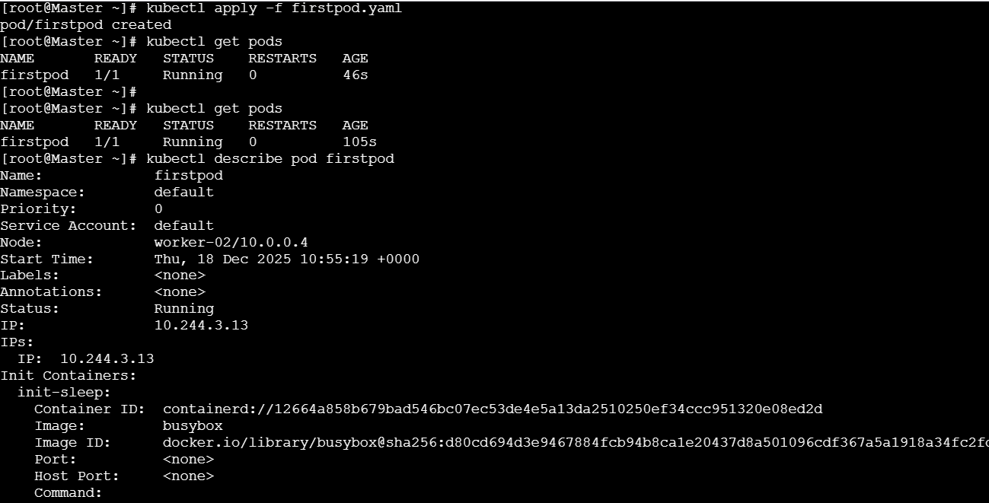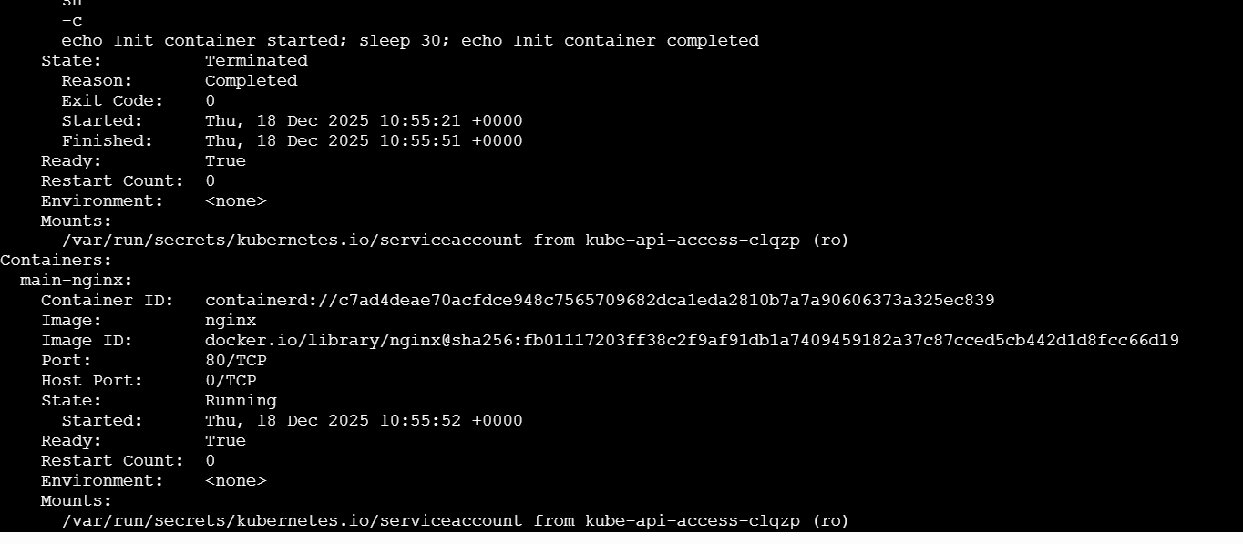

Step 7: Check Init Container logs (VERY IMPORTANT)
kubectl logs firstpod -c init-sleep
Expected output:
Init container started
Init container completed
✔️ Proof that init container ran successfully.

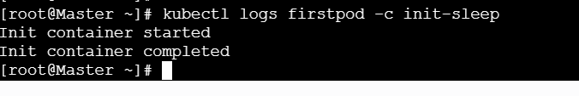
Step 8: Check main container logs (Optional)
kubectl logs firstpod -c main-nginx
You’ll see nginx startup logs.
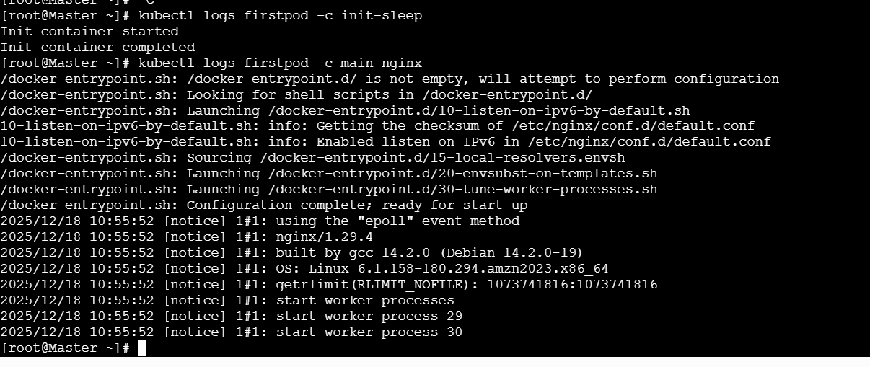
Key Concept (INTERVIEW GOLD)
Init containers are used to perform setup tasks before application containers start, such as waiting for dependencies or initializing data.

🎤 Interview 2-Line Answer
“I configured an init container using the initContainers field in the Pod YAML. It runs before the main container, and I verified its completion using kubectl describe pod and kubectl logs.”

- Run a Dry Run Command to Generate YAML Task: Use the kubectl run nginx --image=nginx --dry-run=client -o yaml command to generate a Pod YAML definition. Modify the generated YAML to suit specific requirements (e.g., labels or environment variables) and deploy it.
Task Goal (Simple)
- Generate Pod YAML using dry-run
- Modify YAML:
  - Add labels
  - Add environment variables
- Deploy the Pod
- Verify everything

Step 1: Generate Pod YAML using Dry-Run (NO creation)
Run this command:
kubectl run nginx --image=nginx --dry-run=client -o yaml
📌 This:
- Does NOT create the Pod
- Only prints YAML
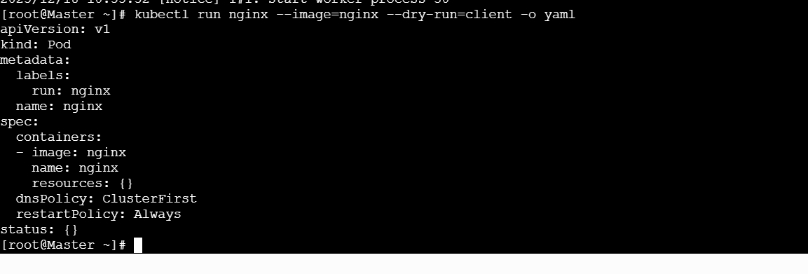
Step 2: Save the generated YAML to a file
kubectl run nginx --image=nginx --dry-run=client -o yaml > nginx-pod.yaml
Verify file:
cat nginx-pod.yaml
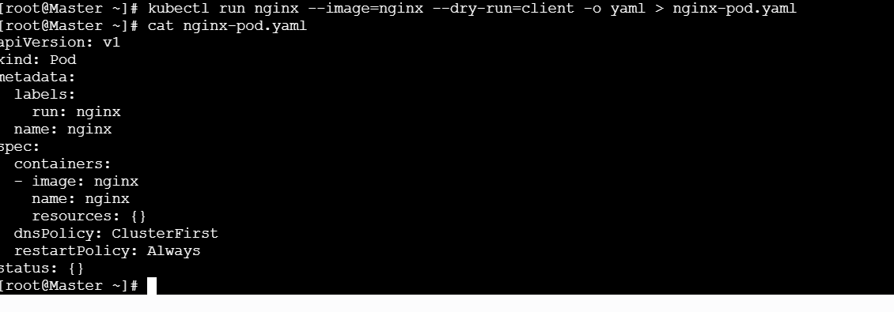
Step 3: Understand the generated YAML (IMPORTANT)
You’ll see something like:
apiVersion: v1
kind: Pod
metadata:
labels:
run: nginx
name: nginx
spec:
containers:
- image: nginx
name: nginx
✔️ This is a basic Pod definition
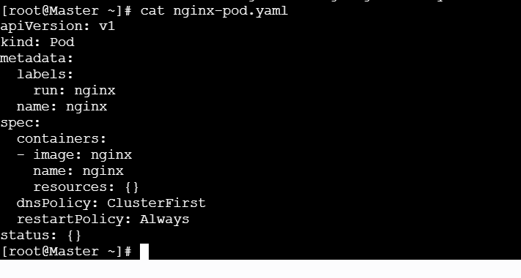
Step 4: Modify the YAML (Add labels + env vars)
Open file:
vi nginx-pod.yaml
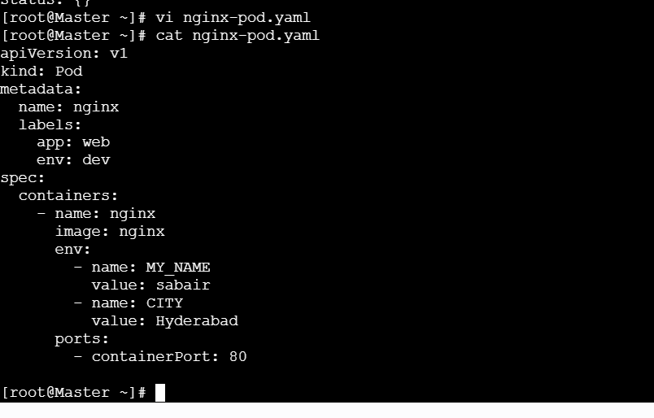
Step 5: Deploy the Pod
kubectl apply -f nginx-pod.yaml
Expected:
pod/nginx created
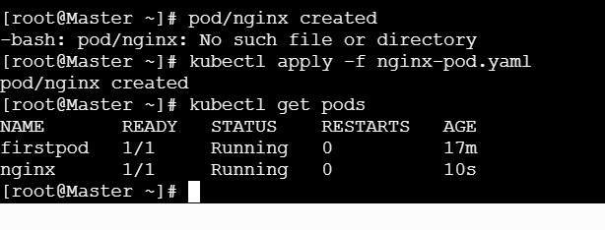
Step 6: Verify Pod is running
kubectl get pods
Expected:
nginx 1/1 Running

Step 7: Verify labels
kubectl get pod nginx --show-labels
Expected:
nginx 1/1 Running app=web,env=dev
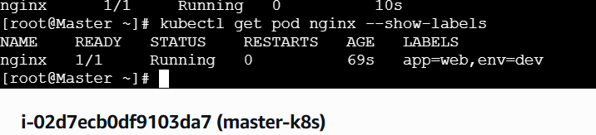
Step 8: Verify environment variables
kubectl exec nginx -- env | grep -E "MY_NAME|CITY"
Expected:
MY_NAME=sabair
CITY=Hyderabad
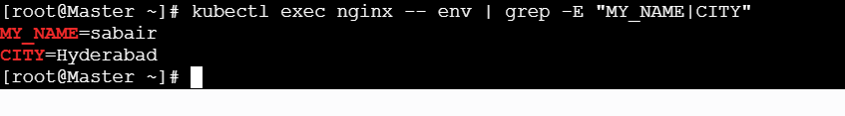
Key Concept (INTERVIEW GOLD)
The --dry-run=client option allows generating Kubernetes resource YAML without creating it, which is useful for review and customization.

Interview 2-Line Answer
“I use kubectl run with --dry-run=client and -o yaml to generate a Pod definition, modify it as needed, and then deploy it using kubectl apply.”

- Use kubectl apply vs kubectl create Task: Create a YAML file to define a Pod. First, deploy it using kubectl create -f <file_name>.yml and then modify the YAML (e.g., change the image version). Use kubectl apply to redeploy and verify the difference between both commands.

Task 7 explained in the SAME clear, step-by-step style you want.
We’ll clearly show the difference between kubectl create and kubectl apply.

🎯 Task Goal (Simple)
- Create a Pod YAML
- Deploy using kubectl create
- Modify the YAML (change image)
- Redeploy using kubectl apply
- Understand the difference

🔑 Key concept (before starting)
Command | Purpose
kubectl create | Create resource once
kubectl apply | Create or update resource
Step 1: Create a Pod YAML file
vi create-vs-apply.yaml

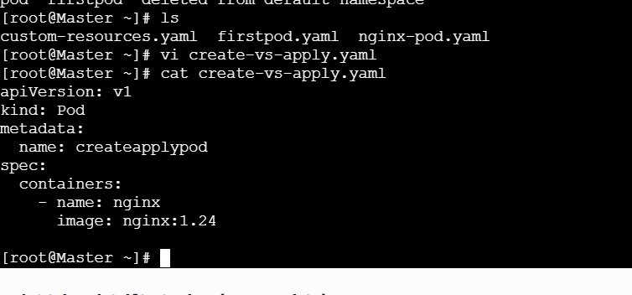
Step 2: Create the Pod using kubectl create
kubectl create -f create-vs-apply.yaml
Expected:
pod/createapplypod created
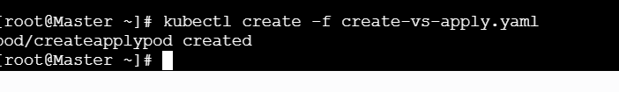
Step 3: Verify Pod
kubectl get pods
Expected:
createapplypod 1/1 Running
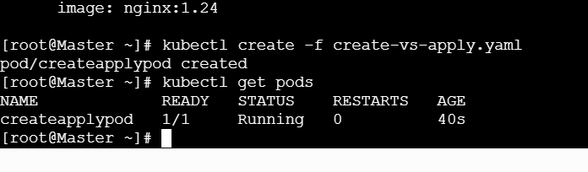Step 4: Modify the YAML (change image version)
Open file again:
Step 4: Modify the YAML (change image version)
Open file again:
vi create-vs-apply.yaml

🔄 Updated YAML (Version 2)
apiVersion: v1
kind: Pod
metadata:
name: createapplypod
spec:
containers:
- name: nginx
image: nginx:latest
Save & exit.
Step 5: Try kubectl create again (IMPORTANT)
kubectl create -f create-vs-apply.yaml
Expected:
Error from server (AlreadyExists): pods "createapplypod" already exists
❌ create cannot update existing resources
Step 6: Use kubectl apply to redeploy
kubectl apply -f create-vs-apply.yaml
What happens?
- Kubernetes compares last-applied config
- Tries to update the Pod
- IMPORTANT RESULT (Pod behavior)
- You will get:
- The Pod "createapplypod" is invalid:
- spec.containers: Forbidden: pod updates may not add or remove containers
- 👉 Because Pods are immutable.
- Step 7: Correct way to show difference (DELETE + APPLY)
- Delete the Pod:
- kubectl delete pod createapplypod
- Reapply:
- kubectl apply -f create-vs-apply.yaml
- Verify:
- kubectl describe pod createapplypod | grep Image
- Expected:
- Image: nginx:latest
- 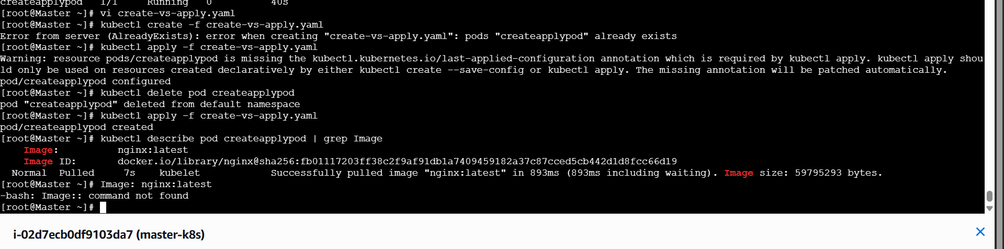
Real Difference Explained (VERY IMPORTANT)
🔹 kubectl create
- Creates resource only once
- Fails if resource exists
- No tracking of changes
🔹 kubectl apply
- Declarative
- Tracks changes (last-applied-configuration)
- Used for updates
- Works best with Deployments, not Pods

🧠 Interview GOLD Explanation
kubectl create is imperative and used for one-time creation, while kubectl apply is declarative and supports configuration updates by tracking changes.

🎤 Interview 2-Line Answer
“I use kubectl create for initial resource creation. For updates and configuration management, I use kubectl apply, which compares the desired state with the current state.”

- Edit an Existing Pod Configuration Task: Use kubectl edit pod <pod_name> to modify the running Pod's environment variables or image. After making the changes, verify if they took effect by checking the container logs or environment variables using kubectl exec.

Task Goal
- Edit a running Pod
- Change image or environment variable
- Verify the change using kubectl exec / logs
- STEP 1: Check Existing Pods
- kubectl get pods
- Example output:
- NAME READY STATUS AGE
- my-pod 1/1 Running 5m

STEP 2: Describe the Pod (Optional but Recommended)
kubectl describe pod my-pod
👉 This helps you know:
- Current image
- Existing environment variables
- Container name
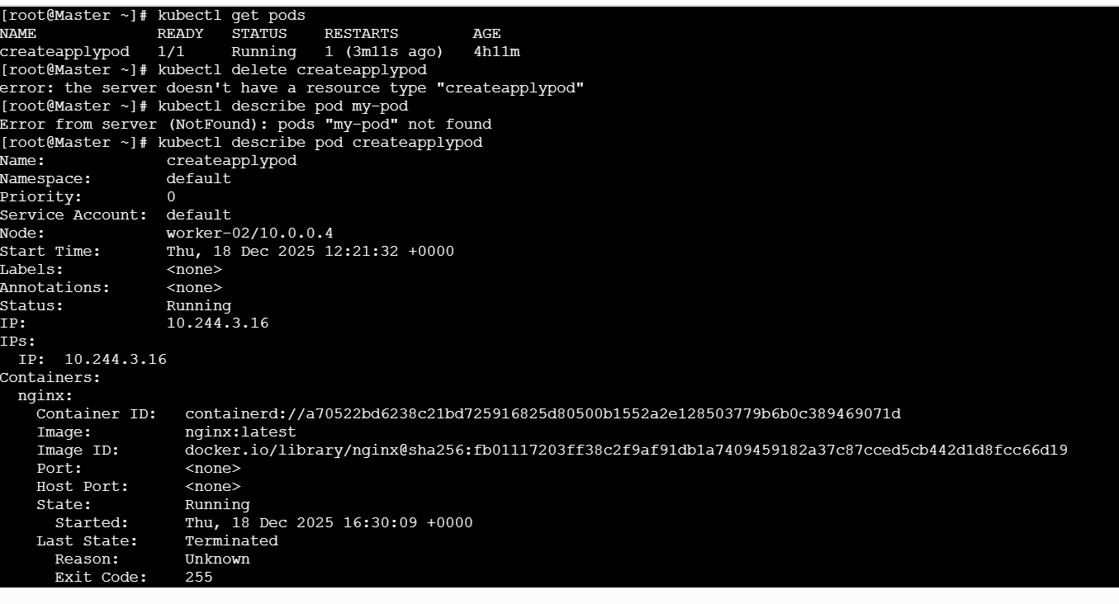
STEP 3: Edit the Pod
kubectl edit pod my-pod

➡ This opens the Pod YAML in a text editor (usually vi).
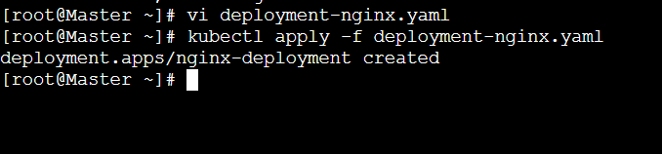
Apply the Deployment
kubectl apply -f deployment-nginx.yaml

🔹 Verify Pod
kubectl get pods
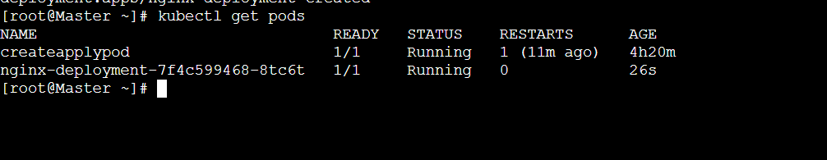
Verify Image
kubectl describe pod <pod-name> | grep Image
Expected:
Image: nginx:latest
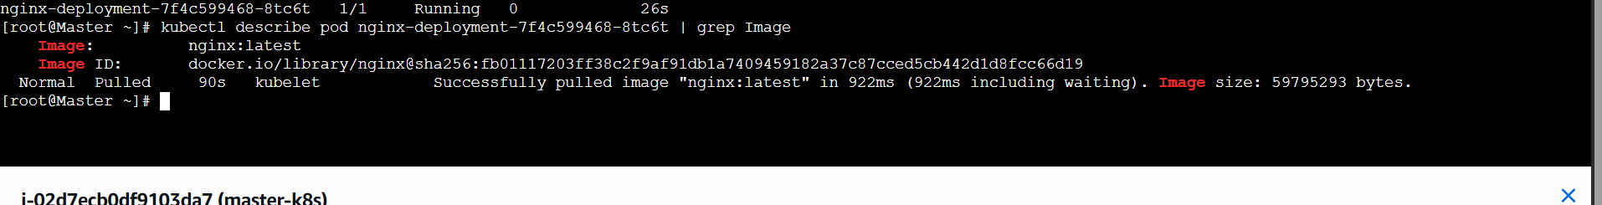
Verify Environment Variable
kubectl exec -it <pod-name> -- env | grep APP_ENV
Expected:
APP_ENV=production
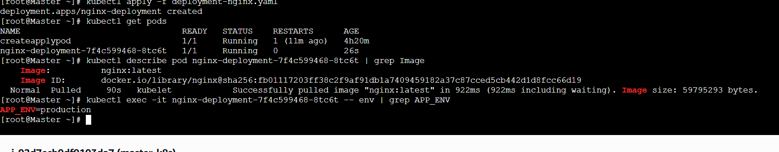
INTERVIEW GOLDEN POINT (VERY IMPORTANT)
We should not edit Pods directly. In real-time projects, we always modify the Deployment because Pods are immutable. Kubernetes recreates Pods automatically when the Deployment changes.

- Expose a Pod Using a Service Task: Create a YAML file to expose your firstpod using a Service (ClusterIP). Ensure that your service is exposing the Pod on port 80 and verify it using kubectl get svc.
TASK GOAL
- Expose firstpod
- Use Service type: ClusterIP
- Port 80
- Verify using kubectl get svc
- STEP 1: Verify Pod Is Running
kubectl get pods
Expected:
NAME READY STATUS AGE
firstpod 1/1 Running 2m

📌 Important: The Pod must be Running.

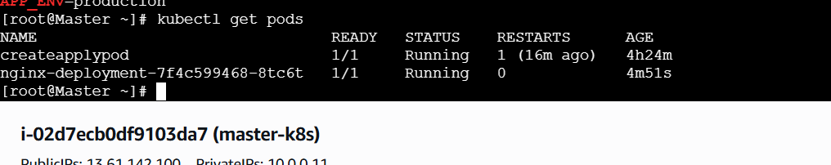

STEP 2: Check Pod Labels (Very Important)
- Service works using labels + selectors.
- kubectl get pod firstpod --show-labels
- Example output:
- NAME READY STATUS LABELS
- firstpod 1/1 Running app=nginx
- 👉 If labels are missing, add one.
Actually there is no table

- STEP 3 (If Needed): Add Label to Pod
- kubectl label pod firstpod app=nginx
- Verify:
- kubectl get pod firstpod --show-labels

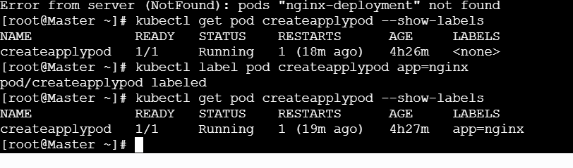
STEP 4: Create Service YAML (ClusterIP)
📄 firstpod-service.yaml
apiVersion: v1
kind: Service
metadata:
name: firstpod-service
spec:
type: ClusterIP
selector:
app: nginx
ports:
- protocol: TCP
port: 80 # Service port
targetPort: 80 # Pod container port
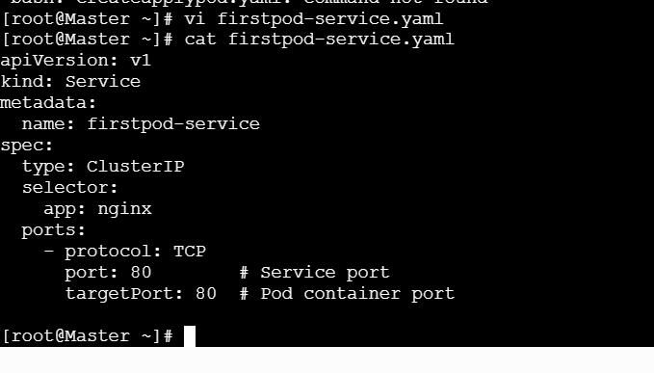
STEP 5: Apply the Service
kubectl apply -f firstpod-service.yaml
Expected:
service/firstpod-service created
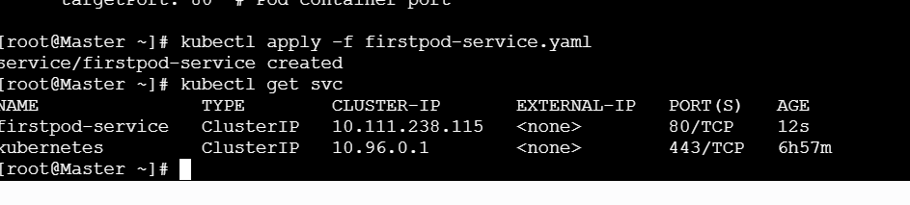
STEP 6: Verify Service Creation
kubectl get svc
Expected output:
NAME TYPE CLUSTER-IP PORT(S)
firstpod-service ClusterIP 10.96.120.15 80/TCP

Your Pod is now exposed internally in the cluster.
STEP 7: Verify Service Is Linked to Pod
kubectl get endpoints firstpod-service
Expected:
IP_ADDRESS:80
👉 This confirms Service → Pod connection.
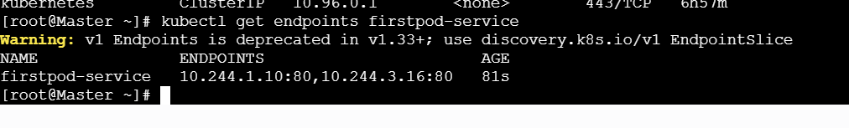

STEP 8: Test Service Access (Inside Cluster)
kubectl exec -it firstpod -- curl localhost:80
OR
kubectl exec -it firstpod -- curl firstpod-service
Expected:
Welcome to nginx!
FINAL VERIFICATION COMMAND (BEST)
kubectl run testpod --image=curlimages/curl -it --rm -- sh
curl firstpod-service

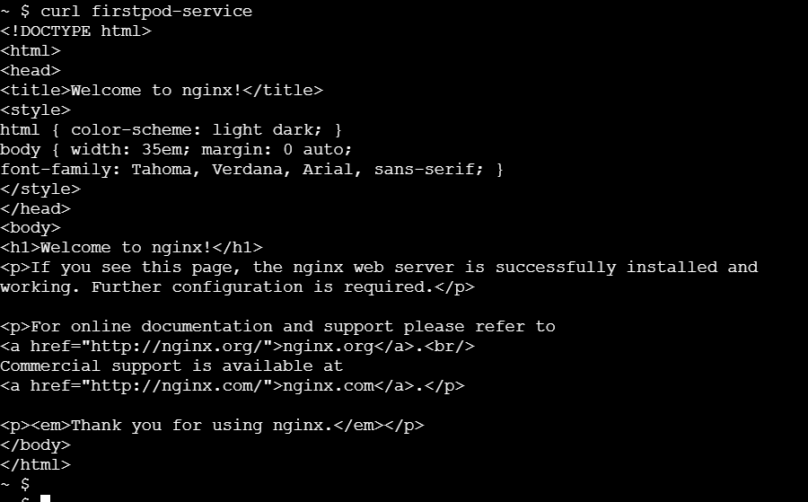

- Pod with Resource Limits and Requests Task: Add resource requests and limits to the containers in your YAML file. Specify CPU and memory requests/limits for both containers and deploy the Pod. Use kubectl describe pod to verify if the resource configurations are correctly applied.
TASK GOAL
- Create a Pod
- Add CPU & Memory requests and limits
- Deploy the Pod
- Verify using kubectl describe pod

🔹 STEP 1: Understand Requests vs Limits (Very Short)
Term | Meaning
Requests | Minimum guaranteed resources
Limits | Maximum allowed resources
📌 Scheduler uses requests, kubelet enforces limits.

STEP 2: Create Pod YAML with Resource Requests & Limits
📄 resource-pod.yaml
apiVersion: v1
kind: Pod
metadata:
name: resource-demo-pod
spec:
containers:
- name: nginx-container
image: nginx:latest
ports:
- containerPort: 80
resources:
requests:
cpu: "250m" # 0.25 CPU
memory: "128Mi" # Minimum memory
limits:
cpu: "500m" # 0.5 CPU max
memory: "256Mi" # Max memory

STEP 3: Deploy the Pod
kubectl apply -f resource-pod.yaml
Expected:
pod/resource-demo-pod created
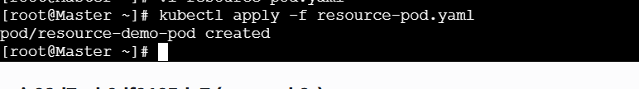
STEP 4: Check Pod Status
kubectl get pods
Expected:
resource-demo-pod 1/1 Running
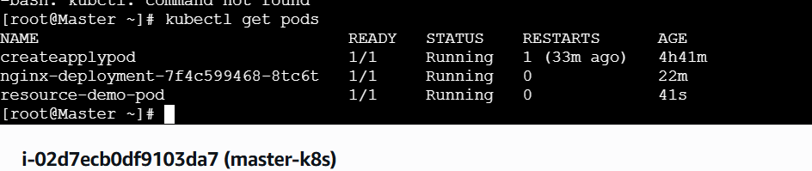
STEP 5: Verify Resources Using Describe
kubectl describe pod resource-demo-pod
Look for this section 👇
Containers:
nginx-container:
Limits:
cpu: 500m
memory: 256Mi
Requests:
cpu: 250m
memory: 128Mi
This confirms resources are applied correctly.
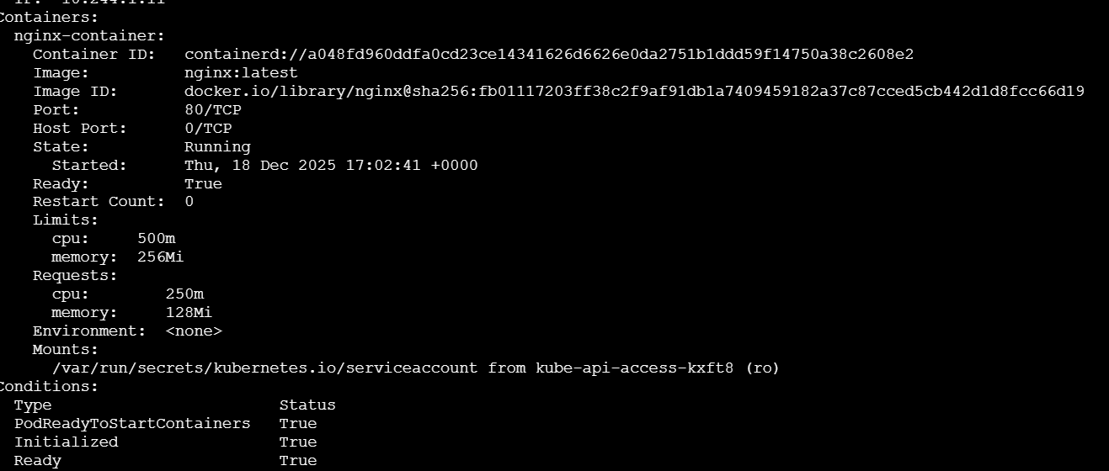
STEP 6 (Optional): Check Node Resource Allocation
kubectl describe node <node-name>
Scroll to:
Allocated resources:
CPU Requests
Memory Requests
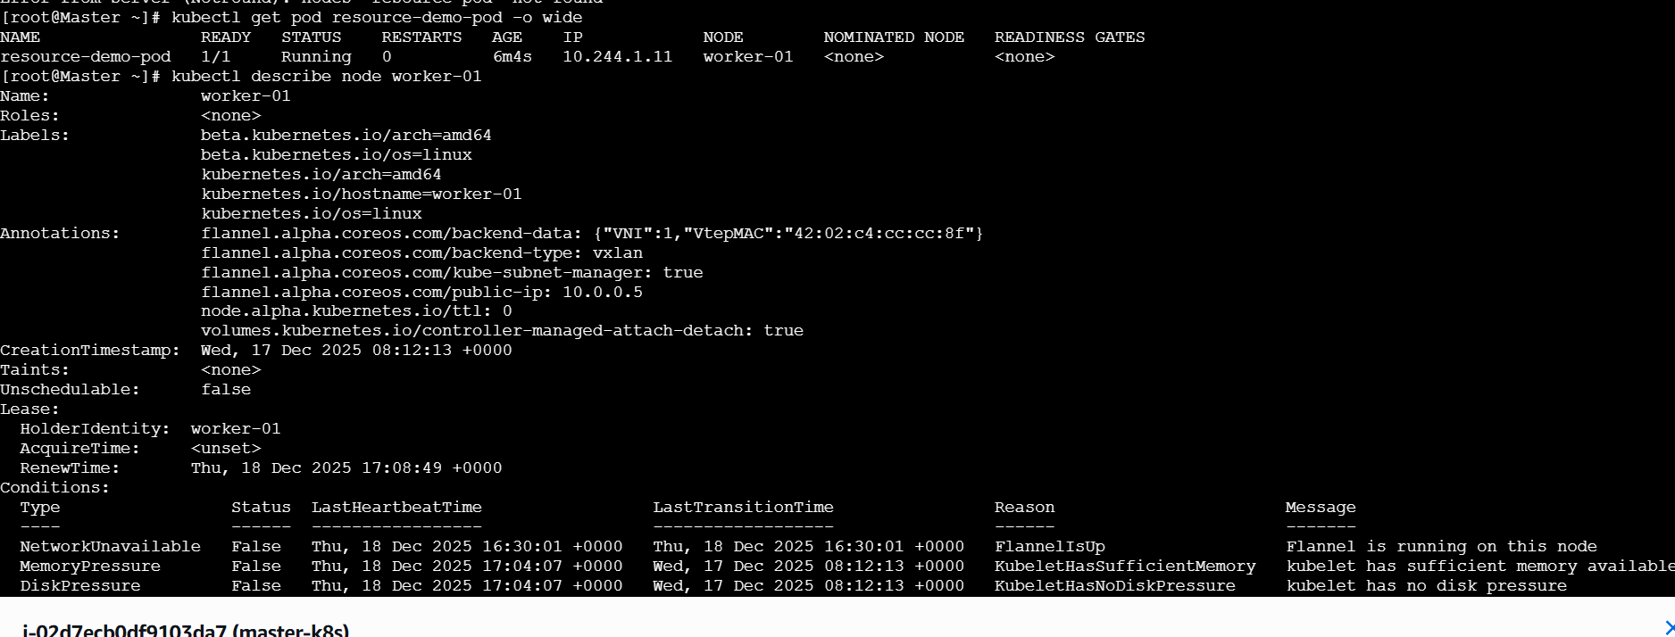
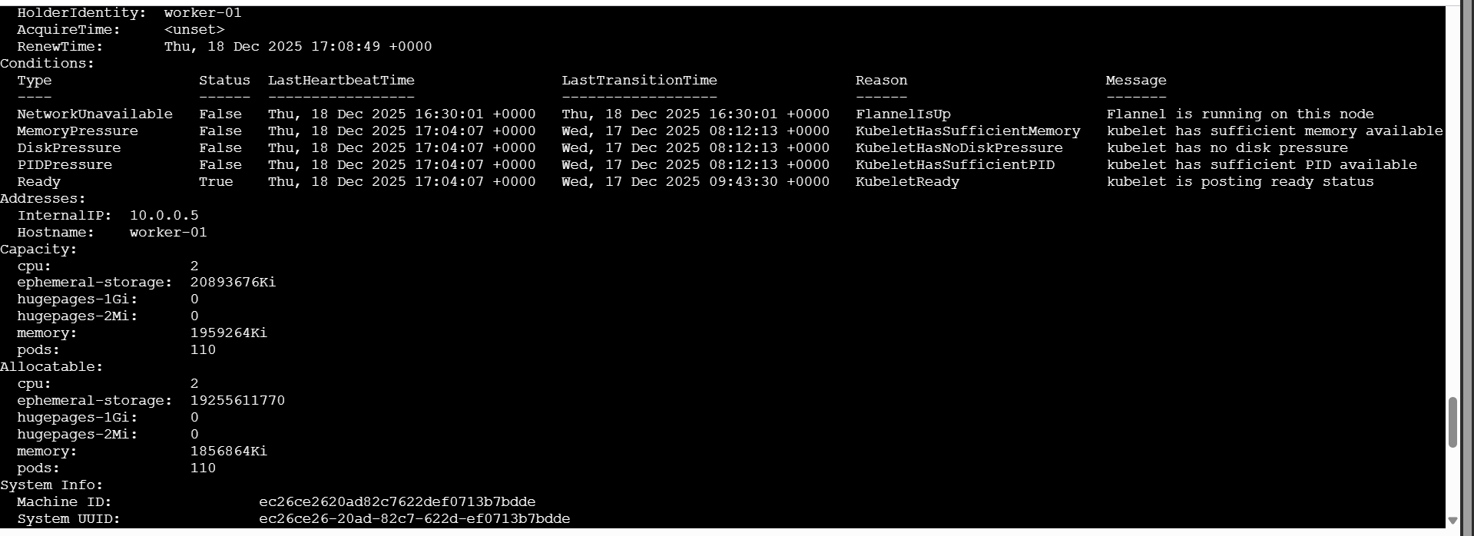
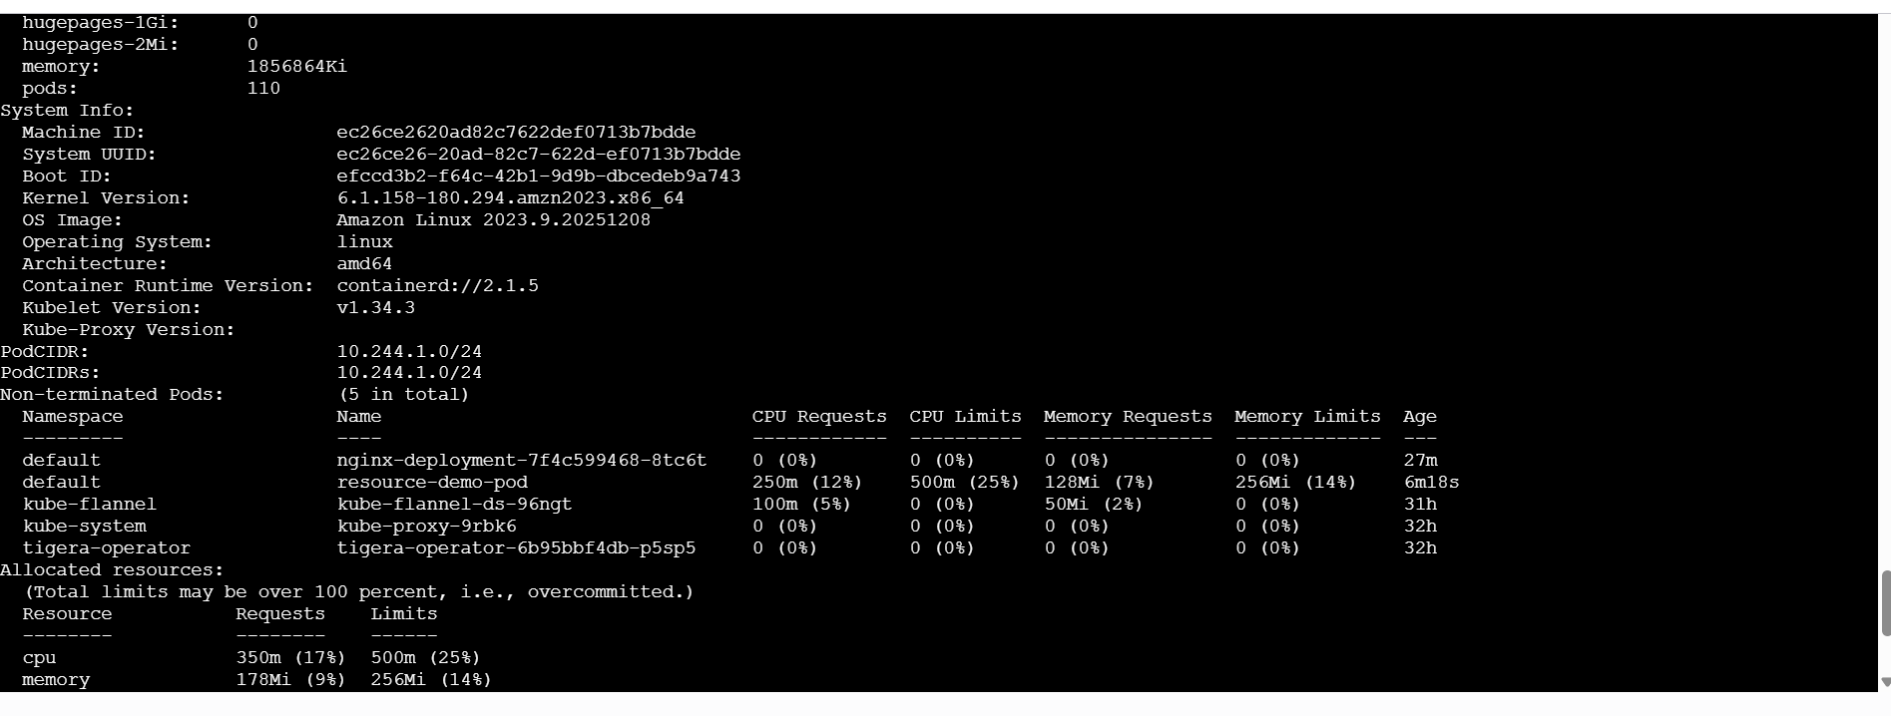
COMMON ERRORS & FIXES
Error | Reason
Pod Pending | Node doesn’t have enough requested resources
Limit < Request | Limits must be >= requests
Wrong unit | Use m, Mi, Gi

🧠 INTERVIEW ONE-LINE ANSWER
Resource requests define the minimum resources guaranteed to a container, while limits define the maximum resources it can consume. Kubernetes schedules Pods based on requests and enforces limits at runtime.

🔑 INTERVIEW QUICK VALUES (Remember These)
- CPU → m (millicores)
- Memory → Mi, Gi
- 1 CPU = 1000m
- ONE-LINE QUICK DELETE (ADVANCED)
- If you are sure and want to delete all pods in the namespace:
- kubectl delete pod --all

