Start working on k8s-04 tsaks.
- Deploy an application using a Deployment with 3 replicas and a rolling update strategy.
What is this? (Brief)
A Deployment in Kubernetes is used to:
- Run an application
- Maintain multiple replicas
- Perform rolling updates with zero downtime
Rolling update means:
Pods are updated one by one, not all at once.

🔹 Why do we use it?
- High availability (multiple replicas)
- Zero downtime during updates
- Easy rollback if deployment fails
- Automatic pod recreation if a pod crashes

🔹 Where is it used?
- Production applications
- Web servers (Nginx, Apache)
- APIs, microservices
- Any app needing continuous availability

🚀 Step-by-Step: Deploy Application with 3 Replicas & Rolling Update

✅ Step 1: Create Deployment YAML
Create a file:
vi nginx-deployment.yaml
Paste this 👇
apiVersion: apps/v1
kind: Deployment
metadata:
name: nginx-deployment
spec:
replicas: 3

strategy:
type: RollingUpdate
rollingUpdate:
maxSurge: 1
maxUnavailable: 1

selector:
matchLabels:
app: nginx

template:
metadata:
labels:
app: nginx
spec:
containers:
- name: nginx
image: nginx:1.25
ports:
- containerPort: 80
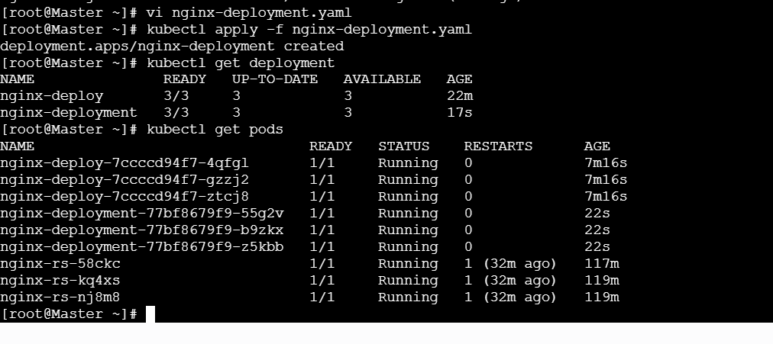
Step-by-Step: Perform a Rolling Update
✅ Step 4: Update the Image Version
Edit deployment:
kubectl edit deployment nginx-deployment
Change:
image: nginx:1.25
to:
image: nginx:latest
Save and exit.
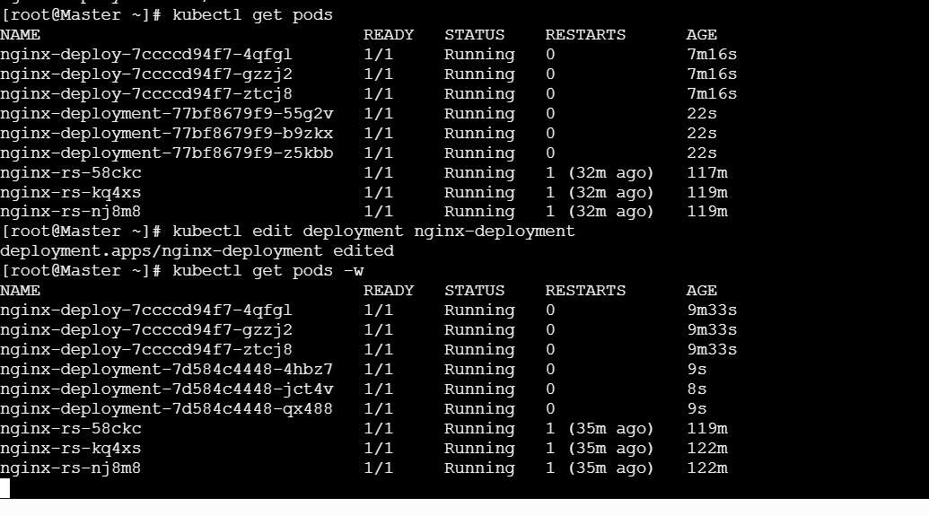
Step 5: Watch Rolling Update Live
kubectl get pods -w
You will see:
- One new pod created
- One old pod deleted
- Process repeats until update finishes
🎉 No downtime occurs
Step 6: Verify Rollout Status
kubectl rollout status deployment nginx-deployment
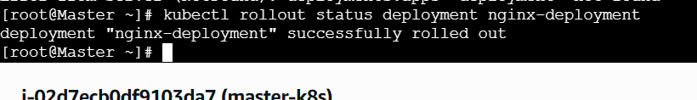
🔁 Step 7: Rollback (If Needed)
kubectl rollout undo deployment nginx-deployment
✔ Instantly reverts to previous version
🧠 Understand Rolling Update Settings (Important)
Setting | Meaning
replicas: 3 | Always 3 pods running
maxSurge: 1 | 1 extra pod allowed during update
maxUnavailable: 1 | Only 1 pod can go down

🧠 Interview-Ready One-Line Answer
“A Deployment with rolling update strategy updates pods gradually to avoid downtime while maintaining desired replicas and allows easy rollback.”

🧩 Simple Real-Time Example
- Production website running 3 pods
- New version released
- Users continue accessing site
- No service interruption

✅ Summary (Easy to Remember)
- Deployment → manages app lifecycle
- 3 replicas → high availability
- Rolling update → zero downtime
- Rollback → safety net

- Configure a Deployment with a Recreate strategy and observe the downtime.
What is Recreate strategy? (Brief)
In Kubernetes, Recreate means:
- Kubernetes stops ALL old pods first
- Then starts new pods
- Result: downtime occurs

🔹 Why / When do we use Recreate?
- When old and new versions cannot run together
- Apps using exclusive resources (single DB lock, file lock)
- Legacy applications
- Maintenance windows where downtime is acceptable

🚀 Step-by-Step: Configure Recreate Strategy

✅ Step 1: Create Deployment YAML (Recreate)
Create file:
vi recreate-deployment.yaml
Paste this 👇
apiVersion: apps/v1
kind: Deployment
metadata:
name: nginx-recreate
spec:
replicas: 3

strategy:
type: Recreate

selector:
matchLabels:
app: nginx-recreate

template:
metadata:
labels:
app: nginx-recreate
spec:
containers:
- name: nginx
image: nginx:1.25
ports:
- containerPort: 80

✅ Step 2: Deploy the Application
kubectl apply -f recreate-deployment.yaml
Verify:
kubectl get pods
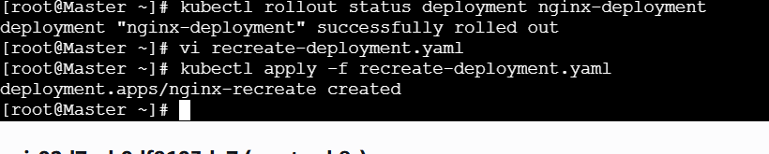
kubectl get pods

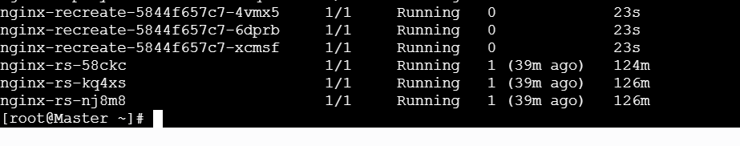

Step-by-Step: Trigger Recreate Update

✅ Step 4: Update the Image (Trigger Recreate)
Edit deployment:
kubectl edit deployment nginx-recreate
Change:
image: nginx:1.25
to:
image: nginx:latest
Save and exit.
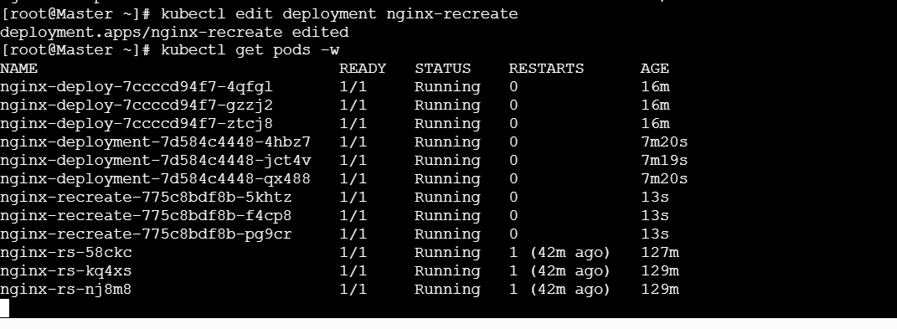
Step 5: Watch Pods Closely (Important)
Run:
kubectl get pods -w
🔥 What You Will Observe
- All old pods are TERMINATED
- No pods running (downtime)
- New pods start after deletion completes
This confirms Recreate strategy behavior.

Step 6: Observe Downtime (Proof)
While update is happening, run in another terminal:
curl http://<Node-IP>:<NodePort>
Expected result during update:
Connection refused
OR
Service unavailable
✔ This is downtime
After pods start:
Welcome to nginx!
Step 7: Confirm Strategy Type
kubectl describe deployment nginx-recreate
Look for:
StrategyType: Recreate
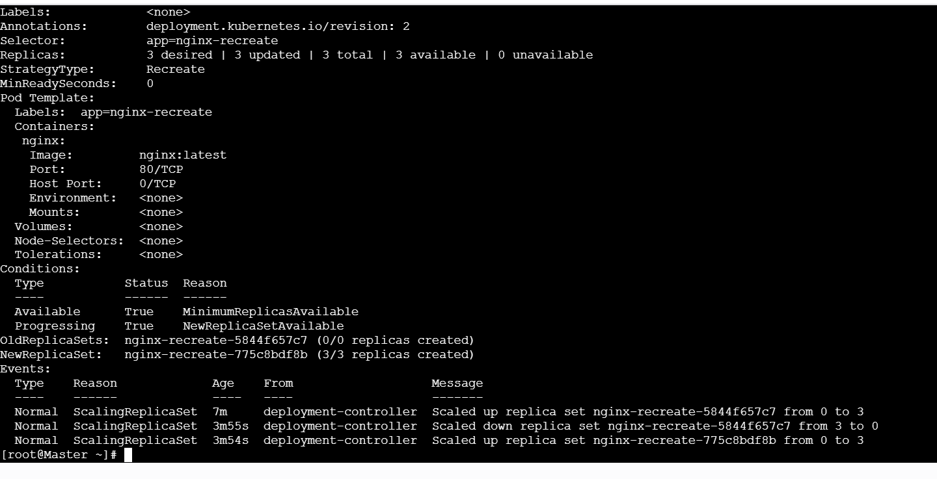

🧠 Interview-Ready One-Line Answer
“Recreate strategy stops all existing pods before creating new ones, which causes downtime but is useful when old and new versions cannot run simultaneously.”

⚖️ Recreate vs Rolling (Quick)
Feature | Recreate | Rolling
Downtime | Yes ❌ | No ✅
Pods updated | All at once | Gradually
Production use | Rare | Common

🧩 Real-Time Example
- App uses single DB schema
- New version incompatible with old
- Recreate ensures clean switch

- Update an existing Deployment and perform a rollback to the previous version.
What are we doing? (Brief)
- Update a running Deployment (new app version)
- Observe rollout
- Rollback safely to the previous version if needed
Why this matters:
- Zero/low downtime
- Safe releases
- Fast recovery from bad deployments

🚀 Step-by-Step: Update & Rollback a Deployment
Example uses an nginx Deployment.
If you already have one, just replace the name.
Step 1: Check Existing Deployment
kubectl get deployments
Describe it:
kubectl describe deployment nginx-deployment
Check current image:
kubectl get deployment nginx-deployment -o wide

Step 2: View Deployment History (Before Update)
kubectl rollout history deployment nginx-deployment
You’ll see something like:
REVISION CHANGE-CAUSE
1 <none>
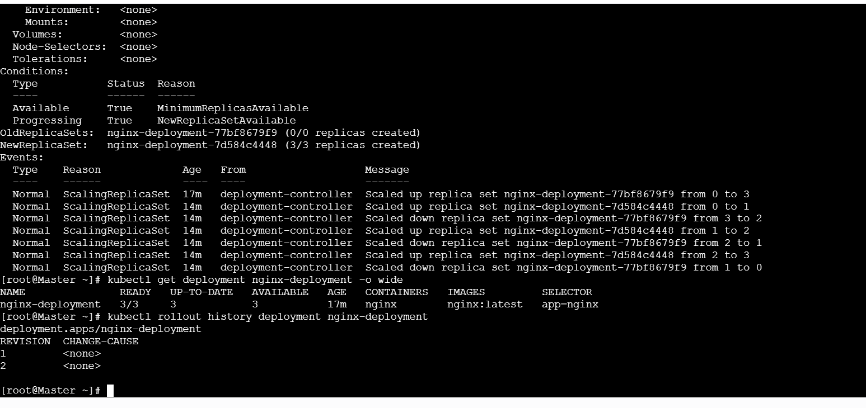
Step 3: Update the Deployment (New Version)
Option A (Recommended – one command)
kubectl set image deployment/nginx-deployment nginx=nginx:latest --record
--record helps track change history (interview tip)
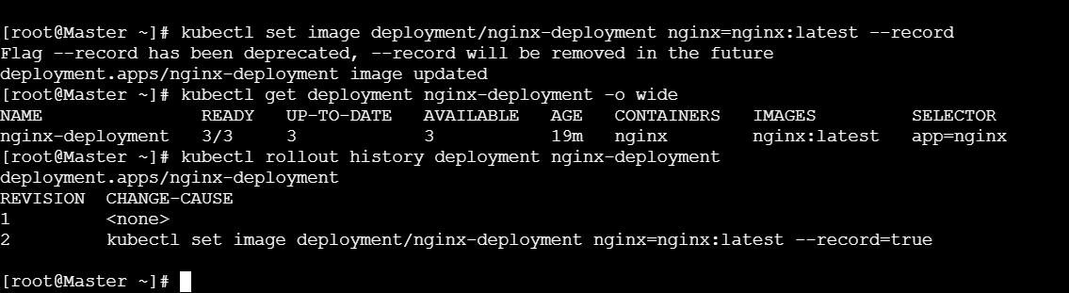

Step 4: Watch the Rollout Live
kubectl get pods -w
Or:
kubectl rollout status deployment nginx-deployment
✔ Update completes successfully.
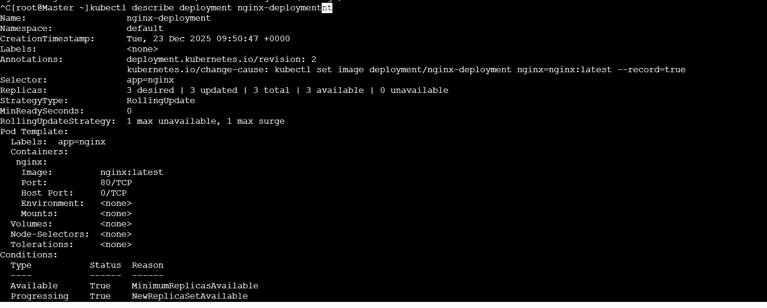

Step 5: Verify New Version Is Running
kubectl describe deployment nginx-deployment
Or check pods:
kubectl get pods -o wide
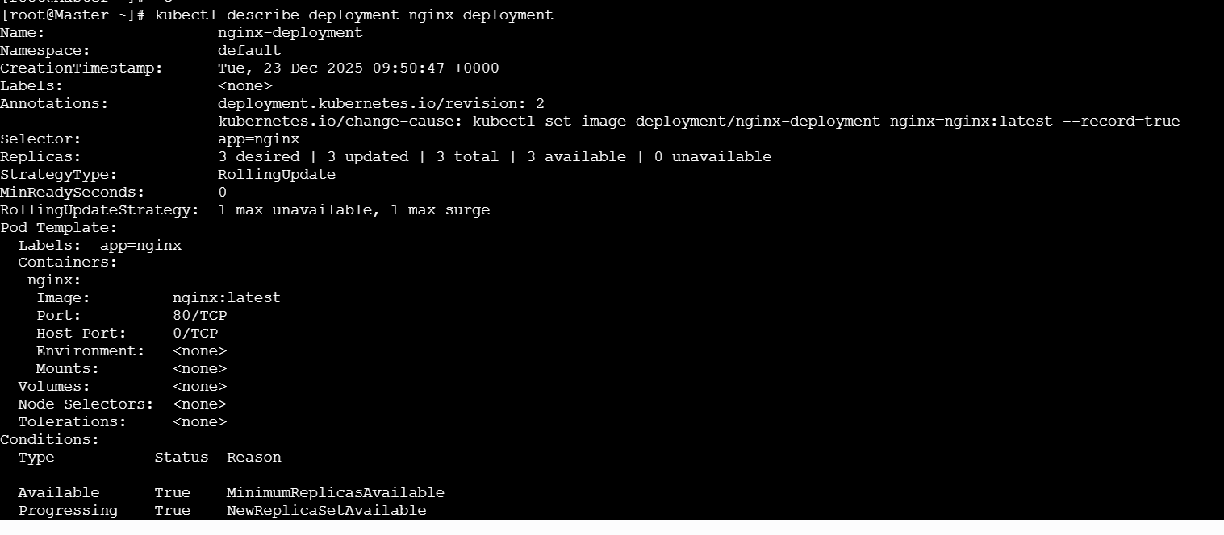
Step 6: Check Rollout History
kubectl rollout history deployment nginx-deployment
Example:
REVISION CHANGE-CAUSE
1 nginx:1.25
2 nginx:latest

✅ Step 7: Rollback to Previous Revision
Roll back to immediate previous version
kubectl rollout undo deployment nginx-deployment
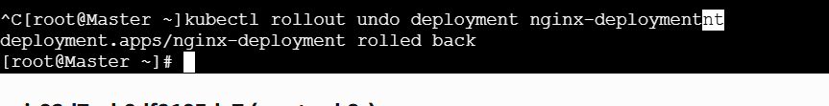

Step 7: Rollback to Previous Revision
Roll back to immediate previous version
kubectl rollout undo deployment nginx-deployment

(Optional) Roll back to a specific revision
kubectl rollout undo deployment nginx-deployment --to-revision=1

✅ Step 8: Verify Rollback
kubectl rollout status deployment nginx-deployment
Check history again:
kubectl rollout history deployment nginx-deployment
✔ Old version is restored.
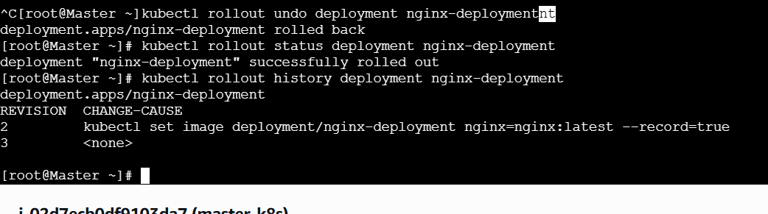

🧠 What Actually Happened? (Simple)
- Kubernetes saved old ReplicaSets
- Rollback re-activates the previous ReplicaSet
- Pods are recreated with the old image

🧠 Interview-Ready One-Line Answer
“We update a Deployment using kubectl set image or kubectl edit, and if the release fails, we roll back using kubectl rollout undo, which restores the previous ReplicaSet safely.”

⚠️ Important Notes (Interview Gold)
- Rollback works only if revision history exists
- Use --record to track changes
- Rolling update strategy avoids downtime

🧹 Cleanup (Optional)
kubectl delete deployment nginx-deployment

- Modify a Deployment to add resource requests and limits for CPU and memory.
What are resource requests & limits? (Brief)
- Requests → minimum CPU/memory guaranteed for a container
- Limits → maximum CPU/memory a container can use
Why we use them:
- Fair resource sharing
- Prevent one pod from crashing the node
- Better scheduling and cluster stability
Where used:
- Production deployments
- Multi-tenant clusters
- Performance-critical apps

🚀 Step-by-Step: Add CPU & Memory Requests and Limits
Example uses an existing Deployment named nginx-deployment.

✅ Step 1: Check the Existing Deployment
kubectl get deployment nginx-deployment
Optional (see current spec):
kubectl describe deployment nginx-deployment

Step 3: Add resources Section (Important Part)
Inside the container spec, add this block:
resources:
requests:
cpu: "100m"
memory: "128Mi"
limits:
cpu: "500m"
memory: "256Mi"
Full container example (context)
spec:
containers:
- name: nginx
image: nginx
ports:
- containerPort: 80
resources:
requests:
cpu: "100m"
memory: "128Mi"
limits:
cpu: "500m"
memory: "256Mi"
Save and exit.

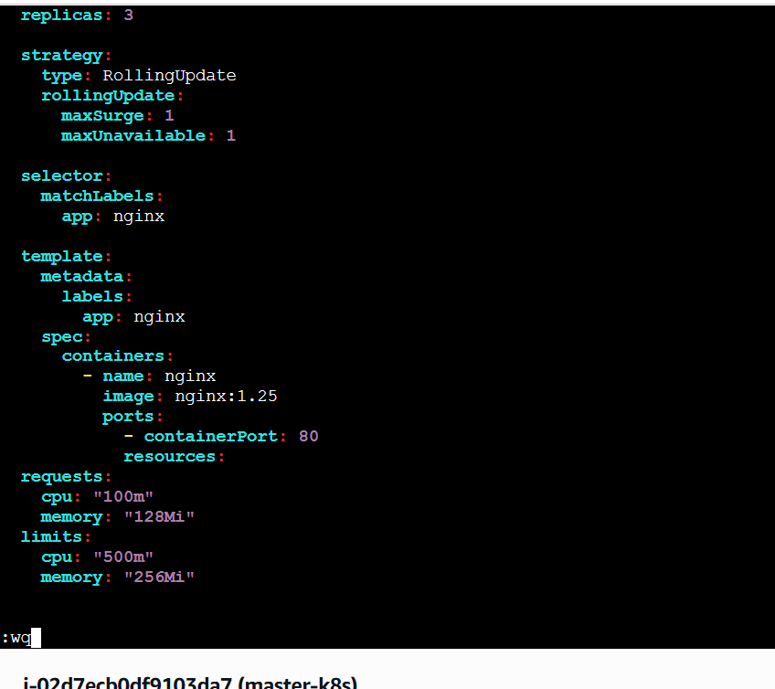

Step 4: Observe Pod Recreation (Rolling Update)
kubectl get pods -w
Pods will be:
- Terminated
- Recreated with new resource settings

✅ Step 5: Verify Resources Are Applied
kubectl describe pod <pod-name>
Look for:
Requests:
cpu: 100m
memory: 128Mi
Limits:
cpu: 500m
memory: 256Mi

🔍 Step 6: (Optional) Check Resource Usage
If metrics server is installed:
kubectl top pod
Step 6: (Optional) Check Resource Usage
If metrics server is installed:
kubectl top pod

🧠 Understand Values (Important for Interview)
Value | Meaning
100m CPU | 0.1 core
500m CPU | 0.5 core
Mi | Mebibyte (memory unit)

⚠️ Important Behavior (Must Know)
- Exceed CPU limit → throttled
- Exceed memory limit → pod killed (OOMKilled)
- Scheduler uses requests, not limits

🧠 Interview-Ready One-Line Answer
“Resource requests guarantee minimum CPU and memory, while limits cap maximum usage to prevent resource starvation and ensure cluster stability.”

🧩 Real-Time Example
- Web app guaranteed 128Mi memory
- Cannot exceed 256Mi
- Prevents crash of other applications

✅ Summary (Easy to Remember)
- Edit Deployment
- Add resources
- Requests = guaranteed
- Limits = maximum
- Pods restart automatically

If you want next, I can:
- Show what happens when limits are exceeded
- Explain QoS classes
- Compare requests vs limits
- Convert this into 2-minute interview answer
Just tell me 👍
Error from server (NotFound): deployments.apps "nginx-deployment" not found [root@Master ~]# ll total 60 -rw-r--r--. 1 root root 184 Dec 23 07:00 apache-pod.yaml -rw-r--r--. 1 root root 156 Dec 23 07:02 apache-service.yaml -rw-r--r--. 1 root root 123 Dec 18 12:18 create-vs-apply.yaml -rw-r--r--. 1 root root 824 Dec 17 09:47 custom-resources.yaml -rw-r--r--. 1 root root 437 Dec 18 16:41 deployment-nginx.yaml -rw-r--r--. 1 root root 225 Dec 18 16:51 firstpod-service.yaml -rw-r--r--. 1 root root 319 Dec 18 10:54 firstpod.yaml -rw-r--r--. 1 root root 425 Dec 23 09:50 nginx-deployment.yaml -rw-r--r--. 1 root root 180 Dec 23 09:29 nginx-nodeport.yaml -rw-r--r--. 1 root root 177 Dec 23 07:11 nginx-pod.yaml -rw-r--r--. 1 root root 299 Dec 23 07:29 nginx-rc.yaml -rw-r--r--. 1 root root 346 Dec 23 07:50 nginx-replicaset.yaml -rw-r--r--. 1 root root 375 Dec 23 09:57 recreate-deployment.yaml -rw-r--r--. 1 root root 395 Dec 18 17:01 resource-pod.yaml -rw-r--r--. 1 root root 339 Dec 23 09:21 rs-exclude-backend.yaml [root@Master ~]# kubectl describe deployment nginx-deployment Error from server (NotFound): deployments.apps "nginx-deployment" not found [root@Master ~]# kubectl describe nginx-deployment error: the server doesn't have a resource type "nginx-deployment" [root@Master ~]# kubectl edit deployment nginx-deployment Error from server (NotFound): deployments.apps "nginx-deployment" not found [root@Master ~]# its saying not found
You’re doing the right commands, but the object name doesn’t exist in the cluster right now.
Let’s fix this calmly, step by step, and I’ll explain why it’s happening so you remember it for interviews.

❗ Why you are getting “deployment not found”
This error means:
The Deployment nginx-deployment is NOT created in the cluster, even though the YAML file exists on disk.
📌 Very important concept in Kubernetes:
Having a YAML file ≠ resource exists in Kubernetes
You must apply it first.

✅ Step 1: Check what Deployments actually exist
Run:
kubectl get deployments
👉 You’ll most likely see NO deployments or a different name.
That’s why:
kubectl edit deployment nginx-deployment
fails.

✅ Step 2: Check the Deployment name inside the YAML file
Open the file you already have:
vi nginx-deployment.yaml
Look carefully at this section:
metadata:
name: nginx-deployment
⚠️ If the name is different, you must use THAT exact name in kubectl commands.
Example:
- If name is nginx-deploy
- Then command must be:
- kubectl edit deployment nginx-deploy

✅ Step 3: Create the Deployment (THIS IS THE MISSING STEP)
Since it’s not created yet, run:
kubectl apply -f nginx-deployment.yaml
Now verify:
kubectl get deployments
You should see:
nginx-deployment 3/3 3 3 …
✅ Now the Deployment exists

✅ Step 4: Now Edit Deployment (This Will Work)
kubectl edit deployment nginx-deployment
OR describe it:
kubectl describe deployment nginx-deployment
✔ No more “not found” error.
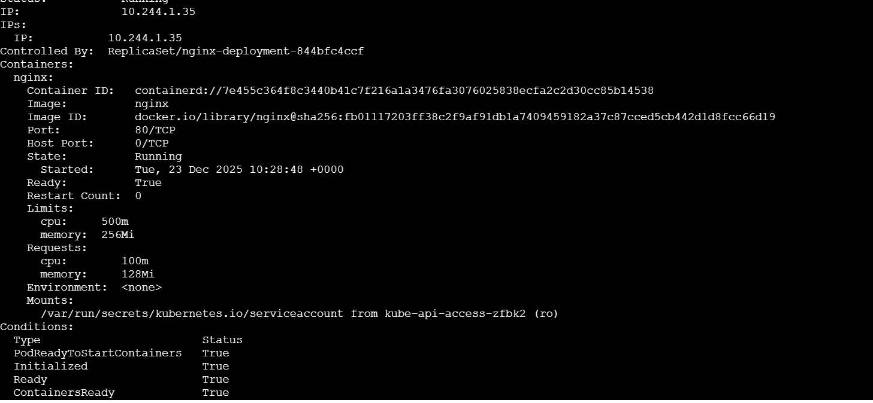
What These Values Mean (Short & Clear)
Field | Meaning
100m CPU | 0.1 core guaranteed
500m CPU | Max 0.5 core allowed
128Mi | Guaranteed memory
256Mi | Max memory allowed
- CPU over limit → throttled
- Memory over limit → pod killed (OOMKilled)

🧠 Key Learning (VERY IMPORTANT – Interview Point)
Situation | Reason
YAML file exists | Only stored on disk
Deployment not found | Not applied to cluster
kubectl apply | Creates/updates resource
kubectl edit | Works only on existing resource
👉 Kubernetes works on live objects, not files

🧠 One-Line Interview Answer
“The ‘deployment not found’ error occurs when the resource is not created in the cluster. YAML files must be applied using kubectl apply before they can be edited or described.”

✅ Quick Checklist for You
Always follow this order:
1️⃣ Write YAML
2️⃣ kubectl apply -f file.yaml
3️⃣ kubectl get <resource>
4️⃣ kubectl edit / describe

If you want, next I can:
- Add CPU & memory resources to this deployment live
- Help you clean unused YAML files
- Explain apply vs edit vs create
- Give a real interview troubleshooting story
Just tell me 👍

- Create a Deployment with MaxSurge and MaxUnavailable configurations.

What is this? (Brief)
In Kubernetes, maxSurge and maxUnavailable control how rolling updates happen:
- maxSurge → how many extra pods can be created during update
- maxUnavailable → how many pods can be down during update
👉 Used to ensure zero or minimal downtime.

🔹 Why do we use it?
- Control availability during deployments
- Avoid traffic drops
- Safely update production apps
- Balance speed vs stability

🔹 Where is it used?
- Production deployments
- Web servers, APIs
Any app needing controlled rolling updates

Step 1: Create Deployment YAML file
vi nginx-maxsurge-deployment.yaml

✅ Step 2: Paste FULL YAML (Correct & Ready to Apply)
apiVersion: apps/v1
kind: Deployment
metadata:
name: nginx-maxsurge
spec:
replicas: 3

strategy:
type: RollingUpdate
rollingUpdate:
maxSurge: 1
maxUnavailable: 1

selector:
matchLabels:
app: nginx-maxsurge

template:
metadata:
labels:
app: nginx-maxsurge
spec:
containers:
- name: nginx
image: nginx:1.25
ports:
- containerPort: 80

Step 3: Apply the Deployment
kubectl apply -f nginx-maxsurge-deployment.yaml
Verify:
kubectl get deployments
kubectl get pods
✔ You should see 3 running pods
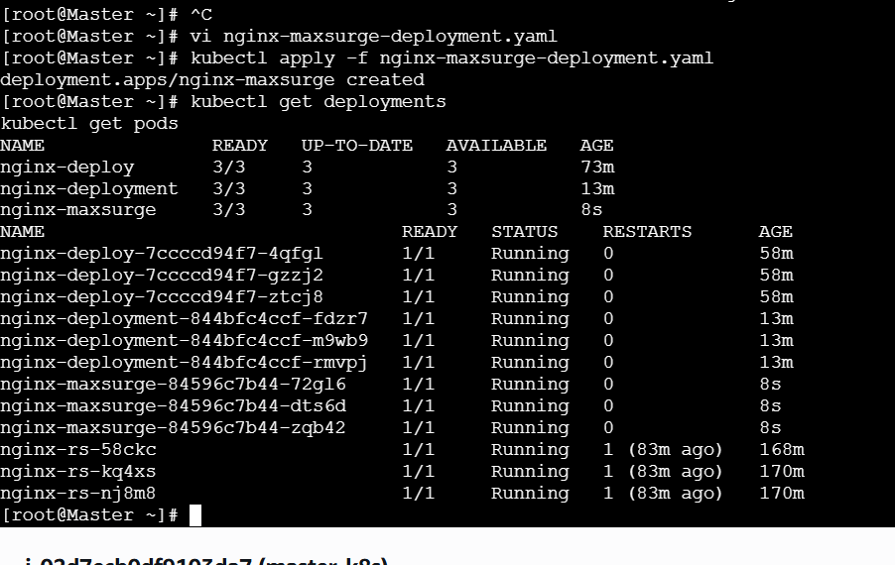
Step 4: Trigger a Rolling Update
Update the image:
kubectl set image deployment/nginx-maxsurge nginx=nginx:latest --record

✅ Step 5: Watch Pods Closely
kubectl get pods -w
🔍 What you will observe
- At most 1 extra pod created (maxSurge: 1)
- At most 1 pod unavailable at any time (maxUnavailable: 1)
- Total pods may temporarily be 4
- Update completes with no downtime
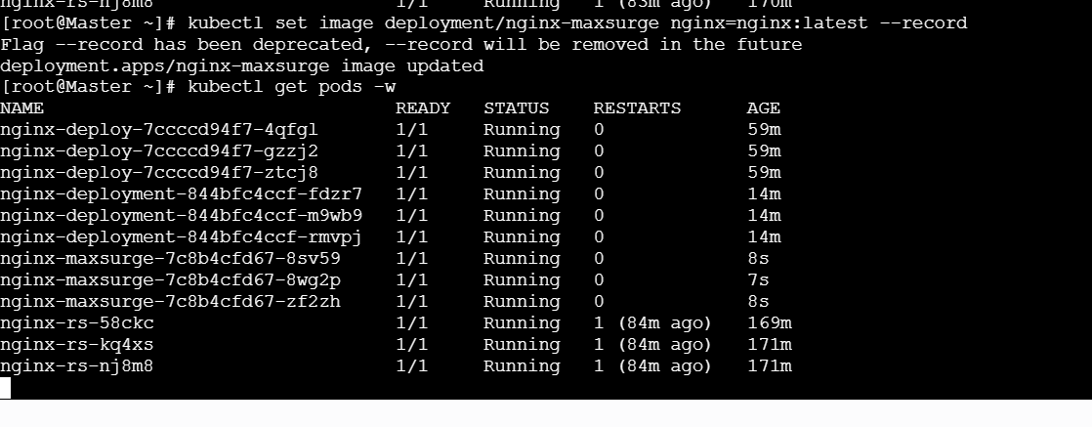
Step 6: Verify Rollout Status
kubectl rollout status deployment nginx-maxsurge
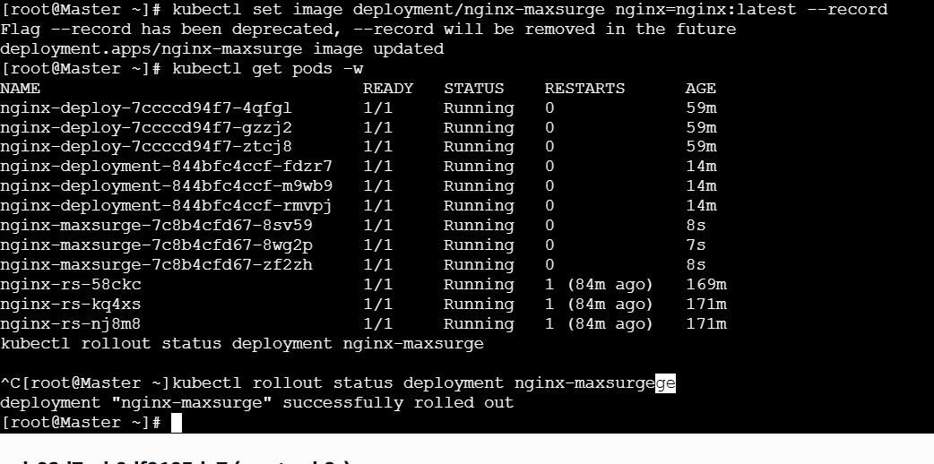

🧠 Understand with Numbers (Very Important)
Setting | Meaning
replicas: 3 | Desired pods
maxSurge: 1 | Can go up to 4 pods
maxUnavailable: 1 | Minimum 2 pods always running

🧠 Interview-Ready One-Line Answer
“maxSurge controls how many extra pods can be created during rolling updates, and maxUnavailable defines how many pods can be down, helping achieve zero-downtime deployments.”
Cleanup (Optional)
kubectl delete deployment nginx-maxsurge

✅ Summary (Easy to Remember)
- Rolling update strategy
- maxSurge = extra pods
- maxUnavailable = allowed downtime
- Used for safe production deployments

- Set up a Deployment with a custom revision history limit.
What is revision history limit? (Brief)
In Kubernetes,
revisionHistoryLimit controls how many old ReplicaSets Kubernetes keeps for a Deployment.
- Used for rollback
- Prevents too many old ReplicaSets
- Saves cluster resources
Default value: 10

🔹 Why do we use it?
- Limit rollback depth (security & cost)
- Clean old versions automatically
- Control cluster clutter
- Production best practice

🚀 Step-by-Step: Deployment with Custom Revision History Limit
Step 1: Create Deployment YAML file
vi nginx-revisionlimit-deployment.yaml

✅ Step 2: Paste FULL YAML (Ready to Apply)
apiVersion: apps/v1
kind: Deployment
metadata:
name: nginx-revisionlimit
spec:
replicas: 3

revisionHistoryLimit: 3

strategy:
type: RollingUpdate
rollingUpdate:
maxSurge: 1
maxUnavailable: 1

selector:
matchLabels:
app: nginx-revisionlimit

template:
metadata:
labels:
app: nginx-revisionlimit
spec:
containers:
- name: nginx
image: nginx:1.25
ports:
- containerPort: 80
Save & exit:
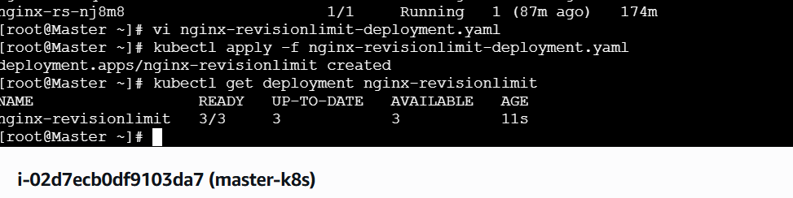
Step 3: Apply the Deployment
kubectl apply -f nginx-revisionlimit-deployment.yaml
Verify:
kubectl get deployment nginx-revisionlimit
Step 4: Perform Multiple Updates
Run these one by one:
kubectl set image deployment/nginx-revisionlimit nginx=nginx:1.26 --record
kubectl set image deployment/nginx-revisionlimit nginx=nginx:latest --record
kubectl set image deployment/nginx-revisionlimit nginx=nginx:stable --record

✅ Step 5: Check Rollout History
kubectl rollout history deployment nginx-revisionlimit
✔ You will see only last 3 revisions
Older ones are automatically deleted
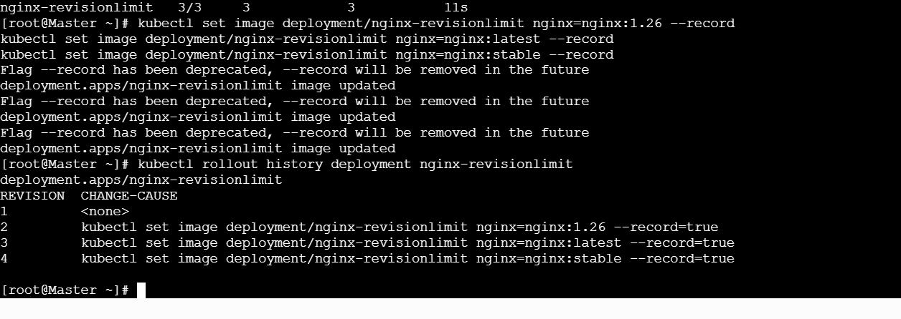

Step 6: Check ReplicaSets
kubectl get rs
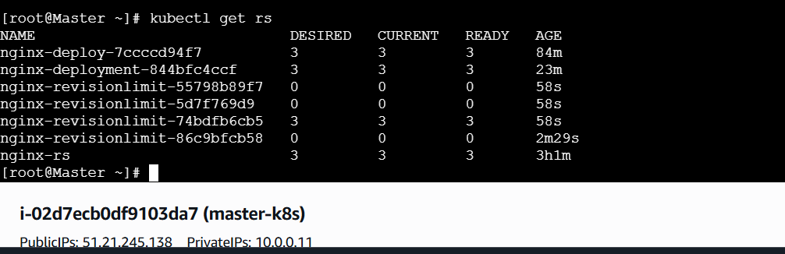
✔ Only current + last 3 ReplicaSets exist

🧠 Important Behavior (Must Know)
Setting | Result
revisionHistoryLimit: 0 | No rollback possible
revisionHistoryLimit: 1 | Only last version
revisionHistoryLimit: 3 | Rollback up to 3 versions
nterview-Ready One-Line Answer
“revisionHistoryLimit defines how many old ReplicaSets a Deployment retains for rollback, helping control resource usage and release safety.”

🧹 Cleanup (Optional)
kubectl delete deployment nginx-revisionlimit

✅ Summary (Easy to Remember)
- revisionHistoryLimit limits old versions
- Helps rollback control
- Default is 10
- Production best practice: 2–5

- Pause a Deployment during an update and then resume it.
What does Pause & Resume mean? (Brief)
- Pause → Stops Kubernetes from continuing the rollout
- Resume → Continues the rollout from where it stopped
👉 Used to safely apply multiple changes before updating pods.

🔹 Why do we use it?
- Avoid partial / accidental rollouts
- Apply multiple config changes together
- Review changes before pods restart
- Production-safe deployment control

🚀 Step-by-Step: Pause & Resume a Deployment
Example Deployment name: nginx-deployment
(Use kubectl get deploy to confirm your name.)
Step 1: Verify Deployment Exists
kubectl get deployments
Ensure nginx-deployment is listed.
Step 2: Start an Update (Image Change)
kubectl set image deployment/nginx-deployment nginx=nginx:latest --record
At this point, rollout starts immediately.
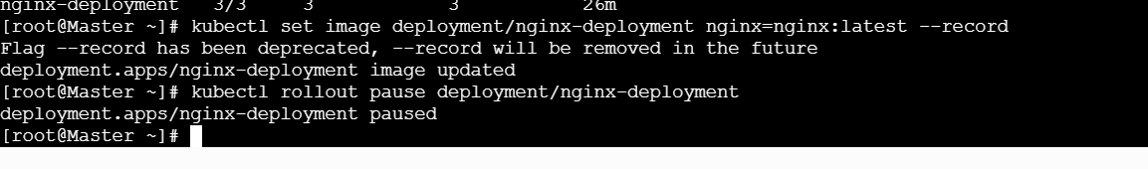
Step 3: Pause the Deployment (IMPORTANT)
kubectl rollout pause deployment/nginx-deployment
✔ Rollout is now paused


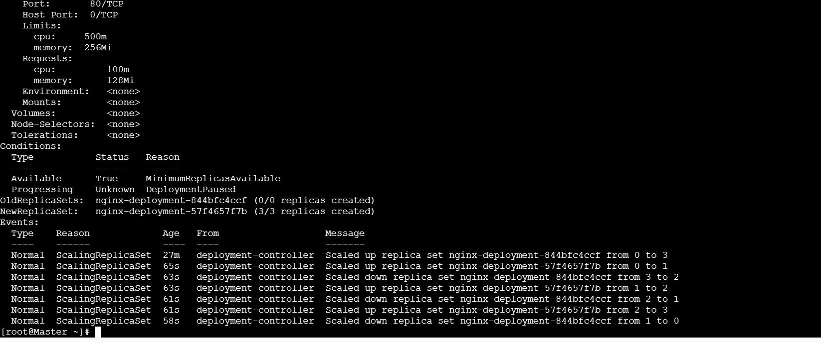
Step 6: Resume the Deployment
kubectl rollout resume deployment/nginx-deployment
✔ Kubernetes now applies all pending changes together
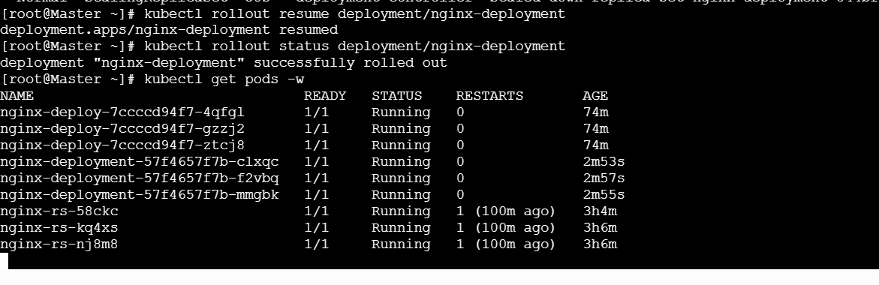

✅ Step 7: Watch the Rollout
kubectl rollout status deployment/nginx-deployment
Or live:
kubectl get pods -w


🧠 What Happens Internally? (Simple)
- Pause → Stops ReplicaSet updates
- Resume → Creates new ReplicaSet
- Pods update using rolling strategy

- Create a pod using resource requests for memory and CPU and observe how the scheduler assigns it to a node.
What is this? (Brief)
- Resource requests tell Kubernetes the minimum CPU & memory a Pod needs.
- The scheduler uses these requests to decide which node can run the Pod.
- This ensures proper placement and avoids node overload.

🔹 Why do we use resource requests?
- Correct pod placement
- Prevent node exhaustion
- Fair resource sharing
- Predictable performance (production best practice)

🚀 Step-by-Step: Pod with CPU & Memory Requests
Step 1: Check Node Resources (Before Scheduling)
kubectl get nodes -o wide
(Optional, more detail)
kubectl describe node worker-01
Look for:
Allocatable:
cpu
memory
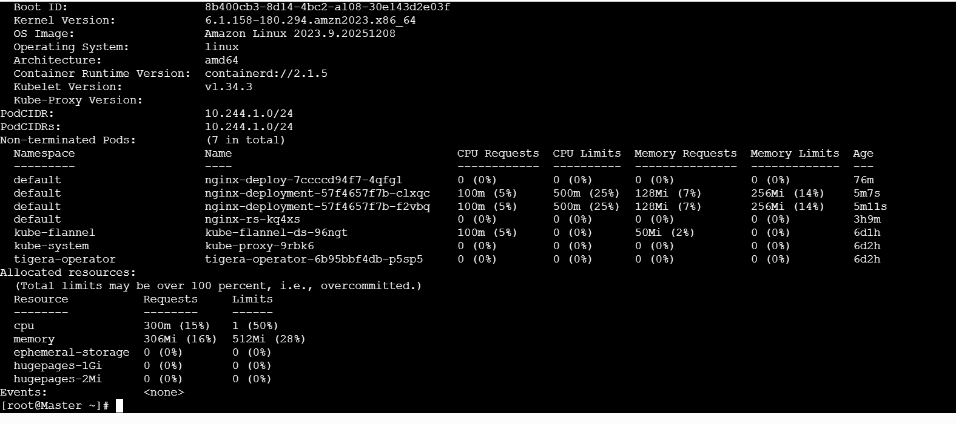
Step 2: Create Pod YAML with Resource Requests
Create a file:
vi resource-request-pod.yaml
Paste this FULL YAML 👇
apiVersion: v1
kind: Pod
metadata:
name: resource-request-pod
spec:
containers:
- name: nginx
image: nginx
resources:
requests:
cpu: "200m"
memory: "256Mi"
Save & exit:
Step 3: Apply the Pod
kubectl apply -f resource-request-pod.yaml
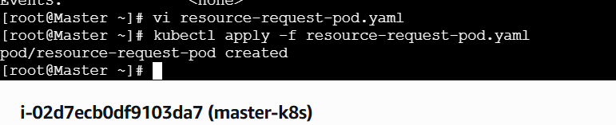
Step 4: Observe Scheduler Decision (IMPORTANT)
kubectl get pod resource-request-pod -o wide
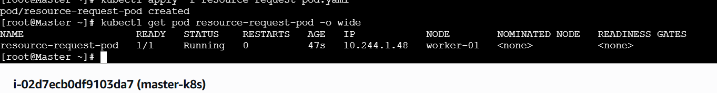
Example output:
NAME READY STATUS NODE
resource-request-pod 1/1 Running worker-01
👉 This shows which node the scheduler selected
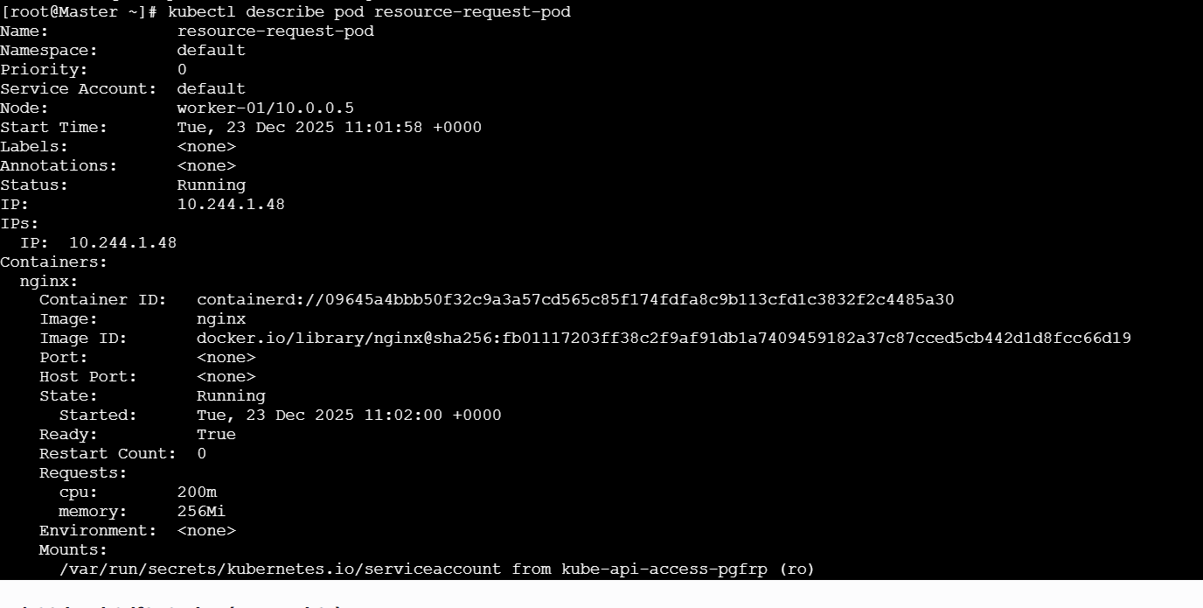
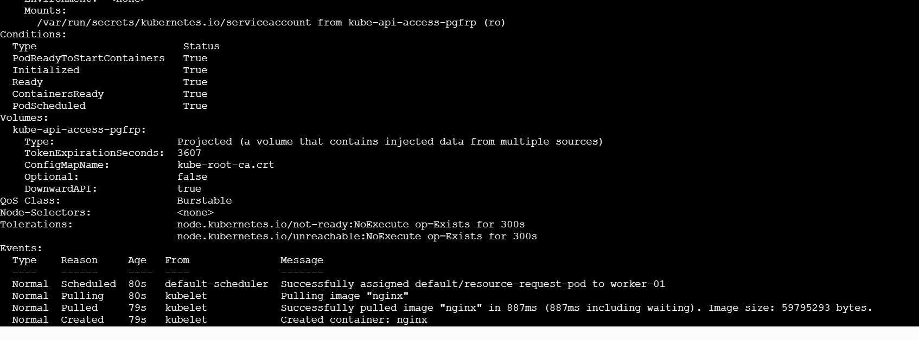
How Scheduler Decided (Simple Logic)
Scheduler checks each node:
- Is enough CPU available?
- Is enough memory available?
- Picks the best-fit node
❌ If no node satisfies requests → Pod stays Pending

🧪 (Optional) Test Scheduler Failure
Edit pod to request very high resources:
requests:
cpu: "10"
memory: "20Gi"
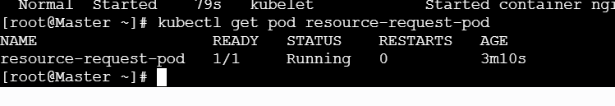
Interview-Ready One-Line Answer
“Kubernetes scheduler uses resource requests to place pods on nodes that have sufficient allocatable CPU and memory.”

⚠️ Important Points (Interview Gold)
- Scheduler uses requests, not limits
- Requests affect node selection
- Limits affect runtime behavior
- Requests define QoS class

🧹 Cleanup
kubectl delete pod resource-request-pod

✅ Summary (Easy to Remember)
- Requests → scheduling decision
- Scheduler → best-fit node
- Insufficient resources → Pending pod
- Production best practice → always set requests

