KUBERNETES-05_TASKS

Start working on k8s-05 tasks.
- Create a namespace dev-environment and apply a resource-based quota that restricts the number of pods to 3 and services to 2.

What are we doing?
We will:
- Create a Namespace called dev-environment
- Apply a ResourceQuota that:
  - Allows maximum 3 Pods
  - Allows maximum 2 Services
- Verify and understand why we use this in real projects

🔹 Why do we use Namespace + ResourceQuota? (Very important)
🔸 Namespace – Logical isolation
- Separates environments like dev / test / prod
- Avoids resource clashes
- Easier access control (RBAC)
🔸 ResourceQuota – Control & safety
- Prevents developers from creating too many pods/services
- Avoids cluster resource exhaustion
- Enforces discipline and cost control
- Very common in enterprise & production clusters
👉 Interview line:
“Namespaces provide logical isolation, and ResourceQuota ensures fair resource usage and prevents any team from over-consuming cluster resources.”

Step 1: Create the Namespace
Command:
kubectl create namespace dev-environment
Verify:
kubectl get namespaces
You should see:
dev-environment
✅ Namespace is ready.
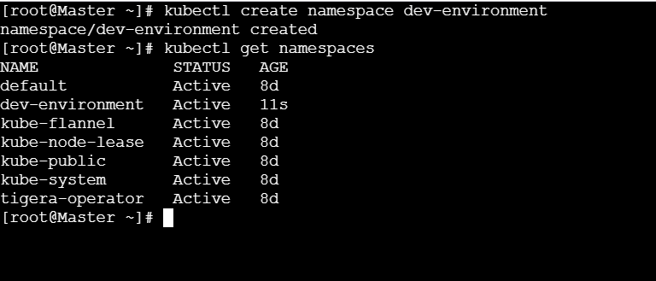
Step 2: Create ResourceQuota YAML
Now we restrict:
- Pods → max 3
- Services → max 2
Create a file:
vi dev-resource-quota.yaml
Paste this YAML:
apiVersion: v1
kind: ResourceQuota
metadata:
name: dev-resource-quota
namespace: dev-environment
spec:
hard:
pods: "3"
services: "2"
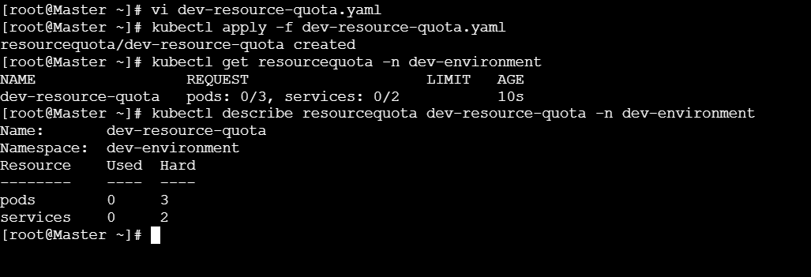
Explanation:
Field | Meaning
kind: ResourceQuota | Defines quota rules
namespace | Applies only to dev-environment
pods: "3" | Max 3 Pods allowed
services: "2" | Max 2 Services allowed
Step 4: Test the Quota (Proof)
Try creating 4 Pods (example):
kubectl run test-pod --image=nginx -n dev-environment
Repeat this command 4 times.
👉 On the 4th Pod, you will get an error like:
exceeded quota: dev-resource-quota, requested: pods=1, used: pods=3, limited: pods=3
🎯 This proves the quota is working.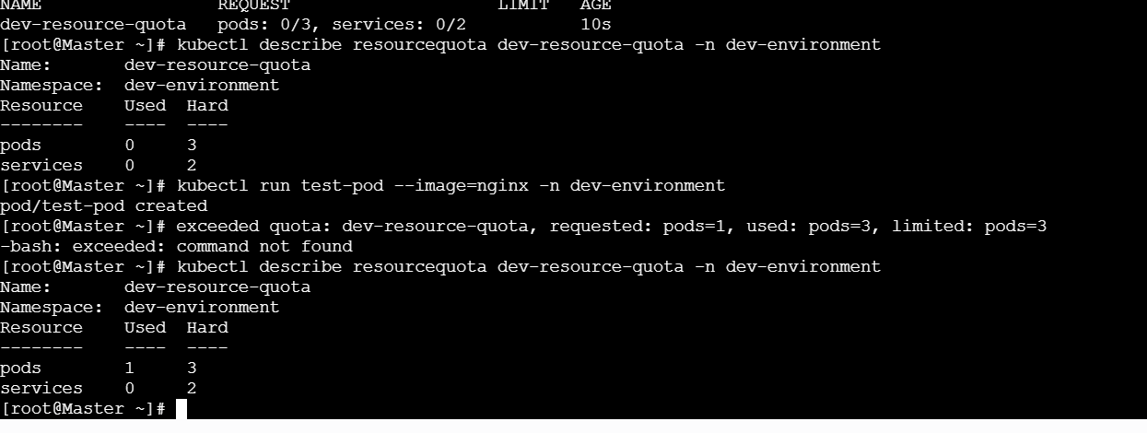

🔹 Real-Time Use Case (Interview Gold ⭐)
Example:
In a shared Kubernetes cluster, multiple teams deploy applications.
Without quotas, one team can accidentally deploy hundreds of pods and crash the cluster.
Using Namespace + ResourceQuota, we:
- Isolate environments
- Control pod/service count
- Protect cluster stability
- Reduce cloud cost

- Create a pod in the prod-environment namespace with 0.2 CPU and 200Mi memory requests, and 0.5 CPU and 500Mi memory limits.

What are we doing?
We will:
- Ensure the namespace prod-environment exists
- Create one Pod in that namespace
- Set:
  - CPU request: 0.2 (200 millicores)
  - Memory request: 200Mi
  - CPU limit: 0.5 (500 millicores)
  - Memory limit: 500Mi
- Verify & understand why this is used in real production

🔹 Why do we use Requests and Limits? (Very important)
🔸 Resource Requests
- Used by Kubernetes Scheduler
- Decides which node the Pod can run on
- Guarantees minimum resources
🔸 Resource Limits
- Enforced by kubelet
- Prevents a pod from overusing CPU/Memory
- Protects other applications
👉 Interview line:
“Requests are used for scheduling decisions, and limits prevent a pod from consuming more resources than allowed.”

🔹 Step 1: Check / Create Namespace
Check:
kubectl get namespace prod-environment
If not exists, create it:
kubectl create namespace prod-environment
🔹 Step 2: Create Pod YAML
Create a YAML file:
vi prod-pod.yaml
Paste this YAML:
apiVersion: v1
kind: Pod
metadata:
name: prod-resource-pod
namespace: prod-environment
spec:
containers:
- name: nginx-container
image: nginx
resources:
requests:
cpu: "200m"
memory: "200Mi"
limits:
cpu: "500m"
memory: "500Mi"
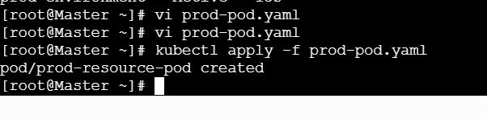

🔹 Step 3: Understand the YAML (Very clearly)
CPU values:
Value | Meaning
200m | 0.2 CPU
500m | 0.5 CPU
Memory:
Value | Meaning
200Mi | Guaranteed minimum
500Mi | Maximum allowed
Key behavior:
- Scheduler checks requests
- Pod will not start if node doesn’t have 200m CPU & 200Mi memory
- Pod cannot exceed 500Mi memory (will be killed if it does)

Step 4: Apply the Pod
kubectl apply -f prod-pod.yaml

🔹 Step 5: Verify Pod
kubectl get pods -n prod-environment
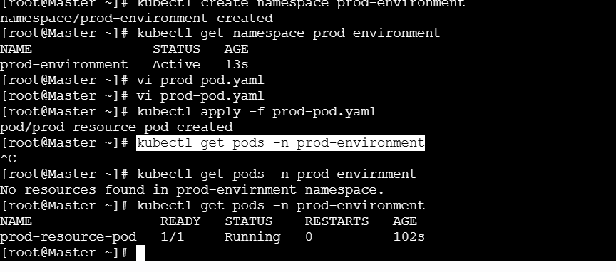
Describe the pod:
kubectl describe pod prod-resource-pod -n prod-environment
Look for:
Requests:
cpu: 200m
memory: 200Mi
Limits:
cpu: 500m
memory: 500Mi
✅ Pod is running with controlled resources.
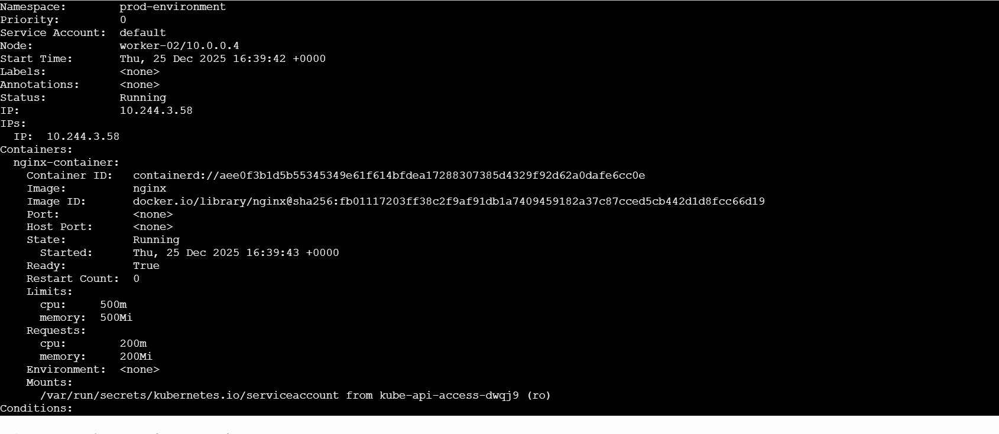

Step 6: How Kubernetes Handles This (Real Behavior)
CPU:
- Pod can burst up to 0.5 CPU
- If CPU is busy → pod is throttled, not killed
Memory:
- Pod can use memory up to 500Mi
- If it crosses → OOMKilled
- Pod restarts automatically

🔹 Real-Time Production Use Case ⭐
Example:
In production, we host multiple microservices.
Without limits, one faulty service may consume all memory and crash the node.
By defining requests and limits, we ensure:
- Fair resource usage
- Stable production environment
- Predictable performance
- Better capacity planning

🔹 One-Line Interview Answer
“I define resource requests to help the scheduler place the pod correctly and limits to prevent any pod from overusing CPU or memory, ensuring production stability.”

🔹 Bonus Interview Q&A
Q: What happens if request = limit?
👉 Guaranteed performance, no bursting
Q: What happens if memory limit is exceeded?
👉 Pod is OOMKilled
Q: What happens if CPU limit is exceeded?
👉 CPU throttling, pod continues running

- In the staging-environment namespace, set a LimitRange that assigns default CPU and memory limits (300m CPU, 600Mi memory) and applies a minimum and maximum CPU.

What are we doing?
In the staging-environment namespace, we will:
- Create the namespace (if not already present)
- Create a LimitRange
- Set:
  - Default CPU limit: 300m
  - Default memory limit: 600Mi
  - Minimum CPU: 100m
  - Maximum CPU: 500m
- Verify and understand real usage

🔹 Why do we use LimitRange? (Very Important)
🔸 Problem without LimitRange
- Developers forget to define CPU/memory
- Pods may consume uncontrolled resources
- Scheduler decisions become unpredictable
🔸 What LimitRange solves
- Automatically applies default limits
- Enforces minimum and maximum resource values
- Ensures standardization across a namespace
👉 Interview line:
“LimitRange enforces default, minimum, and maximum resource usage per pod or container within a namespace, ensuring consistency and preventing resource misuse.”

Step 1: Check / Create Namespace
kubectl get namespace staging-environment
If not present:
kubectl create namespace staging-environment
Step 2: Create LimitRange YAML
Create the file:
vi staging-limitrange.yaml
Paste this YAML:
apiVersion: v1
kind: LimitRange
metadata:
name: staging-limitrange
namespace: staging-environment
spec:
limits:
- type: Container
default:
cpu: "300m"
memory: "600Mi"
defaultRequest:
cpu: "200m"
memory: "300Mi"
min:
cpu: "100m"
max:
cpu: "500m"
Step 3: Understand the YAML (Clearly)
What each section does:
Section | Purpose
default | Applied if developer does not specify limits
defaultRequest | Used for scheduler if request not provided
min | Container cannot request less than this
max | Container cannot exceed this
Key points:
- Applies per container
- Works only inside the namespace
- Automatically injects values into pods

🔹 Step 4: Apply LimitRange
kubectl apply -f staging-limitrange.yaml
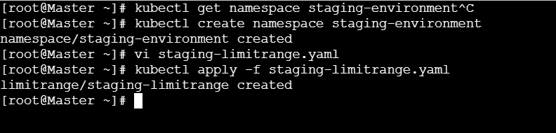

Step 5: Verify LimitRange
kubectl get limitrange -n staging-environment
Describe it:
kubectl describe limitrange staging-limitrange -n staging-environment
You will see:
Default CPU Limit: 300m
Default Memory Limit: 600Mi
Min CPU: 100m
Max CPU: 500m
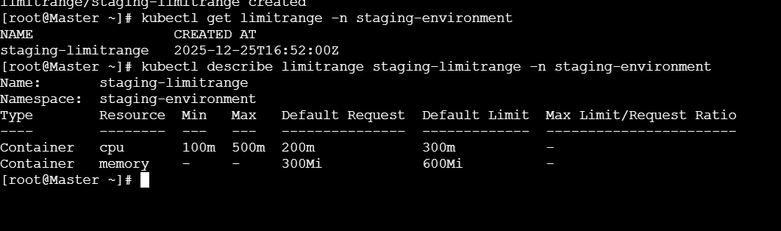
Step 6: Proof – Test with a Pod
Create a Pod without resource values:
kubectl run test-pod --image=nginx -n staging-environment
Describe the pod:
kubectl describe pod test-pod -n staging-environment
You will see automatically applied values:
Limits:
cpu: 300m
memory: 600Mi
Requests:
cpu: 200m
memory: 300Mi
🎯 This proves LimitRange is working.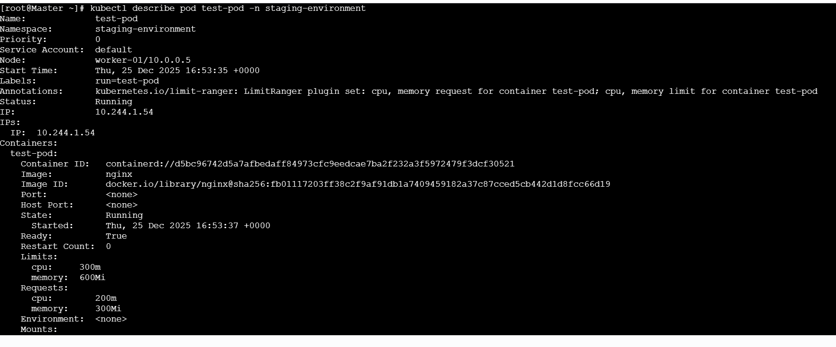
🔹 What Happens If Rules Are Violated?
Example:
If someone sets:
cpu: "50m"
❌ Pod creation will FAIL:
must be greater than or equal to 100m
If someone sets:
cpu: "700m"
❌ Pod creation will FAIL:
must be less than or equal to 500m

🔹 Real-Time Production Use Case ⭐
Example:
In staging environments, multiple teams deploy frequently.
LimitRange ensures every pod:
- Has safe default limits
- Follows CPU boundaries
- Avoids accidental overuse
- Maintains cluster stability

🔹 One-Line Interview Answer
“LimitRange enforces default, minimum, and maximum CPU and memory values per container in a namespace, ensuring consistent and controlled resource usage.”

- Create a pod and a NodePort service in the default namespace, then create another pod in the test namespace and communicate between them using Service DNS.
Excellent question 👍
This task tests core Kubernetes networking + DNS, which is very common in interviews and real projects.
I’ll explain step by step, very clearly, and also explain why we do this.

🔹 What are we doing?
We will:
- Create a Pod in the default namespace
- Expose it using a NodePort Service
- Create another Pod in the test namespace
- Communicate from test namespace Pod → default namespace Service
- Use Kubernetes Service DNS (not IP)

🔹 Why is this important? (Concept First)
Why Service DNS?
- Pod IPs are dynamic
- Services provide stable DNS + load balancing
- Kubernetes DNS allows cross-namespace communication
👉 Interview line:
“Pods communicate using Service DNS because pod IPs are ephemeral, while services provide stable networking and service discovery.”

🔹 Step 1: Create Pod in default namespace
Create pod YAML:
vi default-pod.yaml
apiVersion: v1
kind: Pod
metadata:
name: web-pod
spec:
containers:
- name: nginx
image: nginx
ports:
- containerPort: 80
Apply:
kubectl apply -f default-pod.yaml
Verify:
kubectl get pods

🔹 Step 2: Create NodePort Service (default namespace)
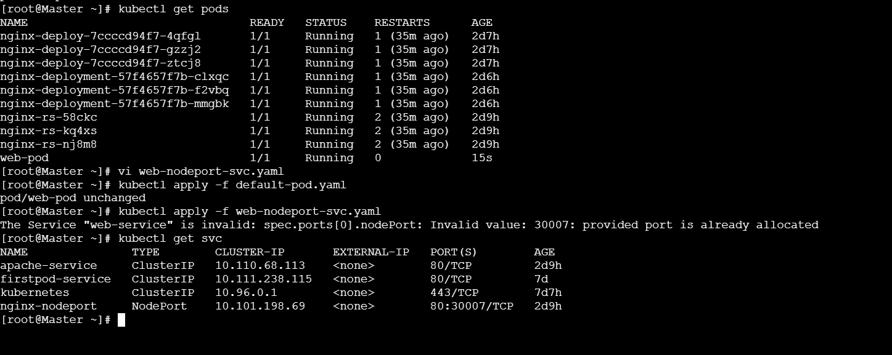
Create service YAML:
vi web-nodeport-svc.yaml
apiVersion: v1
kind: Service
metadata:
name: web-service
spec:
type: NodePort
selector:
app: web
ports:
- port: 80
targetPort: 80
nodePort: 30007
⚠️ Important: We need labels.
So update the Pod to include label.
Update Pod (fix):
metadata:
name: web-pod
labels:
app: web
Re-apply:
kubectl apply -f default-pod.yaml
kubectl apply -f web-nodeport-svc.yaml
Verify:
kubectl get svc
You’ll see:
web-service NodePort 10.x.x.x <none> 80:30007/TCP


🔹 Step 3: Create test namespace
kubectl create namespace test
Verify:
kubectl get ns

🔹 Step 4: Create Pod in test namespace
This pod will act as a client.
Create pod:
vi test-pod.yaml
apiVersion: v1
kind: Pod
metadata:
name: client-pod
namespace: test
spec:
containers:
- name: busybox
image: busybox
command: ["sleep", "3600"]
Apply:
kubectl apply -f test-pod.yaml
Verify:
kubectl get pods -n test
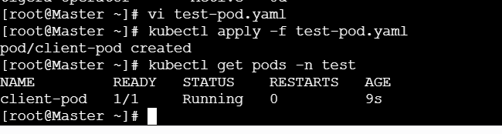

🔹 Step 5: Understand Service DNS format
Full DNS format:
<service-name>.<namespace>.svc.cluster.local
In our case:
web-service.default.svc.cluster.local

🔹 Step 6: Communicate using Service DNS
Enter test pod:
kubectl exec -it client-pod -n test -- sh
Test connectivity:
wget -qO- web-service.default.svc.cluster.local
OR:
nslookup web-service.default.svc.cluster.local
🎯 You will see HTML output or DNS resolution → communication successful

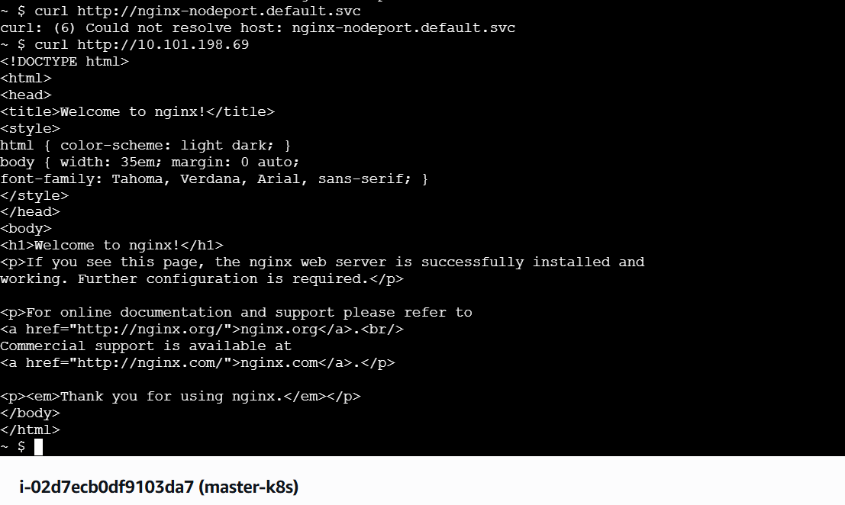

🔹 How this works internally (Simple)
- DNS request goes to CoreDNS
- CoreDNS resolves service name
- Service forwards traffic to Pod
- Pod responds back

🔹 Why NodePort here?
- Exposes service externally
- Allows access from:
  - Browser
  - External systems
- Used mostly for:
  - Testing
  - Demos
  - Labs
👉 Interview line:
“NodePort exposes services externally by mapping a port on each node to the service.”

🔹 Real-Time Use Case ⭐
Example:
A backend service runs in default namespace.
A testing tool runs in test namespace.
Using Service DNS, both can communicate reliably without hardcoding IPs.

🔹 One-Line Interview Answer
“Pods communicate across namespaces using Service DNS in the format service-name.namespace.svc.cluster.local, which provides stable service discovery.”

🔹 Common Interview Follow-ups
Q: Can pods communicate directly using pod IP?
👉 Yes, but not recommended (IP changes)
Q: Is NodePort required for inter-pod communication?
👉 ❌ No, ClusterIP is enough inside cluster
Q: What handles DNS in Kubernetes?
👉 CoreDNS

- Apply a LimitRange with a max limit/request ratio of 2 for memory in the performance-environment namespace, and test by creating a pod with mismatched resource requests and limits.
What is the goal?
We will:
- Create a namespace performance-environment
- Apply a LimitRange that enforces
max limit/request ratio = 2 for memory
- Test it by creating:
  - ❌ a pod that violates the rule (should FAIL)
  - ✅ a pod that follows the rule (should PASS)

🔹 Why do we use max limit/request ratio? (VERY IMPORTANT)
🔸 The problem
Without this rule, a developer can do:
- Request: 100Mi
- Limit: 2Gi
👉 Scheduler thinks the pod is lightweight,
but at runtime it can consume huge memory and crash nodes.
🔸 What this rule enforces
- Memory limit cannot be more than 2× the request
- Prevents fake/low requests
- Makes scheduling accurate
- Protects node stability
🧠 Interview line (memorize):
“A max limit/request ratio prevents pods from under-requesting resources while over-consuming at runtime.”

🔹 Step 1: Create the namespace
kubectl create namespace performance-environment
Verify:
kubectl get namespace performance-environment
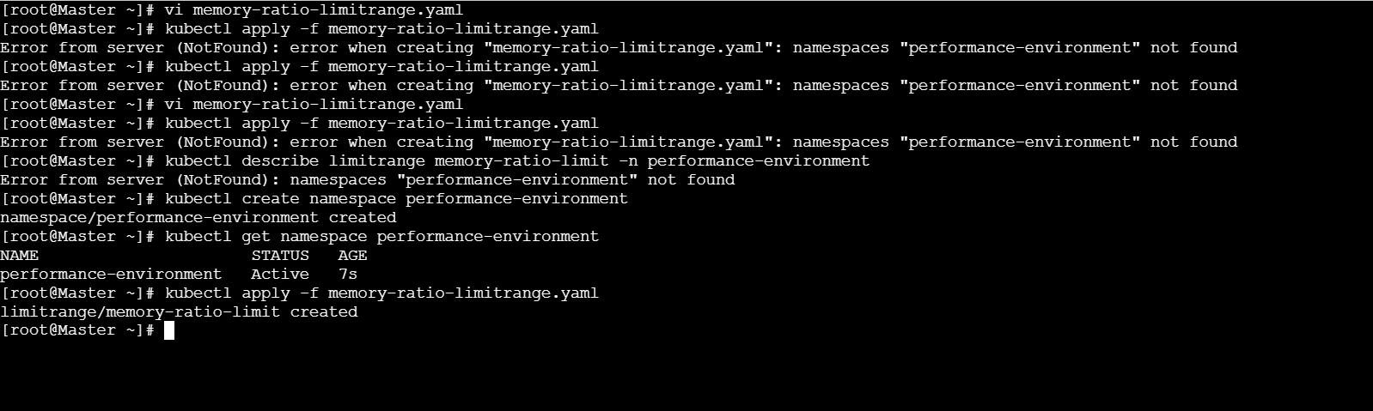
Step 2: Create the LimitRange (ratio = 2)
Create the YAML file:
vi memory-ratio-limitrange.yaml
Paste this:
apiVersion: v1
kind: LimitRange
metadata:
name: memory-ratio-limit
namespace: performance-environment
spec:
limits:
- type: Container
maxLimitRequestRatio:
memory: "2"
Apply it:
kubectl apply -f memory-ratio-limitrange.yaml
Verify:
kubectl describe limitrange memory-ratio-limit -n performance-environment
You should see:
Max Limit/Request Ratio:
memory: 2
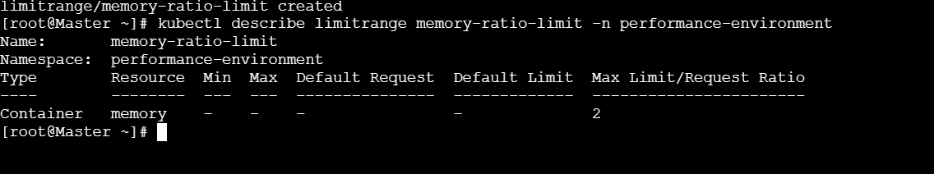

Step 3: Test with a ❌ BAD pod (mismatched resources)
❌ This pod breaks the rule
- Request = 200Mi
- Limit = 600Mi
- Ratio = 3 ❌
Create file:
vi bad-pod.yaml
apiVersion: v1
kind: Pod
metadata:
name: bad-memory-pod
namespace: performance-environment
spec:
containers:
- name: nginx
image: nginx
resources:
requests:
memory: "200Mi"
limits:
memory: "600Mi"
Apply:
kubectl apply -f bad-pod.yaml
❌ Expected error:
Error: limit to request ratio for memory is too high
🎯 This proves the LimitRange is enforcing the rule.

Step 4: Test with a ✅ GOOD pod (valid ratio)
✅ This pod follows the rule
- Request = 200Mi
- Limit = 400Mi
- Ratio = 2 ✅
Create file:
vi good-pod.yaml
apiVersion: v1
kind: Pod
metadata:
name: good-memory-pod
namespace: performance-environment
spec:
containers:
- name: nginx
image: nginx
resources:
requests:
memory: "200Mi"
limits:
memory: "400Mi"
Apply:
kubectl apply -f good-pod.yaml
Verify:
kubectl get pods -n performance-environment

🔹 Step 5: Understand the math (simple)
Memory Request | Memory Limit | Ratio | Result
200Mi | 600Mi | 3 | ❌ Rejected
200Mi | 400Mi | 2 | ✅ Allowed
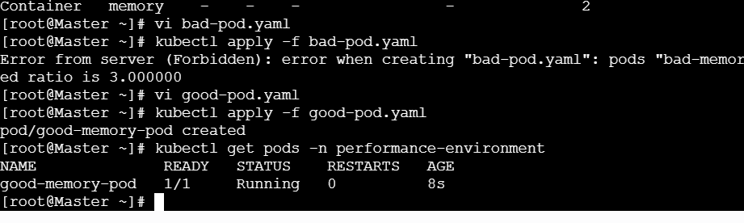
🔹 Real-world production use case ⭐
Example:
In performance-sensitive namespaces, teams sometimes under-request memory to get scheduled faster.
A max limit/request ratio ensures honest resource requests, stable nodes, and predictable performance.

🔹 One-line interview answer (MEMORIZE)
“I use LimitRange with a max limit-to-request ratio to ensure memory limits are proportional to requests, preventing scheduling abuse and improving cluster stability.”

🔹 Quick comparison (interview bonus)
Feature | LimitRange | ResourceQuota
Controls per-container behavior | ✅ | ❌
Controls namespace total usage | ❌ | ✅
Enforces request/limit ratio | ✅ | ❌

✅ You’ve learned:
✔ Advanced LimitRange rules
✔ How Kubernetes validates pods
✔ How to test enforcement properly
✔ Real production reasoning

