KUBERNETES_06_TASK

- Create a ConfigMap from a directory containing multiple files and inject the variables into a pod as environment variables.

Goal
- We have multiple files in a directory
- Create a ConfigMap from that directory
- Inject all values as environment variables into a Pod
- Verify inside the container

🧠 Real-world example
Imagine you have app configs like:
- DB host
- DB port
- App mode
Stored as files (very common in real projects).
Step 1: Create a directory with config files
On your master node / local machine:
mkdir app-config
cd app-config
Create multiple files:
vi DB_HOST
mysql.service.local
vi DB_PORT
3306
vi APP_ENV
production
Check files:
ls
✅ Output:
DB_HOST DB_PORT APP_ENV
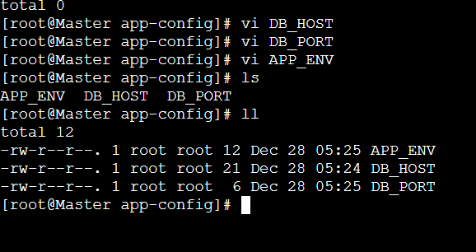
Step 2: Create ConfigMap from the directory
Run:
kubectl create configmap app-config-map --from-file=app-config/
Verify:
kubectl get configmap
Describe it:
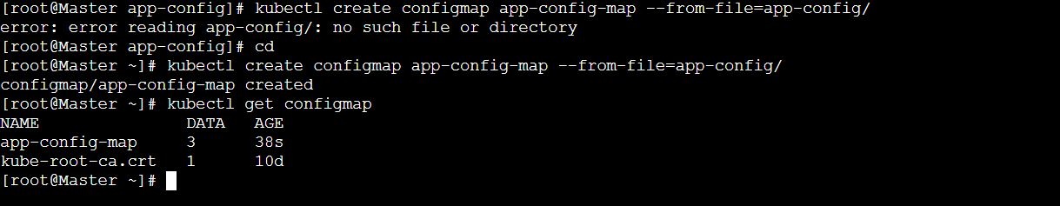
kubectl describe configmap app-config-map
You will see:
Data
====
APP_ENV: production
DB_HOST: mysql.service.local
DB_PORT: 3306
✔️ Each filename becomes an environment variable name
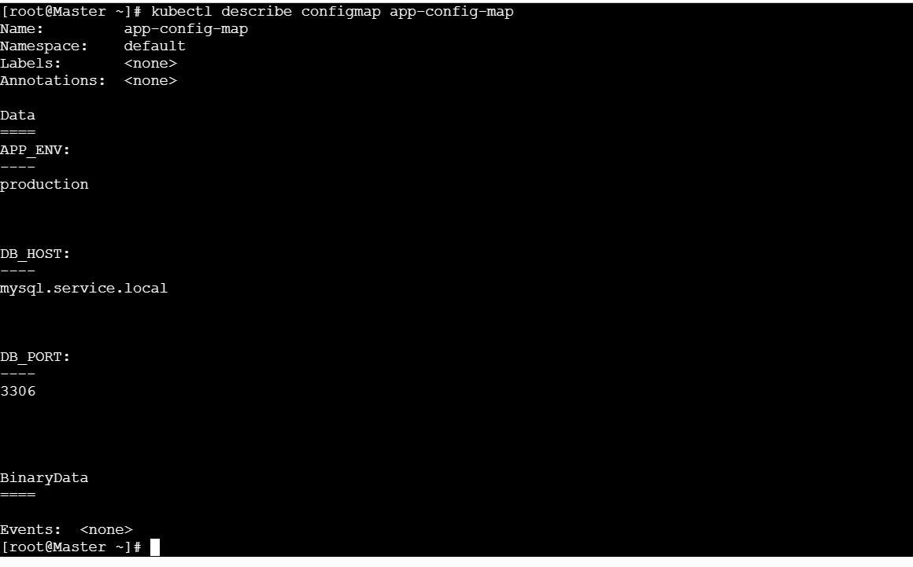
Step 3: Create a Pod using ConfigMap as ENV variables
Create Pod YAML:
vi configmap-env-pod.yaml
apiVersion: v1
kind: Pod
metadata:
name: configmap-env-pod
spec:
containers:
- name: test-container
image: busybox
command: ["sh", "-c", "sleep 3600"]
envFrom:
- configMapRef:
name: app-config-map
Step 4: Deploy the Pod
kubectl apply -f configmap-env-pod.yaml
Check Pod status:
kubectl get pods
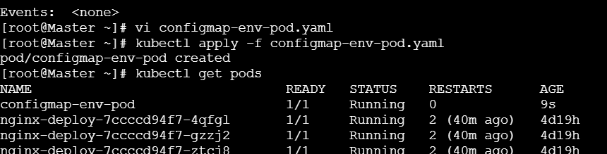

✅ Step 5: Verify environment variables inside Pod
Enter the container:
kubectl exec -it configmap-env-pod -- sh
Print env variables:
Env
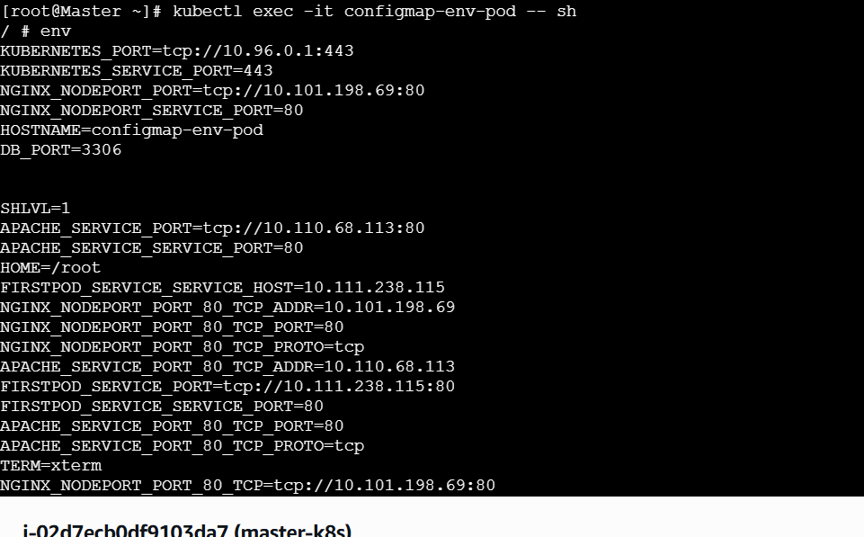
Or check individually:
echo $DB_HOST
echo $DB_PORT
echo $APP_ENV
✅ Output:
mysql.service.local
3306
production
🎉 SUCCESS!

🧩 How this works (Simple explanation)
Component | What it does
Directory | Holds multiple config files
ConfigMap | Converts each file → key-value
envFrom | Injects all keys as env variables
Pod | Consumes the variables
Important Notes (Very important)
- File name must be valid ENV name
  - ❌ db-host.txt
  - ✅ DB_HOST
- ConfigMap values are not encrypted
- For passwords → use Secrets, not ConfigMaps

🔄 Real-time usage example
- Spring Boot → application configs
- Node.js → .env variables
- Microservices → environment-based config

🧠 Interview-ready explanation (Say this confidently)
“In Kubernetes, we can create a ConfigMap from a directory using --from-file. Each file name becomes a key and file content becomes the value. Using envFrom, we inject all ConfigMap keys as environment variables into the container, which is commonly used for application configuration without rebuilding images.”

- Create a ConfigMap from a file and mount it as a volume inside a pod, ensuring the configuration data is available as files.

Perfect 👍 This is a very important Kubernetes scenario and commonly asked in real-time + interview.
Let’s do it slowly, step by step, with clear purpose at each step.

🎯 Goal
- Create a ConfigMap from a file
- Mount it as a volume inside a Pod
- Ensure config is available as a file, not ENV
- Verify inside the container

🧠 Real-time use case (why this is needed)
- Applications read config from files:
  - application.properties
  - nginx.conf
  - config.json
- You don’t want to rebuild the image when config changes
- Kubernetes injects config dynamically using ConfigMap volumes

✅ Step 1: Create a configuration file
Create a file on your machine (master node):
vi app.properties
Add content:
APP_NAME=OrderService
APP_ENV=production
APP_PORT=8080
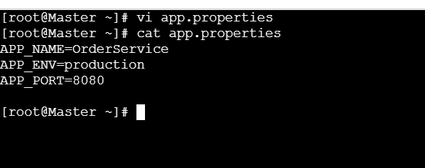
Save & exit.
Check file:
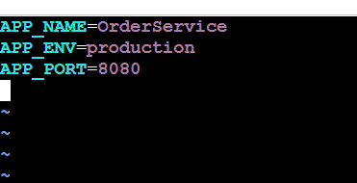
cat app.properties

✅ Step 2: Create ConfigMap from the file
Run:
kubectl create configmap app-config-file --from-file=app.properties
Verify:
kubectl get configmap
Describe it:
kubectl describe configmap app-config-file
You’ll see:
Data
====
app.properties:
----
APP_NAME=OrderService
APP_ENV=production
APP_PORT=8080
✔️ The file name is preserved
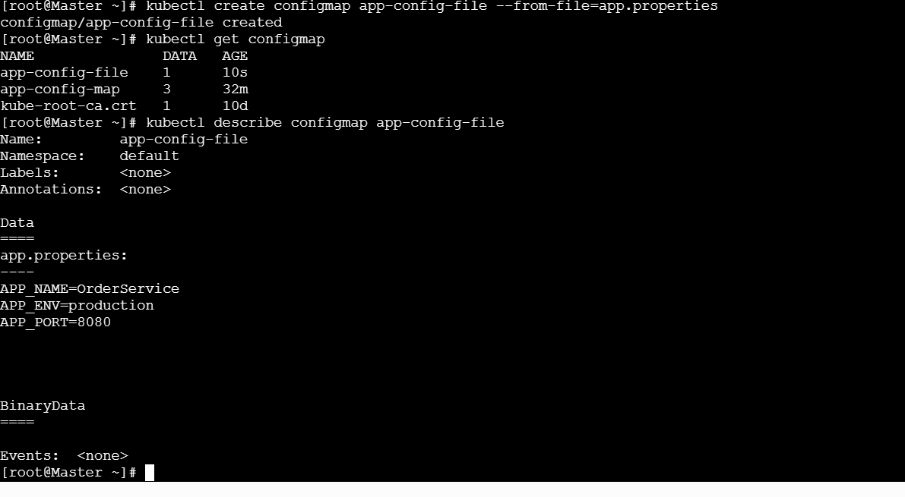

✅ Step 3: Create Pod YAML with ConfigMap volume
Create YAML file:
vi configmap-volume-pod.yaml
Paste this:
apiVersion: v1
kind: Pod
metadata:
name: configmap-volume-pod
spec:
containers:
- name: app-container
image: busybox
command: ["sh", "-c", "sleep 3600"]
volumeMounts:
- name: config-volume
mountPath: /etc/config
volumes:
- name: config-volume
configMap:
name: app-config-file
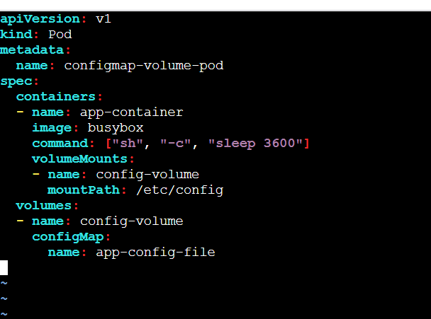

🧠 Explanation (important)
Section | Purpose
volumes | Defines ConfigMap source
configMap | Refers to ConfigMap
volumeMounts | Mounts volume into container
mountPath | Directory where file appears

✅ Step 4: Deploy the Pod
kubectl apply -f configmap-volume-pod.yaml
Check status:
kubectl get pods
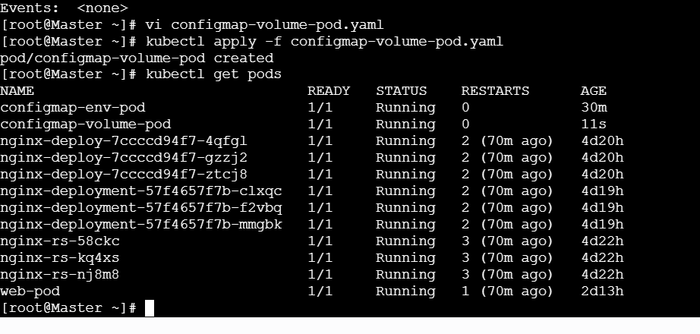

✅ Step 5: Verify file inside the Pod
Enter the Pod:
kubectl exec -it configmap-volume-pod -- sh
List files:
ls /etc/config
Output:
app.properties
View content:
cat /etc/config/app.properties
Output:
APP_NAME=OrderService
APP_ENV=production
APP_PORT=8080
🎉 ConfigMap successfully mounted as a file!
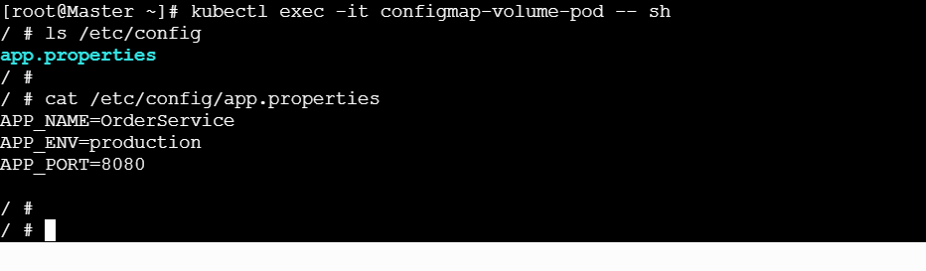

🔥 Very Important Behavior (Interview gold)
🔄 What happens if ConfigMap is updated?
- Volume-mounted ConfigMaps update automatically
- No Pod restart needed (few seconds delay)
- ENV-based ConfigMaps ❌ do NOT auto-update
👉 This is why volumes are preferred for config files.

🆚 ENV vs Volume (Quick Comparison)
Feature | ENV | Volume
Config format | Key-value | Full files
Auto update | ❌ No | ✅ Yes
Best for | Small vars | App configs
File support | ❌ No | ✅ Yes

🗣️ Interview-ready answer (Say this)
“We create a ConfigMap from a file using kubectl create configmap --from-file. Then we define a volume using the ConfigMap and mount it into the container using volumeMounts. This makes the configuration available as files inside the pod, which is ideal for applications that read configuration from the filesystem.”

- Create a Secret with sensitive information (username and password) and inject it into a pod as environment variables.

Great—this is core Kubernetes security knowledge and very common in interviews.
I’ll walk you through it step by step, clean and practical.

🎯 Goal
- Create a Secret with username & password
- Inject them into a Pod as environment variables
- Verify inside the container

🧠 Real-time use case
- Database credentials
- API username/password
- Third-party service login
👉 Never store these in ConfigMaps or Pod YAML directly.

✅ Step 1: Create a Secret (imperative way – easiest)
Run this command:
kubectl create secret generic db-secret \
--from-literal=DB_USERNAME=admin \
--from-literal=DB_PASSWORD=MyStrongPassword123

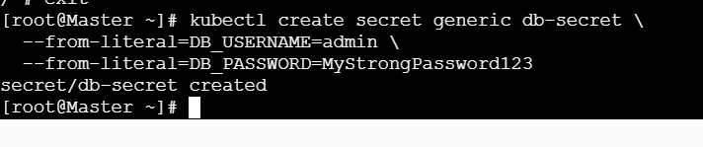

✅ Step 2: Verify the Secret
Check if it exists:
kubectl get secrets
Describe it:
kubectl describe secret db-secret
Output will look like:
Data
====
DB_USERNAME: 5 bytes
DB_PASSWORD: 19 bytes
⚠️ Note: Values are hidden (base64 encoded internally).
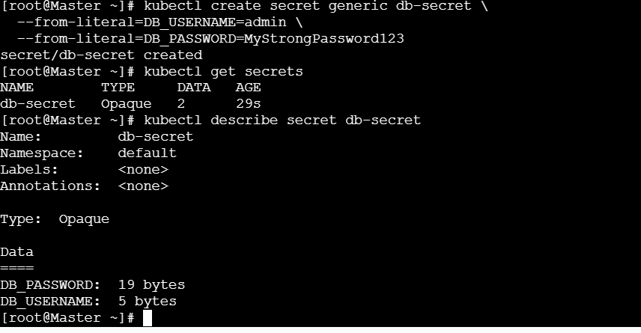

🧠 (Optional but good to know)
To view actual value (for learning only):
kubectl get secret db-secret -o yaml
Decode manually:
echo "YWRtaW4=" | base64 –decode
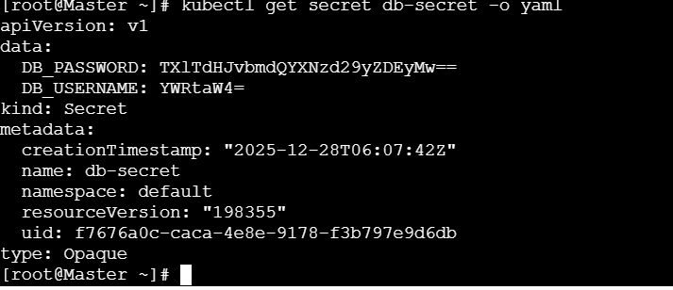

✅ Step 3: Create Pod YAML using Secret as ENV variables
Create a Pod file:
vi secret-env-pod.yaml
Paste this:
apiVersion: v1
kind: Pod
metadata:
name: secret-env-pod
spec:
containers:
- name: app-container
image: busybox
command: ["sh", "-c", "sleep 3600"]
env:
- name: DB_USERNAME
valueFrom:
secretKeyRef:
name: db-secret
key: DB_USERNAME
- name: DB_PASSWORD
valueFrom:
secretKeyRef:
name: db-secret
key: DB_PASSWORD

🧠 Explanation (important)
Field | Meaning
secretKeyRef | Refers to Secret
name | Secret name
key | Key inside Secret
env | Injects as ENV variable

✅ Step 4: Deploy the Pod
kubectl apply -f secret-env-pod.yaml
Check Pod:
kubectl get pods
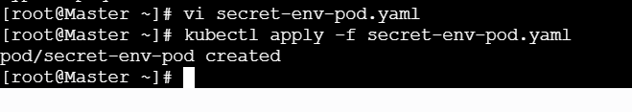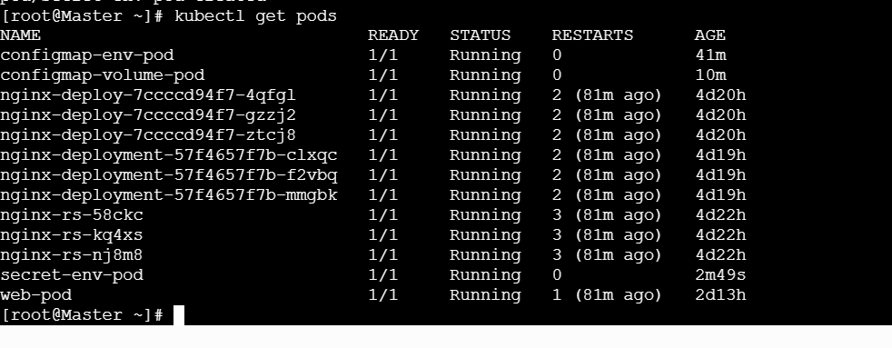

✅ Step 5: Verify Secret inside the Pod
Enter the Pod:
kubectl exec -it secret-env-pod -- sh
Check environment variables:
echo $DB_USERNAME
echo $DB_PASSWORD
✅ Output:
admin
MyStrongPassword123
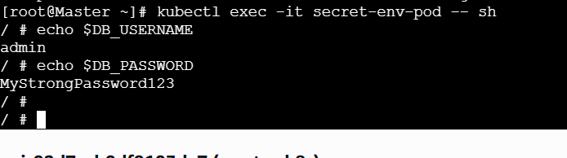
Secret successfully injected as environment variables!

🔥 Interview-Important Points (Very important)
❓ Why Secret instead of ConfigMap?
Feature | ConfigMap | Secret
Sensitive data | ❌ No | ✅ Yes
Base64 encoded | ❌ No | ✅ Yes
RBAC protected | ❌ Weak | ✅ Strong
Use case | App config | Passwords, tokens

⚠️ Important Security Notes
- Secrets are base64 encoded, not encrypted by default
- Enable etcd encryption for production
- Don’t log secrets
- Prefer Secrets + RBAC

🗣️ Interview-ready answer (say this)
“We create a Kubernetes Secret using kubectl create secret generic. Then we inject the secret values into a pod using env with secretKeyRef. This securely passes sensitive data like usernames and passwords without hardcoding them in pod definitions.”

- Create a Secret using a YAML file, mount it as a volume in a pod, and verify the specific Secret values are available as files.
Excellent 👍 This is the most complete + production-style Secret usage in Kubernetes.
I’ll explain it step by step, very clearly, just like a real DevOps lab + interview answer.

🎯 Goal
- Create a Secret using YAML
- Mount the Secret as a volume
- Access Secret values as files inside the Pod
- Verify the values

🧠 Real-time use case
- TLS certificates (.crt, .key)
- DB credentials files
- API tokens used by applications reading from files
- More secure than ENV (not exposed via env)

✅ Step 1: Create Secret values (Base64 encoding)
Kubernetes Secrets require base64-encoded values in YAML.
Encode values:
echo -n "admin" | base64
Output:
YWRtaW4=
echo -n "MyStrongPassword123" | base64
Output:
TXlTdHJvbmdQYXNzd29yZDEyMw==
📌 Important: Use -n (no newline)
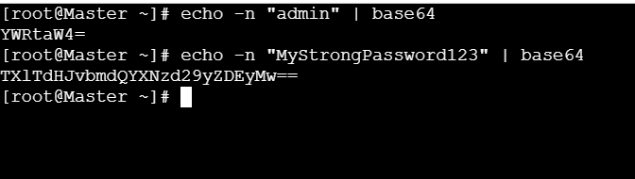

✅ Step 2: Create Secret YAML file
Create file:
vi db-secret.yaml
Paste:
apiVersion: v1
kind: Secret
metadata:
name: db-secret-file
type: Opaque
data:
username: YWRtaW4=
password: TXlTdHJvbmdQYXNzd29yZDEyMw==
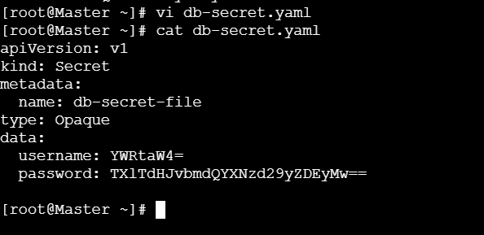

🧠 Explanation
Field | Meaning
kind: Secret | Declares Secret
type: Opaque | Generic secret
data | Base64 encoded values
username/password | File names when mounted

✅ Step 3: Apply the Secret
kubectl apply -f db-secret.yaml
Verify:
kubectl get secrets
Describe (values hidden):
kubectl describe secret db-secret-file
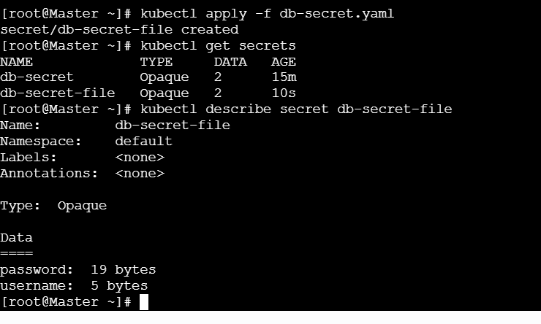

✅ Step 4: Create Pod YAML to mount Secret as Volume
Create Pod file:
vi secret-volume-pod.yaml
Paste:
apiVersion: v1
kind: Pod
metadata:
name: secret-volume-pod
spec:
containers:
- name: app-container
image: busybox
command: ["sh", "-c", "sleep 3600"]
volumeMounts:
- name: secret-volume
mountPath: /etc/secret-data
readOnly: true
volumes:
- name: secret-volume
secret:
secretName: db-secret-file
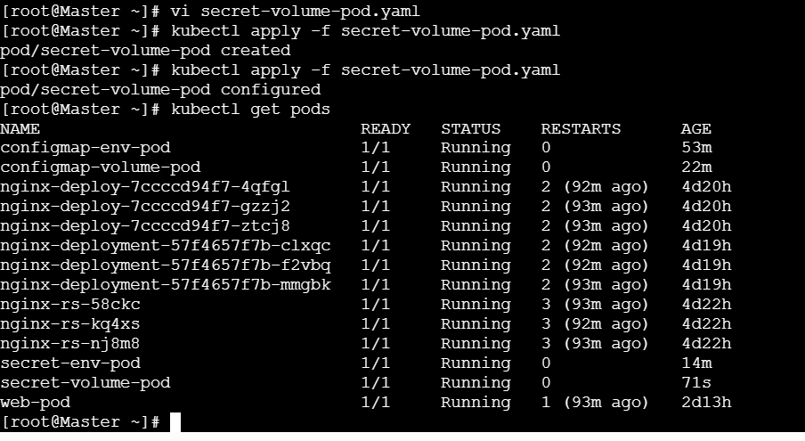

🧠 Key understanding (interview important)
- Each key in Secret → file name
- Each value → file content
- Files are read-only
- Mounted securely

✅ Step 5: Deploy the Pod
kubectl apply -f secret-volume-pod.yaml
Check Pod:
kubectl get pods

✅ Step 6: Verify Secret files inside the Pod
Enter the Pod:
kubectl exec -it secret-volume-pod -- sh
List files:
ls /etc/secret-data
Output:
username
password
View content:
cat /etc/secret-data/username
cat /etc/secret-data/password
Output:
admin
MyStrongPassword123
🎉 Secret successfully mounted as files!
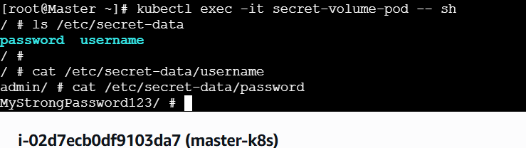

🔥 Interview Gold Points (Very important)
❓ Why mount Secret as volume instead of ENV?
Feature | ENV | Volume
Visibility | Can leak via logs | More secure
Auto update | ❌ No | ✅ Yes
Large secrets | ❌ Bad | ✅ Good
Certs / keys | ❌ No | ✅ Yes

⚠️ Security Best Practices
- Secrets are base64 encoded, not encrypted
- Enable etcd encryption
- Use RBAC to restrict access
- Never commit Secret YAML to Git (use Vault / Sealed Secrets)

🗣️ Interview-ready answer (say this confidently)
“We create a Kubernetes Secret using a YAML file with base64-encoded data. Then we mount the Secret as a volume in the pod. Each key becomes a file and the value becomes the file content, which is ideal for securely providing credentials or certificates to applications.”

- Inject a ConfigMap as environment variables and a Secret as files into the same pod, ensuring both are accessible within the pod.
🎯 Goal
In ONE Pod:
- Inject a ConfigMap as environment variables
- Mount a Secret as files
- Verify both are accessible inside the container

🧠 Real-time use case
- ConfigMap (ENV): app mode, service name, port
- Secret (FILES): DB password, API token, certificates
👉 This is best practice in Kubernetes.

STEP-BY-STEP IMPLEMENTATION

✅ Step 1: Create a ConfigMap (for ENV variables)
Create ConfigMap using literals:
kubectl create configmap app-config \
--from-literal=APP_NAME=PaymentService \
--from-literal=APP_ENV=production
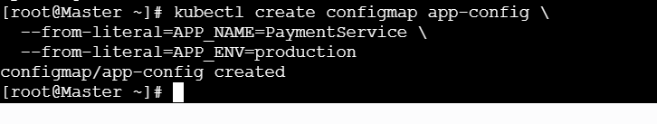
Verify:
kubectl get configmap
kubectl describe configmap app-config
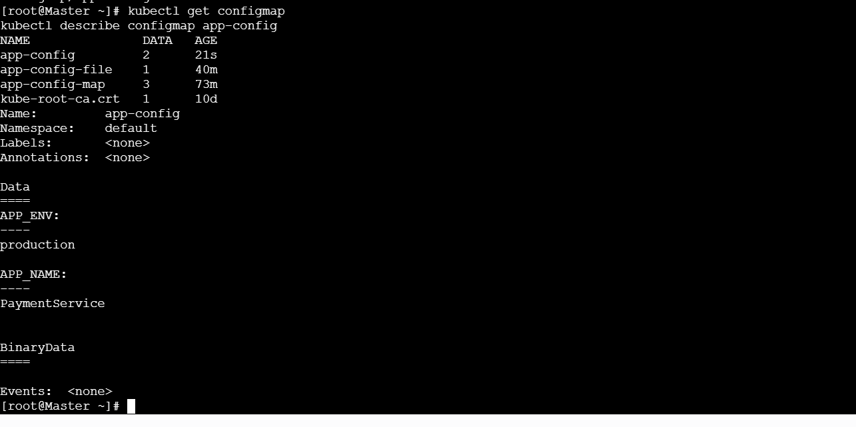

✅ Step 2: Create a Secret (for file-based access)
Create Secret:
kubectl create secret generic db-secret \
--from-literal=username=dbadmin \
--from-literal=password=StrongPass@123
Verify:
kubectl get secrets
kubectl describe secret db-secret
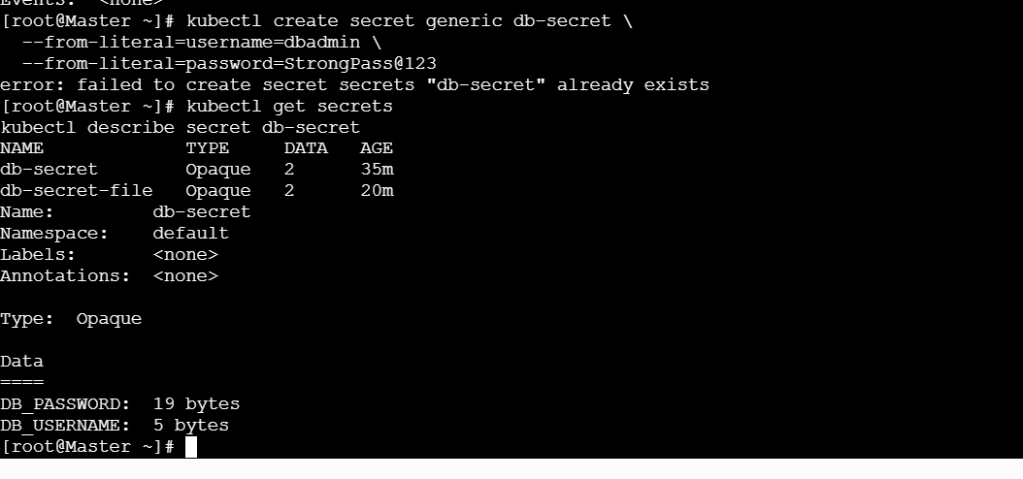

✅ Step 3: Create Pod YAML (ConfigMap as ENV + Secret as Volume)
Create Pod definition:
vi mixed-config-secret-pod.yaml
Paste this YAML:
apiVersion: v1
kind: Pod
metadata:
name: mixed-config-secret-pod
spec:
containers:
- name: app-container
image: busybox
command: ["sh", "-c", "sleep 3600"]

# 1️⃣ ConfigMap injected as ENV variables
envFrom:
- configMapRef:
name: app-config

# 2️⃣ Secret mounted as files
volumeMounts:
- name: secret-volume
mountPath: /etc/secret-data
readOnly: true

volumes:
- name: secret-volume
secret:
secretName: db-secret
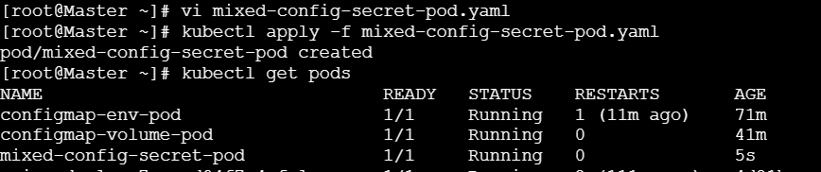

🧠 YAML Explanation (Very Important)
Section | Purpose
envFrom | Injects all ConfigMap keys as ENV
configMapRef | Refers to ConfigMap
volumes.secret | Uses Secret as volume
volumeMounts | Mounts Secret into container
mountPath | Directory for secret files

✅ Step 4: Deploy the Pod
kubectl apply -f mixed-config-secret-pod.yaml
Check Pod status:
kubectl get pods


✅ Step 5: Verify inside the Pod
Enter the Pod:
kubectl exec -it mixed-config-secret-pod -- sh

🔹 Verify ConfigMap ENV variables
echo $APP_NAME
echo $APP_ENV
Output:
PaymentService
Production
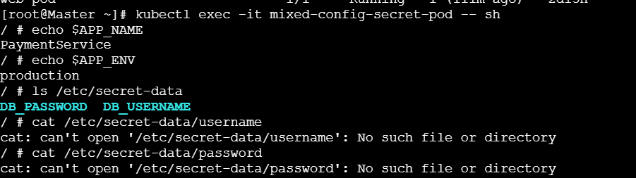

🔹 Verify Secret files
ls /etc/secret-data
Output:
username
password
Check contents:
cat /etc/secret-data/username
cat /etc/secret-data/password
Output:
dbadmin
StrongPass@123
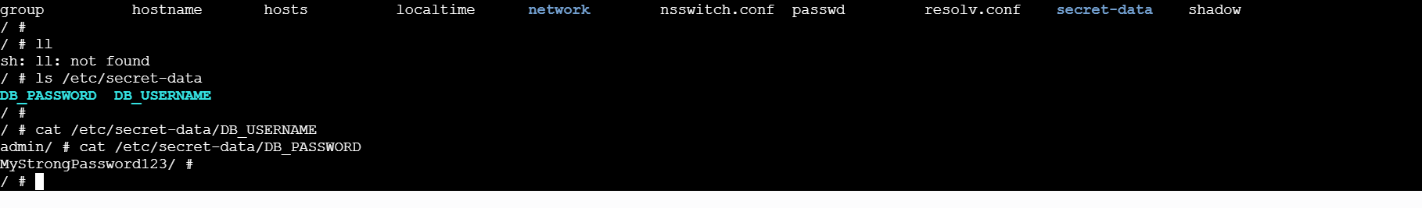
🎉 SUCCESS: Both ConfigMap and Secret are accessible in the same Pod

🔥 Interview Gold Explanation (Say this)
“In Kubernetes, we inject non-sensitive configuration using ConfigMaps as environment variables and sensitive data using Secrets mounted as volumes. This approach keeps credentials secure while allowing applications to consume configuration in the most appropriate format.”

🆚 Why this design is BEST PRACTICE
Data Type | Method | Reason
App config | ConfigMap → ENV | Easy access
Passwords | Secret → Files | More secure
Certs | Secret → Files | Required by apps
Auto update | Volume | Live refresh

⚠️ Important Notes
- ENV-based ConfigMaps ❌ don’t auto-update
- Volume-based Secrets ✅ auto-update
- Secrets are base64 encoded, not encrypted
- Enable etcd encryption in production

🚀 What you should learn next (recommended)
- Mount specific keys only
- Update ConfigMap/Secret & observe live change
- ConfigMap vs Secret (deep comparison)
- TLS Secret with Nginx
- HashiCorp Vault / Sealed Secrets
If you want, I’ll continue step-by-step 👍

