KUBERNETES-TASK-07

Task 1: Execute all yaml files shown in video.
Task 2: Taint a Node and Schedule a Tolerant Pod Taint a node with special=true:NoSchedule. Create a pod with a toleration that matches the taint, allowing it to be scheduled on the tainted node.
Got it 👍 Let’s do this cleanly, step by step, exactly like you’d do in a real Kubernetes cluster.

🎯 Task Goal (Simple Words)
- Taint a node so normal pods cannot run on it
- Create a pod with toleration so it can run on that tainted node

🔹 Step 1: Check available nodes
kubectl get nodes
Example output:
NAME STATUS ROLES AGE VERSION
master Ready control-plane 10d v1.29.0
worker1 Ready <none> 10d v1.29.0
worker2 Ready <none> 10d v1.29.0
👉 Choose a node to taint (example: worker1)
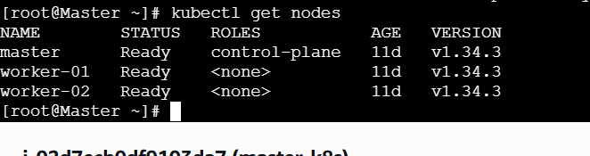

🔹 Step 2: Taint the node
Command:
kubectl taint nodes worker1 special=true:NoSchedule
✅ What this means
- special=true → key=value
- NoSchedule → no pod will schedule here unless it has toleration
Verify taint
kubectl describe node worker1 | grep -i taint
Output:
Taints: special=true:NoSchedule

🔹 Step 3: Try creating a normal pod (to prove taint works)
kubectl run test-pod --image=nginx
Check status:
kubectl get pods
You’ll see:
STATUS: Pending
Check reason:
kubectl describe pod test-pod
❌ Reason:
node(s) had taint {special=true: NoSchedule}
👉 Perfect! Taint is working.

🔹 Step 4: Create a Pod WITH toleration
Create a YAML file:
vi tolerant-pod.yaml
✍️ YAML File (IMPORTANT PART)
apiVersion: v1
kind: Pod
metadata:
name: tolerant-pod
spec:
containers:
- name: nginx
image: nginx
tolerations:
- key: "special"
operator: "Equal"
value: "true"
effect: "NoSchedule"

🔹 Step 5: Create the pod
kubectl apply -f tolerant-pod.yaml
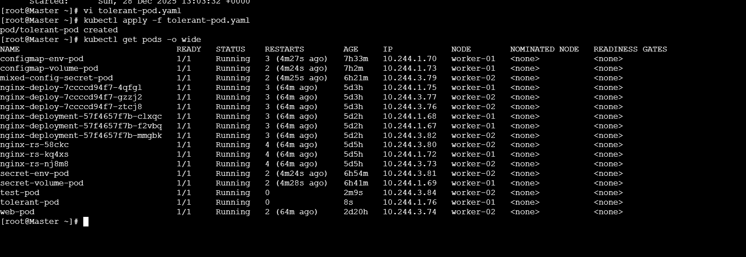

🔹 Step 6: Verify pod scheduling
kubectl get pods -o wide
Output:
NAME STATUS NODE
tolerant-pod Running worker1
✅ Pod is running on the tainted node
That means toleration is working correctly.
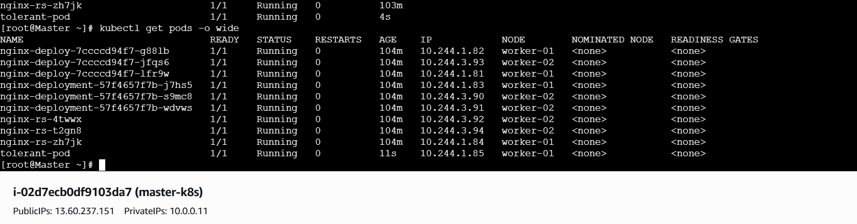

🔹 Step 7: Explain this in Interview (VERY IMPORTANT)
👉 Taint
Taints prevent pods from being scheduled on a node unless explicitly allowed.
👉 Toleration
Tolerations allow pods to be scheduled on tainted nodes.
👉 Real-time Use Cases
- Dedicated nodes for:
  - Databases
  - GPU workloads
  - Critical applications
- Separate prod / test workloads
- Node maintenance control

🔹 Step 8: Cleanup (Optional)
Remove taint:
kubectl taint nodes worker1 special=true:NoSchedule-
Delete pods:
kubectl delete pod tolerant-pod test-pod

🧠 One-Line Summary (Interview Ready)
Taints repel pods from nodes, and tolerations allow specific pods to bypass those restrictions.

Task 3: Use NodeSelector to Schedule a Pod on a Specific Node Label a node with env=dev. Create a pod with a nodeSelector that schedules it only on the node labeled env=dev.
Perfect 👍 This is a classic Kubernetes scheduling task. I’ll walk you through it slowly, step by step, exactly how you’d do it in real time and explain why each step matters.

🎯 Task Goal (Simple Language)
- Label a node → env=dev
- Create a pod that runs only on that labeled node using nodeSelector

🔹 Step 1: List available nodes
kubectl get nodes
Example output:
NAME STATUS ROLES AGE
master Ready control-plane 10d
worker1 Ready <none> 10d
worker2 Ready <none> 10d
👉 Choose a node for dev
Example: worker1
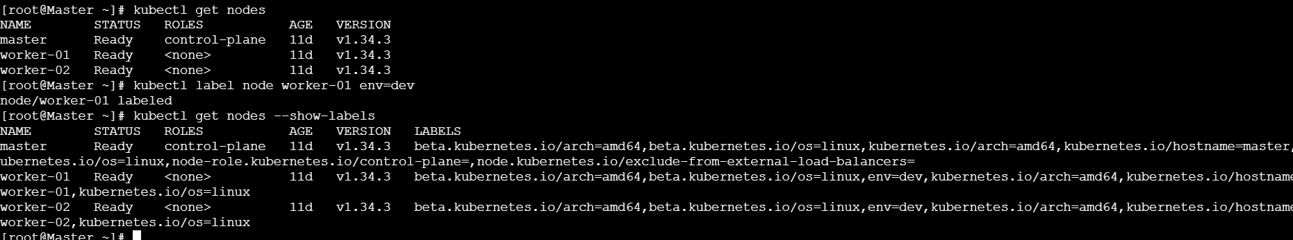

🔹 Step 2: Label the node
Command
kubectl label node worker1 env=dev
Output
node/worker1 labeled


🔹 Step 3: Verify the node label
kubectl get nodes --show-labels
You should see:
worker1 env=dev
✅ Label is successfully applied.
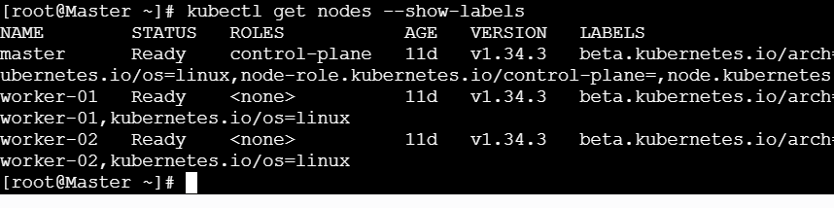

🔹 Step 4: Create a Pod with nodeSelector
Create a YAML file:
vi dev-node-pod.yaml

✍️ Pod YAML (IMPORTANT)
apiVersion: v1
kind: Pod
metadata:
name: dev-node-pod
spec:
containers:
- name: nginx
image: nginx
nodeSelector:
env: dev
🔍 What this means
- Pod will ONLY schedule on nodes with env=dev
- If no node has this label → pod stays Pending
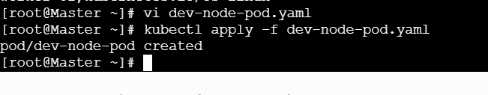

🔹 Step 5: Create the pod
kubectl apply -f dev-node-pod.yaml

🔹 Step 6: Verify pod scheduling
kubectl get pods -o wide
Expected output:
NAME STATUS NODE
dev-node-pod Running worker1
✅ Pod is running only on the node labeled env=dev
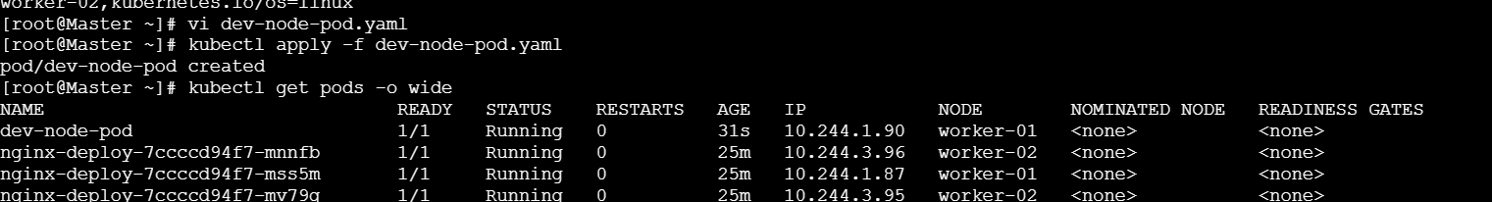

🔹 Step 7: Proof test (Optional but powerful)
Remove label
kubectl label node worker1 env-
Now check pod:
kubectl get pods
You’ll see:
STATUS: Pending
Reason:
kubectl describe pod dev-node-pod
no nodes match node selector
👉 This proves nodeSelector is enforced.

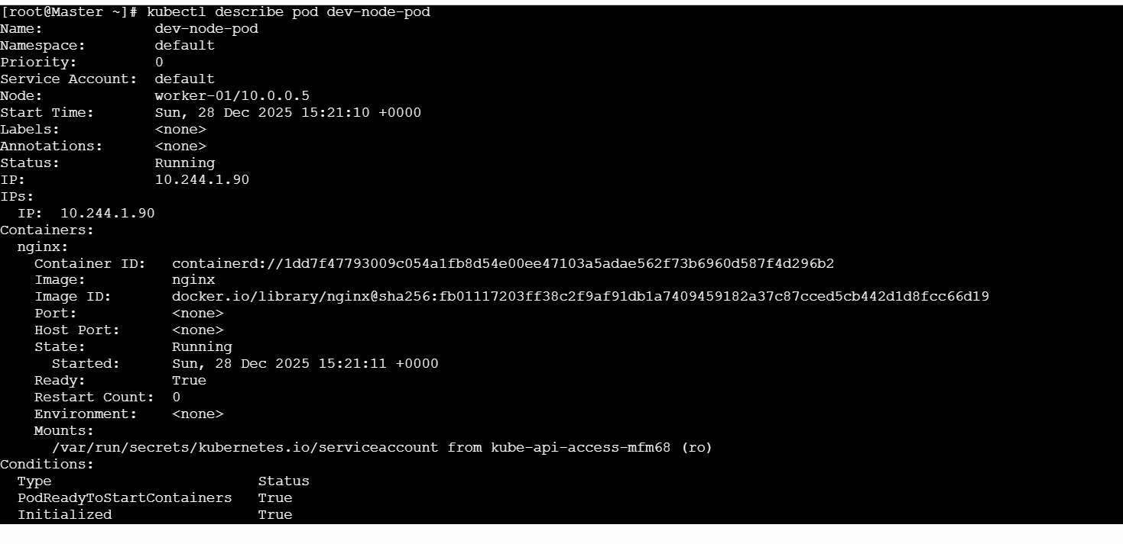
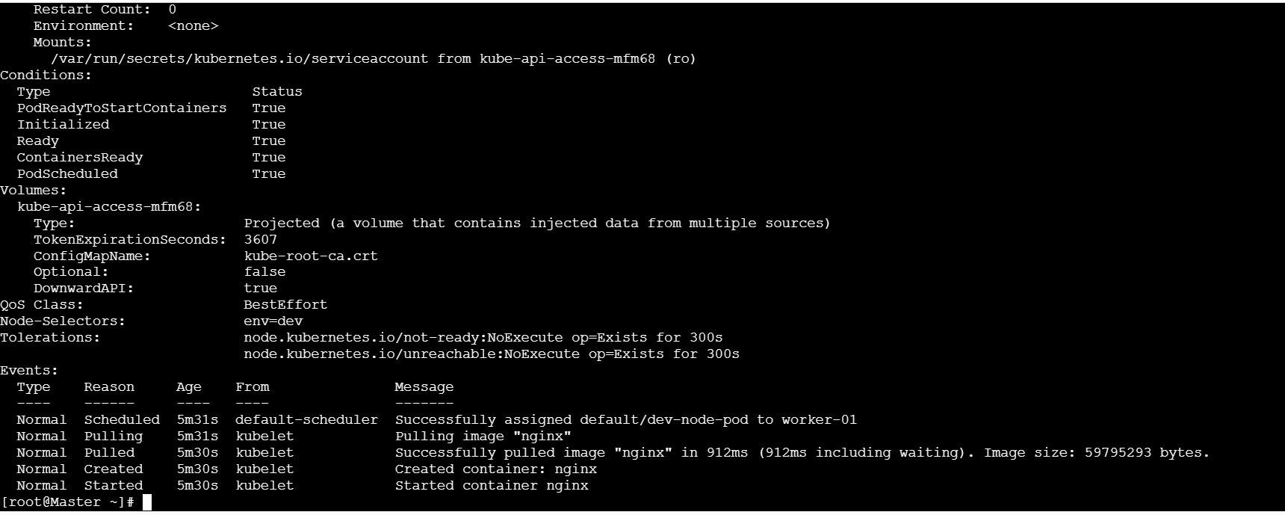

🔹 Step 8: Real-Time Use Cases
- Run dev workloads on dev nodes
- Separate:
  - dev/test / prod
  - GPU / non-GPU
  - SSD / HDD nodes
- Cost optimization in cloud

🧠 Interview-Ready Answer (Say This)
NodeSelector is a simple scheduling mechanism that forces a pod to run only on nodes with matching labels.

⚠️ Important Notes (Very Common Mistakes)
❌ Label mismatch → pod stuck in Pending
❌ nodeSelector is hard constraint (no fallback)
✅ For advanced rules → use Node Affinity

Task 4: Use Node Affinity with Soft Scheduling Label a node with env=test. Create a pod with
PreferredDuringSchedulingIgnoredDuringExecution node affinity, preferring to schedule it on a node labeled env=test. Remove the label and verify the pod continues to run.

Perfect 👍 This task is very important because it shows the difference between hard vs soft scheduling. I’ll walk you through it step by step, using your actual nodes:
Your nodes:
- master
- worker-01
- worker-02

🎯 Task 4 Goal (Plain English)
- Label a node with env=test
- Create a pod with soft node affinity
(PreferredDuringSchedulingIgnoredDuringExecution)
- Pod should prefer the labeled node
- Remove the label
- Pod should continue running (no eviction)

🔹 Step 1: Label a node with env=test
Let’s label worker-01.
kubectl label node worker-01 env=test
Verify:
kubectl get nodes --show-labels
You should see:
worker-01 env=test
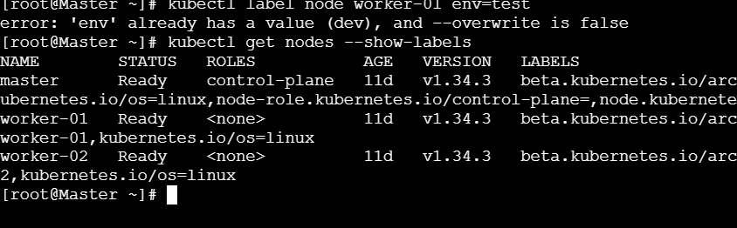

🔹 Step 2: Create Pod YAML with soft Node Affinity
Create a YAML file:
vi soft-affinity-pod.yaml

🔹 Step 3: Pod YAML (IMPORTANT)
apiVersion: v1
kind: Pod
metadata:
name: soft-affinity-pod
spec:
containers:
- name: nginx
image: nginx

affinity:
nodeAffinity:
preferredDuringSchedulingIgnoredDuringExecution:
- weight: 100
preference:
matchExpressions:
- key: env
operator: In
values:
- test
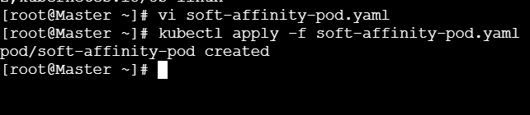

🔍 What this means
Field | Meaning
preferredDuringScheduling | Soft rule (try, not force)
weight: 100 | Highest preference
env=test | Preferred node label
IgnoredDuringExecution | Pod won’t be removed if label changes

🔹 Step 4: Create the pod
kubectl apply -f soft-affinity-pod.yaml


🔹 Step 5: Verify pod scheduling
kubectl get pods -o wide
Expected:
NAME STATUS NODE
soft-affinity-pod Running worker-01
Pod is preferred to worker-01 because of label.
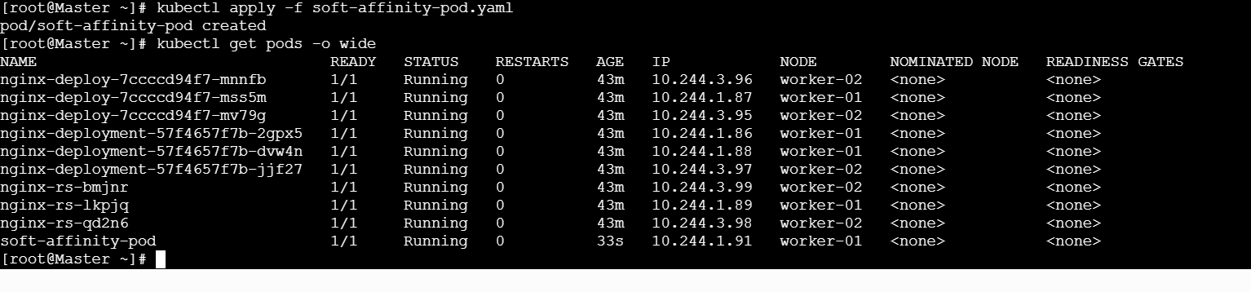

🔹 Step 6: Remove the label (KEY TEST)
Now remove the label while pod is running:
kubectl label node worker-01 env-
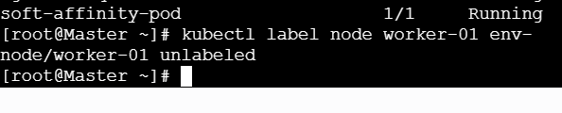

🔹 Step 7: Verify pod still runs
kubectl get pods -o wide
Result:
soft-affinity-pod Running worker-01
🎉 Pod continues running → this proves
IgnoredDuringExecution behavior.
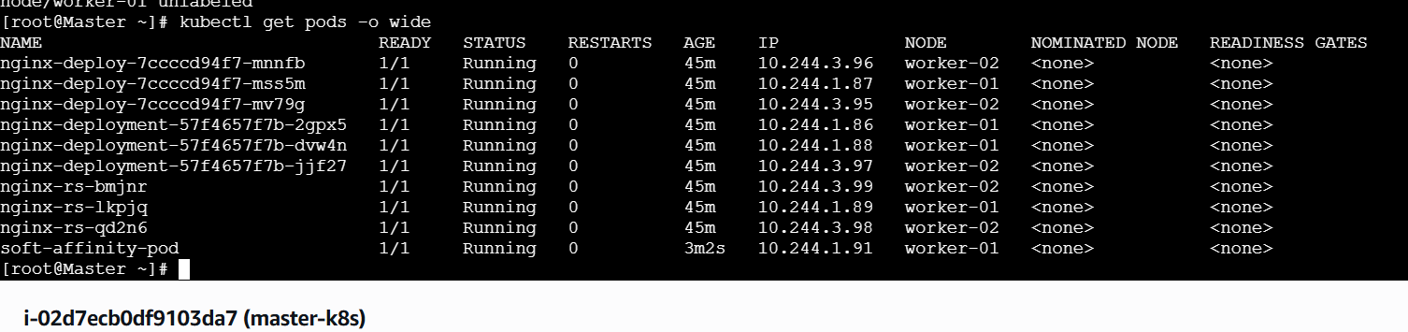

🔹 Step 8: (Optional Proof) Restart pod
Delete pod:
kubectl delete pod soft-affinity-pod
Recreate:
kubectl apply -f soft-affinity-pod.yaml
Now check:
kubectl get pods -o wide
➡️ Pod may land on any available node, because label is gone.
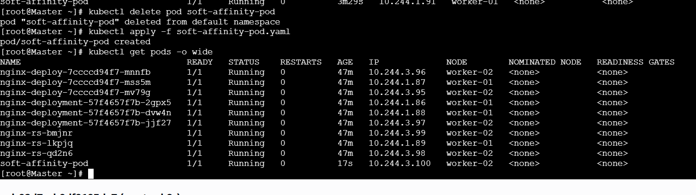

🧠 Interview-Ready Explanation (Say This)
PreferredDuringSchedulingIgnoredDuringExecution is a soft affinity rule. Kubernetes tries to place the pod on the preferred node, but if the label is removed or unavailable, the pod continues running without eviction.

🔥 Hard vs Soft (Quick Comparison)
Feature | NodeSelector | RequiredAffinity | PreferredAffinity
Constraint | Hard | Hard | Soft
Pod pending if no match | Yes | Yes | ❌ No
Pod evicted if label removed | N/A | No | No

🧹 Cleanup (Optional)
kubectl delete pod soft-affinity-pod

Task 5:
Implement Node Affinity with Hard Scheduling Create a pod with RequiredDuringSchedulingIgnoredDuringExecution node affinity, ensuring it will only be scheduled on a node labeled env=prod. Verify the pod cannot be scheduled if no node has the env=prod label.

Excellent 👍 Task 5 is the “hard scheduling” version, and interviewers love this one.
I’ll guide you step by step, using your real nodes:
Your nodes:
- master
- worker-01
- worker-02

🎯 Task 5 Goal (Plain English)
- Create a pod with hard node affinity
- It must run ONLY on nodes labeled env=prod
- If no node has env=prod → pod must stay Pending
- Label a node → pod should schedule

🔹 Step 1: Confirm NO node has env=prod
kubectl get nodes --show-labels
Make sure you do not see env=prod.
This is important for verification.

🔹 Step 2: Create Pod YAML with HARD Node Affinity
Create YAML file:
vi hard-affinity-pod.yaml

🔹 Step 3: Pod YAML (VERY IMPORTANT)
apiVersion: v1
kind: Pod
metadata:
name: hard-affinity-pod
spec:
containers:
- name: nginx
image: nginx

affinity:
nodeAffinity:
requiredDuringSchedulingIgnoredDuringExecution:
nodeSelectorTerms:
- matchExpressions:
- key: env
operator: In
values:
- prod

🔍 What this means
Field | Meaning
requiredDuringScheduling | Hard rule
env=prod | Pod MUST run here
IgnoredDuringExecution | Pod won’t be evicted if label removed

🔹 Step 4: Create the pod
kubectl apply -f hard-affinity-pod.yaml
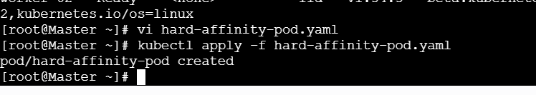

🔹 Step 5: Verify pod is NOT scheduled
kubectl get pods
You will see:\
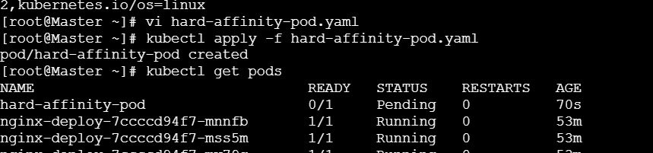
hard-affinity-pod Pending
Check reason:
kubectl describe pod hard-affinity-pod
You’ll see:
0/2 nodes are available: node(s) didn't match node affinity.
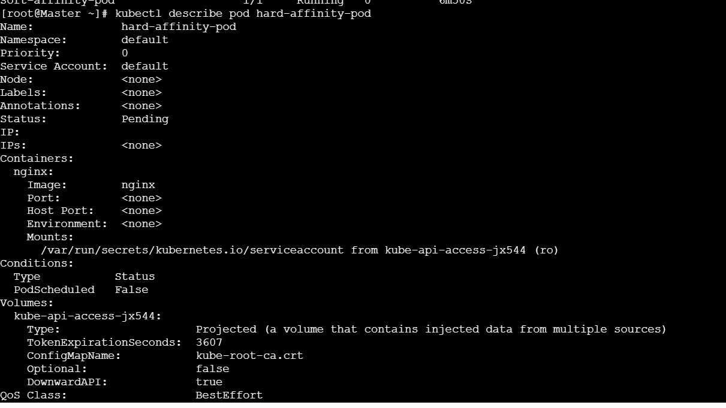
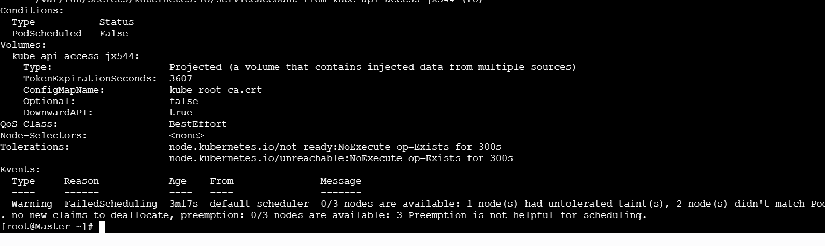
✅ This proves hard affinity works

🔹 Step 6: Label a node with env=prod
Let’s label worker-02.
kubectl label node worker-02 env=prod
Verify:
kubectl get nodes --show-labels
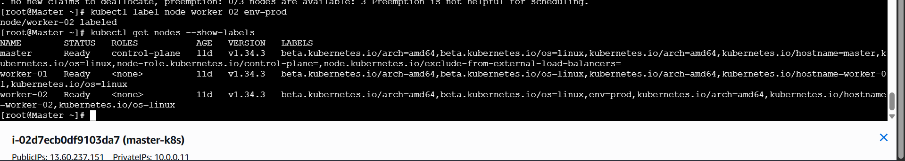

🔹 Step 7: Verify pod is now scheduled
kubectl get pods -o wide
Expected:
NAME STATUS NODE
hard-affinity-pod Running worker-02
🎉 Pod scheduled ONLY after matching label exists
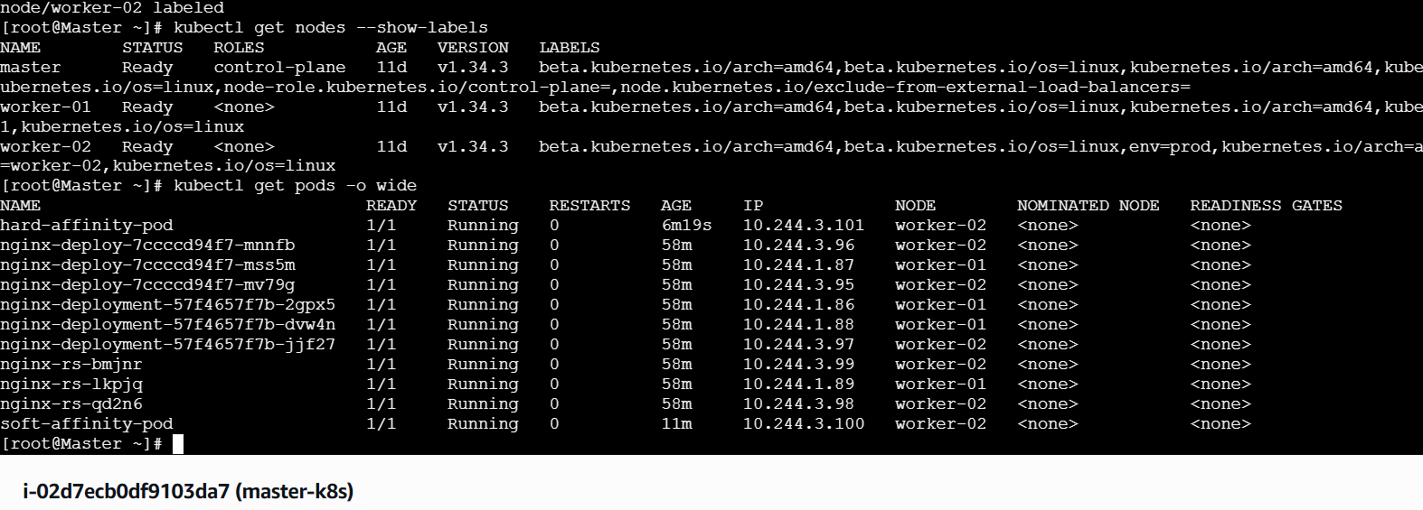

🔹 Step 8: Remove the label (IMPORTANT TEST)
kubectl label node worker-02 env-
Now check:
kubectl get pods -o wide
Result:
hard-affinity-pod Running worker-02
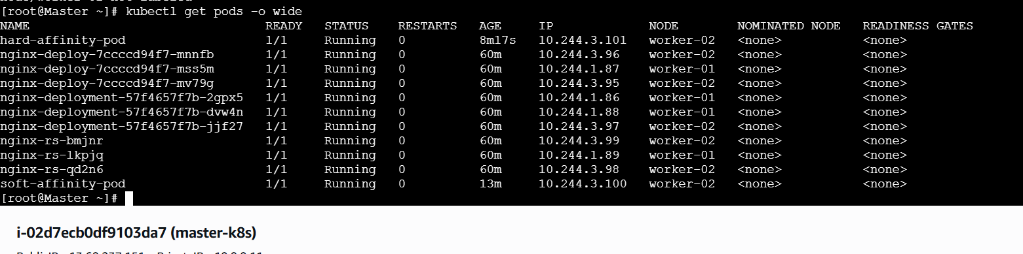
👉 Pod continues running because of
IgnoredDuringExecution.

🧠 Interview-Ready Explanation (Say This)
RequiredDuringSchedulingIgnoredDuringExecution enforces strict node placement during scheduling. If no matching node exists, the pod remains pending.

🔥 Hard vs Soft Affinity (Quick Table)
Feature | Soft Affinity | Hard Affinity
Rule type | Preferred | Required
Pod Pending if no match | ❌ | ✅
Evicted if label removed | ❌ | ❌
Use case | Optimization | Isolation / compliance

🧹 Cleanup (Optional)
kubectl delete pod hard-affinity-pod
kubectl label node worker-02 env-

🚀 Next (tell me what you want)
- Combine Node Affinity + Taints
- Real production interview scenarios
- YAML comparison cheatsheet
You’re now covering advanced Kubernetes scheduling — well done 👏

Task 6: Taint a Node and Use NoExecute with Toleration Seconds Taint a node with special=true:NoExecute. Create a pod with a tolerationSeconds field (e.g., 60 seconds) and observe it gets evicted after 60 seconds on the tainted node.

Excellent 👍 Task 6 is very important because it shows pod eviction behavior, not just scheduling.
Let’s do it slowly, clearly, step by step, using your nodes:
Your nodes:
- master
- worker-01
- worker-02
We’ll use worker-01.

🎯 Task 6 Goal (Simple Words)
- Taint a node with special=true:NoExecute
- Create a pod with tolerationSeconds = 60
- Pod should:
  - Run on the tainted node
  - Get evicted after 60 seconds

🔹 Step 1: Make sure pod is NOT already running
(If exists, delete old pod)
kubectl delete pod noexecute-pod --ignore-not-found

🔹 Step 2: Taint the node with NoExecute
👉 This taint evicts pods unless they tolerate it.
kubectl taint node worker-01 special=true:NoExecute
Verify taint
kubectl describe node worker-01 | grep -i taint
Output:
Taints: special=true:NoExecute
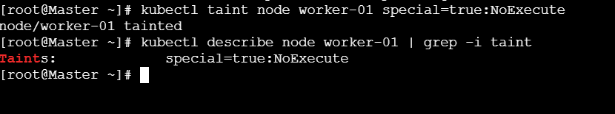

🔹 Step 3: Create Pod YAML with tolerationSeconds
Create file:
vi noexecute-pod.yaml

🔹 Step 4: Pod YAML (VERY IMPORTANT)
apiVersion: v1
kind: Pod
metadata:
name: noexecute-pod
spec:
containers:
- name: nginx
image: nginx

tolerations:
- key: "special"
operator: "Equal"
value: "true"
effect: "NoExecute"
tolerationSeconds: 60
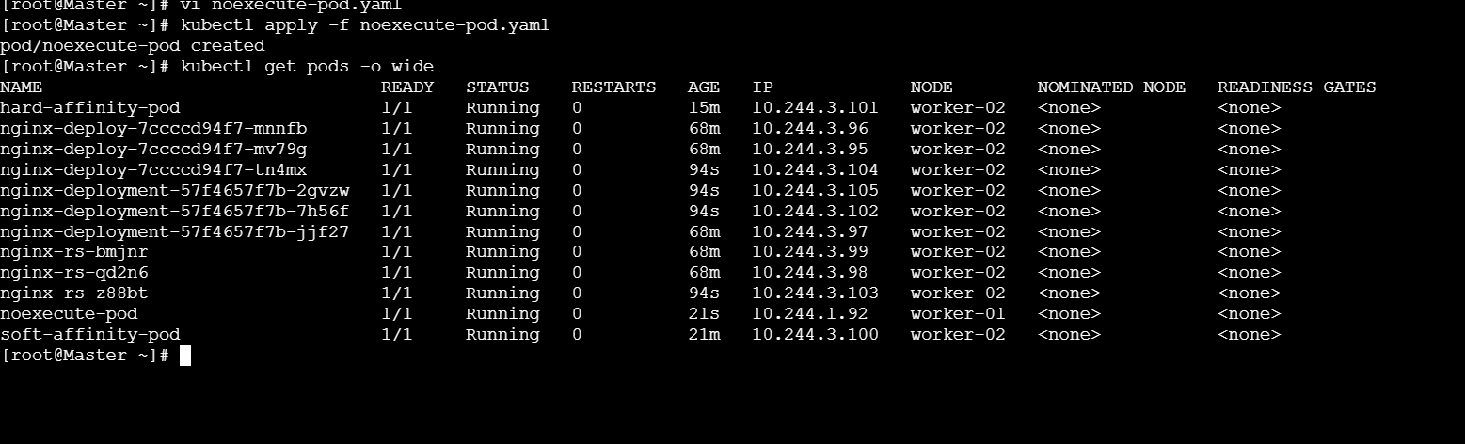

🔍 What this means
Field | Meaning
NoExecute | Pod can run but may be evicted
tolerationSeconds: 60 | Stay only 60 seconds
After 60s | Pod is evicted automatically

🔹 Step 5: Create the pod
kubectl apply -f noexecute-pod.yaml

🔹 Step 6: Verify pod is running (initially)
kubectl get pods -o wide
You will see:
noexecute-pod Running worker-01
✅ Pod is running on tainted node
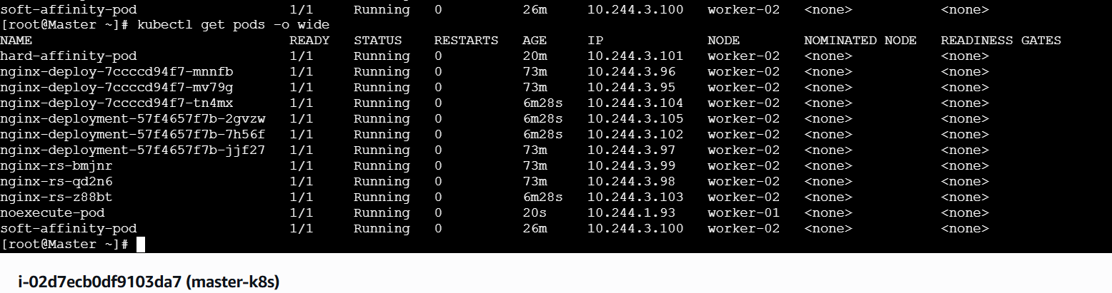

🔹 Step 7: Observe eviction (WAIT ~60 seconds ⏱)
Watch pod status:
kubectl get pods -w
After ~60 seconds, you’ll see:
noexecute-pod Terminating
Then:
noexecute-pod Evicted
or pod disappears.

🔹 Step 8: Confirm eviction reason
kubectl describe pod noexecute-pod
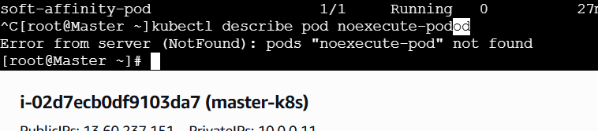
You’ll see:
Reason: Evicted
Message: Pod was evicted due to NoExecute taint
Task requirement satisfied
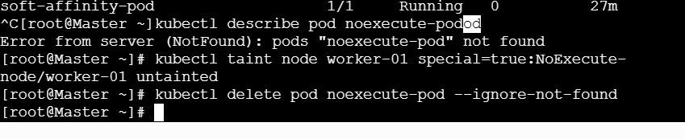

🔹 Step 9: (Extra proof) Pod without tolerationSeconds
If you create a pod without tolerationSeconds, it is evicted immediately.

🧠 Interview-Ready Explanation (Say This)
NoExecute taint evicts running pods unless they tolerate it. With tolerationSeconds, pods can remain for a limited time before eviction.

🔥 Taint Effects Comparison (VERY COMMON QUESTION)
Effect | Behavior
NoSchedule | New pods won’t schedule
PreferNoSchedule | Avoid scheduling
NoExecute | Evict existing pods

🧹 Cleanup (IMPORTANT)
Remove taint:
kubectl taint node worker-01 special=true:NoExecute-
Delete pod (if exists):
kubectl delete pod noexecute-pod --ignore-not-found

