ECS ELASTIC CONTAINER SERVICE
Task related to ECS.
- Set up a highly available ECS cluster with a load balancer and dynamic port mapping.
NOTE:
- Your cluster should maintain at least 6 tasks at any point in time and should be highly available across multiple AZs.
- Use the image below from deployment: sabair0509/hiring-app: works

- Set up a highly available ECS cluster with a load balancer and dynamic port mapping.
First, open the AWS console and open the ECS part to get started new
Goal (What we are building)
- Highly Available ECS Cluster
- ALB (Application Load Balancer)
- Dynamic Port Mapping
- Multi-AZ
- Auto-scaling ready

Why Dynamic Port Mapping?
- Multiple containers can run on the same EC2
- No port conflicts
- ALB routes traffic automatically

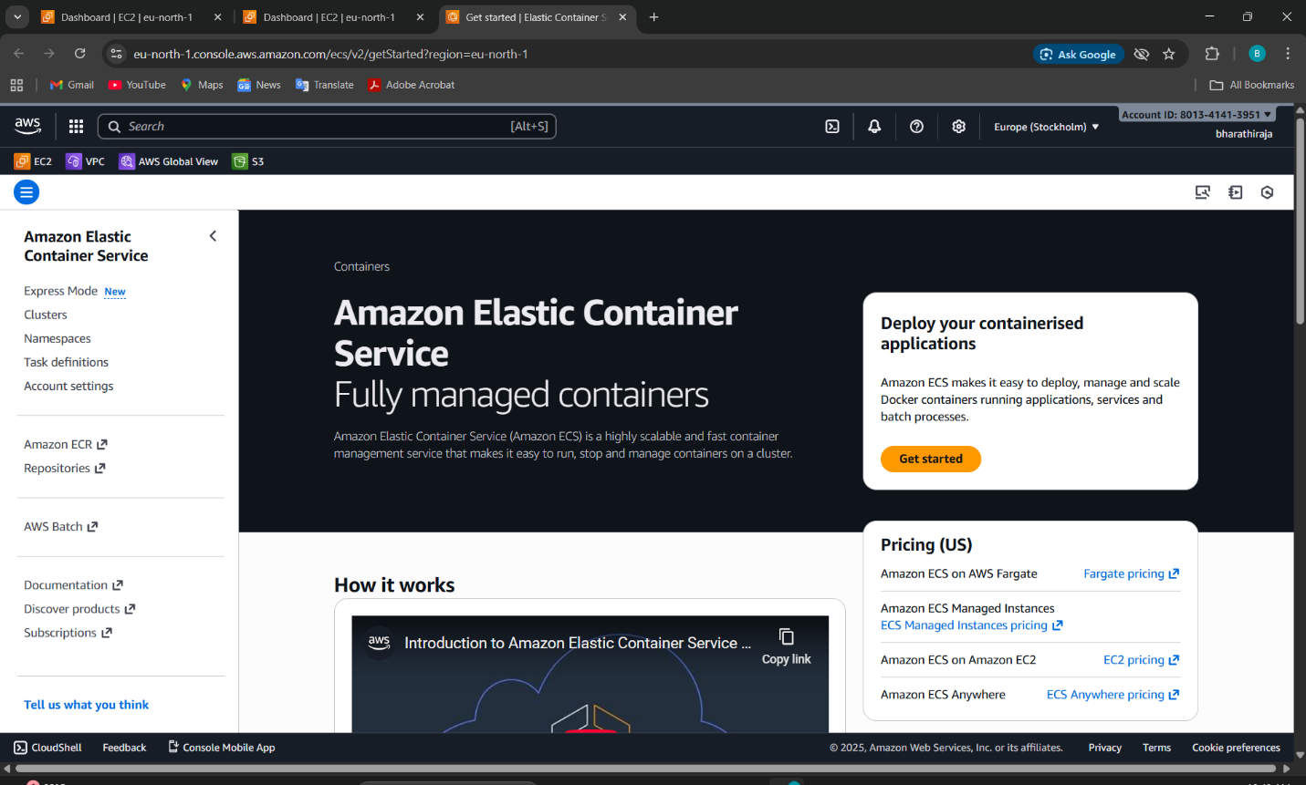
we have to open the cluster
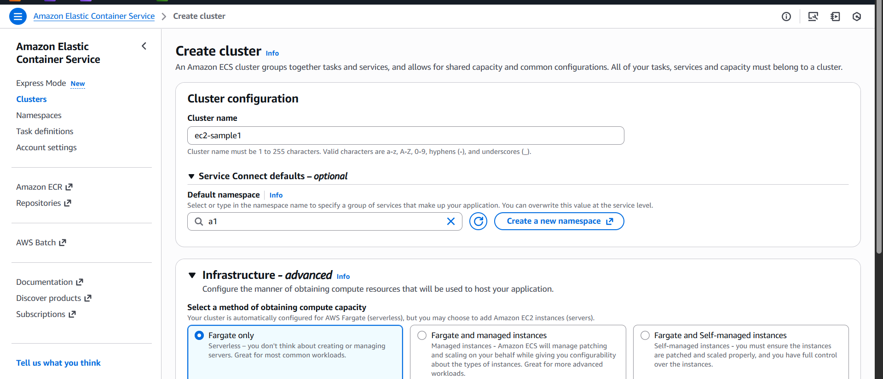
1: Create VPC (Highly Available)
If not already present.
Requirements
- VPC
- 2 Public Subnets (ALB)
- 2 Private Subnets (ECS tasks)
- Different AZs
HA requires a minimum of 2 AZs
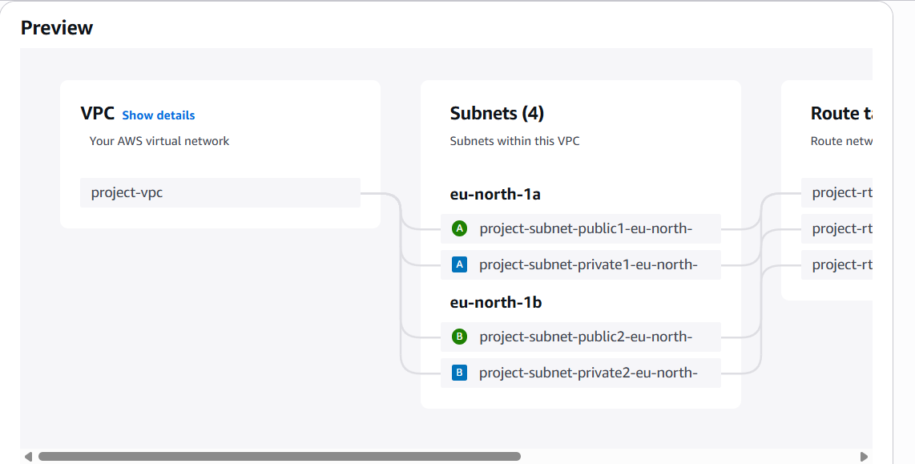
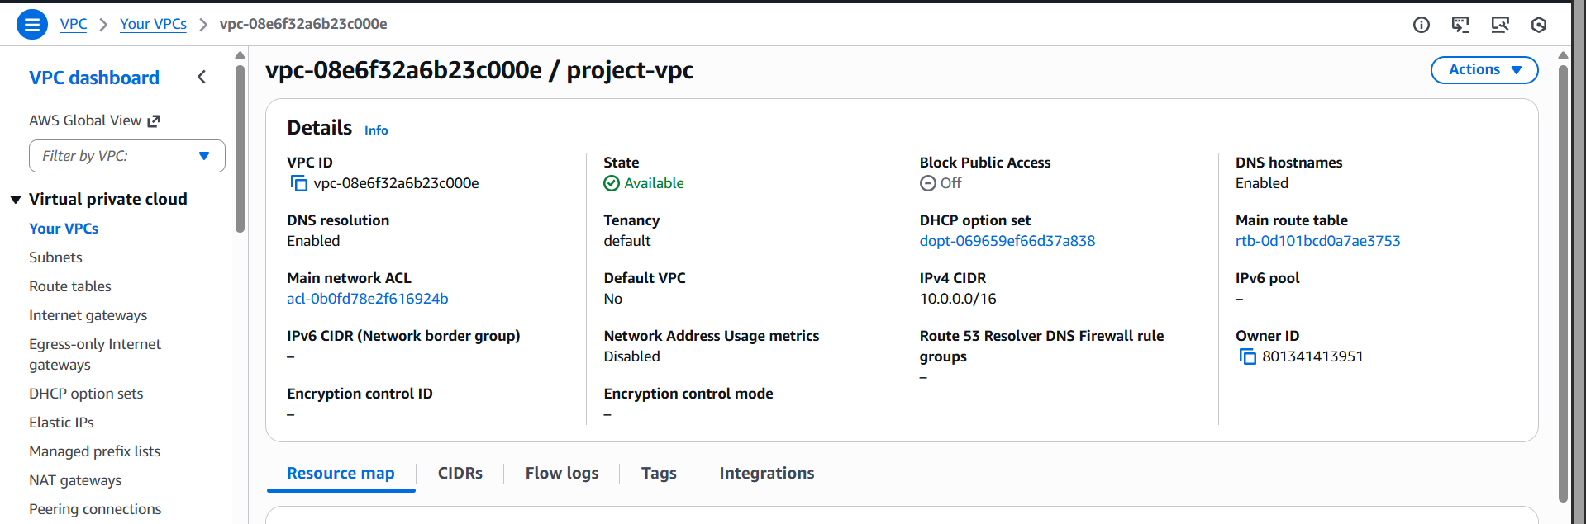
Step 2: Create Security Groups
ALB Security Group
- Inbound:
  - HTTP 80 (or HTTPS 443)
- Outbound:
  - All traffic
ECS Task / EC2 Security Group
- Inbound:
  - From ALB Security Group (All ports)
- Outbound:
  - All traffic
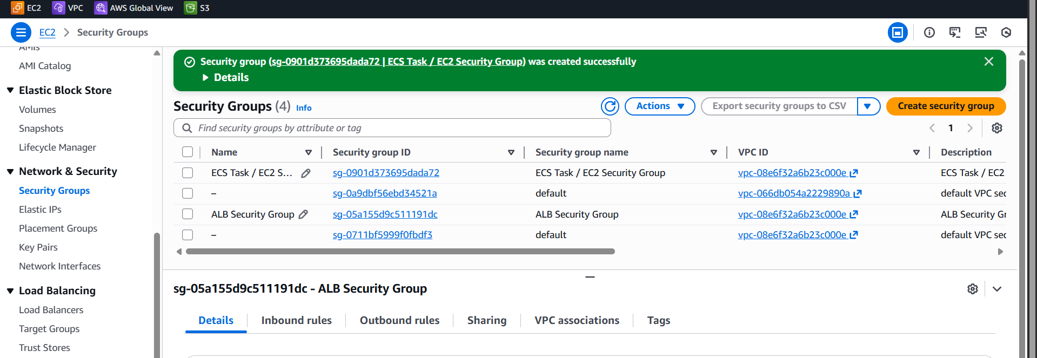
Step 3: Create ECS Cluster
Choose Launch Type
You can do this with:
- EC2 (classic & interview favorite)
- Fargate (serverless)
I’ll explain EC2-based (dynamic port mapping is clearer).
Steps
- Go to ECS → Clusters → Create
- Cluster name: prod-ecs-cluster
- Infrastructure:
  - EC2 Linux
- Instance type: t3.medium
- Auto Scaling Group:
  - Min: 2
  - Max: 4
- Subnets:
  - Private subnets (2 AZs)
- Security group:
  - ECS Security Group
Cluster open
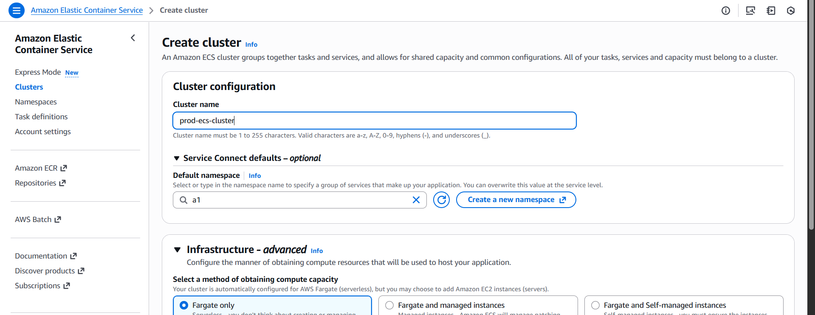
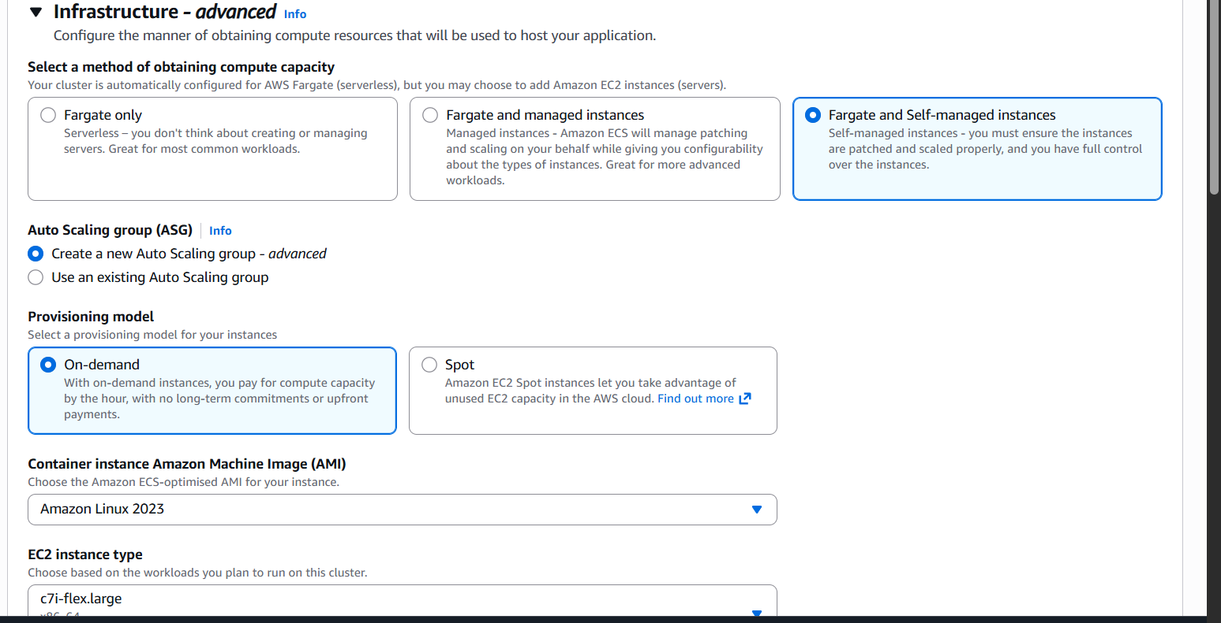
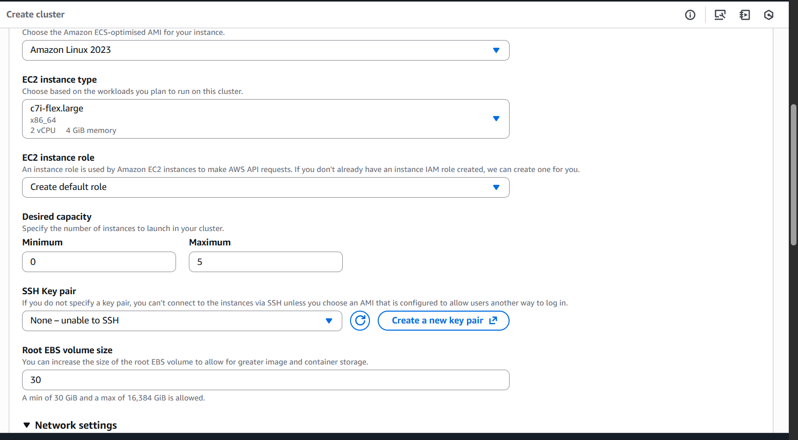
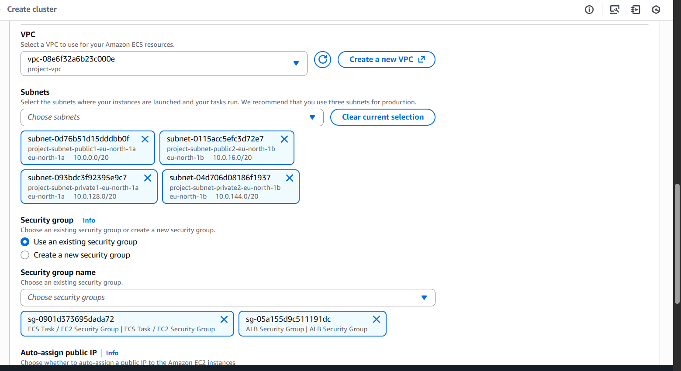
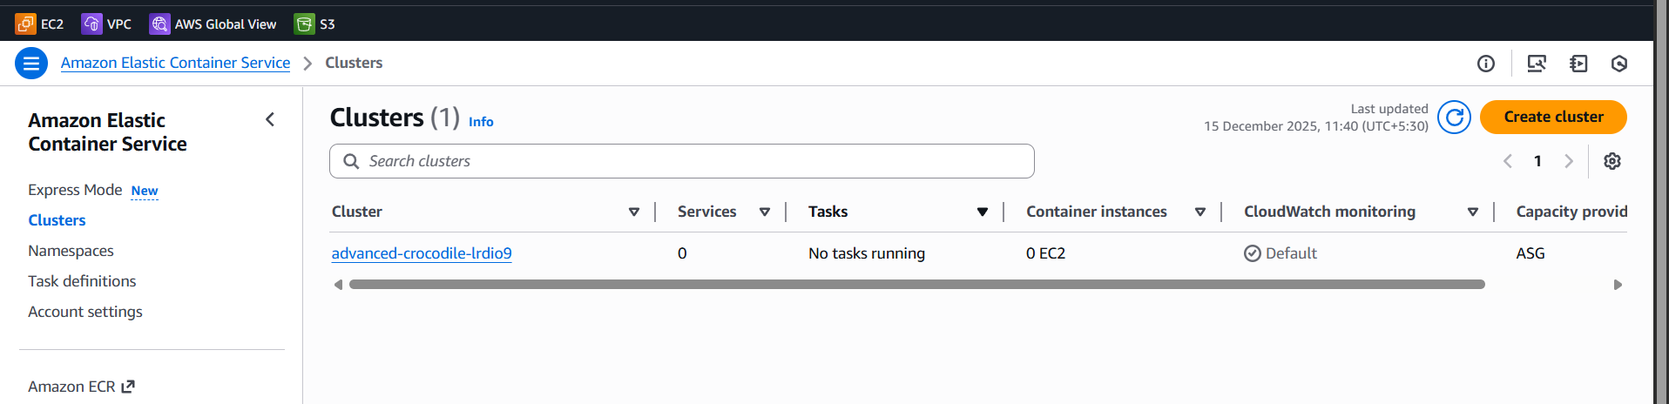

Step 5: Create Target Group (Dynamic Port)
Important Part 🚨
- Target type:
  - Instance (for EC2 launch type)
- Protocol:
  - HTTP
- Port:
  - Traffic port ✅ (NOT fixed port)
- Health check:
  - Path: /
  - Port: traffic port
🎯 This enables dynamic port mapping

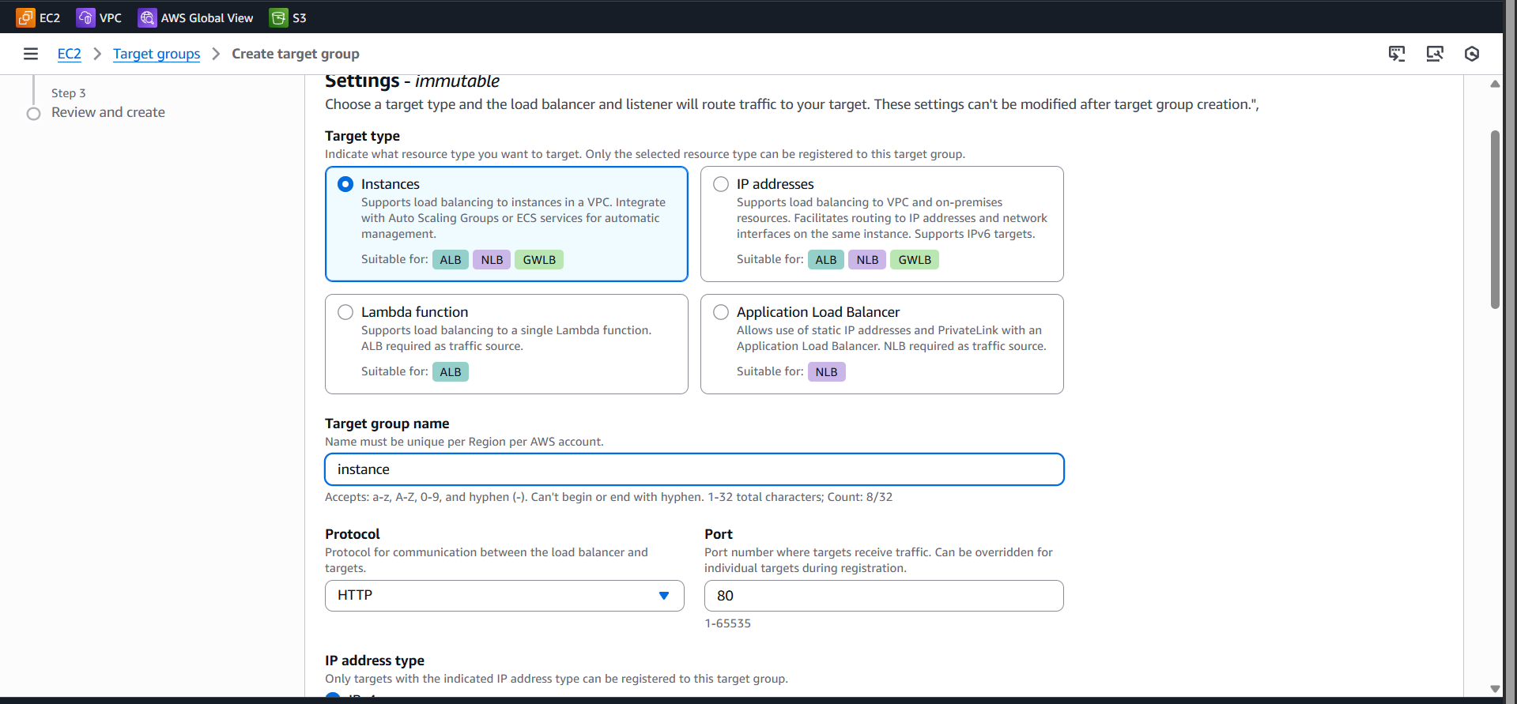
Create a lunch template
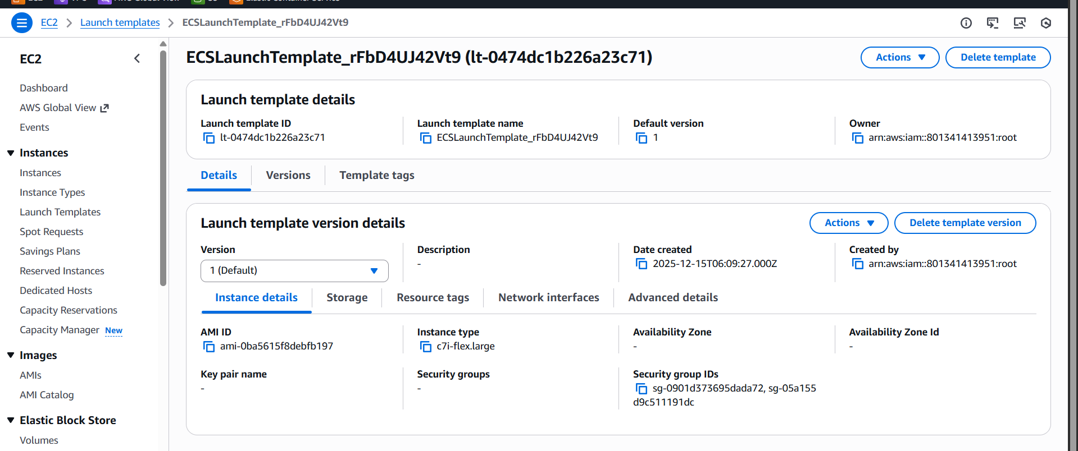
Auto scaling grouping
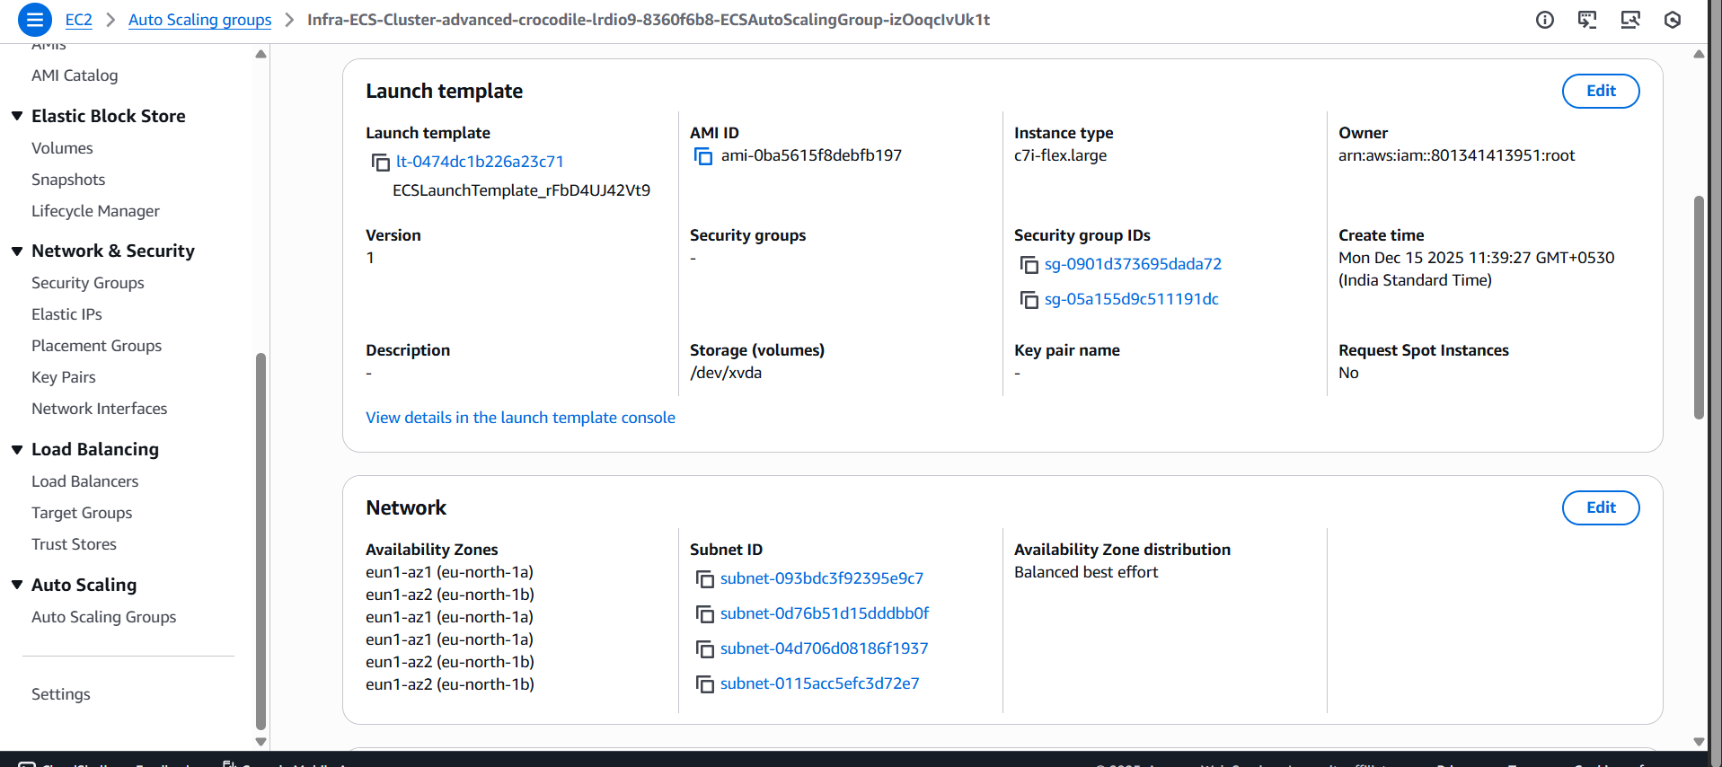
Auto scaling grouping
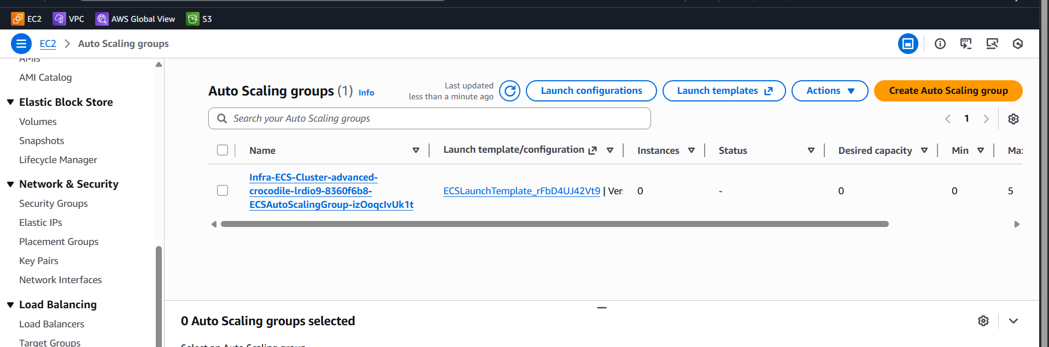

Create ECS Task Definition
Task Definition Type
- EC2
- Network mode: bridge (important)

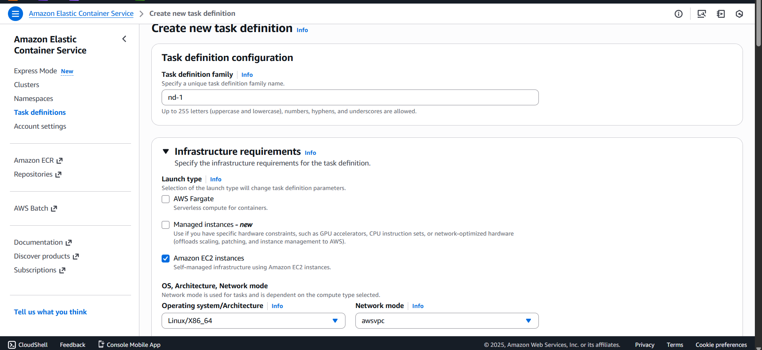
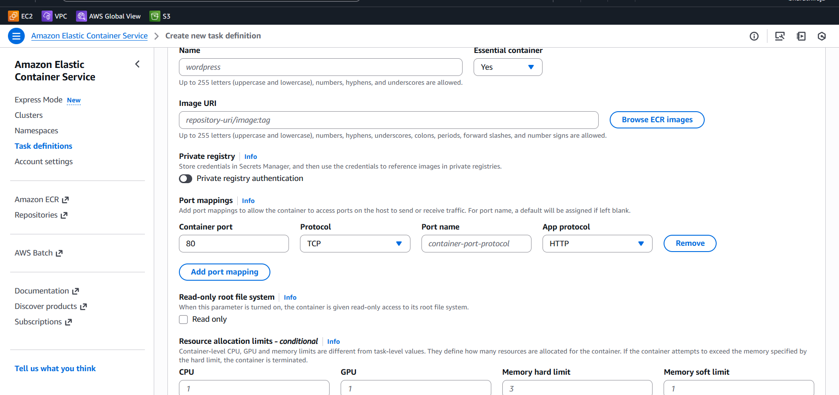
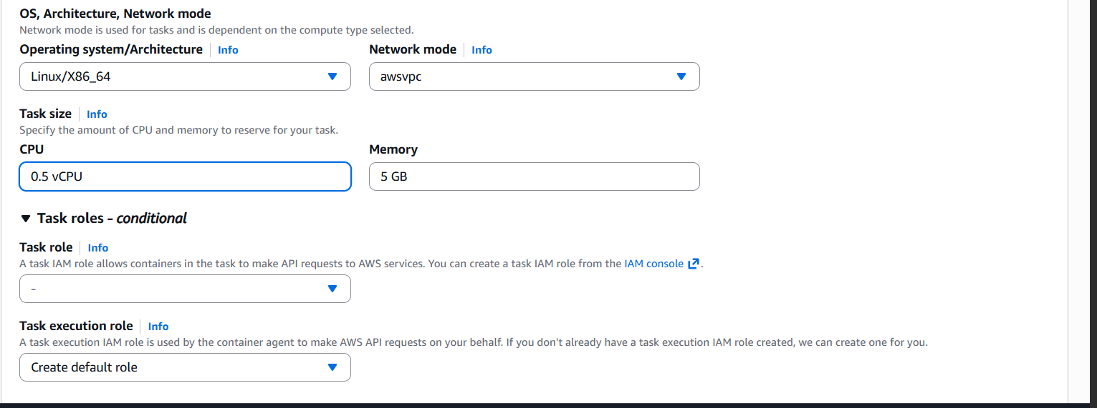
Step 7: Create ECS Service (Core Step)
Service Configuration
- Launch type:
  - EC2
- Task definition:
  - Select the one created
- Number of tasks:
  - 2 (minimum for HA)
Load Balancing Section
- Load balancer type:
  - Application Load Balancer
- Listener:
  - HTTP 80
- Target group:
  - Select the dynamic target group
- Container:
  - nginx (or your container)
- Container port:
  - 80
⚠️ ECS automatically registers EC2 IP + dynamic port to ALB

Application load balancer
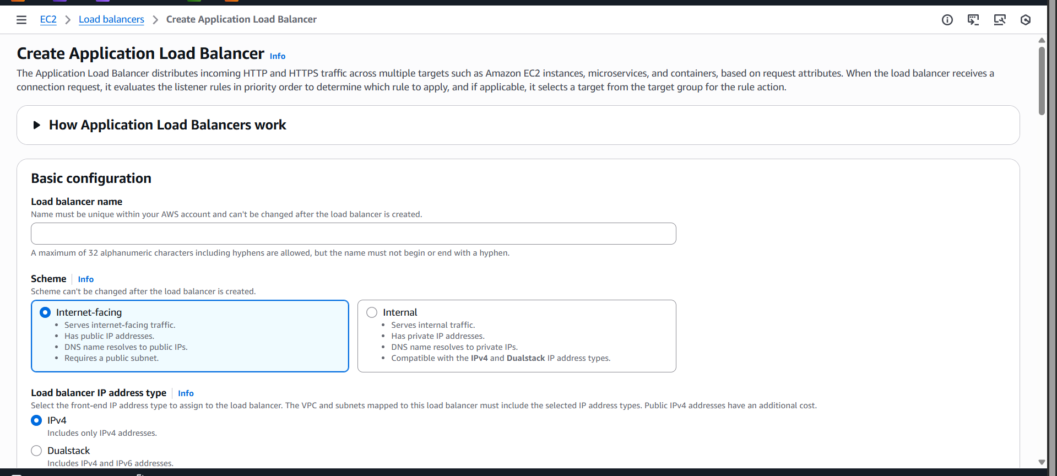
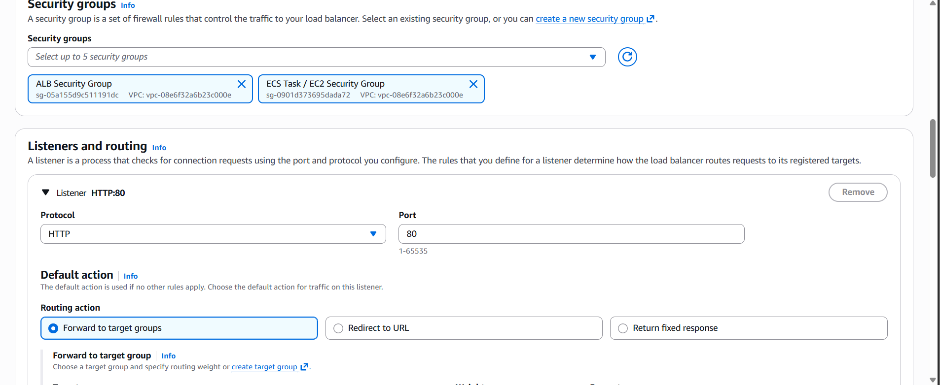
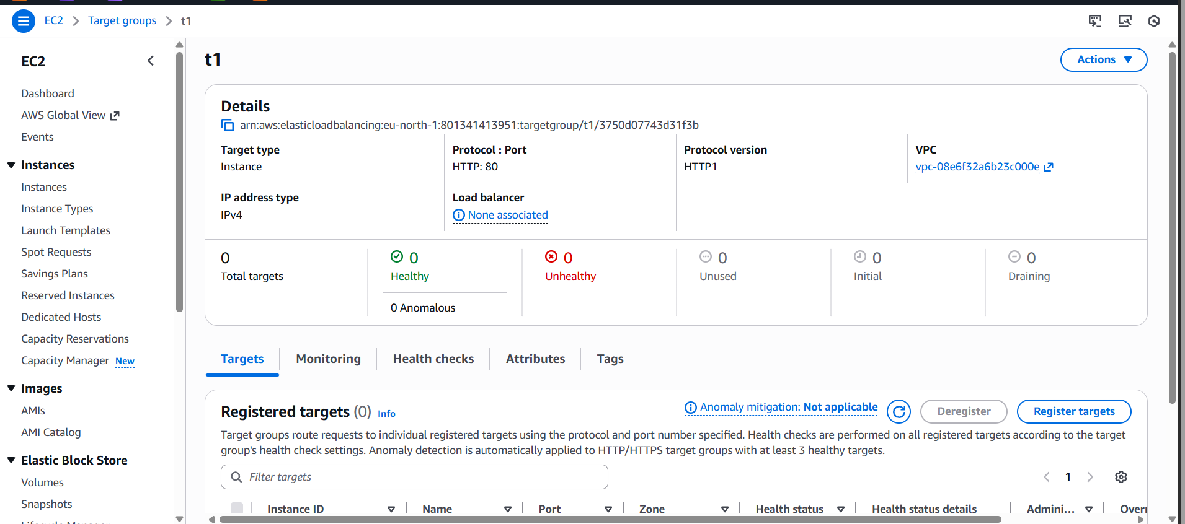

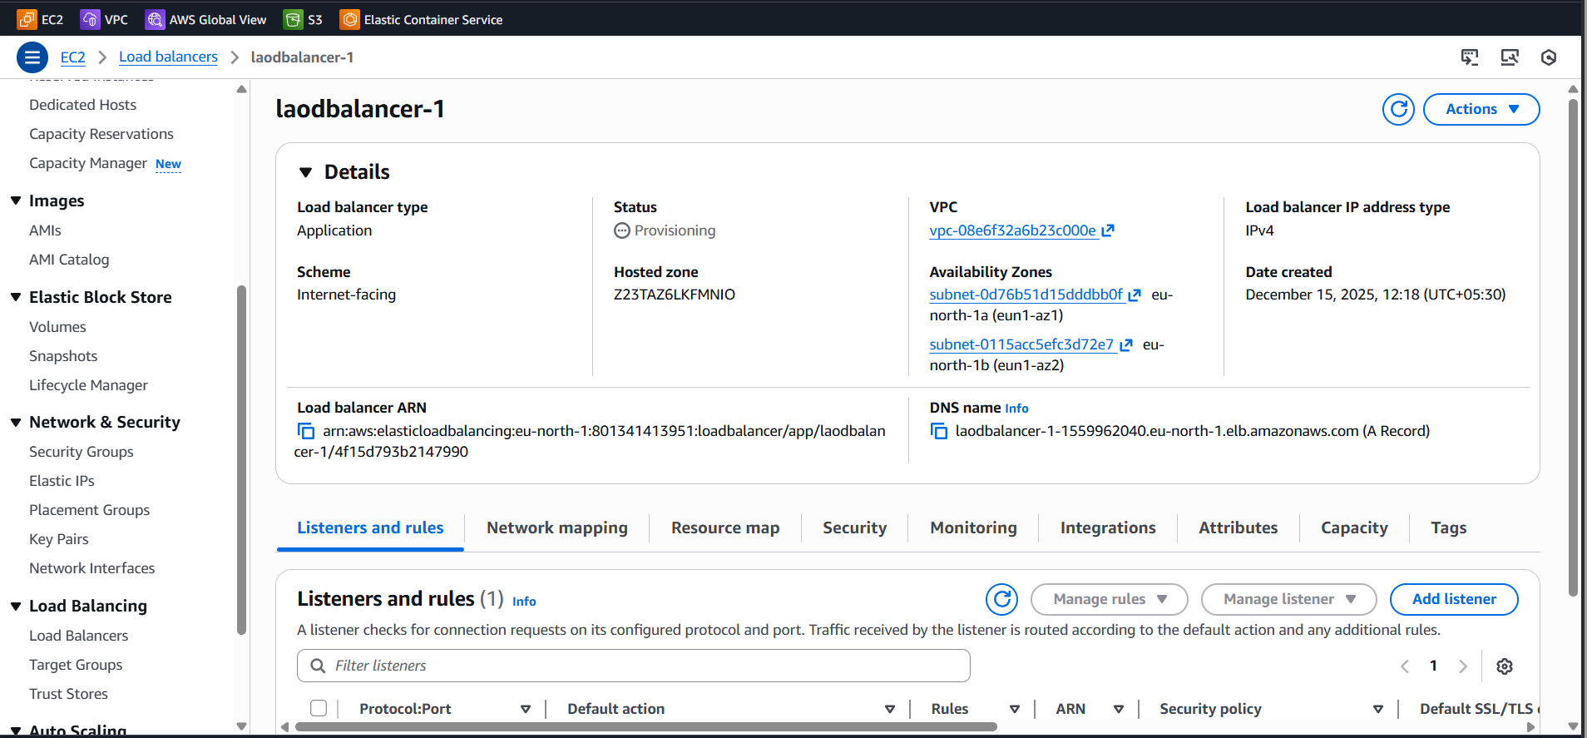

Step 8: Enable Auto Scaling (Optional but Real-Time)
ECS Service Auto Scaling
- Minimum tasks: 2
- Maximum tasks: 6
- Scaling policy:
  - CPU > 70%
EC2 Auto Scaling
- Min: 2
- Max: 6
- ECS automatically places tasks

docker push bharathiraja3234/my_app:tagname
