**BDD - Behavioral Driven Development Testing L1**

**Trend NXT Hands-on**

**Assignment-1**

STEP 1: Launch Open Cart Application

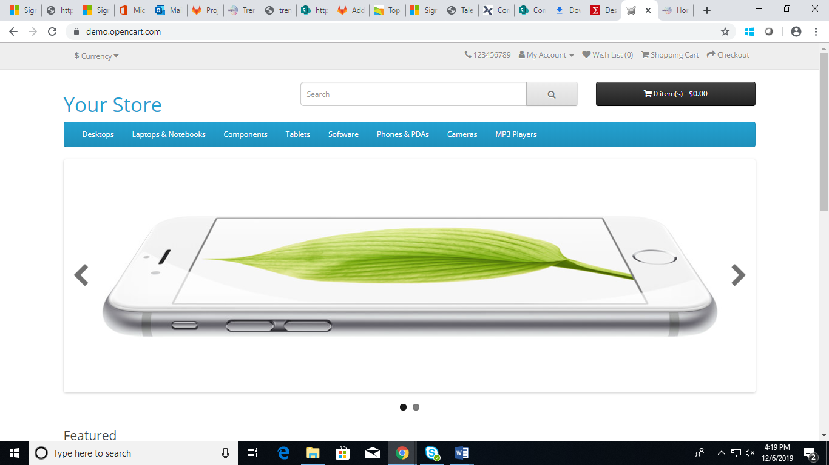

STEP 2: Click on "Register"

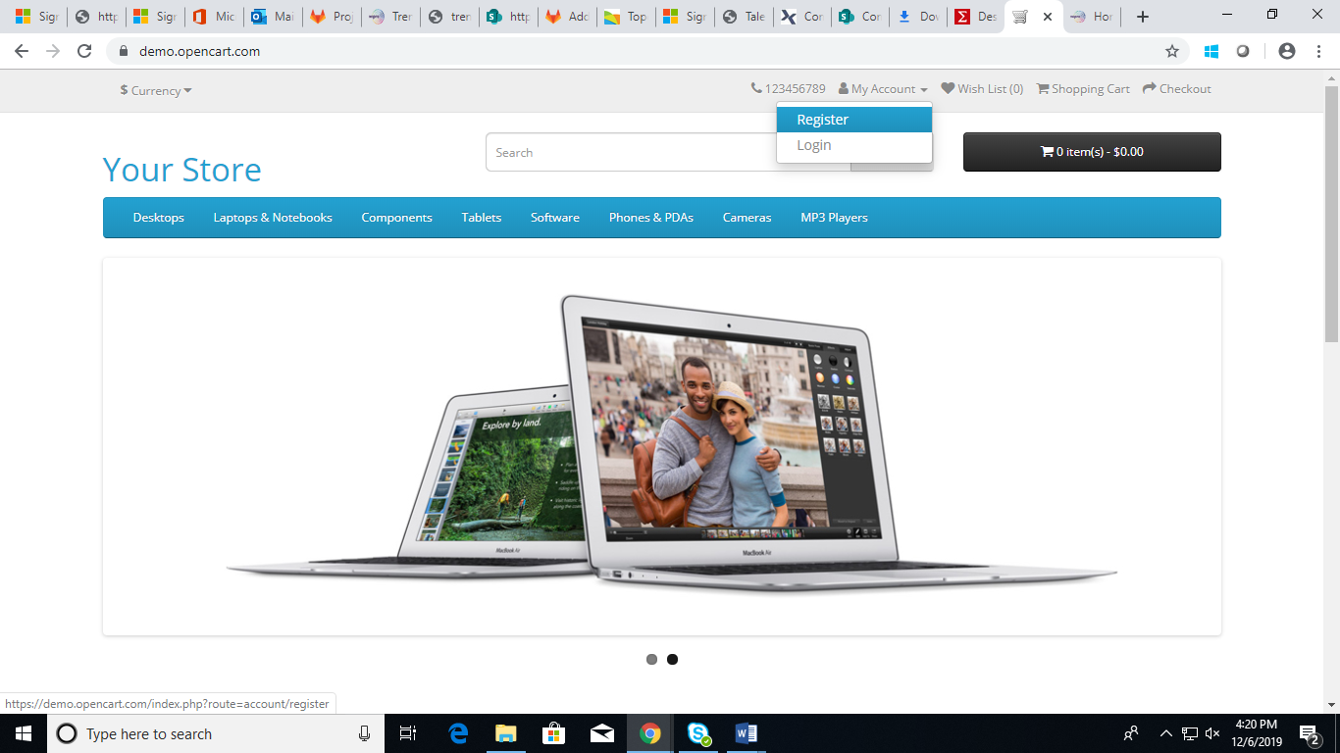

STEP 3: Fill the details -Name, Email, Phone and password. Check the "Privacy Policy" and click on "Continue"

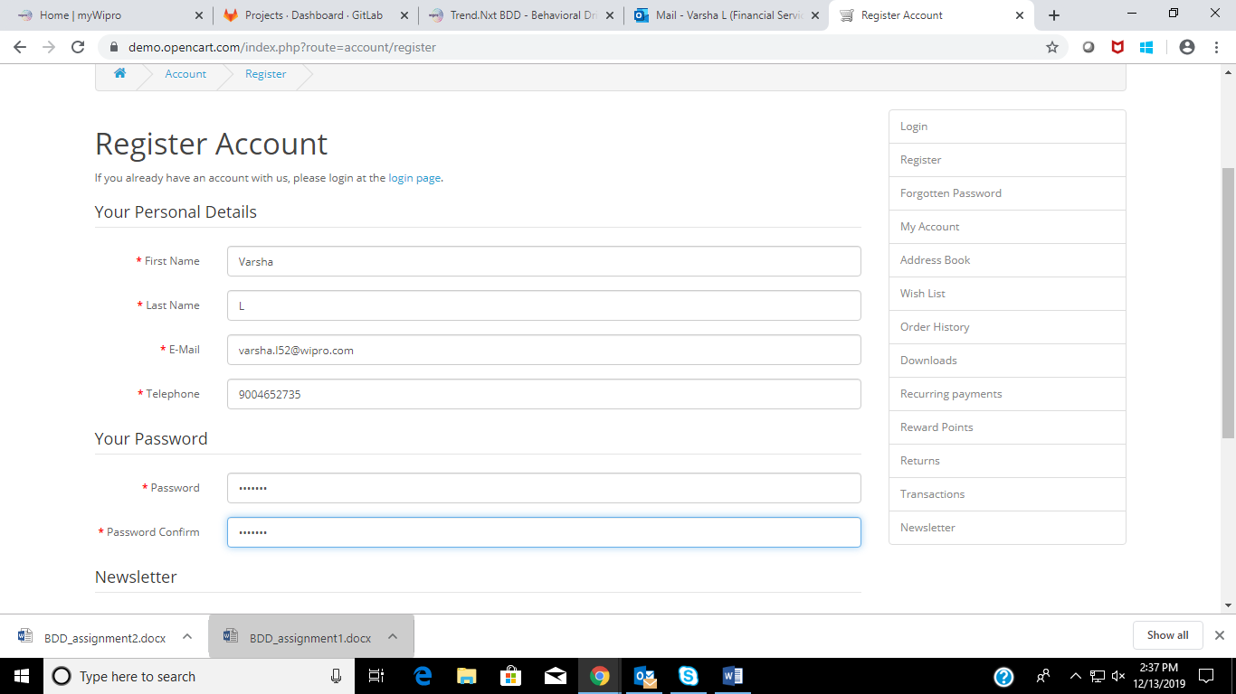

STEP 4: Click on "Contact Us" link

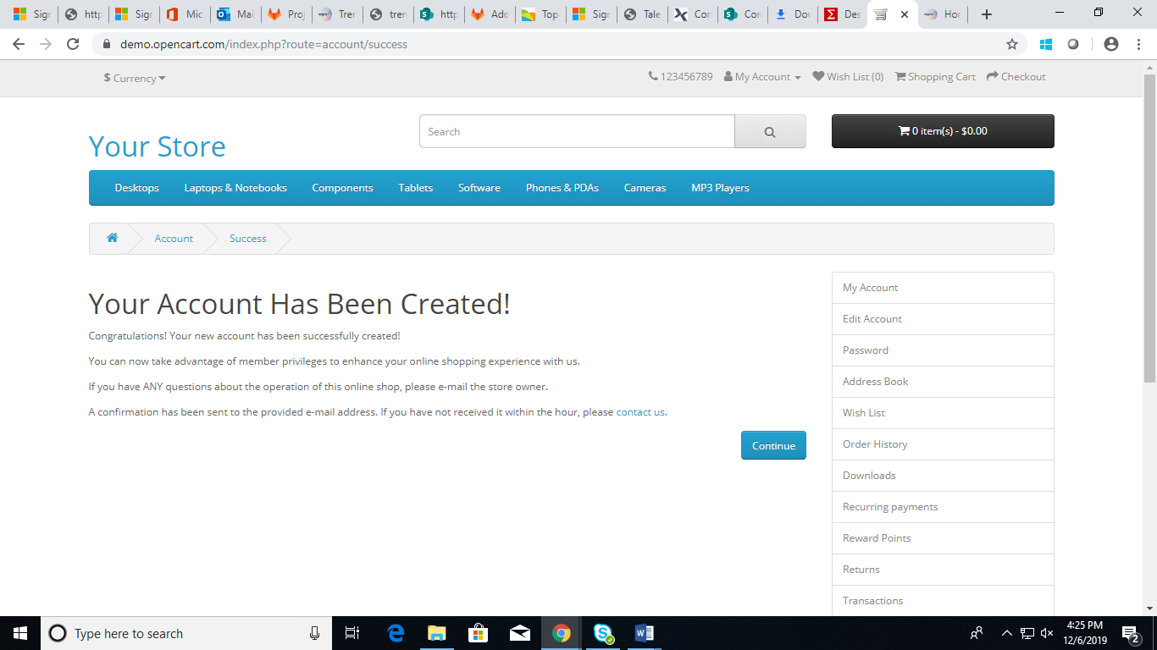

STEP 5: fill in the Enquiry

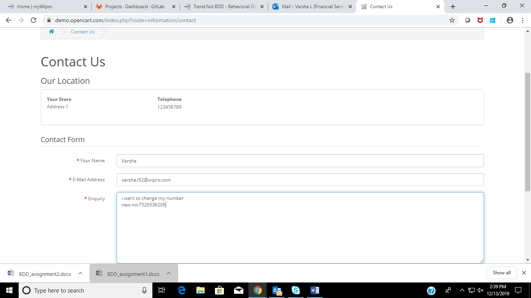

STEP 6: Click on "Submit" and Click on "Continue"

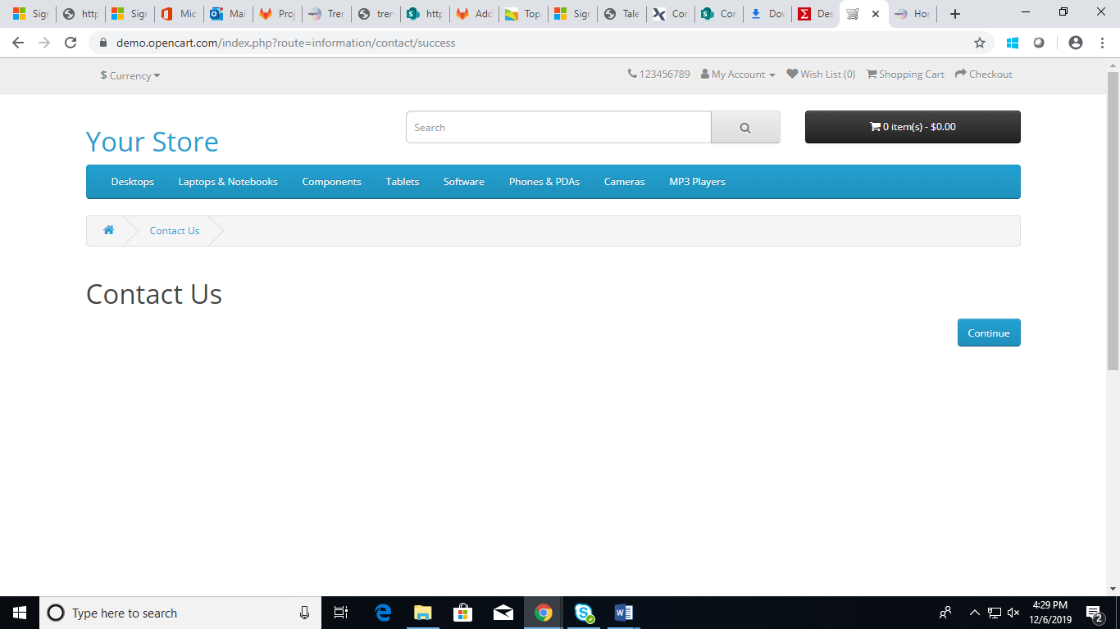

STEP 7: Click on "**Samsung Galaxy Tab**" on home page which is shown as the main advertisement - this might change - but the user should click on this main image only.

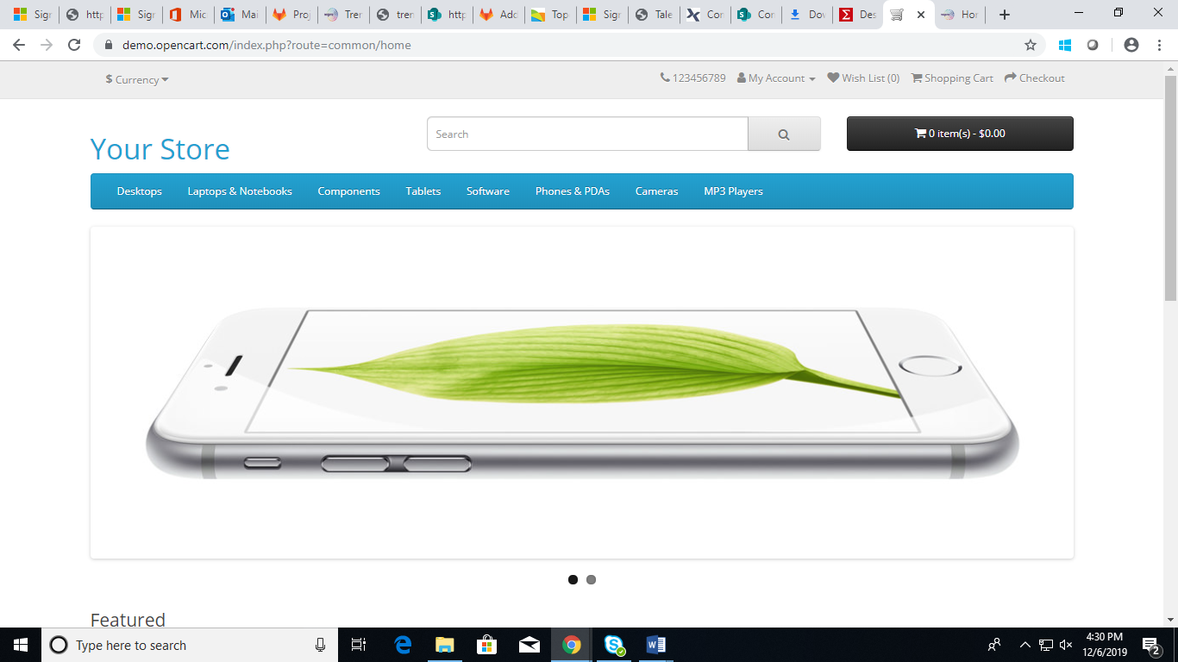

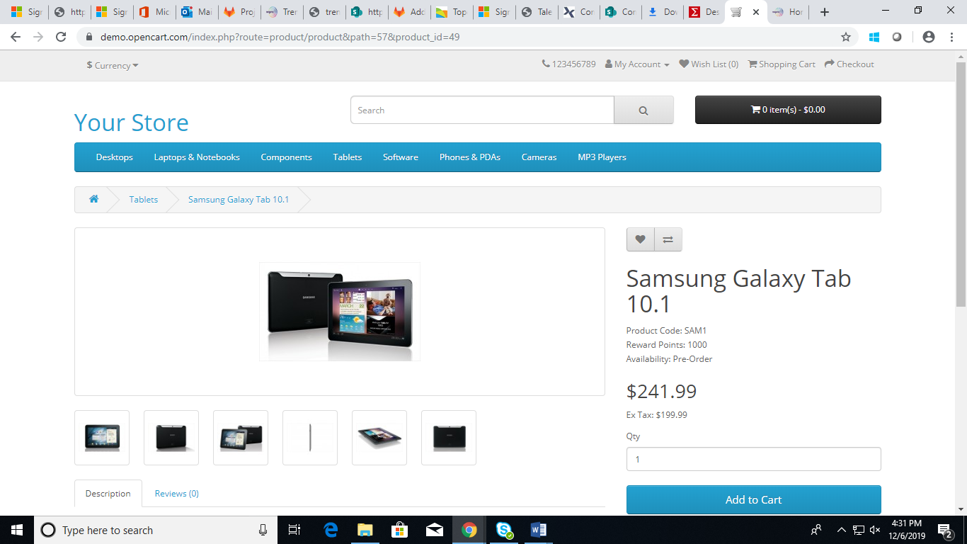

STEP 8: Click on "Review" tab below

Fill in your details -Name and Review. Select the rating as given in Scenario Outline. Enter the code in the box - Click Continue

Fill in your details -Name and Review. Select the rating as given in Scenario Outline. Click Continue

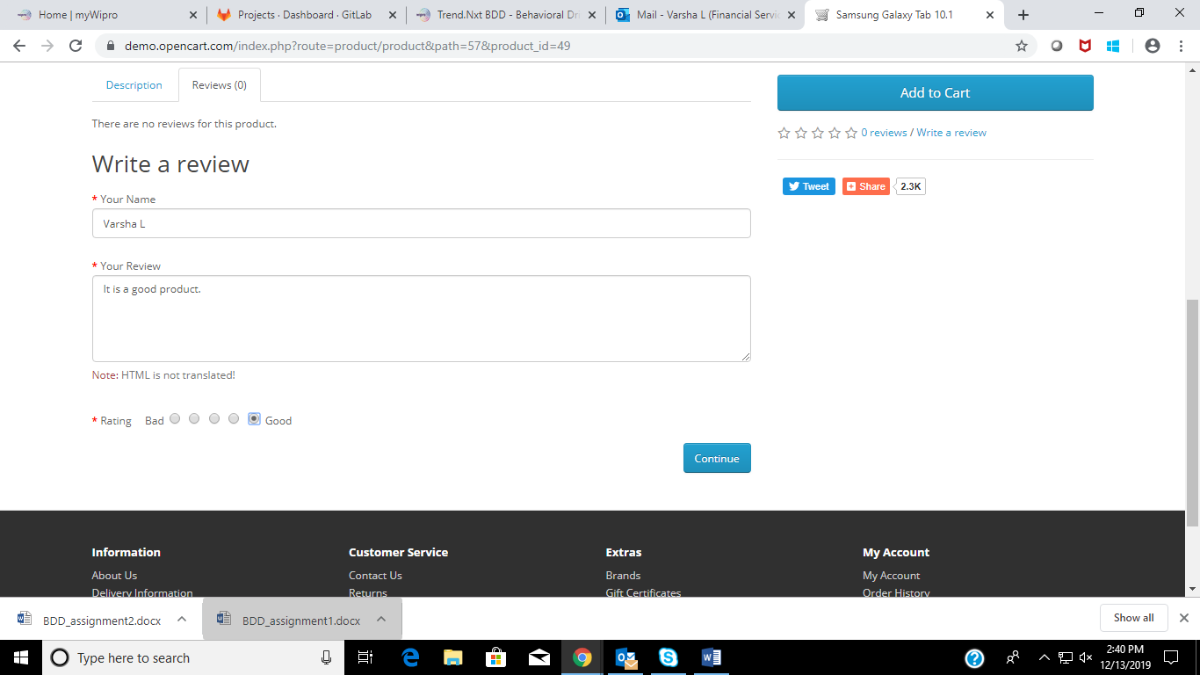

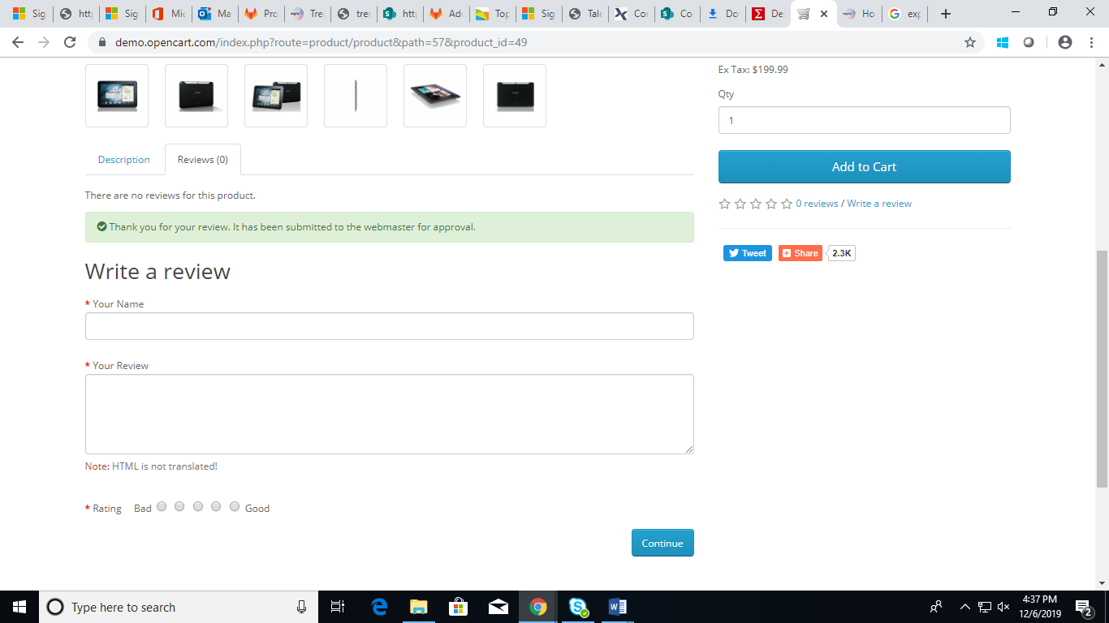

STEP 9: Click on "Add to wish list"

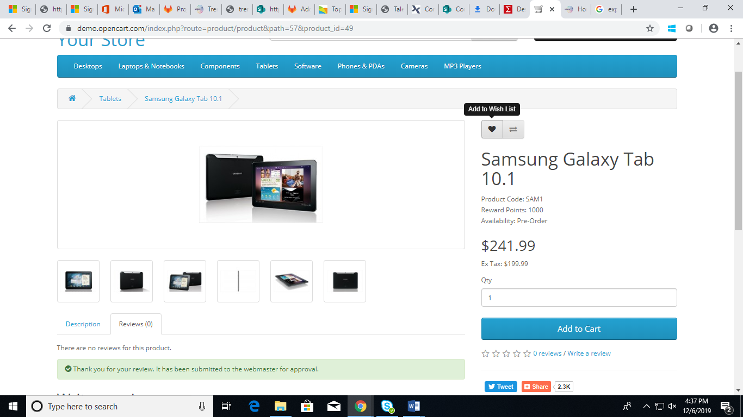

STEP 10: Close the success ribbon message on the page

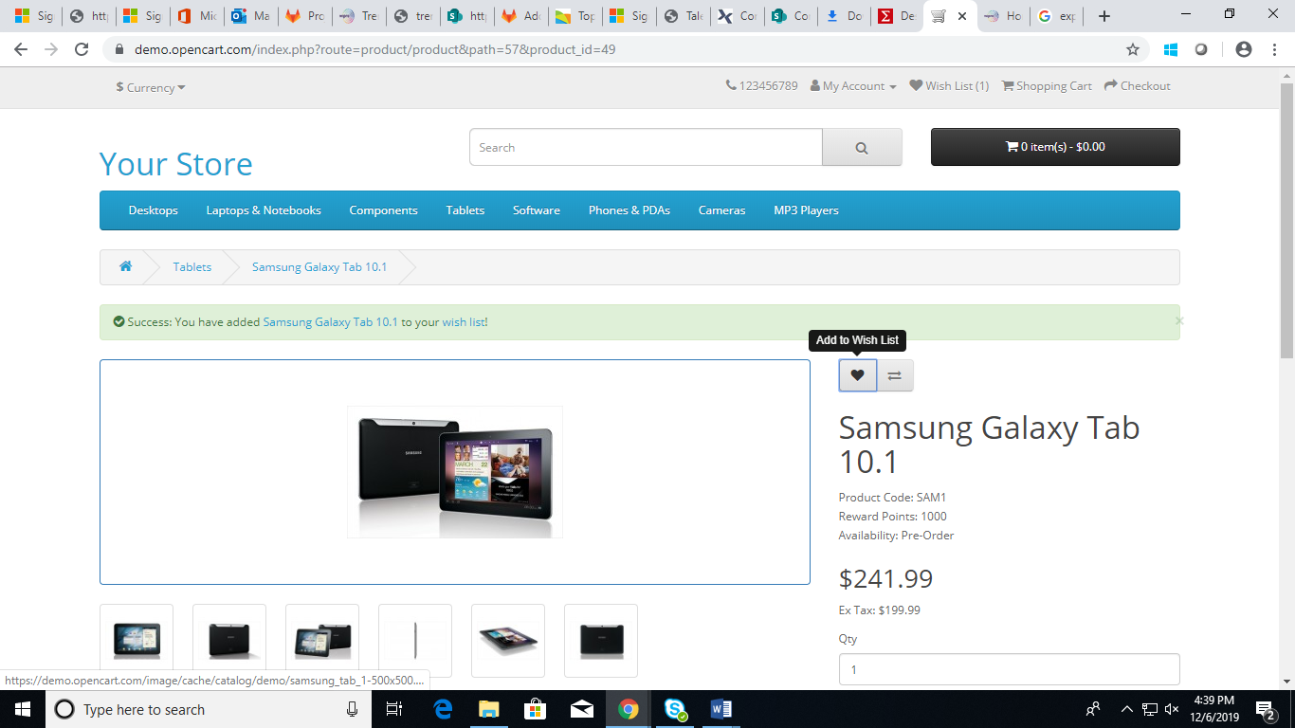

STEP 11: Click on "Wishlist" link.

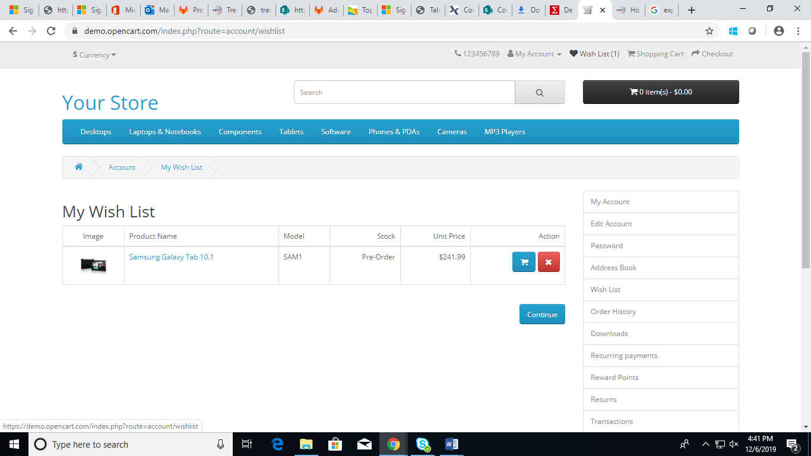

STEP 12: Click on "Pound Sterling".

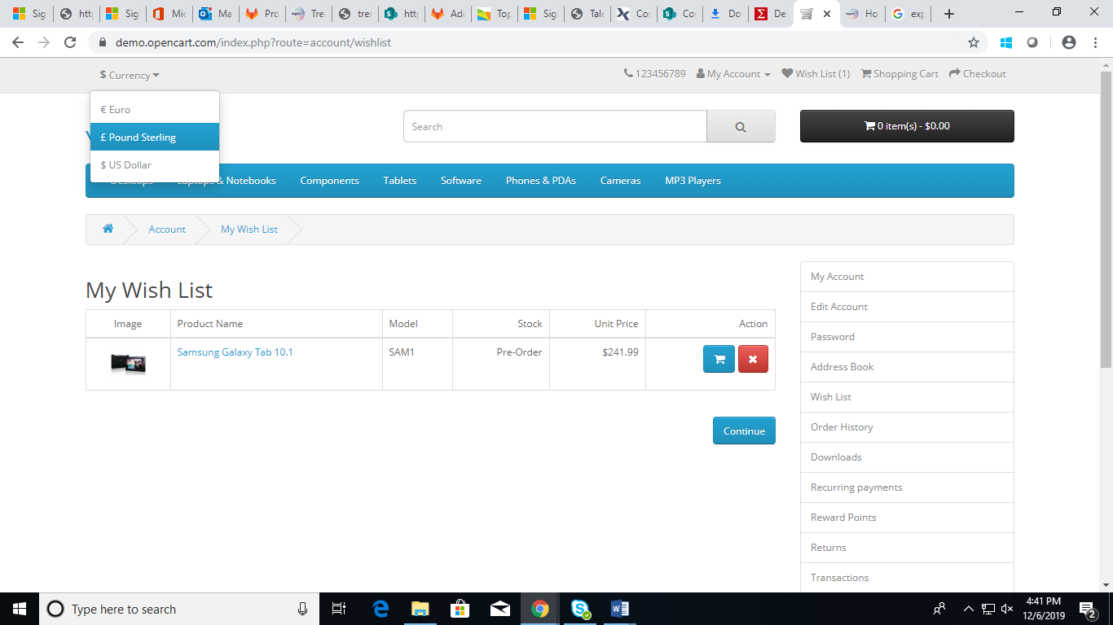

STEP 13: Retrieve the value and display it.

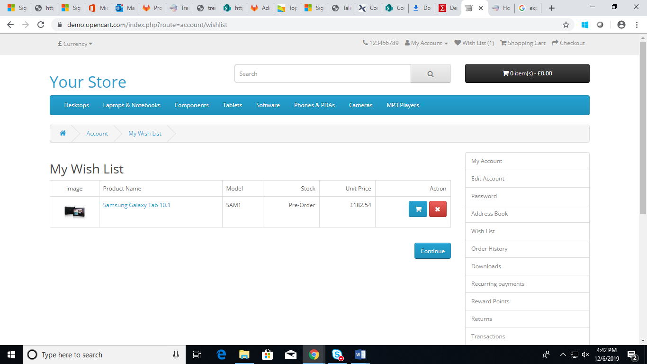

STEP 14: Click on "Euro".

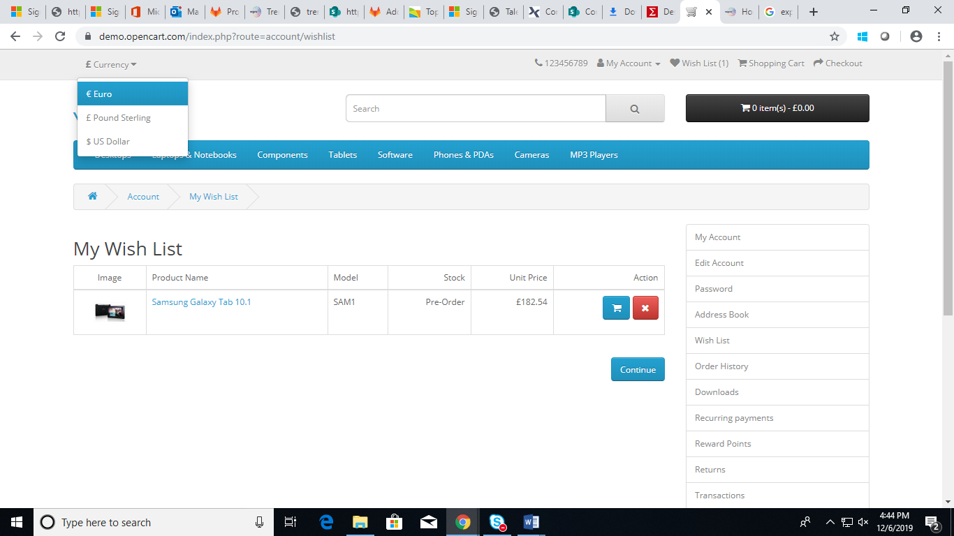

STEP 15: Retrieve the value and display it.

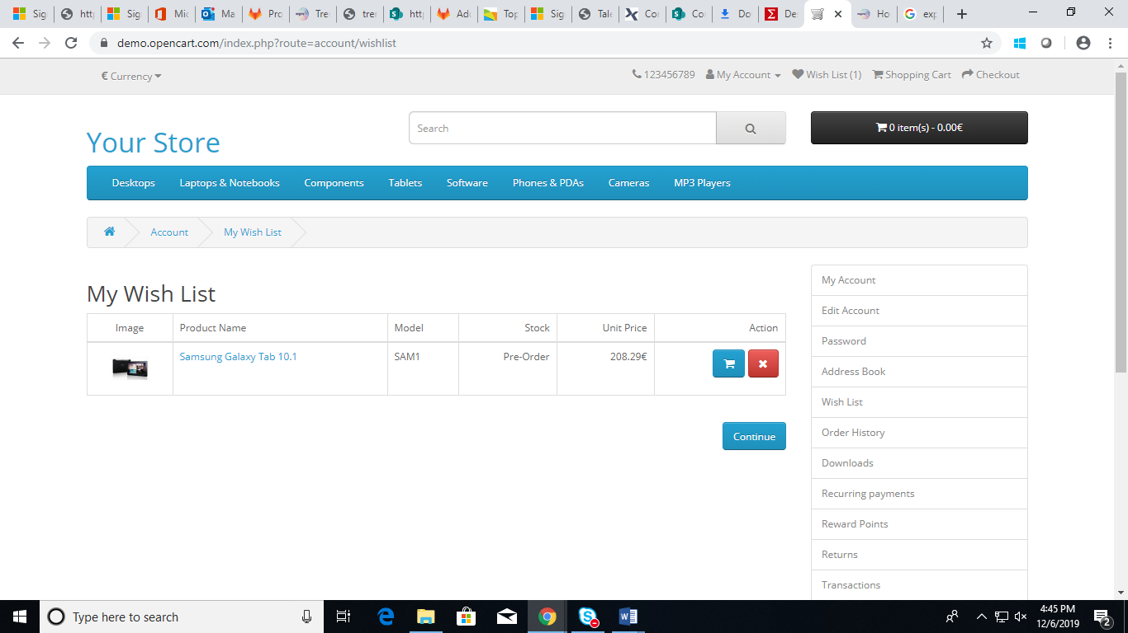

STEP 16: Click on "US Dollar".

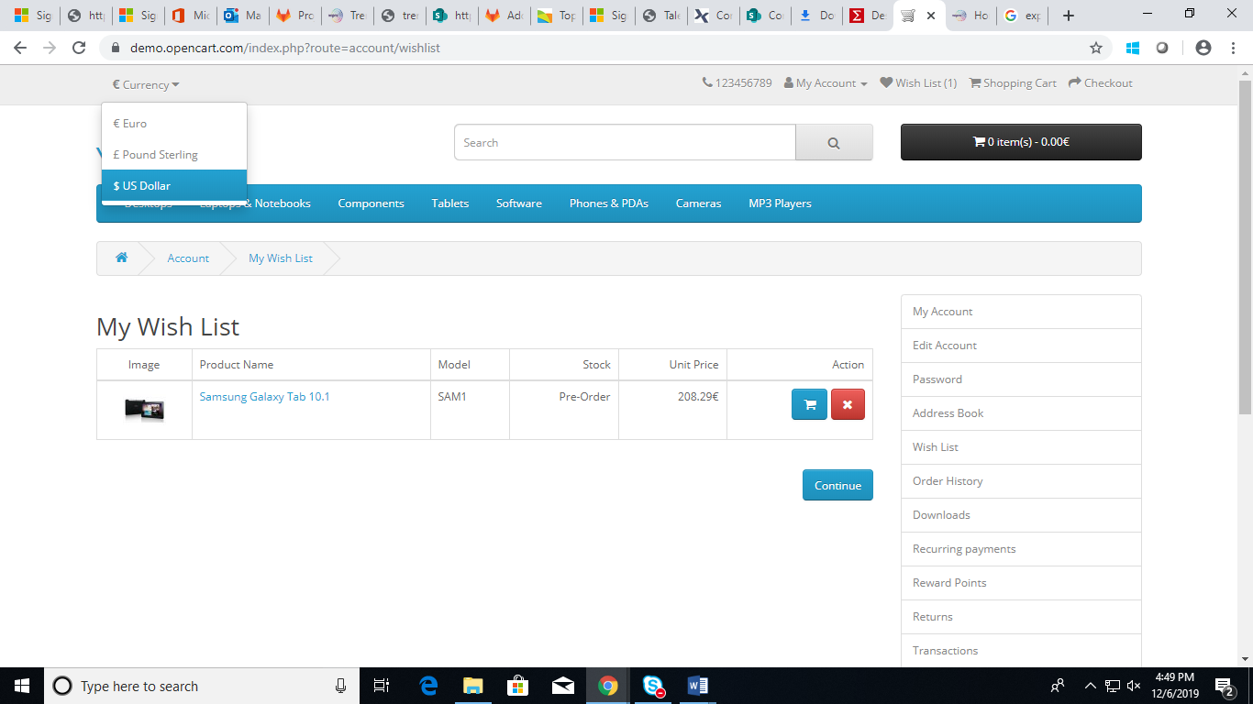

STEP 17: Retrieve the value and display it.

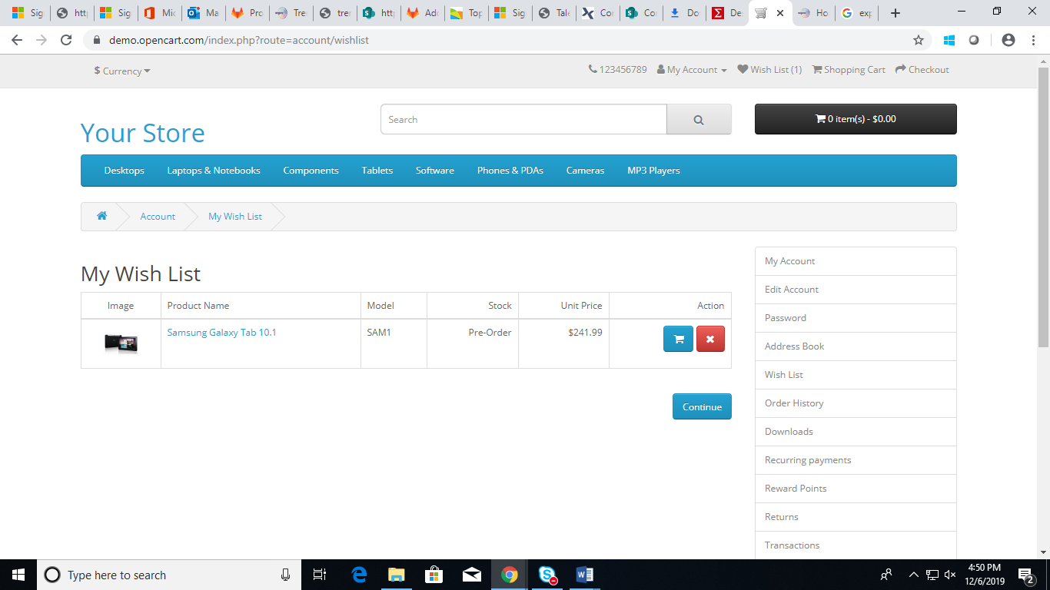

STEP 18: Click on "Add To Cart" icon

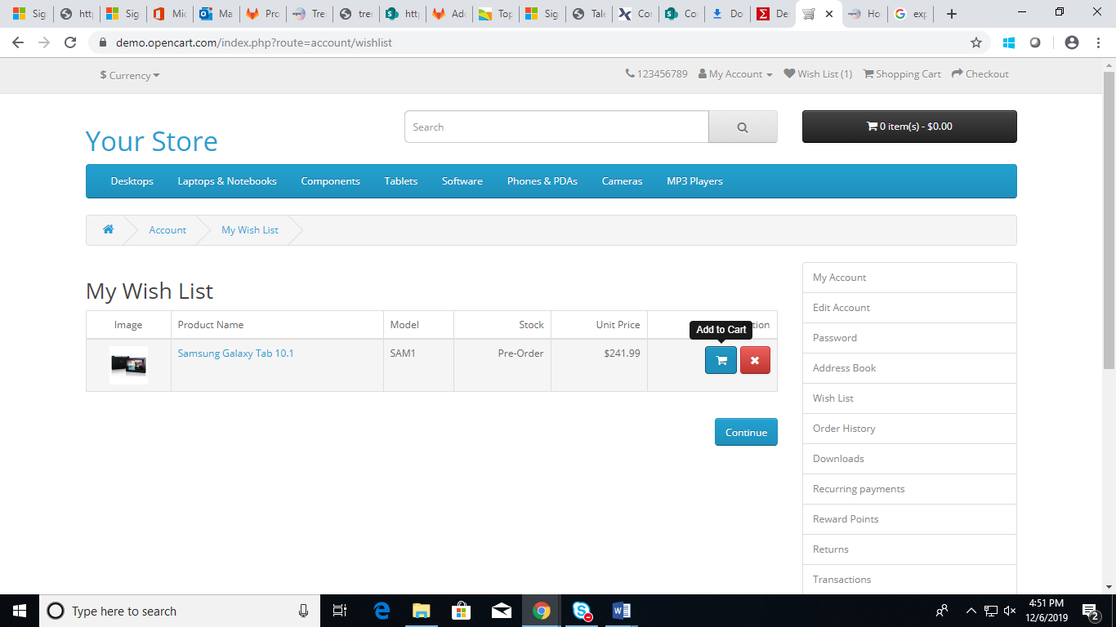

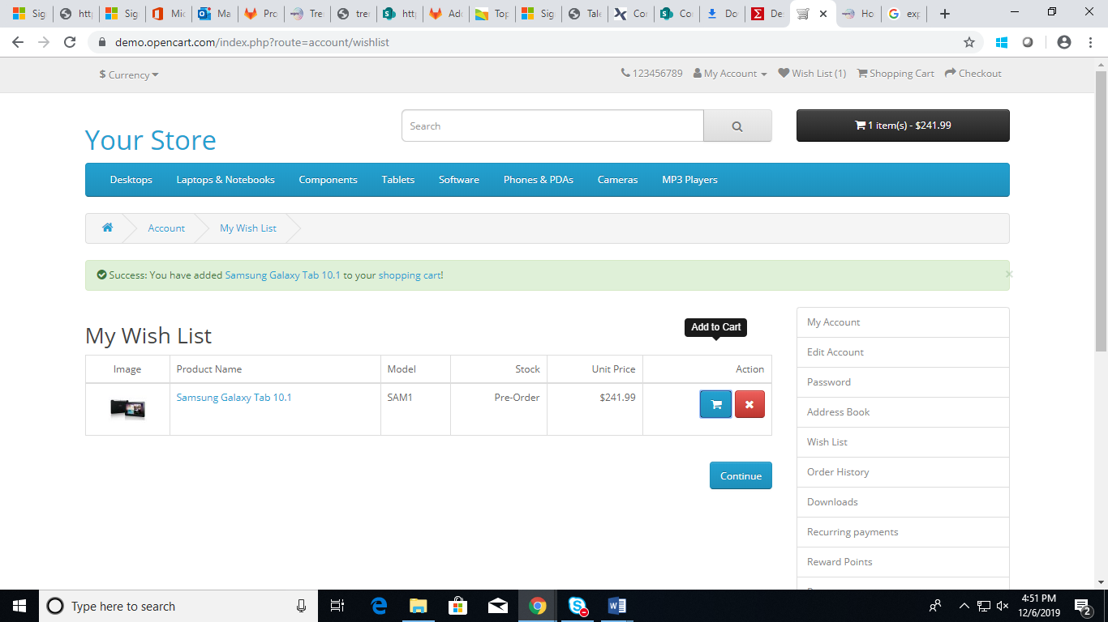

STEP 19: Close the success message on the page.

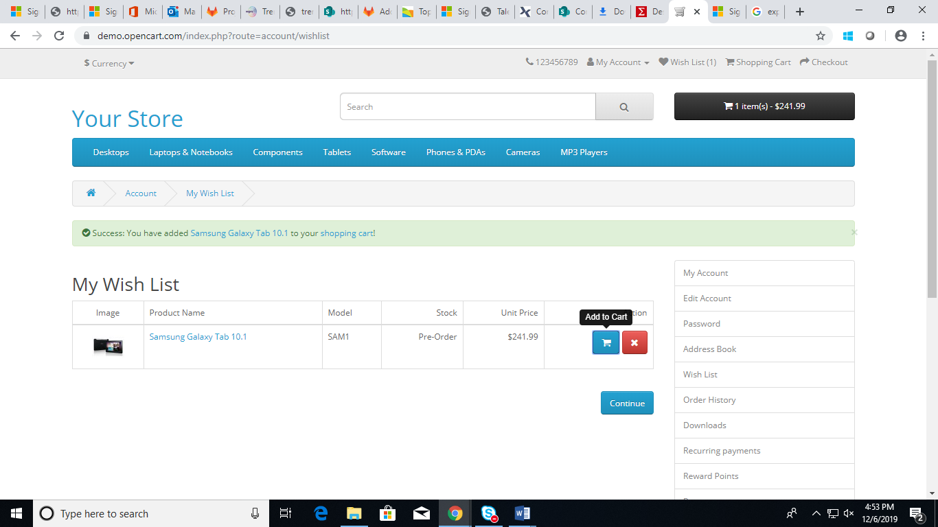

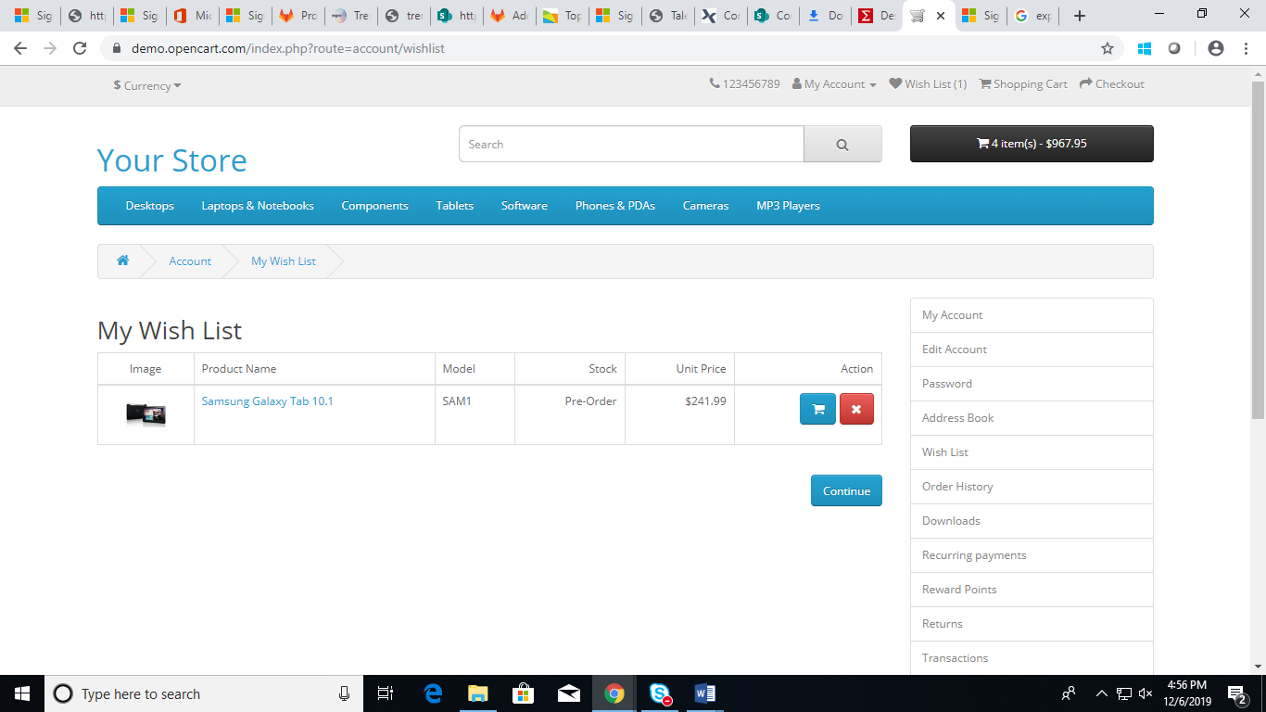

Click "Remove" icon on the product in My Wishlist page

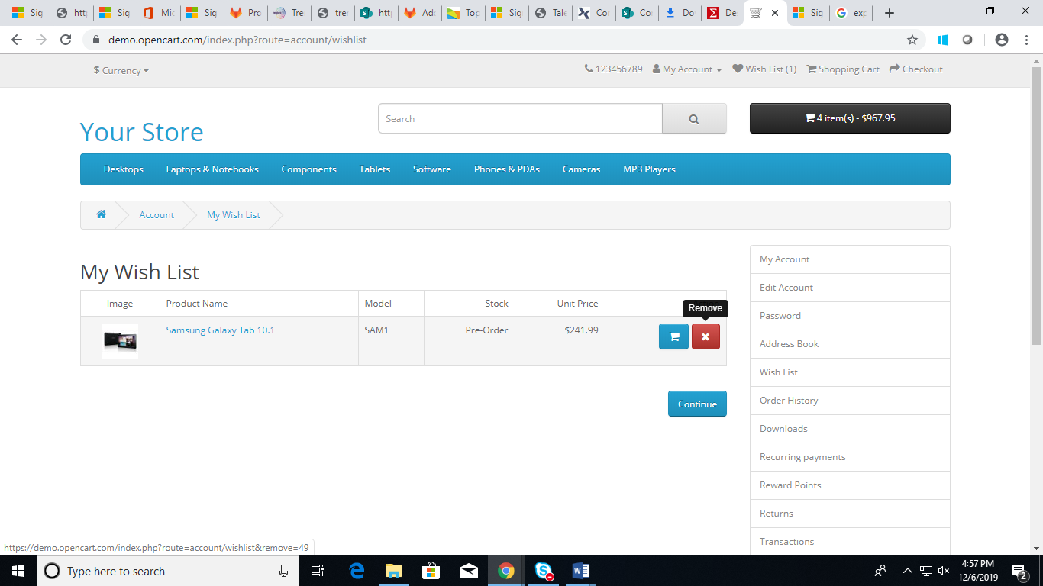

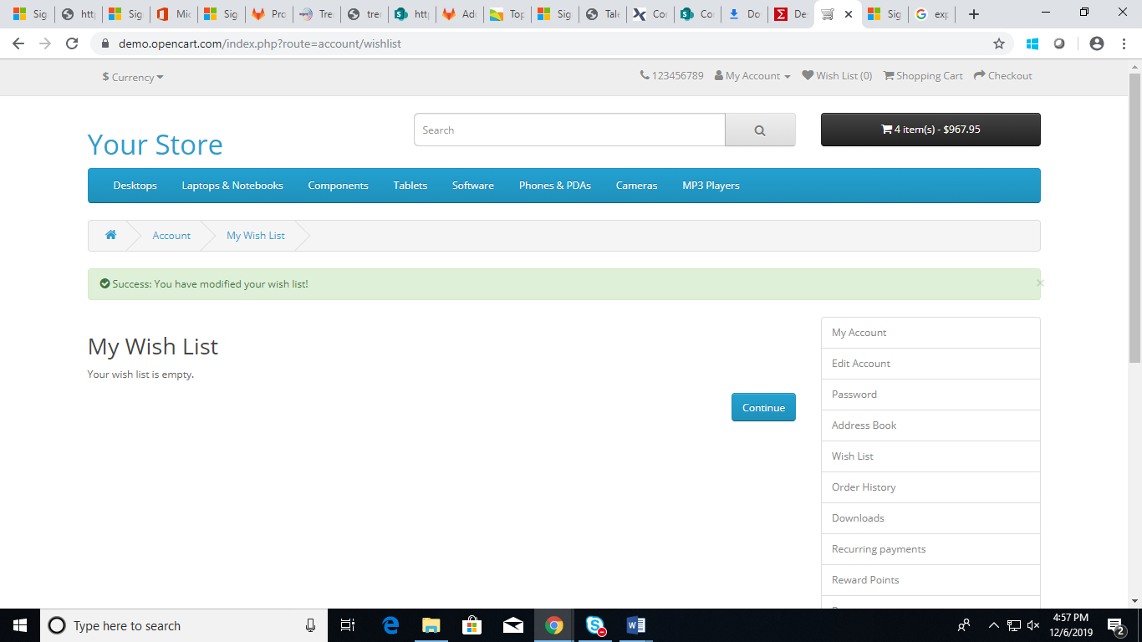

click on continue.

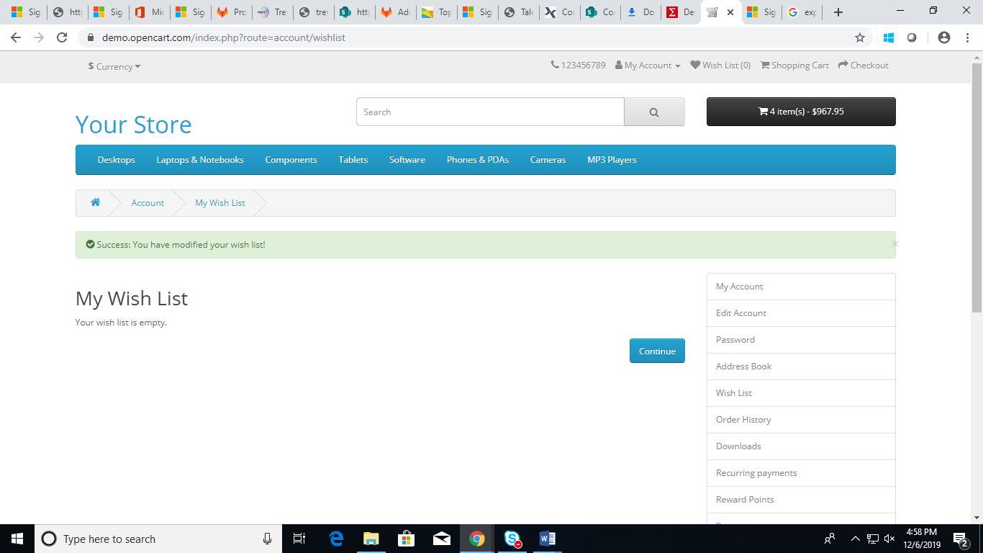

Click on "Logout "

