Week-1
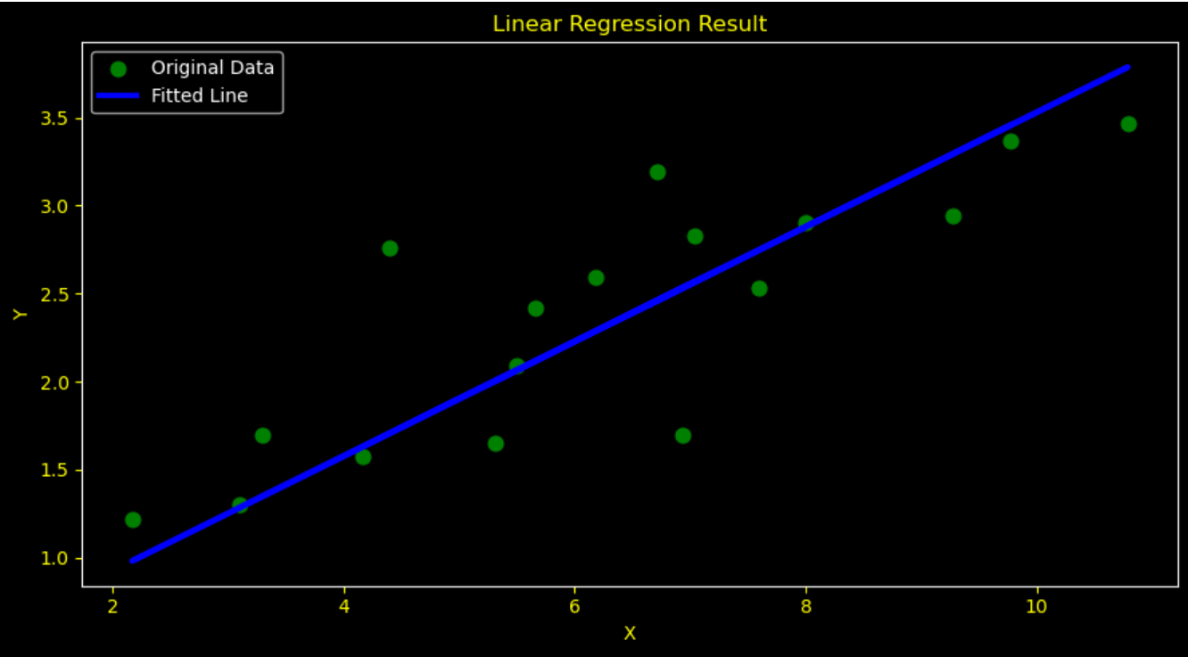

Week-2

The accuracy of the model is “0.924”
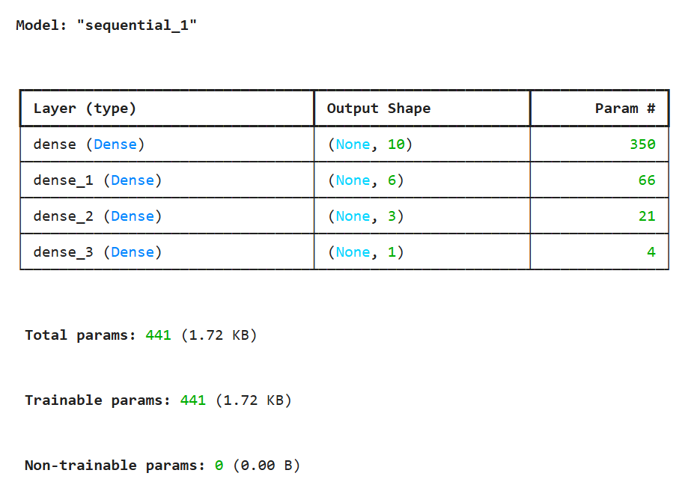

Week-3

The accuracy of the model is “0.87”
