Syracuse Chatbot

System Requirements Specification

**Team:**

**Bharath Karumudi <bhkarumu@syr.edu>**

**Haixin Chang <hchang04@syr.edu>**

**Version: 0.2**



Syracuse

Chatbot

Table of Contents

1. Revision History 3

2. Introduction 3

2.1 Purpose 3

2.2 Project Scope 3

2.3 Overview of Document 3

3. Description 4

3.1 Product Perspective 4

3.2 Product Functions 4

3.3 Constraints 5

3.4 System Models 5

4. User requirements 6

4.1 User Requirements 6

4.2 System requirements 7

4.3 Non-functional requirements 8

# Revision History

|  |  |  |  |
| --- | --- | --- | --- |
| **Name** | **Date** | **Comment** | **Version** |
| Bharath Karumudi | 02/11/2019 | Document Structure | 0.1 |
| Haixin, Bharath | 02/13/2019 | Added content to sections 1 to 4. | 0.2 |

# Introduction

## 2.1 Purpose

This document will provide all the requirements for the project Syracuse Chatbot. It will serve as a reference for both developers and customers during the development of the final version of the system.

## 2.2 Project Scope

Syracuse Chatbot is an AI chatbot that receives questions from users, tries to understand the question, and provides appropriate answers. The application does this by converting an English sentence into a machine-friendly query, then going through relevant data to find the necessary information, and finally returning the answer in a natural language sentence. In other words, it answers your questions like a human. For example, when it receives the question "What is my term fee balance?", it will give a response “You owe $3500.”

The main objective is creating a Web based API, and sample web, mobile interfaces (through Slack and Facebook messengers) that demonstrate the use of the API.

The goal is to provide Syracuse students a quick and easy way to have their questions answered.

## 2.3 Overview of Document

1. Revision History: Provide the date of, reason for, and people who were involved with the modification of this document.  
2. Introduction: Provide an overview of the application, explain the objectives and goal of the project and describe the document structure.   
3. Description: Provide the specification of the system model, the classes model and the main constraints.  
4. Functional Requirements: Provide the analysis of the requirements by feature.   
5. Nonfunctional requirements: Provide some other constraints that affect performance, safety and security.  
6. Use Cases: ​Provide possible scenarios where the user interacts with the application.  
7. Glossary: Definitions of terms used.

# Description

## 3.1 Product Perspective

Chatbot is a web-hosted application, developed based on the current bot technology. This application acts an intermediate media between users and databases. A user can interact with Chatbot via simple English sentences to request and update information from certain databases. These English sentences are analyzed by a Language Understanding Intelligent Service (LUIS) which is integrated with the Chatbot.

There will be four main units to the system working together to understand the question and return an appropriate answer:

**Generic question construction** - capable of taking a natural language question and making it more generic.   
**Generic answer construction** - capable of taking a generic question template and providing a generic answer template.   
**Generic answer population** - capable of taking a generic answer template and populating it with information from the database to form an answer.   
**Information extraction** - capable of finding information available from the database.

## 3.2 Product Functions

Syracuse Chatbot shall be able to query on:

* Student profile information
* Classes and schedules
* Payment information

## 3.3 Constraints

* + 1. **Limited Question Scope**

Creating a chatbot able to answer every single question about Syracuse is not possible to implement within the duration of the project, so the system will be able to answer questions about limited topics.

* + 1. **Language**

The system will only support questions in standard English language.

## 3.4 System Models

**3.4.1 Use case diagram**

**3.4.2 Context diagram**

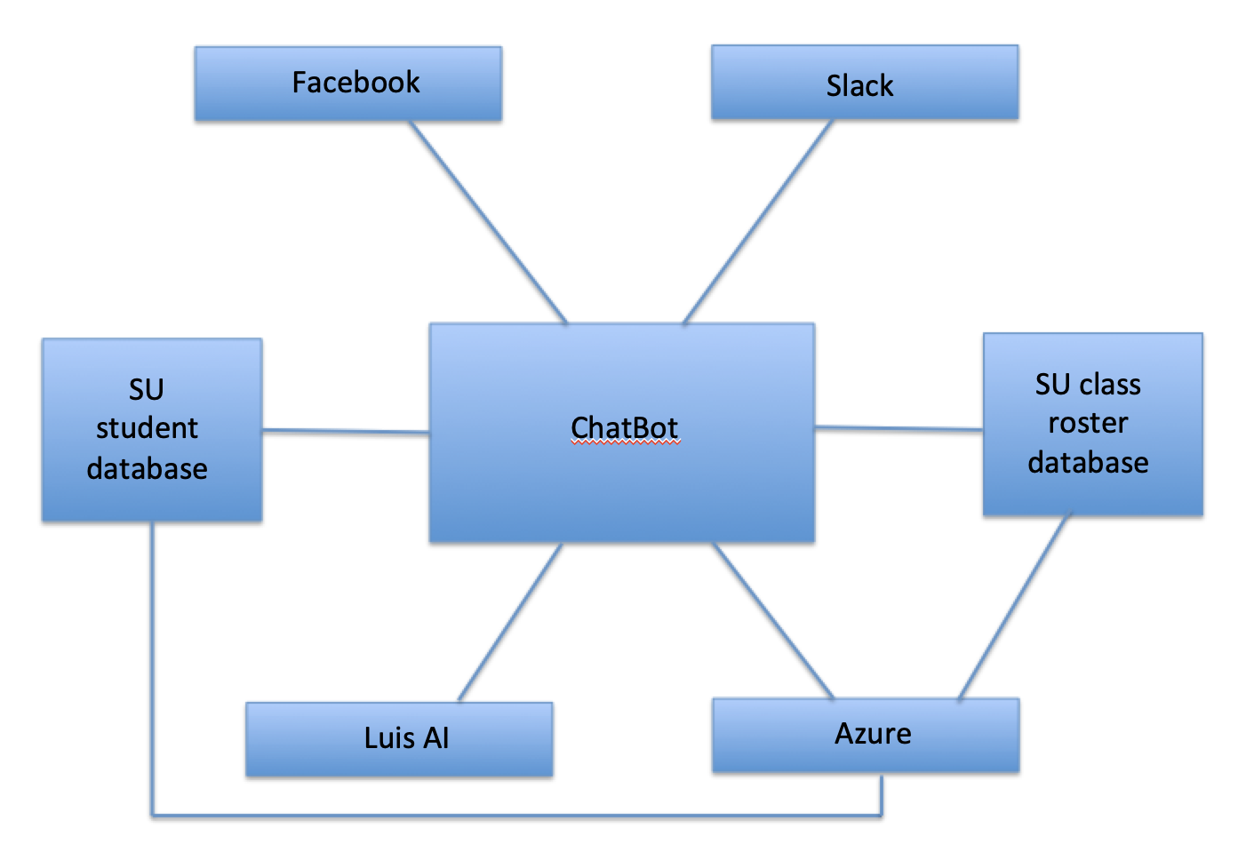

# User requirements

## 4.1 User Requirements

UR1. One shall be able to check his/her profile details such as Name, Email, phone number, address on the records.

UR2. One shall be able to update his/her profile details described above.

UR3. One shall be able to check for the availability of classes.

UR4. One shall be able to enroll for the classes.

UR5. One shall be able to check term fee and balance, as well as upcoming due days and exam schedules.

UR6. One shall be able to check his/her class schedule on a particular day.

UR7. A user shall be able to use ChatBot from Facebook messenger and Slack.

## 4.2 System requirements

SR1. The ChatBot is a web-based application, hosted on Azure.

SR2. A database is hosted on Azure which has the same basic information as Myslice, including student’s profile, class information

SR3. A database is hosted on Azure which contains university’s class roster and class availability etc.

SR4. Users’ requests in the form of natural language are handled by Luis APP, which sends extracted information to ChatBot.

SR5. The ChatBot shall search the database on a per request basis, in response to the user’s request and provide the desired information such as profile, class enrollment, finance information, due day and schedules.

SR6: The ChatBot can be accessed through both Facebook messenger and Slack.

SR7: The ChatBot shall send greeting massages or a random Syracuse fun fact or a University alert upon start.

SR8: The ChatBot should be able to handle multiple users’ requests at the same time.(How many users?????)

## 4.3 Non-functional requirements

NR1. The ChatBot shall be able to respond to users’ request within 10 MS.

NR2. The ChatBot shall validate a user’s ID against the SU ID each time it is being used.

NR3. The ChatBotshall protect user’s password and any sensitive information by encrypting data before storing it database.

NR4. The ChatBot shall be easy to use. Normally a user should be able to learn to use within 3 hours.