**GIT ASSIGNMENT**

**SECTION** **0 :**

1. **Create a directory ‘project_dir’ & cd to ‘project_dir’**

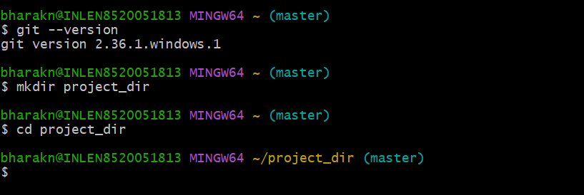

**2. Initialize git version database (git init)**

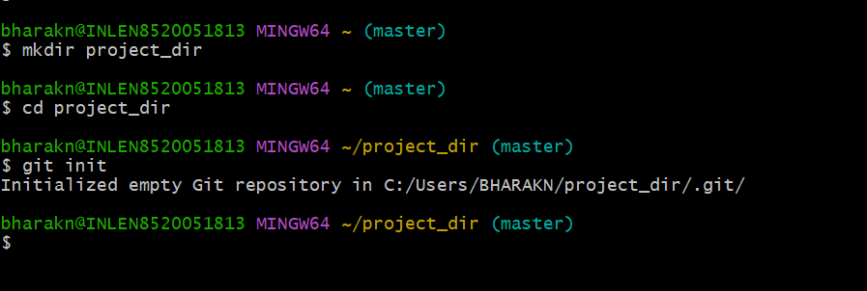

**3. Create a new file index.html**

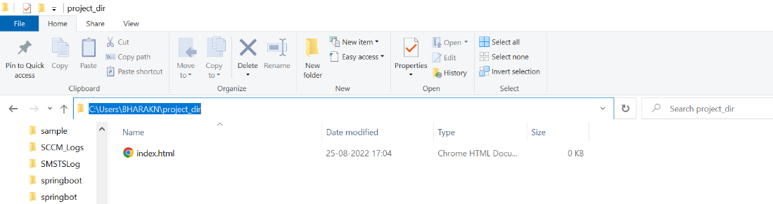

**4. Check git status**

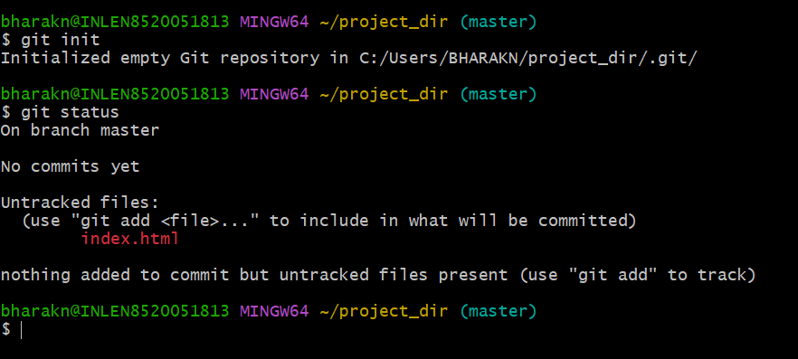

**5. Stage the index.html**

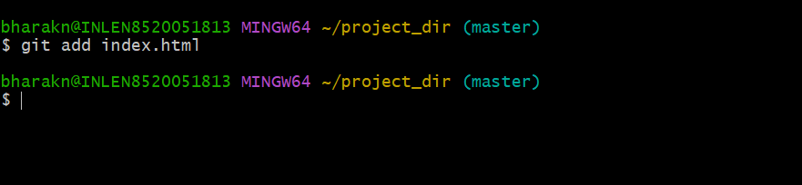

**6. Commit index.html**

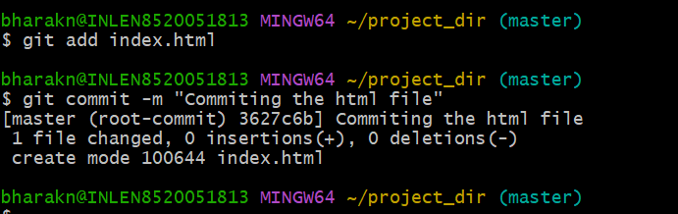

**7****.** **Make few changes in index.html & create a new file info.txt**

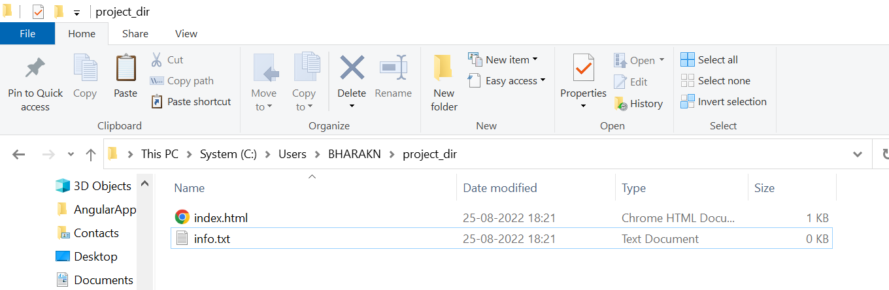

**8. Check git status**

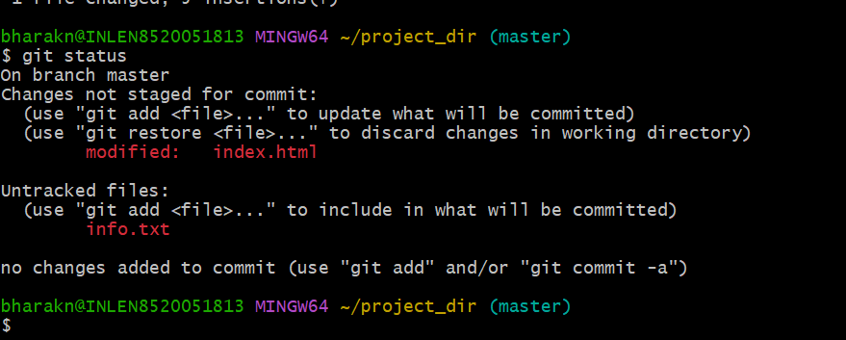

**9. Configure git to ignore all text files**

**10. Check git status**

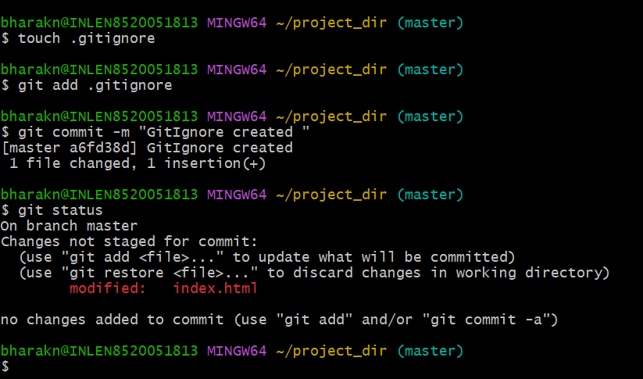

**11. State and commit index.html**

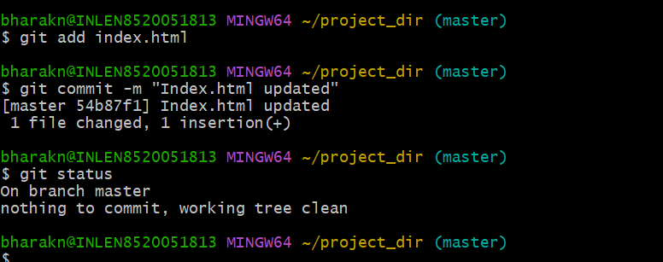

**12. log all your comments**

**$** clear

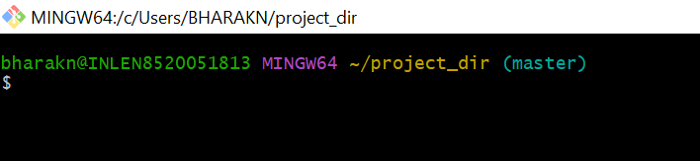

**13. Make changes in index.html**

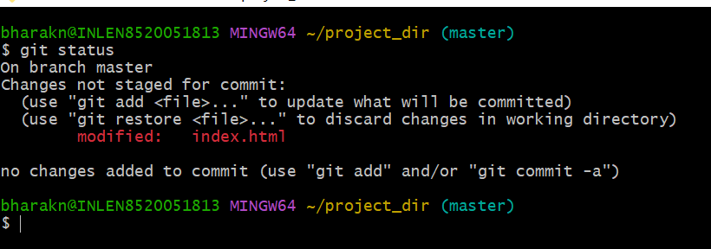

**14. Revert changes made in html using git command**

**15. Again change index.html**

**16. Stage index.html**

**17. Revert back to last stage**

**18. Rename ‘add’ comment to ‘myadd’**

**19. Use ‘myadd’ command any stage and commit index.html again.**

**20. Revert the last commit**

**GIT BRANCHING**

**Section 1 :(HTML Assignments)**

**22. Create an empty directory “Assignments” and cd to “Assignments”**

**23. Create a README.txt inside “Assignments” & write few lines about the contents of “Assignments” folder**

**24. Commit README.txt file**

**25. Create a new branch ‘html-assignments’**

**26. Switch to html-assignment branch**

**27. Copy all HTML assignments to “Assignments” folder**

**28. Commit HTML Assignments into ‘html-assignments’ branch**

**29. Make minor changes into few files belonging to ‘html-assignments’ branch**

**30. Commit those changed files**

**31. Switch to master branch**

**32. Make minor changes in README.txt file & commit those changes into master**

**33. Again switch to ‘html-assignments’ branch**

**34. Make minor changes into few files belonging to ‘html-assignments’ branch**

**35. Commit those changes**

**36. Switch to master**

**37. Merge “html-assignments” to “master”, Confirm all html assignments are shown in master**

**38. Finally delete the “html-assignments” branch**

**Section 2 : CSS Assignments**

1. **Create a new branch CSS Assignments**

1. **Switch to ‘css-assignments’ branch**

1. **Copy all CSS Assignments inside ‘Assignments’ folder**

1. **Commit CSS assignments into ‘css-assignments’ branch**

1. **Make minor changes into README.txt file on line 1 belonging to ‘css-assignments’ Branch**

1. **Commit those changed files**

1. **Switch to master branch**

1. **Make minor changes to README.txt file on line 3 & commit those changes in master branch**

1. **Again switch to ‘css-assignments’ branch**

1. **Make minor changes to files belonging to ‘css-assignments’ branch**

1. **Commit those changes**

1. **Switch to master**

1. **Merge “css-assignments” branch to “master” branch. Confirm all assignments are showing in master**

1. **Finally delete “css-assignments” branch**

**Section-3: (JavaScript Assignments)**

1. **Create a new branch “js-assignments”**

1. **Switch to “js-assignments”**

1. **Copy all JavaScript assignment inside “Assignments” folder**

1. **Commit all JavaScript assignments in “js-assignments” branch**

1. **Make minor changes into README.txt file on line 1 belong to “js-assignments” branch**

1. **Commit those changed files**

1. **Switch to master branch**

1. **Make minor changes into README.txt file on line 3 belong to “master” branch and commit those changes**

1. **Switch to “js-assignments”**

1. **Make minor changes to some files belonging to “js-assignments”**

1. **Commit those changes**

1. **Switch to master branch**

1. **Merge “js-assignments” branch to “master” branch. Confirm all assignments are showing in master**

1. **Finally deleted “js-assignments”**

**GIT REMOTING**

**Section 3:(pushing assignments to remote repository)**

**39. Create a github account**

**40. login into github account**

**41. Create a new public repository ‘freshersbatch-oct16’**

**42. Commit and push any sample files to this repository under ‘Assignments’ directory**

**Section 4:**

1. **One developer from the project team will create eclipse project ‘SampleProj’ & add sample source code files. Then commit all files through eclipse GIT plugin.**

1. **Collaborate other team members with your GitHub account so that they can also modify the committed files.**

**3. Other developers from the same team will checkout all files from remote repository. This might get conflicts since certain files fail to merge . in such case, merge it manually**

1. **Commit and push the ‘SampleProj’ project**

