CHAPTER 1
INTRODUCTION

The agricultural market scenario in India is complex and faces numerous challenges. One of the primary issues is the Lack of Proper Marketing Infrastructure, leading to inefficient supply chains and significant losses for farmers. This is exacerbated by inadequate transportation facilities, poor communication networks, and insufficient storage capacity. Another significant problem is the Dominance of Middlemen, who often exploit farmers by offering low prices for their produce. This reduces farmers' income and makes them vulnerable to debt traps. Furthermore, the Lack of Market Information and Inadequate Access to Credit Facilities hinder farmers' ability to negotiate fair prices and invest in their farms.

1.1 Agricultural Marketing Scenario in India

India, being an agrarian economy, has a significant portion of its population engaged in agriculture. According to government statistics, nearly 58% of the rural households depend on farming as their primary means of livelihood. However, many farmers in small towns and remote villages face challenges in accessing quality agricultural inputs like seeds and pesticides due to logistical and infrastructural constraints. With the rapid growth of e-commerce and delivery services in India, there has been a noticeable increase in the adoption of technology-driven solutions in agriculture. Despite this, a large gap still exists in ensuring timely delivery of essential inputs to farmers in less accessible regions. Initiatives like Agri Drop aim to address this gap by leveraging technology to connect farmers with resources they need for improved productivity. Furthermore, India generates approximately 350 million tons of agricultural waste annually, most of which is either underutilized or disposed of inefficiently. Biowaste management solutions are gaining momentum as industries increasingly seek sustainable raw materials. Agri Drop's initiative to facilitate the collection and sale of agricultural waste addresses this emerging market while promoting environmental sustainability. The increasing prevalence of smartphones and internet penetration in rural India creates a favourable environment for implementing platforms like Agri Drop, empowering farmers with access to necessary resources and contributing to the broader goals of agricultural development.

1.2 Scenario of Agricultural waste management in India

India's agricultural waste management scenario is a pressing concern, with the country generating over 620 million tonnes of agricultural waste annually. Unfortunately, only 25-30% of this waste is utilized as livestock fodder and energy production, leaving a significant amount to be discarded. The improper disposal of agricultural waste leads to severe environmental consequences, including air and water pollution, soil degradation, and climate change. The burning of crop residues, for instance, releases harmful pollutants into the atmosphere, contributing to health problems and environmental degradation. To address these challenges, the Indian government has launched initiatives promoting sustainable agricultural waste management practices, such as composting, mulching, and bioenergy production. The government provides financial assistance to farmers for adopting these practices and encourages the development of community composting centres.

CHAPTER 2
LITERATURE REVIEW

Literature Survey is a crucial part of any project to understand existing innovations and analyse future needs. The following papers focus on need of fine-tuning in Indian agriculture.
[1] E-national Agricultural Market (e-NAM) in India
Swapnil Gupta, Prof. P. S. Badal 2020
This paper systematically reviews developments in Indian agricultural marketing and emphasizes on addressing the challenges in the implementation of e-NAM to achieve the goal of doubling farmer’s income. The e-NAM (Electronic National Agriculture Market) portal is a pan-India electronic trading portal that networks the existing Agricultural Produce Market Committee (APMC) mandis to create a unified national market for agricultural commodities. Well-functioning agriculture marketing leads to price discovery, efficiency in supply chain and opportunity to scale up in the value chain. By linking markets, these marketing systems transmit right signals to farmers on new market opportunities and guide their production to meet preferences for quantity, quality, and varieties. This paper also reviews pathways to integrate farmers to market i.e. Linking sellers and buyers to markets is a key factor that will bring better participation in the evolving markets and ensure better returns to both sellers and buyers.

[2] Agro-waste for renewable and sustainable green production
Sanjay Mavinkere Rangappa and Suchart Seingchin, 2024
This review provides an overview of agro-waste, offering insights into its generation, categorization, composition and associated environmental implications. The sustainable utilization of the agro-waste is explored addressing pressing waste management and resource optimization issues. Promising pathways for utilizing agricultural waste, encompassing composting, production of animal feed, bioenergy generation, fibre extractions and biochar production are explored. Additionally, the review examines the complexities of efficiently managing and utilizing agricultural waste, addressing challenges such as the diverse nature of waste sources, compositional variations, contaminants, and practical feasibility considerations. It also explores potential solutions, including the need for further research, infrastructure development, and the establishment of regulatory frameworks and policies to improve agricultural waste management.

[3] Agricultural waste management strategies for environmental sustainability
Mohammad Yakoob and Maulin P. Shah,2022
This paper highlights the urgent need to shift from burning agro-waste to proper utilization to improve environmental conditions. Abundant agricultural wastes (AWs) are being generated each day to fulfil the increasing demands of the fast-growing population. The limited and/or improper management of the same has created an urgent need to devise strategies for their timely utilization and valorisation, for agricultural sustainability and human-food and health security. The AWs are generated from different sources including crop residue, agro-industries, livestock, and aquaculture. The main component of the crop residue and agro-industrial waste is cellulose, (the most abundant biopolymer), followed by lignin and hemicellulose (lignocellulosic biomass). The AWs and their processing are a global issue since its vast majority is currently burned or buried in soil, causing pollution of air, water and global warming. But lignocellulosic biomass can also serve as a sustainable source of biofuel (biodiesel, bioethanol, biogas, biohydrogen) and bioenergy in order to mitigate the fossil fuel shortage and climate change issues.

[4] Current Trends in Agriculture and Allied Sciences
Anandita Borthakur and Dr. Sayanika Borah,2023
This paper addresses the need of expanding science, technology and sustainable farming awareness among farming communities. In developing countries like India, rural people are mainly involved with agriculture and allied activities. Although agriculture is essential to survival of human, it also produces significant quantities of waste that needs to be managed wisely. Common agricultural waste includes crop residues, manure, pesticides, packaging materials etc. Only 25 to 30 percent of India's annual production of more than 620 million tonnes of agricultural waste is used for the production of energy and animal feed. To clear the land in a rice-wheat cropping system for the timely seeding of the following crop, the majority of Indian farmers use residue burning techniques. By burning crop residue, hazardous chemicals like CO2, CH4, N2O, H2S, O3 and smog are released into the air, causing air pollution.

[5] Agricultural Marketing in India: Challenges, Opportunities, and Transformation
V Basil Hans, Govindaswamy and Shankaranarayana Udupi, 2023
This paper provides a concise overview of the agricultural marketing landscape in India, highlighting key aspects such as market structures, government interventions, technological advancements, and challenges faced by stakeholders. The evolving nature of agricultural marketing, marked by policy reforms and a shift towards direct marketing, is explored. Government initiatives, including Minimum Support Price (MSP) mechanisms and recent legislative acts, are examined in the context of their impact on farmers and market dynamics. The paper emphasizes the role of technology in reshaping traditional practices and the potential it holds for creating transparent and efficient market mechanisms. Challenges such as fragmented land holdings, inadequate infrastructure, and information disparities are acknowledged as critical impediments. As India navigates the path towards modernizing its agricultural marketing system, striking a balance between the interests of farmers, consumers, and market participants emerges as a crucial consideration for fostering a sustainable and resilient agri-food sector.

CHAPTER 3
PROBLEM STATEMENT

3.1 Aim of the project

Agricultural communities in India face various challenges in accessing essentials, agricultural income is often unpredictable and insufficient, making it difficult for farmers to purchase essentials, farmers may lack access to technology, such as precision agriculture tools, that can improve efficiency and reduce costs this highlights the need for an e-commerce website dedicated to buy agricultural products, enables buyers to compare prices. Agriculture contributes significantly to the country's total greenhouse gas emissions, primarily due to methane emissions from livestock and rice cultivation. Additionally, the burning of crop residues, especially in northern India, contributes significantly to air pollution, particularly during the winter months stress the need to selling of agricultural waste/residues to bio industries for bio-energy production. Developing an E-commerce website to help farmers buy certified pesticides and fertilizers and also sell the agricultural waste. Addressing challenges like air pollution and soil quality degradation caused by burning agricultural residue to augment farmer’s income and promote sustainable energy production since India aims to achieve Net Zero Carbon Emission by 2070.

3.2 CHALLENGES

1.Financial Constraints
- Low income: Agricultural income is often unpredictable and insufficient, making it difficult for farmers to purchase essentials.
- High input costs: Rising costs of seeds, fertilizers, pesticides, and labour can leave farmers with limited funds for other essentials.

2.Infrastructure and Logistics
- Limited access to markets: Rural areas often lack well-connected markets, making it difficult for farmers to sell their produce and access essentials.
- Poor transportation: Inadequate transportation infrastructure can increase the cost and time required to transport essentials, such as seeds and fertilizers.
- Storage constraints: Inadequate storage facilities can lead to spoilage and waste, reducing farmers' ability to access essentials.

3.Information and Education
- Limited access to information: Farmers may lack access to critical information on best practices, market prices, and weather forecasts.
- Low literacy levels: Limited literacy can hinder farmers' ability to read and understand labels, instructions, and other essential information.
- Limited extension services: Inadequate extension services can limit farmers' access to guidance on sustainable agricultural practices.

4.Government Policies and Schemes
- Complexity of government schemes: Farmers may struggle to navigate complex government schemes and programs aimed at supporting agriculture.
- Limited access to subsidies: Farmers may not have access to subsidies or other forms of support, making it difficult to purchase essentials.

5.Environmental Factors
- Climate change: Rising temperatures, changing precipitation patterns, and increased frequency of extreme weather events can impact agricultural productivity and access to essentials.
- Soil degradation: Soil erosion, nutrient depletion, and salinization can reduce agricultural productivity and increase the cost of essentials.
- Water scarcity: Limited access to water can reduce agricultural productivity and increase the cost of essentials.

6.Technological Constraints
- Limited access to technology: Farmers may lack access to technology, such as precision agriculture tools, that can improve efficiency and reduce costs.
- High cost of technology: The cost of technology, such as drones and satellite imaging, can be prohibitively expensive for small-scale farmers.

3.3 LIMITATIONS

1.Lesser Technological Advancements
Unavailability of platforms to buy and sell agricultural and organic byproducts.
1.1 Lack of Profitability
- Low margins: Agriculture is a low-margin business, making it less attractive to private companies seeking higher profits.
- High risks: Agricultural production is subject to various risks, such as weather, pests, and diseases which can deter private investment.
2.Limited Investment in Research and Development
2.1 Limited R&D investment:
- Private companies in India may not invest sufficient resources in research and development to improve agricultural productivity and efficiency.
2.2 Dependence on public research institutions:
- India's agricultural research and development is largely dependent on public institutions, which may not have the same level of resources or expertise as private companies.
3.Limited access to markets
3.1 Limited market access:
- Small and marginal farmers often lack access to formal markets, making it difficult for private companies to purchase their produce.
3.2 Dominance of traditional markets:
- Traditional markets, such as mandis, continue to dominate India's agricultural marketing landscape, making it challenging for private companies to establish themselves.

4.Lack of Awareness:
- Most of the rural community is unaware about the potentiality of agricultural waste as source of energy.
5.Stubble burning:
- Burning of agricultural residue leads to air pollution and soil degradation.

3.4 APPLICATIONS

For Farmers
1. Market Access: Farmers can sell their products directly to consumers, wholesalers, or retailers, increasing their market reach.
2. Price Transparency: Farmers can set their own prices, ensuring they receive a fair market value for their products.
3. Reduced Intermediaries: By selling directly to buyers, farmers can reduce their reliance on intermediaries and increase their profit margins.
4. Improved Supply Chain Management: Farmers can manage their inventory, track orders, and optimize their logistics through the e-commerce platform.

For Buyers
1. Convenience: Buyers can purchase agricultural products from the comfort of their own homes, 24/7.
2. Wider Selection: Buyers can access a wider variety of agricultural products from different farmers and regions.
3. Competitive Pricing: Buyers can compare prices from different farmers and negotiate better deals.
4. Quality Assurance: Buyers can view product information, reviews, and ratings to ensure they are purchasing high-quality products.

For the Agricultural Industry
1. Market Trends Analysis: The e-commerce platform can provide insights into market trends, demand, and supply, helping farmers and buyers make informed decisions.
2. Supply Chain Optimization: The platform can help optimize the supply chain by reducing transportation costs, improving logistics, and minimizing waste.
3. Farmer Empowerment: The platform can empower farmers by providing them with access to markets, finance, and technology.

For Sellers
1. Increased Reach: E-commerce websites allow sellers to reach a global audience, increasing their customer base and potential sales.
2. 24/7 Sales: With an e-commerce website, sellers can sell their products 24 hours a day, 7 days a week, without the need for physical store hours.
3. Reduced Operational Costs: E-commerce websites reduce the need for physical stores, inventory storage, and other operational costs associated with traditional retail.
4. Improved Customer Experience: E-commerce websites provide customers with a convenient and personalized shopping experience, including product recommendations, reviews, and ratings.

For Bio-Industries
1.Biowaste purchase: Companies can buy and sell biofuels, such as biodiesel and bioethanol.
2.Bio-waste trading: Companies can buy and sell bio-waste, such as agricultural waste, forestry waste, and food waste.

CHAPTER 4
SOFTWARE REQUIREMENTS

4.1 User Requirements

Functional Requirements:

1. Product Information: Display detailed product information, including product name, description, price, quantity, and images.
2. Product Categories: Organize products into categories (e.g., organic, non-organic, spices, grains) for easy browsing.
3. Search Functionality: Implement a search bar to allow users to search for specific products.
4. Shopping Cart: Allow users to add products to a shopping cart and view cart contents.
5. Checkout Process: Implement a secure checkout process that accepts various payment methods (e.g., credit cards, net banking, wallets).
6. Order Tracking: Provide users with order tracking information, including order status and shipping details.
7. Product Reviews: Allow users to leave reviews and ratings for products.
8. Product Recommendations: Suggest related products to users based on their browsing and purchasing history.

Non-Functional Requirements

1. Security: The website should ensure the security and integrity of user data and transactions.
2. Scalability: The website should be able to handle a large volume of users and transactions.
3. Usability: The website should be user-friendly and easy to navigate.
4. Performance: The website should have fast loading times and responsive pages.
5. Compatibility: The website should be compatible with different browsers, devices, and operating systems.
4.2 System Requirements

Functional Requirements:
1. Software Environment: The system must run on any operating system and support web browsers like Google Chrome, Mozilla Firefox, and Safari. It should be compatible with text editors/IDEs such as Visual Studio Code and have version control integration with Git and GitHub.
2.Programming Language: JavaScript is the most common language for handling events, data processing, and running scripts.
3.Development tools:
Front-end Development Tools
              - HTML/CSS: For structuring and styling web pages.
              - JavaScript: For adding interactivity to web pages.
Back-end Development Tools
- JavaScript: For event handling and dynamic update.
4.Database:
1.Firebase:
a. Cloud-based platform developed by Google that provides a suite of tools and services for building, managing, and scaling web and mobile applications.

Non-Functional Requirements:
1. Hardware Specifications: A personal computer or laptop or smart phone.
2. Network and Connectivity: A stable internet connection is required for browsing through the website.

4.3 Domain Requirements

1. Fast, Stable, and Secure Web Hosting: Choose a reliable hosting provider with good uptime, security features like SSL/TLS certificates, and fast loading times.
2. Friendly Interface: Ensure your website is easy to navigate, responsive, and accessible on both desktop and mobile devices.
3. Product Catalog: Include detailed product listings, categories, search functionality, and filtering options.
4. Shopping Cart and Checkout Process: Implement a smooth shopping cart experience with options for guest checkout, multiple payment methods, and order review.
5. Order Management: Provide order tracking, order history, and options for returns and cancellations.

CHAPTER 5
SYSTEM DESIGN

5.1 METHODOLOGY

1.Frontend Technologies:
- HTML (Hyper Text Markup Language): Used to create the structure of web pages, including forms, dashboards, and user interfaces.
- CSS (Cascading Style Sheets): Used for styling the web pages, ensuring a visually appealing and responsive design.
- JavaScript: Adds interactivity to the web pages, such as form validation, animations, and dynamic updates.
2. Backend Technologies:
- Firebase Functions Used to handle server-side logic like email notifications, authentication, and database updates.
- Database Interaction: JAVASCRIPT is used with databases like Firebase (No SQL) store and retrieve data for dynamic websites. It has built-in support for interacting with these databases.
3.Database:
- Firebase is set of cloud-based tools and platforms from Google that helps developers build web application

5.2 MODULE DESIGN

BUYER
- Authentication and Registration Module:
Separate registration for users and seller. Validation of input fields using regular expressions to ensure accurate data entry. Email verification link sent upon registration to verify user or seller accounts. Objective: Ensures that only genuine users and sellers access the platform.
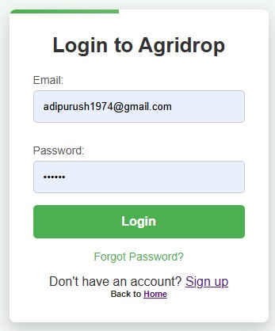
Fig 5.2.1 Buyer Registration Fig 5.2.2 Buyer Login

- Category Module:
It would typically allow users to select from icon of category.
- Pesticides & Fertilizers
- Tools
- Biowaste
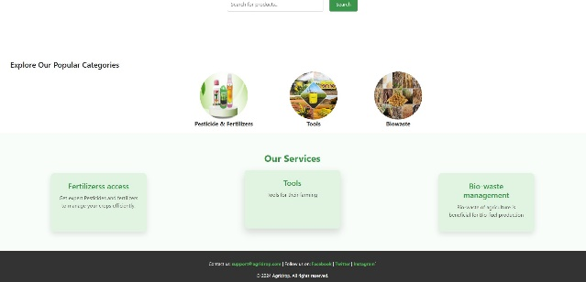
Fig 5.2.3 Products Category
3.Search Module:
- Users are able to search for their desired products
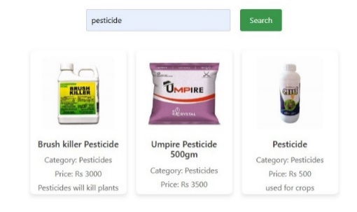
Fig 5.2.4 Search products

4.Add to Cart Module:
Allowing users to select and store items they wish to purchase while they continue browsing.
- Product Selection
- Storing Product in Cart (by clicking on add to cart button)
- Updating the Cart (remove, add, grand total)
- Cart Summary and Checkout
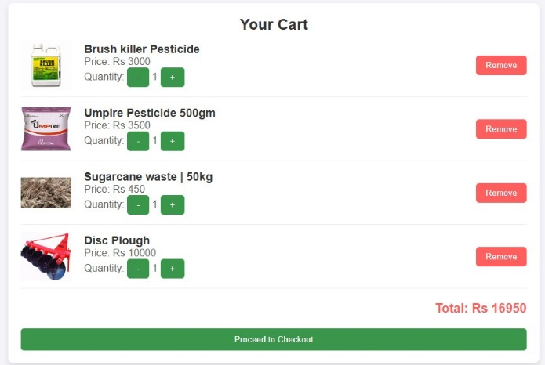
Fig 5.2.5 Cart View

5.Order Module:
- Order Creation
- Users are able to input the address
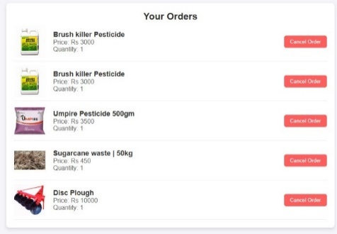
Fig 5.2.6 Order Summary
6.Payment Module:
- Users are able to choose payment options e.g. UPI or Cash on delivery
- Payment is done and order is confirmed
Example shown below for UPI payment

Fig 5.2.7 UPI Payment Interface

SELLER
1.Seller Registration and Login:
After login as a user, one can become seller through seller registration and seller login.
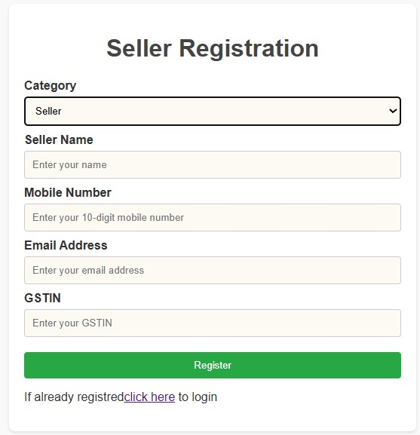
Fig 5.2.8 Seller Registration Fig 5.2.9 Seller Login

2.Sell the product:
Sell the product e.g. Biowaste by specifying product name, category, price, description and images of the product and the product is added to catalog.

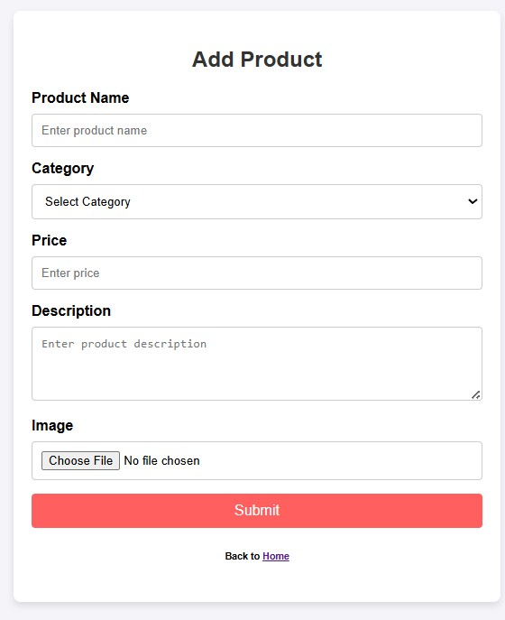
Fig 5.2.10 Seller adding product

5.3 DETAILED DESCRIPTIONS

- User Workflow:
- Register/Login: Users create accounts with basic details or log in if they’re existing users.
- Select Category: The user chooses the type of product one wants to purchase.
- Search products: Users can search products e.g. grass cutting tool.
- Add to cart: The user selects a product and adds to cart.
- Order: The order continues and address interface is popped up.
- Payment options: After entering address user is allowed to choose the payment option
and payment is done.
- Seller Workflow:
- Register: Seller registers with their details like GST No or PAN details.
- Sell Waste: Sellers enter information about the product and enter quantity and price.
- Product added to Catalog: Product can be viewed in catalog and bio-industries can purchase.
- Authentication:
    - A verification link is sent to user’s registered email.
    - User is expected to click the link in order to proceed using the platform.

CHAPTER 6
SYSTEM DEVELOPMENT

6.1 UI Design
Using HTML and CSS.

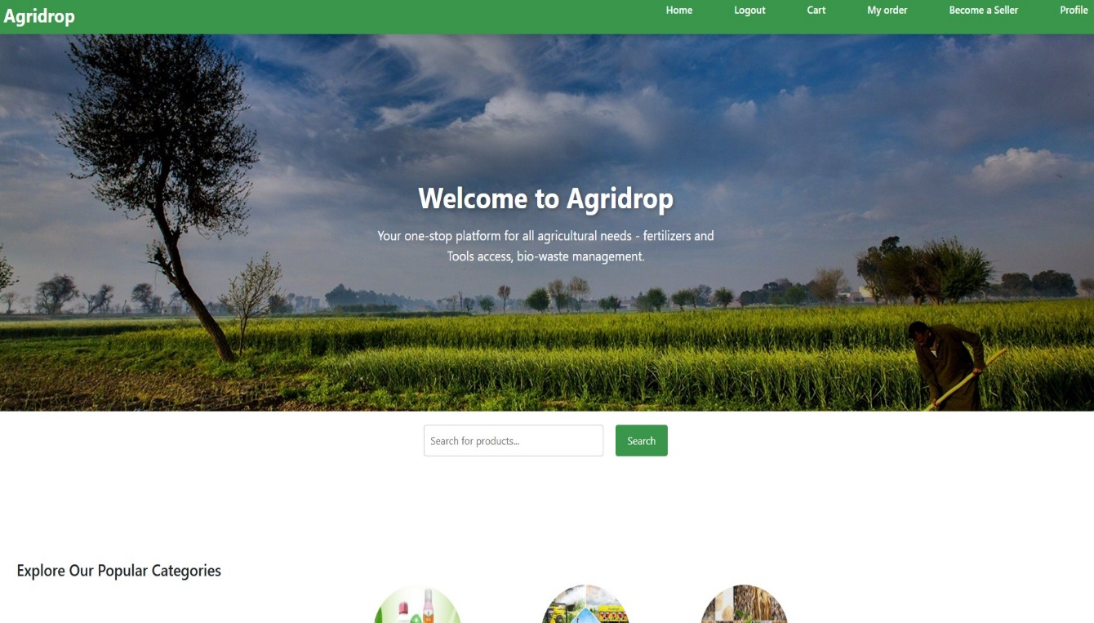
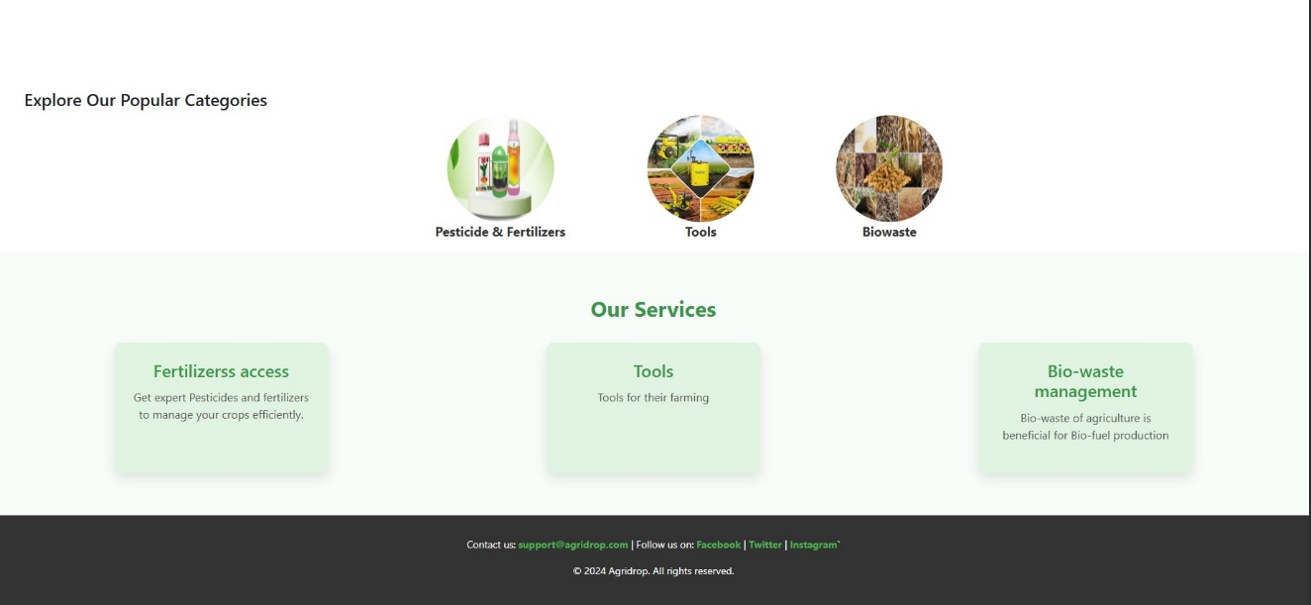
Fig 6.1.1 User Interface

6.2 Database Connection

Using Firebase NoSQL as it is a cloud-based platform developed by Google that provides a suite of tools and services for building, managing, and scaling web and mobile applications.
Firebase Database is used for storing user, seller and product details.
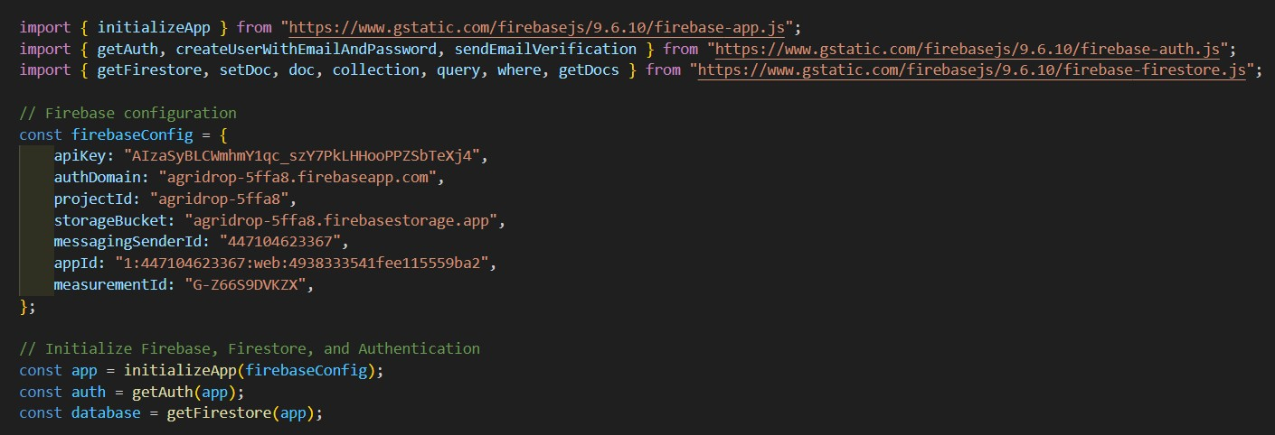
Fig 6.2.1 Database connection

CHAPTER 7
SYSTEM TESTING

E-mail Verification-A verification link is sent to registered user email soon after login.

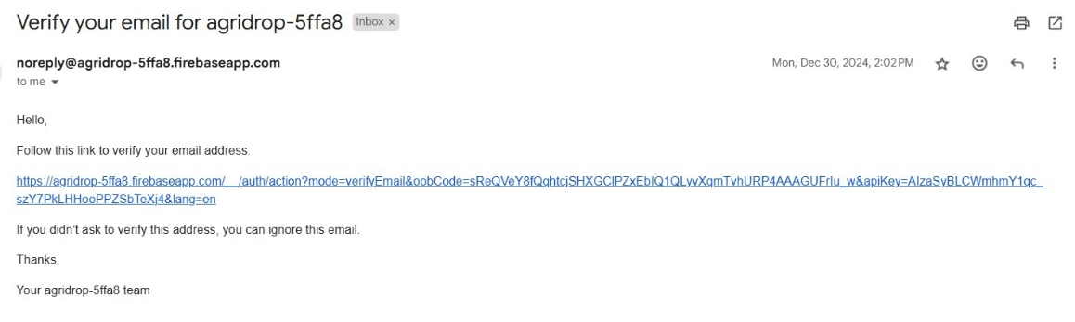
Fig 7.1.1 Email Verification

Testcase 1: User trying to buy product without login.

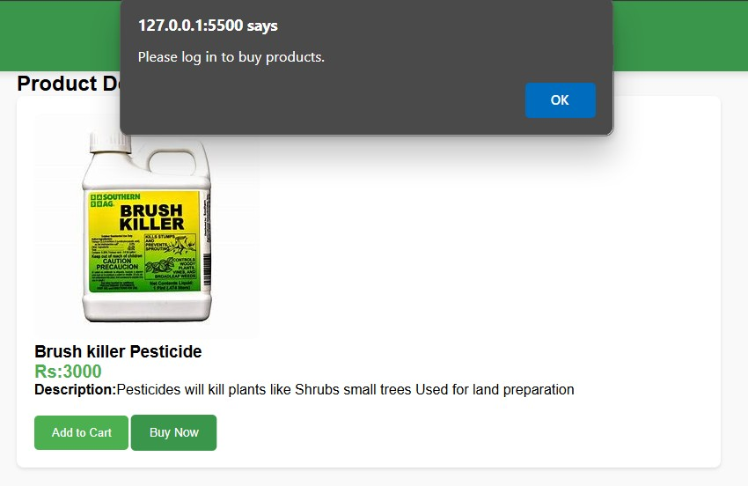
Fig 7.1.2 Request for login

Testcase 2: Seller trying to sell a product which has been banned, it can be removed.

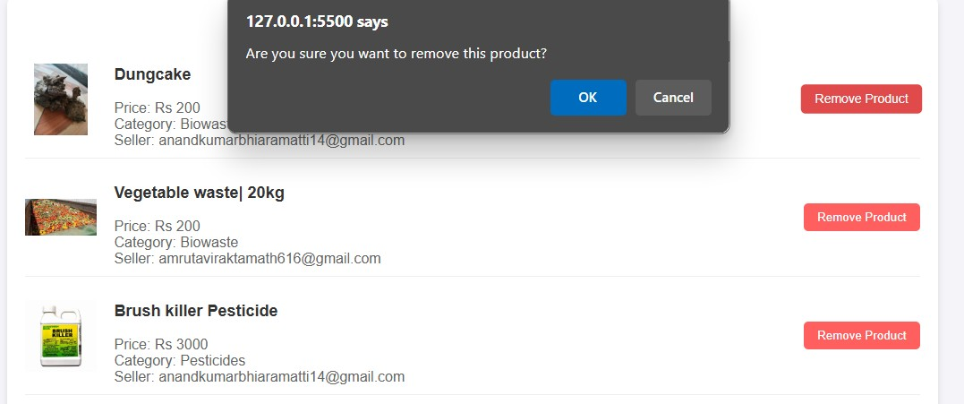
Fig 7.1.3 Removal of a banned product

Testcase 3: User is able to remove one product from the cart.

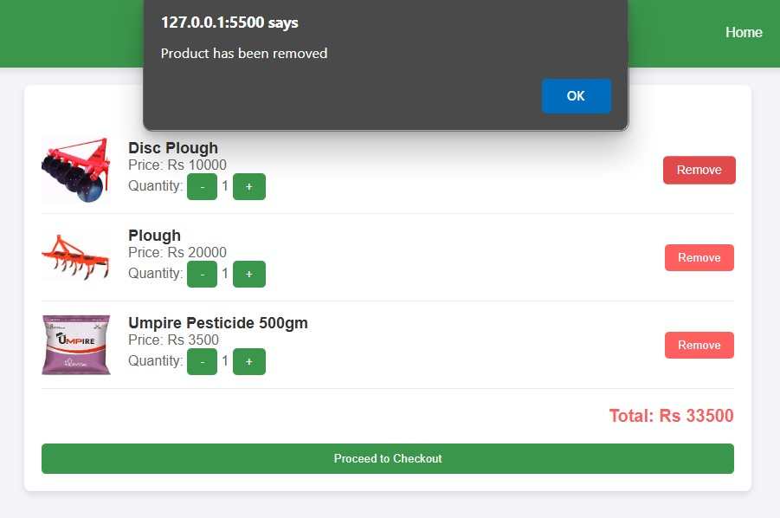
Fig 7.1.4 Removal of product from car

Testcase 4: User is able to cancel the order.
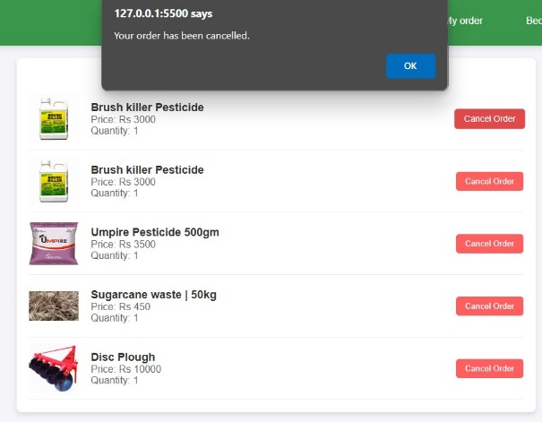
Fig 7.1.5 Order cancellation

CHAPTER 8
FUTURE SCOPE AND CONCLUSION

FUTURE SCOPE
1. Multilingual Support
Introduce multiple regional languages to make the platform accessible to farmers across diverse linguistic regions. Include voice-guided navigation and chatbot assistance in local languages for ease of use.

2. Delivery:
Use AI and machine learning to optimize delivery routes and minimize transit times. Partner with local logistics providers to improve last-mile delivery to remote areas.

3.Collection of Biowaste from Farmers:
Develop a scheduling system for efficient biowaste collection based on farmer availability. Introduce incentives for farmers to encourage regular participation in biowaste recycling programs.

4. Location Tracking:
Enhance real-time location tracking for delivery agents to provide accurate updates to farmers. Integrate geofencing to ensure efficient delivery and biowaste collection in designated zones.

5. Order Tracking:
Implement a live tracking system that updates farmers on the status of their orders at every stage. Provide detailed notifications about estimated delivery or collection times.

6. Pricing of Biowaste:
Develop a dynamic pricing model based on the quality and quantity of biowaste collected. Introduce a transparent pricing structure to ensure farmers receive fair compensation for their biowaste.

CONCLUSION

The AgriDrop platform is designed to revolutionize agriculture by addressing critical challenges such as limited access to quality inputs and sustainable agro-waste management. By empowering farmers with a digital marketplace for purchasing products and selling agricultural waste, the platform promotes economic growth and environmental sustainability. By leveraging modern delivery mechanisms, the platform ensures timely access to essential agricultural resources such as seeds and pesticides, empowering farmers to improve their productivity and efficiency. In addition to resource delivery, AgriDrop incorporates an innovative approach to sustainability by facilitating the collection and recycling of biowaste generated after harvest. This not only provides farmers with an eco-friendly method of waste disposal but also creates opportunities for industries to utilize this biowaste as raw material, fostering a circular economy. The project emphasizes the importance of bridging the urban-rural divide in agricultural support and aims to bring technological advancements to areas that are often underserved. Agri Drop has the potential to significantly enhance the livelihoods of farmers, contribute to sustainable agricultural practices, and support a greener and more resilient agricultural ecosystem.

REFERENCES

1.Swapnil Gupta, Prof. P. S. Badal, “E-national Agricultural Market (e-NAM) in India”,2020.
2.Sanjay Mavinkere Rangappa, Suchart Seingchin, “Agrowaste for renewable and sustainable green production", A review, Vol.434, 1 January 2024.
3. Mohammad Yakoob, Maulin P. Shah, "Agricultural waste management strategies for environmental sustainability", Vol 206, 15 April 2022.
4. Anandita Borthakur, Dr. Sayanika Borah, “Current Trends in Agriculture and Allied Sciences", Vol 2, pp.68-76, November 2023.
5. V. Basil. Hans, Dr. Govindaswamy and Shankaranarayana Udupi "Agricultural Marketing in India: Challenges, Opportunities, and transformations", December 8, 2023.

