Tableau Dashboard Export Report

Export Summary
Generated: 2025-06-13 19:38:26
Total Dashboards: 2

Dashboard 1
Project: New
Workbook: Pie & Bar
Dashboard: Pie & Bar Combo
Exported: 2025-06-13 19:37:39

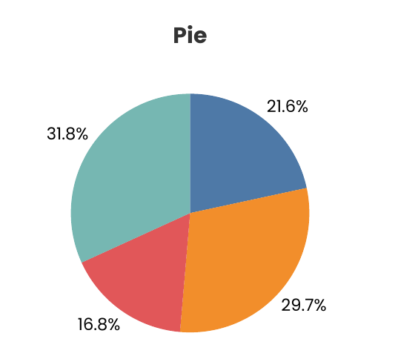

Dashboard 2
Project: New
Workbook: Pie & Bar
Dashboard: Pie & Bar Combo
Exported: 2025-06-13 19:38:00

