Tableau Dashboard Export Report

Export Summary
Generated: 2025-06-13 20:24:41
Total Dashboards: 2
Export Format: Microsoft Word Document (.docx)

Dashboards 1 & 2
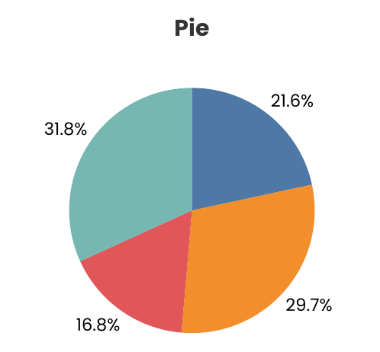 | Dashboard 1  Project: New  Workbook: Pie & Bar  Dashboard: Pie & Bar Combo  Exported: 2025-06-13 20:24:02

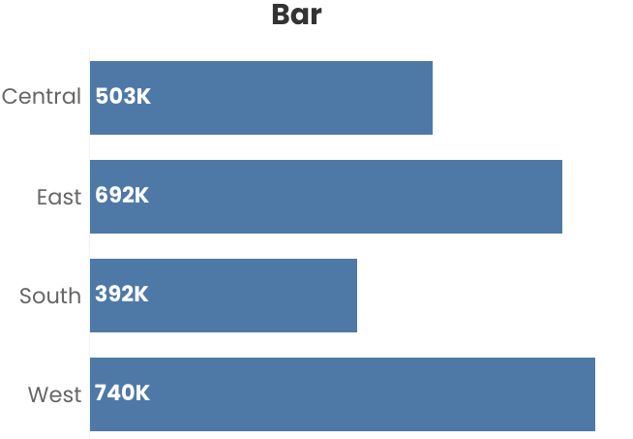 | Dashboard 2  Project: New  Workbook: Pie & Bar  Dashboard: Pie & Bar Combo  Exported: 2025-06-13 20:24:20

