# COMP-SCI 5540 Principles of Big Data Management

# University of Missouri-Kansas City

# Department of Computer Science and Electrical Engineering

# Project Report



**GitHub URL:** https://github.com/bharathkumarna/Principles-of-BigData

# Team – 6

Abhiram Reddy Nalla

Bharath Kumar Natesan Arumugam

Sai Kumar Ponnamaneni

Sibi Chakravarthy Ramesh

# Theme: (Wrestling)

The Ultimate Fighting Championship (UFC) is the world’s leading mixed martial arts (MMA) promoter and has held over 300 events to date. UFC is a combat sport abide by Unified Rules of Mixed Martial Arts where the outcomes are pre-determined and the matches are not choreographed. The UFC also connects with tens of millions of fans through its social media sites like Facebook, Instagram, and Twitter. The estimated tweets posted per hour (based on 1% sample) about #UFC is around 800.

World Wrestling Entertainment, Inc. (WWE) is an entertainment company that deals primarily in professional wrestling. WWE shows are purely entertainment based, featuring storyline-driven, scripted and choreographed matches. The estimated tweets posted per hour (based on 1% sample) about #WWE is around 750.

## References:

1. Wikipedia
2. Hashtags.org Analytics

# C:\Users\bn4n5\AppData\Local\Microsoft\Windows\INetCacheContent.Word\UML.JPGUML Diagram:

# Design Steps:

1. Collect social media data (tweets) using any theme as filter and store it as JSON files.
2. A Spark Context is created to establish connection to Spark Cluster.
3. SQL Context class is created which represents an entry point into all functionality in Spark SQL.
4. Data Frames are created based on content of JSON file and register it to tables.
5. Run SQL queries programmatically using SQL function on registered tables.
6. Store the returned results as JSON file.

# Libraries:

Spark Core contains the basic functionality of Spark and Spark SQL is Spark’s package for working with Structured data.

1. org.apache.spark:spark-core_2.11:2.0.02
2. org.apache.spark:spark-sql_2.11:2.0.02

Signpost has been designed to work in conjunction with Apache HTTPComponents library for signing HTTP messages on the Scala platform in conformance with the OAuth Core 1.0 standard.

1. oauth.signpost:signpost-commonshttp4:1.2.1.22
2. org.apache.directory.studio:org.apache.httpcomponents.httpclient:4.02
3. signpost-core-1.2.1.22
4. org.apache.directory.studio:org.apache.httpcomponents.httpcore:4.02

Tweepy – An easy-to-use Python library for accessing the Twitter API.

1. tweepy-3.5.0

# APIs:

1. Twitter public REST APIs - GET followers/ids

Resource URL: *https://api.twitter.com/1.1/followers/ids.json*

Returns a collection of user IDs for every user following the specified user.

# Programming Languages:

1. Scala – to run Spark Programs.
2. Python – to run Tweets collection program.

## Environment:

## Runtime Information:

|  |  |
| --- | --- |
| *Name* | *Value* |
| Java Version | 1.8.0_101 (Oracle Corporation) |
| Scala Version | version 2.11.8 |

## Spark Properties:

|  |  |
| --- | --- |
| *Name* | *Value* |
| spark.sql.warehouse.dir | file:///c:/tmp/spark-warehouse |
| spark.scheduler.mode | FIFO |
| spark.master | local[2] |
| spark.executor.id | driver |
| spark.driver.port | 55681 |
| spark.driver.host | 192.168.1.146 |
| spark.app.name | CountSpark |
| spark.app.id | local-1478459427915 |

## System Properties:

|  |  |
| --- | --- |
| *Name* | *Value* |
| file.encoding | UTF-8 |
| hadoop.home.dir | C:\hadoop-2.3.0\bin\tweet |
| idea.launcher.bin.path | C:\Program Files (x86)\JetBrains\IntelliJ IDEA Community Edition 2016.2.5\bin |
| os.arch | amd64 |
| os.name | Windows 10 |
| os.version | 10.0 |

# Queries:

## Query 1:

## Description:

Query to display the top 10 users who tweeted the most times.

## Code:

val Query1 = sqlcontext.sql("select user.name,user.screen_name, count(user.followers_count) as tweetsCount from querytable1 group by user.screen_name,user.name order by tweetsCount desc limit 10")

## Query 2:

## Description:

Query to display the top 10 users with most Sensitive Tweet numbers.

## Code:

val Query2 = sqlcontext.sql("select user.name,count(user.name) as no_of_sensitive_tweets from querytable1 where possibly_sensitive=true and user.lang='en' group by user.name order by no_of_sensitive_tweets desc limit 10")

## Query 3:

## Description:

Query to display the top hashtags used in my collected tweets in conjunction with data in the HashtagsTopics.txt file posted on Blackboard.

## Code:

val Query3 = sqlcontext.sql("select querytable3.name,count(querytable1.text) as count from querytable1 join querytable3 on querytable1.text like concat ('%',querytable3.name,'%') group by querytable3.name order by count desc limit 10 ")

## Query 4:

## Description:

Query to display cities with most number of Twitter users.

## Code:

val Query4 = sqlcontext.sql("select user.location,count(*) as no_of_users from querytable2 where user.location <> 'null' and user.location like concat ('%', ',' ,'%') group by user.location order by no_of_users desc limit 10")

## Query 5:

## Description:

Query to display the most popular time zones.

## Code:

val Query5 = sqlcontext.sql("SELECT user.time_zone,count(*) as no_of_tweets from querytable2 where user.time_zone <> 'null' group by user.time_zone order by no_of_tweets desc limit 10")

# Runtime Measurements for Queries:

|  |  |  |  |
| --- | --- | --- | --- |
| *Query* | *Runtime – JSON*  (sec) | *Runtime – Display*  (sec) | *Total*  (sec) |
| Query 1 | 11 | 6 | 17 |
| Query 2 | 6 | 5 | 11 |
| Query 3 | 14 | 13 | 27 |
| Query 4 | 17 | 13 | 30 |
| Query 5 | 10 | 9 | 19 |

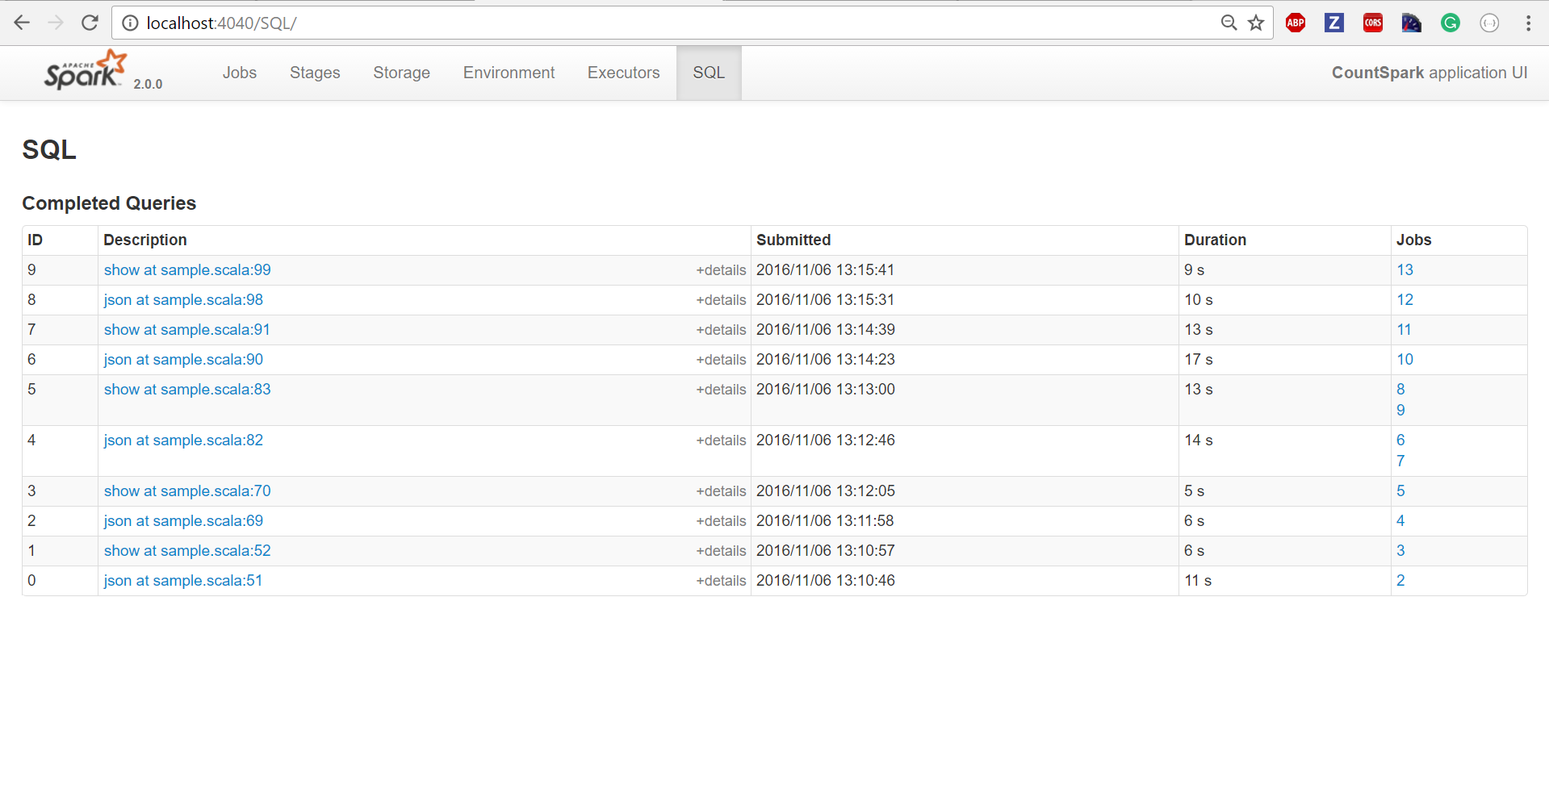

# Code:

# Collecting Tweets:

from tweepy.streaming import StreamListener

from tweepy import OAuthHandler

from tweepy import Stream

#Twitter Authentication

access_token = *"1048610250-QQZ8D05FWBIon130QSgjg0XGDN0dw3lXXhP7KFt"*

access_token_secret = *"RRiMG6c7mIY61apEJWSwoxMMaSVN8tQwIcuK627ugp46r"*

consumer_key = *"RRAnQIWfiuDBpJm94OWgwmpEF"*

consumer_secret = *"uXj3hPKmkU931K8ye5FMZemBUky4UyEQxQCz2Ej5qyS4zp0Ddw"*

class **StdOutListener**(StreamListener):

def **on_data**(*self*, data):

print(data)

with open(*'fetched_tweet.json'*,*'a'*) as tf:

tf.write(data)

return True

if __name__ == *'__main__'*:

l = StdOutListener()

auth = OAuthHandler(consumer_key, consumer_secret)

auth.set_access_token(access_token, access_token_secret)

stream = Stream(auth, l)

#Filter Tweets according to theme

stream.filter(track=[*'UFC'*,*'WWE'*])

# Spark SQL Program:

**import** oauth.signpost.commonshttp.CommonsHttpOAuthConsumer  
**import** org.apache.commons.io.IOUtils  
**import** org.apache.http.client.methods.HttpGet  
**import** org.apache.http.impl.client.DefaultHttpClient  
**import** org.apache.spark.{SparkConf, SparkContext}  
**import** org.apache.spark.SparkConf  
**import** org.apache.spark.SparkContext  
**import** org.apache.spark.sql.SQLContext  
  
**object** sample {  
 *//Twitter Authentication* **val** *AccessToken* = **"1048610250-QQZ8D05FWBIon130QSgjg0XGDN0dw3lXXhP7KFt"**;  
 **val** *AccessSecret* = **"RRiMG6c7mIY61apEJWSwoxMMaSVN8tQwIcuK627ugp46r"**;  
 **val** *ConsumerKey* = **"RRAnQIWfiuDBpJm94OWgwmpEF"**;  
 **val** *ConsumerSecret* = **"uXj3hPKmkU931K8ye5FMZemBUky4UyEQxQCz2Ej5qyS4zp0Ddw"**;  
  
 **def** main(args: Array[String]) {  
  
 System.*setProperty*(**"hadoop.home.dir"**,**"C:\\hadoop-2.3.0\\bin\\tweet"**)  
 **val** conf = **new** SparkConf().setAppName(**"CountSpark"**).setMaster(**"local[2]"**).set(**"spark.sql.warehouse.dir"**,**"file:///c:/tmp/spark-warehouse"**)  
 **val** sc = **new** SparkContext(conf)  
 **val** sqlcontext = **new** SQLContext(sc)  
 **import** sqlcontext.implicits._  
  
 *//Spark DataFrames* **val** tweetsfile = sqlcontext.read.json(**"C:\\Users\\bn4n5\\workspace\\Pb-ass\\mypackage\\fetched_tweet.json"**)  
 tweetsfile.registerTempTable(**"querytable1"**)  
  
 *//Spark RDD's* **val** string=sc.textFile(**"C:\\Users\\bn4n5\\workspace\\Pb-ass\\mypackage\\fetched_tweet.json"**)  
 sqlcontext.jsonRDD(string).registerTempTable(**"querytable2"**)  
  
 **var** a=**'Y'  
 while** (a==**'Y'**) {  
 *//Menu Option  
 println*(**"****** Analytical Queries using Apache Spark ******"**)  
 *println*(**"1=>Top Users who has Tweeted the most times"**)  
 *println*(**"2=>Users with Most Sensitive Tweet Numbers"**)  
 *println*(**"3=>Top Hashtags used in my collected data in conjunction with Trending Hash tags Topics"**)  
 *println*(**"4=>Cities with most Twitter users"**)  
 *println*(**"5=>Most Popular Time Zones"**)  
 *println*(**"Enter your choice:"**)  
 **val** choice=readInt()  
 choice **match** {  
  
 **case** 1 =>  
 *//Query 1 using Spark DataFrames* **val** Query1 = sqlcontext.sql(**"select user.name,user.screen_name, count(user.followers_count) as tweetsCount from querytable1 group by user.screen_name,user.name order by tweetsCount desc limit 10"**)  
 Query1.write.json(**"C:\\Users\\bn4n5\\workspace\\Pb-ass\\mypackage\\Query1"**)  
 Query1.show()  
  
 *//Query 1 calling public API* **val** name = readLine(**"Enter screen name to find user IDs for every user following the specified user:"**)  
 **val** consumer = **new** CommonsHttpOAuthConsumer(*ConsumerKey*, *ConsumerSecret*)  
 consumer.setTokenWithSecret(*AccessToken*, *AccessSecret*)  
 **val** request = **new** HttpGet(**"https://api.twitter.com/1.1/followers/ids.json?cursor=-1&screen_name="** + name)  
 consumer.sign(request)  
 **val** client = **new** DefaultHttpClient()  
 **val** response = client.execute(request)  
 *println*(IOUtils.*toString*(response.getEntity().getContent()))  
 *println*(**"Press Y to continue or N to exit:"**)  
 a = readChar()  
  
 **case** 2 =>  
 *//Query 2 using Spark DataFrames* **val** Query2 = sqlcontext.sql(**"select user.name,count(user.name) as no_of_sensitive_tweets from querytable1 where possibly_sensitive=true and user.lang='en' group by user.name order by no_of_sensitive_tweets desc limit 10"**)  
 Query2.write.json(**"C:\\Users\\bn4n5\\workspace\\Pb-ass\\mypackage\\Query2"**)  
 Query2.show()  
 *println*(**"Press Y to continue or N to exit:"**)  
 a = readChar()  
  
 **case** 3 =>  
 *//Query 3 using Spark DataFrames  
 //Query 3 uses data in the PopularHahtagsAndTopics.txt file posted on Blackboard in conjunction with my collected data* **val** text = sc.textFile(**"C:\\Users\\bn4n5\\workspace\\Pb-ass\\mypackage\\PopularHahtagsAndTopics.txt"**).map(_.split(**"/n"**)).map(frt => *Text*(frt(0))).toDF()  
 text.registerTempTable(**"querytable"**)  
 **val** Query=sqlcontext.sql(**"select querytable.name from querytable where querytable.name like '%#UFC%' or querytable.name like '%#WWE%' or querytable.name like '%#MMA%' "**)  
 Query.registerTempTable(**"querytable3"**)  
 **val** Query3 = sqlcontext.sql(**"select querytable3.name,count(querytable1.text) as count from querytable1 join querytable3 on querytable1.text like concat ('%',querytable3.name,'%') group by querytable3.name order by count desc limit 10 "**)  
 Query3.write.json(**"C:\\Users\\bn4n5\\workspace\\Pb-ass\\mypackage\\Query3"**)  
 Query3.show();  
 *println*(**"Press Y to continue or N to exit:"**)  
 a = readChar()  
  
 **case** 4 =>  
 *//Query 4 using Spark RDD's* **val** Query4 = sqlcontext.sql(**"select user.location,count(*) as no_of_users from querytable2 where user.location <> 'null' and user.location like concat ('%',',','%') group by user.location order by no_of_users desc limit 10"**)  
 Query4.write.json(**"C:\\Users\\bn4n5\\workspace\\Pb-ass\\mypackage\\Query4"**)  
 Query4.show()  
 *println*(**"Press Y to continue or N to exit:"**)  
 a = readChar()  
  
 **case** 5 =>  
 *//Query 5 using Spark RDD's* **val** Query5 = sqlcontext.sql(**"SELECT user.time_zone,count(*) as no_of_tweets from querytable2 where user.time_zone <> 'null' group by user.time_zone order by no_of_tweets desc limit 10"**)  
 Query5.write.json(**"C:\\Users\\bn4n5\\workspace\\Pb-ass\\mypackage\\Query5"**)  
 Query5.show()  
 *println*(**"Press Y to continue or N to exit:"**)  
 a = readChar()  
  
  
 }  
 }  
 }  
}  
**case class** Text(name: String)

# Output:

## C:\Users\bn4n5\AppData\Local\Microsoft\Windows\INetCacheContent.Word\Query1.pngQuery 1: **Top Users who has Tweeted the most times (Twitter API)**

## C:\Users\bn4n5\AppData\Local\Microsoft\Windows\INetCacheContent.Word\Query2.pngQuery 2: **Users with Most Sensitive Tweet Numbers**

## C:\Users\bn4n5\AppData\Local\Microsoft\Windows\INetCacheContent.Word\Query3.pngQuery 3: **Top Hashtags used in my collected data in conjunction with Trending Hashtags Topics**

## C:\Users\bn4n5\AppData\Local\Microsoft\Windows\INetCacheContent.Word\Query4.pngQuery 4: **Cities with most Twitter users**

## Query 5: **Most Popular Time Zones**

