Synopsis
on

“Autism Spectrum Disorder Detection using
Machine Learning”

ABSTRACT

It is always a complex procedure to diagnose autism spectrum disorder (ASD) because there is no particular medical test for autism, like a blood test, to make a diagnosis for the disorder. Autism spectrum disorder is defined by the disability and impairments of participating in social communication or the presence of restricted or repetitive behaviours, or both. It is a behaviourally diagnosed condition. To make a diagnosis, doctors look at the child's developmental history and behavior. Apparently, most children do not attain a proper diagnosis for autism until it is too late. In some cases, parents are reluctant to accept that their child's mental growth is not developing along with the child's physical growth. This lateness in diagnosis hinders a child's ability to get the help they need to keep developing. It is important to diagnose ASD as early as possible through monitoring, screening, and evaluating a child's development so that we can ensure proper care and support for an autistic child to help them reach their full potential. So, we are developing a system that will have the ability to diagnose Autism and come up with a reliable and effective conclusion even without the help of a professional. We hope this system will be very helpful for those concerned parents who are worried about their child's growth and activities, at the same time it will be very useful for the professionals.

INTRODUCTION

Autism, formally known as Autism Spectrum Disorder (ASD), is a complex neurodevelopmental condition that affects individuals in various ways. It is characterized by a wide range of symptoms and challenges that primarily impact social interaction, communication, and behavior. Autism is often described as a "spectrum" disorder because it manifests differently in each person, with varying degrees of severity and a diverse array of strengths and difficulties. Autism typically becomes apparent in early childhood, often before the age of three. However, it can continue to influence an individual's life throughout their lifespan. While the exact cause of autism remains the subject of ongoing research, it is believed to result from a combination of genetic and environmental factors. Some common features of autism include: Social Challenges: Individuals with autism may have difficulty with social interactions, including understanding social cues, maintaining eye contact, and forming relationships. Communication Difficulties: Many people with autism experience challenges in verbal and nonverbal communication. Some may have delayed speech development, while others may struggle with expressive and receptive language skills. Repetitive Behaviors: Individuals with autism often engage in repetitive behaviors or routines. These behaviors can include hand-flapping, rocking, or an intense focus on specific interests or topics. Sensory Sensitivities: Sensory sensitivities are common in autism. Individuals may be hypersensitive (overreacting to sensory stimuli like lights, sounds, or textures) or hyposensitive (underreacting to sensory stimuli). Strong Interests: Many individuals with autism have intense and focused interests in specific subjects or activities, often referred to as "special interests." These interests can be a source of passion and expertise. 3 Autism Spectrum Disorder Rigidity and Resistance to Change: Individuals with autism may prefer routines and can become distressed when faced with unexpected changes. It's important to note that autism is a lifelong condition, and while there is no cure, early intervention and various therapies, such as speech therapy, occupational therapy, and behavioral interventions, can significantly improve the quality of life for individuals with autism. Additionally, with appropriate support and understanding from family, friends, and the community, many individuals with autism can lead fulfilling and successful lives, making unique contributions to society. Autism awareness and acceptance are crucial in promoting inclusivity and ensuring that individuals with autism are given the opportunities they deserve to reach their full potential. 2.2 Outline According to the WHO’s statistical data, 0.63% of children are diagnosed with Autistic Spectrum Disorder (ASD). ASD occurs in children and continues to expand to adolescents and adults. In most cases, symptoms appear within the first 5 years of life. ASD is a serious neurodevelopmental disorder with very high healthcare costs. ASD is characterized by a permanent lack of social interaction and stereotypical behavior, often accompanied by a widespread deterioration of communication skills If ASD can be diagnosed early, it can be treated. Early detection of ASD plays a vital role in clinical diagnosis.This diagnosis can then inform personalized treatment regi-mens to improve the quality of life of children with ASD and their families. Unfortunately, the process of diagnosis of ASD can take a long time with expensive testing methods. Recently, the increase in ASD cases around the world is a motivation for doctors/scientists to find more effective screening methods. Today, with the advancement in modern technology, we can store a huge amount of data. Data mining is an important task to make decisions based on the collected data. This is linked to machine learning. In recent years, machine learning has acquired many achievements and it is gaining more importance in applied sciences such as medicine and biomedicine. In clinical decision making and diagnostics, machine learning methods are used or recommended to support data interpretation. Therefore, methods of screening diseases with the aid of machine learning are extensively studied.

AIM & OBJECTIVES

The main objective is to develop an application which can allow the user to be able to find out whether he/she may have chances of being Autistic. Other objectives of this application is to be able to satisfy the need for early detection of Autism and provide necessary details about such a medical condition. The application also consists of available doctors who specialize in certain fields, this can be vital and informative to the user. Our aim is to make this web application user friendly and accessible.

Objectives:
- The dataset Collection for Autism Spectrum Disorder Dataset from various sources.
- Data cleaning, Visualization and Feature Extractions
- Distinct machine-learning classification algorithms were used to build a classifier to predict the Disease.
- Modelling the data with classifiers
- Performance Evaluation and Predictions
- Building a web application to demonstrate the output.

EXISTING SYSTEM
The major part of the existing literature on autism spectrum disorder is covered by a prediction system based on traditional machine learning algorithms such as Linear Regression, Logistic Regression, multiple layer perceptron and deep neural network.
Using these machine learning model achieving very less accuracy such 67 to 72% with less precision, recall and F1 Square.

PROPOSED SYSTEM
The proposed models are validated by using performance measurement parameters such as accuracy, precision, and recall. In this research, autism spectrum disorder prediction has been investigated and compared using common parameters such as application type, simulation method, comparison methodology, and input data. The key purpose of this study is to give a centralized framework to use for researchers working on autism spectrum disorder prediction. Here we developed Random Forest, Support vector machine and KNN Algorithm to achieve good performance and evaluation of the model.
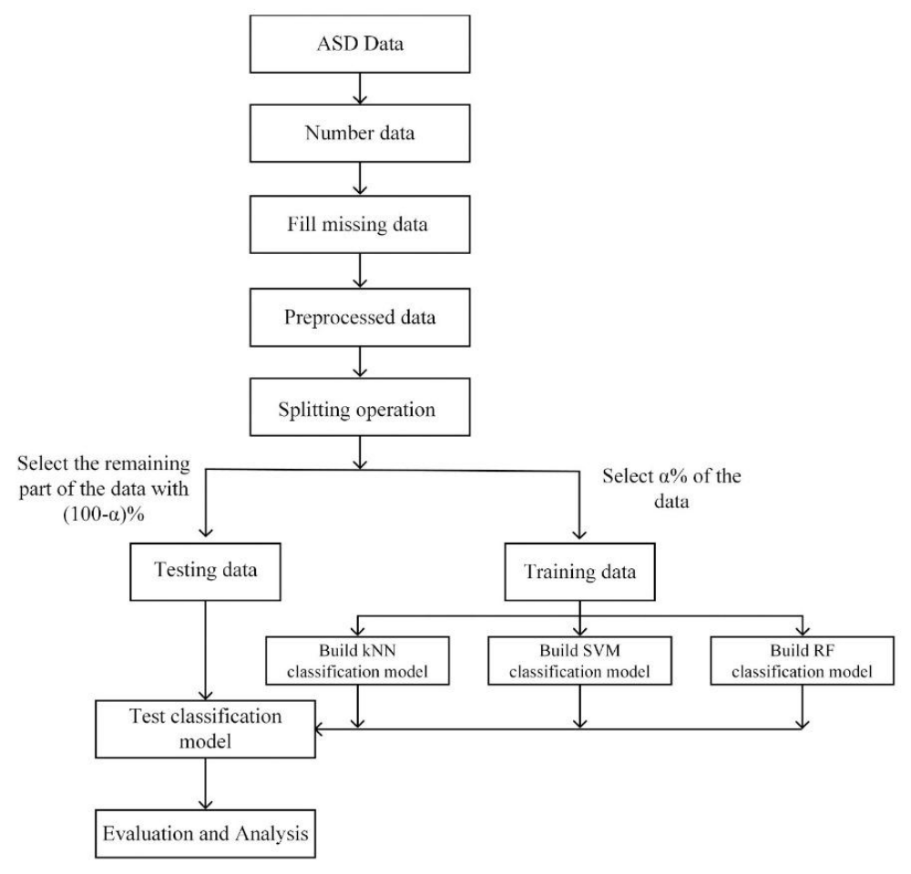
Figure 1: Proposed model

SYSTEM REQUIREMENT & SPECIFICATIONS
Requirements analysis is critical for project development. Requirements must be documented, actionable, measurable, testable and defined to a level of detail sufficient for system design. Requirements can be architectural, structural, behavioural, functional, and functional.
A software requirements specification (SRS) is a comprehensive description of the intended purpose and the environment for software under development.
Software Requirements
Scripting language : Python Programming
Scripting Tool : Anaconda Navigator (Jupyter Notebook) or Google Colab
Operating System : Microsoft Windows 8/ 10 or 11
Dataset : UCI Machine Learning Repository - Autism Dataset
Machine Learning Packages : Numpy, Pandas, Matplotlib , Seaborn Packages etc..
Web Application Platform : Flask ( Python Full Stack Framework )
Hardware Requirements
Processor : 3.0 GHz and Above
Output Devices : Monitor (LCD)
Input Devices : Keyboard
Hard Disk : 1 TB
RAM : 8GB or Above

REFERENCES

[1] Thabtah, Fadi. "Machine learning in autistic spectrum disorder behavioral research: A review and ways forward. (2018) " Informatics for Health and Social Care : 1-20.

[2] Thabtah, Fadi, Firuz Kamalov, and Khairan Rajab. (2018) "A new computational intelligence approach to detect autistic features for autism screening." International journal of medical informatics 117: 112-124.

[3] Vaishali, R., and R. Sasikala. "A machine learning based approach to classify Autism with optimum behaviour sets. (2018) " International Journal of Engineering & Technology 7(4): 18.

[4] Constantino, John N., Patricia D. Lavesser, Y. I. Zhang, Anna M. Abbacchi, Teddi Gray, and Richard D. Todd. (2007) "Rapid quantitative assessment of autistic social impairment by classroom teachers." Journal of the American Academy of Child & Adolescent Psychiatry 46(12): 1668-1676.

[5] Daniel Bone, Matthew S. Goodwin, Matthew P. Black, Chi-Chun Lee, Kartik Audhkhasi, and Shrikanth Narayanan. (2015) "Applying machine learning to facilitate autism diagnostics: pitfalls and promises." Journal of autism and developmental disorders 45(5): 1121-1136.

[6] Dennis Paul Wall, J. Kosmicki, T. F. Deluca, E. Harstad, and Vincent Alfred Fusaro. (2012) “Use of machine learning to shorten observationbased screening and diagnosis of autism.” Translational psychiatry, 2(4): e100.

[7] Dennis P. Wall, Rebecca Dally, Rhiannon Luyster, Jae-Yoon Jung, and Todd F. DeLuca. (2012) “Use of artificial intelligence to shorten the behavioral diagnosis of autism.” PloS one, 7(8): e43855.

[8] Fadi Thabtah. (2017). “Autism spectrum disorder screening: machine learning adaptation and DSM-5 fulfillment.” In Proceedings of the 1st International Conference on Medical and Health Informatics, pp. 1-6. ACM.

[9] Daniel Bone, Chi-Chun Lee, Matthew P. Black, Marian E. Williams, Sungbok Lee, Pat Levitt, and Shrikanth Narayanan.(2014). “The psychologist as an interlocutor in autism spectrum disorder assessment: Insights from a study of spontaneous prosody.” Journal of Speech, Language, and Hearing Research, 57(4): pp.1162-1177. [10] Fadi Thabtah. (2017) “ASD Tests. A mobile app for ASD screening.” www.asdtests.com [accessed December 20th, 2017].

