* 1. Create a simple ASP.NET MVC Web Application with the configuration of using the local Git.

[**https://github.com/bharathmunakala/MyRepo.git**](https://github.com/bharathmunakala/MyRepo.git)

**https://BH398747@dev.azure.com/BH398747/TopGearDevOps1/_git/TopGearDevOps1**

**MINGW64:/d/Bharath/FullStack**

BH398747@L-156108850 MINGW64 ~ (master)

$ cd D:\Bharath\FullStack\C#

bash: cd: D:BharathFullStackC#: No such file or directory

BH398747@L-156108850 MINGW64 ~ (master)

$ d:

bash: d:: command not found

BH398747@L-156108850 MINGW64 ~ (master)

$ git init

Reinitialized existing Git repository in C:/Users/bh398747/.git/

BH398747@L-156108850 MINGW64 ~ (master)

$ gid add README.md

bash: gid: command not found

BH398747@L-156108850 MINGW64 ~ (master)

$ git add README.md

fatal: pathspec 'README.md' did not match any files

BH398747@L-156108850 MINGW64 ~ (master)

$ git commit -m "first commit"

On branch master

Initial commit

Untracked files:

.VirtualBox/

.bash_history

.conda/

.config/

.gitattributes

.gitconfig

.gitignore

.idlerc/

.keras/

.matplotlib/

.templateengine/

3D Objects/

AgentLog.txt

AppData/

Application Data/

Automation Anywhere/

Contacts/

Cookies/

Desktop/

DevOpsProject1/

Documents/

Downloads/

Favorites/

IntelGraphicsProfiles/

Links/

Local Settings/

Microsoft/

Music/

My Documents/

NTUSER.DAT

NTUSER.DAT{8ebe95f7-3dcb-11e8-a9d9-7cfe90913f50}.TM.blf

NTUSER.DAT{8ebe95f7-3dcb-11e8-a9d9-7cfe90913f50}.TMContainer00000000000000000001.regtrans-ms

NTUSER.DAT{8ebe95f7-3dcb-11e8-a9d9-7cfe90913f50}.TMContainer00000000000000000002.regtrans-ms

NetHood/

OneDrive/

Pictures/

Recent/

SAP/

Saved Games/

SciTE.session

Searches/

SendTo/

Start Menu/

Videos/

VirtualBox VMs/

mcafee dlp quarantined files/

mm.cfg

ntuser.dat.LOG1

ntuser.dat.LOG2

ntuser.ini

ntuser.pol

source/

nothing added to commit but untracked files present

BH398747@L-156108850 MINGW64 ~ (master)

$ git commit -m "D:\Bharath\FullStack\C#"

On branch master

Initial commit

Untracked files:

.VirtualBox/

.bash_history

.conda/

.config/

.gitattributes

.gitconfig

.gitignore

.idlerc/

.keras/

.matplotlib/

.templateengine/

3D Objects/

AgentLog.txt

AppData/

Application Data/

Automation Anywhere/

Contacts/

Cookies/

Desktop/

DevOpsProject1/

Documents/

Downloads/

Favorites/

IntelGraphicsProfiles/

Links/

Local Settings/

Microsoft/

Music/

My Documents/

NTUSER.DAT

NTUSER.DAT{8ebe95f7-3dcb-11e8-a9d9-7cfe90913f50}.TM.blf

NTUSER.DAT{8ebe95f7-3dcb-11e8-a9d9-7cfe90913f50}.TMContainer00000000000000000001.regtrans-ms

NTUSER.DAT{8ebe95f7-3dcb-11e8-a9d9-7cfe90913f50}.TMContainer00000000000000000002.regtrans-ms

NetHood/

OneDrive/

Pictures/

Recent/

SAP/

Saved Games/

SciTE.session

Searches/

SendTo/

Start Menu/

Videos/

VirtualBox VMs/

mcafee dlp quarantined files/

mm.cfg

ntuser.dat.LOG1

ntuser.dat.LOG2

ntuser.ini

ntuser.pol

source/

nothing added to commit but untracked files present

BH398747@L-156108850 MINGW64 ~ (master)

$ git remote add origin https://github.com/bharathmunakala/TopGear.git

BH398747@L-156108850 MINGW64 ~ (master)

$ git push -u origin master

error: src refspec master does not match any

error: failed to push some refs to 'https://github.com/bharathmunakala/TopGear.git'

BH398747@L-156108850 MINGW64 ~ (master)

$ cd /?

bash: cd: /?: No such file or directory

BH398747@L-156108850 MINGW64 ~ (master)

$ cd D:\Bharath\FullStack\C#

bash: cd: D:BharathFullStackC#: No such file or directory

BH398747@L-156108850 MINGW64 ~ (master)

$ cd D:/Bharath/FullStack/C#

BH398747@L-156108850 MINGW64 /d/Bharath/FullStack/C#

$ echo "test content for git tutorial" >> CommitTest.txt

BH398747@L-156108850 MINGW64 /d/Bharath/FullStack/C#

$ git init

Initialized empty Git repository in D:/Bharath/FullStack/C#/.git/

BH398747@L-156108850 MINGW64 /d/Bharath/FullStack/C# (master)

$ git clone https://github.com/bharathmunakala/MyRepo.git

Cloning into 'MyRepo'...

warning: You appear to have cloned an empty repository.

BH398747@L-156108850 MINGW64 /d/Bharath/FullStack/C# (master)

$ git commit -m "added CommitTest.txt to the repo"

On branch master

Initial commit

Untracked files:

.vs/

CommitTest.txt

ContosoUniversity.sln

ContosoUniversity/

nothing added to commit but untracked files present

BH398747@L-156108850 MINGW64 /d/Bharath/FullStack/C# (master)

$ ^C

BH398747@L-156108850 MINGW64 /d/Bharath/FullStack/C# (master)

$ cd D:/Bharath/FullStack

BH398747@L-156108850 MINGW64 /d/Bharath/FullStack

$ git init

Initialized empty Git repository in D:/Bharath/FullStack/.git/

BH398747@L-156108850 MINGW64 /d/Bharath/FullStack (master)

$ ^C

BH398747@L-156108850 MINGW64 /d/Bharath/FullStack (master)

$ git clone https://github.com/bharathmunakala/MyRepo.git

Cloning into 'MyRepo'...

remote: Enumerating objects: 4, done.

remote: Counting objects: 100% (4/4), done.

remote: Compressing objects: 100% (3/3), done.

remote: Total 4 (delta 0), reused 0 (delta 0), pack-reused 0

Unpacking objects: 100% (4/4), done.

BH398747@L-156108850 MINGW64 /d/Bharath/FullStack (master)

$ git clone https://BH398747@dev.azure.com/BH398747/TopGearDevOps1/_git/TopGearDevOps1

fatal: could not create work tree dir 'TopGearDevOps1': Permission denied

BH398747@L-156108850 MINGW64 /d/Bharath/FullStack (master)

$ git remote add origin https://BH398747@dev.azure.com/BH398747/TopGearDevOps1/_git/TopGearDevOps1

BH398747@L-156108850 MINGW64 /d/Bharath/FullStack (master)

$ git push -u origin --all

fatal: HttpRequestException encountered.

An error occurred while sending the request.

fatal: Authentication failed for 'https://BH398747@dev.azure.com/BH398747/TopGearDevOps1/_git/TopGearDevOps1/'

BH398747@L-156108850 MINGW64 /d/Bharath/FullStack (master)

$ git push -u origin --all

fatal: unable to access 'https://BH398747@dev.azure.com/BH398747/TopGearDevOps1/_git/TopGearDevOps1/': Failed to connect to dev.azure.com port 443: Timed out

BH398747@L-156108850 MINGW64 /d/Bharath/FullStack (master)

$ git push -u origin --all

fatal: unable to access 'https://BH398747@dev.azure.com/BH398747/TopGearDevOps1/_git/TopGearDevOps1/': Failed to connect to dev.azure.com port 443: Timed out

BH398747@L-156108850 MINGW64 /d/Bharath/FullStack (master)

$ git push -u origin --all

fatal: unable to access 'https://BH398747@dev.azure.com/BH398747/TopGearDevOps1/_git/TopGearDevOps1/': Failed to connect to dev.azure.com port 443: Timed out

1. Commit the changes to the local Git.

BH398747@L-156108850 MINGW64 /d/Bharath/FullStack (master)

$ git remote add origin https://BH398747@dev.azure.com/BH398747/TopGearDevOps1/_git/TopGearDevOps1

fatal: remote origin already exists.

BH398747@L-156108850 MINGW64 /d/Bharath/FullStack (master)

$ git push -u origin --all

fatal: HttpRequestException encountered.

An error occurred while sending the request.

fatal: Authentication failed for 'https://BH398747@dev.azure.com/BH398747/TopGearDevOps1/_git/TopGearDevOps1/'

1. Create a domain onto VSTS with online Git repository.
2. Configure ASP.NET MVC Web Application to connect the domain created on VSTS and sync up the local Git with the online Git

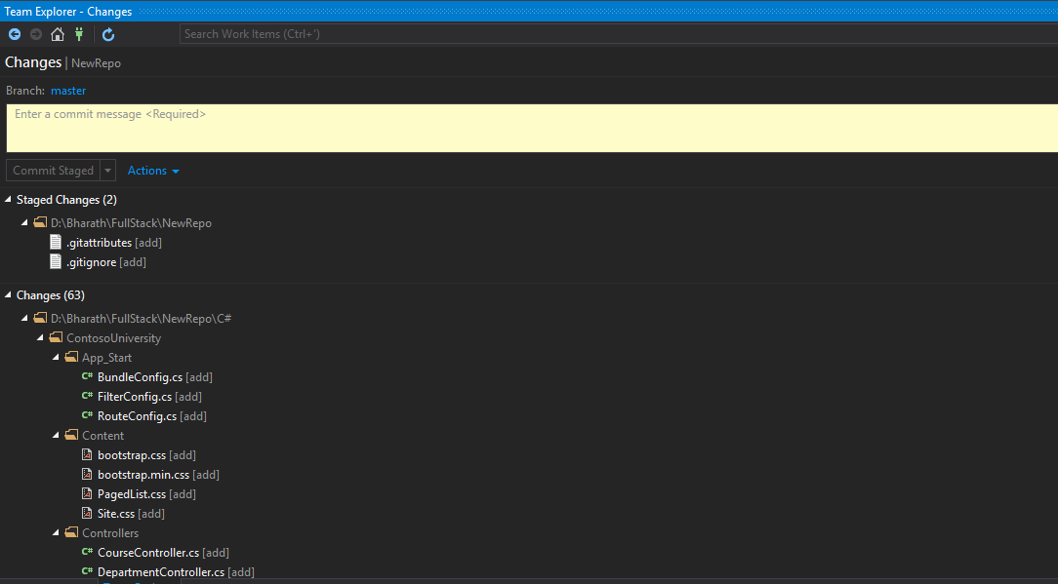

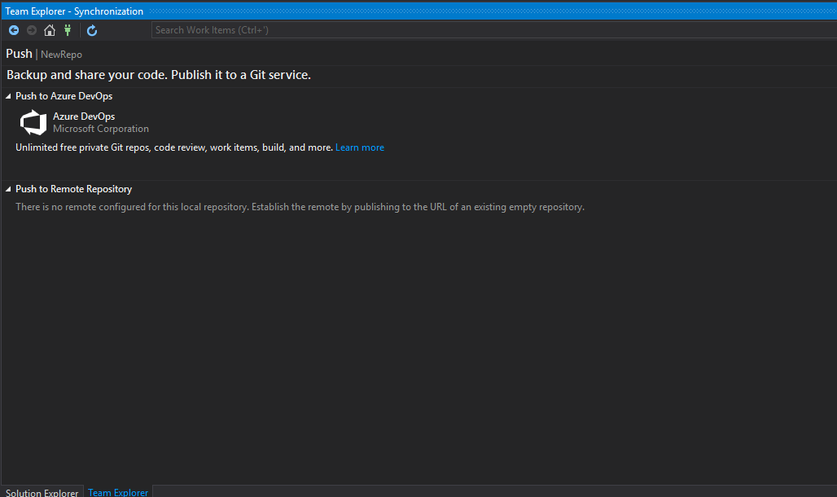

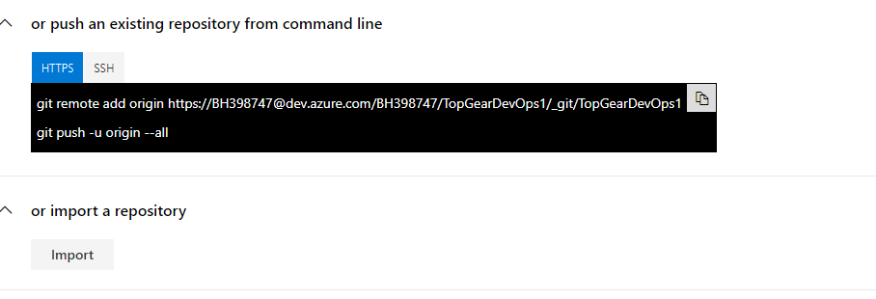

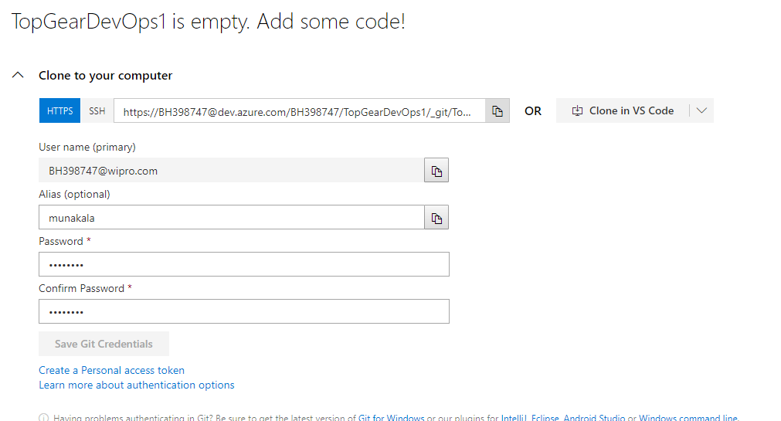

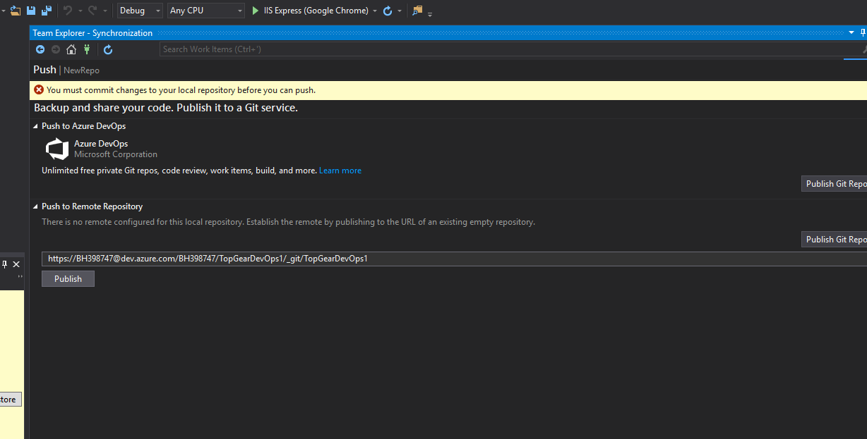 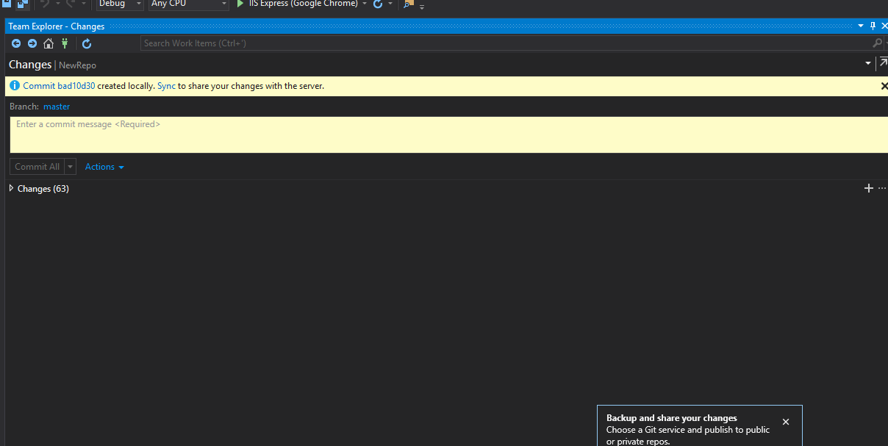

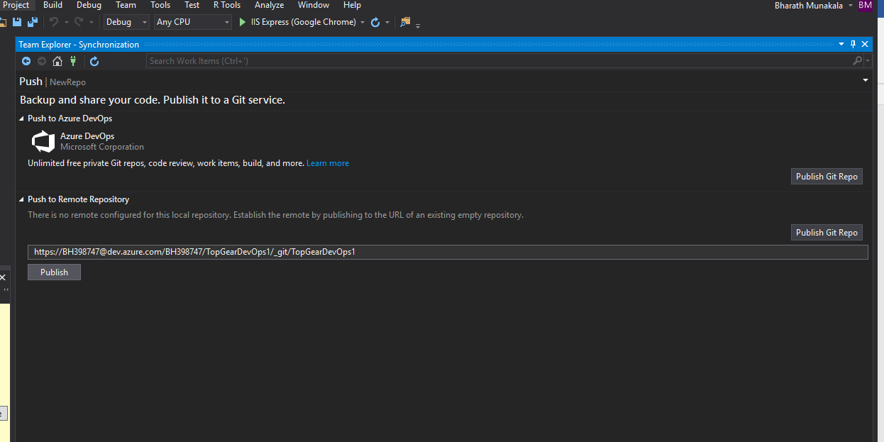

Getting error while accessing

Opening repositories:

C:\Users\bh398747

Opening repositories:

D:\Bharath\FullStack\NewRepo

Commit bad10d30 created locally in repository D:\Bharath\FullStack\NewRepo

Opening repositories:

D:\Bharath\FullStack\NewRepo

The calling thread cannot access this object because a different thread owns it.

Pushing master

Error encountered while pushing branch to the remote repository: Git failed with a fatal error.

unable to access 'https://BH398747@dev.azure.com/BH398747/TopGearDevOps1/_git/TopGearDevOps1/': Failed to connect to dev.azure.com port 443: Timed out

Pushing to <https://BH398747@dev.azure.com/BH398747/TopGearDevOps1/_git/TopGearDevOps1>

Pushing master

Error encountered while pushing branch to the remote repository: Git failed with a fatal error.

unable to access 'https://BH398747@dev.azure.com/BH398747/TopGearDevOps1/_git/TopGearDevOps1/': Failed to connect to dev.azure.com port 443: Timed out

Pushing to <https://BH398747@dev.azure.com/BH398747/TopGearDevOps1/_git/TopGearDevOps1>

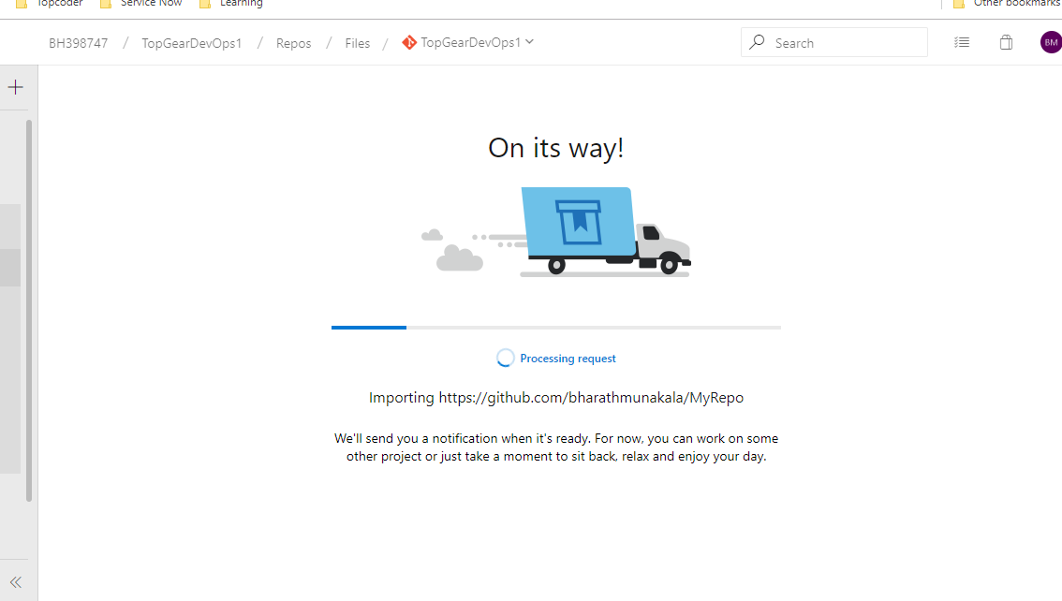

1. Create a new build definition onto domain on VSTS with the configuration of “continuous build” and target platform to be “App Service - Azure Cloud” (for the auto deployment).

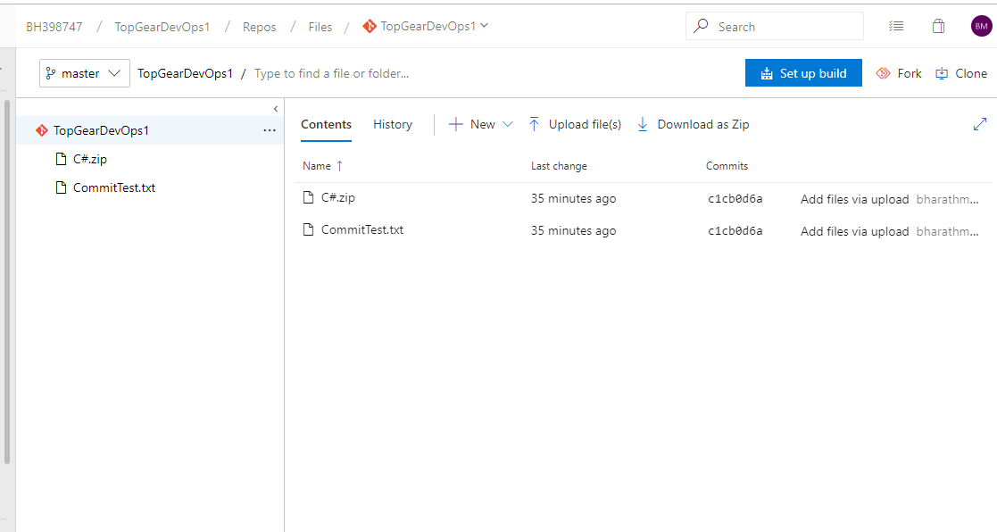

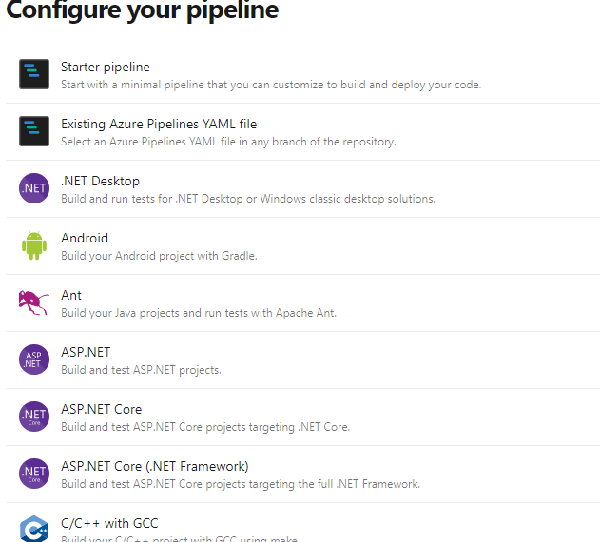

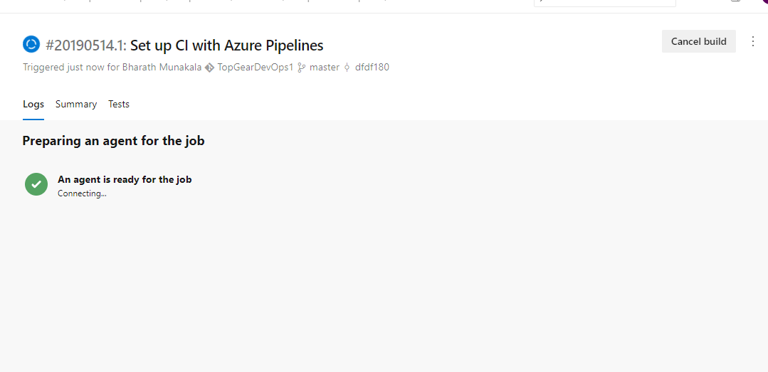

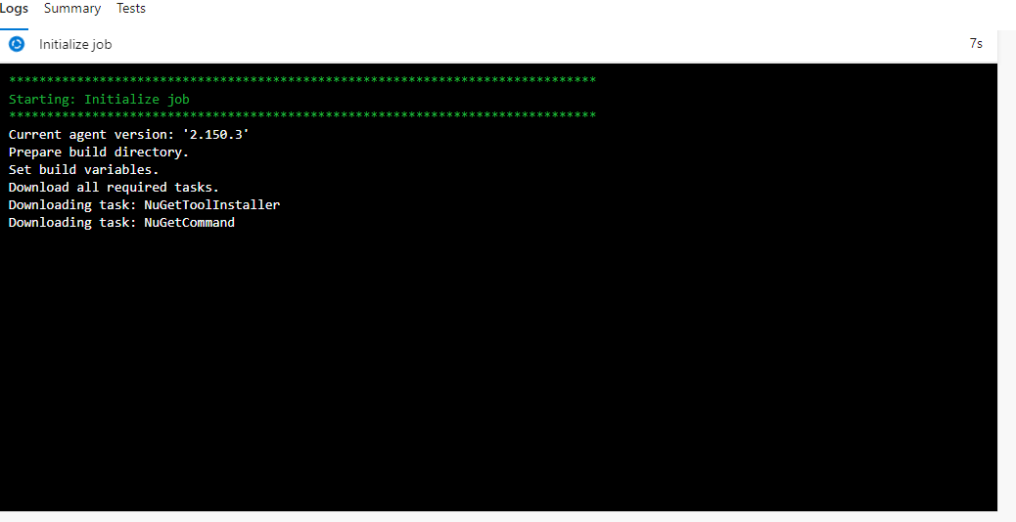

**The Solution was not found because there was a connection error while commiting the code into git repository.**



