Personal Contact Saver

User Understanding Document:   
Complete Project

Version 1.0

Date 11-7-2017

Revision History

|  |  |  |  |
| --- | --- | --- | --- |
| **Date** | **Version** | **Description** | **Author** |
| 11/07/2017 | V1.0 | First Draft | Bharath Psc |

Table of Contents

1. Purpose 3

2. Introduction 3

3. Flow chart 3

3.1.1 Login 3

3.1.1 User creation 3

3.1.1 User Deletion 3

3.1.1 User Password Update 3

4. Contact 3

4.1. contact creation 3

4.1. contact updation 3

4.1. contact deletion 3

# Purpose

* The purpose of the document is to make the user understand the project Personal Contact Saver.

# Introduction

* This project help is saving contacts of each user i.e., contact name, email and birth date.
* 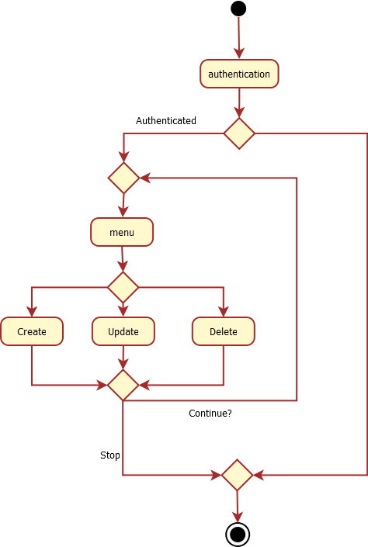

# Login

* User can login with his unique credentials.
* This is for the authentication of the application.

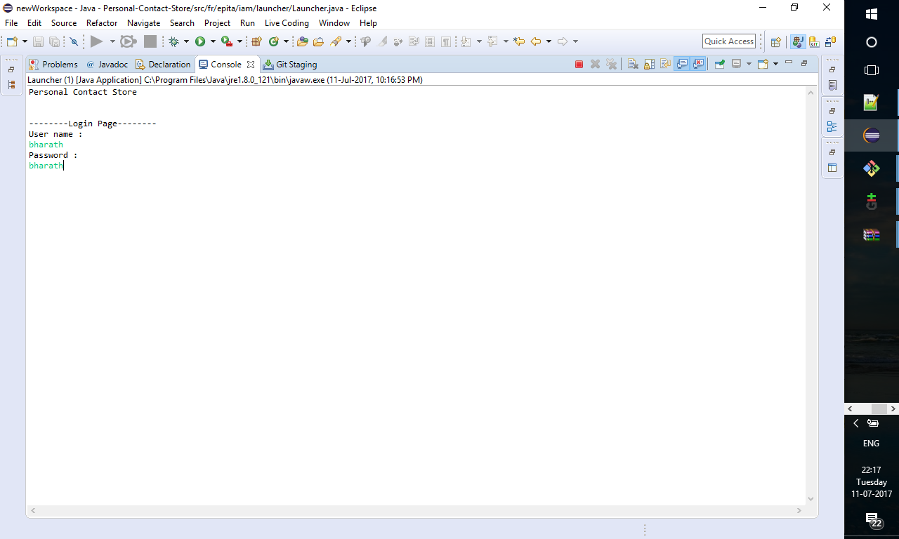

# User Creation

* For to login, user needs a user name and password, so he can create a user name and password
* The creation option comes when only the user gives wrong credentials.
* User can choose a user name and password and will be navigated to the login page again if successfully created.

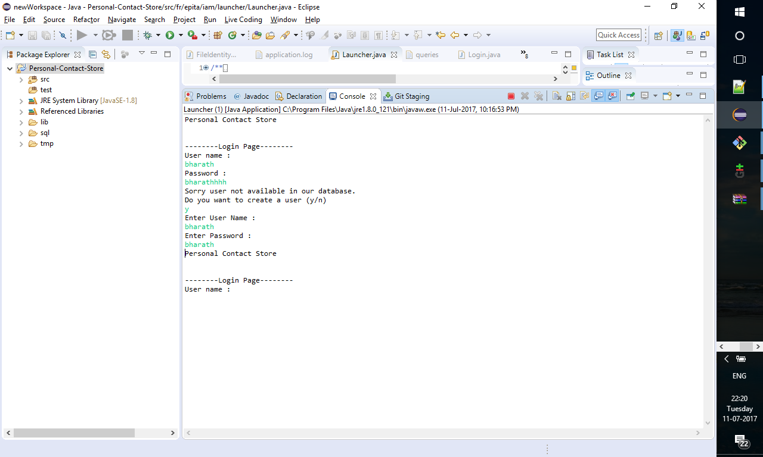

# User credentials updating and deletion

* User can only update his password but not the user name.
* A user can be deleted.
* These update and delete options will be enabled if and only if the respective user logs in to the system.
* After updating the password, user needs to log in again for security reason.

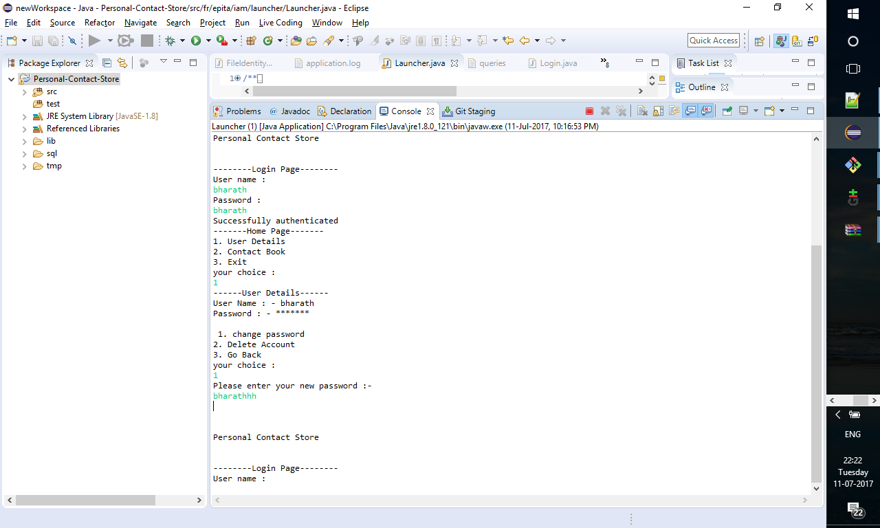

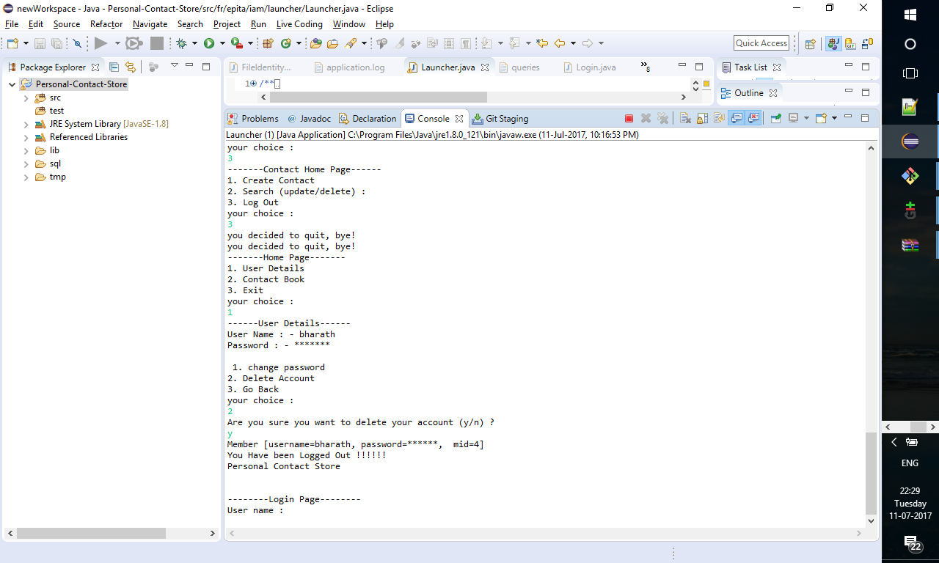

# Contact Book

* Each contact book is unique for each user.
* A user can only view the contacts he created.
* A contact book contains name, email and birthdate.
* Any contact can be created in the contact book only if a user is logged in
* Contact name and email are alpha numeric strings
* Birth date is of SQL date type i.e., “for example 1994-06-27”

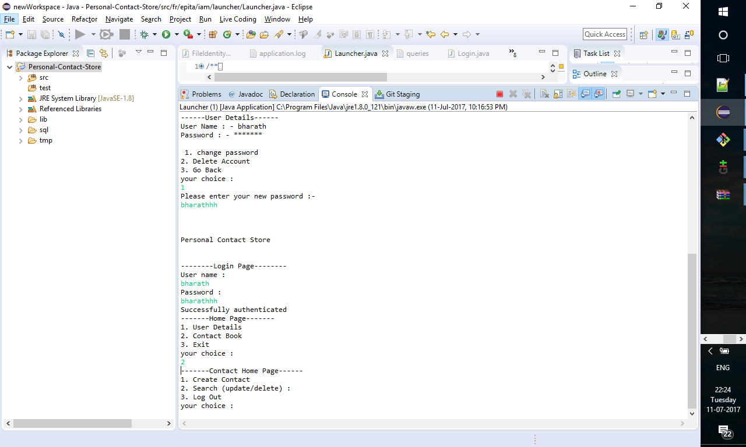 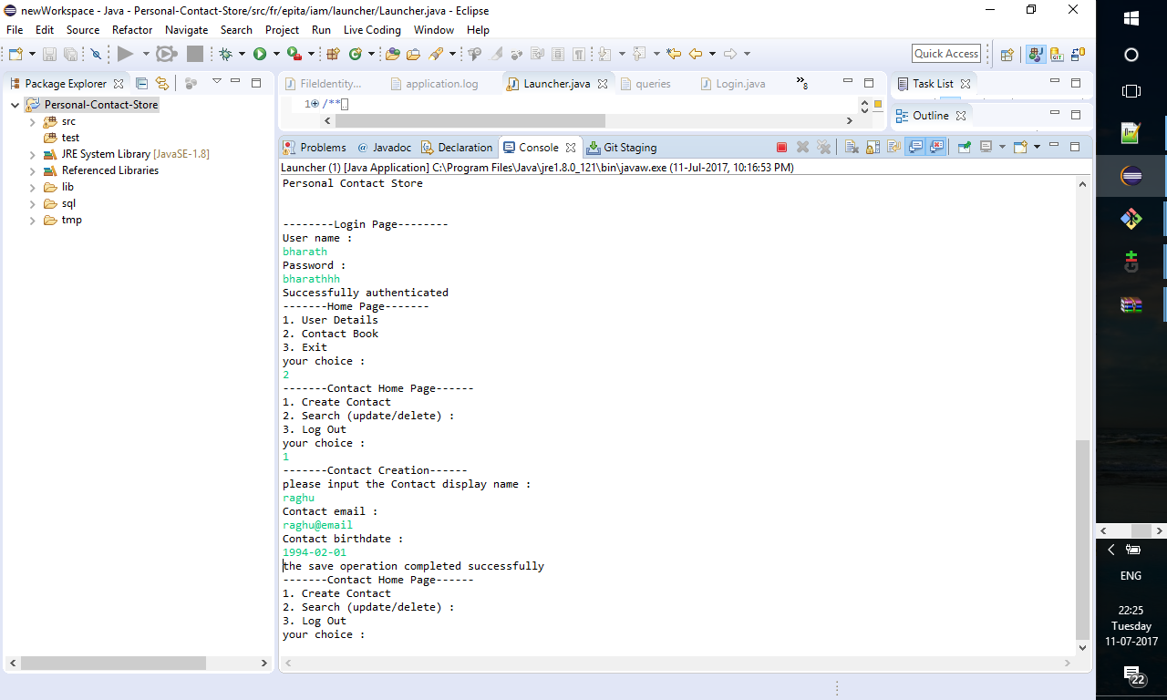

# Contact updating and deletion

* Any contact can be updated after creation or later.
* A contact can be updated using its given unique id.
* All the fields like name email and birth date can be updatable.
* Deletion of contact is different from deletion of user credentials.
* There is no asking of are you want to delete the contact before deleting.
* So, user has to be careful before deleting.

