Make Commerce Happen

1. Introduction

This is design document for providing logistics support for the business customers with the following assumptions
- Partners will provide the rate and hub details.
- Commerce companies will request for the quotation for delivering shipments with details like shipment quantity, pick up and drop address.
- Quotation will have the cost estimation and ETA details based on partners.

2. Architecture Design

The platform service will be Spring boot based rest service. The Input will be received via postman and the output will be displayed on the standard system output.(Command prompt)

The data will be persisted in mysql database.

Google API’s and open source shortest path calculation algorithm will be used to get the cost-effective and reliable way to deliver shipments.

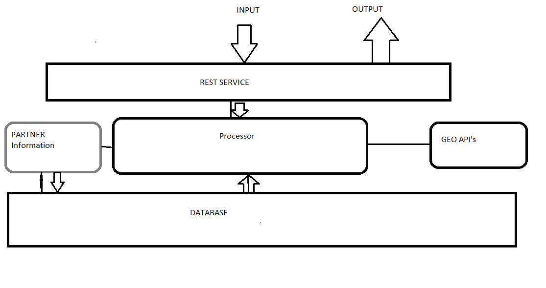

Modules:

- Partner
- Update partner information
- Add or remove partner information
- Get Partner information

- Processor
- Read Request
- ProcessRequest
- GenerateResponse

- DataLayer
- CRUD operations
- ACID

- GeoCalculator
- Find shortest path
- Calculate ETA

- ReportGeneration
- Partner information details
- Total number of requests
- Request details
- QuotaionDetail for each request

3. Database Design

Tables schemas

Partner
Description | This table holds information of all the partners that the platform supports or tied up with.
Attribute | Description | Type | Examples of values
Id | Id of a Partner | INTEGER | Between 1 and 999999999
Name | Name of Partner | VARCHAR | DTDC
TransportType | Mode of transports available at partners end | VARCHAR | Car, Truck etc
quantity | Number of available quantities. | INTEGER | Between 1 and 999999999
rate | Cost wrt to mode of transport used for delivery. | VARCHAR | Between 1 and 999999999
OutofCitySupport | Provides out of city support for shipment delivery or not | VARCHAR(1) | 0/1
Location | Partners Location | VARCHAR | String

Primary key = #id.

Shipment
Description | This table holds information of all shipments to be delivered to customers.
Attribute | Description | Type | Examples of values
Id | Id of a Shipment | INTEGER | Between 1 and 999999999
Name | Name of Shipment | VARCHAR | DTDC
Pickup_address | Address of the warehouse from where shipment needs to be picked. | VARCHAR | Car, Truck etc
Delivery_address | Address where shipment needs to be delivered. | INTEGER | String
Type | Type of the shipment | VARCHAR | Fridge, Cloths etc
Request_date | Date when the quotation was received. | TIMESTAMP | Date
Customer_name | Name of Shipment | VARCHAR | DTDC

Primary key will be #id

Git Hub :
https://github.com/bharathphatak/careem

