**Stack overflow developer servey 2020**

**-Bharath Kumar P**

**-Roll no:20**

Data-set:

Download link: https://insights.stackoverflow.com/survey

It contains four files as follows:

1. public dataset csv.

2. schema csv.

3. readme file.

4. pdf file describng about the servey.

Language preference:

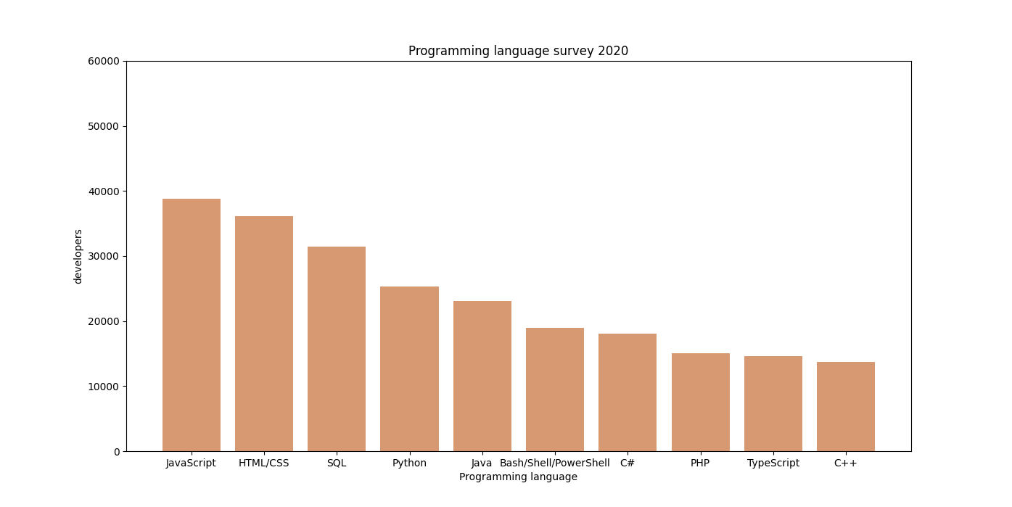

Code:

with open("./data/survey_results_public.csv") as f:

csv_reader = csv.DictReader(f)

webframework_counter = Counter()

language_counter = Counter()

for line in csv_reader:

webframeworks = line['WebframeWorkedWith'].split(';')

webframework_counter.update(webframeworks)

print(webframework_counter )

The above code will return the following Counter object which is futher plotted in graph:

Counter({'NA': 22182, 'jQuery': 18316, 'React.js': 15167, 'Angular': 10617, 'ASP.NET': 9258, 'Express': 8961, 'ASP.NET Core': 8082, 'Vue.js': 7322, 'Spring': 6941, 'Angular.js': 6826, 'Django': 6014, 'Flask': 6005, 'Laravel': 4680, 'Ruby on Rails': 2944, 'Symfony': 1851, 'Gatsby': 1703, 'Drupal': 1369})

Similarlly the following analysis is done.

Employment:

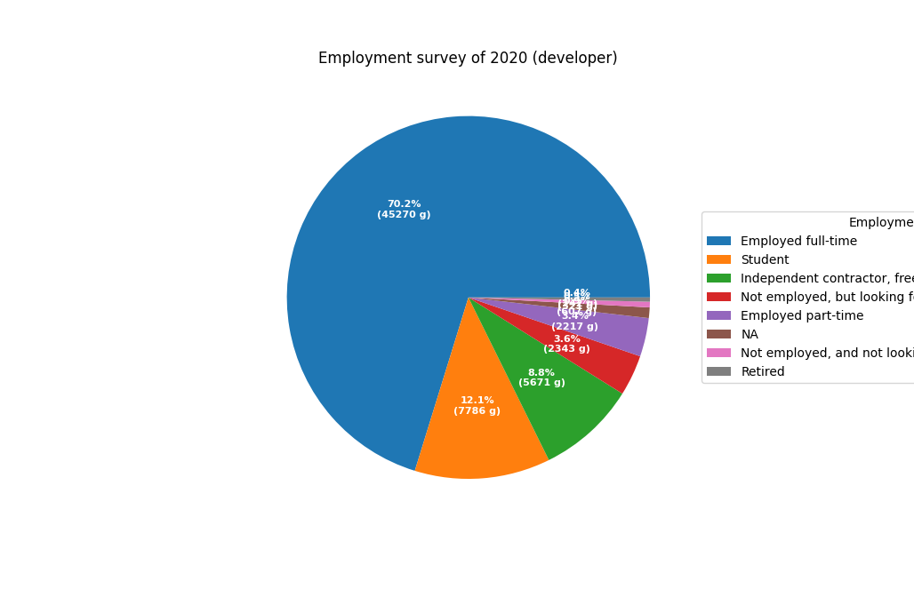

Web Framework:

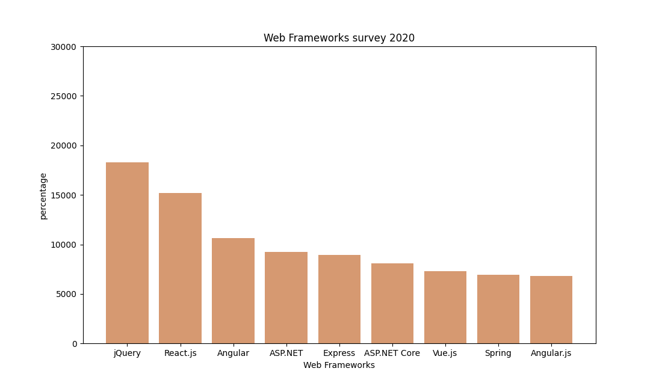

Platform:

