**Code Flow Diagram:**

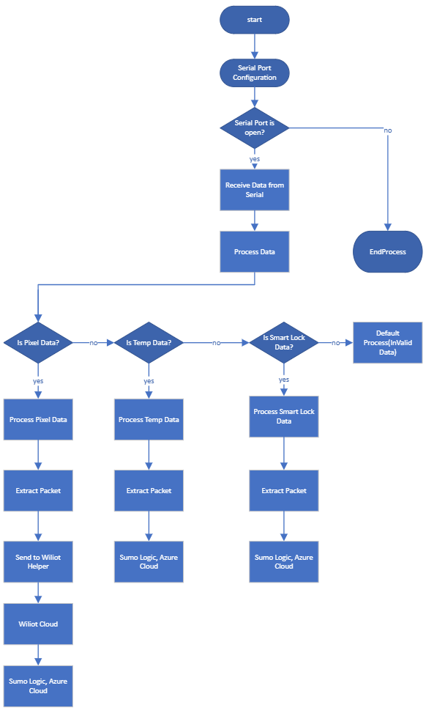

**Serial Port Configuration:**

1. config serial with required port and baud rate
2. If serial port is open, then starts receiving data, data gets processed, otherwise, program end here.

**Process Data:**

1. received data starts process, based on condition it satisfies it go, process pixel data, or process trh data or process smartlock data.

**Process Pixel Data:**

1. Raw data extracted from received data from using extract process.
2. With the help of wiliot helper, payload created, and sent to wiliot cloud.
3. Sumologic receives the data from wiliot cloud via S3.
4. Azure cloud receives data from wiiliot cloud using post pi.

**Process Temp Data:**

1. Raw data extracted from received data from using extract process.
2. Sumologic receives the data from wiliot cloud via S3.
3. Azure cloud receives data from wiiliot cloud using post pi.

**Process SmartLock Data:**

1. Raw data extracted from received data from using extract process.
2. Sumologic receives the data from wiliot cloud via S3.
3. Azure cloud receives data from wiiliot cloud using post pi.

**Default Process:**

1. If data does not follow to required conditions, it will go default process, give invalid data as output.

**Functionality:**

1. **Temperature Sensor:**

* TRH sensor is sending data in ascii format.

**AT-TRH_ID: TRH#1A4B9E_ADD:9E4B1A0997E8_T:7030_H:0318_B:A60E_CRC:C5A4**

* Before Sending data to azure for storage, it is converted to hexadecimal and a given key-value pair in Json format is sent to the cloud.

**TRH#1A4B9E**

**{**

**"UnitID": "TRH#1A4B9E",**

**"Temperature": 24.810000000000002,**

**"Humidity": 60.28,**

**"Battery Voltage": 3.75,**

**"status": "success"**

**}**

**Data stored in Azure:**

**Data Visualization: Sumo-Logic**

1. **Smart-Lock:**

* Smart Local is sending data in ascii format:

**AT-SLB_ADD:569589D68BF8_D:7F14014E44000531_CRC:8C51.**

* Before Sending data to azure for storage, it is converted to hexadecimal  and a given key-value pair in Json format  is sent to the cloud.

**{**

**"unitId": "569589D68BF8",**

**"locking Counter": 49,**

**"Lock status": "[BleSuccessUnlocking, PininPlace, Locked,            NfcSuccessUnlocking]",**

**"status": "success"**

**}**

**Data stored in Azure:**

**Data Visualization: Sumo-Logic**

**Working**

1. **Pixels:**

* From pixels encrypted data is received.

