**Objective**

The objective of this initiative to use a Raspberry Pi as an IoT gateway and several IoT sensors (such as a smart lock ,TRH and Wiliot-Pixels), the goal is to send and store the sensor’s data to an Azure cloud for future analytics and visualize the data in sumo-logic.

**Scope**

* Enable the logistics-Cold Chain Tracking solution on the Azure cloud to tap new customers.
* Attempting to use a Raspberry Pi as a gateway (replacing Optio3 Gateway).

**Architecture Overview:**

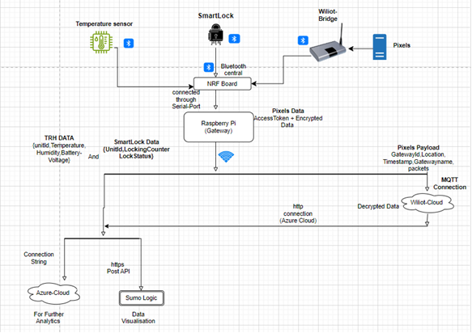

1. With the aid of Wiliot Bridge, the pixels will deliver payload containing GatewayId, Gatewayname, Location, and packets to NRF Board.
2. A RaspberryPi NRF development kit is attached, and it will receive data from various sensors. In this example,it is from Pixels, TRH and Smart-lock.
3. Now, the payload is transmitted over a MQTT connection to Wiliot Cloud, as the data originating from pixels is encrypted and will only be decrypted within Wiliot Cloud.
4. Data is transferred from the Wiiliot cloud to the Azure cloud for storing and to carry out additional operations. Data from Azure is sent to Sumo-Logic for visualization.
5. Likewise, other sensors such as temperature and smart lock are used.The temperature and smartlock data are transferred straight to Azure Cloud,simultaneously sends them to Sumo-Logic.