**SonarQube**:

Application is connected with SonarQube Analysis, which helps in finding vulnerabilities and bugs in our application.

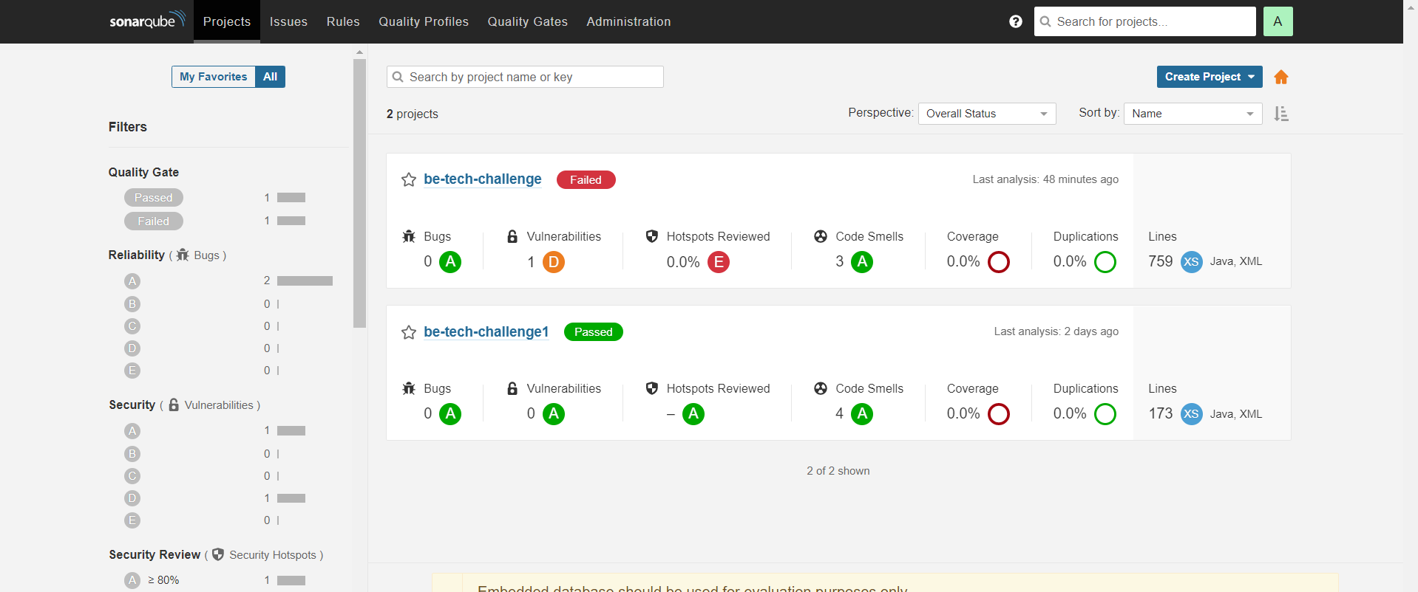

**Steps to SonarQube in local.**

* Install SonarQube and start the Sonar qube application.
* Sonar qube will be hosted in http://localhost:9000/
* Default username and Password is **admin: admin**
* Steps to generate Token for SonarQube:
* **Account -> myAccount -> Security -> GenerateToken**
* Once above steps is completed , start our spring boot project.
* Then run command
* mvn sonar:sonar -Dsonar.host.url=http://localhost:9000 -Dsonar.login={Token Generated}

**Swagger**:

Our Application is connected with swagger , Which provide Information about all Rest Endpoints present in our application.

Url : <http://localhost:8080/swagger-ui.html>

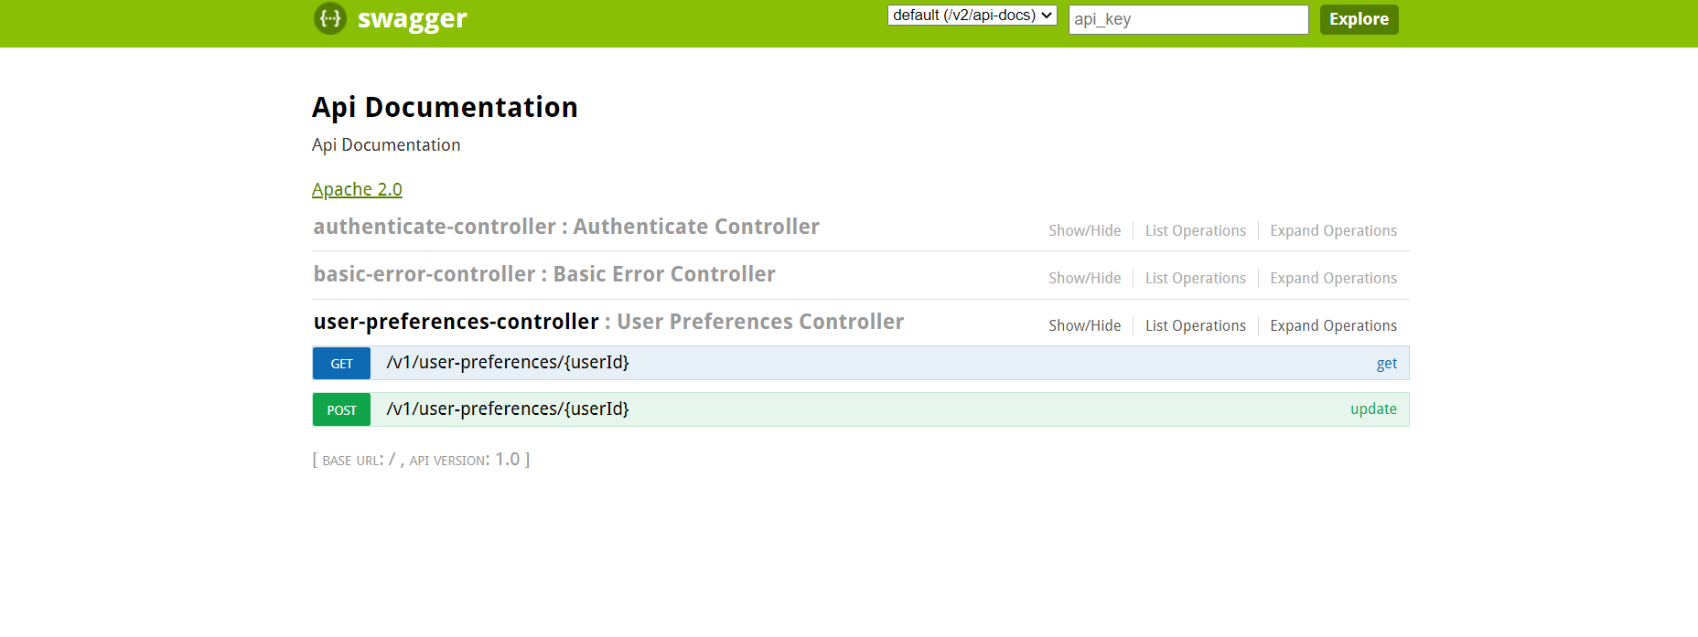**Redis Implementation**:

Provide all configuration for Redis cache. We can update server host name and port and connect to Redis Cache.

Class name: RedisConfiguration

