CS 189 Homework

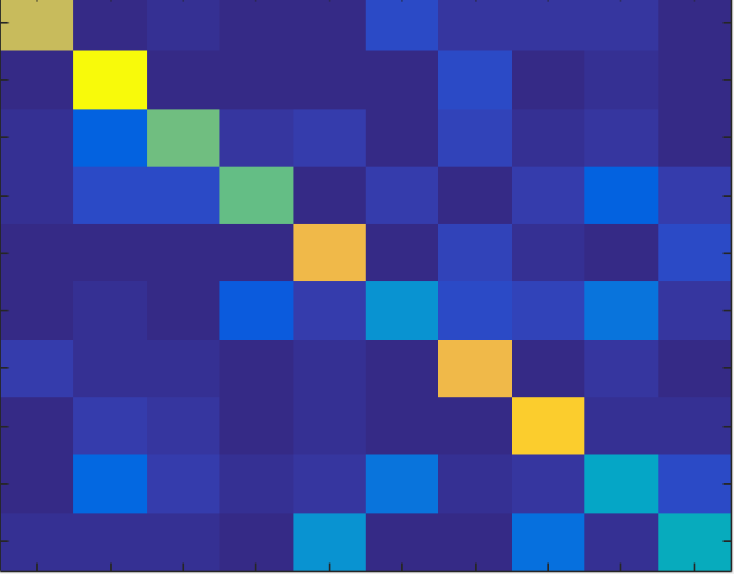

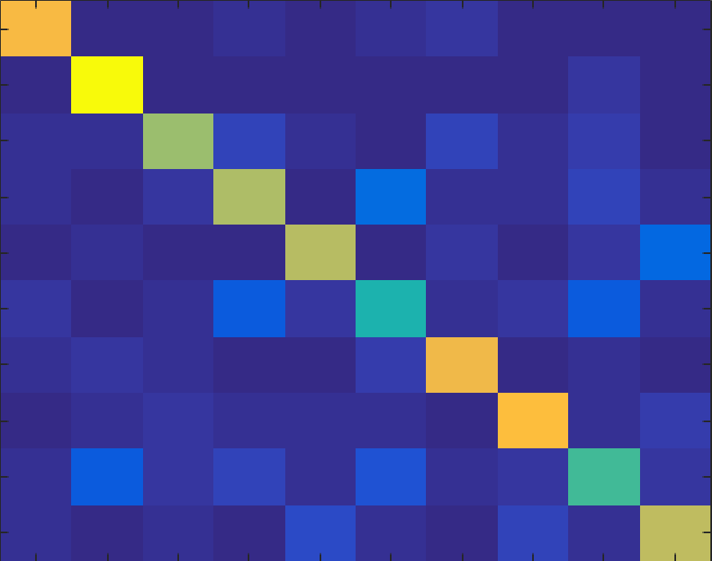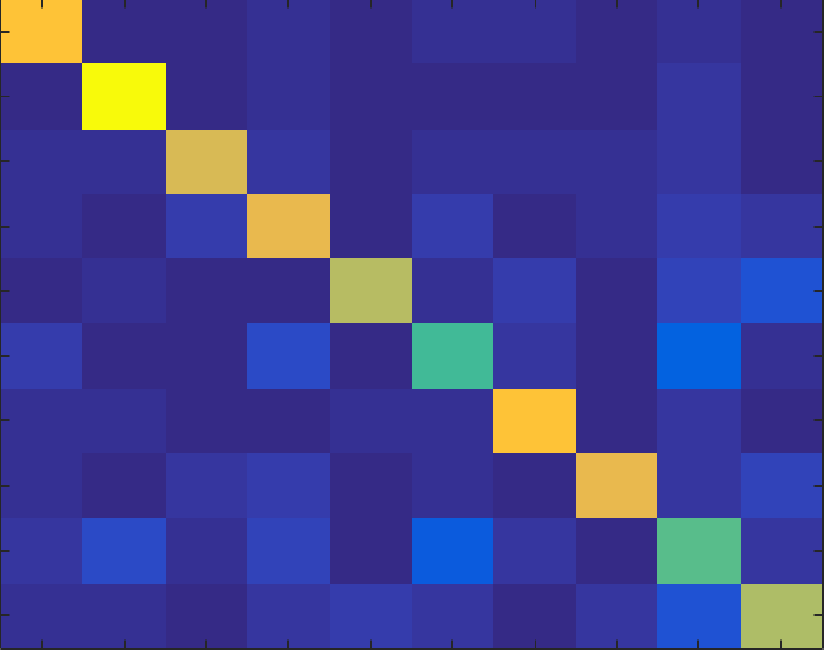



The transitions from left to right show how the concentration of correctness increases as we increase the sample size of the classifier. The final sample size is shown below, the one with 10000 training examples.



Question 3:

When I tried running this question for c values between 1 and 10 with a step increment of 0.1, I got the highest c_value to be 4.7 and The error to be around 18%.

Question 4:

When I varied c values, this time till 20 instead of 10, I got 1.6 and an error of around 15%.

Kaggle Scores:

Username: bharathsatheesh95

Digits score: 0.843

Spam Score: 0.785