EXPERIMENT – 12 Demonstrate virtualization by Installing Type-2 Hypervisor in your device, create and configure VM image with a Host Operating system (Either Windows/Linux), using VMware workstation
Aim:
To demonstrate virtualization by installing a Type-2 Hypervisor (VMware Workstation) and creating/configuring a Virtual Machine (VM) with a host operating system (Windows/Linux).
Procedure:
- Installed VMware Workstation (Type-2 Hypervisor) on the host device.
- Launched VMware Workstation and selected “Create a New Virtual Machine.”
- Configured VM settings:
  - Allocated CPU cores and RAM.
  - Assigned virtual hard disk size.
  - Chose installation media (ISO image of Windows/Linux).
- Installed the chosen operating system (e.g., Ubuntu Linux / Windows 10) inside the virtual machine.
- Configured network settings (NAT/Bridged) for internet access inside the VM.
- Installed VMware Tools for better performance and integration with the host.
- Tested the VM by launching applications and verifying that it works independently of the host OS.
Output:
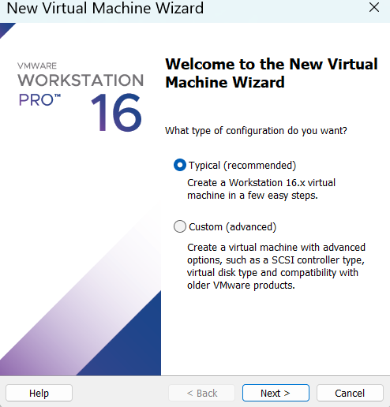

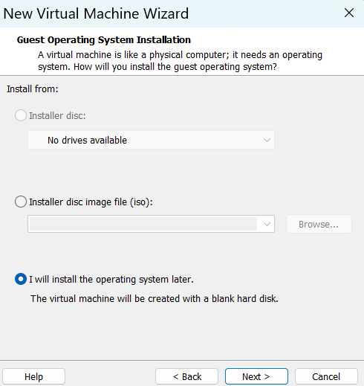

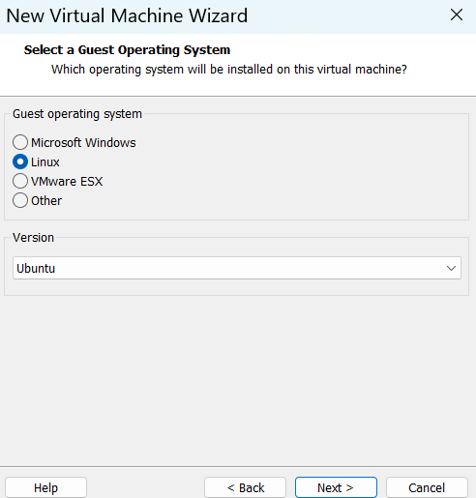

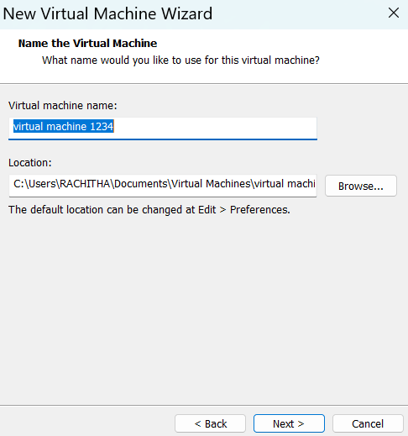

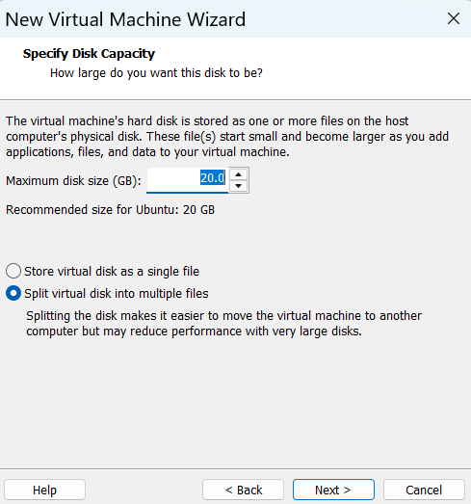

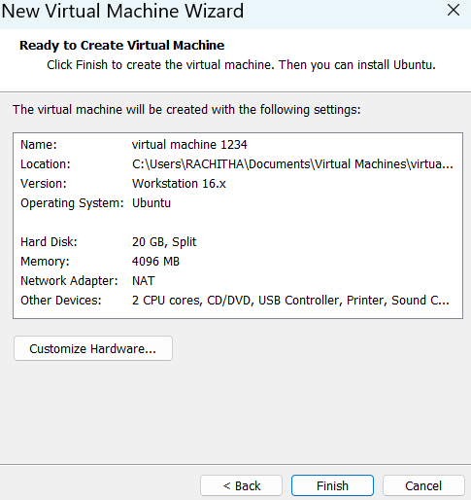

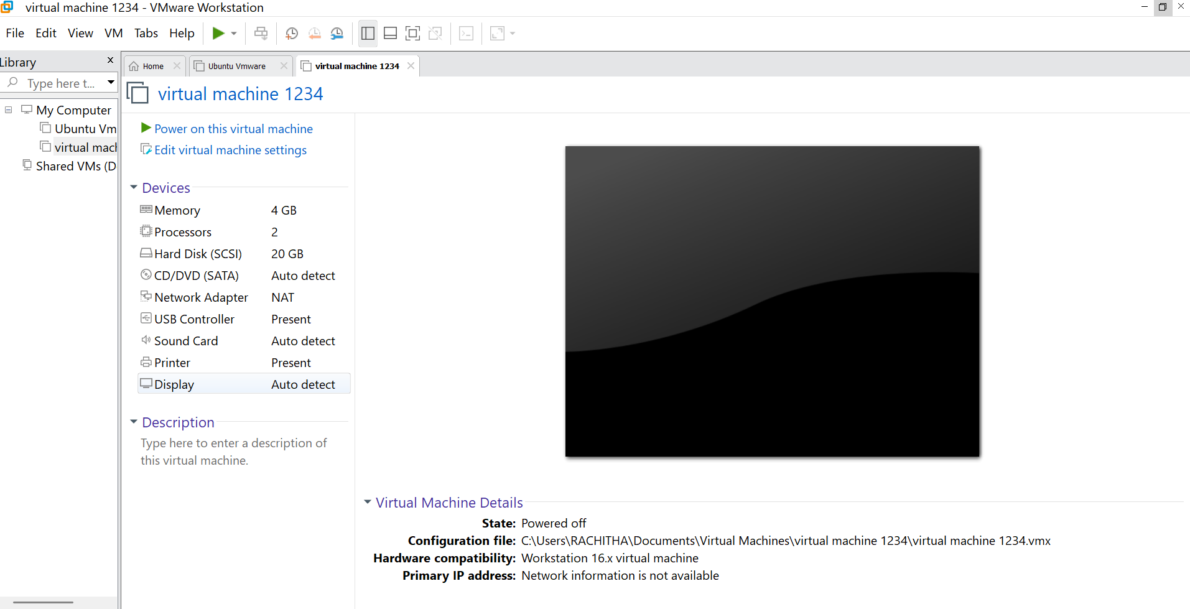

Result:
Virtualization was successfully demonstrated using VMware Workstation (Type-2 Hypervisor). A fully functional virtual machine with the selected operating system was created and configured, proving the concept of running multiple OS environments on a single physical device.

