EXPERIMENT – 13 Create a Virtual Machine with 1 CPU, 2GB RAM and 15GB storage disk using a Type 2 Virtualization Software using Vmware workstation.
Aim:
To create and configure a Virtual Machine with 1 CPU, 2 GB RAM, and 15 GB storage using a Type-2 Virtualization Software (VMware Workstation).
Procedure:
- Install and launch VMware Workstation on the host operating system.
- Click File → New Virtual Machine (Ctrl+N).
- In the wizard:
  - Select Typical (recommended) and click Next.
  - Choose Installer disc image (ISO) or Install later.
- Assign a name to the VM and choose the storage location.
- Set the Virtual Disk Size to 15 GB and select Store virtual disk as a single file.
- Click on Customize Hardware:
  - Set Processors: 1 CPU.
  - Set Memory (RAM): 2048 MB (2 GB).
  - Verify Hard Disk: 15 GB.
  - Attach the OS ISO to the CD/DVD drive if installing an operating system.
- Click Finish to create the Virtual Machine.
- Power on the VM to start the OS installation.
- Verify the configured resources (CPU, RAM, Disk) from the VM settings.
Output:
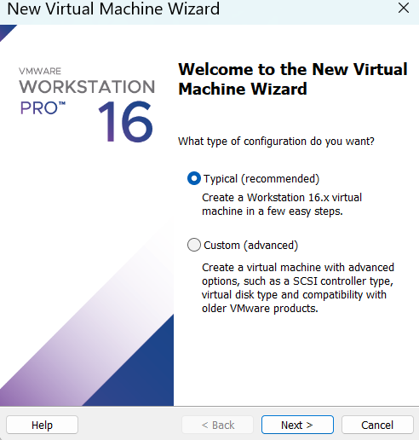
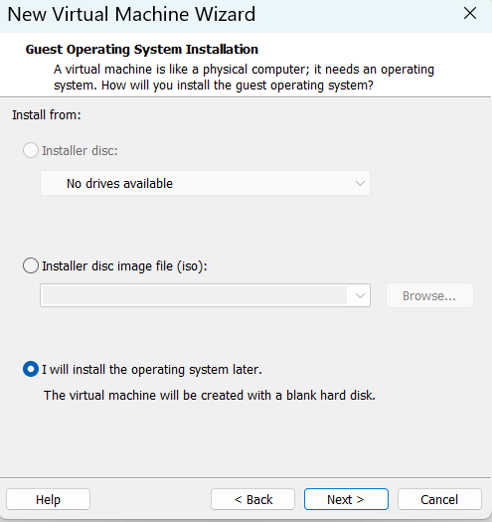

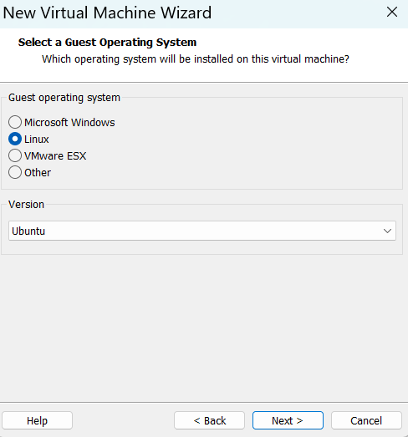

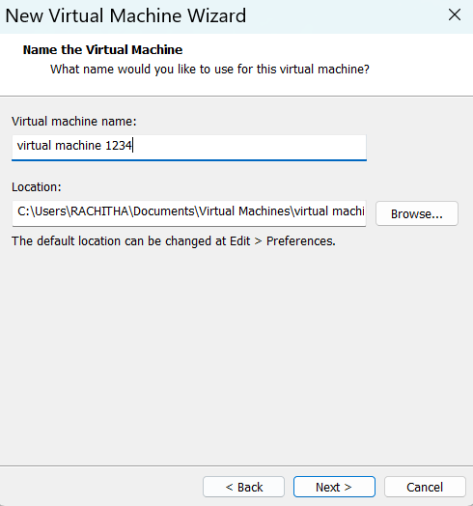

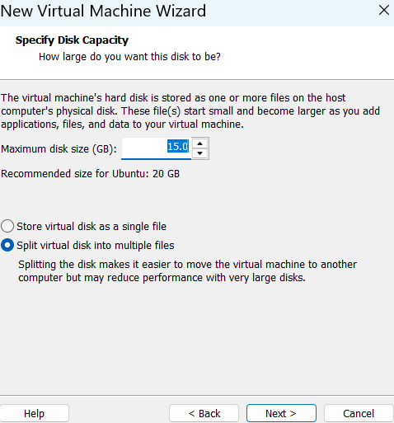

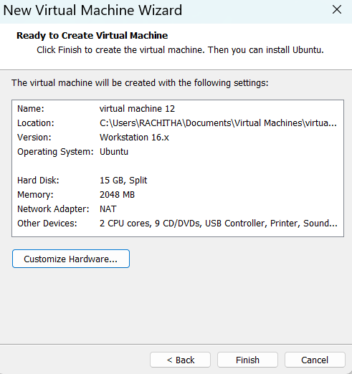

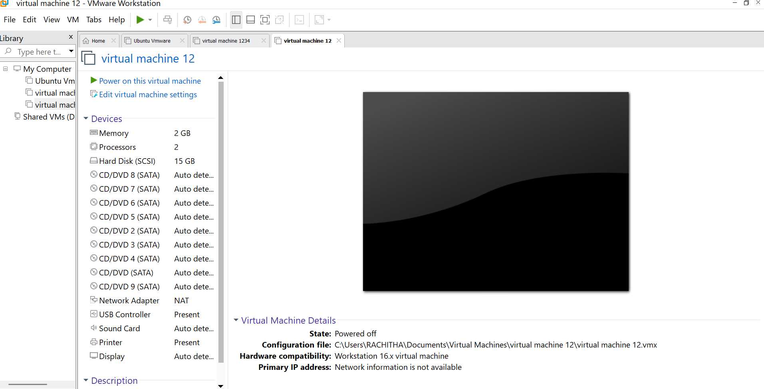

Result:
A Virtual Machine with 1 CPU, 2 GB RAM, and 15 GB storage was successfully created using VMware Workstation (Type-2 Hypervisor). The VM is ready for operating system installation and execution.

