EXP 20: Demonstrate Infrastructure as a Service (IaaS) by establishing the remote connection, launch the created VM image and run on your desktop using Azure.

AIM: To demonstrate Infrastructure as a Service (IaaS) by establishing the remote connection, launch the created VM image and run on your desktop using Azure.

PROCEDURE:

STEP 1: CREATE AN ACCOUNT IN MICROSOFT AZURE.
STEP 2: GO TO RESOURCE GROUP AND CREATE A RESOURCE GROUP. STEP 3: GIVE NECESSARY THINGS FOR RESOURCE GROUP.
STEP 4: CREATE A VIRTUAL NETWORK FOR TO CREATE A VIRTUAL MACHINE.
STEP 5: NOW CREATE A VIRTUAL MACHINE WITH UR IP ADDRESS AN USERNAME AND PASSWORD FOR YOUR VIRTUAL MACHINE.
STEP 6: AND YOUR VIRTUAL MACHINE IS DEPLOYED.
STEP 7: NOW CONNECT THE VIRTUAL MACHINE AND DOWNLOAD THE RDP FILE TO OPEN YOUR WINDOWS VIRTUAL MACHINE.
STEP 8: CREATED A NEW WINDOWS VIRTUAL MACHINE.

IMPLEMENTATION:
STEP 1: CREATE AN ACCOUNT IN MICROSOFT AZURE.
STEP 2: GO TO RESOURCE GROUP AND CREATE A RESOURCE GROUP.
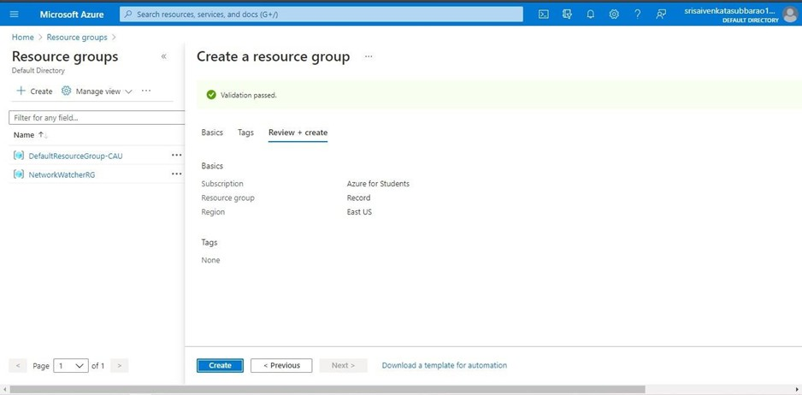

STEP 3: GIVE NECESSARY THINGS FOR RESOURCE GROUP.
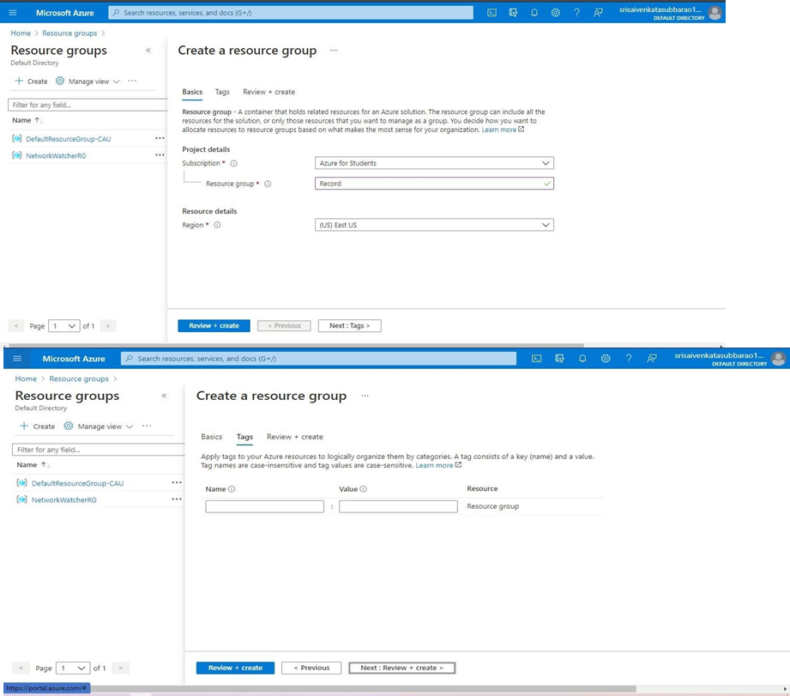

STEP 4: CREATE A VIRTUAL NETWORK FOR TO CREATE A VIRTUAL MACHINE.
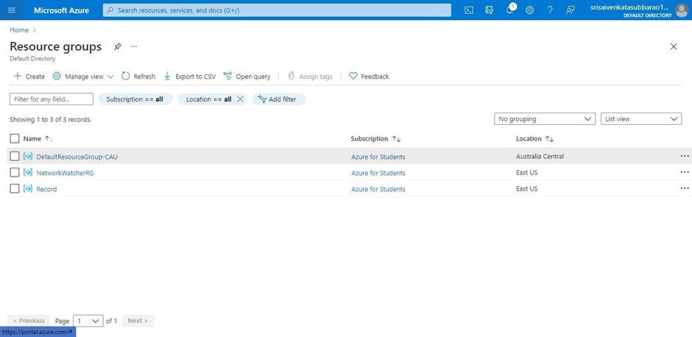

STEP 5: NOW CREATE A VIRTUAL MACHINE WITH UR IP ADDRESS AN USERNAME AND PASSWORD FOR YOUR VIRTUAL MACHINE.

STEP 6: AND YOUR VIRTUAL MACHINE IS DEPLOYED.
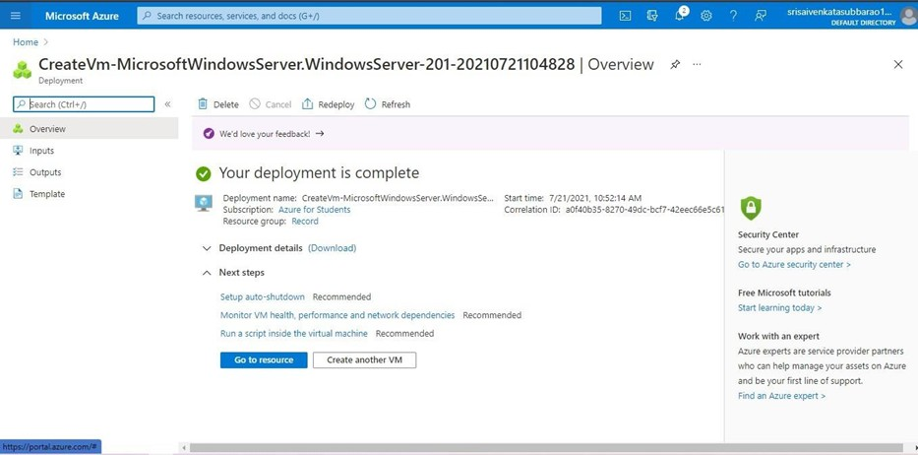

STEP 7: NOW CONNECT THE VIRTUAL MACHINE AND DOWNLOAD THE RDP FILE TO OPEN YOUR WINDOWS VIRTUAL MACHINE.
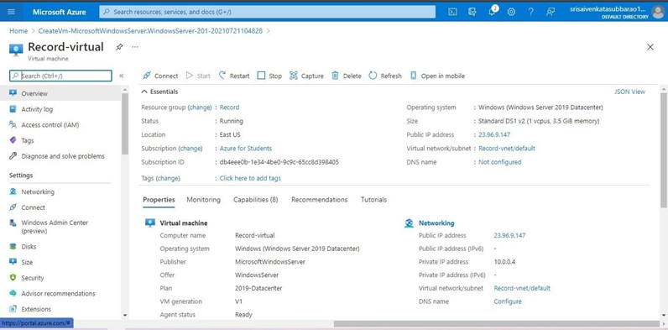

STEP 8: CREATED A NEW WINDOWS VIRTUAL MACHINE
