EXP 25: Create a SQL storage service and perform a basic query using any Public Cloud Service Provider (Azure/GCP/AWS) to demonstrate Database as a Service (DaaS) using Azure.

AIM: To create a SQL storage service and perform a basic query using any Public Cloud Service Provider (Azure/GCP/AWS) to demonstrate Database as a Service (DaaS) using Azure.

PROCEDURE:
STEP 1: GO TO AZURE AND GO TO SQLDATABASE. STEP 2: NOW CREATE A SQL DATABASE.
STEP 3: SELECT THE RESOURCE GROUP AND ENTER THE SERVERNAME THAT APPLICABLE.
STEP 4: IN NETWORKING SELECT ALLOW AZURE SERVICES AND RESOURCES TO ACCESS THIS SERVER.
STEP 5: IN ADDITIONAL SETTINGS SELECT SAMPLE. STEP 6:AND THE SQL DATABASE IS DEPLOYED
STEP 7: NOW GO TO QUERY EDITOR.
STEP 8:NOW AGAIN LOGIN TO THE SQL DATADATABASE
STEP 9: OUR TABLES WILL SHOWN AND TYPE THE QUERY TO EXECUTE.

IMPLEMENTATION:
STEP 1: GO TO AZURE AND GO TO SQLDATABASE. STEP 2: NOW CREATE A SQL DATABASE.
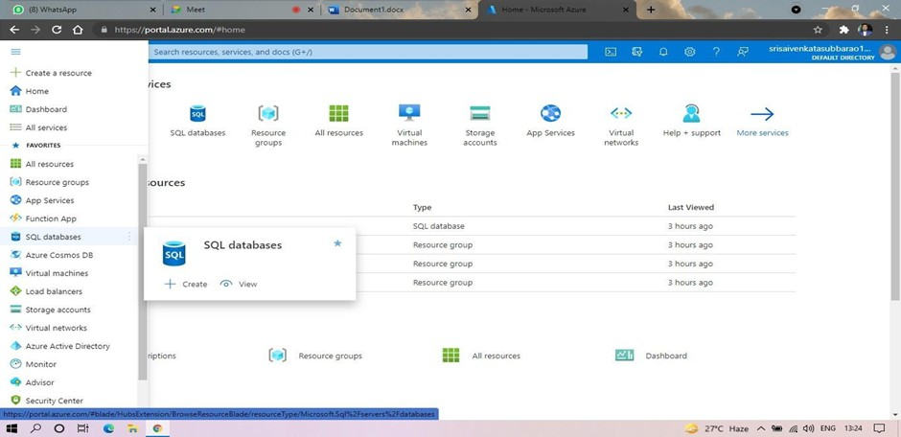

THAT APPLICABLE.
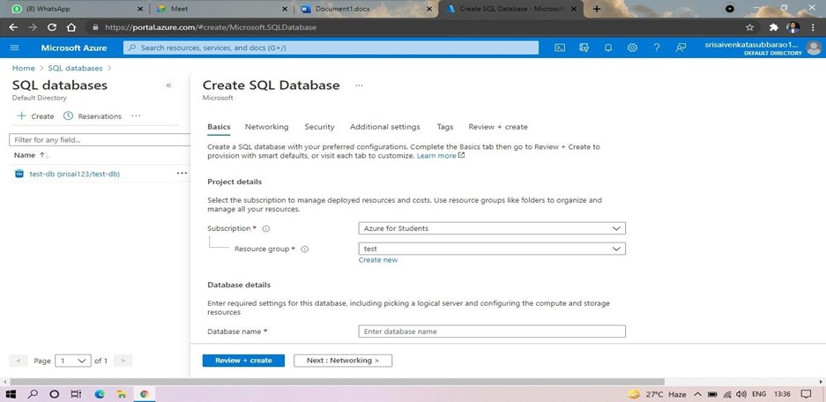

STEP 4: IN NETWORKING SELECT ALLOW AZURE SERVICES AND RESOURCES TO ACCESS THIS SERVER.
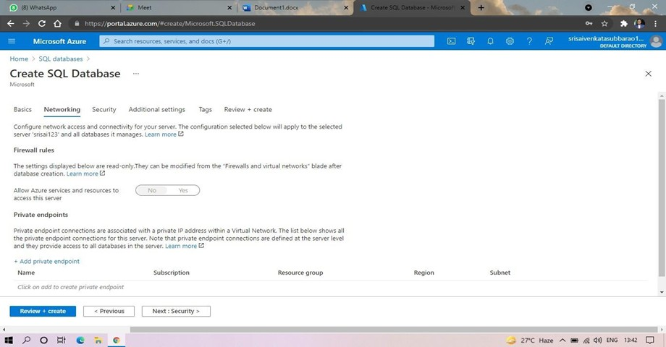

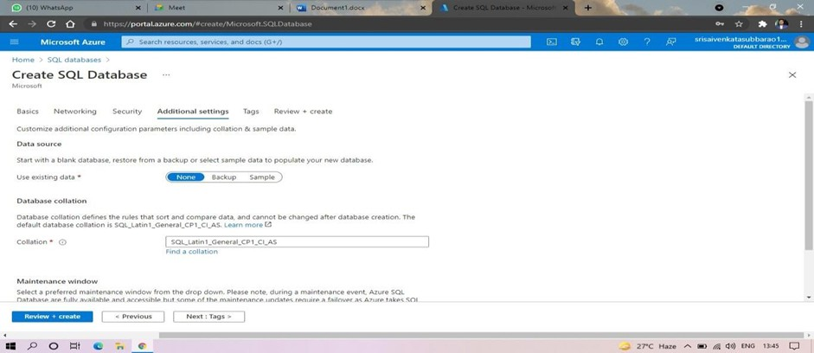

STEP 6: AND THE SQL DATABASE IS DEPLOYED.
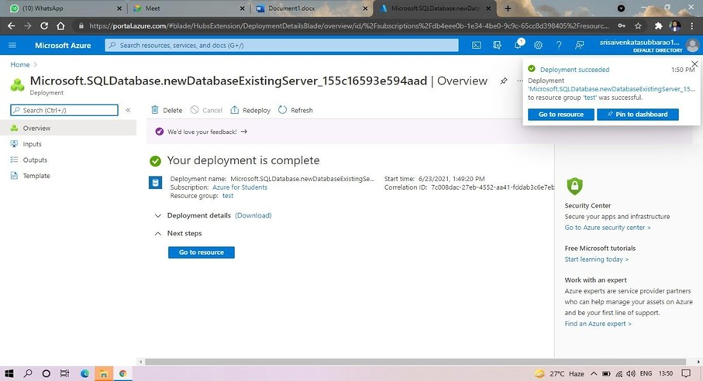

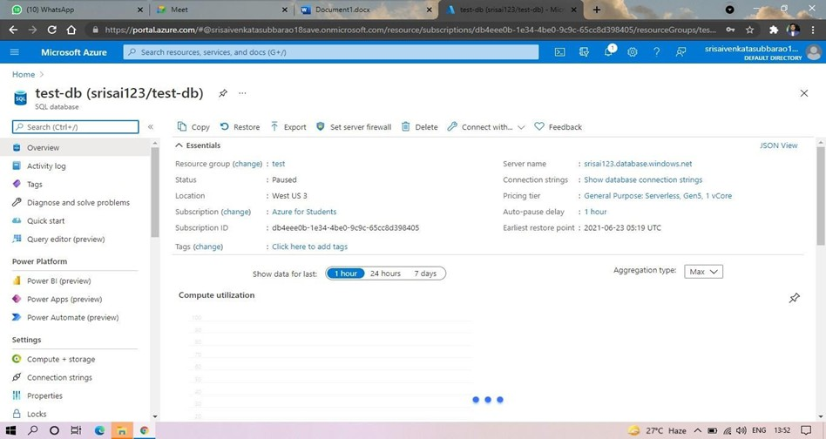

STEP 8: AND NOW AGAIN LOGIN TO THE SQL DATABASE
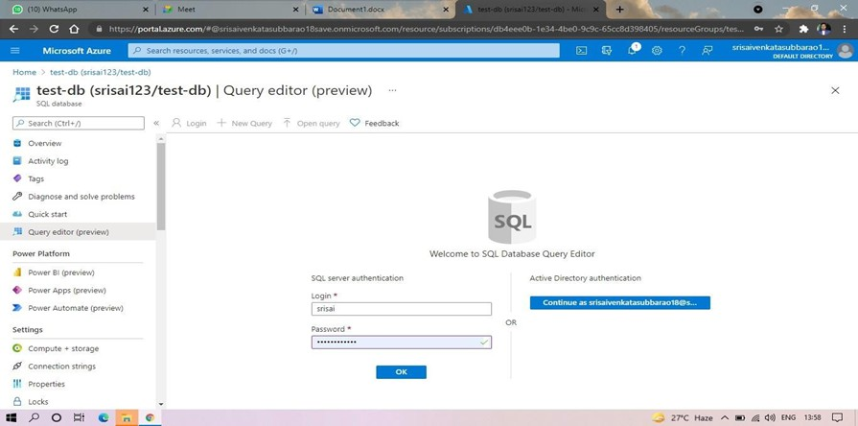

EXECUTE.
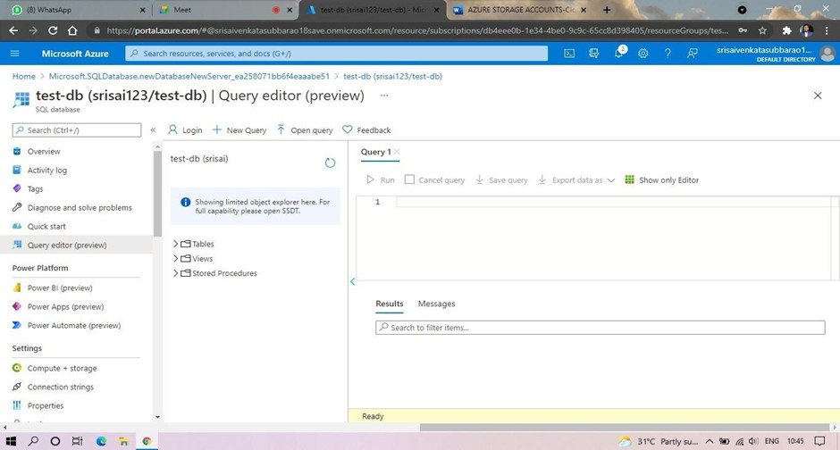

STEP 10: AND OUR OUTPUT IS READY.
