EXPERIMENT – 10 Create a Cloning of a VM and Test it by loading the Previous Version/Cloned VM using virtual box.
Aim:
To create a clone of a Virtual Machine in VirtualBox and test it by loading the cloned VM independently.
Procedure:
- Open Oracle VirtualBox on your host system.
- Select the virtual machine (VM) you want to clone.
- Make sure the VM is powered off before cloning.
- Go to Machine → Clone from the menu bar.
- The Clone Virtual Machine wizard opens → Click Next.
- Enter a name for the cloned VM and choose a location to store it.
- Select the type of clone:
  - Full Clone – creates an independent copy of the VM.
  - Linked Clone – shares disk with the original VM, saving space.
- Click Clone → VirtualBox will create the cloned VM.
- Once the cloning process is complete, select the cloned VM and start it.
- Verify that the cloned VM loads successfully and works independently from the original VM.

Output:
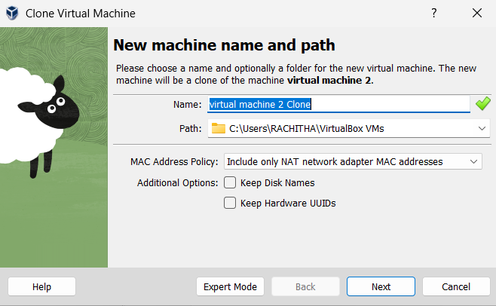
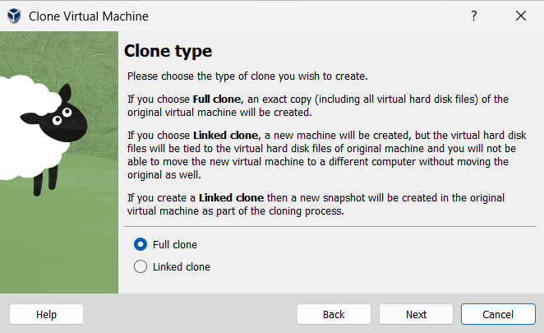
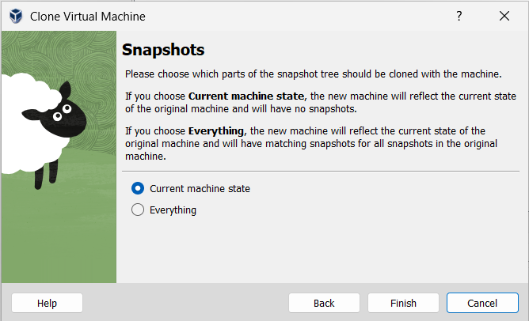
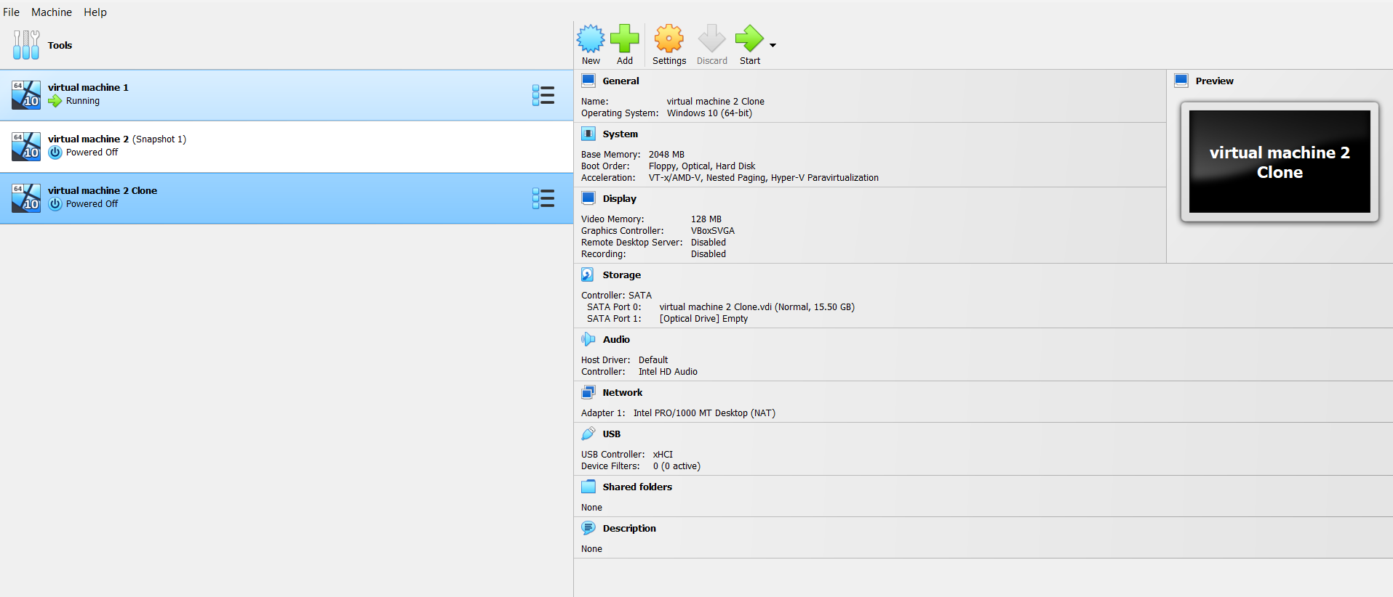
Result:
The VM was successfully cloned in VirtualBox. The cloned VM started and functioned correctly, demonstrating independent operation and the cloning feature for testing or backup purposes.

